The
Sheffield
istorical Society
,:-::,

Spring 2011

Mark Dewey Research Center: Genealogies & More
The Society received a huge trove of books from the estate of the late Ursula Gamble Kilner of Salisbury, CT, a member in the formative years of our group. Ursula was an accomplished genealogist and she and her husband were avid readers and bibliophiles throughout their lifetimes.

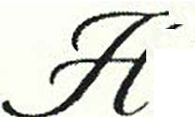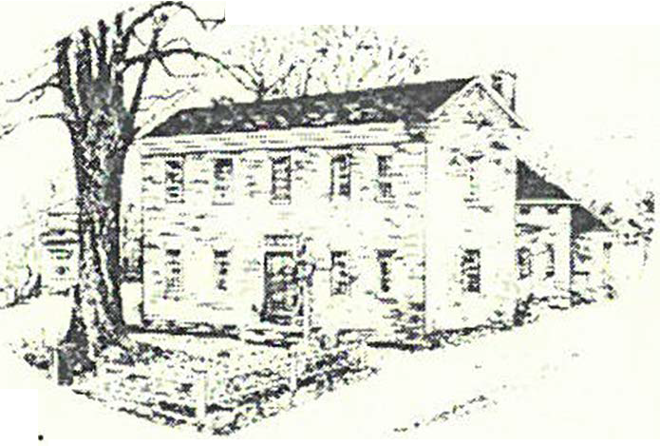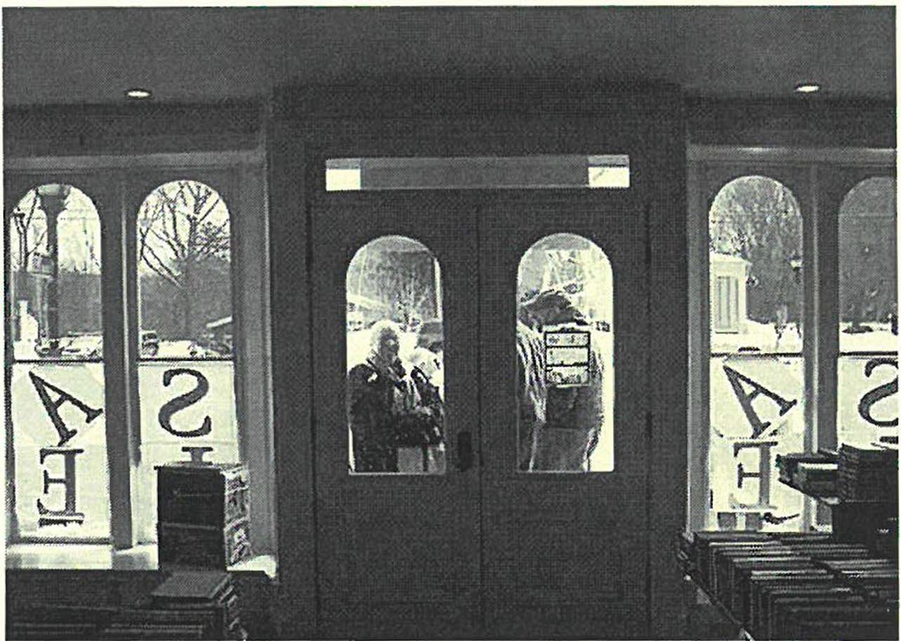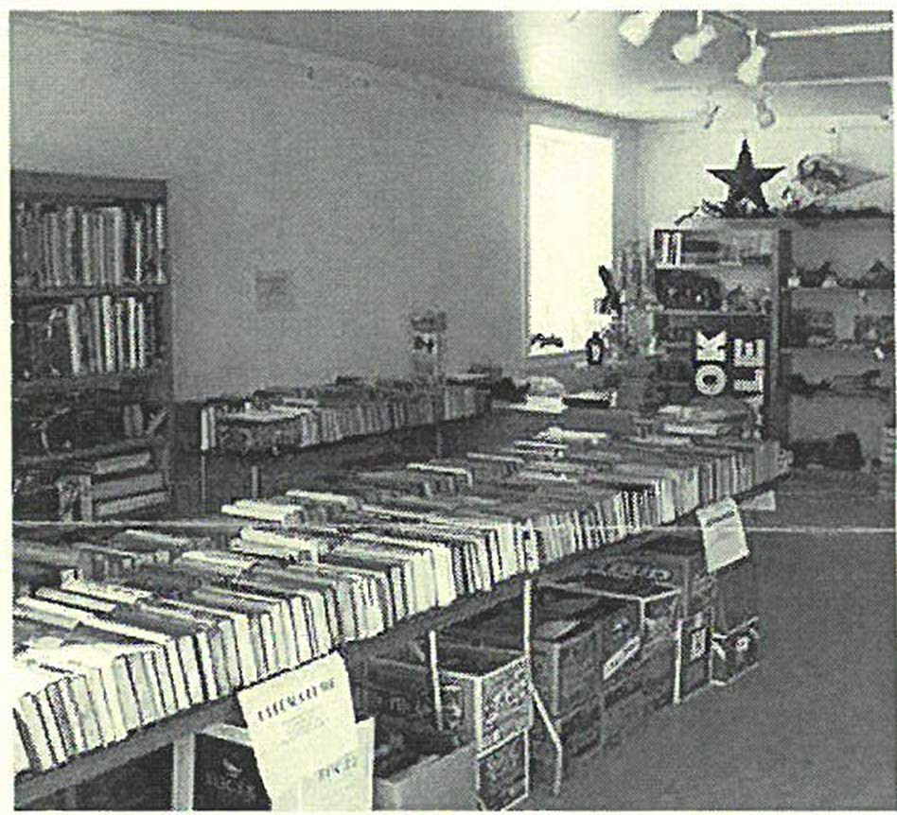The collection will be put to different uses, but most important to our mission are the hundreds of historical and genealogical tomes on states, counties and towns of the cri-state area of Massachusetts, Connecticut and New York and general and specialized volumes on United States history. These have already become part of the permanent collection of our research library which is maintained on the Society's campus next door to our headquarters, the Dan Raymond House. The unique aspects of the library's collection, however, continue to

f
Er1,ger msto111ers li11i11g, 11pfor the opwi,,g, o the book srtlr ti! the Old Stone Ston

011e small tomer �rthe (ll'{lilrtblr books rt/ the book Srtlr.
be our manuscript, photograph and subject ftles on Sheffield history which do not exist anywhere else.

The published genealogies we now possess are listed below and you are invited to use them and our other resources during regular operating hours, 1 :30 to 4:00 on Mondays and Fridays.

Adams Austin Barber Bartholomew Batchelder Benjamin Bri�bam Boardman Brodhead Bunnell/Bonnell Burrell/Burrill Burt Callender Campbell

m11ti1111ul 011 /'"§ }

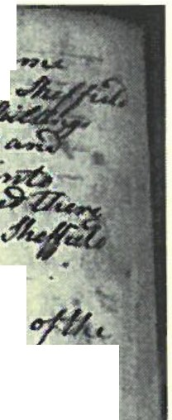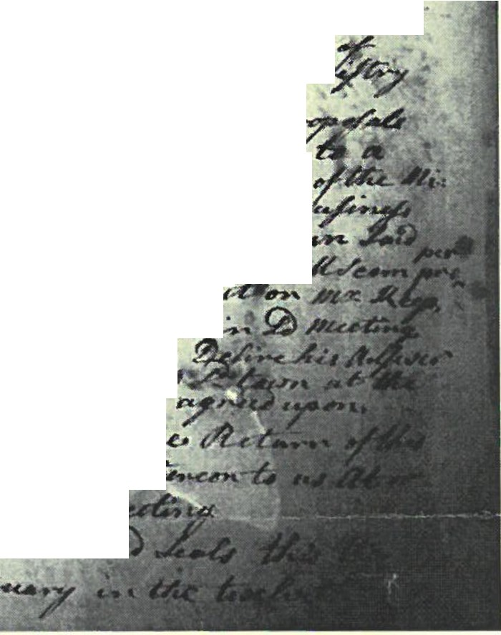
,
lH
OL fk .{.,.....,1/l,e,,C /I if-,-o/2A ...-
n .. U,-;.- .:r1e - /J:;),_.,
-f. /N ,?-u°iC" #u ...,,._
,. "'°"'-1 ,.. _4-4 .... :Id)'c;,• f !Z>.
- ·,?,.
= - -" -IA ./4-="· ---:t ""' //. Ai /u --v,,.
......... ,,. u:t- ..,I ;.... r,-._;:)
. t •• .#,: ,>';, A, ,D/-"= -;r:) ""
- . . . -
(f' --,r•,A/ , / /
';) , ,.; ,·
.. /
/, »
/1/ • . ,/ ,/-,/,u ',-,,,.-./ ,rZ,. "2'•°
/,.,_..,.. ;/ .4..-/?,;,V •". _v pu,u-f,r -
C: n,, • (----:?\• ">/
I _,C
- - >C£-.·..t _!.
. :t,c;,.,: v,c •,:t,t ,.,-./ t ........ .!.,. <1¥«,./ .
< .t, . ltf v // l"Y. 7w ..h' : •._H,L • '/ f .,,...,. -,e. u, ·
. • ,
,- / r_/; ,#'&; / (",',) K,cr<k, f,, I ;;1'c ! •• I'"'-' ><-. -. J
f'1,:.• ./),./ , ., -' ·•f "/" !"I-"',,,/,. - r,,,/ ,.,..c
fr /IL " " ( 7'/,,, ///. <,_1Jjf' =.,"" :?)-r- .,.,(/ .,,, -
X.I:.7. Ir , J'r ,.· , / ,'A , Ir ,."> , ._-,/ £ ,(i,.,,=., C, ,;- ·
hi
l'.I
td!J'uV,,(. n;,¾- r ,,.., . ·. ,f/u'•""-""7-• •""'"-6 --
<,. ' t ,,.,./4,... ·n1,.,J,,,.. r,-,•..,
·"·
,,./.,,9,..',_ 1,..,/.
• " .\/.'.' I .t, •'7
.
•
- .
- ._
, /. ..,,
i : :
- -l
( ,
/.
, ". : ,& .• /> t ,./< / ,/,,/£ ; ;, ' ..,..
., 'A '-"' c>,c. 'i'J
-
.. - /1-r- f,,) /
U D (II //,;: ,.,_,./#- u:... y ef /24' .C# J:.
,I •
·
_,:
c? •f,'
<$_,,, ·' ,,
,- ••, ~ <- " I' "'" . 1• /L/A' (
._..;u
, .l.,{... /.:.,..
;f. ! '.
.,,,,, :
A,r f f,, ..,_ ( p ///''
,./t
tf /LJ,,-1.'nf r. ,:.) J,'-/ P ,;.. <..J1 ,>g;.;I(,.fi
'J'."_ "' t,- f, .,.,./ J ,._,,,r· r, "Y ,#_._.,,!J
,,,,.r : ·-,·'?1 U, .rfo e< (;.,..
t.' - - .
4> n •,( ..,, tr rl.';.,.. -I/
,,.. . ,1-;- , .,,,,,_ .
_ ,,..
/, , /{/r ·•
<-.,..
' •

- ,, , ,., r_{.t} ₍ t,,: . L •
- 1
- - t.L-a-6-
# ,-£t''j e.-:$' -.-:t:.:t:.. ,
- (II!"\. ;z-_ "''- --'i: >'-# C..J' • _,/U.... •
•
_.., ul -
'-'' #'r .e,,I """''
-
. · tt ·tc ·· . .
.' ·'-.'1'/,( /f,,'$),,,l. ,.. /l v
',#.
-,z_' --·
ff«· •-.-r"\ -..., • ta
•. ':..ti
f/)u-f Ln/,7- 7
•-
..
Old Sheffield News - February
17th 1772
\'(/hat you are loo king at is a Notice sent out by the Sheffield Select Men calling for a Town Meeting on T hursday, i\tfarch 5'1\ 1 772 to vote on calling a new Pastor for Old Parish Church • at that time the official state church. This page is from the Town Records and Vital Records restoration project being managed by the Sheffield Town Clerk , Felecie Jo yce. The first two volumes of these have been recently returned and are ava ilab le for study at the Town Clerk's office. Felecie is a great support to the Society and redirects to us the man y interested people who wander into her office loo king to find out more about the history of Sheffield. H er how:s, in case yo u'd like to see what happ ened on other days in Sheffield's past are, i\ f o nday through Friday from 9am to 4pm.
The Notice in its entirety says the following:

'"tJ3er f(J fiires. 'To 1E£t fie. r of tlie Consta6[es of tfi.e 'Town of Sfi.ejfieU in saiaCount y. qreeti:ngs.
In fi.is :Majesties Name you are fi.ere6y requirea fortfi.witfi. to warn a[[ tfi.e Jnfi.a6itants of tfie 'Town of SfiejfieU Qua[ifiea to 'Vote in town affairs to meet at tfi.e :Meeting Jfouse in saia'Town on rr!iursaay 5th (])ay of :Marcfi. ne at one of tfi.e Cfocf<, after noon tfi.en ana tfi.ere to transact the fo[fowing <Business ( '1Jiz)
is1 to Cfi.use a :Moaerator
2(y to See if tfie town wi[[Jlgree to <;ive :Mr. Jofi.n 1(eep a Ca[[ to Settfe in tfi.e 'Town of Sfi.ejfieM in tfi.e work,of tfi.e qospef:Ministry ( 'W fi.ic fi ifJlgreea to)
J{y to agree upon wfi.at offers or proposafs tfi.ey wi[[ mak_J fiim <J?s{ative there to a Settfement an.a Support in saia work,of the :Ministry ana to transact any otfi.er <Business
<J?s{ative to saia:Mr. 1(eep fi.is Sett[eing in saiaWork,as to tfiem tfi.ere Convened' Sfi.a[[ seem proper.
4(y to C fi.use a Commit ty to wait on :Mr. 1(eep ana fet fiim fuww tfi.e 'Votes in saia:Meeting ana tfie (}?J!quest of %e town. (])efine fi.is }lnswer tfi.ereto ana mak_J IJ?sport the town at tfi.e time that sfi.a[[ 6e 6y tfi.em agreed' upon.
Jfere of faiI not ana 111ak_J <R_f turn of tfi.is 11Varrant 11Vitfi hour (])oings tfi.ere 011 to us }It or <Before tfi.e <Ti.me of tfi.e
:Meeting.
<;iven unaer our fi.ancfs ana Seafs tfi.is tfi.e 111r, (])ay of (['e6ruary in tfi.e twefvetfi. <fear of fiis :Majesties <J?sign a11110 1772.
Lemue[ <Bamartf Stepfien (])ewey Si[as 1(e[fogg Jofin}lsMey }laron <RJ)ot Se[ect men of S fiejfie[a"

In terest ing to note is the las t part of the top of the page:
". . . . . .}lt tfi.e Same :Meeting %tea to give fourty Sfii[[ings as a 6ounty on <Eacfi. 'Wolf 1<j[feain SlieffieM ana If fauna in SliejfieM ana fo[fowea into any otfi.er town in tfi.is
Prov ince ana fu[[ea tfi.ere to <J?sceiv e tfi.e Same <Bounty as if
fu[(etf in Sli.effie [a."

Loo ks like in 1772 Sheffield was loo ki ng for both material and spiritual help to keep the wolves fro m the doo r!

De1111i s Sem:.-

William L. Maxson & the Berkshire Trout Farm
A bit of innovacive post-World \Var II technology found its way to Sheffield in the form of an aquaculture venture designed to provide fish for meals to be served by Pan I\merican \'(/oriel Airways on their new trans-Atlancic clipper planes scheduled to begin early in 1949.

Maxson Food System, which developed much of the technology, had early experience in providing frozen meals for troops flying overseas with the Naval Air Transport Service during the war. Maxson called them Straro-Plates and they evolved into what came to be known as the popular TV Dinner of the l 9S0's.

\X/illiam L. Maxson started the trout farm on present-day South Undermountain Road in the spring of 1946. It consisted of a series of hatching troughs, 25 rearing ponds, an arcificial lake and a freezer plant capable of holding one­

t--faxson was a 1921 graduate of the Naval Academy, resigning his commission in I 935. Credited personally with nine invencions, his companies held another 72 patents. One, the "robot na,·igator" was used by Howard Hughes in his flight around the world in l938. Unfornmately, Tuba, as Maxon was known, died at age 58 in 1947 and the $300,000 facility, including four dwellings and a barn on 537 acres was put on the market by his heirs. It brought only $67,500.

The new owner, shifcing gears, ran it as a sportsman's fishing paradise under the name Berkshire Trout Farm. They offered accommodations in a "new luxury i'v[otel" and charged $5.50 per clay for fishing, five trout, maximum weight five pounds. The acreage was later divided into minute "water front" lots too small to build on, that caused a ruckus in a town without any planning in place. For those of you who are familiar with it,

half
million pounds of fish
°
at 40
below zero, said to be
Sherwood Forest in Becket was a similar debacle

enough to fill 12 railroad cars. In aclclicion to providing trout for its precooked dinners, the company also sold fly, fresh fish and rented locker plant space.
perpetrated by the same man.

- James B.. Miller

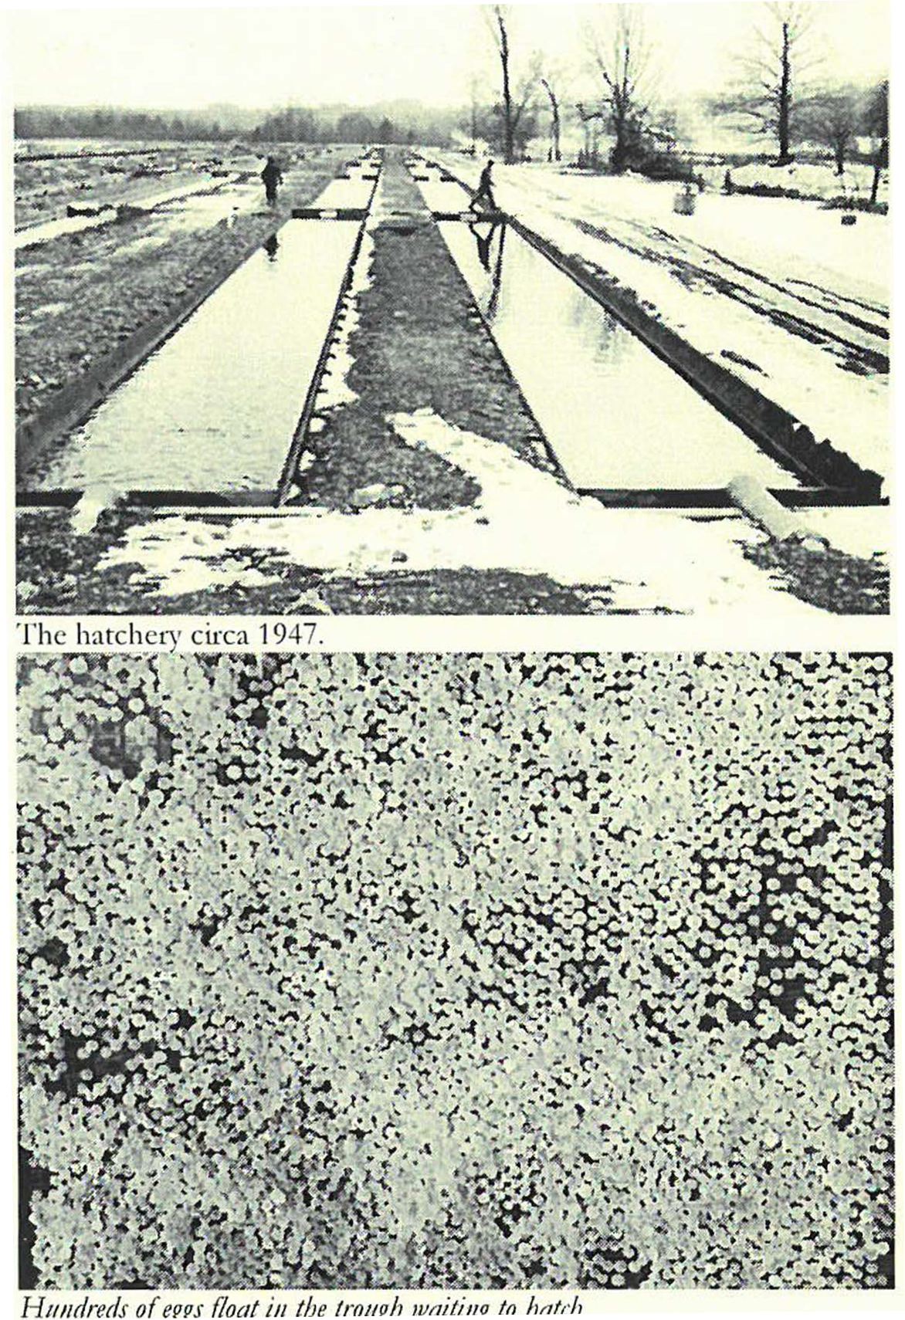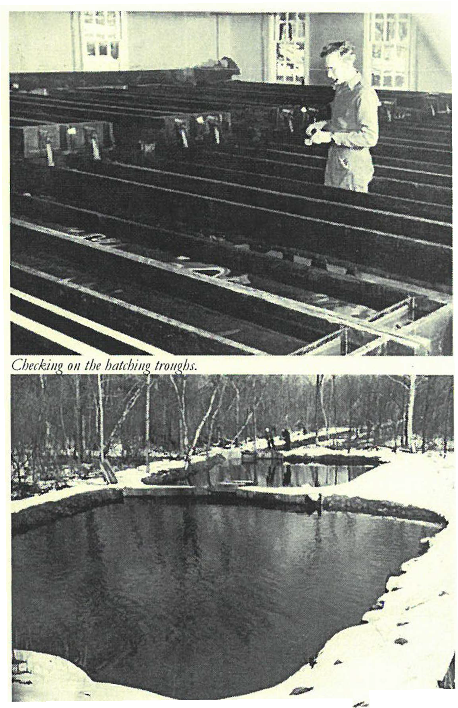

llcaring po11<k

Summer 2011
2le

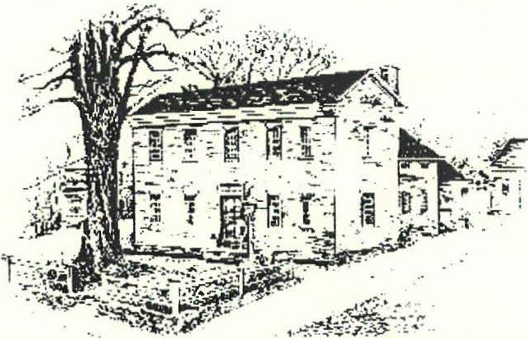
Y£#U
ftiJt-tJrteal clef#

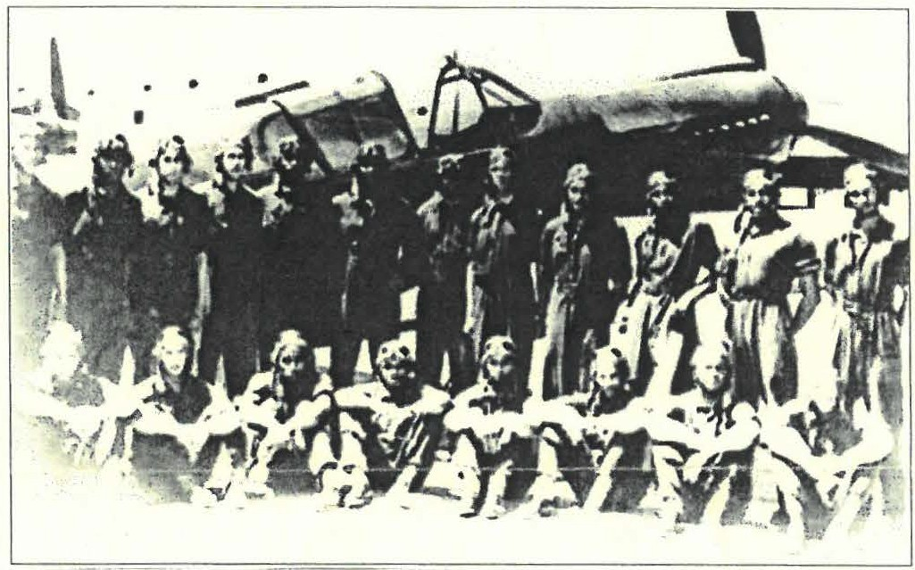
Tuskegee Airmen

September Program to Feature Tuskegee Airmen

On Friday, Sept. 9, the Historical Society will present Bruce Bird, founder of the Museum of Black World War 2 Hi:itory in Pownai, Vcm10nt. Mr. Bit-cl will speak about the Tuskegee Ainn en , the first all Black Airforce unit to fly combat missions in World War II.

The Tuskegee unit was established in January, 1941. as the Anny Air Corps became open to Blacks after decades of segregation. Tuskegee, Alabama, was chosen for the flight school. Because of local prejudice, the 99th fighter squadron was not sent into combat until July 2, 1943, and thus had received more training than any white squadron.
This unit was joined in February, 1944 by the 100th 30l ^{st}
00 00 ' '

until he sustained a back injury in 1977 . As a result of this injury, he started a college career at the tender age of 37, when the state of Vermont financed his Associ­ ates Degree in Industrial Management. Unable to find employment in that field, Bruce returned to school and earned his BA in History in 1985. From 1988 to l 990, Mr. Bird was part time curator of the Vermont Natio nal
G uard Museum, while performing fulltime factory work,

and 302 fighter squadrons to fonn the 332 fighter

group. Eventually the group flew P-51 Mustangs, known as " red tails". The Germans called the 332⁰⁰ the "Schwartze Volgelmenchen ", or " Black Birdmen." While most white pilots were rotated home after 50 missions, black airmen flew as many as 158 missions, because T uskegee could not train enough black men to replace them.

The 450 Tuskegee pilots flew over 1,500 miss ions, destroying 111 enemy aircraft in the air, plus I50 more o n the ground. The Tuskegee Ainnen also included 994 flight crew and 16,000 to 19 ,000 ground crew in the Army Air Corps. Many Black units served with great distinc tion in WW II, and this was a factor in President Truman's order. to desegregate the Military in 1948.

Bruce Bird had spent most of his life as a factory worker
until at age 64, he accepted early retirement. Having read military history, built military models, and col­ lected military artifacts, he decided to open a military museum. When a former school house became available in Pownal, Mr. Bird decided to honor Black troops with a Museum designed to highlight the forgotten service of
  - million African-American servicemen and women who served in World War Two. The Museum of Black WW II History was opened on June 3rd, 2006, and is the only Museum about the African-American service in WW TI in the country.

"Tuskegee Ainnen" will be presented at Dewey Hall in Sheffield on Sept. 9, 2011, at 7:30 p.m. For further in­ formation, call (4 I3) 229-2694.

Joyce Hawkins, with Bruce Bird

Exhibits at The Old Stone Store:

Sat. Aug. 6th - late Sept.
Talking Maps :
These Maps Tell Stories
Maps open windows on our history-South County/
Sheffield from 1794 to the present. The closer you look, the more stories are uncovered!
Sheffield Historical Society Annual Holiday party at the Dan Raymond House.
5:00 p.m.
Sunday, Dec. 11th
Old Stone Store tastings Come check out this year's goodies offered at the Festival of Holi­ days!
7:30 p.m.
Friday, Nov. 10th
The Berkshire Trout Farm
Rhonda Cushwa presents Maxson Food Service & the development of frozen dinners.
7:30 p.m.
Friday, Oct 14th
The Tuskegee Airman
Bruce Bird of the Museum of Black WW2 His­ tory talks about the Tuskegee Airmen, the first Afri­
can American military aviators in the U.S. armed forces.
7:30 p.m.
Friday, Sept. 9th
Old Stone Store
Saturdays 10:00 - 2:00 / Sundays 11:00 - 3:00

SHS programs at
Dewey Memorial Hall:
C LE DAR OF E E TS
<Dear ::M.em6ers and Prientfs,
The Society begins its 39th year of operation on a sad note. The last year has seen us all say good-bye to two of om founding members, Lillian Preiss and Milton Barnum. Lillian and Milton were not only founding members, but both had held most of the Socie ty' s leadership positions including President. Both were continuously active in supporting the Society until health conditions no longer permitted such activity. It's very hard to pick out just one highlight of such long, excellent service, but I personally think most people will connect Lillian with the Society through her book, Sheffield: Frontier Town and Milton with his wonderful local artifact collection and his annual January " What' s It?" program featuring so many items from his collection. More background and obituary notices for both Lillian and Milton are on the Society's web site under the "more" tab and will remain a while lo nger .

The Old Stone Store has been very active this calendar year beginning with our six-week long giant book sale of the bequest left to the Society by Ursula Gamble Kilne r. Detailed information on the collection can be viewed in the Spring
2011 ewsletter found on the website at .IL ://
sheffieldhisto .weebl .com/newsletter.html . Following this was the just-closed exhibit, "She ffield During the Civil War." Open now is 'Talking Maps: These Maps Tell Stories " illustrating some of the changes that have taken place in South County, primarily Sheffield, from the date of the earliest map, 1794, to the 21st century.

A great lineup of monthly program meetings in Dewey Hall starting in September appears in this newsletter, so mark these on your calendar now!

Many hard working member volunteers, board members speakers, and community members make all these events happen , and I'd like to thank several people who have ''timed out" of positions at the June 30th fiscal year end. Connie Cooper has served her three years as Treasurer of the Society and Chair of the Finance and Audit Committee, a major load to carry while she also held a full time job in addition to family duties. I'm happy to say she ha accepted an appointment by the Trustees to the position of Funds Manager . Philip Detjens has served his three years as Secretary of the Society in addition to years of work on the Finance and Audit, Collections, and Fund Raising Committees. Philip has agreed to stay on as a member of the Collections Committee. Please join me in thanking Connie and Philip for their many hours of support for the Society. A list of the current FY12 Officers and Trustees is found here in the newsletter.

The Society thanks those who have continued membership this calendar year with a donation to the Sheffield Historical Society Annual Appeal. Money raised from the Annual

Jf_nnua{'R§ports
<Board of <Directors 2011-2012

Position | Individual | Term
President | H. Dennis Sears | 2012
Vice President | Paul O'Brien | 2013
Treasurer | Lois Levinsohn | 2014
Secretary | Susan Pitman | 2014
Trustee | Paul Banevicius | 2013
Trustee | MarciaBrolli | 2012
Trustee | Wray Gunn | 2012
Trustee | Greig Siedor | 2012
Trustee | Kathleen Tetro | 2012
Trustee | Joyce Hawkins | 2014
Funds Manager | Connie Cooper | 2012
MDRC Director  Administrator | James R. Miller  Barbara L. Dowling | 2012
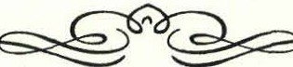
President} utter continued from page 2:

Appeal goes toward the operating expenses of the Society (programs, exhibits, staff, buildings, utilities, etc.). You may want to consider the use of an "IRA Charitable Roll­ over" for your annual appeal donation this year or perhaps for a larger gift to the Society's endowment fund. This year is the last year individuals may roll over up to
$100,000 from an individual retirement account (IRA) directly to a qualifying non-for-profit institution without recognizing the assets transferred as income. If you are 70½ or older and are required to take a "Minimum Re­ quired Distribution" (MRD) from an IRA this year, you might want to consider making such a donation this year. For more information, contact your tax or financial advi­ sor.

Thank you all for your support of the Sheffield Historical Society in both time and treasure and I look forward to seeing you this year at one of our events.

'}[. (})ennis Sears
President, Sheffield Historical Society HDennis Sears@veirzon .net
'I1ie :Mat{<Dewey earcli Center
The research and reference aspect of the Society, represented by our Mark Dewey Research Center, has completed an­ other successful year in assisting people with historic ques­ tions that commonly serves authors, both historical and fic­ tional, usually seeking hard facts as well as perspicacity; house and family history researchers; name origins (Bow Wow Road is a common one); demographics; local slavery (Yes, it existed here.) trees (If you can imagine.) and Black history, among many others. The inquiries number in the hundreds annually and come by walk in, telephone, USPS and e-mail. Although there are slow periods, at times we are overwhelmed. During the lulls the all-volunteer staff does housekeeping activities related to preservation of the perma­ nent collection which grows apace, primarily through dona­ tions by patrons who are grateful for the use of our resources.

Aside from our day-to-day program, we reached two mile­ stones this past year, namely the acquisition of a local histori­ cal collection from the estate of Ursula Kilner and the ser­ vices of Taylor Neil, a young, enthusiastic and energetic vol­ unteer archivist.
An occasion we may not see again was the splendid acquisi­ tion of Ursula's library from her estate. She was an early member of the Society, and a certified genealogist, which explains the vastness of her collection. It covered, among many other subjects, town histories of Massachusetts, Con­ necticut and New York, county histories of the same areas and a number of published genealogies related to families of the tri-state area. The volumes added to our collection num­ ber in the hundreds. Her research manuscripts, now in Ohio being organized, will follow.

This acquisition, indeed, puts the Society in the position of being a significant research facility for the tri-state area. It is doubtful that anybody doing historical work on South County can safely ignore our collection.

Taylor, our most recent volunteer, will be a junior at Mount Everett this fall. His summer time contribution is a perfect fit for the Society since one of our regular volunteers takes that season off. We hope to have Taylor' s talents for at least two more years but hope for even more. His ultimate goal is to become a lawyer.

Drop in sometime to see the new acquisitions and to meet the volunteers. We are open to the public on Mondays and Fri­ days, 1:30 to 4:00 or by appointment if a volunteer is avail­ able. We also post home phone numbers at the Center in the event of a casual out of town drop in.

Betty Chapin, James Miller, Taylor Neil, David Prouty, volunteers

SneffieU¾istorica{ Society

Family/Dual

'FY 2011 Supporter's List

Benefactor
Paul & Carol Collins

Sponsor
Dennis Sears & Rene Wood Wesley McCain & Noreene Storrie Jim & Catherine Miller

Patron
Neal & Julie Chamberlain Ross & Joyce Hawkins Gregg S. Massini
Carl & Pauline Schumann Susan and Ted Pitman Ormsbee Gas Co., Inc.
Ormsbee Gas Co., Inc. Ray & Ginger Alexander Allan & Karin Altman Walter & Doreen Atwood Paul R. Banevicius Arthur Batacchi, Sr.
Paul Benjou & P. J. Birriel Blanche Bennett
Jean W. Blackmur Bill Browne
Bruce & Carol Broyles Mildred & Lo-Yi Chan Elizabeth Chapin
Neil & Kathleen Chrisman
Steven & Julie Hannum Joseph & Susan Hurlburt Dr. & Mrs. James R. Hurley
Robert Jenter & Andrea Scott Joseph & Christine Kelley
Beverly Kradel Allison G. Lassoe Bob & Sue MacVeety
Antonio & Marian Malnati
Barbara E. Martin Jack M. & Lynda B. McKelvey Norman & Jeanne Merrill Richard Meyers & Ann E. Barnes
Dan & Ann Moulton Walter & Gail Orenstein Fred & Elaine Panitz Dan and Andrea Patel
Fred Pomerantz & Ruth Kolbert
Carl Proper George Raymond & Ada Hastings

Philip & Susan Detjens
Emily & John Alexander
    - J. Dibrita
Peter & Patricia Eisbach
Walter & Ursula Cliff
Jonathan & Lisa Reynolds

Edwin L. & Carla M. Boardman Jim Brandi
Michael Farmer Bruce & Marcia Fowle
Dr. Noel L. & Mrs. Baukje Cohen Rob Robins Abbott Combes Ill Mrs. Ted C. Romaine & Family

Marcia Brolli Patricia J. Carlson Gail Kallock
Brian & Lois Levinsohn Elisabeth O'Connor Kent Clow III Constance Cooper
Thomas & Cynthia Dixon
Rene Gibson John James & Kathy Ness Charles & Mary Joch, Jr.
Nancy Kriegel Caroline Y. Lindemann
Jon A. MacClaren & Christopher Sink
Dawn Massini Kent A. Mauk
William & Jacqueline Connell
Gary & Janet Cookson Charlotte H. Dallett Bob & Ann Dean
Dwight & Nancy Dellert Kerry & Anne Douglas John & Audrey Downie Frances A. Eastburn Branch & Margit Elam
Phil & Betsy Garcia
Annie Ryder
Mark Schaffer & David Goldman Bernard & Shellie Schneider Bob and Ann Shanks
Jim & Barbara Shiminski
Susan Silver George T. Smith
Howard & Hope Swanson Marcel & Millie Tenenbaum

Norma Edsall & Alice Corbin
John & Katherine Stookey Joan Brooks
Don Freedman & Susan Rothschild Richard W. & Athena Kimball Peter & Ellen Rowntree
Robert D. Mercurio
Gary & Jean Miller John-Arthur & Trudy Miller Donald & Roswitha Mott John & Charlotte Owens
Michael Saxton
Ruth A. Gillette & Susan Gillette John & Elsie Gilligan
Virginia Goldner
Wray Gunn & Cora Portnoff
Tom & Kathy Tetro Paula Wardynski
John & Marilyn Wightman Barry & Martha Williamson
Don & Nina Worth

Greig Siedor & Christine Ludurszewski Alice Lustig
Patrick & Barbara Burns
Joanne Schmidlin Judy Schnurr
Ken & Becky Schopp

Individual

Malcolm & Barbara Bayliss Robin Berthet
Pam Bloodworth
Elizabeth Cary & Ricky Bernste in
Myron & Marcia Sheinberg
Walton Stevens Robert & Rebecca Thomas
Merle & Karen Varney
Cherryl Andrews Mark Bachetti
Fred & Betty Bangs Ann Barrett
Sally Chamberlain Cook
Holly Coon Priscilla Cote
Dana D. Cummings

Harry Conklin & Ali Winston Loet & Edith Velmans
J. Nicoll & Mary Cooper Sandra Wijnberg Mrs. Franklin Curtis Richard Zimmerman & Elissa Williams
Trumbell Barrett Grace Wallace Brown Grace Campbell
Edwin H. & Barbara Carr, Jr. Anthony & Marjorie Consolini
Nancy B. Emery
lnez Flinn Marcia Friedman
Jim Lamme & Wendy Linscott Philip & Susan Lebowitz

Individual cont. Coffections Committee

Dorothy Marosy
- Twiggs Myers Barbara Jacquette Alice Leason Ann R.iou
Al Trocchi Elsie West Alan F. Buckes
Christopher Coenen & Amanda Morgan
Dr. Dorothea Franklin

During the fiscal year a major addition to the Society's collection was the purchase of numerous letters, dating from 1807-37, written to and by members of the Little Family relating to activities in the Dan Raymond House in Sheffield, currently one of the Society's headquarters

Elizabeth & William Wilson
Allen County Public Library Louis Levine & Pat Molholt Douglas & CandidaLogan Norman & Barbara Margolis Margaret Mitchell
Norma Moulton Istar Mudge Patrice Mullin
Tom & Kathy Orlando
Natalie & Maree Funk
Dr. Margaret Gulick Nancy Wilde Hahn
Virginia M. Jackson-Howden Donald & Franziska Kenney Marsha & David Pottle
Dick & Doris Richardson
Edmund A. & Arlene P. Grossman
Marion Whitman
Peter Traub
buildin s. Another contribution comes in the form of a mid-20¹ century wedding dress, designed by John Bur­ bidge, which expands our collection of period wedding gowns and costumes.

The estate of Ursula Kilner, a former Sheffield Histori­ cal Society member, donated several hundred books, many being important genealogical sources, which we incorporated into the Society's research library, with some material given to other local Historical Societies,

Mr. & Mrs. Tician Papachristou
Wesley Peterson Ken & Joan Powers Jessica Roseman
Steven Borns Frederic Gordon & Kathy Dean
Lois VanCleef
Claire Height
where appropriate. The bulk of the donation was sold, in a major effort on the part of many volunteers, to vari­ ous educational organizations, local book dealers and to the general public thereby generating several thousands

Norman Schnayer & JoyceFreundlich
John & lrma Sisson Evelyn Small Betsy Smith
Jack & Sandra French Anthony Sabatelli Dana & Chris Williams
of dollars of unexpected and most welcomed income.

Finally, the task to transcribe details of the Society' s collection from paper inventory sheets onto a computer software program for ease of reference is ongoing.
Philip S. Detjens, Director

71ie <Program Committee

rrlie Pinance ana}f.udit Committee
The Finance and Audit Committee meets quarterly to review md monitor the Society's budget and portfolio. Year-to­ fate income and expense balances are compared to actual llld any material variances are investigated. Portfolio allo­
;ations are reviewed with adjustments made, if necessary.

fhe Committee reviews the Annual Statement, Tax Return md budget and recommends their approval by the Board of Trustees.

fhe Committee supports the wonderful work of the Society md its officers, board and administrator and the quality pro­ file and programs offered to the community.

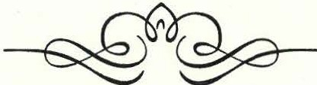
The Program Committee has worked hard this past year to bring you quality speakers and interesting material. Speakers have included Dennis Picard showing us how the well equipped Civil War volunteer might turn out, Ed Kirby talked about the Iron industry in the Housa­ tonic Valley, Dr. MaryNell Morgan-Brown presented a program on W.E.B. DuBois, and we followed in the footsteps of general Knox' s march through the Berk­ shires with Bruce Rueger. And Chris Coenen again tried to stump the crowd in our annual What's It Night.

Other programs for the year included a tribute to Martin Luther King, the writers of the new book, On the Other Side of Glory: the Berkshire Men of the 54th Volunteer Infantry Regiment and our annual Old Stone Store Tast­ ings and the Sheffield Historical Society Holiday Party.

We have lots of exciting and educational-and just plain fun- programs lined up for the new year, so we hope you can join us.

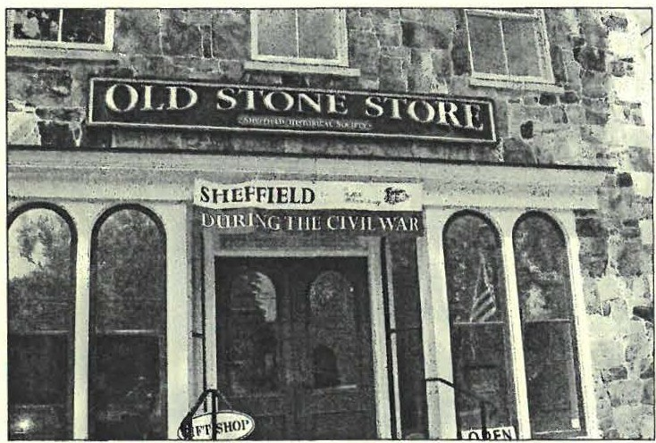
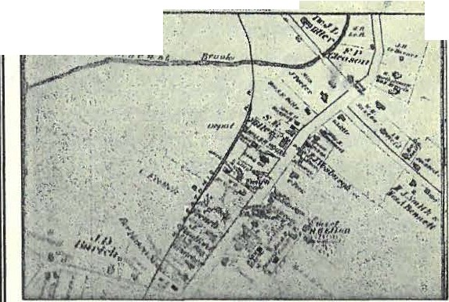June -Ju{y P,;cfii6it:
TALKING MAPS
THESE MAPS TELL STORIES
The closer you look
the more stories are uncovered!
A new exhibit at The Old Stone Store
August6to
Late September, 2011
v,... ,.,...
I
The Sheffield Historical Society presents:
S J,l1l 1}1l•l1 {1'J1'li, 'll,.U1
,ow,,°" tNt,r,uo ·
,"'-'k1•- f<1A#"/f,1«/. .
James R. Miller and Taylor Neil curate an ex­ hibit of local maps illustrating some of the changes that have taken place in South County, primarily Sheffield, from the date of the earliest map, 1722, to the 21st century.
SfiejfieU (J)uring tfie Civi{'War
'Ifie ex.,fti6it ran from 9rf.ay 21st to)'l.unust 1st.

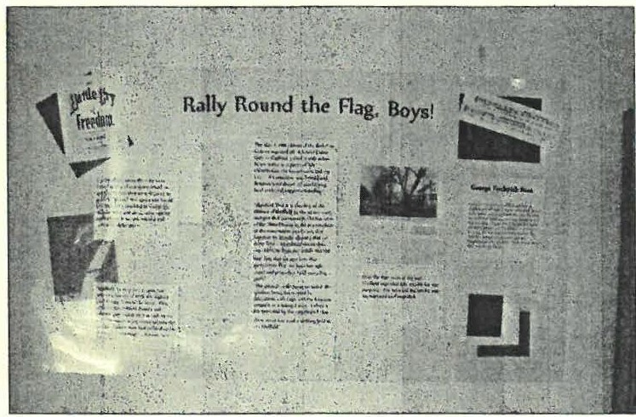
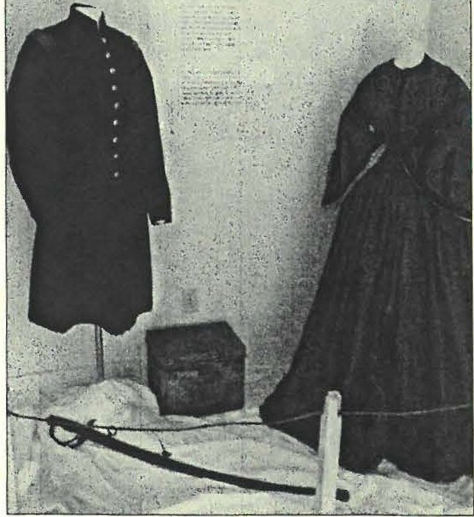
·.,
Ou r Bright & Happv Homt So rur .\way

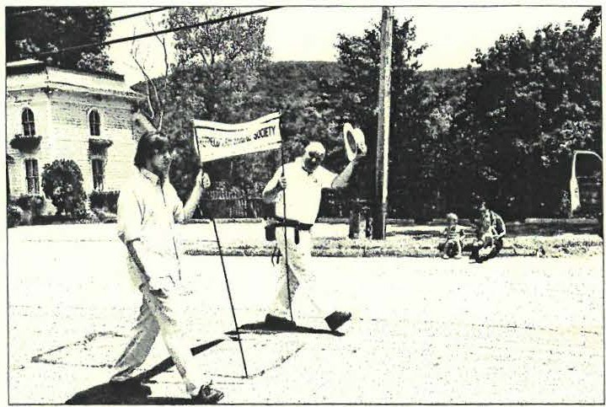
SHS President, Dennis Sears, and volunteer researcher, Taylor Neil, carry the Society banner in the parade.
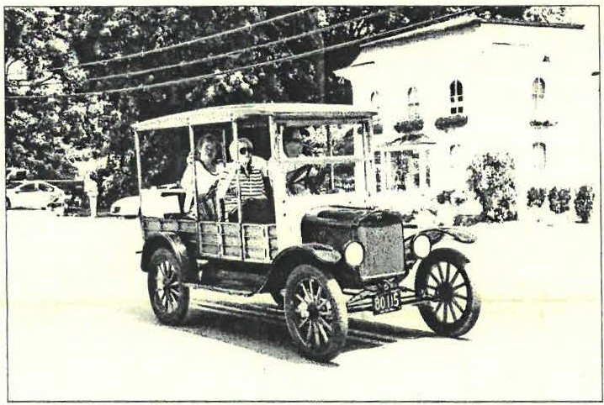
SHS Shows the Old Way to get from the Station to the Farm.
Passenger Seat - Betty Chapin, Right Rear Seat - Susan Pit­ man, Left Rear Seat - Kathy Tetro, Driver and owner of the 190X Ford Station Wagon is Natale Marasco .

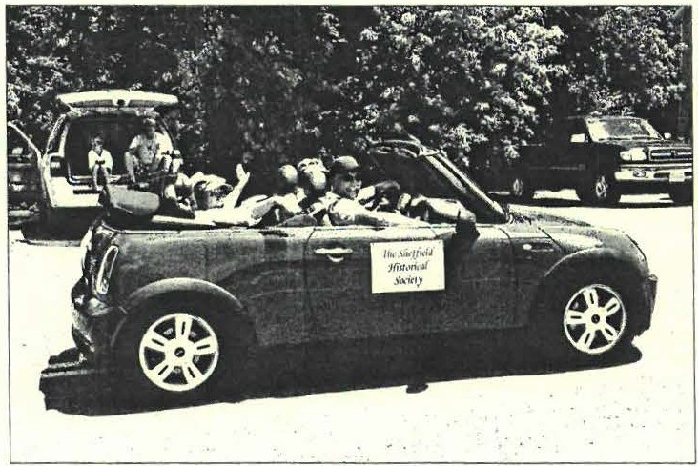

SHS Shows the New Way to get from the station to the / arm!
Driver and owner of the Mini Cooper convertible- Brian Levin­ sohn, Passenger Seat - Paul O' Brien, Rear Seat Right - Lois Levinsohn, Rear Seat Left - Dorothy Marosy.
'Ifie Sliejfieuf ']{istorica{ Society

Out el,)l6out

The town of Great Barrington celebrated their 250th year with a parade through downtown. The Sheffield Histori­ cal Society showed our support by marching - and driv­ ing- in the parade and joined in the fun and excitement of the day., always happy to share our heritage.

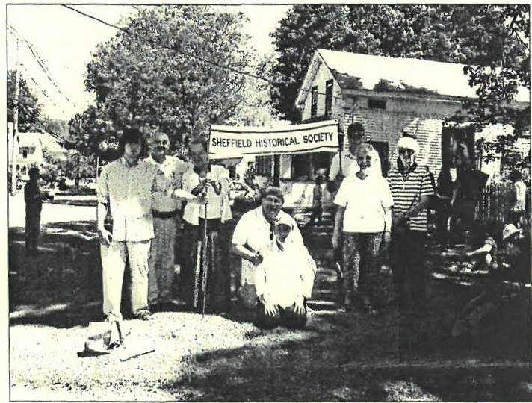
SHS Prepares for the Long March.
Left to right; Taylor Neil, Dennis Sears, Susan Pitman, Brian &
Lois Levinsohn, Paul O'Brien, Dorothy Marosy and Betty Chapin.

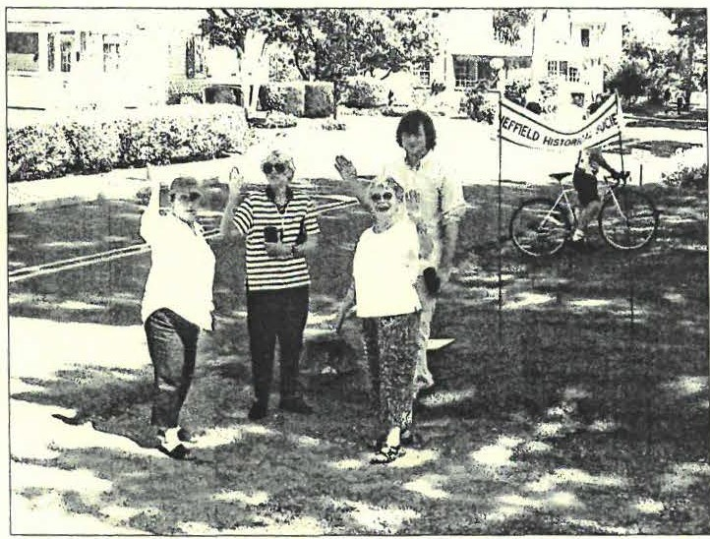

Ready togo!
Lois Levinsohn,, Dorothy Marosy, Betty Chapin and Taylor Neil are on their way.

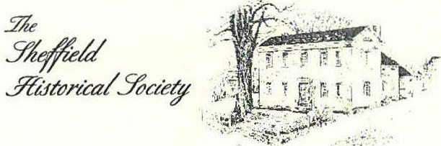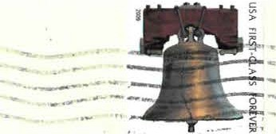
- -

Dan Raymond House Museum • Mark Dewey Research Center • Old StoneStore
·----

The Sheffield HistoricaSlociety's mission is to promote11 wider undentanding of the people and events that preceded us in this area, and to transmit that heritage to current and famre generations,

137-161 Main Street P.O.'Box 747
Sheffield, MA O1257
Catherine and Jim Miller [L] P.O.Box 7
Root Lane
Sheffield, MA 01257

Phone: 413-229-2694
Email: sh heff Ml:!i1!oryJ1rg

The Mark Dewey ResearchCenter is open Monday & Friday, I:30 p.m. to 4:00p.m., or by appointment.
Phone:413-229-3682
Email: mdrc@sheffieJdhistory.org

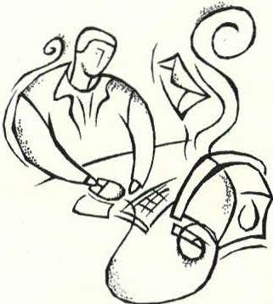
Paperless possibilities!
Help insure your contributions to the Sheffield Historical Society go farther-we are trying to save money and volunteer time by moving interested members to an electronic e-mail format. Receive your quar­ terly newsletter right on your computer and have fewer papers clutter­ ing up your life! Plus, you can read it from wherever you have access to your e-mail account. If you would prefer to receive your Society newsletters via your computer, please let us know.

This is an opt-in alternative. You will continue to receive your newsletter in a hard copy format unless you request otherwise. If you are interested, please contact us via email, by phone or through our website. If you do de­ cide to go paperless, please make sure we have the correct email account ad­ dress that you would like us to send your newsletter to.

­
L::=,_S=-

Thank you!

Summer 2012
21c

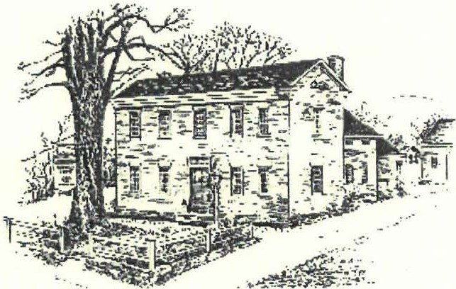
Yk/foU
.Y&torti:al3/Jae

IDSTORIC BARNARD BROTHERS of SHEFFIELD
On September 14, The Sheffield Historical Society will present Gerald (Rory) O' Connor, who will speak about his two illustrious ancestors, Sheffield natives, Civil war Brigadier-General John Gross Barnard and his brother, Frederick A.P. Barnard, onetime president of Columbia University.

General Barnard and his brother Frederick were the sons of Colonel Robert Foster Barnard and Augusta Porter Barnard. Frederick Barnard was the elder son, born in Sheffield in 1809. He graduated from Yale College and became a professor of mathematics and natural philosophy at the University of Alabama, and eventually chancellor of the University of Mississippi. He served there until the outbreak of the Civil War, when, his sympathies being with the North, he resigned. He took over as president of Columbia College in 1864 and served there for twenty-five years. Although unsuccessful in his attempts to allow the admittance of women to the college, after his death an affiliated college for women was established and named Barnard in his honor. In 1893 Columbia University erected a memorial chapel in Sheffield's Center Cemetery in honor of Dr. and Mrs. Barnard, which can be visited to this day.

The younger son John was born in 1815 on the Barnard homestead, built in 1780 by his grandfather, Aaron Root and called Netherby Hall. It is now the home of Mr. and Mrs. Howard Mott and site of the recent Historical Society Garden Party. At the age of 14 he entered the United States Military Academy at West Point, graduating at second rank in one of the
strongest classes the Academy had ever produced. Barnard was then assigned to the Army Corps of engineers, en­ gaged in the con­ struction of Fort Schuyler, the forti­ fications of Pensa­ cola and Mobile Harbors and de­ fenses around bat­ tlefields during the Mexican War.

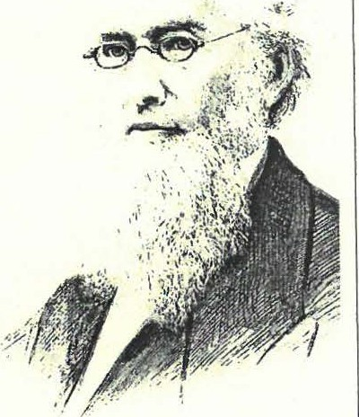During the Civil
Frederick A.P. Barnard
War, as chief engi- neer of the army of
the Potoma c, Gen- . J
eral Barnard was put in charge of defense construc­ tion around the capital at Washington, D.C. He was cited five times for "gallant and meritorious services" in both the Mexican and the Civil War.* After Gen­ eral Barnard' s death in 1882, the Army and Navy Journal gave him this tribute: "If a marble monument should be erected, ... of the life and work of General John G. Barnard, enough could be read, not only to satisfy the pride of all his kindred who shall come after him, but to convey a lesson as to how much may be accomplished in the life of one man". * No Shef­ field soldier of any time has risen to a higher rank than he. In 1937 the town park just north of the vil­ lage green in Sheffield was dedicated to General Bar­ nard and his brother, Frederick A.P. Barnard.

Gerald O'Conner is one of General Barnard' s four
Continued on p. 8

Prom tlie (llresitfent
Thank you

I would like to take this opportunity to say "THANK YOU" to all of our friends who continue to support the Sheffield Historical Society ! I am so pleased to see the many, many volunteers who come out and give their time to the Society. Just in the past few months, volunteers have staffed the Old Stone Store and exhibits, stood behind the Easter bake sale table, helped out at our Golf Tournament, and created a fabulous garden party ! Our annual appeal is going very well, our membership of over three hundred people have been very generous in helping the Society continue with the good work we are known for. It is because of all of you that we are able to maintain our historic properties and programs.
This year because of the generosity of our members, we were able to award a five hundred dollar scholarship to Brittany Siter. Ms Siter is a 2012 graduate of Mount Everett Regional School and will be attending the University of Rhode Island, majoring in Political Science.

News on our buildings

You may have noticed a new roof on the Education Building, directly behind the Dan Raymond House. he old roof was beyond repair, we now have a new thirty year roof protecting the building. The Mark Dewey Research Center roof is also in need of repair. The cedar roof has acquired a disturbing layer of moss. In some

cases moss on an old roof is quaint, not so in this situation. The layer of moss has deteriorated the roof­ ing material to the point where it needs to be replaced before the winter sets in.

Upcoming events

We have some exciting events coming this fall begin­ ning with Sheffield in Celebration and continuing with the Sheffield Spiritfest (watch your email and the web­ site for the details) in October.

Back to school education initiatives

Our Administrator , Barbara Dowling and I will be working with the students and staff of the Southern Berkshire Regional School District to re-introduce the Sheffield Historical Society to the children of the dis­ trict (if you are interested in working with us on this please drop us a line).

A thank you to our outgoing board members and welcome to our incoming board members

A big thank you to Marcia Brolli, Kathy Tetro, Dennis Sears and Greig Siedor for their years of dedicated ser­ vice. Dennis Sears will be stepping down as President, but will remain as a board member as well as our Funds Manager. We have three new board members, Lisa Reynold, Kent "KC" Clow and Jeff Browne , welcome and thank you all !

Paul O'Brien President
- - ---------------

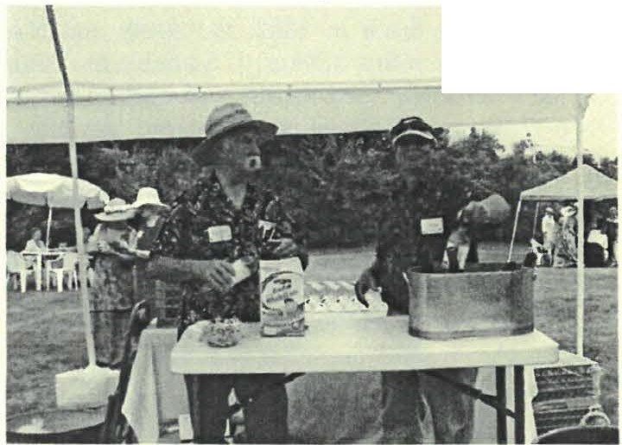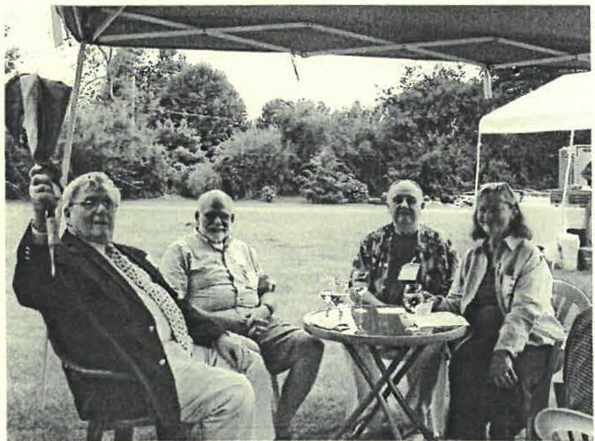
_J;

/'age]
Harry Conklin and Ted Pitman tend bar at the Summer Garden party.
Ross Hawkins, Bob Brigham, Dennis Sears and Iona Brigham sit and enjoy a glass of wine in the gardens.

The Sheffield Historical Society invites the support of you and your friends through membership.

Name(s) _ _ _ _ _ _ _ _ _ _ _ _ _ _ _ _ _ _ _ E-Mail _

Address---------------------------------
Please check: New Renew Membership for year July 1, 2012 to June 30, 2013
_
Individual ($5 - $49) Family($50 - $99) Patron ($100 - $499) _
Sponsor ($500 - $999)
Please make checks payable to: The Sheffield Historical Society, P.O. Box 747, Sheffield , MA 01257

CALENDAR OF EVENTS
OldStone Store - open for the season - Saturdays & Sundays 11:00 to 3:00

SHS programs at Dewey Memorial Hall:

Friday, September 14th 7:30 p.m.
The Barnards - Gerald O'Connor will talk about Sheffield natives General John Barnard, Chief Engineer of the Union Anny, and Professor Frederick Barnard, President of Columbia University and namesake of Barnard College.

Friday, October 12th 7:30 p.m.
Post and beam Architecture - Learn about timber framing with Jack Sobon.

Friday, November 9th 7:30 p.m.
Opening Reception - Festival of Holidays -Enjoy adrink and some early-bird holiday shopping at the Old Stone Store.

December
Sheffield Historical Society Holiday Party - at the Dan Raymond House

Friday, January 11th 7:30 p.m.
The Knox Trail - Bernie Drew will present a program on his newest book, Henry Knox & the Revolutionary War Trail in Western Massachusetts, and the history of the Knox Trail.

Exhibits:

July 21st through September 2nd
Drawing the Line: Political Cartoons in America - Paul Banevicius shares his collection of political cartoons in this election year - some humorous, some poignant, and some downright nasty! At the Old Stone Store. Don't miss this one!!!

Place r here. For maximum impact, use two or 1hree sentences.

Sheffield Historical Society presents
DRAWING THE LINE:
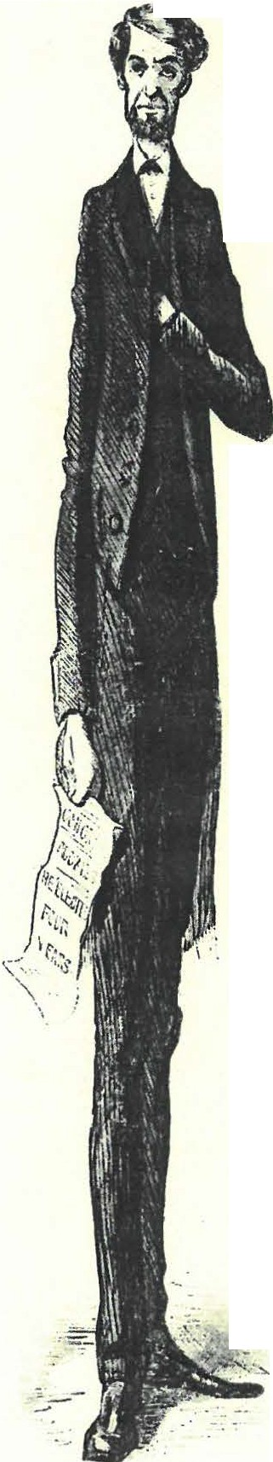
  - 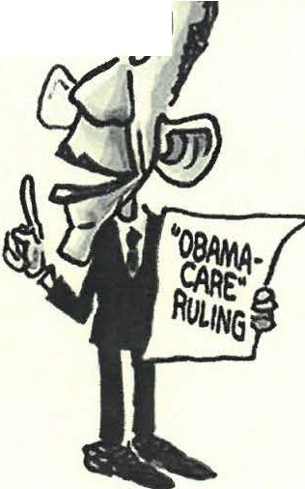Political Cartoons in • ca
1

Featuring Original Art & Sketches from the Collection of Paul Banevicius

July 21- September 3, 2012
    - Reception: Sat., July 28,4-6p111
at the Old Stone Store Gallery
on the Green in Sheffield, Massachusetts
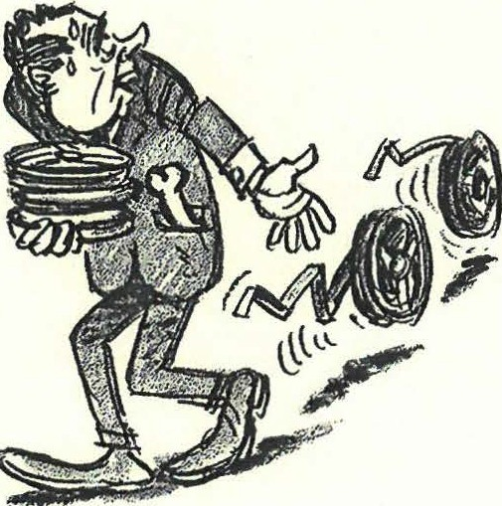
Gallery Hours: Open Saturdays & Sundays 11-3
or by appointment. Cail 413-889-1129 formore info.

Page4

%e'Year'Without a Summer

Material for this article came from a collection of letters, re­ cently gifted to The Society, written by Sarah Townsend Hale to her nephews Hosea and Hiram Townsend in Ohio. Liberties have been taken with spelling and punctuation.

Everybody, as you know, is talking about the weather. One hot summer! But take yourself back almost 200 years, 1816 to be exact, and you would have experienced the opposite, the year without a summer, when there was a killing frost in every sum­ mer month. In that year local farm fields were ceme­ teries of cornstalks. A severe drought had left them brown, withered and dead, with starvation lurking about.

There were suggestions early in the spring of a cool summer. Mid May had unusually low temperatures accompanied by frosts as far south as Virginia. In the Berkshires " the ground froze hard and high wind May first. Scarce a green thing to be seen, very cold need a good fire," reported Sarah Townsend Hale to her nephews in Ohio.

After a warmer start to June it quickly turned colder with a mix of rain and snow in Quebec and light snow in the Adirondacks. On June 7th, 12 inches of snow blanketed portions of New England sparking the talk of famine for the first time. Sarah further re­ ported, "there is much said about the scarcity of fod­ der [for the animals] which tis very dear."

June was bad enough but July started out no better. A killing frost crossed New England destroying com, bean, cucumber and squash crops. Fortunately, har­ dier wheat, rye and potatoes did much better. On June 20th, Sarah wrote "We have a most extraordinary season as yet such never known here before. Grass very thin & late, com small & much curled . . . where there is any, looking as if it would never come to any­ thing. It appears unaccountable that there is any­ thing, ground froze hard middle of May & the 7th of June hard snow ... 6th of June & everything cut down with frost. 1s1 of July frost." Milder weather contin-
ued well into August when another frost hit, dam­ aging crops further. On August 20th a powerful cold front crossed the Northeast bringing violent thunderstorms and reports of temperatures falling as much as 30 degrees within minutes. The sum­ mer growing season came to an end on August 28, aborted by yet another frost which brought ice to local lakes.

The impact of the season was severe, with too little food for animals taken in for the winter season. Fortunately there were enough grains and potatoes harvested to prevent a full blown famine but hard­ ship did occur with Sarah writing, "the season is so cold & backward winter grain was not harvested till 8 and 10 August . . . and the spring wheat & rye till the last week ... in September. The com does not ripen." The result was grain tripled in value and the shortage forced farmers to sell their cows and pigs, driving the price of meat down. Beef fell over 50 per cent and pork 75 per cent. The following year, 1817, marked a major migra­ tion oflocals westward to New York and beyond.

What was the cause of this weather? Religious fundamentalist blamed sinners and some even blamed the scientific experiments Benjamin Franklin had done with lightning rods. But the likely cause was the eruption of Tambora volcano on the island of Soembawa in Indonesia on April 1st\ 1815, a year previous. The eruption was a super colossal event which killed nearly I0,000 people immediately and another estimate 80,000 from starvation and illness. According to esti­ mates 1.7 million tons of dust were put into the atmosphere, reaching North America about 12 months later.

A year of poverty, 1816, the year without a sum­ mer, came to an end.

James R. Miller

Poge5

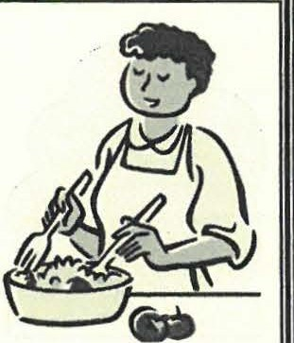
Joinus at the Shqfield Historical Society Salad Bar during Shqfield in Celebration , September 8& Fairground food has never been this good orthis
good for youf Plusfree internet
"r I g e-n-e-a-w'-gy'.Bn. ngyourfam:r".J..,·L'.!t}:Or-
mation toget started onan educational, lifelong hobby.
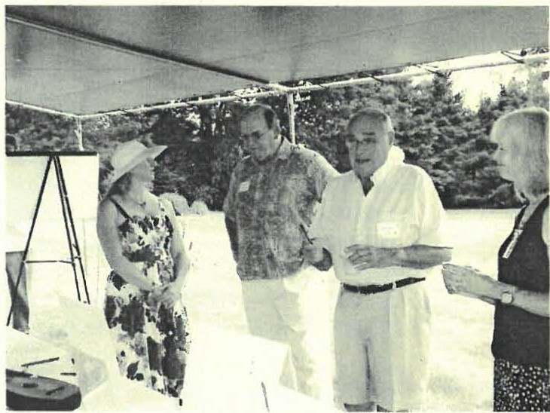
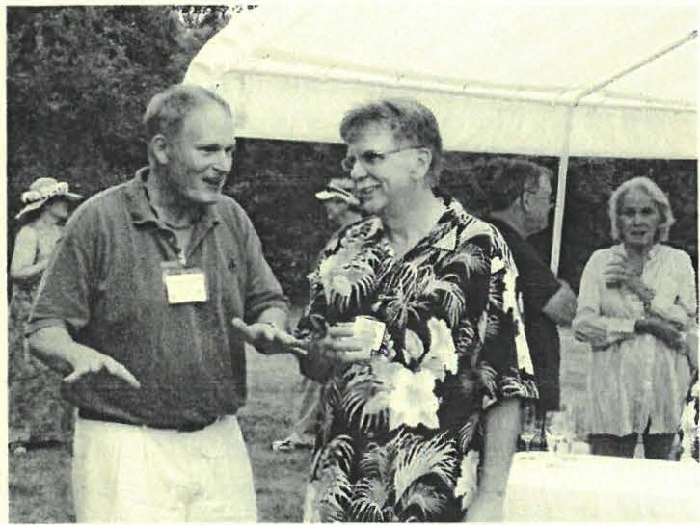
Sum.mer Garden Party 2012

Lisa Reynolds, Rusty Mott, Herb Abe/ow and Carolyn Fu/­ Lon discuss the silent auction items.
Paul Banevicius and Paul O ' Brien share a tall tale while in the background (left to right) Susan Pitman, Ted Pitman, Jim Miller and Sharon Casdin enjoy the party.

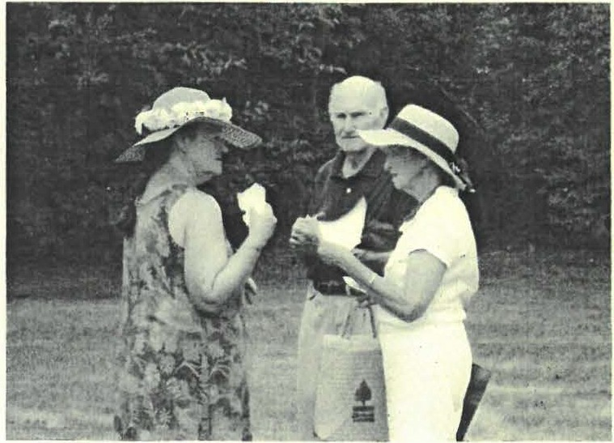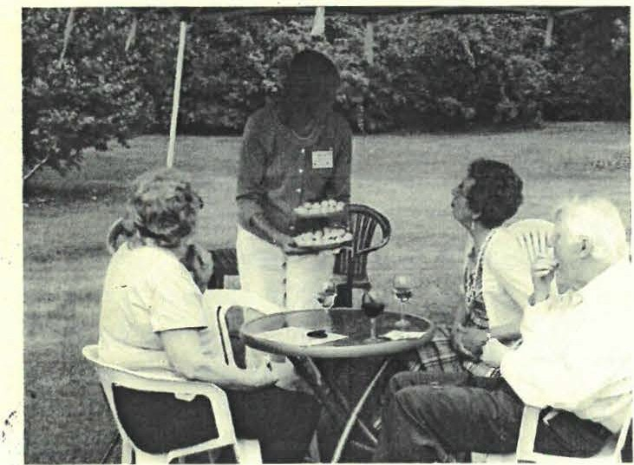

Page6
Susan Pipnan, Dr. Peter Eisbach and Patricia Eisbach in the garden.
Kathy Tetro passes hors d' oeuvres to Barbara Burns, Marilyn Wightman an d Patrick Burns.

Summer qartfen (party

On July 15th, the Sheffield Historical Society, along with friends and supporters, were out in force cele­ brating the season with a not-to-be-missed Summer Party in the wonderful gardens of Netherby Hall, home of Veta and Rusty Mott. The weather threat­ ened rain and a few drops fell, but even that wasn' t enough to dampen the spirits of all who attended. And when the sun eventually made its appearance, the glory of the gardens drew many to wander and admire.

Many thanks to all who made our Summer Garden Fundraiser so much fun and such a success! Fore­ most thanks go to Veta and Rusty Mott, who shared their beautiful gardens with us and provided such a wonderful site for our afternoon event. Susan Pitman and Kathy Tetro worked hard as co-chairs for the party and it would never have happened without them. Thanks also to the summer party committee - Veta Mott, Lois Levinsohn, Carolyn Fulton, Sharon Palma, Phyllis Webb, and Catherine Miller. And our hearts thank - but our waistlines not necessarily - all those who brought hors d'oeuvres, sweets and other goodies for everyone to enjoy.

Thank you to our Corporate Sponsors Berkshire Re­ gion Legacy Bank and Salisbury Bank as well as for the support of the Sheffield Cultural Council. Our appreciation also to the donors of our silent auction items: Kathy and Tom Tetro, Paul Banevicius, The Magic Fluke, The Hungry Hen, Ward's Nursery, The MarketPlace, Body & Soul, Tom Ingersoll, the Gar­ den Goddesses and Barrington Stage Company. The Beautiful flower arrangements were created by MaryEllen O'Brien.

And, of course, our appreciation to all of you who came and supported the event.

We hope everyone had a good time and we look for­ ward to you joining us for other Historical Society events!

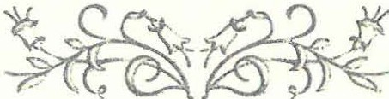
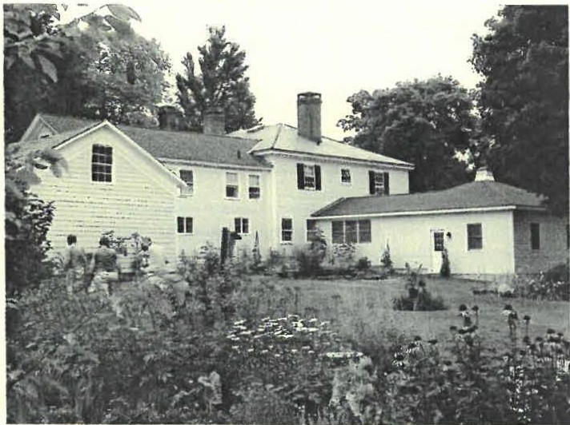
A small part of the beautiful gardens of Netherby
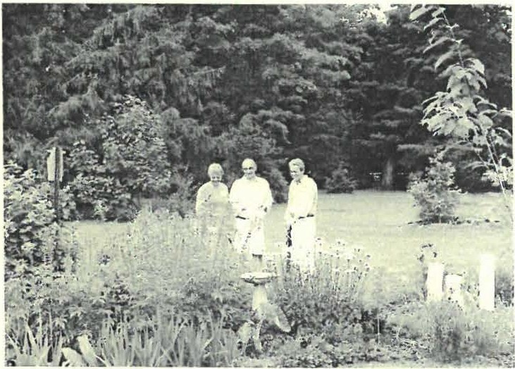
Trudy Weaver-Miller, Dr. Peter Eisbach and Patricia Eisbach enjoy the sun and the gardens.
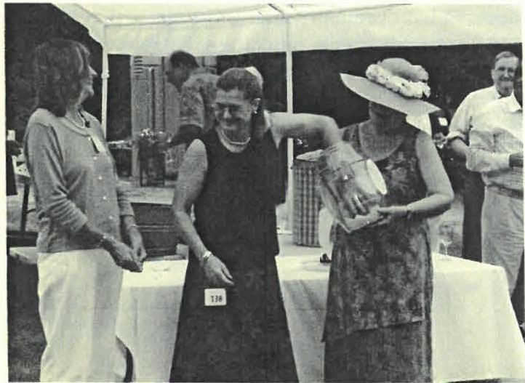

Veta Mott draws the winning ticket for the door prize while Kathy Tetro and Susan Pitman look on.

Page 7

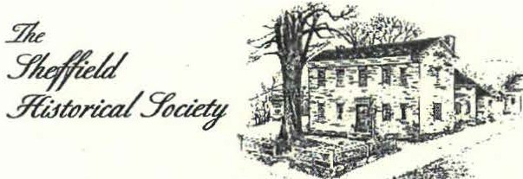

Dan Raymond House Museum • Mark Dewey Research Center • Old Stone Store
Tht Sheffield Hiltorical Socittyr mission iJ to promote a wider u1uknta11ding of tht peoplL alld evmu that prtmkd us in thil area, a1ld to trllllSmit that hmtagt to°'"mt and fi,ture gmu ations.
WWW.SHEFFIELDHI ST ORY.ORG
137-161 Main Street
P.O. Box 747 Sheffield, MA 01257 Phone: 413-229-2694
Email: s hs@sheffieldhis1ory.org

The Mark Dewey Research Center is open Monday & Friday, I:30 p.m. to 4:00 p.m., or by appointment.
Phone: 413-229-3682
Email: mdrc@sheffieldhistory.org

The Old Stone Store
On the Green in Sheffield Phone: 413-229-2287

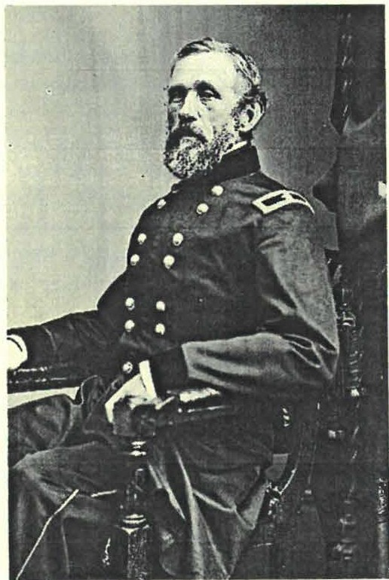The Barnards - continued.from p. I

Brigadier-General John G. Barnard

great grandsons. Gerald, called Rory, grew up OD a dairy farm on Hulett Road in Sheffield near the New Marlborough town line. He graduated from Berkshire School and Trinity College in Hartford, Conn. He left Sheffield at age 26 to work as a newspaper reporter in Connecticut but eventually migrated back to the Berkshires to work for the Berkshire Eagle, remaining there until his retirement in 1994. He is married to the former Claire Warner of Sheffield. They have three sons, a daughter and five grandchildren, and now live in Central Vermont.

Mr. O' Connor's program, "Historic Barnard Brothers of Sheffield" will be held at Dewey Hall in Sheffield OD Friday, September 14, at 7:30 p.m. The program is free and open to the Public.

Joyce Hawkins

*quotations and other source material from: Li//ian E. Preiss, SheQield, Frontier Town. pub. 1976 -on sale in the Old Stone Store

Poge 8

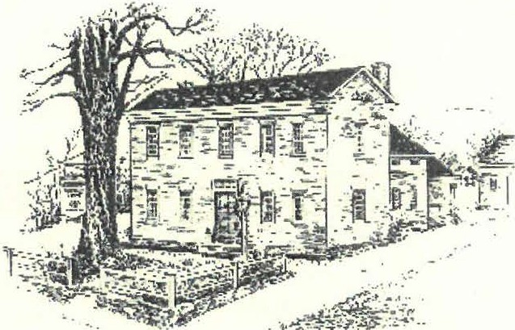
.Yle
YJ#eU
.ff&tPrtcal.YbaerP

Winter 2013

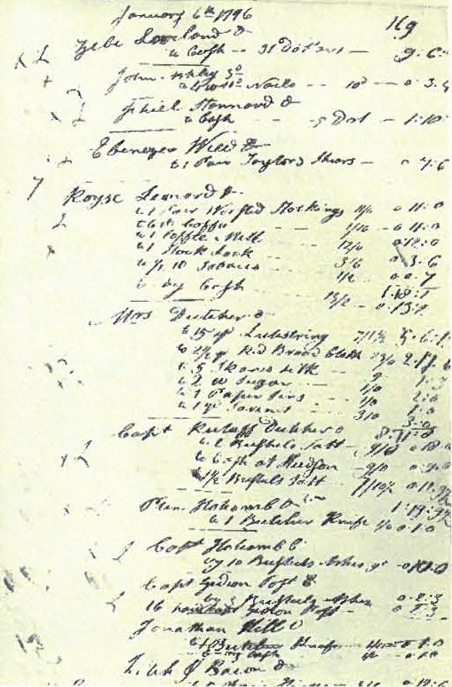
.
-,o
1.n. ·
.11,Y
.",,"
'?
" 7
' ·r
.p

''i )
".
i
.;),,-,
..,,
- ",L.
!-
,",
:
P./
A long-term loan of unprecedented importance came to the Society through the thoughtfulness of member Joseph C. Hurlburt formerly of Ash­ ley Falls who was raised there in the William Ashley House by parents Walter and Alice. In short, the loan materials are key to the recon­ struct of the daily life of Sheffielders in the l 8th and 19th century and constitute, perhaps, the most significant addition to our knowledge of locals' lives at that time.

The collection' s major feature is several 18th and 19th century account books and family

JI. fiIJlm L Jf_cp PO<J{'WJf.<J{© 'TO TJlP, 1KJ!lf CY.E:NTV<J{<Y
correspondence relating to the tri-state area, the Ashley family and its extensive business enterprises which were centered along the Konkapot River in what eventually came to be known as Ashley Falls. Until now only one 18th century account book relating to Sheffield is known locally and it is not in the possession of the Society.

The Hurlburt collection is invaluable to social and eco­ nomic historians, yielding insights into the local human condition and material culture in such areas as housing, diet, health and medicine, textiles and clothing, livestock and personal property values plus the cost of labor. Other accounts contain information on the family' s saw, card­ ing, dyeing, fulling and grist mills along with its nail manufactory for the same time frame. In its totality, the collection paints a clear commercial and economic picture of Sheffield and the surrounding area beginning before the American Revolution and extending 200 years beyond.

The documents are also useful to family histo rians, reduc­ ing dependence on the federal decennial census reports that begin only in 1790 and offer very limited content. Conveniently the collection is largely self-indexed with the names of account holders entered alphabetically fol:.. lowed by an item-by-item list of goods both purchased from and sold to the Ashley general store from year to year.

Watch for an exhibit at the Old Stone Store next summer, highlighting the collection, with the most interesting reve­ lations scheduled for release at that time.

James R. Miller

Prom the <Presitfent
Happy New Year! I hope that you all had a happy and restful new year. The Sheffield Historical Society is catching its breath from a very busy year and is gearing up for another full year of activities. We are well rested and ready for another great year!

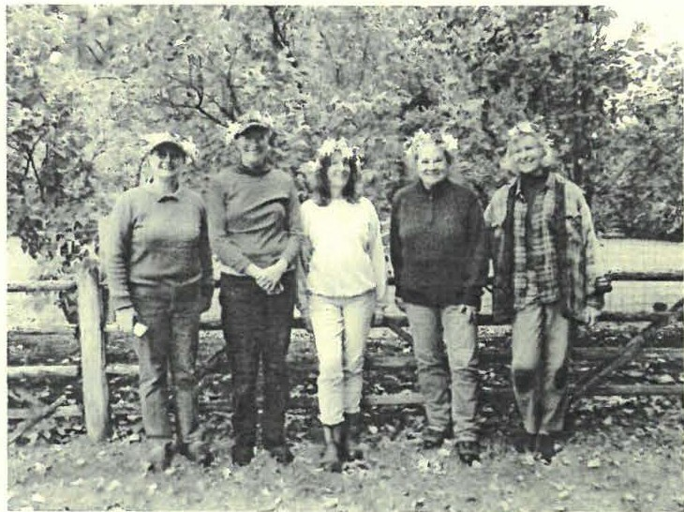
The Garden Goddesses al work - Veta Mou, Kathy Tetro, Sharon Palmer, Susan Pitman and Carolyn Fulton.

Events and Exhibits Our exhibits at the Old Stone Store, our monthly lecture series and our fund­ raising activities all received rave reviews and re­ cord attendance this past year. We added a golf out­ ing, Spiritfest, Candy Cane Carnival, Garden Party and a volunteer recognition cookout. This upcoming year we have three major exhibits scheduled, An­ tique Toys, Unmentionables, and the Ashley Family records. The Sheffield Historical Society will be hosting a Garden Club of America Flower Show in conjunction with the Lenox Garden Club to kick off our month long Spiritfest . The flower show ,
" Berkshire Haunts" will feature floral arrangements , horticultural displays and photographs. There will be a special 'Preview Party" to open the show. Watch our website, emails and mailings for more on these exciting events.

Paul O'Brien President
DRAWING THE LINE:
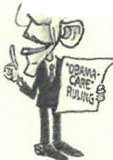Political Cartoons in AmltJ'ca
•
"I'
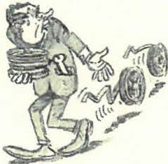
40th Year The Sheffield Historical Society is in the middle of it's 40th year as an organization. I am so grateful for the fine work our founders did back in 1972 when they took up the task of creating the society. I am reminded every time I walk through our properties, look through our archives or talk with our Members, how hard they worked to make this society the success that it is today. We are all proud to be members of the Sheffield Historical Society.
We will have a chance to show that pride at a 40th year celebration during our annual meeting in June of 2013, so bring your memories and appetites!
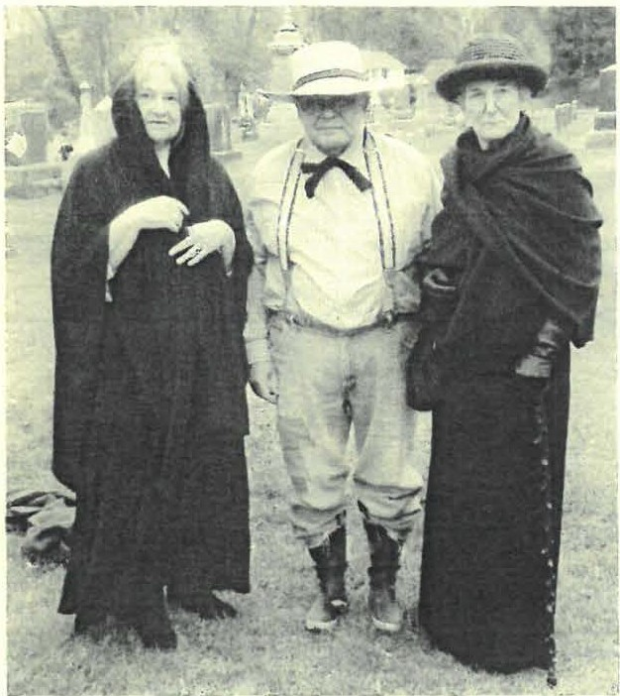
S usan Pitman, Brian le vinsohn and Catherine Miller as three scary spirits!

Sheffield Historical Society Board members:
Paul O' Biren (President), Wray Gunn (Vice President), Lois Levinsohn (Treasurer), Susan Pitman (Secretary), Dennis Sears, Jeff Browne, Joyce Hawkins, Lisa Reynolds, Paul Banevicius, and K.C. Clow.
Page 2

Please make checks payable to: The Sheffield Historical Society. Send to: P.O. Box 747, Sheffield , MA 01257
Patron ($101 - $500) Sponsor ($501 -
Family($5l - $100)
_ _ Individual ($15 - $50)
$1,000)
The Sheffield Historical Society invites the support of you and your friends through membership.

Name(s) E-Mail _ _ _ _ _ _ _ _ _ _ _

Address - - - - - - - - - - - - - - - - - - - - - - - - - - - - - - - - -
Please check: New Renew

CALENDAR OF EVENTS
OldStone Store - closed for the season

SHS programs at Dewey Memorial Hall:

Friday, February 8th Murders, Accidents & Sudden Deaths in Sheffield - 7:30
Join Society Administrator, Barbara Dowling, as she relates tales of strange and sometimes tragic events from Sheffield's past.

Friday, March 8th Slavery & Freedom in Berkshire County - 7:30 p.m.
Professor Frances Jones-Sneed tells of our African-American Heritage here in the Berkshires.

Friday, April 12th Native Americans in South County - 7:30 p.m.
Bartholomew's Cobble Ranger, Rene Wendall, talks about the presence of Native Americans here in Sheffield and the vicinity.

Friday, May 10th Gold Star Mothers - 7:30 p.m.
Greg Siedor presents a program on Sheffield natives who died in World War Two.

Friday, June 14th SHS Annual Meeting - 7:30 p.m.
40th Year celebration and ice cream social!!!

For more information on What's Going on in Sheffield?** Visit the Sheffield Community Calendar<http://www.localendar.com/public/SheffieldCalendar

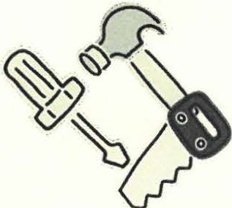
'Wm{'Wee tf-Jlpri{20thcd,21st
(.\
We, as members of the Sheffield committee has compiled a list Historical Society, are very fortunate of projects which range from to have 5 buildings of local historical simple to fairly complex that
0

importance under our stewardship. While we all enjoy using these buildings for our various activities, we must also ensure that they remain in good condition so that we can continue to enjoy them in the future. Therefore, we are reaching out to the entire membership to join us
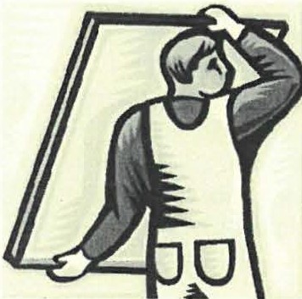
on the weekend of April 20 & 21 for our first annual SHS Work Weekend. The build­ ing and grounds
we need to tackle. We have "something for everyone" so no special talents are required.
Please join your fellow members as we put a shine on our campus and ready it for the coming summer sea­ son. Give however much time you can - one hour or 2 days - we'll welcome it all. It promises to be a fun and rewarding time so please join us.
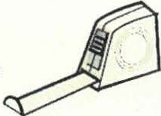
More details will follow in the next newslette.r

Jeff Browne

Come join us!

Page
Spi,ritPest

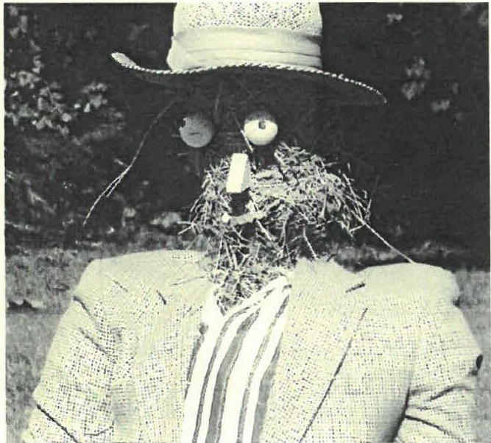
The October SpiritFest was a new activity for the Soci­ ety this past fall. The Society built upon the always popular Spiritwalk by adding a Zombie building con­ test, a pumpkin carving contest and a scary movie night. Unfortunately, the majority of the activities took place during the north east's version of a haunting - Hurricane Sandy! Although a few of the activities were canceled, those in attendance for the Spirit Walk, Zom­ bie building and scary movie enjoyed a spirited adven­ ture. SpiritFest 2013 will be bigger and better with the addition of a Garden Club of America flower show "Berkshire Haunts."

}lnnual}lppea[ d, 9dem6e ship 2012

Dan Raymond Circle
Sharon Casdin
Benefactors
Deborah Reich
Paul & Carol Collins Dennis Sears & Rene Wood

Sponsors

Thomas Dixon
Jim & Catherine Miller Brian & Lois Levinsohn

Patrons

Beth Bartholomew
Barbara and Malcolm Bayliss Robin Berthet
Jim Brandi Caroline Brandt MarciaBrolli Joan Brooks Tony Carlotto Patricia Carlson
Ursula and Walter Cliff Kent Clow ill
J. Nicoll & Mary Cooper Constance Cooper
Alice Corbin
John & Diane Cowen Susan and Philip Detjens Anthony & Elaine Dibrita John & Audrey Downie Nonna Edsall
Emily & John Alexander Sandra Wijnberg
Wesley McCain & Noreene Storrie

Patricia and Dr. Peter Eisbach
Don Freedman & Susan Rothschild Carolyn Fulton
Ruth & Susan Gillette Tracy Goodnow
Joyce and Ross Hawkins
Bruce Howden & David Prouty John Hull ID
John James & Kathie Ness Mary and Charles Joch, Jr. James and Beverly Kimball Richard & Athena Kimball Allison Lassoe
Alice Lustig
Jon MacClaren & Christopher Sink Kent Mauk
Robert Mercurio & Joe Kolodziej Gary & Jean Miller
Donald & Roswitha Mott
Frank & Kimba Richardson Carol and Joseph Reich

Paul & MaryEllen O'Brien Elisabeth O'Connor Charlotte A. Owens
Ors. Fred & Elaine Panitz Susan and Ted Pitman Sandra Preston
Ellen Rowntree Michael Saxton
Becky and Ken Schopp Pauline Schumann Sheffield Pottery
Marcia and Myron Sheinberg Greig Siedor & Christine Ludwiszewski
Nancy Smith
John & Katherine Stookey Rebecca and Robert Thomas Gay Tucker
Loet and Edith Velmans

Education Fund Donors

Mr. & Mrs. Douglas Coo per Constance Cooper
John & Gretchen Court Barbara Hochberg
Mr. & Mrs. Mike Kay
James Kelly Marian Malnati Dawn Massini Nancy Miller
Wesley & Elizabeth Petersen
Mark·Schaffer & David Goldman Judy Schnurr
Mr. & Mrs. Richard Solar Gay Tucker

Page 5

Family/ Dual

Dale & Sandra Alden Allen & Karin Altman Doreen and Walter Atwood Paul Banevicius
Timothy Beard
Paul Benjou & P.J. Birriel Blanche Bennett
Pam Bloodworth
Jeff & Wendy & William Browne Mildred & Lo-Yi Chan
Elizabeth Chapin
Kathleen and Neil Chrisman Christopher Coenen & Amanda Morgan Noel & Baukje Cohen
Abbott Combes TlI Janet and Gary Cookson Holly Coon
Janet Cooper & Walter Langsford Dick & Kitty Cunningham
Jean E. Curtiss
Frank & Rhonda Cushwa Charlotte H. Dallett Nancy Dellert
Dorothy and William DeVoti Glenn & Catherine DeVoti
Margit and Branch Elam
Morgan Buckeley & Eleanor Tillinghast
Kerry & Anne Douglas Phil & Betsy Garcia Frank Garretson
Rene Gibson
John & Elsie Gilligan
Drs. Richard Greene & Lindsey Crampton Sharon Gregory
Wray Gunn & Cora Portnoff Steven & Julie Hannum Susan and Joseph Hurlburt James & Donna Hurley Robert Jenter & Andrea Scott Nancy Kriegel & John Villios George & Rochelle Laz.arus Louis Levine & Pat Molhot Douglas & Candida Logan Norman & Barbara Margolis Barbara Martin
Dawn Massini
Linda and Jack McKelvey Norman & Jeanne Merrill Sharon and George Milukas Anne and Daniel Moulton
C. Twiggs Myers
Richard & Laraine Novak Walter and Gail Orenstein Tom Orlando
Judith & Tician Papachristou Richard Pearse & Nancy O'Donohue Lisa and Jonathan Reynolds
Elaine Romaine & Family Allen & Linda Rosen Norman Schnayer & Joyce Frewndlich
Shellie and Bernard Schneider Barb and Jim Shiminski
John & Irma Sisson George T. Smith Nik and Sig Spiegel Michael Stumo
Hope and Howard Swanson Marcel & Millie Tenenbaum Kathy and Tom Tetro
Diana and Henry Vollmer, III Phyllis & Dale Webb Marilyn and John Wightman Martha and Barry Williamson Susan and Tom Young

Individuals

Allen Co. Public Library
Cherryl Andrews & Peter Robinson Mark Bachetti
Frederick & Betty Bangs Ann Barrett
Trumbull Barrett Steven Borns Sheryl Bradley
Grace Wallace Brown AlanBuckes
Edwin H. & Barbara Carr, Jr. Marjorie and Anthony Consolini Barbara Delmolino
Barry & Jean Emberlin Barbara Friedman Natalie & Maree Funk Leonard Graziano
Edmund & Arlene Grossman Dr. Marguerite Gulick
John & Joan Hanlon Terna & Monte Harnik Claire Height
Caitlin & John Hotaling Barbara Jacquette
Paul Kleinwald
James Lamme & Wendy Linscott Alice Leason
Susan and Philip Lebowitz Selma and Gerald Lotenberg Sue and Bob MacVeety Marian MaJnati
Dorothy Marosy Norma Moulton lstar Mudge Patricia Mullin
Wesley & Elizabeth Petersen Marsha and David Pottle
Joan and Ken Powers Larry Reilly
Doris and Alfred Richardson
Ann Riou
Frank & Martha Jane Root Jessica Roseman
Stephen Rosenheck & Virginia Goldner
Anthony Sabatelli Bob and Ann Shanks Evelyn Small
Judith and Ron Timm Lois VanCleef
Paula Wardynski Jackie Weaver Elsie West Marion Whitman
Lynn and Bill Wood

l'age6

'We neeayour fie{p!
The Sheffield Historical Society is reaching out to its many members by inviting them to become actively involved in several of our committees. The work of the society is very important to our community, and the work of our many volunteers aids the society in promoting its mission in our community. The committees listed below are looking for volunteers. If you have already volunteered for our other activities, THANK YOU! If you haven't volunteered and would like to consider helping out, please contact us, by email (shs@sheffieldhistory.org) or by calling us at 229-2694.

Committees:
Exhibitions * Collections * Buildings and Grounds * Making items for the OSS *
Fund Raising * Education

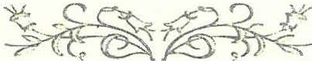
Thank you.

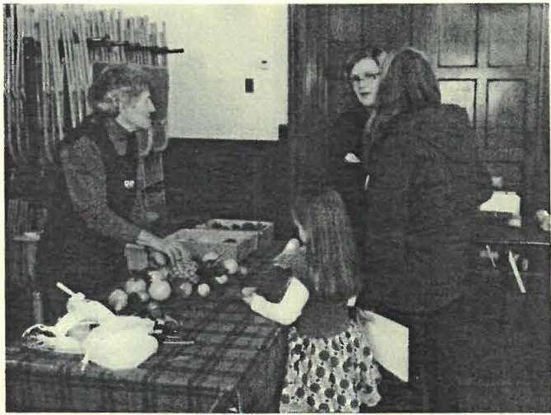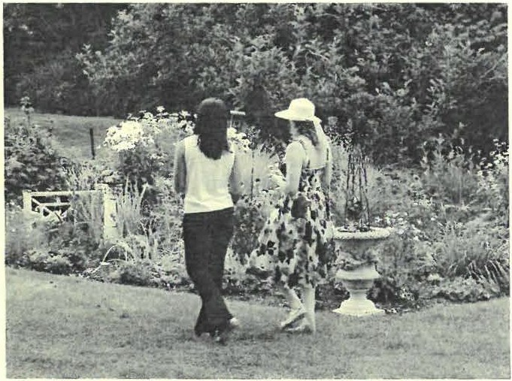

Catherine Miller demonstrates a holiday craft at the Candy Cane Carnival
Strolling in the beauliful gardens of Nelherby Hall at the Summer Garden Parly.

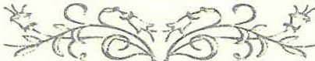

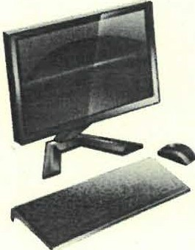
(]Ji,a,n{you, <.Berk.§hire <.Bant !
Berkshire Bank's "Renew & Reuse Technology Partnership Program " recently awarded the Sheffield Historical Society three complete computer systems. The refurbished computers are in use by the Society at the Dan Raymond House and the Mark Dewey Research Center. Many thanks to Berkshire Bank for their generous donation.

Page 7

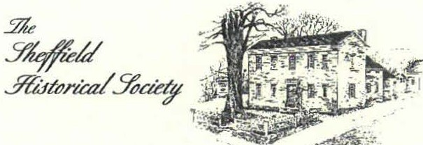

Dan Raymond House Museum • Mark Dewey Research Cemer • Old
S1one Store
Th, Sheffield HistorcialSocietyi miJSion iI to promoet a widn u11dm1a11di11g of 1hr people a11d rvmts that prrudrd us i11 thiI area, and to tra11m1it that luritagr 10 currnu _{t111d} fi,turt!ge11era1ion1.
WWW.SHEFFIELD! IISTORY.ORG
137-161 Main Street
  - Box 747
S heffield, MA O1257 Phone: 413-229-2694
Email: shs@ hcflieldhsi1ory.org

The Mark Dewey Research Center is open Monday & Friday, I:30 p.m. to 4:00 p.m., or by appointment.
Phone: 413-229-3682
Email: mdrc@shefficldhistory.org

The Old Stone Store
O n !he Green in Sheffield Phone: 413-229-2287

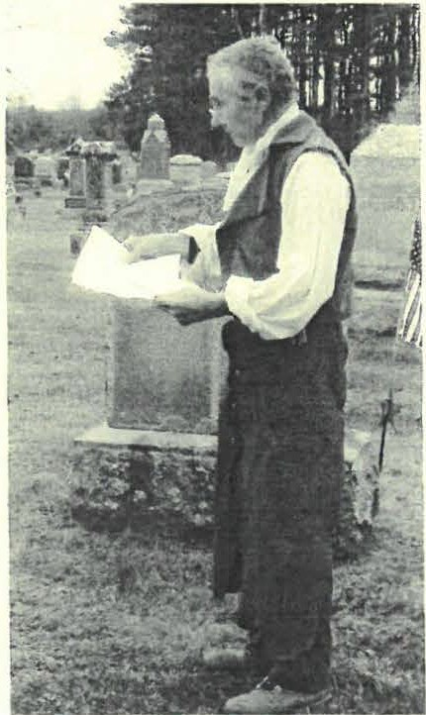
9durtfers, }lccitfentsd Sutftfen (J)eatlis.. . ant!aJew other tanta{izin9 titf6its from Sfiejfieuf history

All right, let' s all admit that we secretly like a good tale about robberies and cannibalism, murders and ghosts. We' re only human after all. But so were our ancestors in th.is area, as everywhere and every time else, and Southern Berkshire County has its own tales to tell of accidents, weather run amok or just the baser side of human nature. Now is the chance to hear it all without any of the guilt - it's history, not the National Enquirer!

The Sheffield Historical Society's February program will feature Society Ad­ ministrator, Barbara Dowling, relating tales of just such interesting happen­ ings from around the area in times past. The program entitled "Murders, Ac­ cidents and Sudden Deaths in Sheffield," will be held Friday, February 8th at 7:30 p.m. in Dewey Memorial Hall. Learn about the murders, tragedies, floods, poltergeists and even a very sticky situation that took place as part of our history. You won' t want to miss this one!

As always, our programs are free and open to the public. There ' ll be refresh­ ments and friends to meet after the speaker runs out of steam. Hope you can make it.
Page 8

Neal Chamberlain portrays stagecoach blacksmith, Jonathan Graham, for the 2012 Spirit Walk.

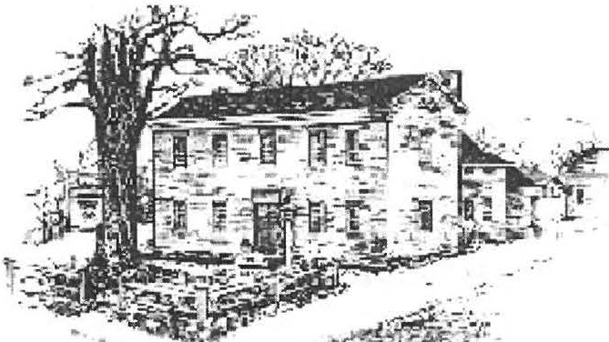
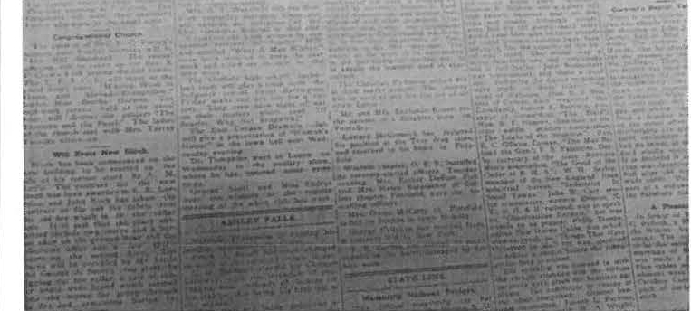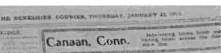5?Jr::
'?l!#edl
...:!74f 1u1.r cu/ S'bae{?

Fall 2013

S fteffieU100 'Years }190.· SeCecteditems, from71ie (}3erRJliire Couriers,
191 3, e:{f,ensive{y condensed and edited.
January 30. The q ues ti on of electric street light ing has bee n disc ussed aga in of late and further nego tia­ tio ns have been started. T he o ld ke rose ne stree t
la mps are almost of no use a t best. What Iig hts are prov ided no w are under the care of the Village Im­ provement Assoc iati o n.
April 3. The a nnua l town mee ting was he ld in S hef­ fie ld las t Monday. The day was one of suns hine and shado w in proportion o f o ne pa11 s uns hine to about ninet ee n parts s had o w, with wind and rain thrown in, but there was a good turno ut of vote rs in the fore noo n and the church sheds ove rflowe d with teams whose
o wners were disc uss in g ca nd idates and town matte rs.
April 10. The ad journed tow n mee ting o pened at

January 2. Fire gutt e d the inte rio r of A.M. Littl e 's ge neral s to re. T he bui lding was saved from destruc­ tio n by the prompt and effic ie nt se rv ice rendered by the telepho ne o perato r, Miss Eliza beth Mc Donn e ll, who was awakened by a choki ng se nsation cause d by the heavy s mo ke wh ic h poured into the of fice. She
q uickl y we nt to the sw itchboard and comm e nce d call­ ing memb ers o f the volunt ee r fire compa ny. In this way a num be r of men we re soo n o n the sce ne and
dra gged the hose ca rt to the building. T he pluc ky te l­ ephone o perator stuck to the board wh ile the fire was being foug ht below. It was o nly when she was able to ope rate the switc hboa rd by touch alone, because of the dense s mo ke and whe n s he had lite rally been
dri ve n from the building by some of the firemen, that Mis s McDonnell left the room. Note: The structur e, now go ne, was ju st so uth of the Co ng rega tio na l
C hurch.
2:30 o' cloc k Monday afternoon. Mod erator Cande presided. Geo rge Hall moved that $1500 be appro­ priated for an agricu lt ure course in the hig h sc hoo l. Mr. Roraback arg ued t hat the expense of the co urse would be about $70 0 to the tow n and that a lread y the ta x rate was too high. F. B. French advised that the to w n wa it a year and see what s uccess was had in Stockb ridge. Following Mr. French·s remarks the
ques tio n was unanimo us ly voted down. S toc kbrid ge also la te r voted it d o wn.
Jam es M. Wa llace is to move his barber shop to new rooms in about two weeks. The new s ho p will be fit­ ted up in the manner of all up-to-dat e barber s ho ps, with mode m facil ities , includ ing ho t and co ld water. April 17. A goo d 25 ce nt s uppe r will be served this
T hursday eve nin g from 5:3 0 to 8 o 'c loc k at the inn of Geo rge G. Peck. The proceeds will go toward the
I ig htin g of the street s a nd everyone is urged to atte nd.

Compiled by James Miller

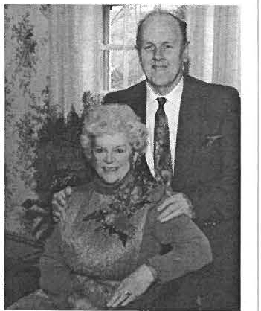

9diCton el 9darion (Bamum and the (Bamum'Too{Coffection
When yo u ask people with a twe nty yea r o r more S heffie ld co nnec tion - locally born. transplants. secon d home own­ e rs o r visito rs. what co uple they think best represe nts S he ffie ld qualitie s. yo u' ll get a lot of great
names. Ask them to narrow it down to who best rep resents traditional Yankee qua lities: you' ll ge t a sma lle r lis t. Ask the m to na rrow it down to who best help ed preserve the look a nd feel o f She fl1c ld. the lis t ge ts even s mal
lcr. Finally. ask them who o n the remaining list they think of when they hear the words ··Shenie ld Histo rical Soc ie ty·" . a nd 1"11 bet you the names yo u' ll hear mos t arc Milton and Marion Barnum.

Ren e a nd I fi rst met Milt. as e veryo ne knew him. a nd Mario n ove r 25 years ago when. as weekend Stave leig h Ho use visitors. we were in vited to one of the wonderful turkey dinners the S heffie ld H is ­ tori ca l Soc iety he ld in the Legio n Ha ll. Milt started the lu nd raisi ng d in ners to restore the old cov­
e red bridge. I had no unders tand ing then th at. yea rs lat er. I would be ge tting up in the mo rning. lookin g a t the Covered Bridge and the America n Legion. thinking of those g rea t turkey dinners. and rememb e r all of the wonde rful peo p le we' ve met the re. After just one samp le of Milt and Marion Barnum' s tale nts in putti ng on the ··S HS T urkey Dinne r.., es pecially after experie ncing Mario n' s lemon meringue pie. we were hooked as memb ers and vo lunteers of the She ffie ld H is torica l Socie ty.

As we talked wit h the Barnum s and liste ned to sto ries abo ut them from others over the years. we came to the conc lu­
s ion that witho ut them the She ffield Historical Soc ie ty wo uld probably not ex ist today. or. at the very least. wo uld be a much different orga nization. Milt was one of the 7 citize ns with the foresight to establis h the Sheffield Historical So ­ c iety. During the start-up o f the Society. Milt partnered wit h Ed Warren to buy and ho ld the Dan Raymond I-lo use property until the Society could take o wne rs hip . Milt used his build ing s kills to lead the Dan Raymond property reno ­ vatio n and guide the volunteer la bor he rounded up for the task. I could talk a bout his s imilar work with the Mark Dewey Resea rch Ce nter . the Parker Law office. the co nstru ctio n of the well ho use. re locat io n of the s mo ke house from
the Episcopal C hurch g rounds . etc.. but I' d soon run out of Newsle tter space \\'ilhou t ge tting to the major point I want to talk about: Milt' s too ls.

Milt' s tools are a legend on their own. One of the first Sheffield H is torica l Soc iety programs I re member was ··Wha t' s It? Night··. Thi s was my first in troduc tion lo anothe r Milt and Mar io n Barnum phenome no n: the Barnum tool co llec ­ tion . In this program he ld a nnua lly for ma ny yea rs in January at Dewe y Hall, 30 or mo re ··tools" were selec ted from the Barnum co llectio n of ove r 1.00 0. placed o n tables a nd the audie nce would have a certain amo unt of time before the start of the program to look at all of them. a nd g uess what it was called or used for. Years later I would visit Mi lt and Marion . and he 'd le t me pick out items from the place they were stored or from those Marion held sway over in the hou se. We 'd sit in the kitchen. chat. and he'd explai n the use of each item. I' d take a photo and create a cheat sheet. which I used the few tim es I had the hono r o fl ead ing the program. The s to ry o f how the Barnums acquired some of the too ls is a lso very interes ting and perhaps a topic for a fu ture S HS Newsletter.

The Barnum fam ily has ge nero usly allowed the Soc iety to purc hase the ent ire Barnum Too l Co llection below market va lue. a nd we have accep ted their o fte r. During M ilt' s li fe , he used these items to educate not only Soc iety mem bers and the childr en of So uth Co unty in the ways of the past. but a lso a llowe d their use in various programs and exhibits. Our plan is to continue the Barnum legacy and use the Ba rnum Tool Collect ion to give childr e n and adults a deepe r, ha nds -on a ppreciat ion of local history a nd a look at a way o f lite lo ng passed.

To continue this legacy c reated by Milt and Ma rion Barnum. the Soc ie ty is establish ing the "Milt and Marion Barnum Tool Co llec tion·· on Society property and seeks your financ ia l s upport in o rder to hold. mainta i n. and properly display it, as well as co ntinue to make it ava ilable for educatio nal purpos es. To that end. the Soc ie ty has a goal to build a modest s tructure to ho use th e tools and honor the legacy establishe d by Milt and Marion. Our goal is to raise at least
$25.000 to meet th e co llectio n pur c hase price balance and cons truction cos ts. T he Soc iety has rece i ve d a c ha lle nge grant whic h will match dollar for dollar every dollar of the fi rs t $ I0.000 raised. -

We invite yo u to consider a gift to he lp us meet this c ha lle nge reac h the goal we have set. If you have any questions. contact me or o ne of the othe r two me mbers of The Milt and Marion Barn um Tool Collection Committee. .Jeff Browne and Paul O'Brien.

I th ank yo uot r yo ur conside ratio n of this id ea and hope you will help us ho no r a coup le who gave much to this cou­n
try and S hef!iel d for over 80 years.

Dennis Sears

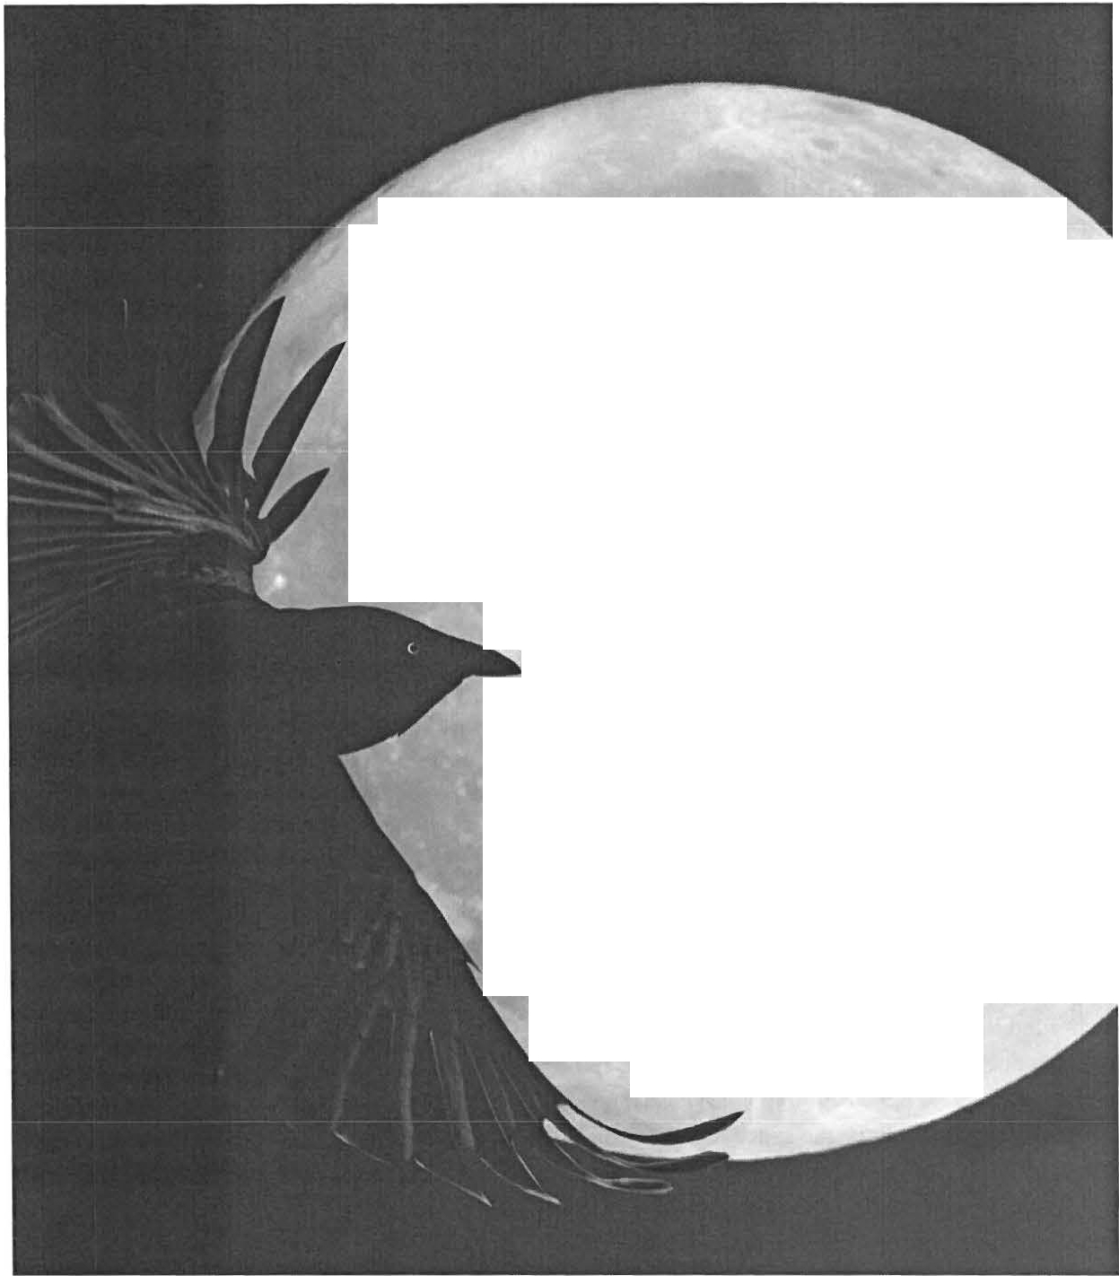The Sheffield Historical Society and
The Lenox Garden Club
Invite you to save the date
October 18, 2013 - 6pm - 8pm
for
SPIRITS AND 1'\QRE
Preview Party for
BERKSHIRE HAUNTS.
a frighteningly good Flower Show.
Please join us for a bewitching cocktail party featuring hors d'oeuvres and liquid spirits.
You will be spellbound to preview prize winning floral designs, spooky horticultural entries and educational exhibits with frightfully important information.
Mark your calendar October 18, 2013
for this hauntingly charming Cocktail Party

Reasons to Reserve Your Ticket Today:
-Reserving your ticket is easier than ever before!
-You'll get $10 off your ticket price for buying in advance
-You'll be the first to know the prize winners of the local and national awards for the displays
-You'll ensure your spot at the Halloween social event of the season!

Advance Tickets: $30 At the Door: $40

Reserve online at www.sheffieldhisto ry.org
or mail us your name, number of guests, and payment.

Community Connections
"The welfare of each is bound up in the welfare of all."- Helen Keller

I ' m sure we' ve all heard it sa id that succe ss can be a direct result of who you know. No man is an island, there' s no " I' ' in " Tea m," many hands make light work, and all those other cliches. The tric k, though, is trying to figure out how all of that trans­ late s into real efforts that can be made to help a place like the Sheffield Historical Society. Over the past month or so, we' ve been exploring just that: how we can forge stronger connections throughout our com­ munity in order to gain mutual benefits on a number of fronts.
One area where we have started making con­ nect ions is, log ica lly , other local hi sto ric organiza­ tions. Sheffield is full of them, and , when you take that eve n a bit further into the rest of the Berkshires and across the border into Connectic ut, there is a huge pool of resources, ma ny of which have been
sta nding on their own, doing their best to succeed and keep their doors open. We have bee n working on finding ways to bring many of these different organi­ zations together and build a more cooperative rela­ tionship.
Each organization has different assets that can help others out. For insta nce, we have a store that is open every weekend in the center of town. It' s a per­ fect location for se llin g the beautiful Mum Bet dolls that help fund the Colone l Ashley House. So we share that space with them to help keep their hou se
on it s feet. In tu rn, we have acquired a large carriage that we currently do not have the space to ho use. But, instead of us having to lose that piece , the Great Bar­ rington Historical Society kindly offered some of their space for us to borrow until we hav e made room. We have also been working in pa1tnership with Dewey Hall to s hare advertisement and inc rease traf­ fic to both places.
Other networking has also proved to be very im­ portant to the Society. Our Mark Dewey Research Center has man y resources that are use ful to the com ­ muni ty, so we recently ho s ted the director of the Bushnell Sage Library and a librarian from Mount Everett High School to have a tour of our archives and discu sse d ways to interconnect our se parate re­ search materials. We have started projects with stu­ dent volunteer groups , as well as the specia l educa­ tion departme nt, to work on getting youth involved in local histor y while lea rning sk ills that will benefit them in their future. Our September monthly program on barns was put on in conjunction with the Sheffield Land T rust, so we were able to have the best of both worlds, discuss the historical importance of our barns while, at the same time, helping spread the word about their barn ce ns us project. We have also entered the world of socia l networking with the creation of our Facebook page, so we can grow new connec tion s direct ly with ind ividuals in our community.
There is no reason why the Sheffield Histo ri­ cal Society, or any loca l organization for that matter, shou ld be a stand-a lone entity. There is so much that this area has to offer, and, through these community connections, we will continue to spread the word and keep each other going.

Mandy O 'Connor

CALENDAR OF EVENTS

Exhibits at the Old Stone Store
Open Saturdays from 10am-3p111 and Sundays from 11am-3pm

"From Alphabet Blocks to Zoetropes: A History of Toys in America'' Berkshire Haunts Flower Show
September 7- October 14

October 19 & 20

SpiritFest 2013

"Hauntings and History: Haunted Houses of the Berkshires" October 11, 7:30pm- Dewey Hall

Zombie Building Contest

Berkshire Haunts Flower Show Preview Party Scary Movies on the Lawn
October 12, 1:00-3:00pm- Dan Raymond House October 18, 6:00-8:00pm- Dan Raymond House October 25, 7:00pm, Dan Raymond House Lawn

SpiritWalk October 26 (27ifraining),2:00-4:00pm, Center Cemetery, Berkshire School Rd

Pumpkin Carving October 29, 3:30-5:00pm, Dan Raymond House

A Walk on the Dark Side October 30, 6:00-7:00pm, Dan Raymond House

Festival for the Holidays Opening Holiday Party
Upcoming Programs
Dewe;i Hall, 7:30 pm

November15 December15

How to Trace Your Genealogy ln; Dennis Sears
Colonial Courtship by Gillian Hettinger and ]01;ce Hawkins
January 10 Februaryl4

The Sheffield Histo rical Society invites the support of you and your frie nds through me mbe rs hip.

Na me(s) E-Mail _

Address - - - - - - - - - - - - - - - - - - - - - - - - - - - - - - - - - - - -
Please check: New Renew

Individ ua l ($ 5 - $50)
Family($ 5 l - $ 100)
Pa tron ($10 I - $500)
Sponsor ($50 I - $ 1 , 000)

Pl ease make check s payable to: The Sheffield Histor ical Society. Send to : P.O. Box 747, She ffield , MA 0 12 57

Jfauntino f£venino to Launch Society's Spi:ritPest

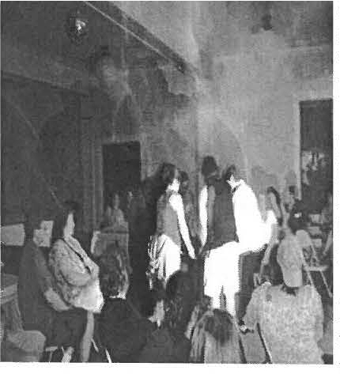
'' From ghoulies and ghosties and long-/egg ety beasties and lhings that go bump in the night, Good Lord deliver us!" T hese words from an o ld Sco ttish prayer may describe feelings afte r the S hef field Historical Society's October program. " Haunt ings and History " will be presented by Jos h Mantel lo of the Berkshire
Paranormal Group on Friday, Octo ber 11 1 at 7:3 0 p.m. at Dewey Hall.
\

Mr. Mantello' s talk , " His to ries and Mysteries ", will show how one must be a historian in orde r to investigate paranormal experience s. Beginning with the Houghton Man s ion in Nort h Adams, he will de sc rib e s us pected ha untings in the Hoosac Tun nel , North Adams, Ventfort Hall in Lenox , Octo ber Mount in Pitts­ field, a nd The Mount in Lenox, among other locat io ns.

Berkshire Parano rm a l was fo und ed approximately IO years ago by Josh and his father Nick Mantello , both members of the Maso nic Lodge in North Adam s whic h is rep uted to be haunted. After hiring an investigative group to test the
mysterio us happen ings in the Masonic Lodge, they became intrigued by the whole process and decided to form their own paranormal group , now numbe ring s ix investigators. T his a lso in volved purchas ing photog raphi c and othe r eq uipment used to investiga te c laims of paranormal expe riences. After the Masonic Lodge, they took on the Houghton Mansion in Nort h Ada ms, as well as clie nts who requested searches of their homes or bus inesses.
Over the years they have investigated si tes in the Berkshires, Eastern New York and Southe rn Ver mont.

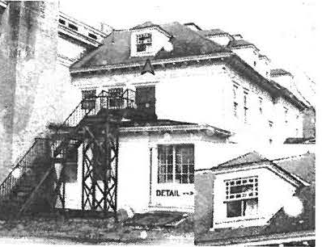
Josh has taken an extreme interest in Paranorma l Photo graphy and has become one of the better known experts in this field. He also lect ures a nd teache s on other subjects in the paranormal field and has atte nded multipl e co nferences and events on many
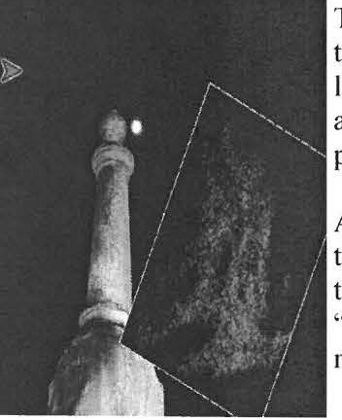
subjects, from G host Huntin g and Paranonnal Investigative Techniq ues , to Pa rano rmal Photography. Josh has also taught a Paranormal Investigat ing or Ghos t Hunting class at loca l sc hools, teaching middle to hig h sc hoo l aged students abo ut modern day
paranormal investigating techniqu es.

After Mr. Mante llo' s description of alleged ha unt ings in well-known histo ric sites in the Berkshir es, aud ie nce members will be encouraged to offe r the ir own stories of mys­

ter io us happen ings in their ho mes and else where. Jo in us on October 11 ¹
h
for

" His to ries and Mysteries'·, the inau guration of the His torica l Society's --S p iritFest'·, a month lo ng se ries of spooky events celeb rating the Halloween season.

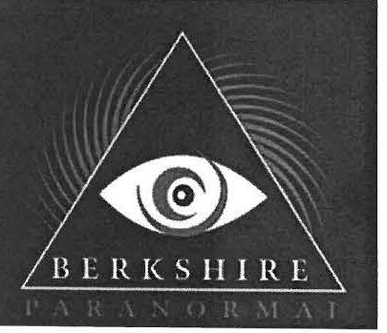
Joyce Hawkins

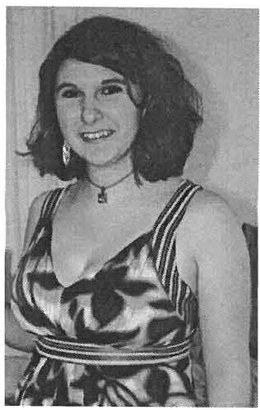
Prom the jldministrator

So you may have been wondering who this
" Mandy O' Co nnor" is that you've been getting e-mails and letters from for the past month or so. We ll, the easi­ est answer is: that's me. I' m Mandy O' Conno r. More rel­
evantly, I ' m happy to say that I' m the new ad­
ministrator for the Sheffield Historical Society. Many of you 1've already had the plea s ure of meet ing, but still more l have not, so let me tell you a bit about myse lf so we're not st range rs.
I was born in Great Barrington, spent a few of my early years moving around the area, and finally landed in Sheffield when I was about IO years o ld. I attended Undermountain Elemen­ tary and the Mount Everett High School, and grew up with the comfort of having mo st of my extended family nearby , since they live almost exclusively in the Southern Berkshires. I went on to study at William s College, whe re I s pent four wonderful years in what is fo ndly referred to as
" The Purp le Bubble " by everyone who goes there. I e nliste d in the Army National Guard two days after graduatio n and did some work at the So uthe rn Berkshire Chamber of Commerce while I waited for my training to begin, which it did in November of that year. I spent two years on active duty travel ing around with them, but
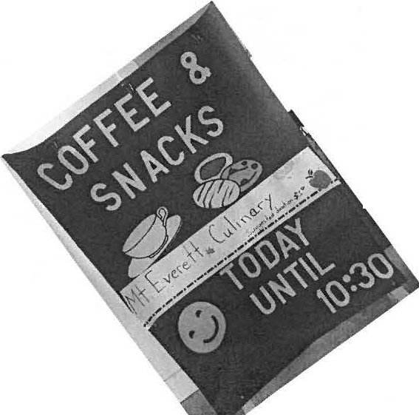
there was one thing that was consistent no matter where I went. 1 was always talking about home.
Of course I missed my family and my house and my pets, but that's not really what I mean when I say I was always talking about home . I mean that, no matter where I was or the great things I saw, nothing could really compare to how much I loved the place that I was from. My friends couldn ' t get me to stop talking about our trees, our hill s, or our histor y. So when I came home and saw the opening at the SHS, I didn ' t waste any time applying. I knew that this was a place where I cou ld make a difference in m y community while learning even more reasons to lo ve it.
So we've loo ked at my hi stor y, now let' s take a quick peek into the future. As administ rator, my main goals are to build our internet prese nce,
sta1t ed ucationa l programs to engage our town' s youth , and create a better network between histori­ cal organizations in our area. There are many new projects in the works, which will be the culmination of our co mbined efforts, so keep an eye out for all so rts of exciting new things that will be happening in the near future! In the meantime , I look forward to meeting all of you! Stay well!
Mandy O'Connor

!Mount P,verett Students at the
Olif Stone Store
Have you sto pped by the Old Stone Store on Monday or Tuesday morn ing ? The Sheffield Histo rica l Society and the Mount Everett Regional students from the Culin ary Arts and Life Skills programs are offering up hot coffee and breakfast treats. Drop in and say hello, hear about the exhibits and upcoming events of the soc iety a s you enjoy a hot cup of coffee and a muffin!

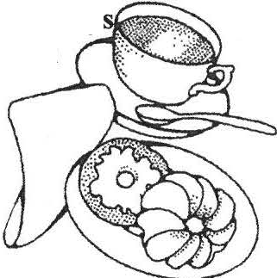
Mondays and Tuesday 8:30 - 10:30am

Help us in our efforts to "Go Green" by sending us your e-ma;/ ad dress! By adding yourself to our e-mail list, you will be more promptly inform ed of activities going on at the Sheffield Historical Society. lf you'd like to receive our e-blasts on upcoming events, please let us know.
Otherwise, we 'II onl y e- m ail you when we need to contact you directly. Thanks!

Name:----------------------
E-Mail:-----------------------
Please add me to your mailing list: Yes No _

Please either e-mail us with your information to shs@sheffieldhistory.org
-OR-
Mail this form in to:
PO Box 747, Sheffield, MA 01257

Thank you!!

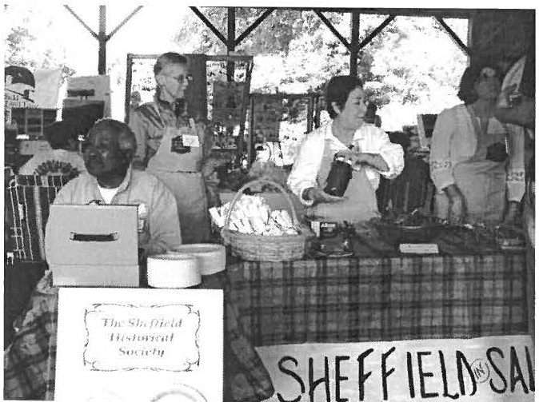
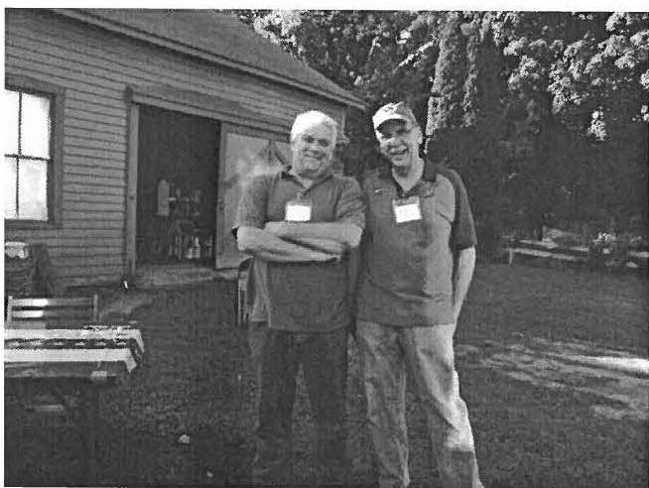

Salad Bar during Sheffield in Celebra1io11 2013 Jeff Browne and Paul O' Brien al !he ·f ot umeer Cooko111

. SPl T FEST 2013 (, --
Pait of the fun of living in s uch a histo ric town is ge ttin g to pla y wit h all the s pirits that go along with it. This October is filled with fun and exc it ing eve nts that will bring o ut the s pooky side of Sheffield. You won' t want to m iss it!
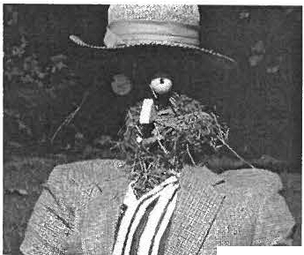
Our Spiritfest kic ks off wit h "Hauntings and History," a program on October 11 at 7:30pm at De wey Hall. Berkshire Para­ nom1 a l Group will be giving a talk on th e ghos ts they ' ve me t at
many of o ur loca l histo ric ho mes, inc lu ding Yentfort Hall, T he Mo unt , th e Houghton Mansion, and more ! T he n the public will be
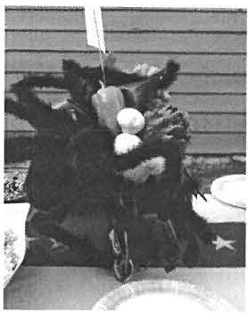
invited to share their own ghos t storie s. Not to be misse d! Then, the following day at the Dan Raymond Ho use, on Saturday the 12th 1:00 to 3:00pm, you can paiticipate in o ur Zombie Building Con­
----test. Bring a team of frie nds, o r so me people from yo ur o wn loca l o rga nizat ion, and try your hand at bringi ng your zombie to life !
On Friday, October 18, from 6:00-8:00pm , the hig hl ight event of our Spir itFe st will take pla ce in the BerkshireHaunts Hal­ loween Flower Show Preview Party, in partnership with the Lenox Flowe r Club . Start at the Dan Raymond Hou se fo r a bew it c hing cocktail party featuring hor s d'oeuvres and liquid spir its. Visit the
ex hib its. You will be spellbound to prev ie w prize winn ing floral de­ s ig ns, s pooky hort ic ultural entries , a nd educat io na l ex hibit s with frightfully imp o rtant information. Ca n' t make it to the party? Don't fret! The Flower Show will be open to the public fo r the rest of the weekend in the Old Stone Store.
The fo llow ing week, on Friday, October 25 at 7:00pm on the lawn behind the Dan Raymond Hou se, the Sheffield Histo rical Soc iety and SADD will be hos ting a Scary Movie Night . Free for all, bundle up and bring the family for a fun night of(not so) spooky movies , includ ing " The Childr e n," a camp y film shot right here in Sheffield, and " Abbott and Costello Meet Franke nste in." Refreshme nts will be served ins ide the Educat ion Ce nter. Then, on

Saturday the 26¹
h
from 2:00-4:00pm (or Sunda y if it rains), yo u

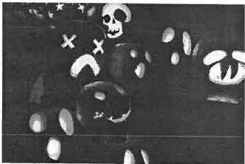
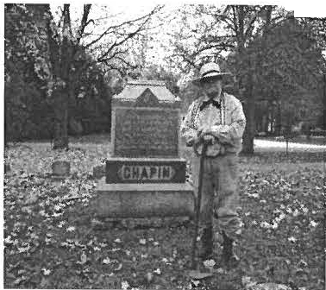will have the chance to meet the sp ir its of S heffie ld citize ns pa st at o ur an nua l SpiritWalk. The Cente r Ce mete ry on Berkshire Schoo l road will, qu it e litera lly, come to li fe! Come hea r the stories of those buried there and as k them yo ur q uest ions!
- ?!!
·
To finish up the Spirit Fest, we will be host ing Pumpkin Carving at the Dan Raymond Ho use o n Tuesday, October 291 from 3:30-5:00pm. Gracio us ly donated by Howden Fann , we will suppl y th e pumpkin s so yo u do n' t have to worry about finding a pumpkin las t minut e before Ha lloween. Fina lly, on Wednesday,
\
October 301 from 6:00-7:00pm , come to the Dan Raymond Ho use
\
a nd ta ke a little Walk on the Dark Side. See all our spooky zom­ bies and jack- o-la nte rns and get a little early trick-or-treating in!

Mandy O 'Connor

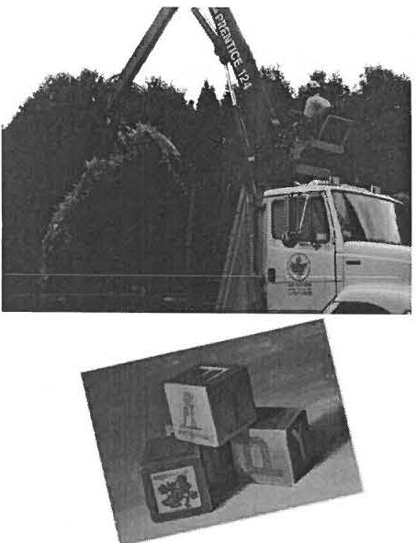
(Barrett 'Tree Services to tfie <.R§scue!!!
You may have noticed the very large remnant s of a 60 year old pine behind the Dan Raymond House , if you look back there today ,you will see that it has been remo ved. Barrett Tree Services donated the ir time and equipment to
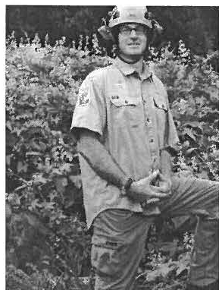
remo ve the rather lar ge load of pine from our property. Hat s off to a great job! THANK YOU!
Visit Barrett Tree Service at www.barretttreeservice.com.

Prom jl_{pna6et <Bfock§ to Zoetropes: a Jfistory of oys in }lmerica
The Sheffield Historical Soc iet y opened a brand new exhibit in our Old Stone Store on Sept. 7. The exhibit includes paper toys & game boards, dolls, wooden toys, and metal toys, dating from as early as the 1840s and extending through crucial parts of 20th century American his to ry. Toys are brought up to date with Trivial Pursuit, Hello Kitty , a nd Barbie do lls. The exhibit is n' t all about lea rning the history of toys, it' s also interactive to remind us that we're all c hildren at hea rt , and everyone, yo ung and old, plays with toys.
The re is a 19th century circus puzzle, zoetrope, and mec ha nica l bank, and many 20t h century games s uch as
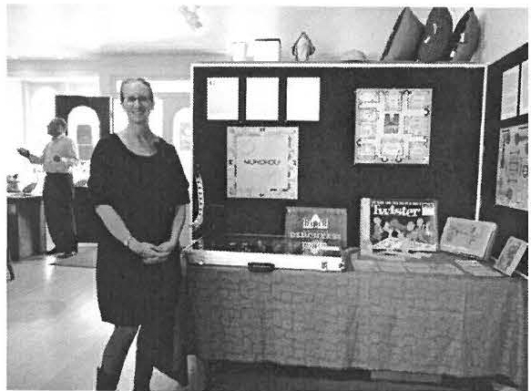Ca nd y Land, Co nnect 4, Memory and Twister to play wit h. T he o ldes t toy in the exhibit is a complete set of General and Mrs. Tom Thumb paper
.:..r-- , j
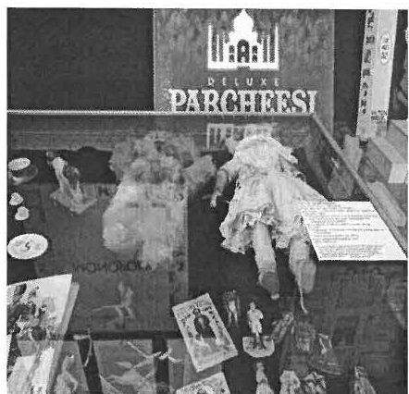
do lls p roduce d by McLoughlin Bros. in 1840. The re are also beautiful ex­ amples of toy theatres from Europe which would have been popular in the mid-19th century and three wonderful tea sets from around 1930 made of three different materials and in their original boxes. The dolls on display represent eve ry decade from mid- 19t h century rig ht up to 1990s. They are made of every possible material - rag
dolls , porcelain , bisq ue, metal , and plas­
tic. Did you know that all dolls had brown eyes until Queen Victoria? During her life time dolls began to be made with her blue-color ed eyes.
In co nj uncti o n with the Sheffie ld in Ce leb ratio n events on Frida y, Sept. 6, the exhibit opened with over 20 people , most ly kids , ha vin g the opportunity to see it firs t. And the n the o pe ning reception on Sunday , Sept. 8th gathered man y mem ­ bers old and new as well as Sheffield neig hb ors to vie w it. The Historical Society will be hosting this exhibit until October I 3 ^{th} on Saturdays and Sundays from 1 1:00 am to 3:00 pm. There is someth ing for everyo ne, you ng and old. So take a journe y
with us through decades of childhood fun! Who knows , maybe you ' ll eve n find an old favorite... or a ne w one!

Lisa Reynold\·

Prom the <Presit[ent

Your Sheffield Historical Society has been bus y!
We j ust finished celebrating our fo1tieth year as a Society , and we are looking fo1ward to the next forty. We started the year with two outstanding exhibits. The first was an exhibit on the Ashley Family Records, and the second was an exhibit on Antique Toys. Both exhibits received rave review s from our record crowds. The " If This House Could Talk" self guided walking tour of historic houses in Sheffield was a wonderfu I compliment to the exhibits.

As the fall approaches, we will be holding our second annual SpiritFest (see article and schedule in the ne wsle tter) Rounding out the year , we will be having the grand opening of the Old Stone Store / " Festival of Holidays ", and our annua l membe rs' Holiday Party on December 15th at the Dan Raymond House. This year, the Dan Raymond House will be decorated for the
ho lidays by severa l of our loca l designers. The House will be open on the weekends during the ho lida y seaso n for tour s, which is a new and exciting activity for the Society!

A big "Thank You " to our members for their continued suppo 1t of the Society , and a special ·'T hank You " to a ll of our dedicated volunteers that help us in presenting the many and varied activities of our society. On to year Forty-One!

Paul O'Brien President
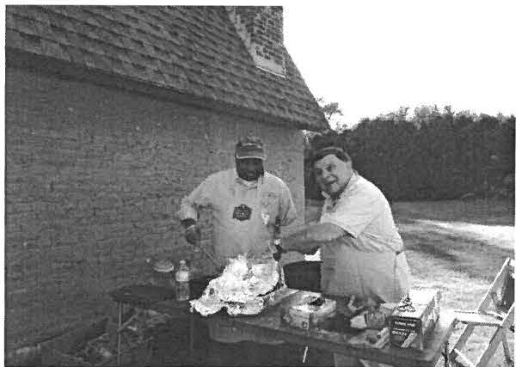
Wray Gunn and Brian Levinsohn grilling at the I·0111nteer Cooko ut
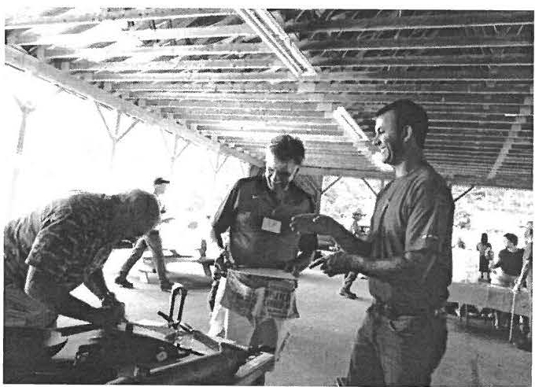
Paul O'Brien and a few visitors at the What ·s It? Table

'Wliat's It?
Can you name the item below and guess what it was used for? (Answer Underneath)

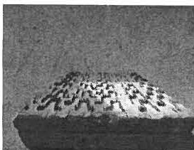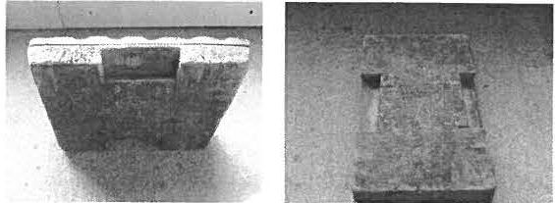

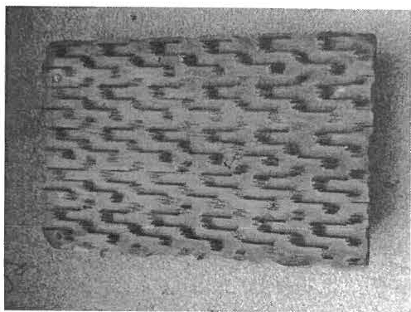
Sheffield Historical Society Board Members:
Paul O' Brie n (Pre s ide nt), Wray Gunn (Vice President), Lois Levinsohn (T reas urer) , Susan Pitman (Secreta ry), Dennis Sears, Jeff Browne, Joyce Hawkin s, Lisa Reyno lds, K.C. Clo w, Peter Kinne , Tony Carlotto

    - u.1a11v d poo.11 xnvf v .wf po1q 2Uf /U1.1d v Sf ssa112 .1110 ;a.ms 11; a101dw o. J 1ou a. ., a 1 ·1sauo4 aq 01., :.1a.11suv

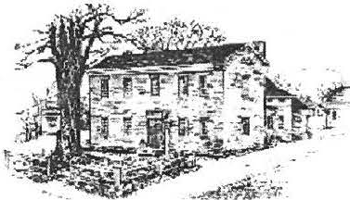
# di
2k
.fftifu1nca/ .51'6CU:'fy

nan Raymond f-lvuse Museum • 1\1/ark /)ewey Resea rch Ce nter • Old Swne '-'1ure
The Sheffield Historical Society's mission is to promote a wider under­ standing of the people and events thatpreceded us in this area, and to transmit that heritage to current and futuregenerations.

WWW.SIIEFFIELDl-1ISTOR Y.ORG
137-161 Main Stree t
P.O. I3ox 747 Sheffield. MA 01257

The Dan Raymond House is open Saturdays.
9:00am to 5:00pm, or by appointment.
Phone: 413-229-2694
Email: shs@shefficldhistorv.org

The Mark Dewey Research Center is open Mondays & Fridays, I:30 p.m. to 4:00 p.111., or b y appointment.
Phone : 413-229-3682
Email: mdrc@sheflieldhistory.org

The Old Stone Store
On the Green in Sheffield Phone: 413-229-2287

We need your help!
The Sheffield Historical So ciety runs on the su pport we get from volu nteers. Yo ur work serves the
comm uni ty, and now we are searching for bette r ways to serve you. We don' t want to fill your inbox with requests, but we also d on' t want you to miss out o n opportunities you might be interes ted in. To make sure you neve r miss a beat but hear only about things you like to do, please chec k off your vo lunteering interes ts in the table belo w and send it back to us at: PO Box 747, Sheffield , MA 01257,e-mail us at
shs@sheffieldhistory.o rg, or call us at 229-2694. THANK YOU!!!!

 | Coo king |  | C lasses
 | House-Keep ing |  | Maintenanc e
 | Living History / Reenactment |  | Old Stone Store
 | Doce nt |  | Garden ing/ Landscap ing
 | Too ls (O rgan izing, Ca talog uing, etc) |  | Resea rch
 | Decorat ing |  | Art (Posters, Logos, Graphic Design, etc)
 | Events |  | Other

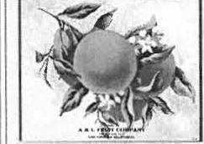
MERRY CHRISTMAS
The American tradition of en­ joying oranges at C hris tma s and Hanukkah began in the
I 880 ' s when the
trans-continental railroad system allowed for fresh citrus fruits to be shipped all
across the
country even in the dead of winter.
Early !!ot h c. orang-e ho, lahe l

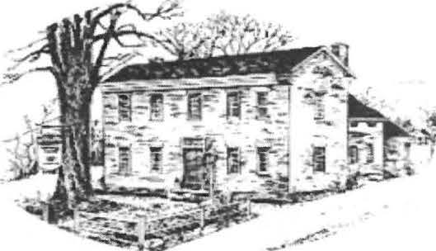
.Yhe
3% ----- u
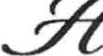
MCtJr ca/.¼c e{p

Fall 2014 Newsletter

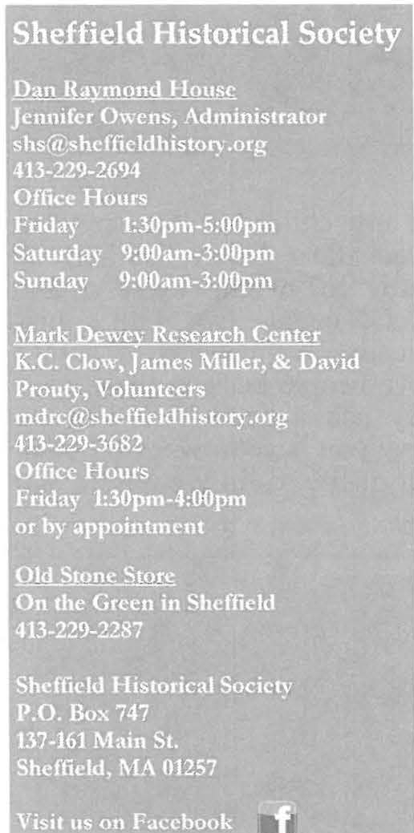
In the 1980's Ruth Barnum Leffingwell (1916-1998) wrote down her recollections of her childhood in She ffie ld in a sho rt unpub­
lished manu script called ··Family Re flecti o ns.'' Beginnin g this iss ue , and
co ntinuin g o n in future iss ues , we will be bringing you excerpts from her manuscript.

Another very special time at the farm was Christmas time. It was also a special time at school and at church. At school there was usually a program directed by the teacher. Of course everything was prettied up with red folding bells and red and green tissue paper. Also we would color different things with crayons. We usually had pieces to speak. I remember Pa teaching me mine. Every­ body was dressed up. Of
course, the lamp was lighted. Just being back at the school with your family at evening was so nice.

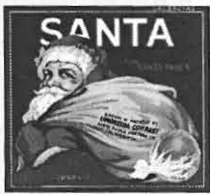
At Christmas the church was even prettier than the school. There was a tall decorated Christmas tree. The altar was nice, and again everybody was
dressed up. There was really pretty Christmas music, and we children spoke our pieces . We exchanged gifts by pull­ ing names, that way everybody got a gift. The church gave us all an orange plus a bag of Christmas candy. It seems that everything we did really didn't cost any money to attend. I
think Pa and Ma were so good to us by taking us to those nice places so co, n.·,urno., ,,.1c;£ 2

'ilwfn,·ld I,li torical Soc i<-1) . Fall 20 I+ """ .,, h ·lf h- ldhbt or) .or!!

Prom the }lclministrator

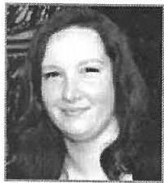In this issue we thought we'd share with you stories and photos that represent what the Holi­ day Season in Sheffield was like at the turn of the 20th cent ury . In addition to the excerpt from Ruth Barnum Leffing well's "Family Reflections," we are showcasing some of the won­
,
derful photos we have in our collection. Sheffield has many holiday traditions, and one of them is the Historical Society's annual Festival <if Holi days. In its 15t h year, there is once again a wide assortment of hand crafted and locally-made gifts, ornaments, and delectable treats for
sale. To see some of the items before you stop by the Old Stone Store, please visit the Festival efH.olidays
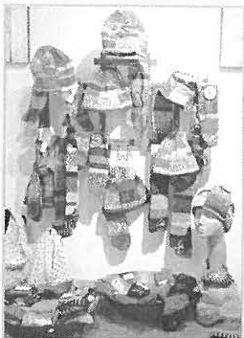
website: htt p:/ / theolds tonestore. weebly.com / -J ennifer Owens

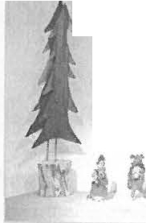
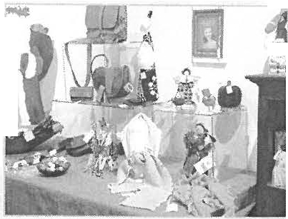
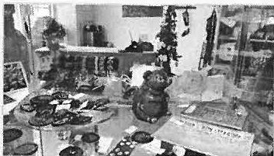
- ,.. _r
Some of the items for sale at the Old Stone Store
.. .

(JifJ?J!ff} .. Y. . .

• t" -• -
we could get the meaning of it all. We were really taught about Christmas and the mean­ ing of it all at home too.
Now at our home, Christmas was really something else. Pa always got us a tree, and we made all the decorations for it. We would pop com and string it. We kept it for a few years. We also cut and mixed some flour and water for paste and made circles for the tree. We colored little pieces of pa­

exchanged my childhood for anything else. We were all so happy, had fun, and worked hard. Our parents loved us and taught us. Of course, we didn't miss money, because we never had any; I can't believe people back in those days with money had a better life than we did. I believe you have to work for what you get out of life to fully enjoy it, and that we did.

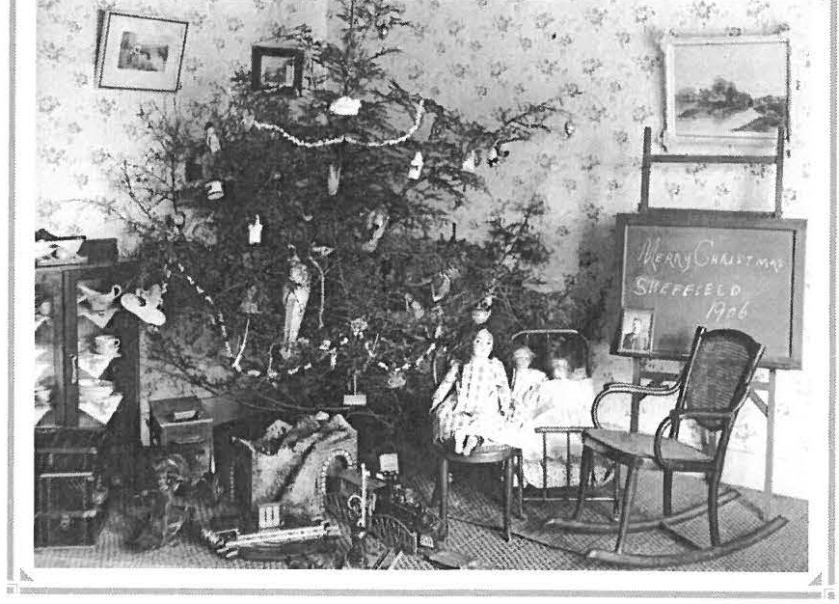
per. We used the same ribbon over .,;::----------------------• and over. We mostly got things like
stockings and shoe laces. If we all got a new pencil that was rare. Ma always seemed to get some candy with walnut meats in it. I don't know where she hid it, but it was there. Pa used to crack the butternuts and take the meats out for her. We had a nice butternut tree right down by our well. We had walnut trees too.
Now that I am older, I wouldn't have
A slig htly more s umptu o us Sheffie ld Chris tmas morning, 19 0 6
2 She ffie ld Histo ric al Soc iNy, Fall 20 I+ ww w.shcfficl clhisto ry.o rg

M .UtG.\I U 'I' BUCil'I'E
cards
CATA (C0M:\,fCXI'.rY
ACCJi:SS '.r0 'l'H1i: AH'l'S)
craft &paper goods jewelry
P.\i'UEL.\ DAJ/l'0X
scherenschnitt
FESTIVAL
of
HOLIDAYS

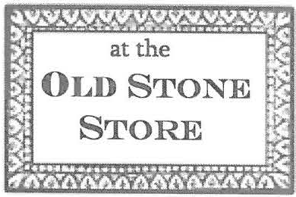

hand-crafted gifts for everyone on your list MADE. BYLOCAL.
ARTISANS
M.\RY l LJ,J N O'nRnjx
November
gth
jewelry
E1...1z.u m TII O'D0XX}iJLL
Long Roadjewelry
PENUOSI· DESIGX
hand-blown glass jewelry
E l, I Z.\ HE'r ll TII0RXE POST
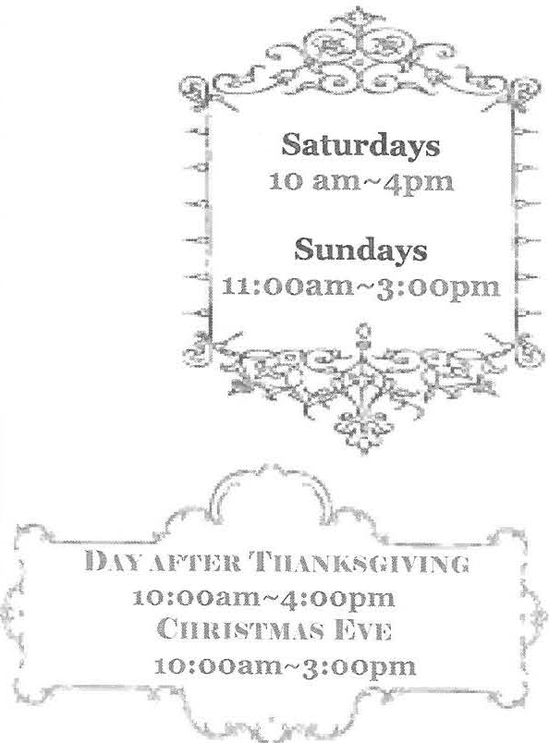
felt &

KIUSTEN
KAX'l'Ji:H
wooden items
M .\I U. \ GAY
ARTISANS
C II .\ Ul...l N E
RJijARD0X
chalkware Santas
cloth dolls

hand-carved painted Santas

M.\ UIS \ J0YCli:
photography

G .\ UY L EV1£IT,L li:
books & postcards
A I . \ N D .\ M0RGAX
knitted infant sweaters
& holiday cards
GEOltGI RE.liWES
leather goods
. J{ l l) \ & G .\ lt '\' SCIICMJi:H
hooks & cards
.Jl Pl•' SPCGXARDI
gravity wine bottles holders
L YND.\ wrnCIIXICKI

Sheffie ld I lis tori cal Society, Fall 201+ W I\ " \\' .s hellk lclhistm y.org 3

Let it snow

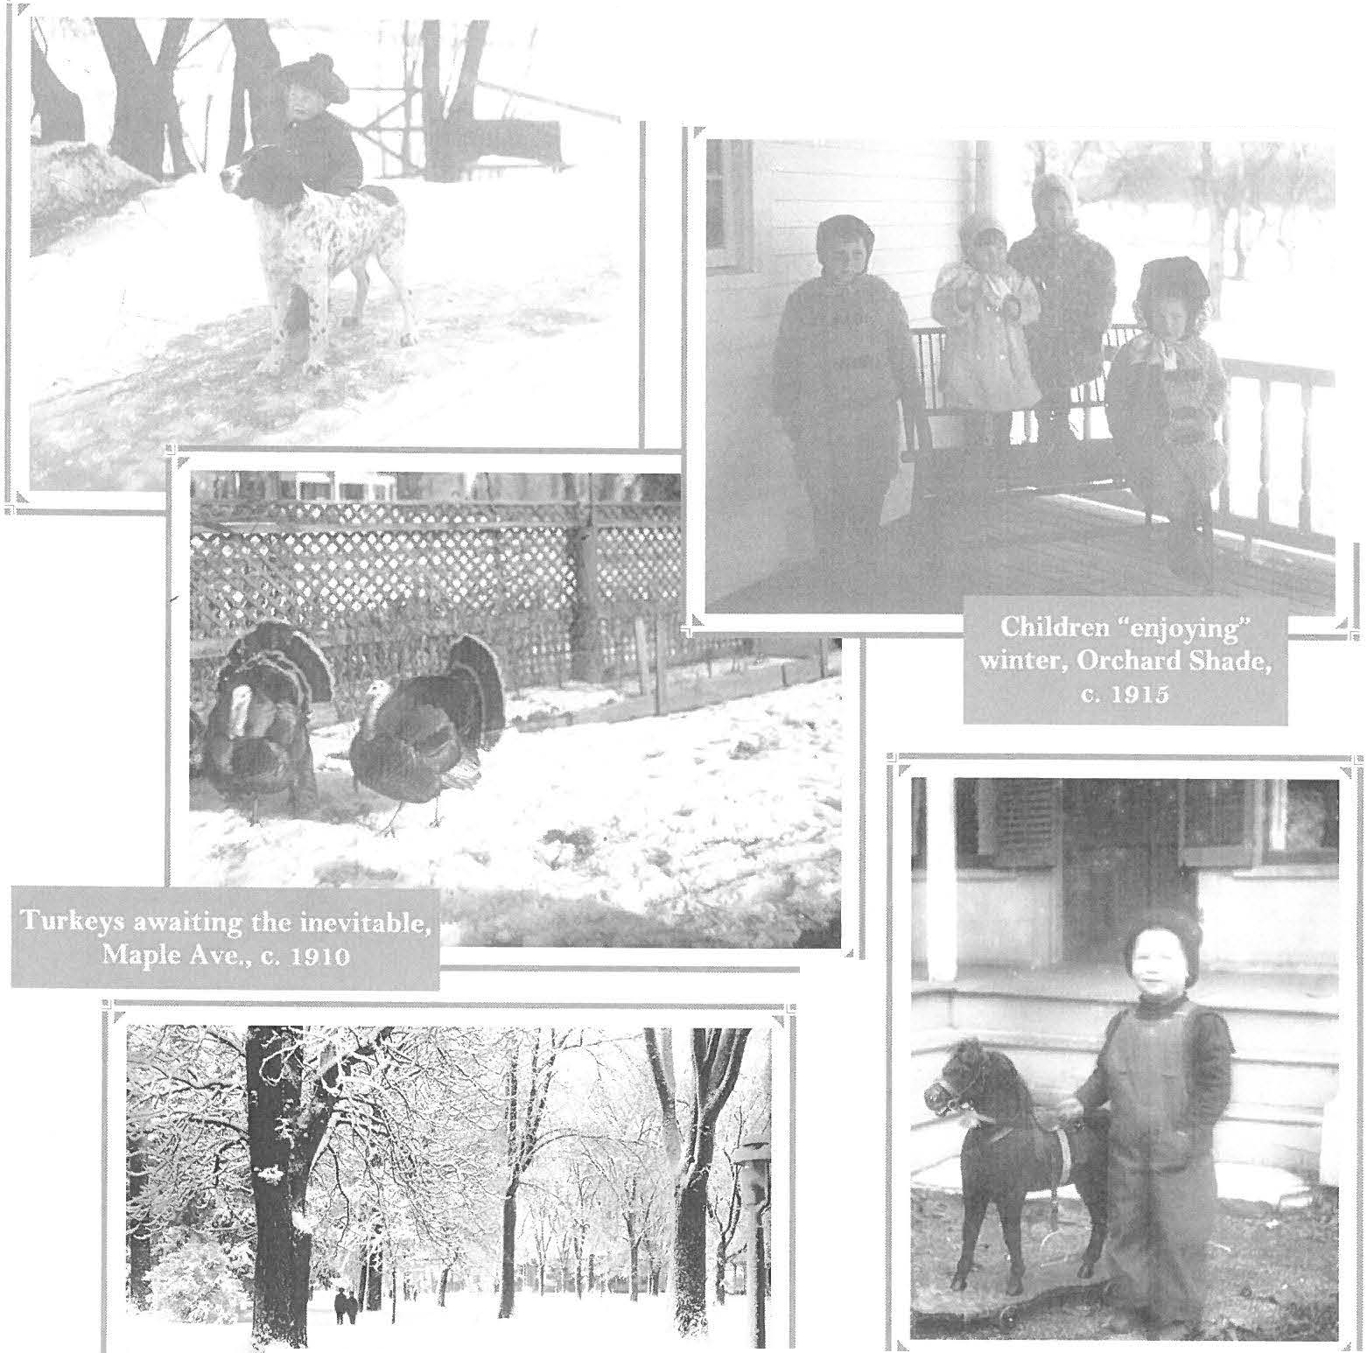.; -

---------------- ·

:---------------.

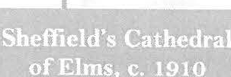
\,

;-----------------------"'.
4
\- -.

S hc ffit>ld Historical Soc iety, Fall 20 1+ ww" ·.shc ffie ldh isto ry.or

Sleighbells ring...
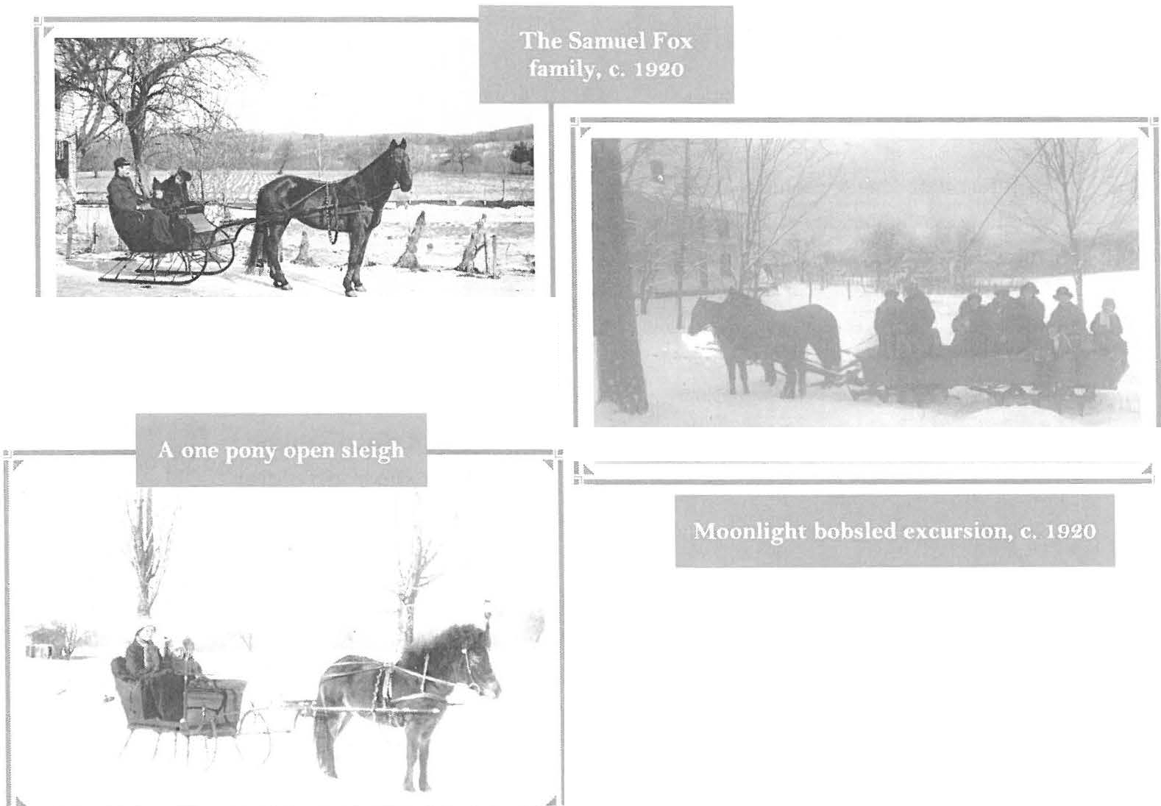
., - - .. .,.
Jf ollday 'Reciye
From:"CookingFavorites
of Sheffield," Sheffield Grange No. 224
A "yule kaga" is a spiced and candied
Norwegian holiday bread

YULE KAGA
2 c. sc al ded mi.lk
Mr s . Richard LeGe yt
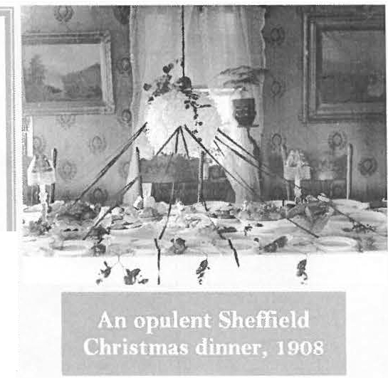2 eggs

I / c . s hort e ning, scant
:! ·3 c. s uga r
2 t s µ. s alt
I 14 ts p. cardamon. seed
4 c. sifted flour 1 tsp. cinnamon 1 c. li ght rais ins l c. chcrrics

2,) kgs . dry yeast
l c, citr on

1 4 c. l uk ewa r m wat er 4 more c. ilollr
Scald and cool milk with s ho r t e ning, i:iuga t·j sail and cardamon s ee d. Whcrl cool . add yeast which ha.s b een dis s ol ved in wa ter . Add 4 c . flour, ci1rna mo n lnd fruit, Add addi l w na l 4 c . flour .
Hai sc until doubl e in bulk. Pun.c h down . Kn ead , R t i s e unt U
doubl e in 2 bread tins . Bake at : so de g r e e s 45 m i nut es . .!
( Shell car clom on seeds may be c-r ush e d betw ee n t wo spoons. ) n

hCm'
t•lcl I listo rica l · oc it>ty. Fall 10 I+ \\'\\'\\'., lw ffie lclhi to ry.o rg 5

Recent Exhibits & Programs
®i tilling, ®rinking &t. Prohibition exhibit
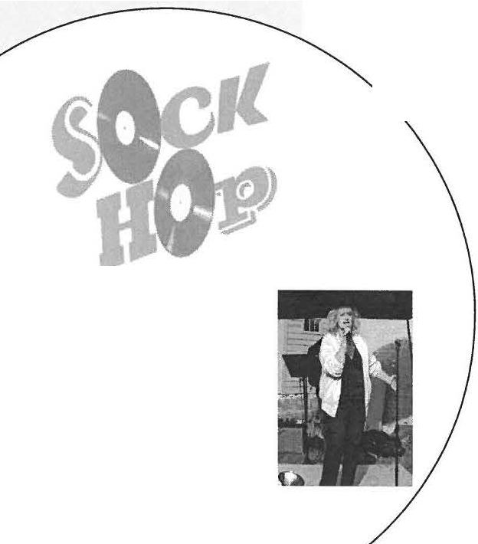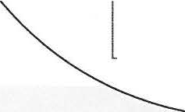Rounding out a year of well-received exhib "Distilling, Drinking & Prohibition. " An assortm of antiqu e alcohol making apparatus from Shef- field was on display, ranging from an apple cider press to a liquor still to the bottl es
its, was
ent
Our first Sock Hop featured a classic car show, an oldies concert, a hula hoop contest,
and vintage treats.
Jeannie Romeo crooning all of the favor ite oldies
and jugs that held those prized locally­ made libations. The monthly program at Dewey Hall, "Traditional New Eng­ land Cider Making, History and Tech­ niques," welcomed Dennis Picard who gave a highly-informative and enjoy­ able presentation on the history and traditi ons of hard cider making.

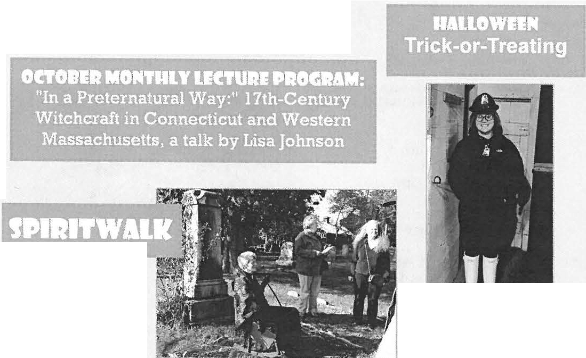
Sptrit fest 2014-
Madison Ryan in costum e, handing o ut candy to Tr ick -or­ Treater s going door -to -doo r at the Soci ety 's histo ric buildings
The spir it of Eliza Sage recounts a life as a teacher and suffragette

6
I!
Sheffield Historical Society
Board Members:
Paul O'Brien (President) Wray Gunn (Vice President) Lois Levinso hn (Treasurer)
K.C. Clow (Secreta ry) Tammy Black well Tony Carlotta
Mandy O'Connor Al Romeo
Rebecca Schopp Denn is Sears Kathy Staripoli
Student Advisors
Madison Ryan Alexa nder Valentini
Sheffie ld I listo rica l Socie t y, Fall 20 1+ ww w.s hcffit ld hi to ry.o rg

In October we welcomed the 5th Grade class at Undermountain Elementary S chool to participa te in a "Living History Day". This is the second year we have run this program, and plan to con­
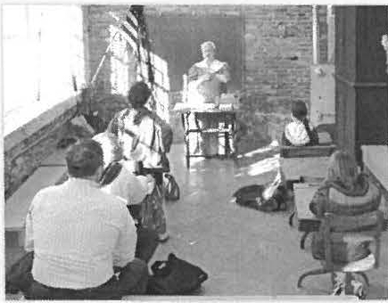
tinue and expand it in the fut ure. The s tudents rotated between sta tions where they learned about and participated in activities that brought to life wh at it was like to live in Sheffield in the 19th cent ury. They made ca ndle s a nd butter, work ed with antique tools, listened to a lawyer's ac­ count of a famous trial, and learned their lessons at a recreation of an
one -room schoolhou se. A popula r
t sta tion was genealogy, where the
,;·r.: M?-_f:f..f'..m-T- .t:£J:£33®".£.. ':c. r·£½ •
iii HOW MANY RELATIVES DO YOU HAVE? fi
t.1:J's.= ..e=,'t:t | . .-a=== r•._
I \'Qt ,
:? r1arcn1 11
-I cranJp..1rcn1..: X ,trrut rien1l11:-.n: nb 16 c:.:::r :1nd 1>.trt'nb J2 :!1!1! c rand1l.trC'nh
(1..f c:,:1.u: ur111d 11,1rt n1 ..;
118 !!:!l,! l!:runclpan-nb
? :: i.:,rand 11:in n1,
12 l!l!l!:t.\!l!.\!.i.:.rn n tl 11:.in:nh
- n2-1 S:.t: t:f!r.1nclpurc n1,
- ft-t8 1-;JLJ;!m: ;.:e.AJ,: 1:,l"itllcljl.lr C:Uh
- U t'l6 :tl!l!lo:)!l!l.!C!!.L:,:r :1nt111:.1n ·nt i,
M.192 e:,: :,att!,J:.2.£!!!! nt Rd(l.-f"rrll'i
l fd c.ti::.:f! cr.a-m l11an 111
,\2 ,768 :.: . l!.':!l!f i r:1m.l11art•n1,
f. . .\(1 l!l! :U: !!..:l!t:j4:}!gr.rnllp1tr c 111"'
I J I ,0 72 c. l!t! L:l!:!lo:L: \:J? r:.iru l parenh
262. 1-'-' :! l!i:l!l!i! cr:.in t11uarrn1
I .II JM.$7Ct i,!:.tL!:Zt:.',! m=-:Jt::
c,.:1ml1 i:.r , ·n 1,
2.wn . 1 2 1: ce.::,:1. !:ti!
( ; n md p.in:nh

In. nTh / .i or11, I" •· f w,:. 1 , ,•.,., ,..._ r JW!>

children were guided through trac-
ing their ancestors usi ng the societ y's recor ds online genealogy re­ sources. But as a nyo ne who h as se t out on the journey of uncovering
their family history

knows, it ta kes much more than a twenty minute session to dig deep into the pas t. So we hope to welcoming the s tud ents back to conti nue tra cing their genealogies.
Always been curious about
uncovering your family history?
Whether you have ties to Sheffield or not, the historians at the Mark Dewey Re­ search Center can guide you in finding the right resources for your genealogy quest.
The Center is open 1:30pm-4pm Fridays or by appointment. Contact us at mdrc@sheffieldhistory.org
or 413-229-3682

Upcoming Monthly Programs and Exhibits

Extreme Weather
An exhibit presenting historic photos and ac­ counts of severe weather events in Sheffield: floods, record snowfalls, droughts, and tornadoes. Frank
Lowe nstein
new year!

Berkshire County Antique Bottles
This monthly program lecture and exhibit will feature long­
time Berkshire Co unt y resident

will give a talk on the local effects of climate change at the monthly
Have you e ver hea rd of Berk­ shire Crystal Water? He lp us
so lve the mystery of the history of this S hef fie ld bottlin g com­ pany. Email or call us with any info or men10ries you have.
Jim Thomas ' s collection of bot­ tles found throughout Berkshire County. These, along with bot­ tles from the Society ' s collec­ tion, will explore the beauty and function of this simple vessel.

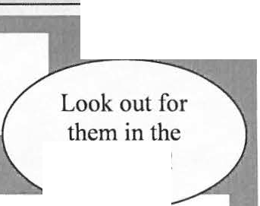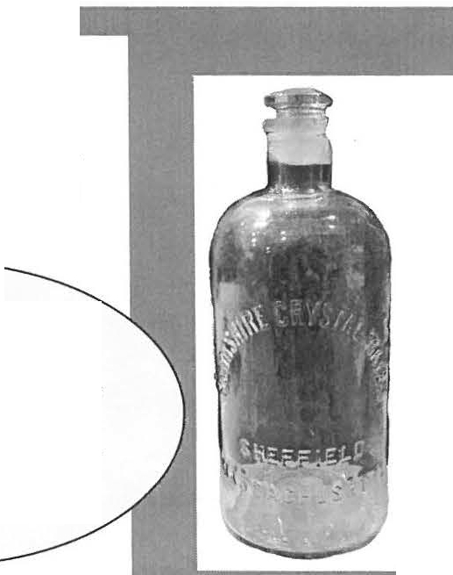program.

7
ShC'ffic lcl I li toric,1I Socie t y, l'all 20 1+ 11·ww . slwf'fk ldhi, to r.v.o r:o,,

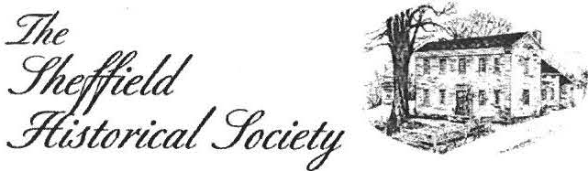

Sheffield Historical Society
P.O. Box 747
Sheffield, MA O1257

The Sheffield I /is1orical Sncie1y·s 111i ssio11 is to pro11101e a wider understanding of 1he people and eve111s tha, preceded us in !his area. mid lo transmit that heri1age to current and f11111re ge 11e ra1io11s.
WWW.S HEFFIELDHISTORY.O RG

·--------------------------------------------------------
Please make checks payable to: The Sheffield Historical Society. Send to : P.O. Box 747, Sheffield , MA 01257
Address - - - - - - - - - - - - - - - - - - - - - - - - - - - - - - - - - - - - - - - - - - - -
Please check: New Renew

_ _ Individual ($15 - $50) _ _ Family($51 - $100) Patron ($101 - $500) Sponsor ($501 - $1,000)
E-Mail - - - - - - - - - - - - - -
Name(s) _ _ _ _ _ _ _ _ _ _ _ _ _ _ _ _ _ _ _ _ _
The Sheffield Historical Society invites the support of you and your friends through membership.
Slw ffie ld 11is t o r ica l ociety,:1 a ll 20 I+ www.she ffie ld hi; to ry. o rg 8 I

