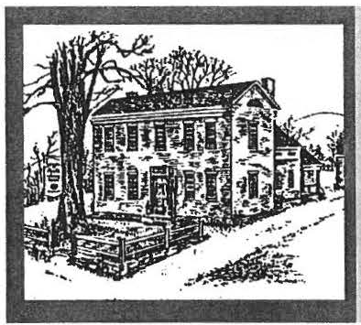
Sheffteld Historical Sociery
Winter 2006 Newsletter

FROA1THE PRESIDENT

Dear Members and Friends of SHS,

The Upper Housatonic Valley Af­ rican Ame rican Heritage Trail celebration in September was a major event in Berkshire histori­ cal recognition. The SHS joined with the UHVAAHT committee and The Trustees of Reservations to create a weekend of eve nts: a semina r at MCLA under the lead­ ership of Dr. Frances Jones­ Sneed; 3 full busses touring Afri­ can American sites with 3 differ­ ent foci; and a sympos ium focus­ ing on adapting historical empha­ sis to include African American citize ns, held at Old Parish unde r the leaders hip of Dr. Joanne Hurl­ but, Director, SHS. The day con­ cluded at The Ashley House with the Trustees of Reservations nam­ ing the Freeman Room- a fust honor for an African America n
vember meeting with Roselle
Chartock' s talk about her trip to Ghana to trace the jo urney of
W.E.B. Dubois "From Birthplace to Burial Site," a talk with slides (Nov. l 0, at Dewey Memorial
Ha ll, 7:30 pm). Sponsoredjointly by the Sheffield Historical Society and the Great Barrington Histori­ cal Society.

Festival of Trees: Holiday Comes Early for Fes­ tival of Trees

Many of the members and friends of the So­ ciety are creating trees, wrea ths , mantel decorations , and cen­ terpieces for your purchase at the Festi­ val of Trees.

Successfully gettin g minia ture
thread, and raffia, pots, dowe ls- and finally each of us makes a trip to the kitchen of the Dan Raymond House, where Jim has set out the trees, wreaths, and Iights. Some people, like Doreen Atwood, who annually cre­ ates a quilted piece for the raffle, completed their offerings ages ago, but the rest of us are bustling .

In addit ion to the festive decorations, there will be holiday cookies and can­ dies to delight young and old, as well as other goodies for your holiday ta­ ble.

For the collectors among you, the hand-painted ornament of the Shef­ field Elm is "the best ever." These will certainly be gone before Decem­ ber, so stop by right away or call in your order (229-2694).

Fresh balsam wreaths with magnifi­ cent bows will be avai lable in De- ce m be r.

citizen in Berkshire County.

The well-received exhibit at the Stone Store on the same theme,
"If They Close the Door on You,
trees on the Stone Store tables by The Festiva l of Trees is both an im­
November l l takes foresight and portant fundraisers for the Society pl a nn i gn . P ineco n e s and milk- anda funt im e. Join us!
weed pods need to be collected
and dried; paint s praying has to be .

done outdoors wh.
tl t Thank you all for your contmued sup-

Go in a Window" based on Bernie .
d 11e 1e empera- d d -11

Drew's book written under the ae­
ture 1s a6ave 50
eg rees; fimd.mg
port an goo w1 .

gis of SHS 2 years ago, closed at the end of October.
the sup plie s sq uirreled away last See you in Sheffield,
yea r requires a working memory. - Marcia Brolli

Our current celeb ration of African American contributions to the Berkshires concludes at the No-
Then one's work space needs to be set up with wire and clippers, glue gu n, scisso rs, rib bons,

(The Festival of Trees committee : Jim Miller, Rene Wood, Catherine Mi ller, Lois Levinsohn, Brian Lcvinso hn. Marcia Brolli, Doreen Atwood , Dorothy Marosy. and Barbara Delmolino. )

Sheffield Historical Society Winter 2006 Newsletter Page 2

Holiday Specials from the Stone Store Shop

A new collection of reproduction redware, made of Sheffield clay by Stephen Earp of Shelburne Falls.This pottery is of finest qual­ ity and may be use d in the ove n.

A new selection of hand-wo ven pieces, made in Pennsylvania by Family Heirloom Weavers. The goods are woven on antique looms and blend with all design styles.
Most are machine washa ble.

And the Shop continues to offer fine baskets, Shaker boxes, glass jewelry, hand-made broo ms, penny rugs, and canvas floor­ clo ths- all made by loca l c rafts­ people.

The very popular Upstairs Holi­ day Tag Sale will be running throughout the Festiva l of Tree s.
Stone Store hours: Saturdays from 10 to 3 and Sumlaysfrom 11 to 3 from the opening, Novem- ber 11, into December. The Store will be open on the Friday after Thanksgiving (Nov. 24, from
10 until 3).

SHS RECIPIENT OF DAY LOGS
The Mark Dewey Research Cen­ ter, the archival branch of the So­ ciety' s collecti on, has acq uired a significant group of 25 agricul­ tural da y logs dat ing from 19 28 to 1951. They were kept by the late Gertrude "Trudie" Huggin s LeGeyt and were a gift from he r famil y.
The LeGeyts are a loca l fa rming family, and the impo rtance of the logs lies in their insight ful g limp ses into the pulse of day-to-day life on a Sheffield farm from just before the Great Depression to the end of World War II and beyond. This was a tim e when agricultur e was still the dominant theme in town life, responsible for most of its em­ ployment and income. Today their l,000-acre property, Toby Hill Fann, is run by a fourth-ge neration LeGeyt.

An early entry, the spring of 1928 , says a lot about the loca l labor mar­ ket for that pre-Depression period. It reads, " Ho mer Fuller com­ mence d work ... at $20.00 per month with board, room, etc. and with the understanding that if he stays I year he is to have bonus to make 300.00." Twenty dollars a mon th was not much of a wage and, interestingly, the " under­
standing" of a possible bonus was taken on faith alo ne, something not seen today.

An entire ly unex pected aspect of the LeGeyt family life was its geo­ graphic mo bility as attested by Trud ie's acco unt of Sunday, May 20, 1933. It reads "After dinner, Mother, Jean, Edwin & I went to Unde r Mt. road up through S. Eg re­ mont to G. B. & over 3 mile hill to Mill River to call on Ada &
Fred . . . . Came back over Brush Hill & stopped at Chas. . . . Went over to Doncaster place & . . . met C has & famil y but did not stop.
Sto pp ed at Wes ts a few minut es. [Later] F. decided to go lo Hills­ dale. So we all went there."

What came to be known as the
Hurricane of 1938 was noted on Wednesday , September 21.
" Raining. Gave up all idea of Springfield fair . . . most awful rain & wind we ever saw in late
p.m. Got all stock in. Trees blown down- telephone out & flood conditions all over New Eng.... Worst flood ever & still rising."

The fami ly dates locally from 1919 , when Frank LeGeyt pur­ chased the farm. It was later run by Frank's son Edwin and his wife Trudie, and then by Richard LeGeyt and his wife Betty, and now by their so n Philip, making for four generations of family owners hip.

Trudi e' s paternal line, Huggins, dates in Sheffield at least from 1756, when Joseph Huggins Sr. was married locally to Sarah Fox. But the Society's family history file s trace it back lo immigrant John Huggins, born in England in 1609, and his wi fe, Bridget Green. Although the Huggins name has disappeared locally, some of the descendant farnilies still in the area are Armstrong, Bennett, Cartinelli, Chapin, Conklin, Clar k, Crine, Eichstedt, Gaylord Mark­ ham, Smith, Stanton, and, of course, LeGeyt.

Thanks to the LeGeyt family, the 25 day logs are now part of the ar­ chival collec tion of the Soc iety and are availa ble for public use.
T hey make a rich add ition to the source material on the day-to-day life of She ffield' s past and we arc grateful to the family for their
tho ughtfulness.
- James R. Miller

Page3
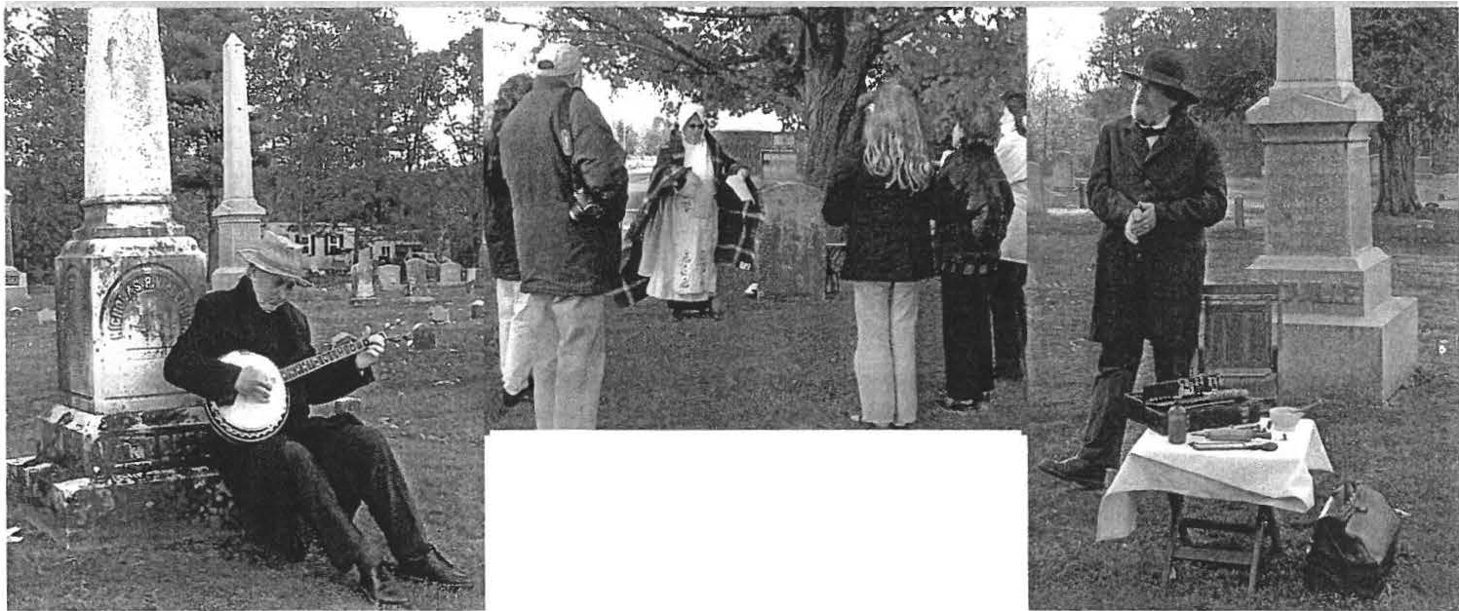

Spirits from our annual Cemetery Stroll held in Sackett Cemetery in Ashley F alls on a very blustery day!

Above: Jean Emberlin as Sarah Esther Austin Pease
Norman Hetting er as Nichola s Van Deusen Dennis Picard as Dr. John Scoville

SPECIAL THANKS TO:

A-1 Security for fully underwrit­ in g the cost , both the equipment and the installation fees, of new fire and securit y systems in the Mark Dewey Resea rch Ce nter and the Dan Raymond House.

To Wray Gunn and Pfizer for underwriting the cost of purchas­ ing 25 copies of the new book Af­ rican American Herita ge: In the Upper Housatoni c Valley. The
items were sold at full value in the
UPCOMING EVENTS

Monthly Meetings are held on the second Friday of every month, September through June, at Dewey Memorial Hall. They begin at 7:30 pm.

Eac h monthly program focuses on a different speake r and theme.
Check your local ne wspapers and the Society's website at
S l! E FF I E L D H IS T O RY. O RG for
the most u p - to - d a t e l i s t - 111g s .
This collaborative program pre­ sented by the Society and the Bushnell-Sage Library will take place on T uesday, February 6, 2007, at the Library. (A ha lf-da y schoo l pr(lgram, sta rting at 12:30 pm.)

Young ste rs will be set on the trail of a mystery involv in g so me as­ pect of a local child ' s life. Th ey may be searchin g for when or where a child lived, or where that child went to school. Along the
s le uths' journey, they will be given clues to unravel the mys­

Stone Store, there by raisi ng funds
for SHS, and all but one co py has
tery. The clues will come in the
form of historic photographs,

been sold to date.

The Massachusetts Cultural Council award for the Sheffield Historical Society for 2006-2007 has been increased by $500, to
$2,500 for this year. The ex tra funds will a llow the SHS Director to attend all three days of the New Eng la nd Museum Associa tio n' s Annua l Con ference in mid­ November in Co nnectic ut.
NEW CHlILDREN'S EVENT:

"IDSTORY MYSTERY"
maps , and artifacts to view. A spe­ cial historic spirit or two will be on hand to provide persona l infor­ mation about the children. By an­ swering a series of riddles, the young sle uths will learn where the next clue is to be found.

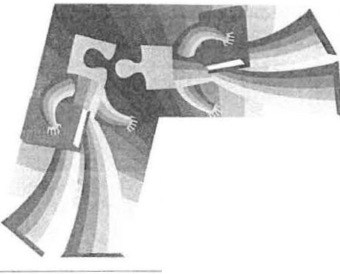The event will be intriguing and fun, and based on research from the archives of the Sheffield His­ torical Society. To register, call th e Library at 229-7004.

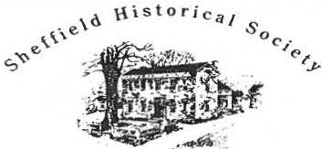
0•" R• 1• • • 4 Ho • • r U11t1t1•
ltl• rlt O,r• 11 ll t t • • , r• c. ,.,,,

159 Main Street
PO Box 747
She ffield, MA O1257

Phone: 413-229-269 4
Email: shs@sheffieldhistory.org

The 1774Dan Raymond House hours: by appointment during the winter months.

Mark Dewey Research Centeropen Monday and Friday aflemoons, I:30 to 4 p.m., and by appointment. Email: mdrc@s heffieldhisto ry.org

Old Stone Store hour s are Sa turda y, IO a .m. to
3 p.m. and Sunday, 11 a. m. to 3 p.m. Closed January through March.

WE'RE ON THE WEB
SHE F F I EL D HI ST O RY. O RG

I
Board of Directors 2006-2007
The Freedom of Baseball

Marcia Brolli President
Gillian Hettinger, Vice-President
H. Dennis Sears, Treasurer Harry E. Conklin, Clerk Trustees:
Philip Detjens Leonard Graziano Brian Levinsohn
Freedom ca n be found in a wide array of circumstances and
time s. Do you realize how lib­ erating sports have been for men and women? In particu lar , baseball has proven a stepping­ stone for thousands of people since its development in the mid-1800s. Have you heard about the African American base ball teams the Albany Bachelors or the Sheffield Feathertales?
surpri ses, begins at the Library at 1 p.m. Bring your whole family, dress appropriately if you like, and bring along your favorite baseball memorabilia to share with others.
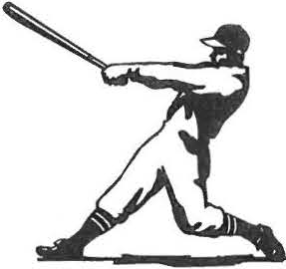
The program is free and open to the public.

Sarah Macy
Mark Ziobro
L
Joanne Hurlbut, Director
On January 15-the Martin Lu­ ther King, Jr. Holiday- the
Bushnell-Sage Library and the Sheffield Historical Society in­ vite you to join us as we explore
] "The Freedom of Baseball."
- This Family Program, full of

On view in the Stone Store: T he Festival of T rees-

History Mystery­
Tuesday, February 6, 2007 A half-day school program

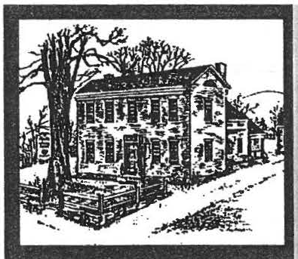
Sheffteld Historical Society Spring 2007 Newsletter

The Freedom of Baseball
Close to fifty people attended this year' s Martin Luther King, Jr. Day collaborative program, an annual event presented by the
··Society and the Bushnell Sage Library. For those who missed it, it was a great program and one filled with local reminiscences of the game, including how race played a factor even in our na­ tional pastime. One of the many stories heard that day was the following account written by Wray Gunn, who could not be at the event. It is such a poignant story that it bears retelling.
WHAT IF ?????
Life works in mysterious
ways. Have you stopped and wondered to yourself, "What If I had done this instead of that?" I have on many occa­ sions . The one that really
sticks in my mind is related in the following story.
In the late summer of 1948, my two brothers and I were very much interested in at­ tending a baseball tryout training camp. This was my senior year of high school at Williams High School in Stock­ bridge, Mass., and my two brothers , David and Saint Clair, had already graduated from school-David from Lee
High in 1944 and St. Clair from Williams in 1946. As I look back, David and Saint (as we called him) were very good athletes and I was al­ ways the baby playing in their shadows. They were both very aggressive and did not give in to opponents, no
matter who or what the situa­ tion was. This was not my style.
In June of that year, David found out that the Saint Louis Browns major league team was to hold a tryout in Port Henry, New York, the week­ end of Aug. 3rd through the 6th. We were excited and de­ cided we would go to the try­ outs. There were some prob­ lems with making this deci­ sion, such as how much money would we need, where would we stay, and how would we get there, all minor problems. We did not have much money and we didn't
know anyone in that area, but we did have Saint's old Buick convertible. So let's do it, we decided!
Of course Ma and Dad thought we were out of our minds, but they realized what it meant to David and Saint. I was just going along for the ride. We had enough money for gas (around .25tt per gal.) and we had about $40.00 among the three of us. For
some unknown reason, I had the most money. I was working as an apprentice at GE in Pittsfield as a spot welder. This was a job where I welded the glass bush­ ings onto the capacity tanks. I was paid by the piece and I did very well.
We got our equipment together, gloves, bats, and mismatched uniforms and off we went. Ma was thoughtful enough to pack us a very nice basket of food to munch on during o ff-hours .
We arrived at Port Henry on the same day that the camp be- gan. Since we had not pre­ registered, we parked our red bomber and did the necessary things to sign up. Thank good­ ness that we did not have to pay a fee.
We were the only Blacks present at this camp. With this in mind, we were now determined to stay on our toes and do the absolute best that we could.
The tryouts were carried out in a precise manner . Players lined up in the positions that they were interested in and
the instructors would then give you a steady workout at that position by hitting balls to you for about 5 to 10 min­ utes steadily. I was an in­ fielder and tried out
for second base and short­ stop. David was an outfielder,

Sheffield Historical Society Spring2007 Newsletter Page 2

and Saint was all-around , being a catcher, pitcher, in­ fielder, and outfielder.
On that first day, it was hot and dr y. It had not rained in weeks. The field was hardand powder y. The balls really came at
you. First to your left, then to your right, over your head and short ones. You did not know where the in­ structor would hit them next. David hurt his arm on the first day and he had to curtail his activities for the rest of our stay. Saint was the clown and was do­ ing everything well. I thought that he excelled in just throwing the ball, with the strongest arm of the three of us. David was the longest hitter, but Saint and I were able to get on base more and were very good at stealing bases.
The first day went well and we mixed in well with the other candidates, though we spent the night in the car with the top up. By now, the big lunch that Ma had put up for us was gone and we had to figure out how to survive through ti/ Sunday night. Sunday night was the big game in which the most promising players would play. We were happy to learn that Saint and I had survived the first cut of the first
da y. On the second day, since Saint and I were now
one of the selected few, food was brought in to the re­ maining candidates. What a relief for all three of us.
Saturda y, the second day, was the final cutting
da y. Saint dropped catching and pitching and stayed with the infield and the out­ field. I stayed with the in­
field. They worked you from fi een to twenty min­ utes at a stretch. This was easy for me but tough on Saint, going from the fnfield to the out fie ld. He did well in the infield but faltered in
the outfield with many of his
throws.
I was determined to stay on my game and try not to overdo. I ran in, out, back, to my left, to my right, and dove for short balls, catch­ ing them before they hit the ground and then whipping them over to the correct
base. This routine was car­ ried out over and over, cov­ ering a span of about three hours for our infield group.
But in the early a ernoon, just before the end of the sessions came, I began to feel dizzy and nauseous. I saw double; then passed out from dehydration. I woke up in the locker room in a cold sweat with blankets on me to keep me from shiver ­ ing so much. I felt terrible and dejected for I just knew then that I would be cut from the Sunday line-u p,
which would be posted in the
m orning . My brother Saint and I both had a sleepless night waiting for the morn­ ing.
Sunday was again a beau­ tiful da y---hot , humid, and cloudless . We heard that the lineups had been posted. Saint and I had a feeling of dread. Would we, the Black kids, be selected to play that night? We
were not going to give up
ho pe. Let's go see. And we did.
As we approached the bul­ letin board, there were all of the candidates milling around trying to look at the board. Some were elated and some were de-
jected. How would we be? We got to the board and searched to see which
list had our names. At first we did not see them, but fi­ nally we found both of our names listed to start the game that night.
WOW! CAN YOU IMAGINE THAT. BOTH OF US FROM THAT SMALL TOWN OF STOCKBRIDGE MADE IT.
We were excited and
elated . We had made it and showed our talent. We had survived the torturous workouts and held our own against a group of talented young baseball players. We felt good.
Practice that day was dif­ ferent as we prepared for the game that night. We

no w.changed to more hit­ ting and practice at the po­ sition you would be playing

played the game under lights. It went well. Saint had one assist and one put­

NEW SERVICE FOR MEMBERS
Page3

that night. I was put in at second base and Saint was in at shortsto p. It was a night gam e. We had never played at night before so we were a bit skeptical about how we would fare .
Game time arrived. Uni ­ forms were issued along with new caps. Boy, we were now set.
Just before game time, I was called aside by the chief talent scout. I had no idea what he wanted. So we went into his of-
fice. There, he had me sit
down and told me that he had an offer to make to me. WOW. To me???? I was speechless. What was the offer? He offered me a contract to play on a Class "D" team in the St. Louis Browns organization. I was flabbergasted . I called my mother and told her, and she and Dad were also ex­ cited. But she also said, "I would rather you 90 to Col­ lege and get a degree and
then think about this." So it was my choice to make a decision.
What should I do? I told David and Saint. I was sur­ prised that Saint had not been extended an offer, as was he. What should I tell him? Saint said, "Let's play the game and then you can give him an answer." We
out . I had two assists but missed a towering fly ball in the short outfield in the lights. Saint had a single that he stretched into a double and I had a single and a stolen base. We both played well against excel­ lent talent.
After the game, I went over the proposal in my head. I thought about the ordeal that Jackie Robinson had just gone through and I thought about being on a Class "D" team. Then my mother's words came back to me. Which was more im­ portant, playing baseball or getting an education? I chose to get the education and my thoughts of being a great baseball player were put on hold, but another chance never came.
And now, almost sixty years later, I 90 to major league ballgames and won­ der ----WHAT IF. I look at the stats of major league players and wonder---­ WHAT IF. ---W HAT IF.-----

WANTED: half-pint and pint mason or ball jars in good condi­ tion. These are to be used by the Society for various preserves, jams, jellies, pic kles, pepper jelly, etc. to be sold at the Stone Store. Please call 229-8668 (Catherine) or 229-0375 (Lois) for more in­ formation or pickup.
AND FRIENDS AT THE MARK DEWEY RE­ SEARCH CENTER

Advanced genealogy research is now available online through the Mark Dewey Research Center.

The MDRC, the library arm of the Society, has subscribed to exten­ sive nationwide databases that are specifically designed for geneal­ ogy. Free to members and friends, trained volunteers are available to assist you in your work.

Conveniently, the timing of this new service parallels the installa­ tion of DSL (fast internet service) that is presently underway cour­ tesy of Society member, treasurer, and volunteer, Dennis Sears.

The Center is open both Friday and Monday from 1:30 to 4:00 and is staffed by volunteers Betty Chapin, David Prouty, and Jim Miller. Since we have only one terminal, an appointment is sug­ gested by calling Jim at 229-8668 or by e-mail at MDRC@Sheffieldhistory.org.
Appointments made by e-mail
will be confirmed. If you come, bring with you as much family history documentation as possible, most importantly names, dates and places of birth, marriage, and death.

Sheffie! Historical Society Spring200T Newsletter Page 4

THANKS to all those who have given to the 2006 Annual Appeal over the last year.

John and Emily Alexander Karin and Allen Altman Doreen and Walter Atwood Mary King Austin
Mark E. Bachetti Betty and Fred .Bangs Ann-Elizabeth Barnes Ann Barrett
Trumbull Barrett
Anne Barstow and Tom Driver in memory of Ellie Gilligan Beth Bartholomew
Arthur J. and Betty Batacclii Paul Benjou and
P.J. Bradley
Blanche and Bill Bennett Berkshire Choral Festival Robin Berthet Construction Jean W. Blackmur in memory of Roger and Virginia Drury Lois E. Bradford in memory of William Bradford
James Brandi
Lois and Lawrence J. Brandt Marcia Brolli in memory of
Ed Brolli Joan Brooks
Grace Wallace Brow11 Bil/Browne
Thomas and A11n F. Buckley Morga11 G. Bulkeley IV Barbara a11d Patrick Burns Dorothy L. Caul in memory of George H. Caul
Neal B. Chamberlain Mildred a11d Lo Yi Chan Elizabeth M. Chapin
Neal and Kathy Chrisman Cathryn Clary and
Ed Schweizer
Walter and Ursula Cliff
Noel L and Baukje P. Cohen Mr. and Mrs. Paul Collins Abbott C Combes
Sue Connell
Mr. and Mrs. William Con11ell Anthony and Marjorie Consolini
Sally Cook
Holly Coon Co11nie Cooper
Norma Edsall and Alice Corbi11 Dorothy Crockett, i11 memory of
Howard Crockett Eleanore J. Curtiss Mrs. Jea11 E. Curtiss Fra11cis J. Dallett A11tho11y J. Dapolito
Dwigl,t and Na11cy Dellert Barbara E. Delmolino Susan and Philip Detje11s
William a11d Dorothy DeVoti ill honor of Milto11 Barnum Elaine A. Dibrita
Kerry alld A11ne Douglas
Johll R. alld Audrey B. Dow11ie
L. Robert Duffy
Margit and Brallch Elam Bart a11d Janet Eisbach Peter a11d Patricia Eisbach Nancy B. Emery
Susall Fischer lllez Flin11
Bruce a11d Marcia Fowle Warner Friedman Pattison Fulton
N.H. Fu11k a11d A.M. Funk Phil alld Betsy Garcia
Frank a11d Helen Bray Garretso11 Rene Gibsoll
Ruth Gillette
John and Elsie Gilligan William A. and Maryanne G. Gillooly
Frederic Gordo11 Joy W. Gottlieb
Leonard Graziano and William Grief
Am, l. Green
Paul and Martha Greene Richard Greene
Edmu11d A. Grossmall
Lovi11a E. Gulotta,in memory of Sallti J. Gulotta
Wray Gun11 alld Cora Portnoff Nancy Wilde Halm
Mrs. Jean J. Haines Joan and John Hanlon Julie Ha11num
Claire K. Height
Gillian and Norman Hettinger Tim Hewins
James R. and Donna W. Hurley Virginia M. Jackson-Howden Mary and Charles H. Joch, Jr. Phyllis and Melissa Joyce
Richard W. and Athena Kimball Kevin and Cathleen Kinne Beverly Kradel
Na11cy Kriegel
Thaddeus B. and Marie G. Kubis Allison G. Lassoe
Marc Lavietes
Dr. and Mrs. George M. Lazarus Susan and Philip Lebowitz Robert and Ruth Ledlie
Lou and Pat Levine Brian and Lois Levinsohn Ann-Marie Light
Wendy T. Linscott and James M. Lamme Ill
Connie Logan
Bob and Sue Macveety
M r. and Mrs. Antonio J. Malnati Barbara and Norman Margolis Dorothy Marosy
Barbara Martin Dawn Massini
Jack and Linda McKelvey Charles McNamara Catherine McNeil and
Mylan Jaixen Robert D. Mercurio
James R. and Catherine B. Miller John-Arthur and Trudy Miller Margaret Mitchell
Donald S. Mott
Daniel and Anne Moulton Norma Moulton
Patrice Mullin
C. Twiggs Myers in memory of Art Chase
Leslie A. Naughton and Jeffrey W. Rubin
Katherine Ness and John James Tessie and Joseph Newmark Rich and Laraine Novak
Mary Ellen O'Brien .
Elizabeth O'Connor
Kathy Orlando in memory of Virginia Drury
Thomas Orlando Ormsbee Gas
Rena Orner in memory of Bill and Ellen Murtagh John and Charlotte Owens Judith Papachristou
Gary Penfield and Ginny Pere/son
Wesley Petersen Fred Pomerantz
David and Marsha Pottle
Joan and Ken Powers in memory

Pages

of Freddie Martin Lucy Prashker
Carlson Propane in memory of Theresa Brazie
Nancy and Bob Rathbun in memory of Laura Percy Joe and Carol Reich
Ann M. Riou
Muriel Rokos
Susan Rothschild and Don Freedman
Kate and George W. Rowe Peter and Ellen Rowntree
Amy Rudnick and Ben Hillman Mary and Bob Safian
Marcia Savage Michael J. Saxton
Bea/a and Stephen J. Schiffman Joanne Schmidlin in memory of Johnl Day
Charles and Elizabeth Schmidt Bernie and Shellie Schneider Judy and Bill Schnurr Kenneth and Rebecca Schopp
Charles and Pauline Schumann Judith and Gary Schumer
Eileen Vining Ha11k Vollmer Ill
David and Barbara West Elsie West
F. Robert Wheeler, Jr. Marion Whitman
Marilyn a11d Jo!,11 Wiglltman Wilkillson Excavating Martha Williamso11
Thomas A. Wilson
Thomas H. and Susan B. Young Richard Zimmerman and
Elissa Williams
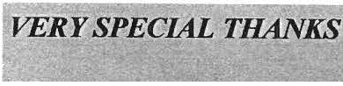Dorothea Zucker-Franklin,M.D.

Many thanks to Kimball Oil and their suppliers for the donation of

a new furnace for the Dan Ray­ mon(} House. When you visit, see the plaque on the cellar door.
" travel" by train, horse and buggy, and antique auto into the past to see many incredible sights! Included will be rarely-seen old-time views of Sheffield and the surrounding area. The event will be held on Friday, April 13. The program begins at 7:30 p.m. at Dewey Me­ morial Hall, which is located on Route 7, in the center of Sheffield. The program is free and open to the public. Refreshments will be served.

Gary Leveille is a local historian and author. His most recent book is the best-selling photo history enti­ tled Old Route 7- Along the Berk­ shire Highway. His previous book is entitled Around Great Barrington and Stockbridge. Leveille is also a
columnist for The Berkshire

Joseph Schwartzman in memory of Beverly Schwartzman
Andrea Scott and Rob Jenter
Record, where he produces the popular "Berkshire Then & Now"

Dennis Sears and Rene Wood Gillian Shallcross
Robert and Ann Shanks Myron and Marion Sheinberg Barbara and Jim Shiminski Susan Silver
Evelyn Small in memory of Jim Small
Betsy Smith in memory of Mildred R. Smith
David A. Smith, Sr. George T. Smith Nik and Sig Spiegel Janet G. Stanton Dr. Walton Steve11s
John and Appy Stookey Noreene Storrie a11d Wesley McCain
Wanda M. Styka Kathy and Tom Tetro
Robert and Rebecca Thomas
UPCOMING EVENTS
March Meeting

William Suriner, talking about his recent publication describing the farm experience in Dalton in the 1940s. Friday, March 9, 7:30 p.m. Dewey Memorial Hall.

April meeting

Much has changed in the Sheffield area over the past 125 years. Join local historian Gary Leveille and the members of the Sheffield His- torical Society as we take a trip
photo history column.

Leveille is vice-president of the Great Barrington Historical Society, principal of Berkshire Creative Communications, and has over 25 years experience as a writer, editor and author. Leveille was formerly a senior editor and editorial project supervisor for Hasbro Games in Springfield, MA. He has worked
on numerous editorial projects for Milton Bradley, Hasbro, Parker Brothers, Disney, National Geo­ graphic, Antiques Roadshow, and many others.

Ronald and Judith Timm
Peter and Doris Traub Albert Trocchi in memory of Edith Trocchi
Lois Van Cleef
Merle and Karen Varney Edith and Loet Ve/mans
back in time to see how things used BE ON THE LOOKOUT in the lo- to be. With the help of rare old cal media for details on additional photographs and a?tique post- . special spring 2007 events, as well ard-s conv rted mto_an ente rn- asinformation on the May and
U1g PowerpoU1t presentation entitled June meetings. Sheffield Then and Now - we will

Sheffield Historical Society Spring2007 Newsletter Page 6

Dear Members and Friends of SHS,
Programs: Joyce Hawkins

The previously-planned Long-
brought in over $17,000 for the workings of the Society­ maintaining the buildings and

It is with regret that the Board of Range Planning meeting of Febru- Trustees accepted the resigna- ary 17, held at the Landmark build- tion of Dr. Joanne Hurlbut, our ing and facilitated by Lynne Te­ Director, effective February 24. relle, Director of Development at Her leadership during her 8-year Recording for the Blind & Dys­ tenure has seen the Society be- lexic, took on additional importance come reputedly the best in the with Joanne's leaving. The 17 par- county. Because of her efforts ticipants included most of the pre- we have studies of our property sent board, many of the past presi- and its buildings, much of the dents, 2 at-large SHS members, and collection is properly stored in Joanne Hurlbut. Its goal to look at acid-free boxes, our school and our future resulted in a revised Mis- cemetery programs continued, sion Statement which did not
and new programs were devel- change the mission of the organiza­ oped with the library; two most tion; a plan to study the programs recent were the baseball-theme by an ad hoc committee consisting program on Martin Luther King of Kathie Ness, Joyce Hawkins, Day and a History Mystery pro- Brian Levinsohn, and Jim and Cath­ gram for students on February 6. erine Miller; and a determination to Last summer's professional preserve the buildings, which is al­ symposiurn, "If They Close the ready under way, including an envi­
grounds, salaries, and programs. By the time you receive this news­ letter, the request for 2007-08 will have been mailed.

Cathy and Tom Tetro are working hard to create an outstanding ex­ hibit of their private collection of antique wicker. Plans are coalesc­ ing for other events to accompany their exhibit in July.

As we go into the future with re­ newed energy, we count on your continued support and good will.
See you in Sheffield, Marcia Brolli
Join us for our spring and summer programs and events!

Door on You, Go in the Win- ronmental upgrade. A major dis­

dow ," crowned her work with us cussion resulted in the renewal of by bringing in two excellent lee- our wish to be a volunteer organiza- turers and a panel of local citi- tion with strong professional sup- zens, including our presiden t, port.
Wray Gunn.
Looking back at 2006, the Festival Temporary plans for running the of Trees and Stone Store sales in
o rganization include the separa- November and December were tion of Joanne's work among the most successful. The net proceeds board member s and volunteers for the 8 weekends were over while the Board of Trustees con- $7,000. Many thanks to all who siders job descriptions for staff- contributed trees and wreaths and ing. The following people have centerpieces, to those who worked accepted interim res ponsibili- the weekends of the event, and to ties: our customers. Special thanks to
Exhibits: Jim Miller Jim and Catherine Miller, Lois Grants: Philip Detjens Levinsohn, Rene Wood and Dennis Newsletter: Lois Levin- Sears, Doreen Atwood, and Doro-
sohn and Catherine Miller thy Marosy.
Annual Appeal: Wray
Gunn and Dennis Sears The 2007 Annual Appeal / Mem-
Collections: C hris Kelley bership Drive will take place in and Jim Miller March. The 2006 Annual appeal
Volunteers Needed!
In addition to the many hardwork­ ing volunteers already lis ted, the Society needs extra hands to help out at its many events. A focus of activity for this year will be the ex­ hibitions in the Old Stone Store.
While it is true that many volun­ teers from 1.ast year will again be behind the desk at the Store, not every one will return this year. [n the past, the Director did fill in on those days when a volunteer could not be found to sit at the Store.
Since that will not be an option for this year, it is even more important that new volunteers step up to greet visitors, talk about the exhibits, and share all the activities the SHS en­ gages in; please call and sign up for some summer fun at the Old Stone Store.

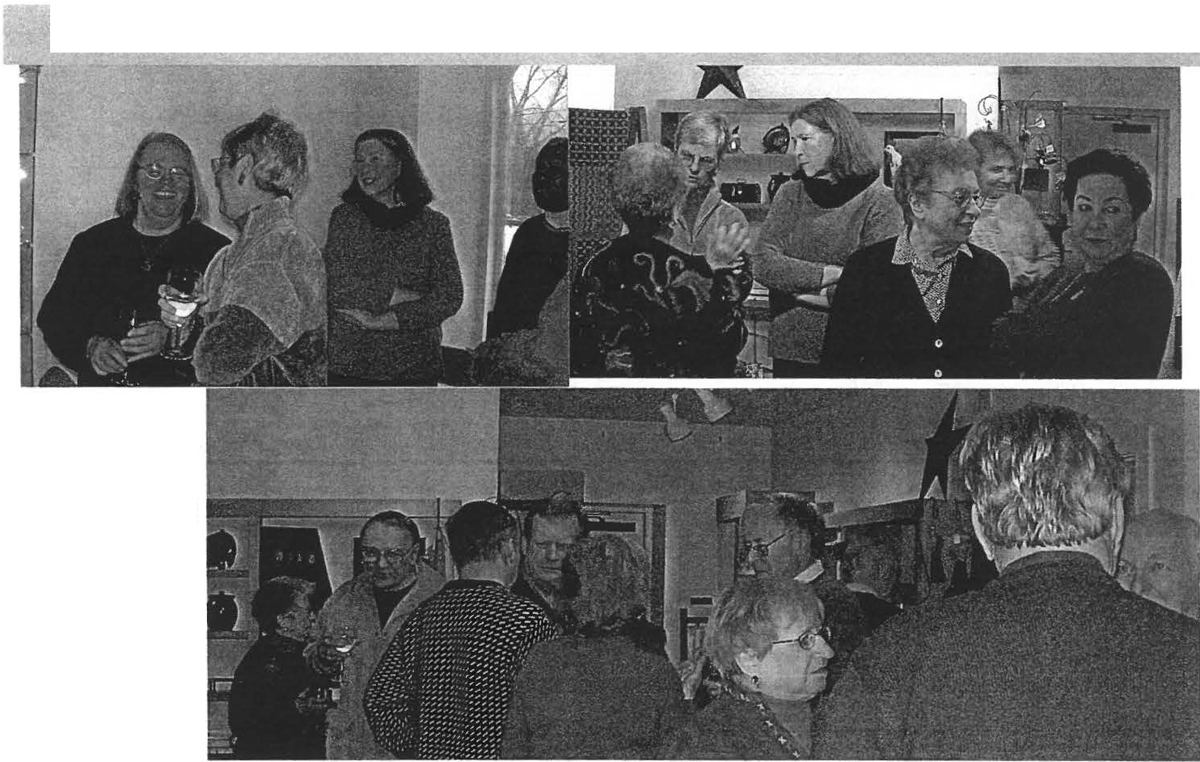
SheffieldHistorical Society Spring2007 Newsletter Page 7
DIRECTOR'S FAREWELL
The farewell party for Director Hurlbut was held on Friday, February I6, at the Old Stone Store. Over fifty people turned out to say goodbye. Foodstuffs were plentiful. talk was lively, and a good time was had by all.

For almost 8 full years, I have tett North Adams m the morning and headed south to Sheffield.
It has i.-,ce n a drive that is both br-.:,..itiful and one which has
' ,rought me to a place where the people are friendly, helpful, and kind. Besides the community, this area is rich in history, which in tum made for interesting sto­ ries to uncover and share with people. I have truly enjoyed sharing those tales, but it is time for me to move on.

I have been holding down three part-time jobs now for many months and all three are de­ manding jobs. I have given up my long commute to Sheffield (almost 3 hours a day) for the other two jobs, which are only 5 and lO minutes from my home.
I will now serve full-time as the Education Access Coordinator for the Northern Berkshire Community Television Corporation. I used the equipment from this organization to
film the fall Symposium If They Close the Door on You, Go in the Window. I will be thinking of Shef­ field as I edit that material in the upcoming weeks. Keep an eye out
for the listings of when that produc­ tion will air on CTSB.

My other job is as an Adjunct Fac­ ulty for Berkshire Community Col­ lege. If you need to learn your American or Western Civilization history , check out the Northern Campus for BCC in North Adams.

I cannot begin to list all the wonder­ ful memories that I will take with me from my years at SHS. The op­ portunity to research so many var-
ied aspects of the local story- from the characters developed in the cemetery programs, to the informa­ tion behind the exhibits, including the artifacts and especially the pho­ tographs of the MDRC collection, to the thematic programs, such as our Native American Heritage
Day- made learning about Sheffield and its people a real pleasure.

But it has truly been the people of Sheffield and surrounding commu­ nities that I have enjoyed working with the most. I will certainly miss that aspect of my job. THANK YOU so much to all who have as­ sisted me over the years!! I could­ never list everyone or say thanks enough. Finally- THANK YOU for my wonderful party!! I will keep my eye on Sheffield and be in touch.

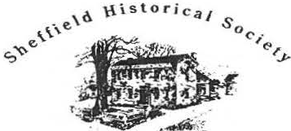
D•• Jt•1•••4 H•••• M•••••
""·'," o . ,, ••,,.,•• c•• ,,,.

159 Main Street
PO Box 747
Sheffield. MA 012 7

Phone: 413-229-2694
Email: shs@.sheffieldhistorv.org

The 1774 Dan Raymond House hours: by appointment durin the winter months.

Mark Dewey Research Center open Monday and Friday afternoons, I:30 to 4 p.m ., and by appointment. Email: mdrcla).sheffieldhistorv.ore.

O ld S to ne Store hours are Saturday, 10 a.m. to
3 p.m. and Sunday, 11 a.m. to 3 p.m. Closed January thro April.

WE'RE ON THE WEB
SH E FF IE LD H! ST n RY O RG

Exhibitions at the Old Stone Store
Beginning in May 2007, the Old cords from the Society and cornmu- Stone Store will open its doors nity items.
Board of Directors 2007
't
:t'
to a full slate of exhibitions.
Here' s a quick preview. Stop in Opening on Friday, June, 15 will be as often as you like; Shop Man- the return engagement of the Five agers Dorothy Marosy and Do- Artists. This exhibition runs
Marcia Brolli President
Gillian Hettinger, Vice-President
H. Dennis Sears, Treasurer Harry E. Conklin, Clerk Trustees:
Philip Detjens Leonard Graziano Brian Levinsohn Sarah Macy
Mark Ziobro
reen Atwood will have plenty of through July l. new materials on hand from

their recent travels to a special American craftsman show in Portland, Maine. So, enjoy the exhibits and take home a little something extra to share with family and friends.

First up will be a collaborative project focusing on the envi­ ronment, in particular on trees. The MDRC will work with Tom Ingersoll and the lo-
I 1 cal sc hoo l community. The ex­
- h.ibit will use photographic re-
Saturday, July 7, will see the open­ ing of Wicker Furniture by Tom and Kathy Tetro. They have vol­ untee red their time and materials to create this fascinating show.

Opening August 18 through Sep­ tember 2 will be the Artist Lori Baker.

The final exhibition will be curated by James R. Miller and focus on lighting devices; this opens Sep­ tember 8.

.Y£e
S%etfoU

..7li:fttJrtCal:/4ae�
Summer 2007 - -..�·
-'+�-�.•--��.'.�..·.-.:-.-
- . . �-<..,.
Early Sheffield Lottery Ticket Resurfaces
The history of lotteries in America goes back to the

dgwick-17�6-1?99.
�"""""-�..,.�g -,.u,i;.,..-:vv;-��\.-..M.\ ,,,., r,.. ·I
ShcjfieldBrid 1,1._,::._ ·'···"··
� T H_I J-S Ticktt ih:ill cntitl� t�c Bcartr to\ , i?,'· �--,'--?
eLqttery. No.2-<Ld'J'
®-� fucIh Prize as may be.L�!�w_ �1niftts7""Number.,F...,,.-.,.f. -�..,.fi,..·"�"·,,,,.-f
!� Subjetl: to no DcduB:'7�
,,;L_ t'•:7..� ·
�- J/l'i<'d"1"J/YWW"ll't�<J �--.,�
This document is a facsimile of a late 18th century Sheffield Bridge Lottery ticket signed by Sheffield's own Theodore Sedgwick. The original recently came up for
auction on e-Bay; unfortunately, the Society was out-bid.

An item offered for sale on e-Bay illuminated a heretofore unknown aspect of Sheffield's internal improvement pro­ gram during its early years. The construction of bridges and roads, a persistent, heavy drain on town finances, was reme­ died, in part, through a bridge lottery in the late 18th cen­ tury. Its purpose was to raise money for their construction and maintenance.
Virginia Company in 1612 when one was held to provide funds for colonization of that future state. They continued to be popular in the 1700's with legislatures authorizing lot­ teries for every type of public improvement from building churches and colleges to the construction of roads and bridges.
The e-Bay item, a ticket for SHEFFIELD BRIDGE LOT­ TERY No. 228 8, (shown here) was signed by Sheffield's Theodore Sedgwick, a member of the Confederation Congress, U.S. Senate, Speaker of the House of Representatives, and later Chief Justice of the Massachusetts Supreme Court.
While the Society bid on the ticket, it dropped out of the bidding at $200. The same item for a Connecticut bridge lottery the same day went for $375. We will have co be sat· isfied with a color copy printed from e-Bay, perfectly fine for research but not so great for exhibit.

-James Miller, MDRC

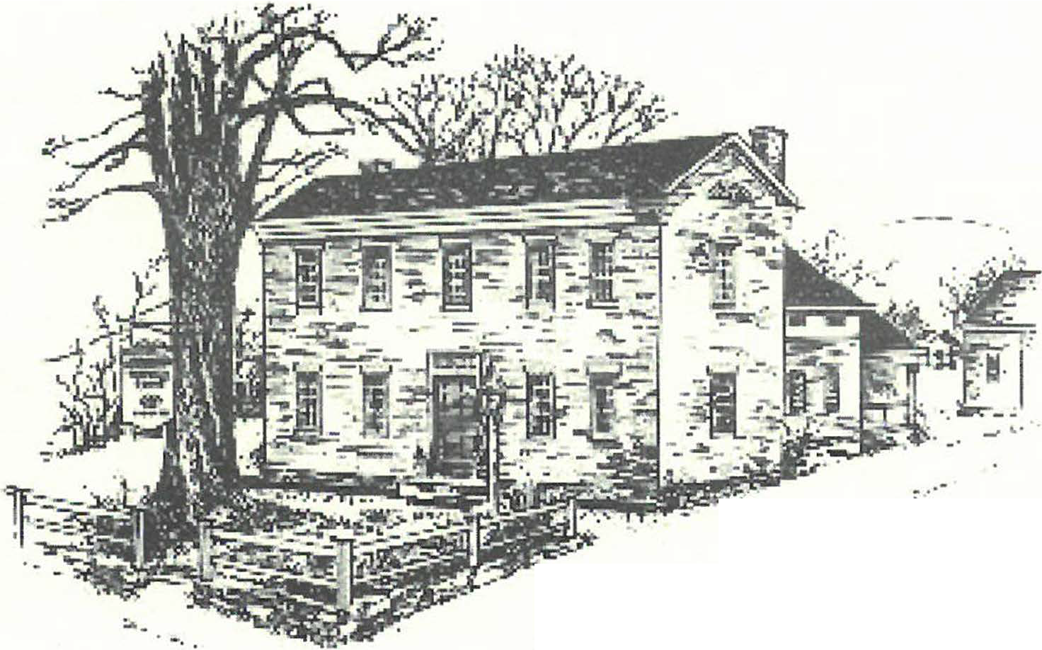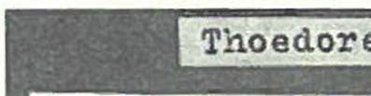Thank you. We thank our friends for gifts both great and small.
- To those who have given to the Annual Appeal I Membership Drive-much appreciation for the work
you enable us to do-both in enhancing the physical plant, supporting our research with new equipment in the office and the research center, and encouraging us to continue. The List will be published in the fall.
- To Rob Robins, Madeleine and Clem, who gave generously from the barn this past spring. Among the items donated were a hand-drawn map offarm Land of Henry and William Boardman, 1849, a missionary membership certificate for M. Elizabeth Sage, 1889, a hay cradle, wooden scythe, and a hay hook with mechanism.
- To Steve Phillipsfor painting the front windows ofthe Stone Store as a gift.
- To Gretta Willig ofGretta's Marketfor donating the coffeefor the opening exhibit at the Stone Store this spring.

Dear Members and Friends of SHS,

So many good things are happening: a new adminis­ trator in the office, fresh paint to come on all the buildings, increased donations to the Annual Appeal/Membership drive, an opening up of the Society grounds to the new parking area for Sheffield center, and great exhibits in the Stone Store.

Our fresh face is Jodnna Jennings, a photographer and graphic artist as well as an historic house expert. We are sharing her with the Bidwell House where she has been a docent, freshened up their newsletter and designed their other print work, created exhibits, planned school programs, and done work with their collections.

She met several of our members at the annual meet­ ing, but please stop by at the Dan Raymond House Tuesday, Wednesday, or Thursday and introduce yourselves. You might enjoy the new tour of the Dan Raymond House and Carriage Barn.

The painting of the Mark Dewey Research Center and Stone Store has been wonderfully done by Steve Phillips, our painting contractor. He will do the Dan Raymond House next, and then the other build­ ings. We are facing major work on the foundation of the Carriage Barn, but the Board agreed to go ahead with the painting.

The exhibit season, under the guidance ofJim Miller, had a terrific start with Tom Ingersoll and the Sheffield Tree Project and Chris Covey and Mt. Everett giving an overview of Sheffield Trees: Pase, Present, and Future. It continues with the Five Friends art exhibit. The highlight of the summer is the 2-floor display of antique wicker by Kathy and Tom Tetro of Corner House Antiques, who are pre­ senting their personal collection of unusual and remarkable antique wicker furniture from July 7 - August 12.

And of course, we will again hold our Summer Feast­ the roast beef, pork, and turkey dinner (formerly the Pigge Roast) and craft fair on August 25.

See you in Sheffield, Marcia Brolli
Please remember to join us for our summer programs and events!
Sheffield H isto rical Society 2
...76inual!7ltjtt1r&
The Mark Dewey Research Center

The Mark Dewey Research Center (MDRC) of the Sociery is a depos­ itory on the history of the cri-state area with primary focus on Sheffield. Its volunteers, Betty Chapin, Jim Miller and David Proury, research and answer inquiries received by e-mail at mdrc@sheffieldhis­ tory.org, telephone at 229-3682, snail mail at Box 747, Sheffield, and drop-ins during regular hours, 1:30 to 4:00 Friday and Monday. (If a volunteer is available, special appointments can also be made.)

Another important function of the Center is collecting material on the town's history. The principal source for this project is through the inquiries that are fielded by the volunteers. As part of the regular oper­ ating procedure, a request is made for a copy of the client's final work. This i what makes our collection absolutely unique since no ocher institution contains so many of these rich depositories of local Sheffield history and genealogy.

The most significant forward movement chis year came through the financial generosiry of an anonymous donor chat allowed the MDRC to subscribe to on-line data bases, digitized books and manuscripts, adding significancly to its research capabilities. One is Ancestry.com of RoocsWeb which offers vast resources of public and private records nationwide. Secondly, with primary emphasis on New England and the middle states, the Center also subscribes on-line to the holdings of Godfrey Memorial Library in Middletown, CT.

The volunteers can assist you in your research if you wish, or you made do your own on site. All of the Center's services are free except for a modest charge for copies.

Jim Miller, Archivist

Treasurer's Comments

In the Treasurer's opinion, the finances of the Sociery are sound and improved as we approach the end of the Fiscal Year. We can measure our success through several metrics:
- Our gross income, (excludes withdrawal from our endowment), will be up around 34%. This primarily due to our every ocher year Silent Auction/Tag Sale.
- Our endowment withdrawal will be well under our 4% limit.
- Our portfolio has grown around 13% net after withdrawal.
- Our annual appeal is running up about 10% over last year.
- We've spent around $10,000 on building maintenance, primarily in
A nnual Reports Continued on Page 5

Sheffield Histo ric al Society 3·

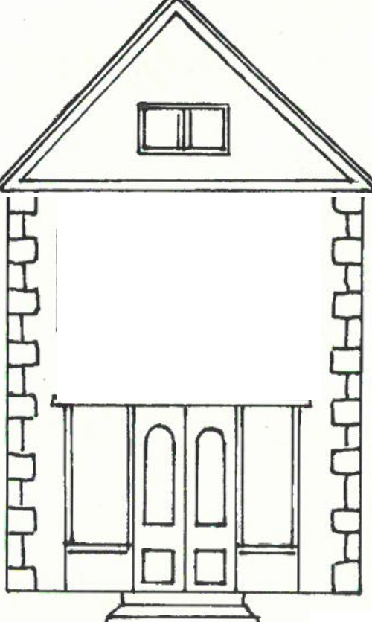CZftctJmUlcf 2007 61/entf

mmm
ff 6.dt#llliJn Ydedui

at t£e O!tf3i1Jne 3i1Jre

July 7-August 12. American Antique Wicker.
Kathy and Tom Tetro of Corner House Antiques are exhibiting on both floors of the Stone Store. The wicker exhibit will feature their private collection including some unique items from the turn
of the last century, 1890-1920.

July 21, 11 am. John Wall, an authority on Wakefield wicker, will present an overview of the life of Cyrus Wakefield, noted founder of American wicker. The presentation will be held in the Old Parish Fellowship Rooms.

July 21, l-4pm. Charlie Flint, appraiser & antiques dealer, owner of Charles Flint Antiques in Lenox, MA, will hold an "American Roadshow" antiques appraisal session. The event will take place in the Old Parish Fellowship Rooms.

August 18-September 3. Lori and Ernie Barker, artists from Goshen, CT, will exhibit their mixed media creations.

September 8-October 30. Fire and Light: American hearth cooking and home lighting devices to 1860.
r--------------------------------------------------------------,
SAVE THE DATE!
Saturday, August 25. Annual Dinner & Craft Fair
at the American Legion Hall on Rte. 7.
L--------------------------------------------------------------.J
Saturday, September 15. John Sedgwick, author of In My Blood, will present a book talk & signing in conjunction with the Bushnell Sage Library/

Saturday, October 13. Sheffield Tombstone Art & Cemetery Tour. Cemetery talk featuring the work of artist Karin Sprague followed by the annual walk led by Jim Miller.

Sat., November 10. Ruth Bass, author of Sarah's Daughter, will present a book talk & signing in conjunction with the Bushnell Sage Library.

Sheffield Historical Society 4
3Pemem rt1f' the ctefy J .ffEi:lttJy.• •

At a Strategic Planning Conference this winter several members met to write a mission statement. Throughout the past 35 years, the Society's milestones have been many.
It is vital to our mission's objective to remain in touch with our roots, particularly in Sheffield, the oldest town in Berkshire county, where to remember our history is never far from remembering who we are.

1972
(August) Society founded by group of 16 local residents officers elected (Lillian Preiss, President) monthly programs (September - June) open to public established

1973
Milton Barnum & Edward Warren purchase Dan Raymond House to
hold until Society is able to raise $25,000 to rake ownership • Society sponsors 2 day event to mark 200th Anniversary of signing of Sheffield Declaration of Independence

1974
Warren & Macchi, Inc. donate Parker L. Hall Law Office • Bicentennial
Grant ($2 ,700) awarded for relocation and restoration

1975
Society rakes ownership of Dan Raymond House

1978
First Annual Antiques Flea Marker on Massini's field • Dan Raymond House library established

1979
Assisted with fund raising for restoration of Upper Covered Bridge• First annual turkey dinner with all the fixings

1980
Developed comprehensive report on furnishing Dan Raymond House

1983
Society beneficiary of $300,000 from estate of Sally Scanlo n • Dan Raymond House restoration begun in earnest • Helped organize and par­ ticipated in the 250th Anniversary activities for Town of Sheffield • First Annual Covered Bridge Ramble (runners and walkers) • Scholarship established for Mr. Everett senior

1984
Society acquires a Post Office box (#747)

1985
Carriage House/Barn renovated • Outdoor flea marker changed ro upscale indoor anriques show at Berkshire School; professional man­ ager engaged to run three day show • Received deaccessioned cast iron toys from Smithsonian Institution • Williamstown Regional Arr Conservatory conducted sire survey of manuscripts, works of arr and printed materials • Federation of Historical Services surveyed rhe DRH Museum • Consultant (free) from Massachusetts Council on Arts and Humanities suggested multiple-period rooms for DRH

1986
Greg Farmer of New England Historical Services, Inc. prepared a narra­ tive history of the DRH • Society purchased rhe Mark Dewey Har Shop, nowMDRC
1988
Ten Year Goals Committee estab lished; decision to establish the Mark Dewey Center for his torical and genealogical research in the hatter' s sho p

1990
Opening of Mark Dewey Research Center

1998
Search Committee established to hire first professional director of Society; Dennis Picard hired • First Annual Artisans Festival (Early American Crafts Festival) • First Spiri rs of Sheffield Cemetery Program • Place in Time Program for elementary school children established • Recreation of march of General Ashley's troops (Shay's Rebellion) • Carriage House tool museum established

1999
Picard resigned; Search Committee established to seek new director • Joanne Hurlbut named second director of Society • Society acquired Old Stone Store; fund raising program to restore begun

2000
Carrie Smith Lorraine photographic exhibit opened • First Festival of Trees established
2001
19th Century Smokehouse relocated and restored

2002
Society published Early Life in Sheffield by James R. Miller • First garden
party initiated • Stone Store renovation completed and available for exhibits • NEH grant ($5,000) received

2003
Society published Spend a Summer in Sheffield & Environs by Bernard Drew • Gift shop in Old Stone store opened • Five year plan for future undertaken

2004
First Silent Auction and Tag Sale • Scholar in Residence Program estab­ lished • Preservation Assistance Grant from National Endowmenr for the Humanities

2005
Native An1erican Heritage Day

2006
Symposium: If They Close the Door on You, Go in the Window
2007
J. Hurlbut resigned; Society begins planning for future
Compiled by Catherine Miller

Annual Reports Continued from Page 2
long overdue painting. We see our way clear to finish this major pro­ gram over the next fiscal year.

Many thanks to all of the donors of time, treasure, and talent who have made this possible over many years and in some cases past their lifetimes through the bequests and donations that have built our endowment.

- Dennis Sears, Treasurer

Report on the Society's Grants

The Sheffield Historical Society wishes to acknowledge, and give its sincere thanks for, the Grants received during 2006-07 fiscal year from the Massachusetts Cultural Council, in the amount of $2500, and the Berkshire Taconic Community Foundation, in the amount of
$500.

The Massachusetts Cultural Council is a state agency in Boston gov­ erned by a Board of private citizens appointed by the Governor rep­ resenting various regions of the State. The mission of the Council is to promote the arts, humanities, and interpretive sciences for all Massachusetts residents. This Grant provided badly needed funds for various building maintenance projects, primarily painting, pertain­ ing to the Society's two main buildings, and additionally, was used to send our Director to attend the New England Museum Association's Annual Conference.

The Berkshire Taconic Community Foundation is a nonprofit organ­ ization headquarted in Great Barrington, MA, serving the Berkshires and four adjoining counties. Its mission is to improve the quality of life in the Berkshire Taconic region through philanthropy. Funds received were used to install fire and security alarm systems and door locks.

Philip Detjens, Finance Committee

Notes from the Programming Committee

Sheffield Historical Society fall & winter events will include two book signings - one with John Sedgwick, author of In My Blood, and one with Ruch Bass, author of Sarah's Daughter. Both programs are being presented in conjunction with the Bushnell Sage Library and will be held at the library.

A cemetery talk in October will feature the work of artist Karin Sprague followed by the annual walk led by Jim Miller. The schedule continues this winter with our annual holiday social and the January "What's It?" featuring Chris Coenen and others.

Spring 2008 events may include a vintage wedding exhibit and a lec­ ture on New England stonewalls by Robert Thorson.

Joyce Hawkins, Programming Committee
Sheffield Historical Society 5
Greetings Members and Friends.'

The Annual Meeting was well attended and I have met many of you already. For those of you who could not make it, please consider stopping by the office in back of the Dan Raymond House. I am here Tuesday­ T hursday, 11 a.m. to 4 p.m.

Aside from attending to administrative matters and playing clerical catch-up, in my first weeks I have spent some time familiarizing myself with the history of the oldest town in Berkshire County. Visits to his­ toric memorials and landmarks -points of interest that generally tend to become prosaic to the local res­ ident - have taken on another dimension since I have started in on my new role. I look forward to finding venues to share my impressions of Sheffield's historic legacy and heritage.

My appreciation and enthusiasm could find expres­ sion in many ways in the future from an exhibit which I might organize and curate, a revitalized children's program, grants to research and pursue, to the preservation of the Society's collection and its dig­ ital archive. But, most tangibly, right now for me would be the focus of the story we tell at the Dan Raymond House.

- have already spent some time among the collection and with the docent training materials that Dennis Picard had first established during his term. As I've been Learning the history, I wonder if there are any volunteers out there who would be interested in lead­
ing a tour of the Dan Raymond House. In reviewing the guest books from the past years I can see that we don't get a huge amount of traffic, but I am confi­ dent that we could change that with some fresh inter­ est and a fresh approach. This is one of my strengths, and I would be happy to train some new docents come mid-July.

With the new position come many responsibilities and challenges. Among them is the design and ongo­ ing maintenance of the Society's website. As many of you have probably noticed, we could really use a face­ lift.' The Society has purchased a copy of Adobe Dreamweaver and I am eager to tackle this project. Is there anyone out there with some web design experi­ ence or interest who might Like to collaborate with me?
The door is always open here and all are welcome. Thank you,
]odnna Jennings,
Your new Administrator

HISTORICAL SOCIE1Y WISH LIST:
Dessert Bakers- Join Us for Pigge Roast!
Call Sheffield Historical Society
(413) 229-2694
O ne contemporary flush toilet

I'"
FORMERLY THE PIGGE ROAST
with Master Roaster Scott Ryan
& CRAFT FAIRE
I
Saturday, August 25, 2007 ffl
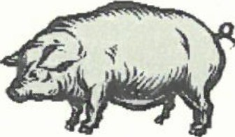
I

2007 BOARD OF DIRECTORS
Marcia Brolli, President
G illian H ettinge r, Vice President H . Dennis Sears, Acting Treasurer H arry E. Conkl in , Clerk

J oyce H awkins Brian Levinsoh n Sarah Macy
Philip Det jens Mark Ziobro

MUSEUM STAFF
Introducing.. .
J oanna J ennings, Administrator

American Legion Hall, SH EFFIELD , .
Craft Faire from 10:00 til 4:00
I
I
Dessert contest at 3:00 Serving from 4:00 until 6:30 ;
Roasting beef , chicken & pork I
I
T AK E- O UT AVAILABL E
Adults $1 7 ($15 pre -paid) , Child ren $8 ffi
j Children under 8 free I
Sponsored by the Sheffield Historical Society ffl
I
CALL (413)229-2694 FOR RESERVATIONS
J

7!-4</y q3no.up £.4vnuvf paSOJ:)
·w·d £ 0l ·w·ll lJ 'A1ipuns Pllll •·w· d £ 0l "W"ll 01 •,(1ip.1nJllS
•spu;i:,p;iM uo u;ido S! 3.J0lS 3U0lS PIO

.JO'A.JOlS! lfPP!lP l{S<e):>.q>w !J!llW3 'lU3WlU!Odd1i 1q .10
·w·d Of!t 0l ·w·d 0£:Y 'AllP!.Jd 7i1 Allpuow u;ido S! .J3lU3'.) q:>.Ill3S3lf A3M3Q lf.IllW

"lU3WlU!Oddll A<f .10
·w·d t 0l ·w·1i 11 •,C1ipsrnq,1-11ips;in,1•.1;,qoPQ -AJOf
u;ido S! ;imoH puoWAlllf =a t LLI
.1o·hoJS!lf PPHPlfS@sqs :1!ll w-3
t 69Z-6ZZ-£I t :3uoqd

LSZIO VW 'PPHPlfS
LtLxog Od l33.JlS "!llW 6Sl
·suo.1.1v.4auaZ a.411J11j puv JWJ-'-'tl:J OJ a3VJ!.4aq JVqJ J!UtSUV-'J puv a,uasa.4<f OJ puv 'ViJ.4V S?qJ U! m P"P;,:,,1.44 JVqJ s:,uaaa puv ;,7</0;,<f ;,qJ Jo Zu!puvJs.4apun
-'i1P!f1l V iJJOW0.44 OJ S! UO!S5!W s,£,;,p os TV:J!-'OJ5!H ppyf;,qs ;,qJ,
!::>cl O. }.cf O.LS I H 0131!!:13 HS 'MMM
JJJUJ:J qJJV;JSJlf tCamJa 3/•VW • ummzw Jfll OH puow{vH uva
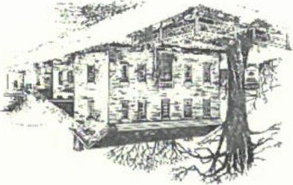
#/ Jr;£/ P O/ f!JE
71#%£
w;

On Saturday, October 13th Karin Sprague of Karin Sprague Stone Ca rvers LLC in North Scituate, Rhode Island will give a demonstration ofletter cutting along with a talk on the origins of
her interest, her techniques and the process chat goes into design­ ing her markers. The program will begin at 2 pm in Dewey Memorial Hall.
Karin Sprague is a noted Ease Coast \s o necutter who special­ izes in custom burial markers that reflect the unique int erests and lives of individ ual customers. Designed and executed in concert with her clients, each piece created at the shop is original, designed by Karin herself, and all of the lettering and sculptu re is ha nd-drawn and hand-carved.
In recent years, the ancient craft of hand-carviGg stone has become virtually unheard of; in fact, Ms. Sprague's is one of bur ten hand cutters still working in che co unt ry today. Her work is much admired an·d sought after. Pare of her mission is to preserve this elegantly precise and meticu lous craft, making it available to the contemporary individual by selling hand-carved work, teach­ ing carving classes, and leadi ng demonstrations at different loca­ nons.
Ms. Sprague has three markers in Berkshire Co unty: two in Sheffield a nd one in Monterey

f ollowing the Sa turday October 13 program by noted scone carver Karin Sprague, a walking tour of nearby Barnard Cemetery will be given by James Miller. His program will focus on che less o bserved characteristics of markers such as carving styles, scone rypes and clues char help to dace markers.
T he work of 19th centur y Sheffield cutter Asahel Savage will be one emph asis of rhe informal tour. He learned his scone cue­ ring in the Wethersfield, Connecticut area, creating baroque style grave markers from brownstone. Almost certainl y Asahel was
Continued on page 5

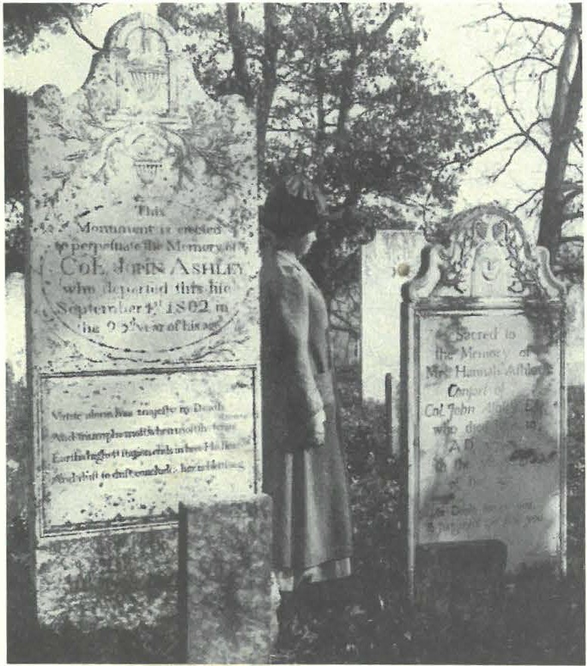
Barnard Cemetery circa I902. An Edwardian woman visits the headstones of Col. John Ashley and his wife Hannah one hundred years after the Colonel's death in 1802.

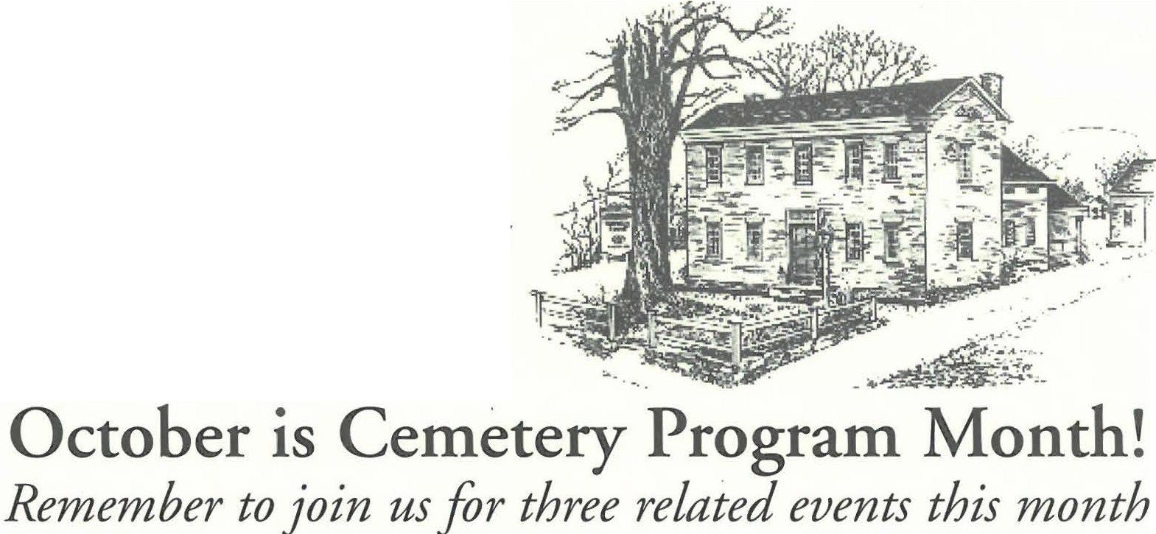Saturday, October 13th • 2 pm
2%e
S%rfo!tl
.ffiuttJrti:al3/Jcte
Autumn 2007
KARIN SPRAGUE & }IM MILLER

Saturday, October 27th • 2 pm
SHEFFIELD SPIRIT WALK

Sheffield Historical Sociecy 2

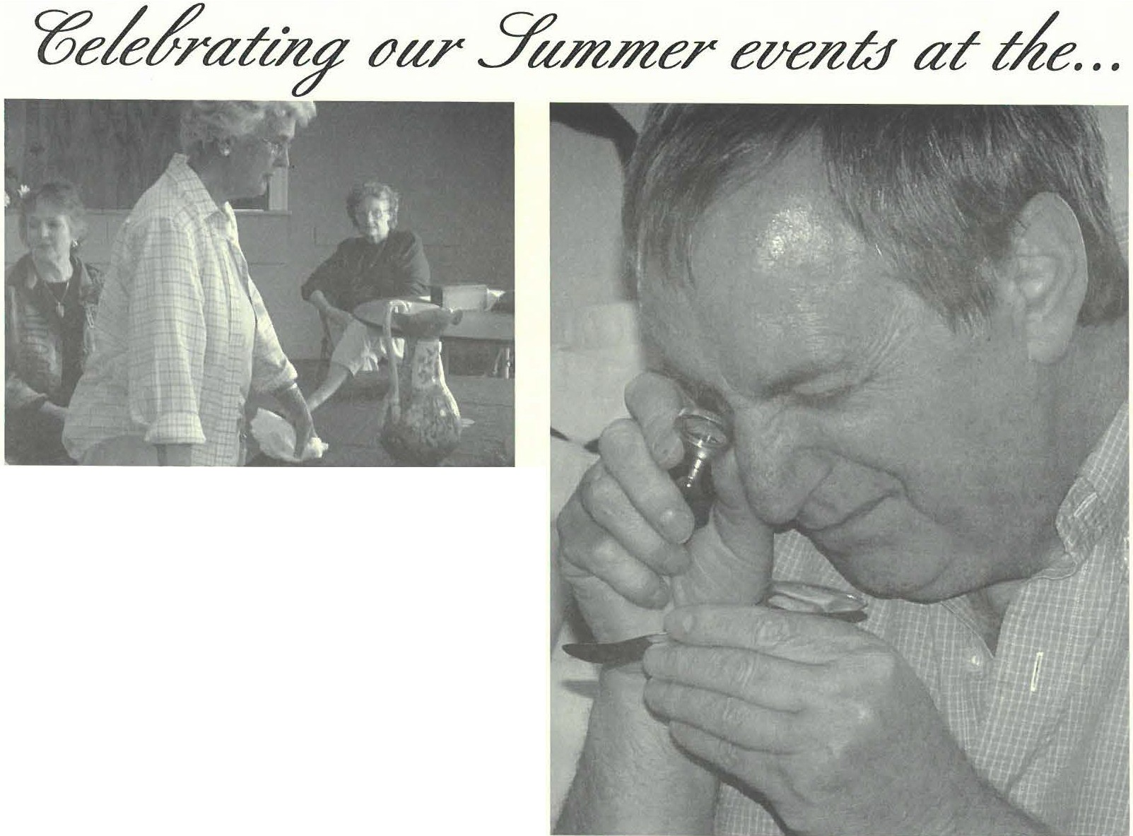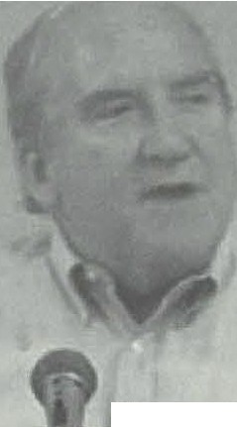Sabina Ullrich has her vase appraised by the Flints while president, Marcia Brolli, and Joan Brook,s who volunteered to cashier, look on.

Photo courtesy_ 11/Corner House Anti ue
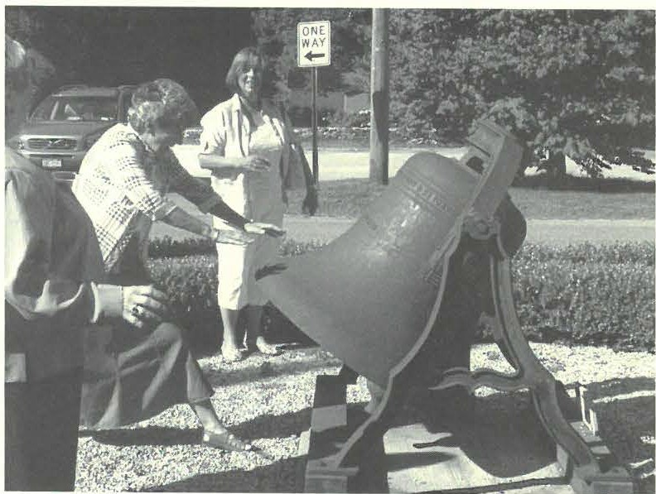
John Wall. Vice President of the Wakefield Historical Society, was our guest speaker on American Antique Wicker Day. He spoke on the life of Cyrus Wakefield, noted founder of American Antique Wicker. For those of you who missed Wall's lecture, stop by the Society to borrow a DVD recording prepared by CTSB-TV

Catherine Miller demonstrates how one rings a bell without a belfry.

Charlie &Joy Flint of Flint Appraisals in Lenox spent the afternoon in the Old Parish Fellowship rooms performing Appraisals and assessments on various heirlooms and notables which people brought in for their expertise.

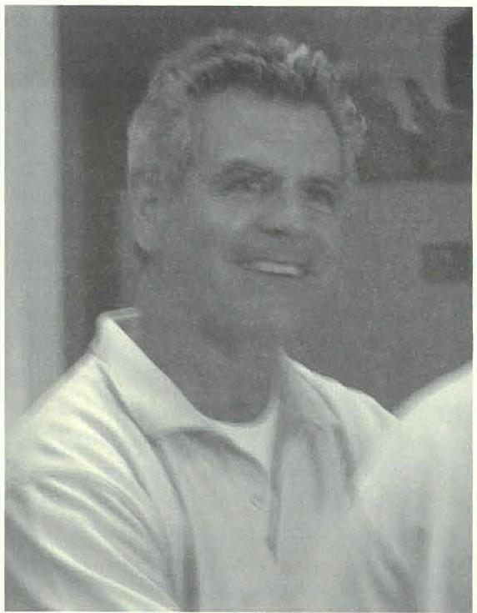
Tom Tetro of Corner House Antiques...

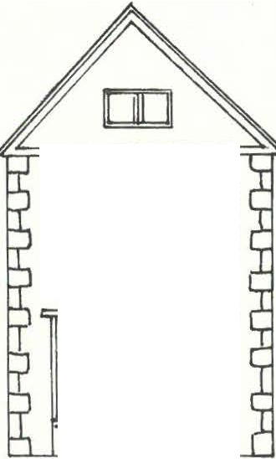Sheffield Histo rical Society 3

mmm

9ftctJnu/lc?_ 2007-cf 6ventt ff 6.d) CtiJn Ydedufr at the OU:Ti1Jne :Ti1Jre
0 | □□0-

September 8th-October 30th
Fire & Light in the American Home, 1660-1860.
An exhibit of American hearth cooking implements and home lighting devices curated by Jim Miller.

Saturday, October 13th, 2 pm. Sheffield Tombstone Art & Cemetery Tour. Lettercarving workshop with Karin Sprague in Dewey Memorial Hall followed by a talk & tour of Barnard Cemetery led by Jim Miller. Refreshments will be served.
Barnard Cemetery is opposite Root Lane on the south side of town.

Saturday, October 27th, 2 pm. Annual Sheffield Spirit Walk.
Just in time for Halloween! Join us in Center Cemetery for a theatrical reencounter with Sheffield history as memorable residents from our town's past are recast! Learn their
stories as they are vividly brought back to life before you.
Center Cemetery is located on Berkshire School Rd.

Saturday, November 1Och, 2 pm. Ruth Bass, author of Sarah's Daughter,
will present a book talk & signing in conjunction with the Bushnell Sage Library.
The program will take place at the Bushnell-Sage Library.

November I Och-December 23rd. 9th Annual Festival of Trees.
Saturdays & Sundays from 10-2 with occassional extended hours.
Shop for everyone on your list at the Sheffield Historical Society's Holiday Bazaar. Featuring an array of handmade goods including miniature trees, wreaths, ornaments, jewelry, holiday treats, gifts, raffles. Upstairs holiday tag sale and Stone Store markdowns.
The Festival will have special extended hours from 11 to 5 on Black Friday (Nov. 23rd).

Sunday, December 2nd, 4:30-6 pm. Dan Raymond House Holiday Social.
Come gather round the festive Keeping Room fireside and enjoy some holiday cheer.
Join friends new and old. Music, merriment and more.

Friday, January 11, 2008, 7:30 pm.What's It? Night
The subject as ever has yet to be determined. Curious? Come find out!
The program will take place in Dewey Memorial Hall

Ruth Bass to Speak on November 10th
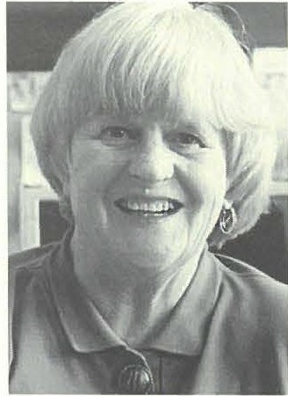
0 n Nov. 10th, the Sheffield Historical Society, in conjunction with the Bushnell-Sage Library,
will present a book signing and talk by Berkshire Eagle col umnist Ruth Bass.
A longtime resident of the Berkshires, Ruth Bass has won many awards for writing and editing and was recently inducted into the New England
Press Association's Hall of Fame.
ShetTteld 1-1istorical Society 4
In Remembrance of Spirits of Sheffield Past: Meditations on Portraiture & Death
0 n Saturday, October 27 the Society will present its Annual Sheffield Spiri t Walk. Starting at 2pm groups of visitors will be
guided through Old Center Cemetery. Featured in the program this year and played by the Society Administrator will be the shade of Carr ie Smith Lorraine, Sheffield's first female photogra­ pher who owned her own portrait business as early as 1902. Other shades will include Frederick Barnard, Rev. James Bradford, Sophia Curtis, Hannah Spurr, and Graham Root.
Ar the turn of the last century in particular there was a fasci­ nation with the doppelganger and death. This preoccupation was undoubt edly influenced in part by the inception of a new medi­ um: photography. In fact, photographic portraiture originally found its tradition in the imaging of the deceased, or post­
mortem phorography. While an unusual, even shocking practice

Ruth Bass
Her weekly column on Mondays considers everything from
by contemporary standards, this type of photography was com­ monplace during this era. We have to remember that untimely

Tanglewood to preserving summer garden produce, and occasionally, local news controversies. Sarah's Daughter, which she will read and discuss, is her first novel.
Sarah's Daughter, set in the post-Civil War era in New England, is the poignant srory of Rose, a 14-year-old girl who has sud denly lost her mother. Trying her best to " hold up" in spite of her own grief, Rose has the new responsibilities of replacing her mother's role in caring for two younger siblings, cooking, cleaning, and helping her father on the farm, while continuing her schoolwork.
Mrs. Bass's heart -rending story is truly a page-turner, historically researched down to the most common household tasks. The 19th century view of women is paramount, as Rose's love of school clashes with her father's perceptions of a girl's duties at home. Rose's perseverance, encouraged by a caring teacher and and the warm-hearted, often funny, support of her girlfriends, and, yes, an older boy, form the heart of this novel.
Ruth's Bass's lecture and book signing will tak-e place at the Bushnell-Sage Library in Sheffield at 2 pm. on Saturday, November 10th.

- JoyceHawkins, Program Chair

will be compiling an emaJ list of men:1IJers so that we can send timely re1ninders of the progrnmming. If you wo1Jd lil e to he included, contact Joanna
We
Jennings at sl1.s sheffieldl1istorv.or
death, especially in that of children and women in childbirth was
still widespread and photography as a medium was still somewhat novel. Further, photography quickly appealed ro the masses because it was affordable: no longer was portraiture restricted to the upper classes in the form of a proper painted likeness. Photography both as a means of index and as the cornersrone in the age of mechanical reproduction is inextricably linked to self­ preservation and (im)mortality.
There was a similar thread that ran through poetry dating from this period. Take, for example, the work of Edgar Lee Mast ers, whose 1916 Spoon River Anthology dealt with death in a small mid-western town. 'Each poem functioned as an epitaph of a dead citizen, delivered by the dead themselves. Some relate their histories and opinions , others make observations of life from the other side, and small-minded ones complain only of the treat­ ment of their graves. However few tell us how they actuaHy died. Speaking candidly, the body of work itself constructs a picture of life in their town that is radically unadulterated.
In both cases, whether the photograph or the lapidary epi­
taph, the portrait memorializes and seeks to provide and promul­ gate a lasting legacy of th e depa rted. "Please remember me," the shades beg of Dante in the Inferno, " Please remember me."
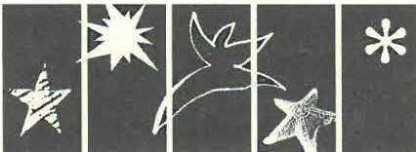- JoannaJennings, Administrator

Sheffield Historical Society is also pleased to announce its 07-08 award
from Massachusetts
Cultural Council of Massachusetts Cultural Council
$2500. A portion of this funding will be applied toward programming in the new year. Future plans will be announced as they develop.

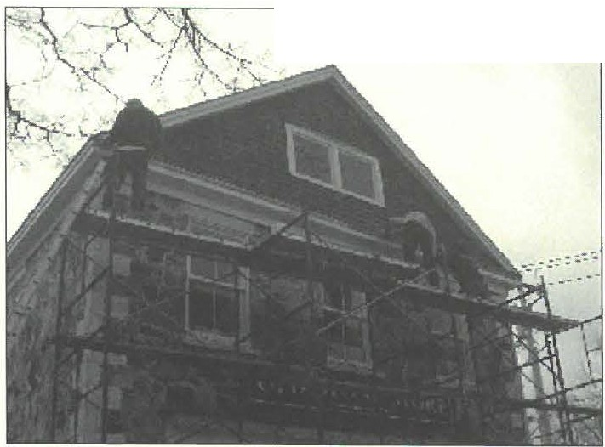Sheffield Hisrorical Society 5

O ct ober 2007

Dear Members and F riends,

Would you co nsider helpin g us t ini sb tbe preservati on of th e S beffi eld H ist o ri c al Society's buildin gs?
.:.-·. , • c.-. \''' \ ,"·,:..
· ·•• .:

Steven Phillips and crew have stayed within the estimate, and in tact baveeven do nated many hours of work beyond th e or igi nal cont ract. We need your help in off se tt i ng th e cost of unanti cipated expen ses which incl ude flashin g and carpentry repairs on the buildin gs, sa nd ing, and even a third coat of paint in places.
Our goa l is to rais e $3,500 to complete th e project. We would be gratef ul for any assista n ce you might provide. This special d ona ti o n may be sent to:
Sheffield Historical Society
PO Box 747
She/field, MA 01257

Cemetery articlecontinued from page _{I}

train ed by a relative of his mother, a second or third generation of the notable Johnson family of carvers from Middletown. In Sheffield, however, Asahel did sim ple cuttings in marble, the local stone of abundance and therefore economy.
l.•
The Savage family came to Sheffield in 1806 from Wethersfield, Connecticut. In that year he purchased, in partner­ ship with his brother-in-law, Daniel Deming, a farm of 375 acres. For the next eight or nine years he worked the land, but in 1815, the two men divided the property, with Savage receiving about half the acreage for $1,000, about 20% of the original purchase price. T his low figure suggests that he received land only, with the house and agricultural buildings being retained by Deming. It was probably then, about 1815, that he turned to stone carv­ ing. This possibility is enforced by Sheffield assessors' list of the following year. It shows, for the first tim e, Savage paying a mod­ est tax on " income," an assessment category reserved for mer­ chants and those who charged for services such as craftsmen, lawyers and physicians. About the same time, his first sig n ed
stone appeared.
For about the next 24 years little is known of Savage's work, but he probably purchased marble for cuttin g grave stones and divided his time between his own cutting and working in shops for others. It was during this period that he trained Richa rd Paine Brown, 27 years his jun ior, who developed into a master carver of distinction.
In 1840, in partnersh ip with his son, Hamlin, Savage pur ­ chased land, worked a quarry and established a marble saw mill and cuttin g shop in Sheffield o n Bow Wow Road. They made use of water power from Willard Brook to operate their equipment. Asahel died in 1850. The quarry went bankrup t in 1857, possi­ bly due to iron pyrite content in its marble that rendered it less satisfactory than other local marbles. Co nveniently, it is this defect that makes the Savage qua rry marble so easy to ident ify today.

-Jim Miller, Archivist

S heffield H isror ical Socie ty 6
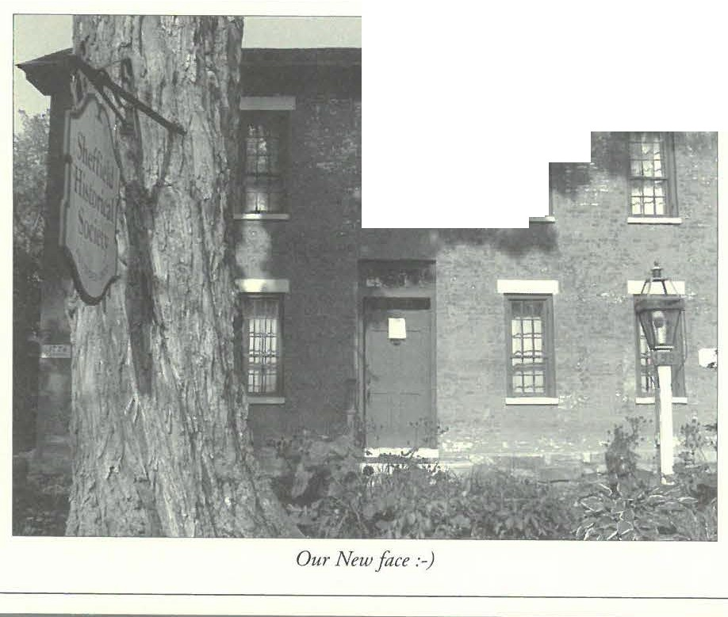Dear Members and Friends of SHS, Welcome to the old and the new.
-·--:··- ··--'al!:
- . ....... - llllDIJ . ......·-1
·.,..
. II •. 1li.:·
l iil
A. . -_ ... ! ""
· !!!! · _{:-o}
..
._E:,l
Ill
Ill
This fall and winter, we will be continuing the month­ ly programs, the Spirit Walk, and the Festival a/Trees.
...

As far the new, the Planning committee last February recommended a reconsideration of our monthly programs and meetings. They suggested that we work with other organizations and that we be more adventurous in the times they are held. As a result, two of this fall's programs are being held in conjunction with and at the Bushnell Sage l ibrary. In September we enjoyed john Sedgwick's reading and talk and signing o/In My Blood, arranged by Jim Miller. Mr. Sedgwick researched the early part of the book at the Mark Dewey Research Center. On November IO Ruth Bass will speak about her book Sarah's Daughter, her novel of early farm life. Both of these book-centered talks are being held at 2 pm on a Saturday afternoon. In 2008 we will be collaborating with the Sheffield Land Conservancy far their February lecture.

Your programming suggestions or thoughts are welcome.

Details of the October programs are elsewhere in the newsletter.

Steven Phillips has nearly finished the painting of the Society buildings. Patience is now needed as we watch the paint peel off the brick portion of the Dan Raymond House. The trustees have been advised that the building could not be painted again until the pres-

. , ..-----....,
Tours of tl1e Dan Raymond House l...ave lessened in\h
past years. We would lil. e to redesign tl1e tours to include volunteer docents and with tl1em builcl on
Sbeffield's |  | history | as a farming community as wel1 as
tl... | e location of tl1e Mumbet story and the Sl...eff ie J.J
Declaration. A committee will be formed to create tl1is

new program under the leadersl1ip of Joanna Jennings.
We can use your
call l1er for more information.
Please
l...elp.

ent paint is gone. Steve and his crew have scraped as much as they can and sealed the bare brick to protect it from the elements. The brick, made on site, is too soft to take any kind of blasting. We are delighted that with the new town parking lot and increased visibility we're able to look so good.

Thanks to Phillips Painting and, of course, the folks who keep the grounds so attractive, Anne Riou, our volunteer in the herb garden, and Kathy Moore, who tends the gardens.

Plans are afoot far next year's exhibit season in the Stone Store. Jim Miller has been diligent in keeping presentations historical and interesting. If you haven't seen his fiery exhibit of "Fire and Light" yet, do go. Local collectors have lent us some wonderfal pieces which, as one volunteer said, prove that you don't need a college education. The spark of American ingenuity is present in every corner of the Stone Store this month.

As our administrator Joanna Jennings has gotten to know Sheffield and the Society, she has taken on more and more responsibility. This newsletter is her doing, as are our publicity and tours. She is foll of new ideas far the new year. Call her to offer your help. She has become part of our lives.

Thank you far your support.
See you in Sheffield,
M arciaBrolli

Sheffield Histo rical Society 7
.%#fa!
- • .YctdtrJrical..¼cie

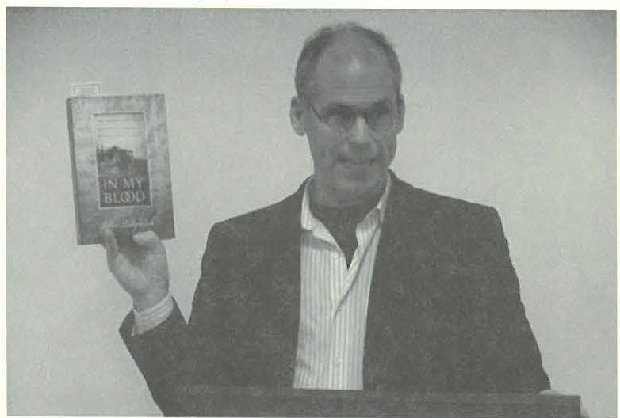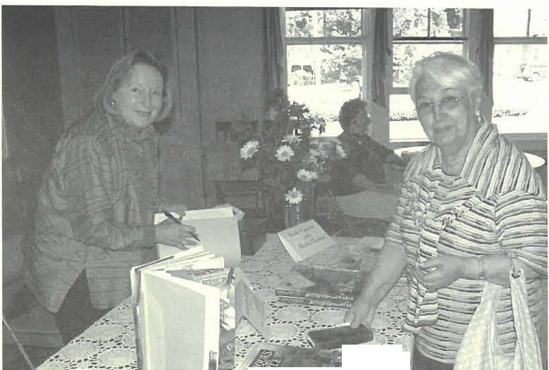
-
.-=..--=-.-:"'11-- '---.::
----i_:§-,

john Sedgwick talked about his recent book In My Blood and gave a
humorous account of the triumphs and sorrows of being a descendant of one of America's most prominent families.
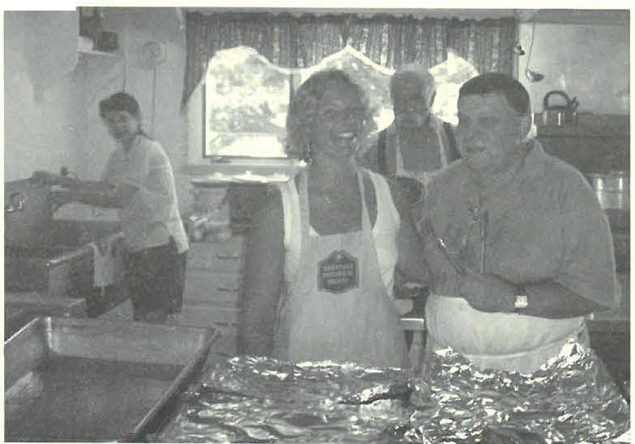
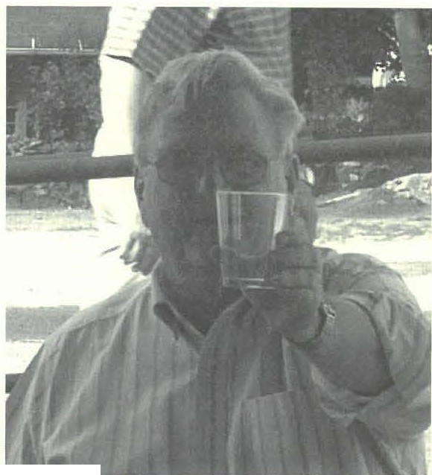Sarah Macy and Brian Levinsohn smile far the camera at the 5th Annual Pig Roast, while the other chefs d' ouev re, Harry Conklin and Grace Campbell look on.
1.-.1- .- •

Ross Hawkins raises a glass to American
Antique Wicker.
Sheila Chefetz pauses for a photograph before she signs a copy of her book Antiques for the Table for a customer. Proceeds.from the book signing were contributed to the Society by Ms. Chefetz.
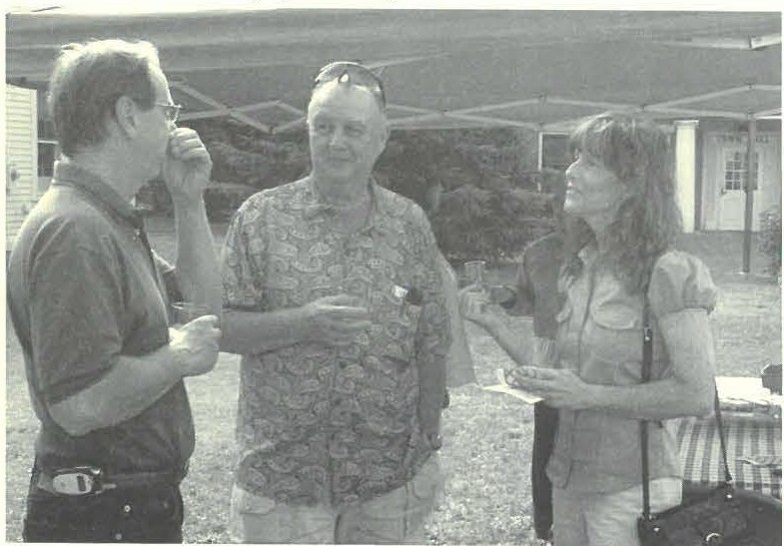
Dennis Sears, Treasurer, and Sharon Palma, Executive Director of the Southern Berkshire Chamber enjoy company and light refteshments at the wicker exhibit reception.
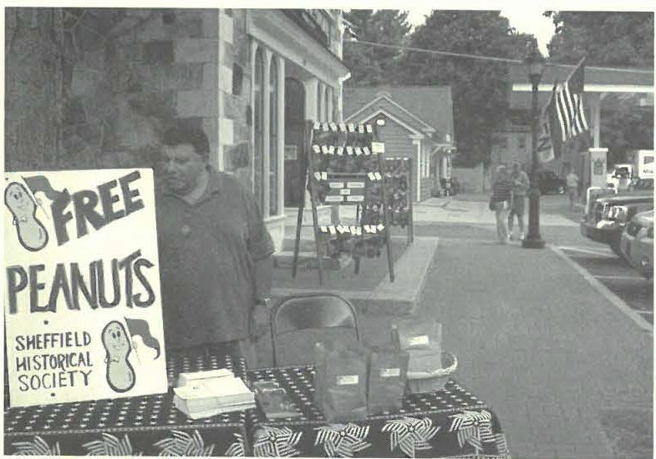
Brian Levinsohn represents the Historical Society during "Sheffield in Celebration" by offering families .free peanuts. For their part in the program the Stone Store /,adies featured their Pair and a Spare socks.

  - One contemporary flush toilet

HISTORICAL SOCIETY WISH LIST:
- A handyman to do odd jobs around the house

2007 BOARD OF DIRECTORS
Marcia Brolli, President
Gillian Hettinger. Vice President
H. Dennis Sears, Acting Treamrer
Harry E. Conklin, Clerk

Joyce Hawkins Brian Levinsohn Sarah Macy Philip Det jens Mark Ziobro

MUSEUM STAFF
Joanna Jennings, Administrator Betty Chapin, Volunteer Archivist Jam es Miller, Volunteer Archivist
.%e_;ffe!tl.Y?utortcalYoae
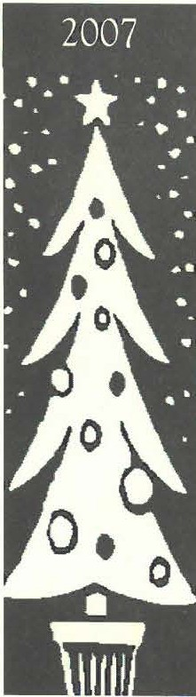
9th Annual
Festival of Trees
The Stone Store, Sheffield Town Green

Weekends in November & December Saturday & Sunday 10-2
Free Admission
Miniature Trees, Wreaths Decorations, Ornaments Holiday Treats
Raffles & Tag Sale

New Holiday Gifts in Stone Store
0 S pecial hours on Black Friday from 11-5°

•• •••••••••••••••••••••••••••••••••••
: HOLIDAY TAG SALE ITEMS :
:Accepted /or Festival o/ Trees:
•• Please contact the office to coordinate drop-oH. 229-2694. ••
•••••••••••••••••••••••••••••••••••

7!-'<IV qZttO.ll/1 £.,vnuvf pWJJ:J
·w·d £ OJ ·w"ll II 'Allpuns pm, '·w·d £ OJ ·w·e 01 'AllpJmes
'spu;np3M uo u;,do S! 3JOJS 3UOJS PIO

2Jo•AJoJS!lfPPHPlfS@:upw '(!llW3: ·Ju3WJU!Odde ,(q JQ
·w·d 0f 't OJ ·w·d 0f'l 'AeP!'tl Ji? ,Cepuow u;1do S! J3lU3:) q:>n3S3lf A3M3Q )jlllW

·Ju3wJu!odde ,Cq JQ
·w·d t OJ · w·1i JI 'A1ipsrnq.1-Aeps;m.1 'J3qOPQ-AJnf
u;1do S! ;1snoH puoWAlllf UllQ tLLI

2,o·AJOJS!lfPp9pqs@sqs 'I!llw-3:
t69l-6ll-£It :3uoqd

LSno VJ',! 'PP HJ3 lfS
LtL xog Od
J33 JJS U!lJW 6SI
·suopv.wU33 ,u111nj puv 1-ua.un:1 01 a3v1!-Jaq 1vq1 l!UlSUV.t/. puv a/Uilsa.u/ 01 puv 'va.,v s!ql "! stz papa:1a.lt/ 1vq1 s1uaaa puv 31do11d 11q1Jo 3u!puv1s.iapu11
.ti1p!m V ,IIOUto.t<f 01 SJ UO!SSJUt s,l:tapos /V3!.lOISJH p,aifjaqs aq.L
110 'A11O.LSI H0 1 3 1.:1:13 HS'&.&.&.
JJIUJ:) CfJJVJSJlJ AJm Ja 2(.JV]IV • UJnJfn]IV JWOH puouilvlJ uva
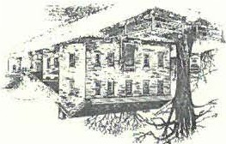
#j l.7'?£/ D _{t7/} _{f?l.E}

?!#%£

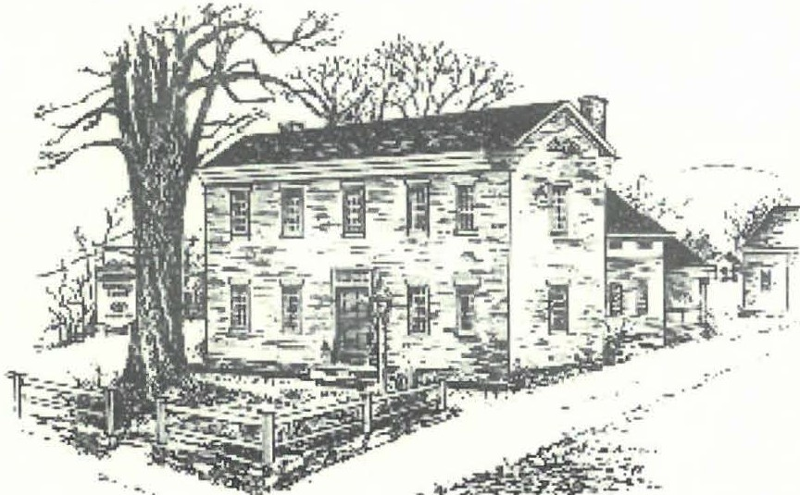
2he
.%e;fo!tl
.ffci:lttJrtealYbaef?
Spring ₂ ₀ ₀ ₈

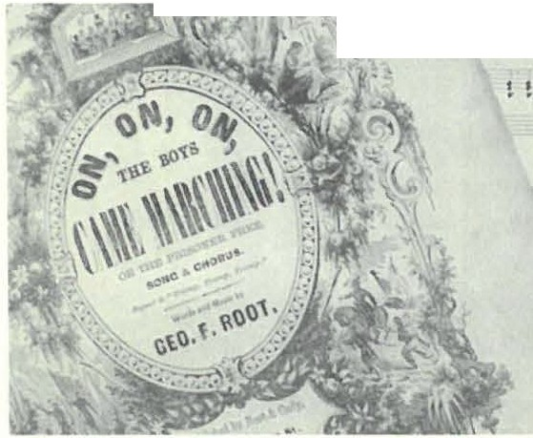Society's Archives Enriched with Civil War-Era Ephemera TheSociety's Mark Dew ey Research Ce nter was the recipient of
\

significa nt ep hemera from me mbers John-Arthur and Trudy Weaver
Miller in the form of three original pieces of sheer music by George Frederick Root.
Roor, the composer of popular C ivil War music, was born in Sheffield on August 30, 1820, and mainta ined a connecrio n wirh the rown unril his death. His high esteem in the commu nity is demo nscrare d by rhe clock in the 1owcr of the Congregario nal C hurch (O ld Parish) that was donared ro the rown by rhe Sheffield C hapter of rhe Grand Army of the Republic in Root's memory. The G.A.R. and the C ivil War are analogues ro the American Legion and World Wars I and 11.
The pieces, just before the Battle, Mother; Tramp! Tramp! Tramp! or Prisonrr's Hope; and On, On, On, the Boys Came Marching! also known as The Prisoner Free are in fin e co ndir io n.
Trud y and John-Art hur were also rhe donors of a signature of George Frederick Roor some time ago. T hese additions ro T he Society's collectio n char also conta ins Root song books, engravings, genealogy, and a biograp hy arc the basis of a stron g research resource on this important historical figure.
.•. •
i
.....

' ..
George F. Root sheet music On, O n, On, the Boys Come Marching
© 1865 by Root and Cady.

The Society's volunt eers are always encouraged by unsolicited donations from the public and want to thank the M illers for their thoughrfuln ess and generosity.

Society to Feature an Unusual Folk Art Collection in Red, 'White & Blue exhibit
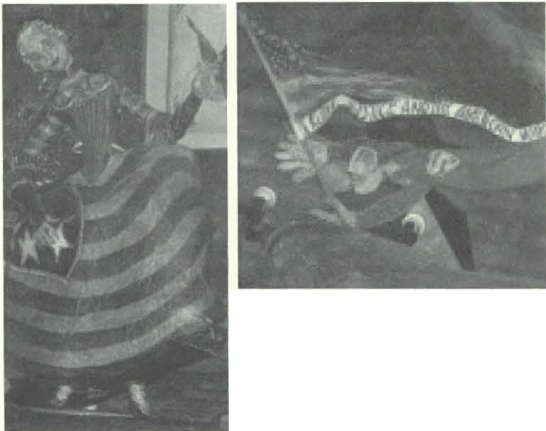
Red,White nnd Blue; Patriotic J\.lotifi in American Folk Art hono ring the 275t h ann iversary of Sheffield 's foundin g in 1733 will open ar rhe
O ld Srone Srore, Saturday, May 10. Ir is a show that will appeal to a rainbow of ages and interests covering rhe gamur of artistic technique and imaginarion.
Beginn ing in the 18th century, democratic American values began ro be expressed through folk arr by unbo unded representatio ns of patriotic symbols such as flags, rhe liberty cap and pole, the bald eagle and classical depictions of Lady Liberty and Geo rge Washington. As interpreted by untrained artisans who made objects largely of utilitarian worth, the new values of democracy and freedo m found their way in ro
American culture through women's handiwo rk, portraiture, advertising

Highlights from Mr. Leigh's Colk ctio11: Left, Whimsical Elizabeth Ross or Lndy Liberty figurine holding needle and thread. Above, Super patriot waving American flag with banner pledging
"Liberl)\ justice, and Pence for nll." For oth er details nbottt the exhibit, see calendar listing 011 page 3.
and signage, furnicure paint ing, carving, military material, polirics, roys, clothing and ephemera.
The heart of rhis celebratory exhibit, wirh selecred additions, is from the collectio n of Sreven Leigh of Grear Barringto n and New York. assembled t hro ugh decades of collecting. An o pening reception will be held Saturday. May 17rh from I ro 4 at which time, Mr. Leigh will be availab le ro answer questio ns and give informal rours of his collection.

'>hcfflcld Hi,coric.il SoLi"l}' 2
£/I cf" /l/-er !Z'r ranM Sfemem reL.

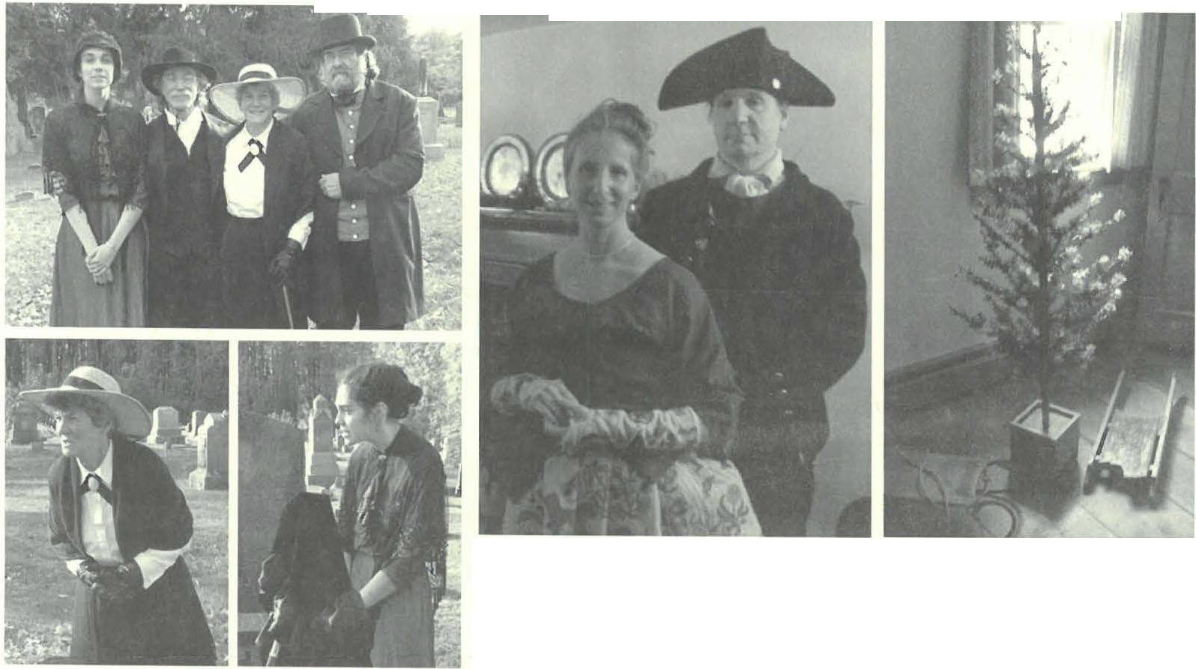
,

The Society held its sixth annual Spirit Walk on October 28 in Center Cemetery. Jotinna Jennings, Ricky Bernstein, Catherine Mille,; and Dennis Picard (top) starred as various recast residents from Sheffield's past. Not pictured among those who participated are: Sarah Elizabeth Barnes, Dwight Kelly, and Sarah Macy. Catherine Miller played Sophia Curtis (left) an wealthy eccentric socialite and Joanna Jennings played Carrie Smith Lorraine (right) Sheffield's first female photogmpher.

/11 mid October the Historical Society hosted two 5th grade classes from Undermountain School in Center Cemetery for a school program. Above, two girls work on a grave
rubbing of a Sheffield family plot. More of their classmates are pictured 011 page 7.
The halls of Dan Raymond House were decked from floor to ceiling to bring in the season at the Holiday Social on December 2. Among the those present were a Loyalist couple from Maple Ave (le.ft).The couple, Jonathan & Lisa Reynolds, are booksellers by ocrnpation but Revolutionary War reenacters by avocation. The Society hopes to involve the Reynolds in the coming years in PJ gra.mming at its 1774 headquarters. Among the decorations and in the Society's collection was a handmade artificial Christmas tree dating.from the late 1800s (right).

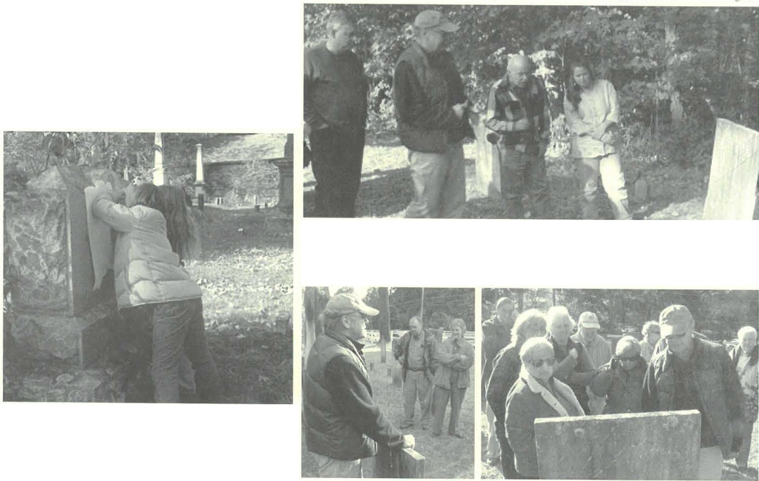
Abo11e, Gary Levielle and Don Freedman are Led byJim Miller on his October 16 guided walk of Barnard Cemetery, while guest speaker Karin Sprague, a letter carver from Scituate, RI, who
joined Jim for the program, looks 011. Dennis Sears and Marcia Bro/Ii (left), Joyce Hawkins, Susan & Philip Detjens, Natalie Funk were among those who attended (right).

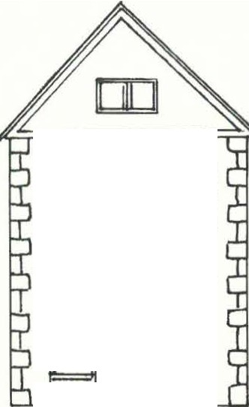Sheffield Hisroncal Society 3

mmm
□O□D-
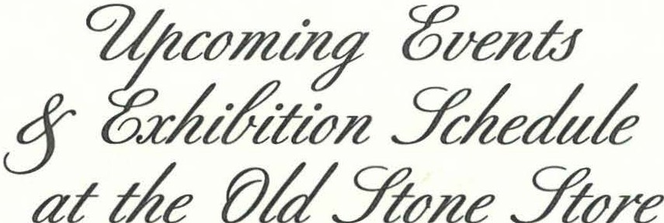

Frid<!}', March 14th, 7:30 pm.
Colonial Garden Planting & Planning.
Ruth Green, owner of Green Arts Garden Design and head gardener at the Bidwell House Museum, will give a slide presentation and talk about heritage garden planting schemes.
The program will be held in Dewey Memorial Hall.
Saturday, April 5th-May 4th. Impressions of the Bidwell House Museum.
Joanna Jennings, the Society Administrator, will show selections from her two past photographic exhibitions of the Bidwell House Museum. In an eerie sort of tableau narrative, these text and image pairings interpret the past using a contemporary technique.
For more information about the artist and her work, visit www.joannajennings.com.
The Old Stone Store exhibit will have an opening reception on Saturday, April 4th, 6-8 pm.
There will be an infonnal gallery talk on Friday, April 18th at 7:30 pm.
Friday, April 11th, 7:30 pm. Roads Less Travelled.
Bernard A. Drew, Berkshire Eagle "Our Berkshires" columnist and Great Barrington Historical Society trustee, will verbally explore a variety of old roads in South County.
The program will be held in Dewey Memorial Hall.
Saturday, May 10th, 2 pm. Wheeler House Tour.
The Great Barrington Historical Society will offer members of the Sheffield Historical Society a private tour of their newly restored headquarters-the 1771 Wheeler House!
The Wheeler House is located on Rte. 7 across from the Big Y!Staples Plaza.
Saturday, May 16th, 6:30 pm. An Unfolding History of the Berkshires.
David J. McLaughlin will present a book talk & signing. In this unique book 'unfolding' timelines tell the history of our picturesque and culturally diverse Berkshire region.
This program will be presented in conjunction with the Bushnell-Sage Library.
The program will be held at the Bushnell-Sage Library.
Saturday, May 10th-June 22nd. Red, White & Blue.
The Society will showcase selections from the collection of Stephen Leigh. All of the objects in chis miscellany have one thing in common: they are red, white, and blue! The exhibit will be curated by Jim Miller, the Society archivist and resident historian.
The Old Stone Store exhibit will h,we an opening reception on Saturday, May 17th, J-4 pm.

Friday, June 13th, 7:30 pm. Annual Meeting & The Comic Strip
Paul Banevicius, Berkshire School Art Department Chair, will present a lecture about his upcoming exhibit in the Old Stone Score on the history of the comic strip.
The program will be he/a in Dewey Memorial Hall.
Friday, June 27th-July 13th. Five Friends Art Exhibit.
For more mfonnation about this e:x.hi hit and other upcoming events, visit u•wu•.sh4Jieldhistory.org.

M 07 Contributors Continued from page 4
Sheflield Hiscoric.1I Soc iccy 6

A Celebration of Traditional Music & Dance

Caroline Y. Linde mann Wendy Linscott Reverend John S. Lis Candida Logan
Gerald & Selma Lotenberg Susan Lushing,
in mm,ory ofWa.//ac, Kaminsky
Alice Lustig
Bob & Sue MacVeery,
in memory of Floyd \"(/oodbeck
Sarah W. Macy
Amonio T. & Marian R. Malnaci No rman & Barbara Margolis Caro le Maghcry
Barbara E. Martin
Shirley Manin Dawn S. Massini,
in memory of Henry M=ini
Mark H. Massini,
i11 mem ory of Hmry M1Usi11i
Wesley McCain & Noreen Sto rrie
Charles & Jacqueline McClure Mylan Jaixcn &
Catherine McNeil Robert D. Mercurio Cary & Jean Miller
Jim & Catherine Miller
John -Arthur & Trudy Miller, i11 honor of Cnthtri,it a,id Jim Milkr
George & Sh:lron Milukas Margaret Mitchell
Donald & Roswitha Mou
Dan & Ann Moulton Norma Moulwn Dorothy Marosy Patrice Mullin
- Twiggs Mym,
i11 memory of Artlmr C Omst MaryEllen J. O'Brien Elisabeth O'Connor
Tom & K.1thy Orlando Thomas O rland o,
in mnnory of PtggJ Orlando
C harlone A. Owens O rmsbeeGas Co. Inc. Fred & Elaine Panin Judith Papachristou Wesley Pererson
Fred Pomcrann
David & Marsha Ponle Ken & Joan Powers,
m memory of Frtddi, Martin
George Raymond & Id a Ha,,tings
Joseph H. & Carol F. Reich Alfred M. Richardson Frank Murphy & Deborah Reich
Ann M. Riou Muriel Rokos
Mrs. T. C. Romaine, Jr., & F.imil>•
Ben Z. Rose
Jessica Roseman
Don Freedman & Susan Rothschild
George W. & Kate Rowe Peter & Ellen Rowntre e
Ben Hillman & Amy Rudnick Mary & Bob Safoan
Dr. Marcia Savage & Carol Sica
M ichacl Saxton Joanne Day Schmidlin
C harles F. & Libby M. Schmidt
Norman Schnaycr & Joyce Freundlich
Bernie & Shellie Schneider William & Judy Schnurr Kenneth & Becky Sc hopp
Charles & Pauline Schumann
Gary & Judy Schumer Joseph Schwartzman Dennis Sears & Rene Wood
Gilian Shallcross Myron & Marcia Sheinberg Barbara & Ji m Shiminski
G reig & Christine Sicdor
S usan Silver
  - Bonnie Silvers Evelyn Small,
in memoryofJim Small
Eliiabeth Smith David A. Smith, Sr. George Smith
Nik & Sig Speigel Walton E. Stevens, i11 memory of Capt. Thomns Stewns C- Rhoda
C allender Stevens John & Katherine E. Srookey
Wanda Styka Howard J. Swanso n Scan & SusJn Td ensky.
in mm,ory of Eleanor Griffiths
Thomas & Ka1hlecn Tetro Robert & Rebecca Thomas Ronald & Judith Timm Percr & DorisTraub
Al Trocchi
Merle & Karen Varney
Mary Vaughn Diana & Henry Vollmer, Ill
John & Ada Wall Don & Claire Ward Paula Wardynski Jackie Weaver,
m memory of Hmry G. \f1'11wr Ill
David & Barbara Wes,
  - Rohen Wheeler, Jr. Marion E. Whitman
John & Marilyn Wigh,man Barry & Martha Williamson
Eliiabcth \V.lson Arnold & Beverly Winston
Bill & Lynn Wood Don & Nina Won h Ron & Veronica Yaple
Eileen Young, i11 memory of Maury Young Tom & Susan Young Elissa Williams &
Richard Zimmerman Dr. Dororhea Zucker-Franklin
The Reveillons! • April 4-5, 2008 • Sheffiekl, MA

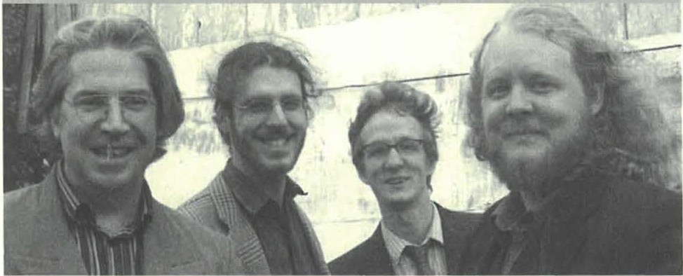
The Reveil/ons! a tradtiional Canadian music and dlmce troupe from Montreal will perform songs and dances baJed011 the amalgam of French, Scotch and lriJh styks.Th e Reveillons! philosophy is that "Tradiroi n is not to remakewhat others did, but to find the spirit in which these things were made."
Friday, April 4, 7:30 pm. From Sheffield, England to Sheffield, MA. Folk music of England- David Berrhiaume of Reveillons!• Folk music of Sheffield­ "Dewey Hall Folk Co ncert Series" and the "4th Saturday Contra Series" have been
playing for the dances in Sheffield for 29 years • History of Q uebec's Traditional Music­ The ReveilJons! fro m Monrreal will pe rform songs and dances based on the amalgam of French, Scorch and Irish styles.
The Friday evening program will take place in Dewey Memorial Hali.
Saturday, April 5, 2-5 pm. Reveillons! Workshops.
Srep dance, feet as percussion, instrume nts, fiddle, Jaw harp.
Thr Saturday a.fiemoo11 program will take place in Dewey Memorial Hall.
Saturday, April 5, 7:30 pm. Dance and Show The Reveillons!
The Saturday evening Dance will be held ,1t the Southenr Bakslure &gional School

Strategic Planning Sessioncontinued from page 5
- Synthes.isT he following six ideas were mosr popular , four of which were interrelated•
.. These six ideas will beco me rhe prioriries of $ H S in 1he next three year .

  - Cataloguin g rhe Dan Raymond House Collection
  - Reconneccing with area Teachers/Schools•
  - Teacher Seminars• and education programs
  - G rounds improved and utilized
  - Co llec tin g Oral Hisroriesu
  - Family Programs' '

- Commitment. Finally, each attendee was asked to personally commit co o ne of these six areas, rhe groups formed to become an informal "committee" of sores. The chairperson of each committ ee has been bolded.
  - Car rie Smith Lorraine Projec1
Carrie Smith Lorraine Committee:Jorm,ia and Chris
  - Cataloguing che Dan Raymond House Collection
Collections Committee: Joa n na , Philip, Ross, Brian and Lois
  - Collecting/Pu blishing Oral Histories
Oral History Committee: Ma rcia , John. Joyce, and Jim
  - Reconnect wit h School/Teachers
Education Programming Committee: Joyce , Catherine, Dennis, Dorothy, and Harry
  - Grou nds Utilization (and Beautificat io n) Project. Jncl11des development of programs to utiliu the DRH &grounds, and Sheffield Town 275th Anniversary programming.
O11treach Committee: Catherine, Gillian, Joyce, Joanna and Lois
- Conclusion. Each committee was asked co ser a dare for their first meeting and to report back ro the board by March 8th, when the board nexc meets.

------------------------

ShdlidJ Hisrorical Society 7

- • •%#efal..YcifttJrical3&cie
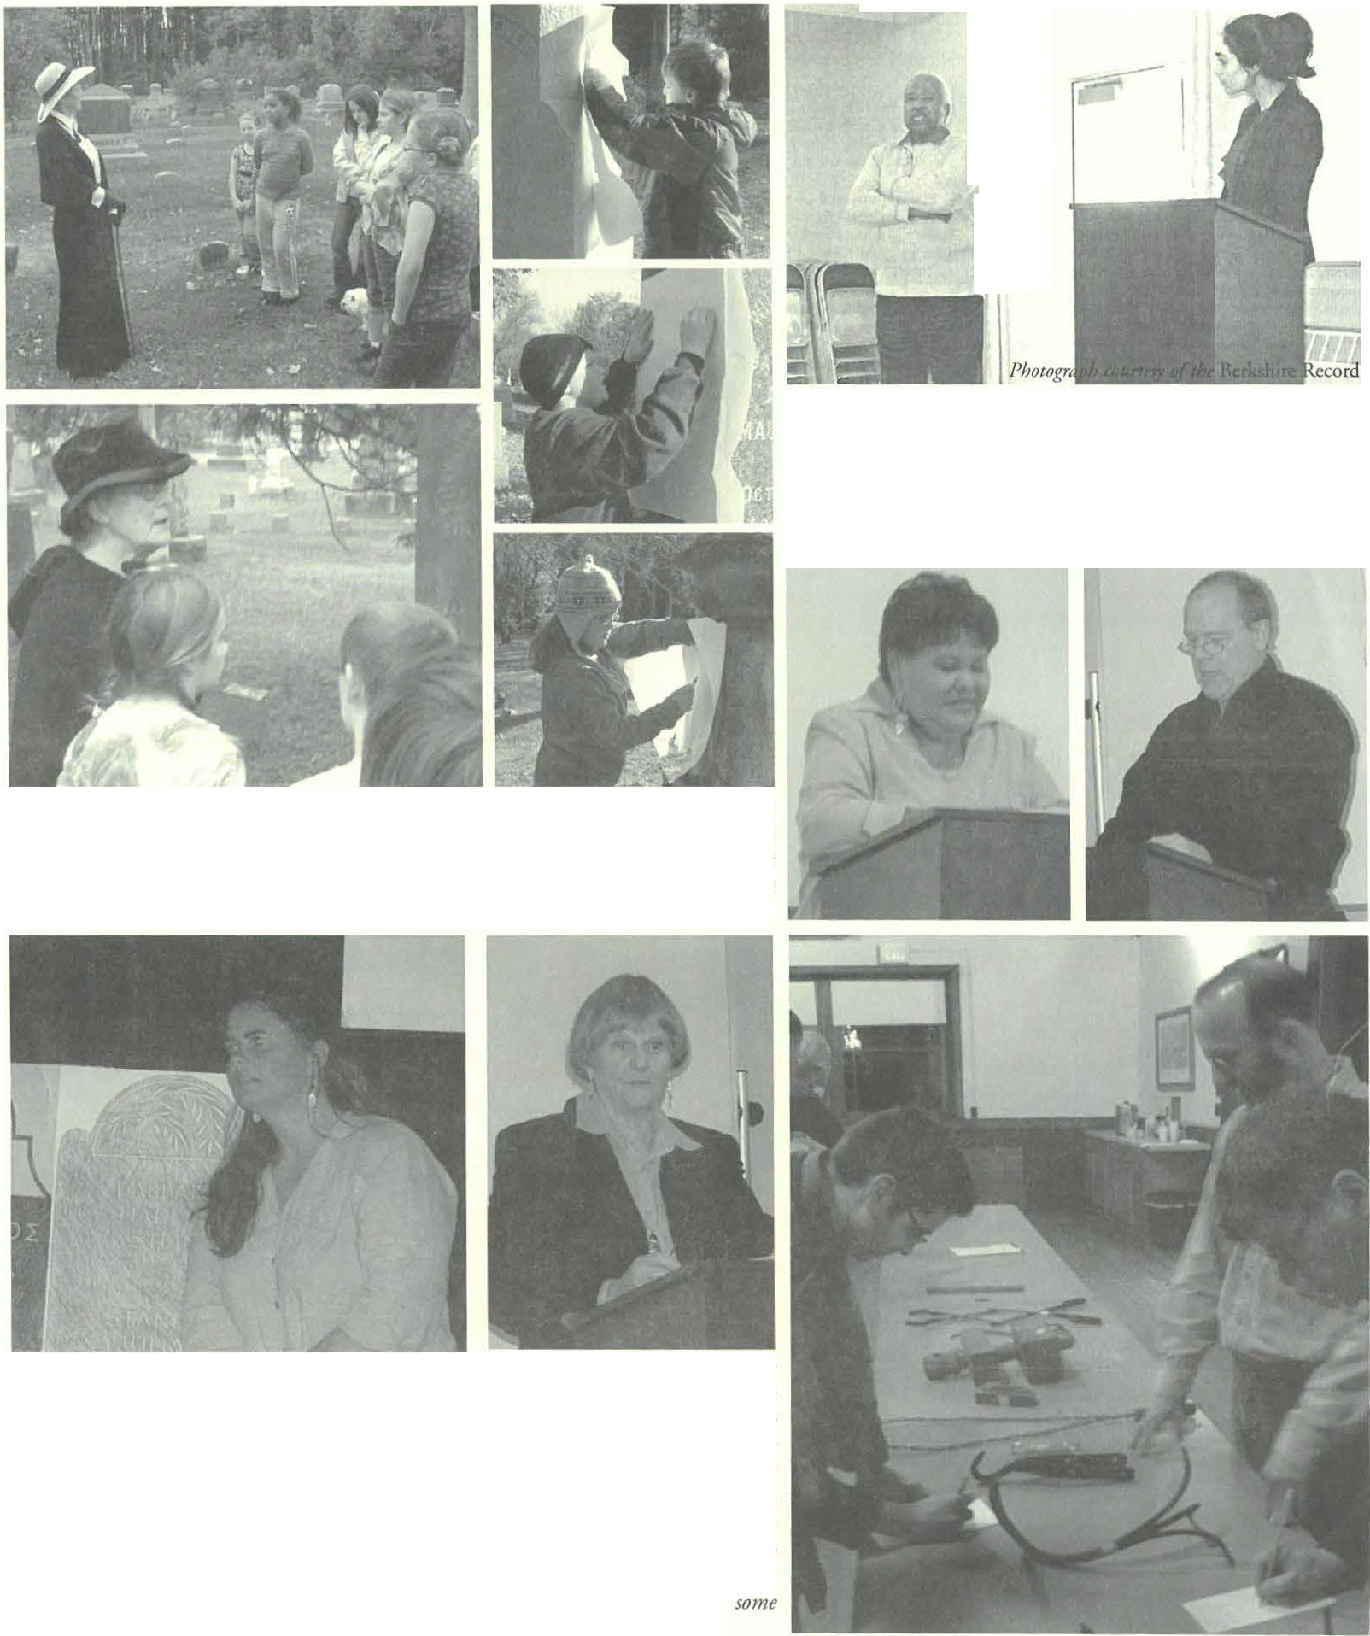r
I I_{I}
II
I I
I
I

Wray Gunn speaks abour local bl11ck heritage while Jorinntt Jenningslooks ₀₁₁ (ab o11e} ar the Martin Luther King Day Program which the Society collaborated ₀₁₁ in January with the Library and Senior Center. Below, Nancy Race (left) relates her experiences growing up as an African American and john-Arthur Miller (right) honors King with selected choral arrangemellls.

In October Undermountain School joined the Society for a Spirit Walk and Cemetery tour led by Jim Miller and Joanna Jennings. Above, Catherine Miller stars as Sophia Curtis, a wealthy eccentric socialite while Marcia Brolli (below} talks about Life as the wife of Rev. Bradford, the fourth Congregational minister of Old Parish Church. At right top, center and bottom, three more Undermou111ain students complete grave mbbings.

Karin Sprague of Karin Sprague Srone Carvers (left) joined Society archivist Jim Miller in mid-October for a slide presentation, talk, and cemetery tour. Ms. Sprague spoke about what originally drew her to the her craft and the unique artistic process that goes into the creation of each gravemarke,: In November, Berkshire Eagle columnist Ruth Bass (center) appeared at the Bwhnell-Sage Library at a book talk and signing which the Society co-hosted. Ms. Bass's recent publication, Sa rah's D aughter , is a historical­ fiction novel about a girl's struggle to raise her siblings after their mother's death in 19rh century rural New England. _{]011} Mclaren, John Weinstein, and a friend fill in their guesses rtt Sheffield Historical Society's annual W hat's Ir Nigh t (right) held ₀₁₁ January I1. While no one guessed the original purpose of each and every historic tool, members came close and refreshments were offered to all participants alike1.

2008 BOARD OF DIRECTORS
Marcia Bro lli, President
Gillian Hettinger. Vire President H . Den nis Sears, Acting Treasurer H a rry E. Conklin, Clerk

J oyce Hawkins Brian Levinsohn Philip Detjens Mark Ziobro
MUSEUM STAFF
Joanna J ennings, Administrator Betty Chapin, Volunteer Archivist James Miller, Volunteer Archivist

About the Image Opposite: Footstone.This footstone belongs to Theodosia, the first wife of Rev. Adonijah Bidwell who was the first Congregational minister of Tyringham. The grave marker's singular motif depicts a pair of ladies boots positioned heel to toe. This image captured a grand prize at the 2007 Monterey Cultural Council Photography Show.

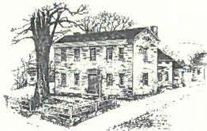
.!ZAe
S%e;fo!t/
...YcuttJrtcal:l'octe
Dan Raymond House Museum • Mark Dewey Research Center
www.S H EFFIELD H I S T O RY . ORG
The Sheffield Historical Society's mission is to promote a wider understanding of the people and events that preceded us in this area, and to preserve and transmit that heritage to current and future generations.
159 Main Street
PO Box 747
Sheffield, MA 01257

Phone: 413-229 -2694
E-mail: shs@sheffieldhistory.org

1774 Dan Raymond House is open
July-October, Tuesday-Thursday, 11 a.m. to 4 p.m. Or by appointment.

Mark Dewey Research Center is open Monday & Friday, 1:30 p.m. to 4:30 p.m.
Or by appointment. Emai:l mdrc@sheffieldhistor.oyrg

Old Stone Store is open on weekends,
Saturday, 10 a.m. to 3 p.m., and Sunday, 11 a.m. to 3 p.m.
Closed January through April

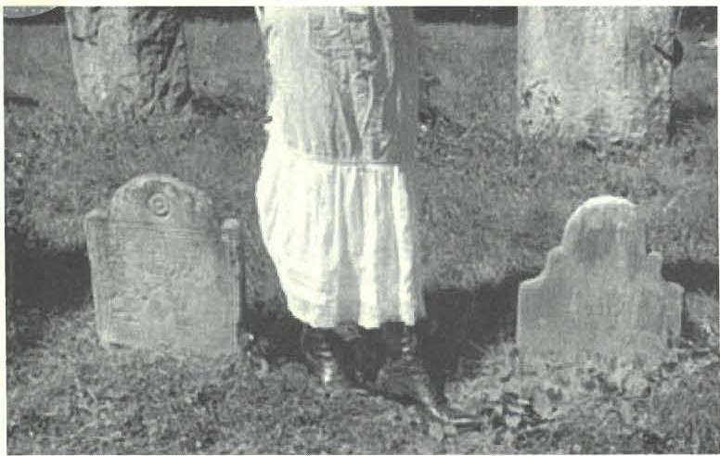
IMPRESSIONS OF THE
!Yltthc-e/1 Ude ettm

April 4-May 5 J 2008

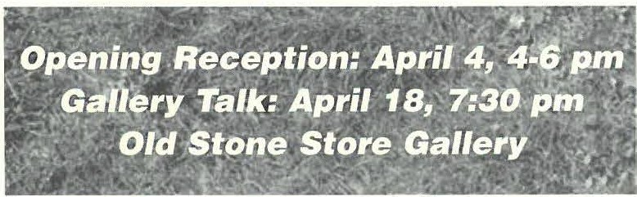

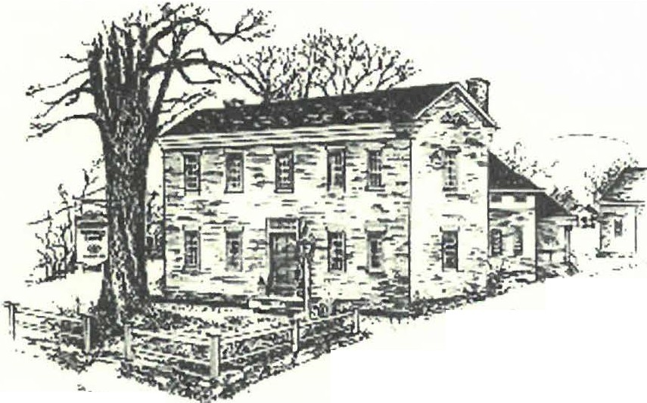2%e
, .
. -₋
- :.;:;- .
--..::
....
'
- - "!fr
--4' .·- - --
Yie}foltl
..!7lidttJrteal3/Jcteff
Late Summer ₂₀₀₈

SHEFFIELD, Frontier Town, Celebrates its 275 Anniversary
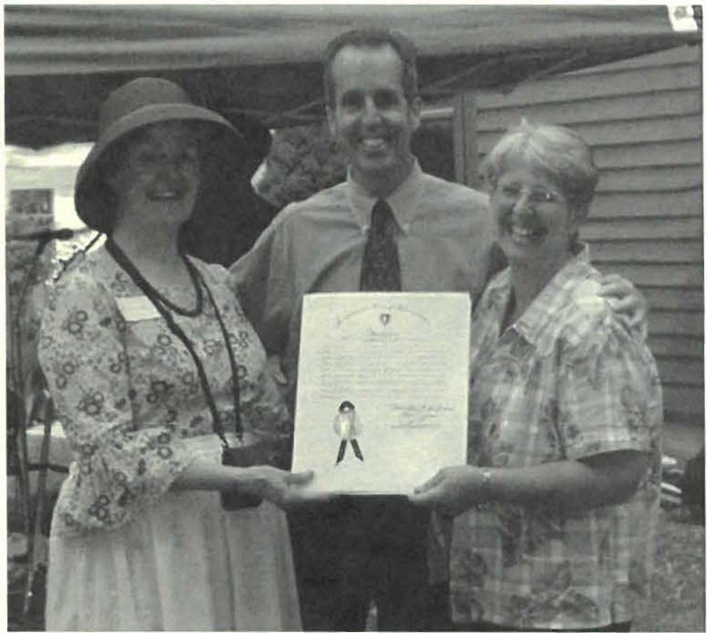
0 n June 21, 2008, the Sheffield H isto rical Society observed the 275 th birt hday of our town with an anniversary celebration. The
event drew a crowd of 150 people some loca l residents, some visitors. (Refer to pages 4-5 for a pictorial cove rage of the event.) T he Society wishes to acknowled ge all those who participated, especially the Bottom of the Bucker Band and the Morris Dancers, who invited themselves and rounded out the afternoo n with a flourish.
The Sheffield H isto rical Society also wishes to thank the following underwriters of the C eleb rat io n o f Sheffield Incor po ratio n o n June 22, 1733 at rhe first commun ity m Berkshire County.
B LUE RIBBON
Sheffield Plastics

RED RIBBON
Carlso n Propane Wh eeler & Taylor
WHITE RIBBON
Sheffield Water Co.

Smitty Pignatelli presents Marcia Bro/Ii, Society President, and Julie Hannum, Chair of the town's Board of Selectman, with a certificate honoring Sheffield's 275th Anniversary.

Society Archives Enriched with New Sheffield Quarry Documentation

Theresearch archives of T he Society were benefited recen tly by a significant contributi on by two Ashley Falls natives, Natalie
Funk and Priscilla Reger. The subject of their co ntributi on is Sheffield quarries, specifically the Ashley Falls quarry that is now the home of Grace Brown.
The two volume co llection was culled "from thousands of such documents o nly recently discovered when the remains of the old Southern Berkshire Marble Co mpany were sold." U nfortunately, most of them were in such poor condit ion that they could not be saved.
According to Natalie and Priscilla, the co llectio n "tells a story of operatio ns from 1899, the date of the earliest handwrit ten in the

files, to abo ut 19I 5. A fatal fire destroyed the quarry buildings, halting production of marble slabs for building purposes for government build ings in Albany, NY, and the nat io n's capital. According to the intro du ctio n by the donors, many of the soldiers' markers in Arlington National Cemetery came from this q uarr y. In later years agricult ural lime was produced, but the site closed down shortly after World War II.
T he research archives, housed in the Mark Dewey Research Cente r, is the major repository of Sheffield history. It is open on Mondays and Fridays, 1:30 to 4:00, for to p ical research, genealogy, and house histo ries. Trained volunteers are available each day for assista nce.

November Program to Remember

Dear Members and Friends,
Shcrfa•ld I listo ric1. 1Soc icry 2

World War II Invasion of Italy
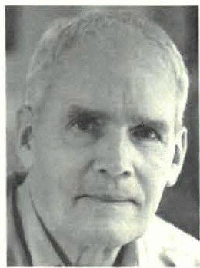
0 n November I 4, the Sheffield
H istorical Society will co mmemora te the sacrifices made by our veterans, part icu larly in World War IL Our speaker, John Toffey, will d iscuss and read from his book,jack Tojfey's r,
A Sons Memoir.
John Toffey is one of four
Summer bring s a hectic combination of work and play. And the Sheffield Historical Society has done both. At the Old Stone Score Gallery, we are presently laughing with the "A Serio us Look at the Funnies," Paul Banevicius's stu nning look at comics through the years. We previo usly enjoyed the "Red, White, and Blue" exhib it featuring the collection of Stephen and Wendy Leigh, and will end the exhibition season with a look at Rob Robins' work. What talented people S heffield has attracted!
We've played by celebrating Sheffield's 275t h anniver sary as a town and hold ing receptions for each exhibit and, as che summer ends, by gathering at a gracious garden parry at the home of

John Toffee
generations ofToffeys who fought in the military. His great-grandfather, John
Hester Velma ns and Peter Cherneff August 30th we will st roll the gardens, listen co the musical d uo, Contempaissance, playing

Sr., earned the Medal of Honor for Valor at Missionary Ridge d uring the C ivil War. H is grandfat her, Joh n Jr., fought with Pershing in Mexico and retired. as a majo r general in com mand of the New Jersey National Guard. His father, John III, the subject of this memoir, attained the rank of lieutenant-colon el before his death in Italy in 1944. John IV himself int e rrupted his studi es at Yale to enlist in I 95 1 during the Korean War, went to Infantry O ffice r Ca nd idate School, and was a company officer in the U.S., Korea, and Japan.
After his service in the Korean War, Toffey com pleted his s tudi es at O hio State University, graduating in I 955 with a degree in English. He has a Master's Degree from Co lumbi a
University. Toffey has served on the faculties of the Kent School, th e Co lumbus Academy, Simon' s Rock College, and Berkshire School, where he taught English, coached football and baseball, and performed vario us ad ministrative duties.
Jo hn Toffey IV was 13 years old when his father was killed in the hill town of Palestrina, one day before the Allies marched int o Rome. Lieutenant-Colon el Jack Toffey had commanded
a combat battalion longer than any other officer in the Mediterranean theater.
Only in 1996, when his facher's lercers were discove red, did John Toffey begin to piece toge ther the story his father " never got co tell." It is a moving account of a young man's journey to know a father who went to war in 1942 and never came back, weaving memories, histo ry, interviews with surviving members of his father's unit , and his father's letters home into a
fascinati ng tale of a family, a war, and che threads that conn ect them.
Toffey's book also portrays life o n th e home front in O hio, where a boy, his siste r and his mot her waited out the war,
scanning newspapers and magazines for news of Dad , and devouring letters full of hum or and love for his family and d reams of a good life after the war.
John Toffey's calk and book signing will rake place on Friday, November 14, a t 7 :30 p.m., at Dewey Memorial Hall in Sheffield.
- Joyce Hawkins, Program Chair
classical guitar an d flut e, and enjoy each othe r's conversation and
company.

As we go in to the fall, th e program com mitt ee, und er the able leadership of Joyce Hawkins, has planned a full and varied progra m for the year. Like lase year, the dates, times, and places vary, so please put each event on your calendar now. You'll like the variety. Please join us often.

Joanna Jennin gs, o ur ad mini st rato r, has put the Sheffield H isto rical Society in the pages of all the local newspapers, on posters all over town (posters which are becoming collecto rs' items), on CTSB, and in the Shoppers' Guide. l am ever so grate ful to her for the success of her first year with us. The office is becoming a busy place-w ith several of us learning PascPerfect, che museum software which is a data base for the collection a nd for the members hip. Philip Detjens has been the busiest in putting the in formation from all our handwritt en and typed notes into che system , I have been struggling with the membership lists, a nd by the end of next winter, we should have it well under way.
Thank you for all your suppo rt. See you in She ffield,
Marcia Brolli, President
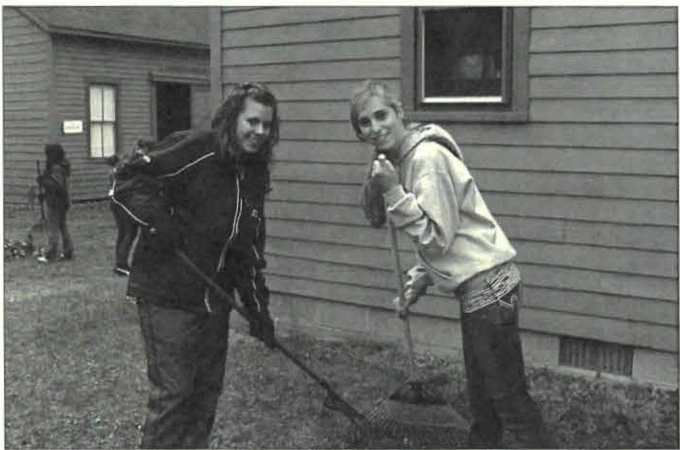

A group of Berkshire School students helped with spring clean-upat the Sheffield Historical Societyon Gracious Living Day on April I 1.

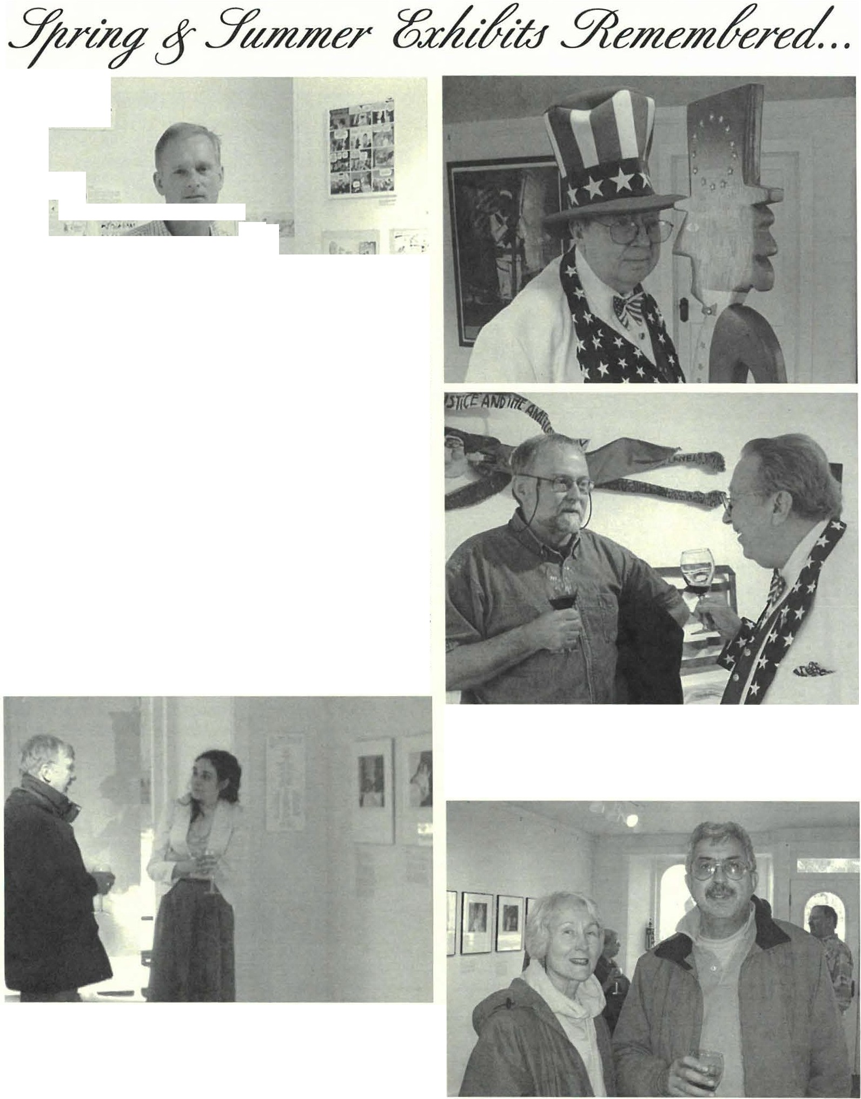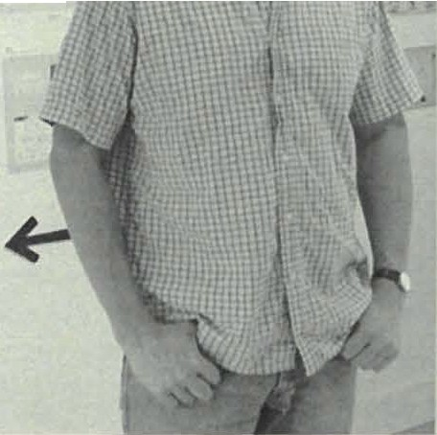
Shd field I lisrm ical ocicry 3

The Golden Age
1,10.1940

. .#'·
: - •• J

L IN "
' I I ..-
y ,

' ti j,.., ·

Paul Banevicius's comic strip exhibit has been a great success-in the guest book there is an entry of Lawrence Klein, Founder & Chairman Emeritus of the Museum of Comic & Cartoon Art in New York City! If you haven't had a
chance to see it yet, don't worry, you still have plenty of opportunity. It will remain up through late September. And if you didn't see the article on the front pages of the Eagle look far it in the September issue of Berkshire Living Magazine. Jennings said, "Paul Banevic1i1s has graced our gallery with a top-notch exhibit which is professionally installed and creatively displayed. You learn something of the progression of the comic strip, but what's more is, it's also engaging and fim!"

At top, Stephen Leigh stands nose to nose with one of the Uncle Sams in the Red, White & Blue exhibit this summer. Above, Stephen ,md farmer Society trustee Mark Ziobro share a toast at the exhibit reception. In the background Mr. Leigh's super patriot waves a banner pledging "Liberty and Justice far All. "

Above, Norman Hettinger engages Joanna Jennings on some of her "visual narratives" this spring at the opening reception far her photography exhibit Impre ssions of the Bidwell House Museum. In the interest of teaching
peoplemore about her artistic process, Ms. Jennings also held a gallery talk far her exhibit. At right, Georgette & Leonard Bumess also attended the reception.

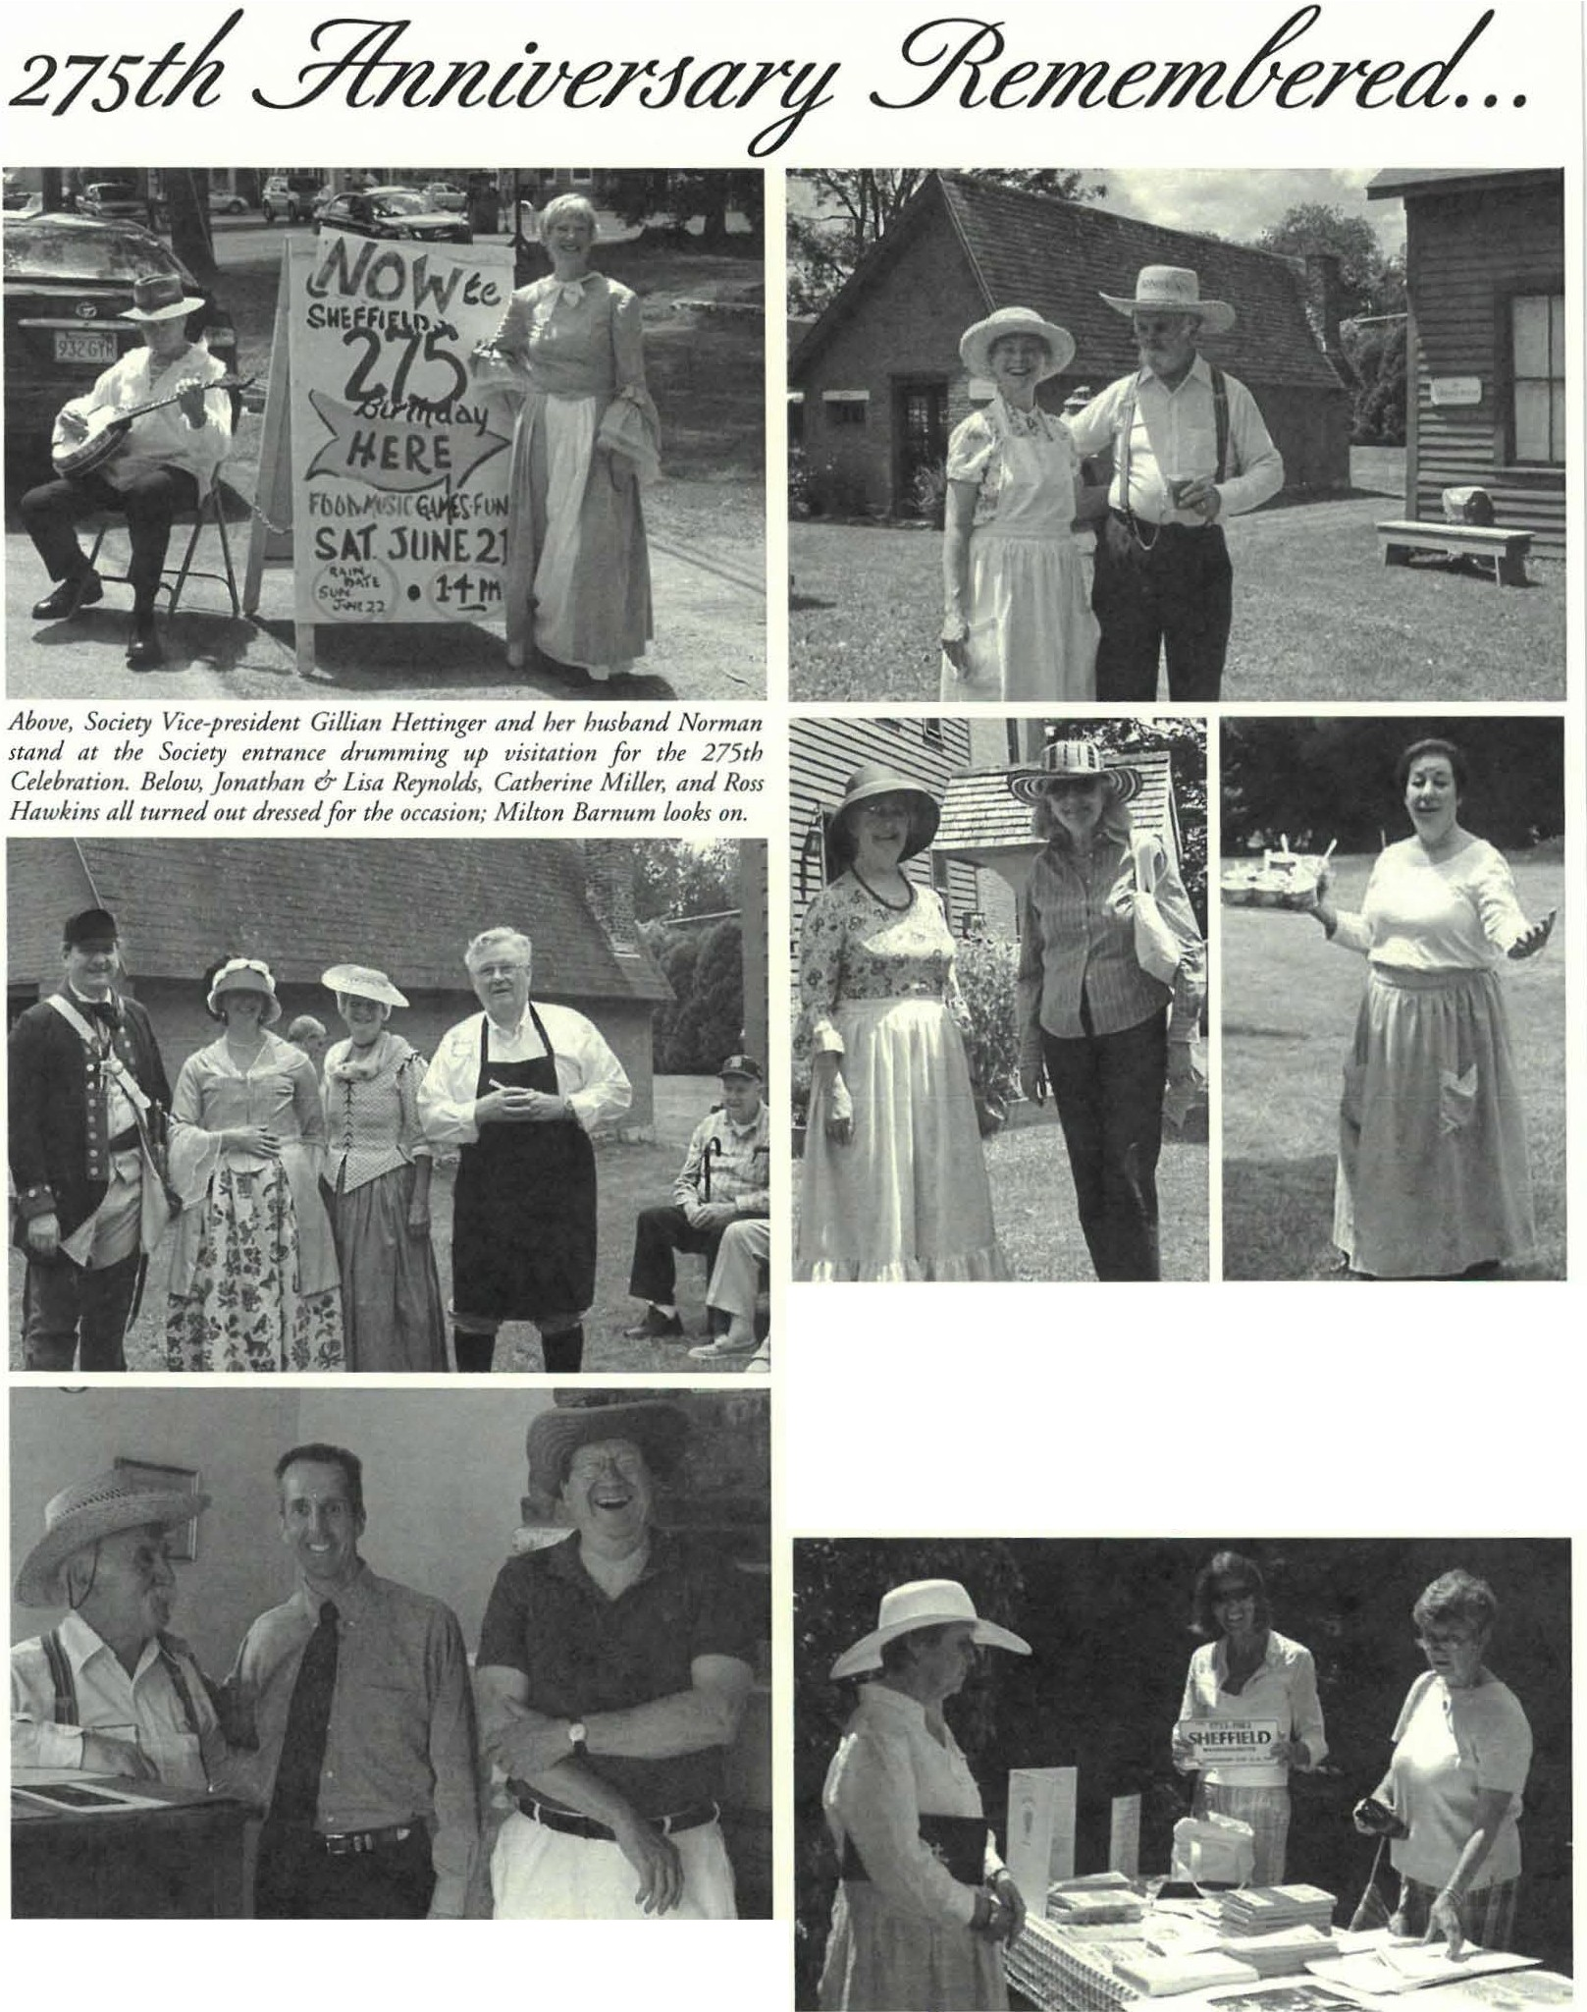
Shd licld Hi, w rical 'iociccy 4

At top, Betsy Garcia and Harry Conklin pose in front of some of the variom historic stn1ctttres on the Society grounds. Beneath, at left, Marcia Brolli greets KAthleen Chrisman. At right, Society trttstu, Lois le vinsohn, hospitality chair, was one of the busy chefi d'oeuvre at the event. Below, Society Treasurer, Connie Cooper, mans an informational table with variow publications the Society has put out over the years. Among the things for sale were both the 250th pictorial history of Sheffield and a newly edited 275th rnpplement. Ann Barrett flashes a SHEFFIELD license plate as Linda Greenwald woks ttp.

Smitty mingles with Society trustees Harry Conklin and Philip Detjem, who were stationde in the I9th century law Offi ce. Harry Conklin, Esq. went as Parker j. Hall, Esq. to whom the two-room office once belonged.

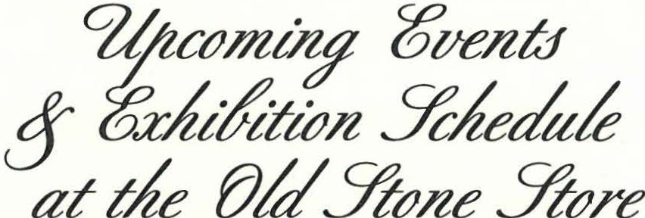

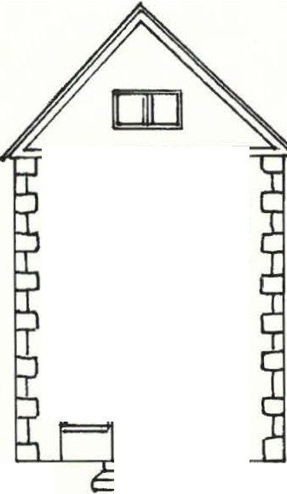July 19-September 28. A History of the Comic Strip: A Serious Look at the Funnies. An exhibit exploring the history of the comic strip through the personal collection of Paul Banevicius featuring original art and over 550 cartoonist sketches. Paul Banevicius is a local resident, faculty in photography, and chair of the Berkshire School Art Department.
mmm
00
□□

Saturday, August 30, 3-6 pm. The Last of the Summer Wme.
The Sheffield Historical Society's end -of-summer garden party will be held at the home of Hester Velmans and Peter C herneff, 778 Hewins Street, Sheffield. T his is a fine occasion to enjoy the late-summer bloom of an elaborate garden and property well appointed with history and rural charm in the company of friends. Summer wine and hors d'oeuvres. Admission is $30 per person. Pre-registration is strongly encouraged. Call 413.229.2694 for reservations.
Saturday, September 20 & Saturday, October 4, 11 am.
Housatonic Heritage Walks: A Walking Tour of Sheffield.
Many well-built historic houses still adorn Sheffield's main street, and chis walking tour is designed to point them out and refer briefly to some of the illustrious Sheffield citizens who owned them. For a more detailed history, visitors are referred to the Sheffield Historical Society's Mark Dewey Research C enter. The tour will start at the Sheffield Historical Society,159 Main Street.
Friday, September 19, 5-7pm. Annual Sheffield Spirit Walk.
Join us in Barnard Cemetery for a theatrical reencouncer with Sheffield history as memorable residents from our town's past are recast! Learn their stories as they are vividly brought back to life before you. Barnard Cemetery is located on Rte. 7 South, opposite Root Lane.
Saturday, September 20, 4-?pm. 3-Roast Feast.
Join the Sheffield Historical Society for its annual dinner.
The feast will be held at the American Legion Hall on the Rte. 7 in Sheffield. Call for reservations.
Friday, September 26, 7:30 pm. Inside the Berkshires.
David J. McLaughlin will present a book talk & signing. In this unique book 'unfolding' timelines
and human interest stories tell the history of our picturesque and culturally diverse Berkshire region.This program will be presented in conjunction with the Bushnell-Sage Library and the Bookloft.The program will be held at the Bushnell-Sage Library.

For the latest list of upcoming events visit us on the web at www.shdJieldhistory.org/calenda.r

(Flip me over for morel)

Saturday, October 4, 12:30 pm. Traces of the Trade: The Massachusetts Story This fall Mass Humanities will be commemorating the 200th anniversary of the abolition of the foreign slave trade, with the newly released film, Traces of the Trade, as the centerpiece of 6-7 events around the state that bring the film to each locality as a local story that is part of the Massachusetts economy (fishing, textile, finance, domestic economy.) The programming will feature screenings of a shorter version of the film, paired with archival materials, at a number
of historical sites throughout the state that have relevance to the economy of slavery.
The program will be held in Dewey Memorial Hall. The extended program includes a bus tour to the Cownel John Ashley House. For reservations, call (413) 229-8600.
Saturday, October 4-November 2. The Work of Seymour Robins.
Seymour Robins is a local designer known for his paper sculpture greeting cards which he designed and produced between the mid-l 950s through the late 1990s for a myriad of corporate clients in a commercial series; the artist's personal oeuvre also included an annual holiday series. This retrospective exhibit will focus on Mr. Robins's artistic process as well as his finished work.This exhibit will have a reception on Saturday, October 18, from I to 4 pm.

Friday, October 10, 7:30 pm. "Cheerful Despite Their Ragged Clothing:" Hessian Prisoners in the Berkshires and Beyond.
Dennis Picard, Director at Storrowton Village and previous Director of the Society, will talk about the experience of German prisoners of war during the American Revolution in western Massachusetts and northern Connecticut. The "Hessians," as they were collectively called, served with the British forces under contract to King George III.
The program will be held in Dewey Memorial Hall.
Friday, November 14, 7:30 pm. John Toffey, author of Jack Toffey's "War
will present this book talk & signing in conjunction with Bushnell-Sage Library in observance of Veteran's Day. In this memoir, Toffee writes of the WW II Allied invasion of Italy where his father was killed. The program will be held in Dewey Memorial Hall

November 8-December 21. Holiday Marketplace.
Saturdays & Sundays from 10-2 with occasional extended hours.
Shop for everyone on your list at the Sheffield Historical Society's holiday bazaar. Featuring an array of handmade goods including miniature trees, wreaths, ornaments, jewelry, holiday treats, gifts, raffles. Upstairs holiday tag sale and Old Stone Store markdowns.
The Festival will have special extended hours from 11 to 5 on B/,ack Friday {Nov. 28).
Sunday, December 14, 3-5 pm. Dan Raymond House Holiday Social.
Come gather round the festive Keeping Room fireside and enjoy some holiday cheer. Join friends new and old. Music, merriment and more.

Friday, January 9, 7:30 pm. What's It? Night.
The items as ever have yet to be determined. Curious? Come find out!
The program will take p/,ace in Dewey Memorial Hall.

For the /a,test list of upcoming events visit us on the web at www.shdJieldhistory.org/calendar

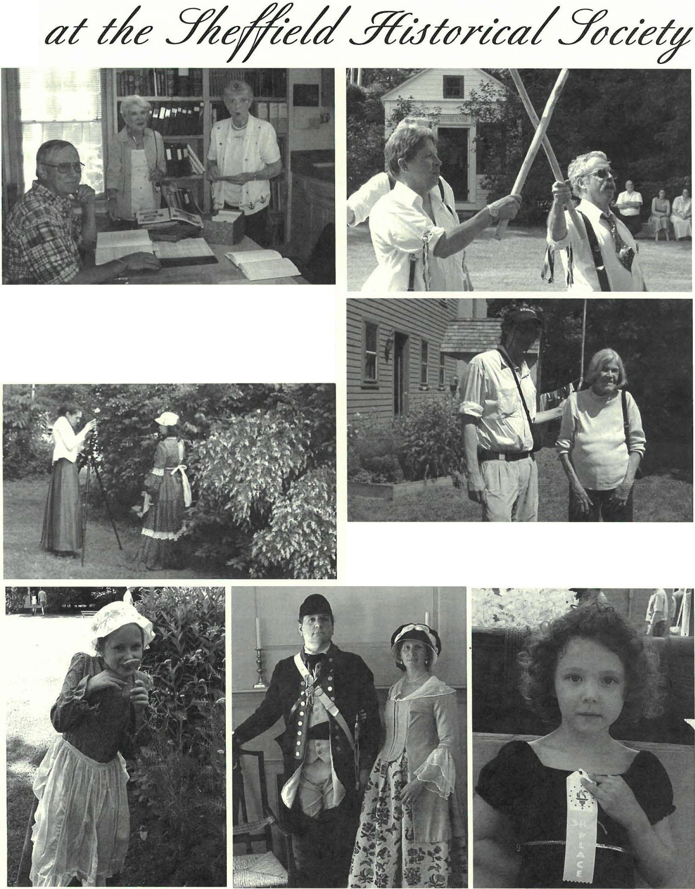
Sheffield Hiscorical Society 5

•• •

Above, the Mark Dewey Research Center was kept open by the Society archivists extraordinaires, Jim Miller and Betty Chapin. Below, the director went as Carrie Smith Lorraine, Sheffield's first woman photographer, to take vintage portrait photographs which the children hand-colored. Below ftom left to right are some of the results-Eastlynd Bates dressed as a girl ftom the period; Jonathan & Lisa Reynolds as a Revolutionary Loyalist couple; and Elizabeth Hotaling as herself displaying a ribbon she won at the event.

At top, the Morris Dancers provide entertainment during the celebration. Above, Steven Borns, of CTSB-Tv, attends the event with Roberta Wheeler. Steven is in midst of working on a documentary film about the Captain Truman Wheeler House for the Great Barrington HistoricalSociety.

hcllicld Hi roric.il S0c:1cty 6
Seymour Robins Exhibit to Open this Fall
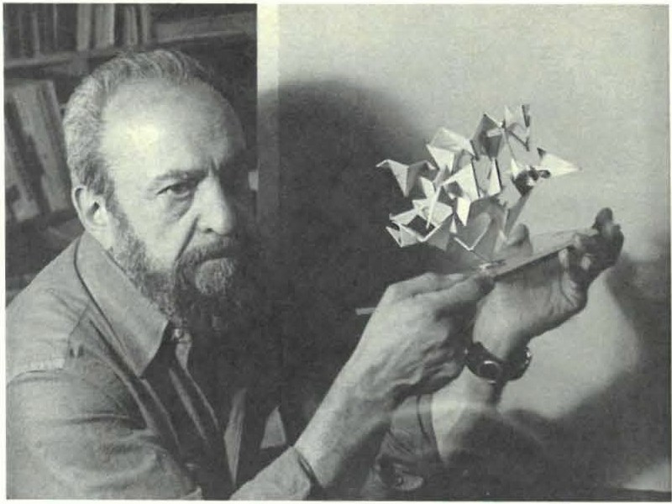
graphic designer, Seymo ur Robins, in an upco ming exhibit of the paper sculptures he created from the mid- I 95 0s through 1998.
O ve r 75 hanging or standin g paper sculp ture creatio ns, whi ch
include designs for corporate clients, museums, and UN IC EF, as well as his own yearly holiday sculp tures, will be featured at a retrospective scheduled for O ctober 4-31 , 2 008. A reception for the artist will be held on Saturday, October 18 from 1-4 PM.
Seymour "Rob" Ro bins lived o n Boa rdman Street for almost 40 years in the old Wilcox barn, which he completely re novate d over the years into his home and stud io. H is career followed his milita ry service and, beginning in the early I 95 0 's, he was o ne of Manhattan's most prolific an d talented graphic and package designers. Rob's lase commission for a paper sculp ture was from MOMA in 1998, when his macu lar degeneration limit ed his vision. Rob, a lifelong student of vision, was also a major

Seymour Robins displays one of his paper sculptures he designed between the mid-I950s- the late I990s. His work will be featured by the Society in a retrospective exhibit curated byJim Miller and Rene Wood this foll

T he Sheffield H is tori ca l Soc iety will present a uniq ue opportunity co view th e creative mind of a prolific a nd talented
co ntributor to the field of perceptio n studies at Prin ceto n University.
T he Society recently accepted a gift of his collec tion of his paper sculptures and ocher graph ic d es ig n materi als. Several of Ro b's sculptures are part of the permanent co llec tion of the Coo per- Hewitt Museum in New York City.

Sheffield Historical Society Acknowledges the Council's (MCC) Support

FY2008 marks the last year in a three-year grant cycle of a
Massachusetts Cultural Council (MCC) Organizational Support Grant chat the Sheffield Historical Society was awarded in FY 2006. Throughout the past two years, numerous monthly programs and exhibits were all made possible through the support of the MCC. This year the Society elected to apply the majority of the
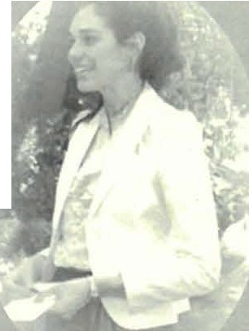
prestigious $2,500 award toward the administrator's salary.
The Society administrator is a pan-time employee of the Sheffield H isto rical Society. The Administrator manages Society operations in accordance with the policies and procedures established by the Board of Trustees. Reporting to the president of the Board, her primary
responsibility is the day- to-day administration of the Society and its
historic seven-building complex, with the primary focus of executing administration, providing communication between the Society, Board of Trustees, and the membership. Secondary focuses include developing educational projects, exhibits,

programming, and preserving the Society's collections. The Society is grateful to MCC for the necessary funding to help maintain the integrity of our organization through the position of administrator.
Another part of the award was used co upgrade the Society's Past Perfect Museum Software from 2.0 to 4.0. This software is recognized by the American Association for Scace and Local History (MSLH) as one of definitive programs used by museum and historical societies across the county. It allows an organization to compile and combine its collections reco rds (archives, library, objects, and photographs) and membership list in one database. The update was long overdue and its purchase has allowed che Society co start the daunting process of digitizing our paper collections inventory.
At a suategic planning conference held in FY 2008 the Society was successful in forming a number of committees to report to the Board. This kind of extended governance is vital since the Society underwent a significant staffing change in FY 2007 from a full-time director to a part-time administrator. Because of the staffing transition more responsibilities now fall upon the Board, its active membership, and cadre of volunteers. Ac the conference it
article continues on page7

Sheffield I li torica l Socicrv 7

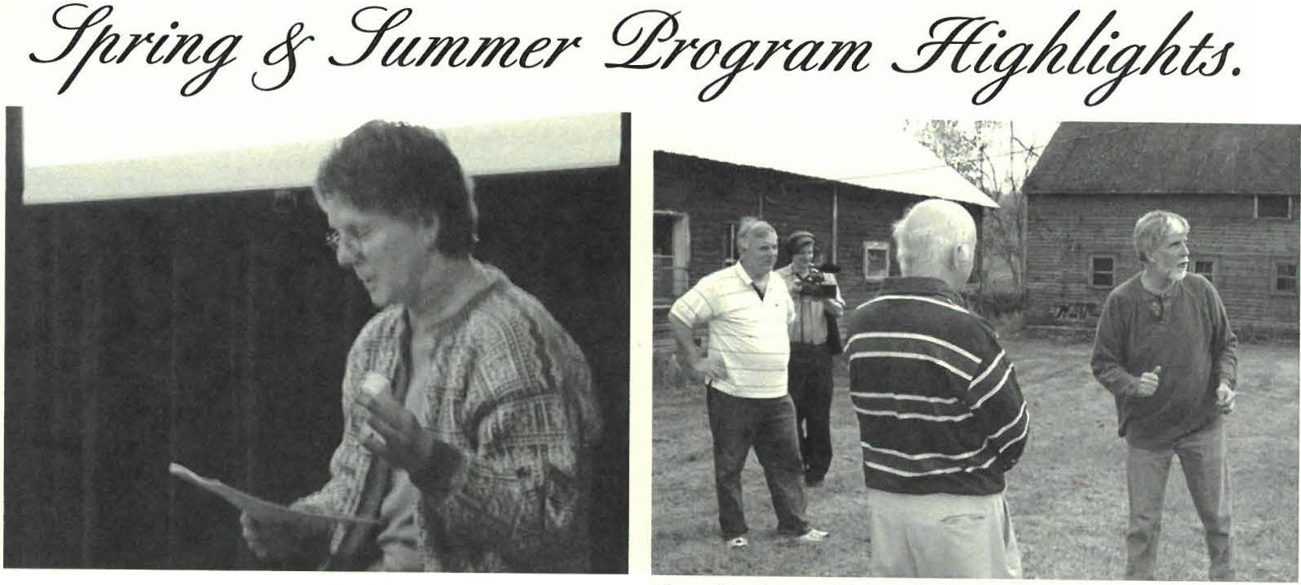Ruth Green of· Green Arts Carden Design in Monterey, MA and head gardener at the Bidwell House Museum prepared a thoughtful powerpoint presentation about heritage garden planting schemes at the Society's March meeting, "Colonial Carden Planning and Planting."On account of Green's fallowing, no doubt, the program was very well attended with garden enthusiasts ftom Berkshire and Litchfield Counties alike!
• •

MCC Ackno wledgementarticle continued ftom page 6

was agreed that one of the organizational priorities was to bring the Society into the 21st century by the digitilization of our paper records. To answer this a collections committee was formed. The Society has set a goal of three years to this project, but the recruit of a collections intern in the future may help expedite this process.
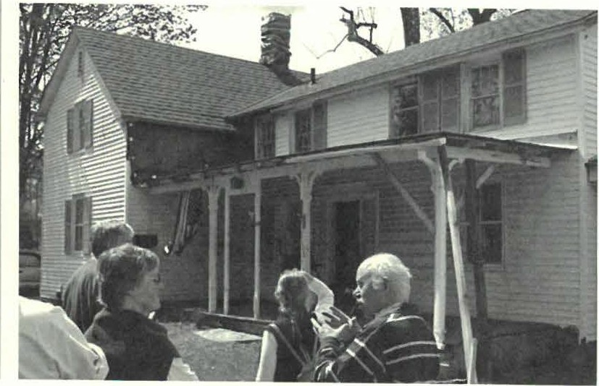The mission of the MCC is to promote excellence, education, access, and diversity in the arcs, humanities, and interpretative sciences in order to improve the quality of life for all Massachusetts residents and to contribute to the economic vitality of our communities. The grants are awarded through a competitive process. Receiving a MCC GOS grant signifies that the Sheffield Historical Society provides a high level of quality in its programs, community service and administrative capacity.
lMassiachuseltts Culltural Council
Sheffiebi HiJtorical Society adminiJtration has been made posible, in
part, by support from Massachusetts Cultural Council a state agency.
Great Barrington Historical Society President, Brian Burke, and Vice-President, Cary Levielle, provide members of the Sheffield Historical Society with a tour of the Truman Wheeler house barns this spring. In the background Steven Borns of CTSB-7V records the tour far use in a documentary film project he has started as part of the CBHS 's Capital Campaign to restore their future headquarters.

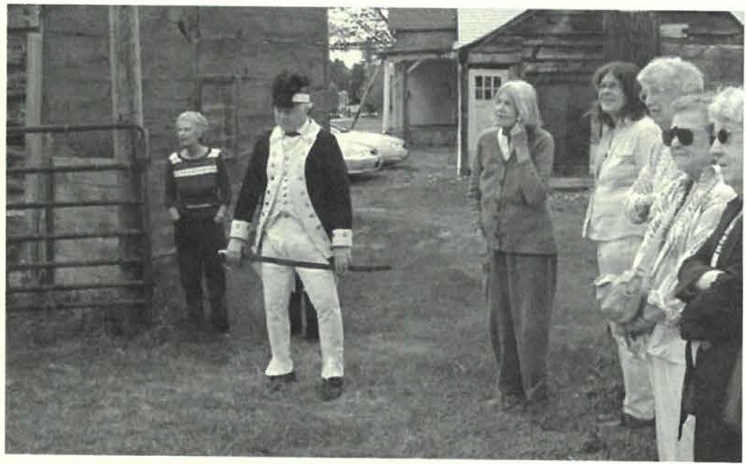
M eanwhile, GBHS trustee James Parrish in fall military character regaled the rest of the group with the story of the Wheeler family and their ancestral home.

2008 BOARD OF DIRECTORS
Mar cia Broll i, President
G illian Hett ing er, Vice President
Co nnie Cooper, Treamrer
H arr y E. Conklin , Clerk

J oyce Hawkin s Lois Levinsohn Philip Decjens D ennis Sears Kath y Tetro
MUSEUM STAFF
Joanna Jennings, AdminiJtrato,· Betty Chapin, Vo/11nteer Archivist J ames Miller, Voltmtee,· Archivist
TheSociety is in the midst of updating our membership database. Please review your name & address, and notify us of any changes!
Weare also in the midst of redesigning our website. Please cont inue to check back for future updates.
New developments will includ e the calendar & special events page with photograp hic highlights from recent exhibits & programs. Thank you for your patience.
A Serious Look at the Funnies
A History of the Comic Strip

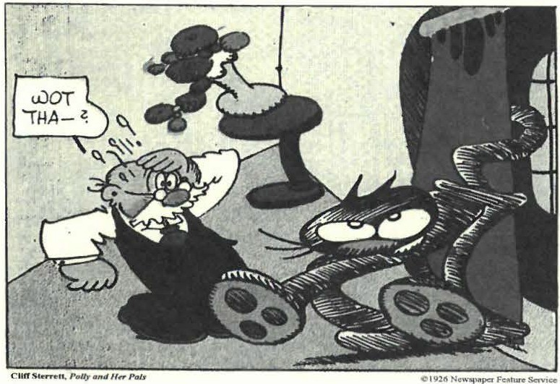
Featuring Original Art & Sketches
from the Collection of Paul Banevicius
July 19-September 18, 1008

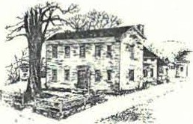
.!.?he
%elftelal
..YlitttJrteal.Yocte
Dan Raymond House Musmm • Mark Dewey Research Center
www.S H E FF I E L D H I ST O RY. O RG
The Sheffield Historical Society'smission is to promote a wider understanding of the people and events that preceded us in this area, and to preserve and transmit that heritage to current and fi1t11re generati ons.
159 Main Street
PO Box 747
Sheffield, MA 01257

177 4 Dan Raymond House is open May-October, Tuesday-Thursday, l l a.m. to 4 p.m. Or by appointment. Phone: (413) 229-2694 Email: shs@sh effieldhisto r.y.oq;

Mark Dewey Research Center is open year round,
Monday & Friday, 1:30 p.m. to 4:30 p.m. Or by appointment. Phone: (413) 229-3682 Email: mdrc@sheffieldh istoey.o q;

O ld Stone Store & GaUery is open on weekends, April-December, Saturday, 10 a.m. to 2 p.m., and Sunday, 11 a.m. to 3 p.m.
Phone: (413) 229-2287

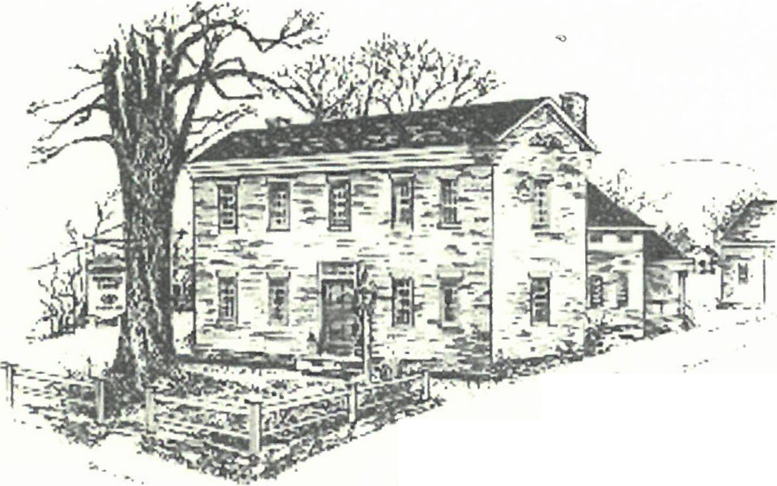!ZJe
- ..
;/-: :·-· .
-:._•f ,r
:... -- 4 ':Y - ....,..
.... _;,,,. ,o• -
."' ..... --
3%elfo!t:I
.ffiuttJrtcalYbae
Spring ₂₀₀₉

Illness & Death in 19th Century Sheffield:

Collection of Letters Provides a New Window into Old Times
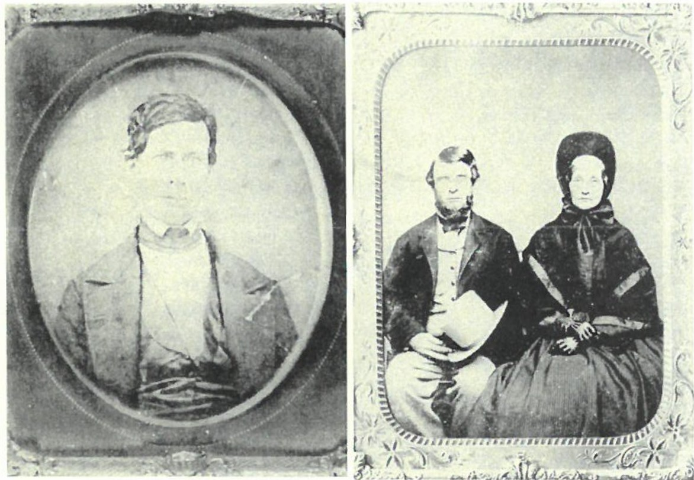
The Mark Dewey Research Center, che library component of
the Society, has recently acquired a group of early 19th centur y letters written from Sheffield to family members in Connecticut. The worth of this collection is the light it sheds on the town's day-to-day life about 190 years ago. The prevailing copies of concern amo ng the correspondents were health and death, and religion and domestic duties as exemplified by the family of Ralph and Maria Fox Little, local merchants of more than average means. Their place of business was an imposing Greek Revival building, now gone, on the site of present-day Gretta's. The missives, extensively quoted below, retain their original spellin g but with modified punctuation added for clarity.
Maria Fox Little was from East Haddam, Connecticut, a

daughter of Aaron Fox and his wife Eunice Beebe. She had sisters Eunice, Almira and Teresa, and it was among the four of chem that the largest number of let ters were written with some to their brother Robert and one to a brother-in-law Brainard Palmer.
It is not to be judged which vividly described death in
the letters is the most horrendous, that of Ruth Kellogg, age 95, the oldest resident, or chat of Almira's new born baby.
Mrs. Kellogg was burned to death alone in her room­ "suppose d she fell in the fire though they found her some distance from it, her cloches burnt off, her gold beads melted on her neck."
In the baby's death, Almira writes to her mother, "the babe had fits from Friday till sometime on Tuesday. The family & neighbors had no expectation of its life from one moment to another.... During the day past it has had several fits I
thought it had done breathing entirel y & sup posed twas torn from the a rm s of its fond friends & to kinder arms received but this idea cou ld not prevent my grief" The following day the letter continues, "[T ]he babe is much as twas yesterday has turns
Two post Civil War era portraits .from the Society archives help bring the letters to lift. At left, Dr. Silas Root Kellogg, is the physician referenced in the letters. At right, an 1860 portrait of Lucius and Lucretia Little. Lucius, also referenced in the letters, was the son of Ralph and Maria Fox Little. He and his wife maintained the family business, L. Little, a dry goods store which remained in the family until the building was destroyed in a 1905 fire. The couple's son, William H., occupied the Dan Raymond House with his wife, Clara P. Little as of 1884. They were the last long-term owners of the house before the Sheffield Historical Society established its headquarters on the premises.

of looking purple or almost black & I cannot discern any appearances of it s breathing for several minutes. . . . [I] t has not tried to suck sin ce yesterday morn but I try feeding it every time I think twill swallow. . . . During the ni ght it has appeared if every breach & groan would be its last. Seeing it seems to melt the hardest heart. . . . All who see it think it would be a relief coo have it breat h[e] its last, agonies are so great." Then, the following day, "T he conflic t is now ended and the lovely babe is now sleeping the sleep of death & this is now a house of weeping and sorrow.
Article continued on page 2

5%e#eif 5l"i:Jt- rtcalYbc fjt

Continued .from .front page

",hdfa·ld Hi,roric.tl Socicry 2

2008-9 ANNUAL APPEAL
MEMBERSHIP DRIVE
Thank you all for your support! We have entered your names into a new data base.
Please let us know if you would like your name entered in another way or if your
name has been omitted.
It is a very pretty featured child & appears lovely in d ath."
The family also endured near-death trauma. Sister Eunice learned in a letter of January 1817, "My Babe has had ill turns all winter. [H]e had some­ thing gather in his head which discharged at his ear. [H]e didn't appear sick but crying as if in distress. [W]e thought he was cross somet im es-till the cause appeared. He has since had a bad humor in his head & neck but has now got about well of that. His physician calls it the rickets in the bowels. I am in hopes he is better. [H]e has days of looking very frail & seems to be in pain & nights that he sleeps but little. We have been much concerned for him & chink him not out of danger now. . . ." And in the same letter, "All this time I want to be talk­
ing to you about sister Teresa health, her babe & yours & etc so much I know

John & Emily Alexander Ginger Alexander
-,
Allen & Karin Altman Doreen & Walter Atwood Fred & Betry Bangs
Ann Barrett Trumbell Barrete Beth Bartholomew,
in memory of Dmltl Bartholomew
Beery & Arthur Bacacchi Barbara & Malcolm Bayliss Timothy Beard
Paul Benjou & P.J. Bradley
Blanche & Bill Bennett Robin Berthet
Jean W. Blackmur Steven Borns Marcia Brolli
Joan Brooks
Grace Wallace Browne Bill Browne
Pauick & Barbara Burns Grace Campbe ll
Tony Carlotto Patricia C arlson
Edwin H . & Barbara Car r, Jr. Sharon Casdin
Neal B. & Julie C ham berlain Elizabeth C hapin
Elliott & Fern Chapnick
Peter Cherneff & Hester Velmans Kathleen & Neil C hr isman Consta nce Cincotta
Ursula & Walter C liff Kent Clow, lII
Christopher & Amanda Coenen
Noel & Baukje Co hen Paul & Carrol Co lli ns Abbott Combes
Sally Cook Holly Coon
Constance Cooper Dorothy & Peter Crockett,
in memory of Howard Crockett
Jean E. C urt is
C harlotte H. Dallen Tony & Dana Dapolito Bob & Ann Dean
Nancy & Dwight Dellerc Philip & Susan Decjens Dorothy & William DeVoci Mr. & Mrs. Anthony J. Dibrita Thomas & Cynthia Dixon John & Audrey Downie
Tom Driver & Anne Barstow,
in memory of Ellie Gilligan
C har les A. DuCharme,
in honor of Marion & Dorothy of
Staveleigh House Days
Frances Eastburn Norma Edsall & Alice Corb in Margie & Branch Elam Patricia & Peter Eis bach
Nancy B. Emery Michael Farmer
Susan & Marcin Fischer
Inez Flinn Dr. Dorothea Franklin Don Freedman & Susan Rothschild
Pattison & Ca ro lyn Fulton
Phil & Betsy Garcia Frank Garretson & Helen Bray-Garretson
Rene Gibson Ruth A. & Susan Gillette
John & Elsie Gilligan Frederic Gordon Richard Greene William G rie f & Leonard Graziano Edmund A. & Arlene P. Grossman Marguerite Guli ck Lovina Gulot ta,
i11 memory of Santi j. Gulotta
Wray Gun n & Cora Portnoff John & Joan Hanlon Terna & Monte Harnik Joyce & Ross Hawkins Esther Heffernan
Claire Height Gillian & Norman Hett ing er
C aitl in Hotaling Susan & Joseph Hurlburt James & Donna Hu rley Virginia M. Jackson-Howden Katherine Ness & John James Robert Jencer & Andrea Scot t Mary & Char les Joch, Jr.
Ursula Kilner James & Beverly Kimball
Beverly Ksadel Jim Lamme & Wendy Linscott
Allison Lassoe Dr. & Mrs. Geo rg e M. Lazasus
Alice Leason Gary LeBeau
Susan & Philip Lebowitz
Robert D. Ledlie Lou & Pac Levine
Brian & Lois Levinsohn
not how to begin my inquiries. I want to see T[eresa] very much but would give more if Doer. Delamatter could see her in the critical state which her health is now in. He is exceedingly skilled in intricate cases where every physician around has failed. He frequently gets a correct idea of diseases."
Accidents also were part of life in the Little family. Maria reports to her sisters, " [Son] Robert runs away. We have no fence to keep him in. It is very dangerous for such children in the street where there is so much travel. A few days since a traveller in a covered loaded wagon drove against him, chrowed him down. The wheel passed several inches over his hip and bowels cornerways & backed off without breaking any bones. His pa fortunately saw the wagon from the store door. When l was near him ran & called to the driver but he didn't hear him nor see Robert 'till the instant his pa reached him. It was the most nar­ row escape I ever saw or heard of."
Silas R. Kellogg, a Sheffield physician, was closely connected with the family. He gave Maria's brother, Robert Fox, the following medical advice. "Should you continue at [medical] school, lee me caution you against neglecting to take a proper degree of exercise. Without this, you'll have the dyspeps ia, blue devils, vapors, & horrors all upon you." He continued on about the Little family's medical problems, "I have no less than three patients in their fam ily now, rho' none of them much sick. Mrs. Lhasa pain in her side, Robt [Little] has a badly inflamed eye & the babe coughs & belches & wheezes & sneezes."
Epidemics added further conce rns for Maria's family. "My family has for some time past been in a situation to req uire more than ordinary care & concern.... They are just now getting over the measles. Lucius first took it. Marietta, Robert & Frank took it of him. Next Ralph, Anna & Augusta &
George the eldest had it hardest as is common & are not as soon over it. We
I
called a physician twice. Have not been as well myself since in consequence of
the fatigue. I expect have had much of the hardest head-ache & distress in my left side." And another epidemic was " ... cholera in almost every city & many of the towns around us."
As with all Society archives, the letters are available for research or simply out of interest. While we have a number of letters in our collection, none are more important than these with respect to the lives of early 19th century residents.
The letters also provide a new window into interpretin g how life was lived at the Sheffield Historical Society before its establishment. As noted in the photograph caption on front page, third generation Littles occupied the Dan

Shdfo.:ld Him,ric:il 'ioci-,r: 3

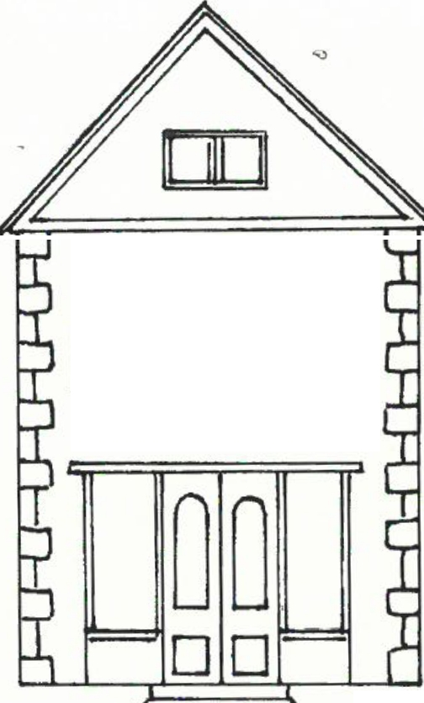CIJHU1? 6uent-J

mmm
cf fff.zht-/laon YdeLJ
at tAe Olt:/Yione Yiore
Friday, February 13, 7:30 pm.
Edison Meets Victor or Nipper's Valentine.
Classical singer John-Arthur Miller will speak about the early history of music recording technologies. Bring along your Valentine to enjoy love songs, learn the difference between "h ill-and-dale " and lateral cut, and, finally, meet "Nipper."
The program will be held in Dewey Memorial Hall.
Saturday, February 21, 9:00 am. Board Retreat.
The Sheffield Historical Society board and extended board will follow-up on the process of
last year's strategic plan. Admission is by invitation only. The re'treat will be held at Landmark Volunteers.

Friday, March 13, 7:30 pm. Sheffield Planting Schemes.
Local horticulturist, writer, and lecturer, Ron Kujawski, author of the popular "Gardener's Checklist" Berkshire Record column and the Berkshire Eagle's "Berkshire Garden Journal," will present a power point presentation on plants and flowers chat will thrive in your Sheffield garden.
The program will be held in Dewey Memorial Hall.
Friday, April 10, 7:30 pm. The Portraiture of Carrie Smith Lorraine.
Joanna Jennings, the Society Administrator, will present a power point presentation focusing on the life, times, and work of Carrie Smith Lorraine, Sheffield's first woman photographer. The program will be held in Dewey Memorial Hall.
Friday, May 8, 7:30 pm. Confessions of a Revolutionary Loyalist Couple. Jonathan & Lisa Reynolds, Revolutionary reenactors extraordinaires, in a program TBA. The program will take place in the Dan Raymond House.
Friday, June 12, 7:30 pm. Annual Meeting & The Battle of Midway.
Grieg Siedor will speak in commemoration of the 65th anniversary of the Battle of Midway at the Society's Annual Meeting. The program will take place in Dewey Memorial Hall.

Friday, June 26-Sunday, July 12. Five Friends Art Exhibit. Walter Bogard, Hans Heuberger, Sean Ryder, Lois Ryder, and Lois Van Clef return for their fourth year to the Old Stone Store with new and recent artwork. The exhibit will correspond
with the Sheffield Art League's Annual Juried Art Competition in Dewey Memorial Hall,
where more of the friends' work will be featured.
The exhibit will be displayed in the Gallery at the Old Stone Store. The Gallery will be open Frida.ys, 11-6 pm, Saturda.ys & Sunda.ys, 11-4 pm. The exhibit will have an opening reception, Saturday, June 27, from 1-3 pm.

This schedule is subject to change. Please visit us on the web at www.SheffieldHistory.org for the latest information.

'lhd°lil'ld I ti,wric.11 '.:,orn:ry 'I

February 200� Dear Friends,
W hat an amazing year we have had! This organization has the most talented and had-working staff and
volunteers. We have much to be proud of. Since the last newsletter in June, we have been busy.

We celebrated the 275th anniversary of Sheffield's founding in a party on the grounds, held a public program every second Friday for ten months of the year, entertained at a reception for each of the Stone Store Gallery openings, joined the spirits at the Center Cemetery in October, celebrated the holidays in December at the
Dan Raymond House, researched countless records in the Mark Dewey Research Center, and maintained the
property, enjoying our new visibility thanks to the completion of the town hall parking lot.

We've held three fund-raisers: the End of the Summer Garden Party at the home of Hester Velmans and Peter Chemeff, the Three-Roast Feast in September, and the two-month long Festival for the Holidays. In addition, you have been generous in your membership levels.

The Stone Store Gallery rose to new heights. The season ended with Rob Robins' exhibit in a retrospective of an amazing career which brought together his family, his friends from Sheffield and Kimball farm, and examples of his work that even he hadn't seen for years. Joanna Jennings' exhibit, "Impressions of the Bidwell House Museum," started the season in April with great visual images in her photography. In May and June we were stunned by the "Red, White, & Blue," featuring in large part the collection of Stephen and Wendy Leigh. This combination of historical and whimsical and truly fine art following the theme gave great delight to attendees. From July-September, we saw Paul Banevicius's remarkable collection of comic strip art. Presented chronologically, it was a true history of the form.

One of the highlights of the winter has been the purchase of the Little letters (see the front page article by Jim Miller) which have added great depth to our collection and a new understanding of their residence, the Dan Raymond House.

In the near future, as a cost-saving measure, Joanna Jennings will be moving into the upstairs apartment of the Dan Raymond House. We welcome her to Sheffield as a neighbor. The Annual Appeal for 2009-2010 is almost ready to be mailed. It is important for us to have your membership and partnership in telling
Sheffield's story.

See you in Sheffield, Marcia Brolli

Feature article concludes
Raymond House in the late nineteenth century.
According to Gregory Farmer, who completed a detailed history of the Dan Raymond House for the Society in 1985, "The Littles seemed to have appreciated the historic value of the brick house and were careful to preserve its character." He notes that, "William H. Little...should receive some attention. By recognizing che historical importance of the old house, Little aligned himself with the growing antiquarian movement in New England. Much of what is known about New England towns and

many of the collections of local historical societies are a direct resulc of the early antiquarians." If Little's efforts didn't receive proper recognition before, Sheffield history can no longer overlook his presence in chis old house both in the flesh and in spirit. The letters bind the Little lineage with that of the Sheffield Historical Society in a direct record which Little started and which the Society preserves, promotes, and transmits.

-James Miller, Volunteer Archivist

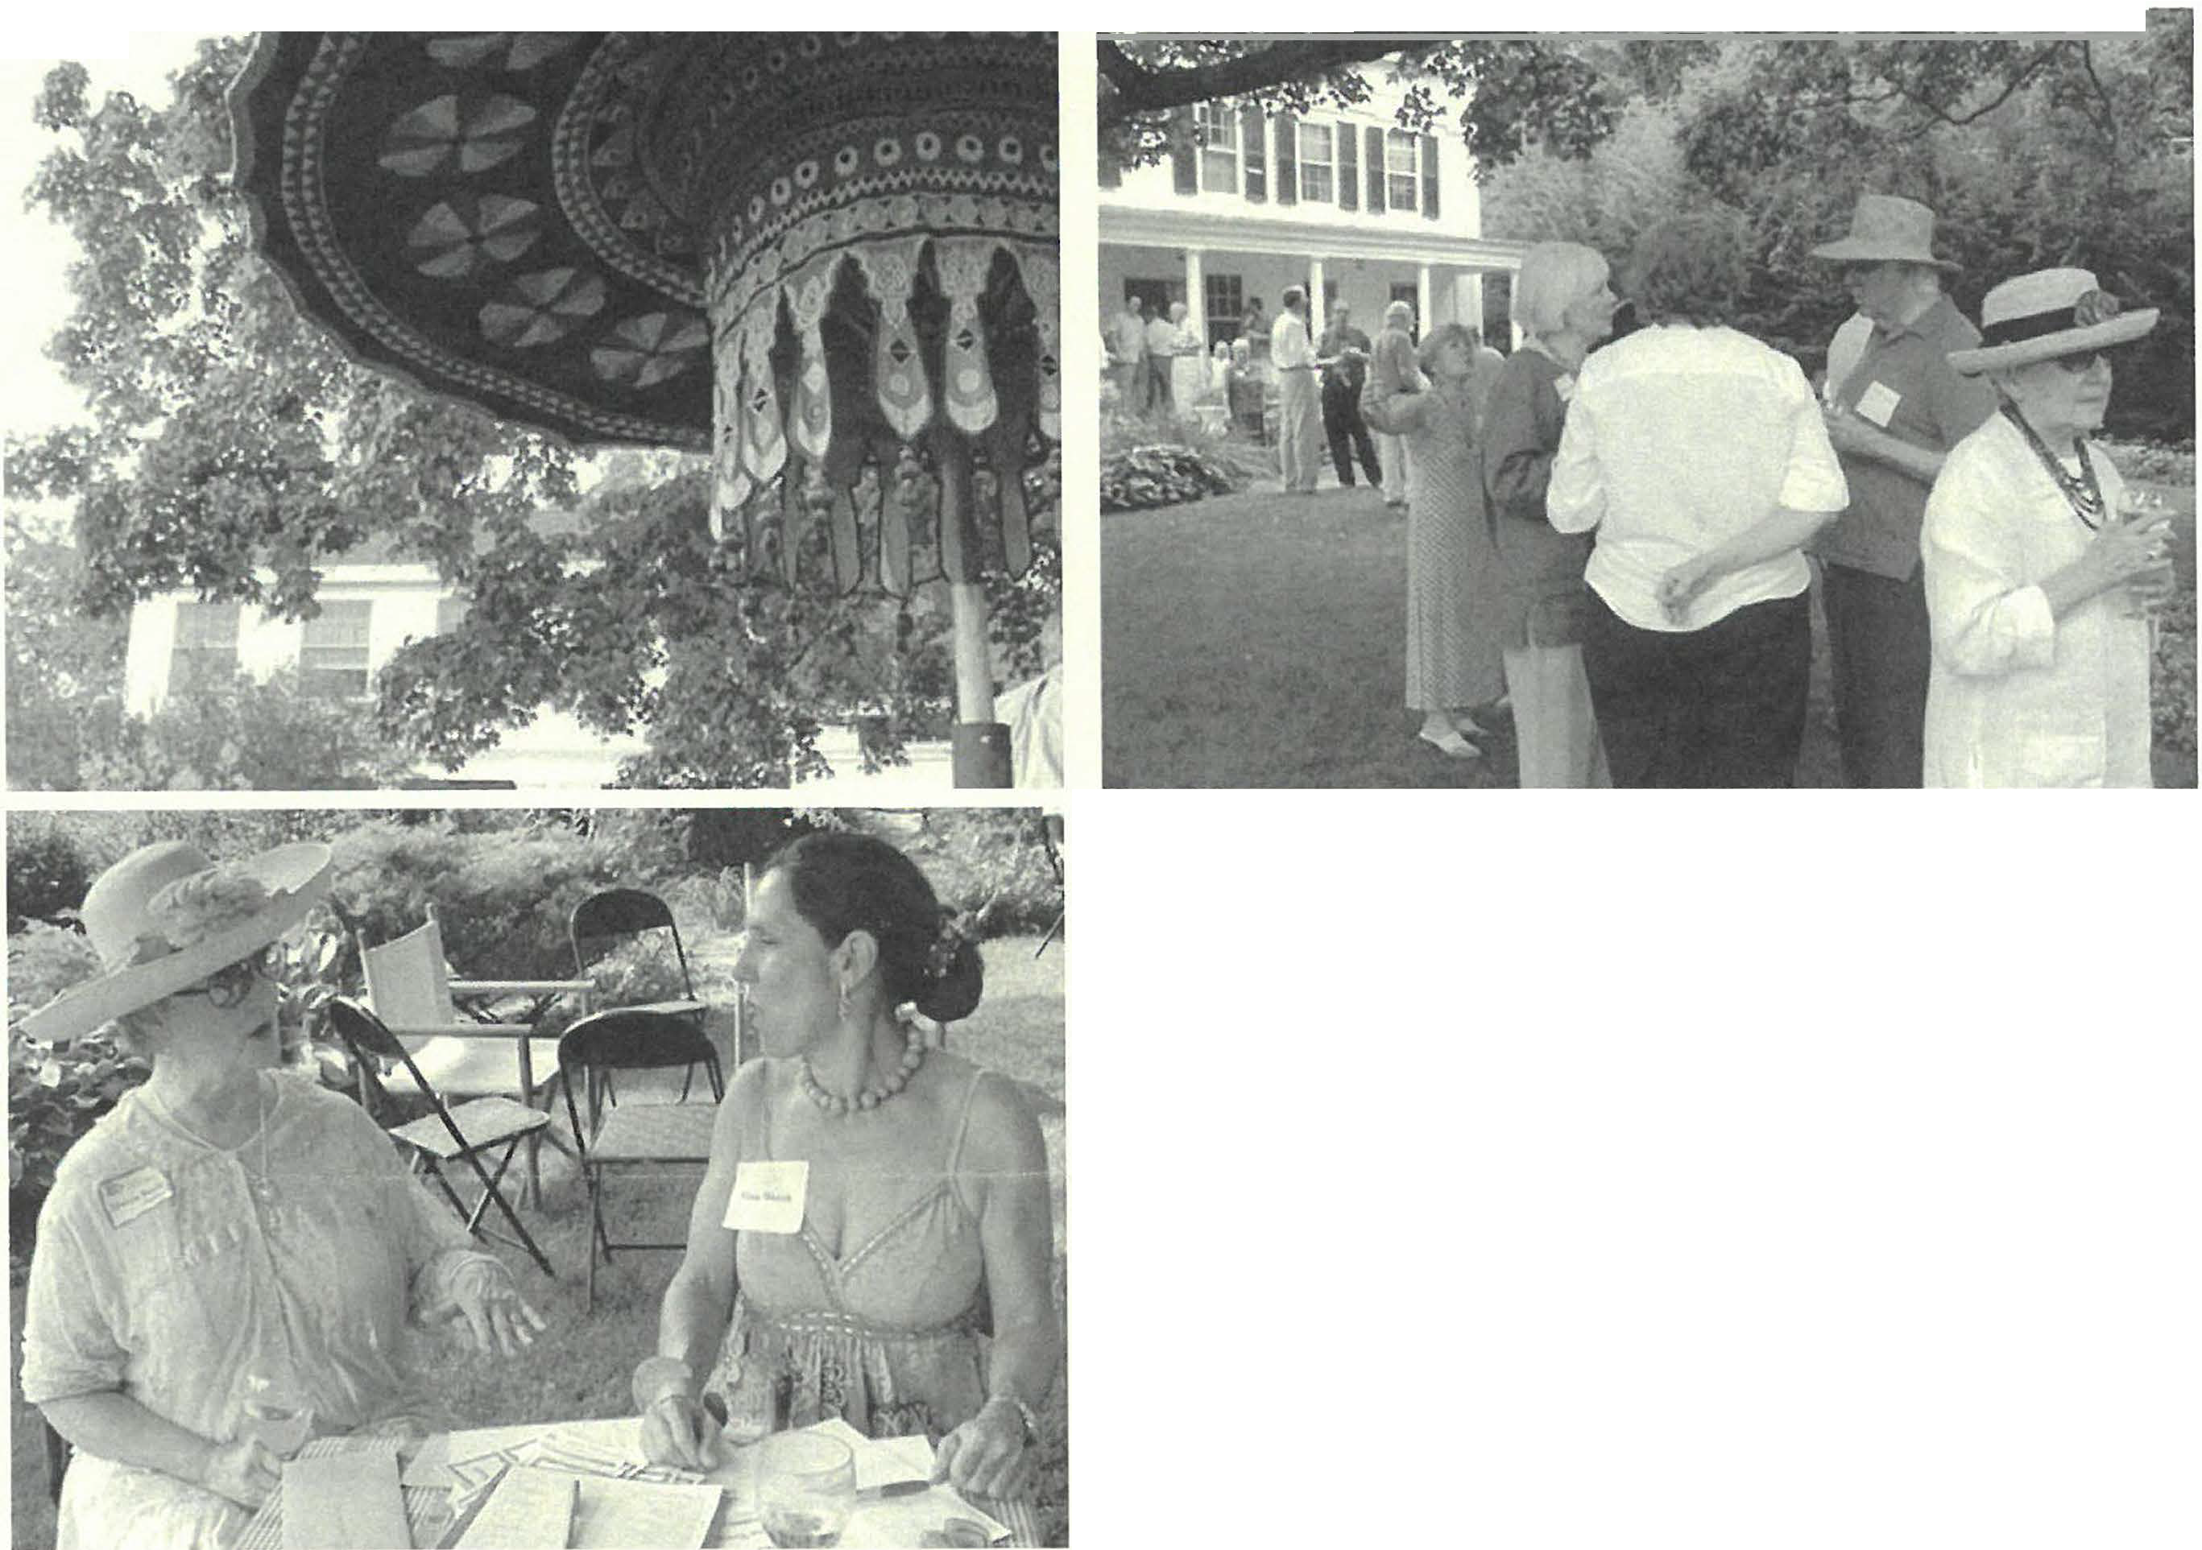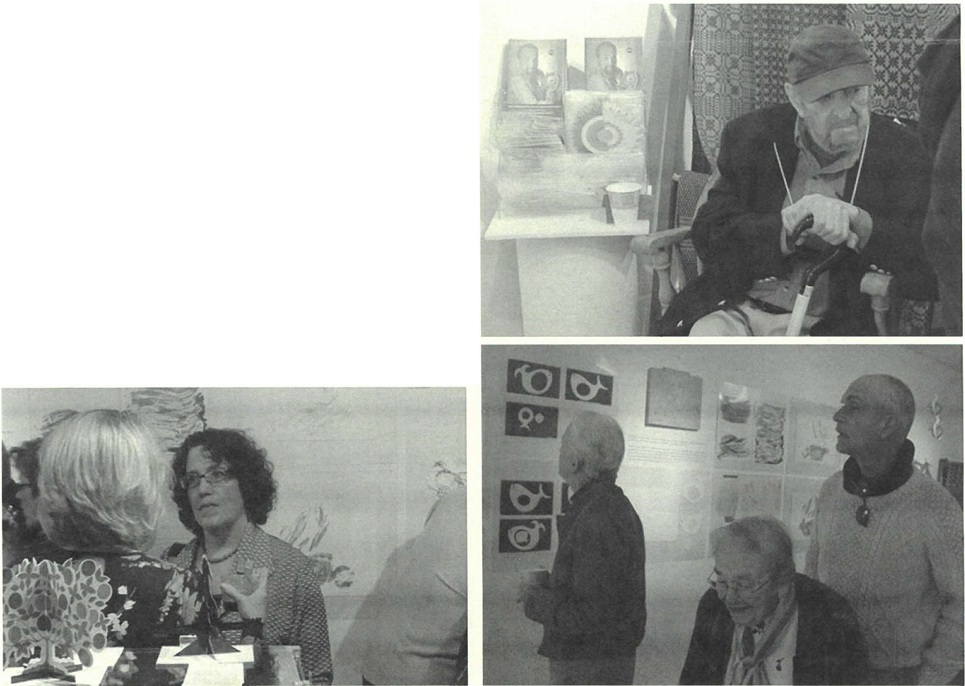Sliefl,dd I li,torical Soci{'[v )
.:Zhe .%ae{f .%mmercf !hll2oo<f ��ram...
'T"'"' - . �· .m •l..&UM;c

I
The Last of the Summer Wine garden party was a success (above.) Above left, an exotic Indian umbrelia contributed to the shelter provided by the branches ofa great old sugar maple which rises above the gardens of the Burrell homestead, presently owned by Hester Ve/mans and Peter Cherne.If who graciously hosted the party. Though rain threatened, the storms held offfar the duration ofthe Labor Day weekend event. Opposite, Marcia Brotli and Nina Worth man the admission table.

The Paper Sculptures & Other Works by Rob Robins exhibit drew a contingent of visitors, including two bus loads of.friends from Kimball Farms and the artist's extendedfamily. The exhibit, which was curated by Rene Wood, featured an explanation of the creative process, a display of the collection, commercial applications, and other design memorabilia /rom Rob's prodigious career. Opposite, Rob Robins seated beside the exhibition booklets he designed for the exhibit. Below, at left, Rob's daughter speaks with a guest. In the foreground are some ofthe paper sculptures on display and in the background, in the photos at left and right, are the graphic arts & die cutting processes explained.

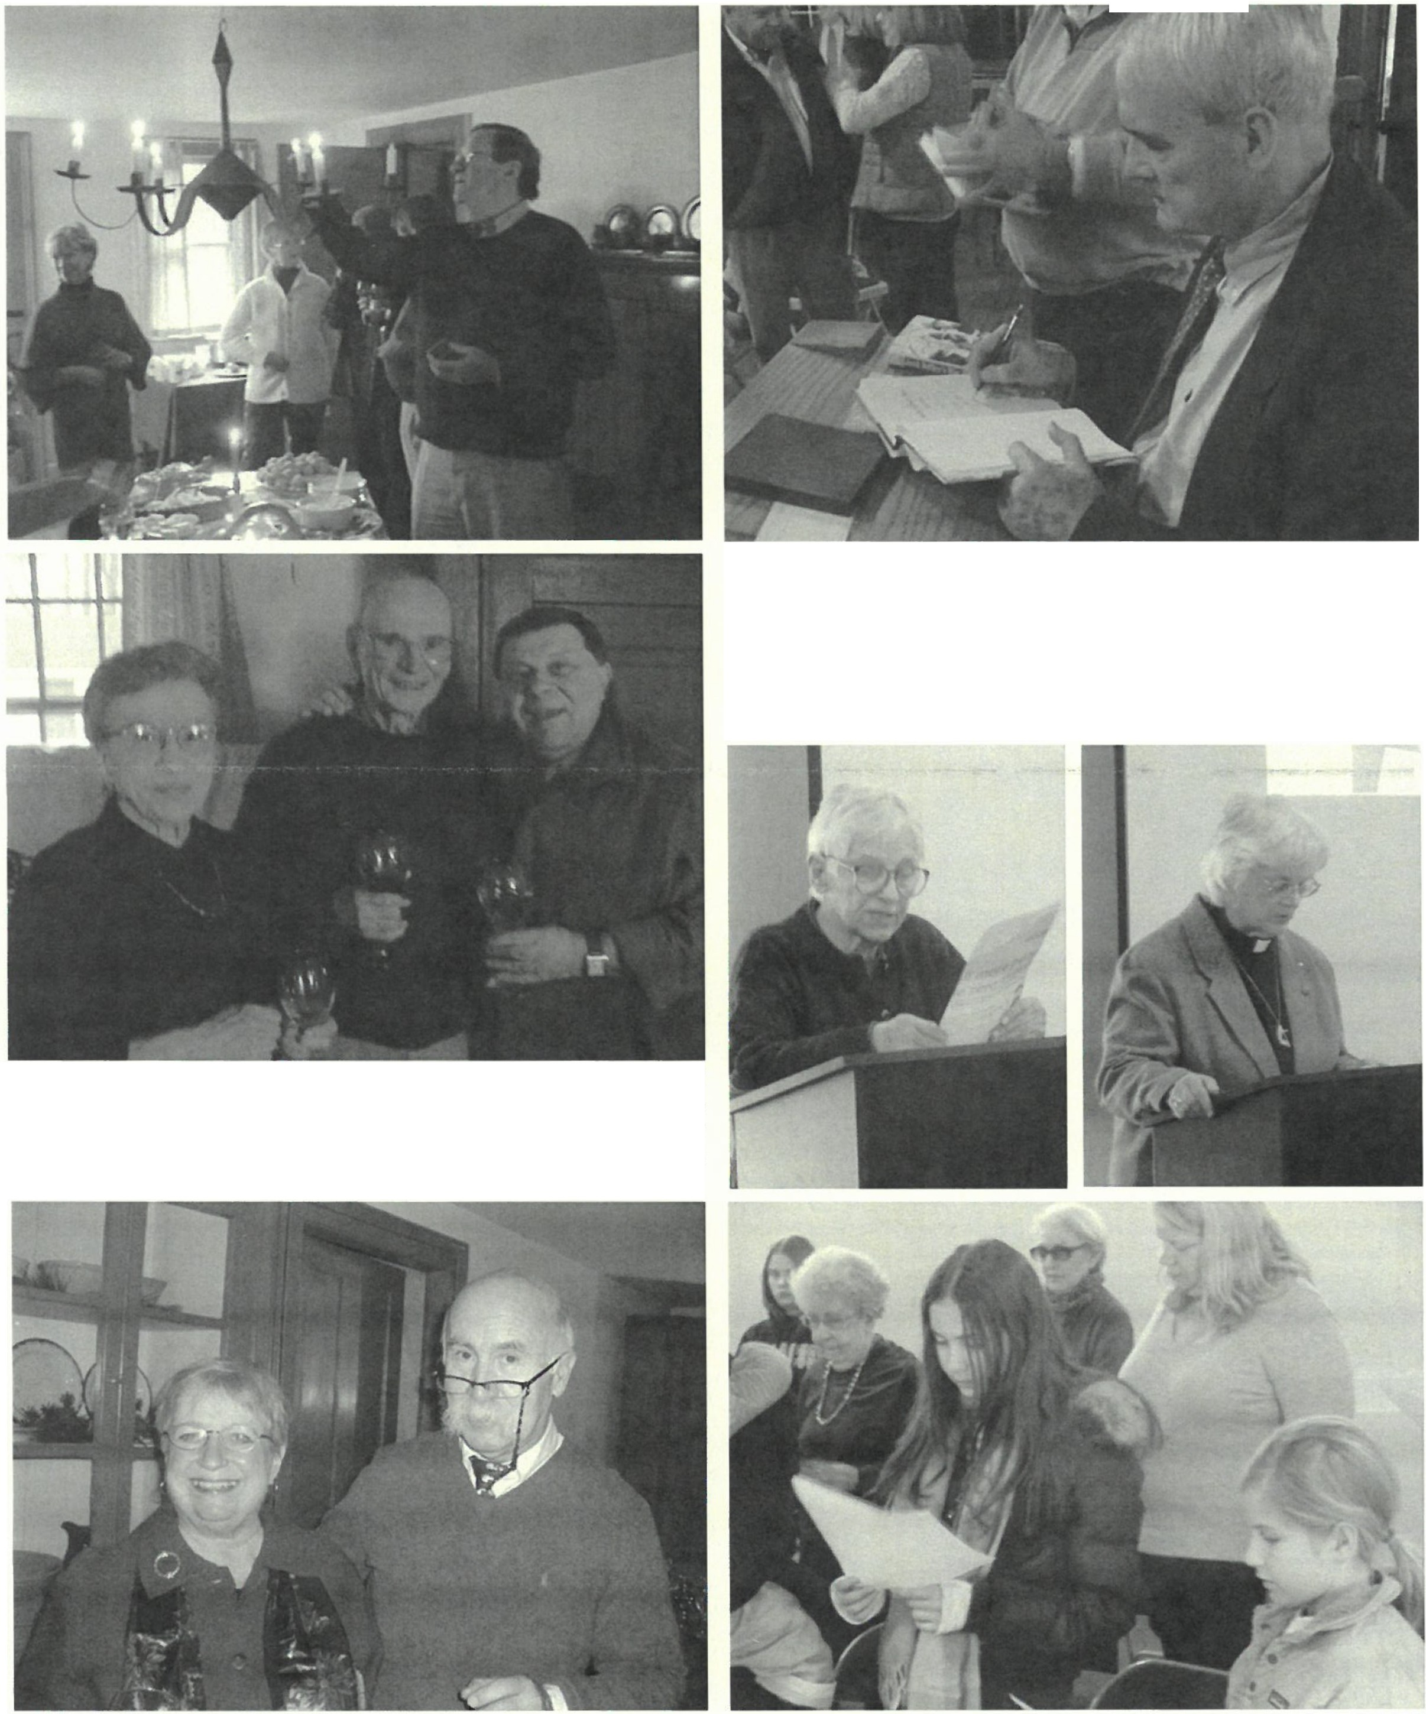
%cnidd Hi,wrical '>oc1ecv G
fJtV 91-'oiter 200Jl-.9 q}Ofram ntOlaed...

,; i'i .> I

A bove, the Society hosted john To/fey at its November meeting in a book talk & signing of his recent WWlf memoir Jack Toffey's War. Below, Jessica Roseman and Betty LeGeyt address Martin Luther King, Jr. at the annual commemorative program in cor!Junction with Bushnell-Sage Library, while (beneath) the granddaughters of Patricia & Peter Eisbach sing.from the King hymn,"Let There Be Peace, " which john-Arthur Miller lea with a piano accompaniment by Jessica Roseman.

At top, Philip Detjens lights the tinned iron chandelier in the Dan Raymond House keeping room at the Holiday Party, while Brian Levinsohn keeps company with Connie & Doug Logan. Below, Joyce Hawkins and Harry Conklin participate in the holiday spirit . Not pictured is Lenny Graziano who returned on keyboard for the occasion.

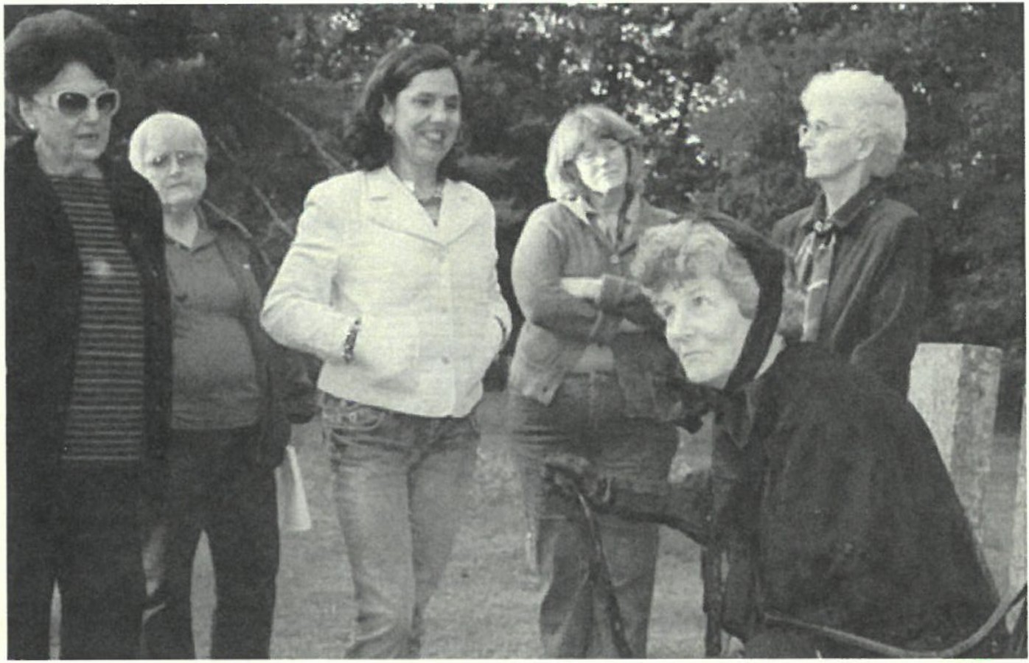
%L'i"t1dd Hiswrical 'iocicty 7
AA 08-09 Contributors continued from page 2

Photos by Alan Papscun & Gary Schumer
Catherine Miller steals the show at the 2008 Sheffieldt irit Walk with her stellar portrayal ofC. Catherine Root Leonard (18 12- 1907 ), a tac l inva lid woman who lived on to become the "oldest woman in She/fi,eld. "Below from le to right, Grieg Siedor asJohn Pell (1697-1758); Lynn Wood as Sal{j Bronson (1796- 1877 ); Neal Chamberlain as Levi Glezen (1775-1842); Ethan Chamberlain as Daniel Bush (1754-1840); Lisa Reyno lds as Mary Doten (1770- 1843); and jean Emberlin as Mary Canfield (1773- 1857 ). Not pictured are Jonathan Reynolds as Dan Raymond (1736- 1809) and jotinna Jennings as Eunice Hickock (1750- 1822).
Caroline Lindeman Douglas &..Candida Logan Susan Lushing,
in memory ofWnl/ace Kaminsky
Alice Lustig
Jon MacClaren & Christopher B. Sink Sue & Bob MacVeety,
in memory of Floyd Woodbeck &
Clarence Martin
Marian & Antonio Malnati Norman & Barbara Margolis Dororhy Marosy
Barbara Martin Shirley Marrin Mark H. Massini
Jim & Catherine Miller Donald & Roswitha Mott Dan & Ann Moulton Norma Mou lton
Israr Mudge Patrice Mullen
- Twiggs Myers,
in memory of Arthur C. Chme &
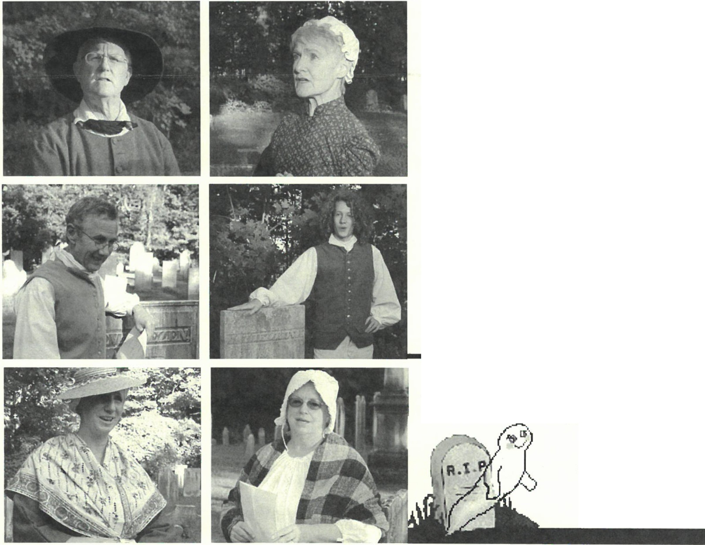Alice Ann Chase Elisabeth O 'Connor Walter & Gail Orenstein Thomas Orlando
Rena Orner
John & Charlotte A. Owens Judith Papachristou
Dan & Andrea Patel Richard Pearce & Nancy 0. Donahue Wesley Peterson Susan & Ted Pitman
Fred Pomerantz & Ruth Kolberr
Marsha & David Pottle Ken & Joan Powers,
in memory of Freddie Martin
George Raymond & Ada Hastings
Doris & Dick Richardson Frank E. Richardson & Kimba Wood
Ann Riou Muriel Rokos
Eli Romaine & Fan1ily
Ben Rose Jessica Roseman
Stephen Rosenheck Constance Rova
Ellen & Peter Rowntree

Annie Ryder Anthony D. Sabatelli,
in memory of C. David &
Da11iel Sabatelli Michael Saxton Mark Schaffer & David Goldma n Joanne Schmidlin
Libby & Ch arles Schmidt Shellie & Bernard Schneider
Judy Schnurr Becky & Ken Schopp Pauline & Carl Schumann Gary & Judy Schumer Dennis Sears & Rene Wood
Bob & Ann Shanks Marcia & Myron Sheinberg Barb & Jim Shiminski Christine & Grieg Siedor
  - Bonnie Silvers Evelyn Small Betsy Smith Dave Smith, Sr. George T. Smith
Dennis & Kathy Sraropoli Walton E. Stevens,
i11 memory of Thomm &
Rhoda Stevens & Zeb11lo11 Appy & John Stookey Hope & Howard Swanson
Marcel & Millie Tenenbaum
Kathy & Tom Tetro Rebecca & Robert Thomas Judith & Ron Timm
Peter Traub
Al Trocchi Rosemary & Arthur Uffner
Sabina Ullrich Karen & Merle Varney Loet & Edith Velmans Bruno & Olga Veronesi
Paula Wardynski
Elsie West
  - Robert Wheeler, Jr. Marion Whitman
Marilyn & John Wightman
Sandra Wijnberg Joe & Darleen Wilkinson
Martha & Barry Willian1son
Lynn & Bill Wood Nina & Don Worth Richard Zimmerman &
Elissa Williams

Hey! Would you like to join us too?
The 2009 Sheffield
Spirit Walk needs the talent
ofYOU!

2009 BOARD OF DIRECTORS
Marcia Brolli, President
Gill ian "Hett in ger. Vice President
Connie Cooper, Treas11rer
Harry E. Conk lin, Clerk

J oyce Hawkins Lois Levinsohn Philip Det jens Denn is Sears Kathy Tetro

MUSEUM STAFF
J oan na J ennin gs, Administrator Beccy Chapin, Volunteer Archivist J ames Mill e r, Volrmteer Archivist

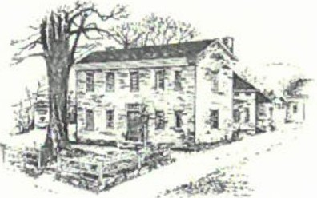
2'£e
.%e;fo!tl
..!7!i:ftortcal cie{y
Dan Raymond House MttSettm • Mark Dewey Research Center
WWW.SHEFF I ELD H I S T O R Y. O RG
The Sheffield Historical Society's mission is to promote a wider understanding of the people and events that preceded us in this area, and to preserve and transmit that heritage to current and fut1tre generations.
159 Main Street
PO Box 747
Sheffield, MA 01257

Phone: 413-229-2694
E-mail: shs@sheffieldhistory.org

1774 Dan Raymond House is open weekdays, Tuesday-Thurs day, 11 a.m. to 4 p.m.
Or by appointment.

Mark Dewey Research Centeris open weekdays,
Monday & Friday, 1:30 p.m. to 4:30 p.m, or by appointment. Phone: 413-229-3682. Email: mdrc@sheffieldhistory.org

Old Stone Store is open on weekends,
Saturday, 10 a.m. to 3 p.m., and Sunday, 11 a.m. to 3 p.m. Closed January through April. Phone: 413-229-2287

YAe
.%#Id

Yl"ifttJrteal..¼cteff
Winter/Spring 2010

··
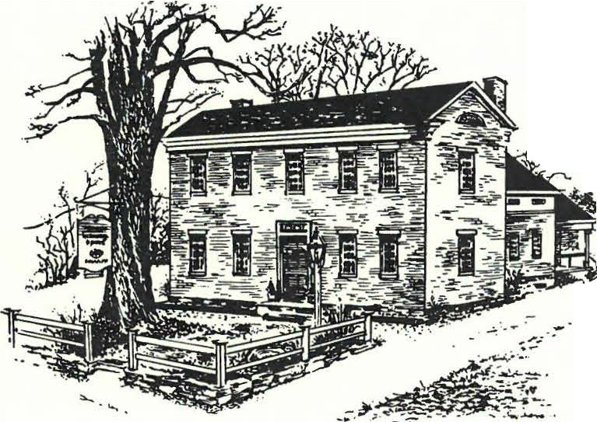/ . :-•
r.-------
- , ..'! _j- .'
I
-•

_:-i··
. . -
- i
-
:
.,..- · .;

There's Something "New" at the Historic 1774 Dan Raymond House
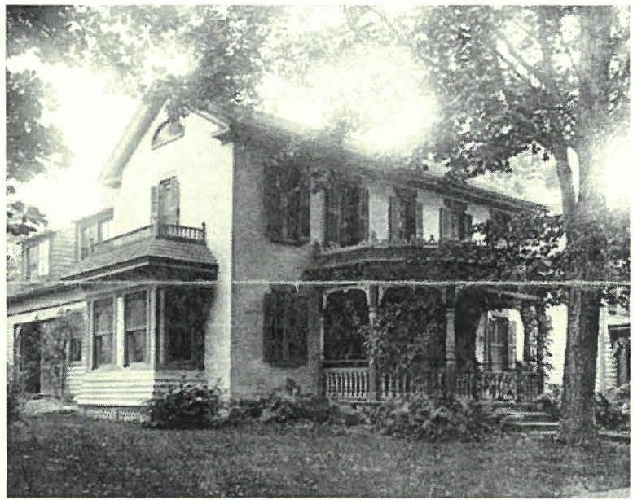
for 28 years since its restoration and preservation, the Sheffield Historical Society's Dan Raymond House has been open to the
public with permanent room-setting displays approp riate for the period of the historic structure. For that duration, the exhibits of 18th century home life have remained largely unchanged. The furnishings are appropriate for teaching children history through the artifacts, and accurately displayed for scholars and visitors to view and learn; however, because the theme and composition has remained largely unchanged over the years, there is a resulting lack of interest to attend a guided tour more than a few times.
I
During the Society's February '09 Planning Retreat an idea was presented to re-open the Dan Raymond House for public tours of the historic museum house with a "new" twist: in an active partnership with local antiques dealers, the museum house
could offer a wealth of op portunity for changing exhibitions of

period furniture and accessories. This will be mutually beneficial for the antiques dealers and for the Society. The Berkshires have been a long-standing destination in the ongoing hunt for antiques, and while the antiques dealers stand to gain added exposure for their merchandise by being credited in the captions for the objects on loan, the Society will have access to almost unlimited resourcesfor display.
All parties would benefit from the press generated by such collaboration. Additionally, visitors to the DRH museum would be encouraged to frequent the area an tiq ues shops; likewise, the antiques dealers would encourage their clients to view the period furniture displayed in room settings in the DRH. The co-operative effort to bolster renewed interest in the DRH museum will be multi-faceted with involvement from the commun ity, local businesses and SHS members. Time and energy will be involved; however, the endeavor is essentially cost-free.
When each Sheffield antiques dealer was initi ally polled about
A rarely seen view of the Dan Raymond House during the Little family's residency (1884-1945) . In a 1985 historical report completed for the Society by Gregory Farmer, Farmer notes that "the Littles seem[ed] to have
appreciated the historic value of the brick house and were care.fol to preserve its character." Whik the house was in good condition, the Society elected to restore its original Colonial lines, removing the Victorian sun porch, south-facing bay window, and alcoves over the ell addition. At this time, the roof was also raised over the kitchen and the borning room added inside.

loaning a variety of antique objects for display in the DRH, the response was overwhelmingly positive and enthusiastic. Many even offered to loan item s from their personal collections. Several attended preliminary meetings to view the rooms, to discuss participation, to hear general ideas about working together, and to learn of the theme of the first exhibition which is planned to open in May 2010.
The Society's recent acquisition of nearly two dozen early-19th century letters, written by members of the Little family, will be the focus of the new Dan Raymond House exhibition .
- - - - - - - - - - - - - - - Feature article continues on page 2

- - - - - - - - - - - - Feature artick continuesfrom front page Shd fid d Historical Society 2

Significance of the Little Family Letters

The collection of handwritten letters, to and from the family of Ralph and Maria Fox Little, is believed to be the earliest extant documentation of early 19th century life in the town of Sheffield. Their worth sheds light on the prevailing topics of the day-health, death, religion, and domestic duties, with an underlying yearning for communi cation and kinship. Thirty
years of family letters offers insight into daily life beginning in 1807.
The letters will be on public view for the first time during the new DRH exhibit. Poignant excerpts with corresponding vignettes on loan from area antiques dealers will be d isplayed in room settings, along with local artists using their choice of medium to create a contemporary visual context for understanding select passages.
Additionally, a separate special exhibition at the Old Stone Store will dovetail with the new DRH exhibit. During the month of June, The ABCs of Letter Writing- the History and Art of 19th Century Correspondence will focus on a retrospective of writing and related items of communication, again on loan from antiques dealers and other members of the community. T he Little family letters and other early handwritten letters will be on display along with items related to calligraphy, fountain pens, inkwells, stamp collecting, etc., and a selection of samplm, ,chool fob, and wdring rabies.
z
Locally-quarried Marble Traced to New Britain, Connecticut Church

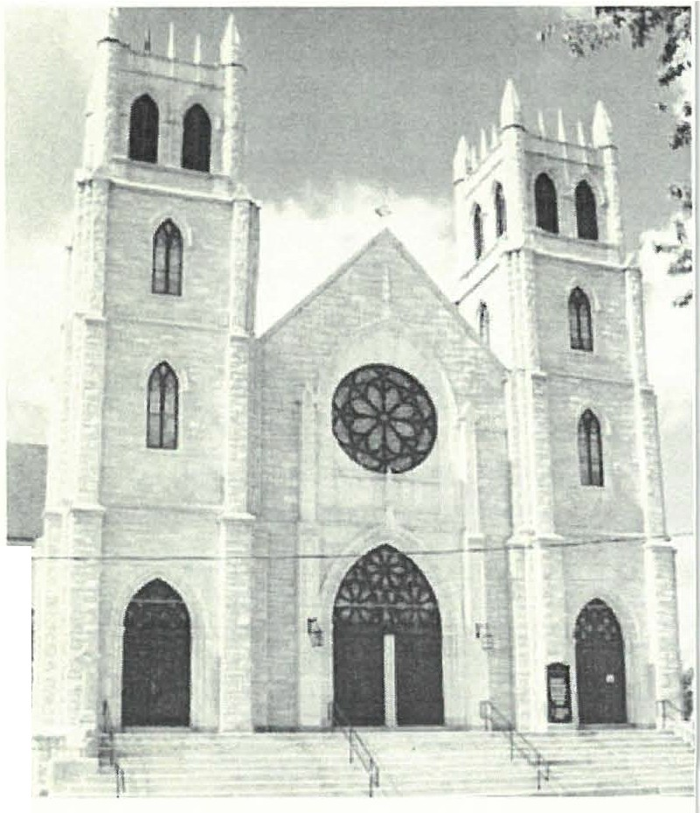Dan Raymond Howe Hiuory . Thi, pan summer rhe Muk Dewey R=arch Center, rhe library
and reference arm of the Society received an inquiry from the First

The Dan Raymond House was built circa 177 4 of homemade brick, believed to be fired on th e site. It originally consisted of a north and south parlor on the first floor and a garret upstairs. Cooking was likely conducted in an attached structure on the back of the house which was replaced by an ell addition at a later date. At the time of its construction, Mr. Raymond was referred to as a "notorious" and "cunning" character and his home was decried as "extravagant." In the present day it is considered an unpr etentious and classic-styled late-18 th century brick colonial. Except for the added ell, the house is nearly the same as it was during the American Revolution.
By mid-1850s the house had been extended with the addition of a large keeping room, buttery and horning room on the first floor, and a second staircase was built , as the garret became a full second story with two bedroom chambers upstairs.
The Dan Raymond House was purchased by two Society members in the 1970s, and they held it until the SHS raised the money to buy the property"'. In 1981 T he Society undertook
- - - - - - - - - - - - - Feature artick concul des on page 6
Lutheran Church of the Reformation in New Britain, CT. In terested in being listed on the Con necticut Registe r of H istoric Places, their researcher wanted to track down undo cumented lore that the church was built of marble from the Ashley Falls Marble Company quarry. Were we, they wanted to know, able to find any documentation to substantiate that story?
From our marble quarry archives, greatly enhanced through the generosity of Natalie Funk and Priscilla Rueger, we were able to provide a positive answer. From company correspondence given by Natalie and Priscilla, the Center was able to cell th e church, then known as the Svenska Lutherska Maria-Kyrkan, that the marble, inde ed, had originated in the Ashley Falls by supplying a company letter that read, in part, "We quarry and finish the marble even to the finest carved work.... Some of the most prominent buildings erected from our product include the ... Swedish Lutheran Church, New Britain, Conn."
The 1906 structure, on Franklin Square Park in New Britain is iconic Gothic in design. The towers lost their crop-topped spires in the 1938 hurricane but the building is otherwise unchanged.
- Jim Miller, Society Archivist

Sheffield Historical Society 3

c1Jmut ram 61/entf cf
6xAt c@M at tAe OU!7itJne !7itJre

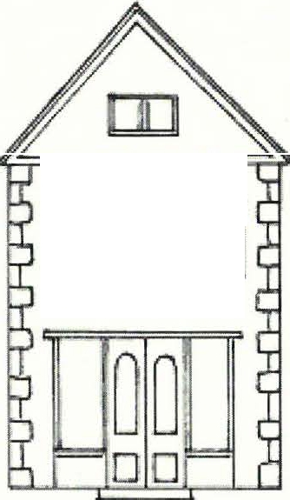Friday, February 12, 7:30 pm. A Colonial Tea Party & Sampler

mm m
To boycott the heavy tax placed on British import teas, colonists learned to substitute "independence teas" which were herbal infusions derived from plants that they would have had growing in their
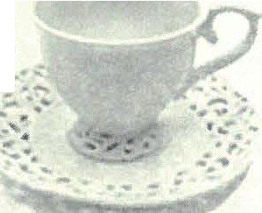
gardens. Coffee also became popular during this period, and remains the preferred brew among Americans to this day. Gillian Hettinger, of Sheffield and New Jersey, literature teacher, scholar, and frequent Sheffield Times contributor, will host this program. Come learn what our ancestors would have been served for tea courtesy of Hamey's & Sons Fine Teas. Bring your

own tea cup and try a taste of each to see if you would have liked them!
The program will be held in Dewey Memorial Hall.

Remember to participate by
bringing your own teacup!

Friday, March 12, 7:30 pm. Plants that will Thrive in Your Garden, Part II
Local horticulturist, writer, and lecturer, Ron Kujawski, author of the popular "Gardener's Checklist" Berkshire Record column and the Berkshire Eagle's "Berkshire Garden Journal," returns to continue his power point presentation on perennials and annuals that will thrive in your Sheffield garden.
The program will be held in Dewey Memorial Hall.

Friday, April 9, 7:30 pm. Historic Paint Colors
This illustrated lecture will present an overview of the most popular New England architectural styles and their historical paint colors from colonial times through the 20th century. Jacqueline Connell is an architectural and landscape consultant and museum educator. She has consulted with owners of historic properties tnroughout New England as well as New York and New Jersey. She has presented lectures on architectural and landscape topics for historical societies, museums, and civic organizations such as Strawberry Banke, Mystic Seaport, Newport Museum of Art, and the High Museum in Atlanta.
The program will be held in Dewey Memorial Hall.
Saturday, April 17, 5-7:30 pm. Spectacular Pasta Dinner
Homemade pasta dinner with an "all-you-can-eat" pasta bar featuring all-time favorite meat and vegetarian pasta dishes. Salad, dessert, ice tea, coffee and tea included. Wine, beer and soft drinks available through the American Legion. Adults and takeout: $1O; children ages 3-10 : $5; children under 3: free. Dinner will also feature a Chinese Auction.
The dinner will take p'4ce at the American Legion Hal4 Rte. 7, Sheffield.

Saturday, May I-Sunday, June 6. Voices from the Fields: The Family Farms of Sheffield In honor of Sheffidd Land Trust's 20th Anniversary, this exhibit will celebrate Sheffield's current and historic farms as a vital part of our community, culture, beauty and economy. The exhibit will showcase highlights from a larger collaborative oral history project undertaken by the Society, the Land Trust, and
This scheduleis subject to change. For the latest information, visit www.sheJfieldhistory.org

Sheffa ld Historical Society 4
many volunteers who are interviewing families and farmers. Also featured will be many photographs, including from the Society's archives and from family collections. While the exhibit will only be able to display a small portion of the information and photographs gathered, the full extent of the material will
become part of the Society's archives on our town's agricultural history.
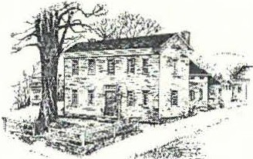
rI ----------------------------------------------------------------------,--------
I
I

SAVE THE DATES!
Saturday, May I-Sunday, October 31, 2010
The Little Family & 19th Century Correspondence
A newly acqu ired collection of 19th cent ury letters written from Sheffield by members of the Little family will be related to the Dan Raymond House, where a later generation of
the family lived. A tableau installation of period furnishings provided by local antiques dealers will complete the scene. Come learn how the letters provide a new window into old times and behold the parlors of the Museum utterly transformed!
The exhibit will be in the Dan Raymond House parlors.
--------------------------------------------------------------------------------
Friday, May 14, 7:30 pm. The Home Front: Sheffield During WWII
Society trustee and avocational WWII historian, Greig Siedor, will give a talk on the impact of the War on daily life in Sheffield based on information gathered from the Society archives. Members of the community will also be invited to share their photos, memorabilia, and recollections. For more
information about this program, see article on page 5. The program will be held zn Dewey ft1iinorza[.R,.,a...l.,l.,,...._• ..._.._.
Saturday, June 12-Sunday, July 11
ABC's of Letter Writing: The History & Art of 19th Century Correspondence A Retrospective exhibit of writing and related objects of communication, on loan from local antiques dealers and other members of the community which references the exhibit in the Dan Raymond House
Museum. The Little family letters and other early handwritten letters will be on display along with items related to calligraphy, fountain pens, inkwells, stamp collecting, etc. and a selection of samplers, school desks, and writing tables. The exhibit will be on view at the Old Stone Store.
Friday, July 16-Sunday, August 1. Five Friends Art Exhibit The Five Friends: Walter Bogard, Hans Heuberger, Sean Ryder, Lois Ryder, and Lois Van Clef return for their fifth year to the Old Stone Store with new and recent artwork. The exhibit will correspond with the Sheffield Art League's Annual Juried Art Competition in Dewey Memorial Hall, where more of the friends' work will be featured. The Gallery at the Old Stone Store will be open Fridays, 11-6 pm,
Saturdays & Sundays, 11-4pm. The exhibit will have an opening reception Saturday, July IB, I-J pm.
Saturday, August ?-Sunday, September 5
From Sheffield to Egremont: A Houses Journey Marsha Ginsberg, a photographic artist and stage designer from NYC and Egremont, has documented the rescuing and subsequent moving and restoration of the the ca. 1840 Conway House from Bow Wow Rd., Sheffield to Jug End Rd., South Egremont. The house has compelling historic merit because it was once thought to have been a stop on the underground railroad. This multi-media exhibit will integrate a series of photographs and film clips edited by the artist and local history research prepared by the Society.
This schedule is subject to change. For the late st information, visit www.sheffieldhistory.org

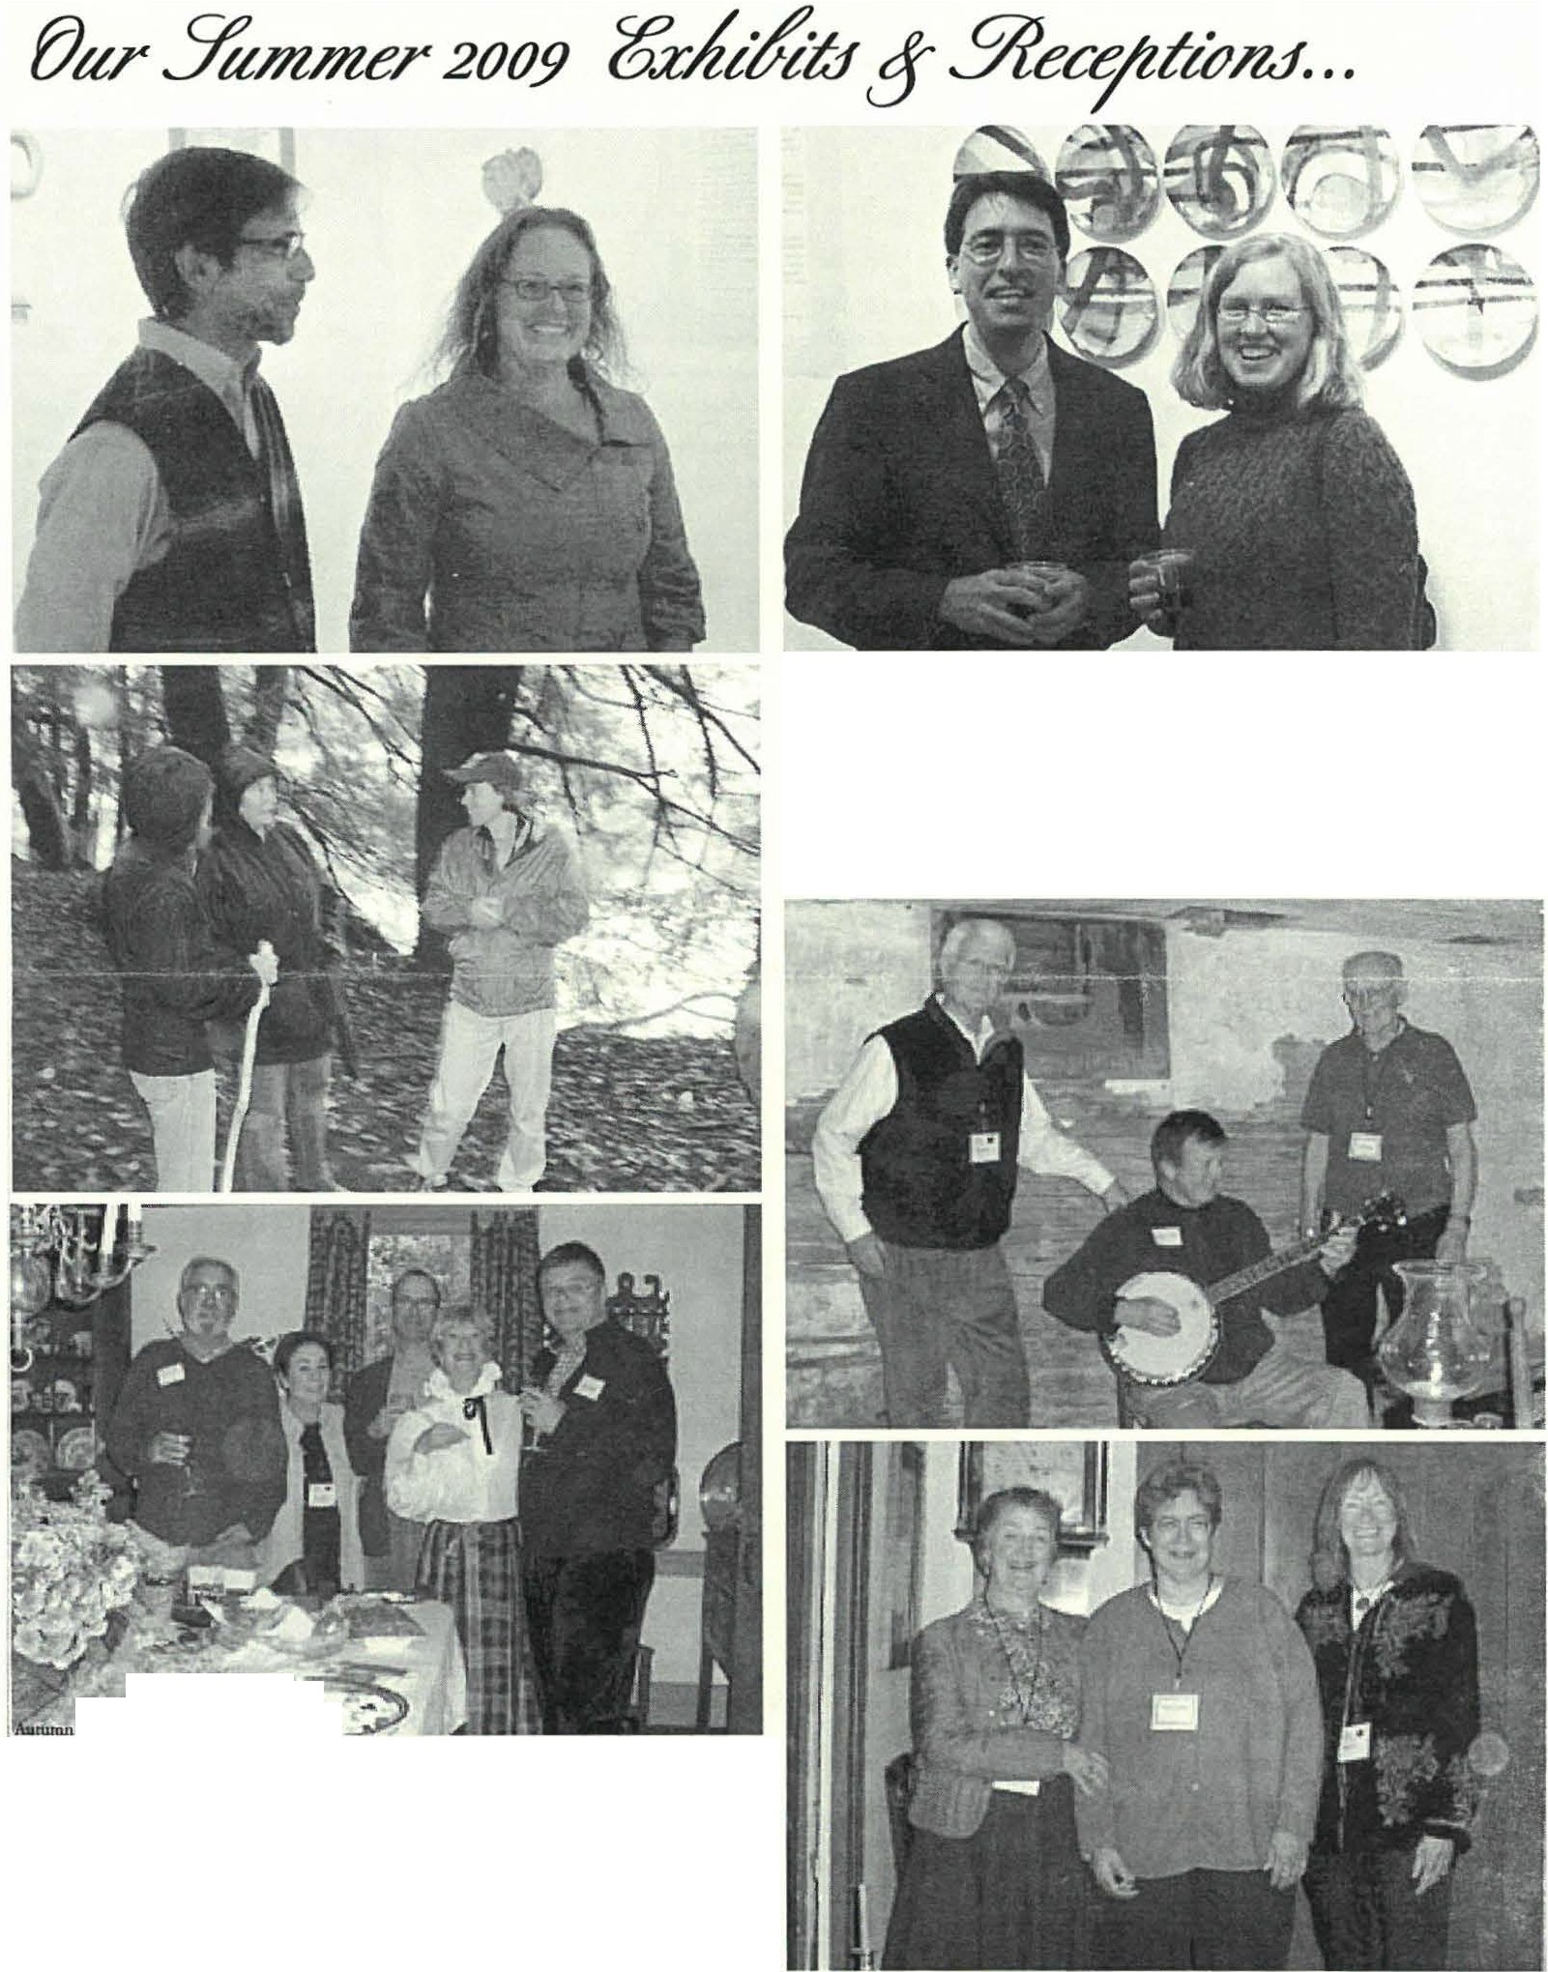Sheffield Historical Sociery 5

At top left, artists Bernie & Jr. & Joey Sage Jablonski of Canaan, CT at the exhibit reception for Imaging Bartholomew's Cobble. They were joined by friends from Litchfield County, CT (above} who stand in front of the artists' collaborative feature installation, a panel of twelve plates which Joey fired and Bernie painted. At left, Tammis Coffin engages Pauline Clarke of Ashley Falls on the poetry of the Cobble. The artists commented on what inspired their artwork on a walk through the Cobble which the Trustees of &servations co-led with the artists and the Society.

Puq,.phor0< by • lcim ₄
- --.,... -· -:
The Society held itr annual benefit at the Captain Dewey hommtad. Once thought to have been a wayside inn, it is now the home of Cari &Darcie Proper. At top right, Greig Siedor played the spirit of Captain Dewey whilst serving alcoholic spirits to the guests in the old cellar tavern. Nonnan Hettinger entertaim Carl Proper with some historical music on his banjo. At bottom righ,t Marcia Bro/Ii and Kathy Tetro help Darcie Proper greet guests in the front stair
hall. Above, Samuel Herrup, Lois Levinsohn, john McC/aren, Gillum Hettinger, and Chris Sink enjoy fine food & spiritr among the antiques in the dining room.

------------ Feature article continued from page 2
an enormous project of preservation and professional restoration to the interior and exterior of the DRH. An added sun porch and bay window were removed, the roof and windows repaired and/or replaced, the unusual corner fireplaces in the north and south parlors were re-constructed, wood floors scraped and oiled by hand, and walls plastered and painted in histo rically accurate colors. Three years later the historic DRH structure was completed and opened to the public in time for Sheffield's 250th Anniversary Celebration in June of 1983. T he acq uisition of furnishings for the museum home immediately began and The Society's collections of period
furniture, accessories, textiles, ceramics, tools, toys, and
Sheffield Historical Society 6
What Was Sheffield Like During WWII?
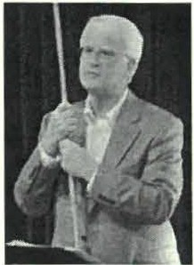
Our moth e r's ration books, fathers and uncles in uniform, gold star symbols in the
parlor window... the numbers of us who share these vague childhood memories are dwindling, and what we know of T he War is now to be gotten mostly from movies. What was Sheffield like during World War II?
Last year Gmg Siedor How did we at home support the war effort?
also spoke on the . . .
subjetcofWWII at On May 14, Greig S1edor will present
the Society's Annual " T he Home Front: Sheffield during World

ephemera has filled all the rooms opened to the public.
Meeting (above). wwrar
II"
at our reguI ar monthiy

T he Society's main office is located in the DRH and numerous special events and workshops are held there and on the grounds each year. The campaign to stim ulate increased int erest in the DRH museum and Sheffield, the oldest town in Berkshi re C o un ty, is the goal in establishing a formal partnership with local antiques dealers.

- The SHS owm 6 additional historic structures: The Mark Dewey Research Center, circa 1816; the Carriage Barn, c. 1870; Parker Hall Law Office, c. 1820; the Education Center, c. 1876, the Smokehouse, c. 1838 ; and the Old Stone Store, c. 1834.

-Kathleen Tetro, Member of the Board of Directors

Grant Awards Announcement

The Society is also pleased to announce that it was the recipient of a $500 grant from Sheffield C ultural Council to fund the exhibit of Little Family Letters in the Dan Raymond House and antiques supplement in the Gallery at the Old Stone Store highlighted above, ABCs of Letter Writing- the History and Art of 19th Century Correspondence.
The Society had also received $500 from Berkshire Bank Foundation in FY 2009. It has deferred the use of this funding until FY 2010 following the postponement of the exhibit, which was originally scheduled for last year.
The Soc iety's mission is threefold: to preserve, prom ote, and transmit our heritage to current and future generations. While this multi-media exhibit will fulfill all th ree criteria, it will be most interested in the third facet. As we seek to transmit this heritage, we are exploring new ways of relat ing t his information to an expanded aud ience.
meeting. Mr. Siedor, the H istorical Society's newest trustee, was born in Hartford, CT, in 1945, six days after the end of World War II, and grew up in Connecticut and Arizona. His father had been a B-17 pilot in the war and attended college in Arizona on the G.I. bill. A graduate of Trinity College and Yale Law School, Greig has been an environmental lawyer in Illinois and is a relatively new resident of Sheffield.
Mr. Siedor has developed a passion for researching and presenting programs about World War II, which he considers one of the most defining momen ts of human history. Members may remembe r that last June, Greig gave a gripping presentation abo,it the-Battle of Midway; using-a-larged odcto­ show how the battle literally devd oped hour by hour. This spring, he will extend his passion through outreach into local schools. In March, Greig will conduct a program at Berkshire School in which he will ask student s to design an air defense system for Great Britain and then lead a discussion abo ut what actually happen ed during the famous Battle of Britain. He will int roduce himself to students dressed as Prime Minister Churchill, while giving one of Churchill's inspiring speeches to the hom e front.
For the Society program, Greig has already begun researching through boxes of materials in the Mark Dewey Research Center, as wdl as newspaper accounts of daily events stored in the public librari es. Society documents include rationing booklets and also special requests for materials, such as shoes, that would otherwise not be allowed under the rationing system. His talk will focus on .the impact of the War on daily life in Sheffield. Members of the comm unity will also be invit ed to share their photos, memorabilia, and recollections.
"Sheffield during World War II" will be presented on May
14, at 7:30 p.m. at Dewey Hall in Sheffield. Anyone who has

lill
•'
*
,;_ · agency which is supported by the Massachusms
MassachusettsCultural Council CulturalCouncil, a state agency.
This program is supported in part by a grant

from the Sheffieki Cultural Council, a local

question s, or who wishes to provide materials and /or

recollections sho uld call (413) 229-2694.
- Joyce Hawkins, Program Chair

Sheffield Historical Society 7

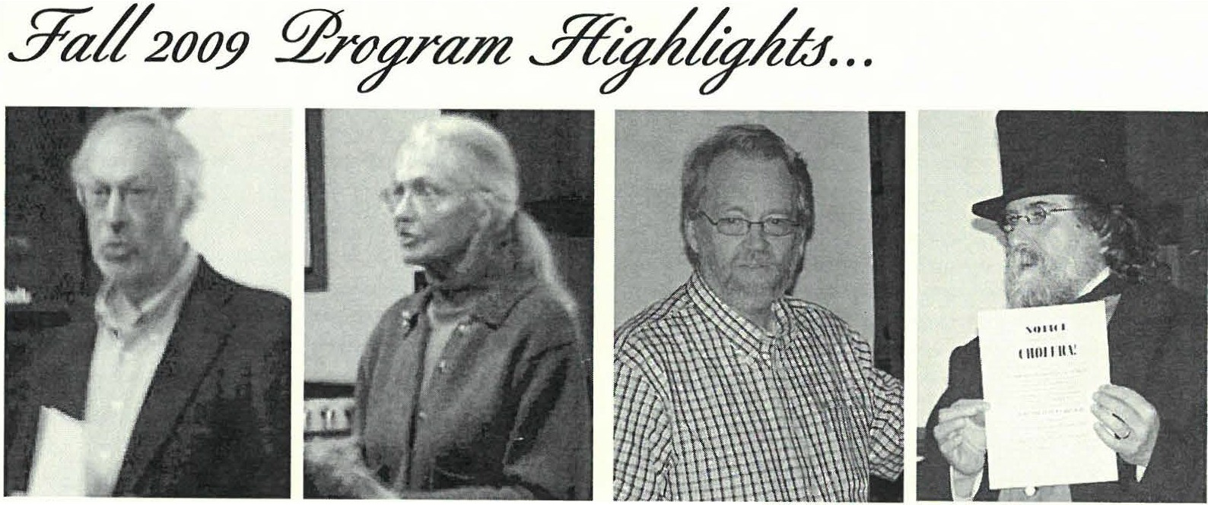
David Levimon and Emilie Piper have co-artthored a scholarly publication fall of groundbreaking research on Mum Bette which narrates her continuing (his)story. Look for To Stand one Minute a Free Woman; Elizabeth Freeman and the Quest for Freedom in book stores and libraries in 2010. The joint program delivered at the Soceity's October meeting drl!W a crowd of African American history bu.ffi and a group of Berkshire School history students.
Bernie Drew of Great Barrington Dennis Picard of Storrowton Village in Hist orical Society spoke about the Springfield flashes an historical achit!Vementsof local inventor William bull.etin on cholera preventives at a Stanl.ey and his influence in the history presentation on early medical care he of el.ectrical engineering at the Society's made at the Society's November September meeting. muting.

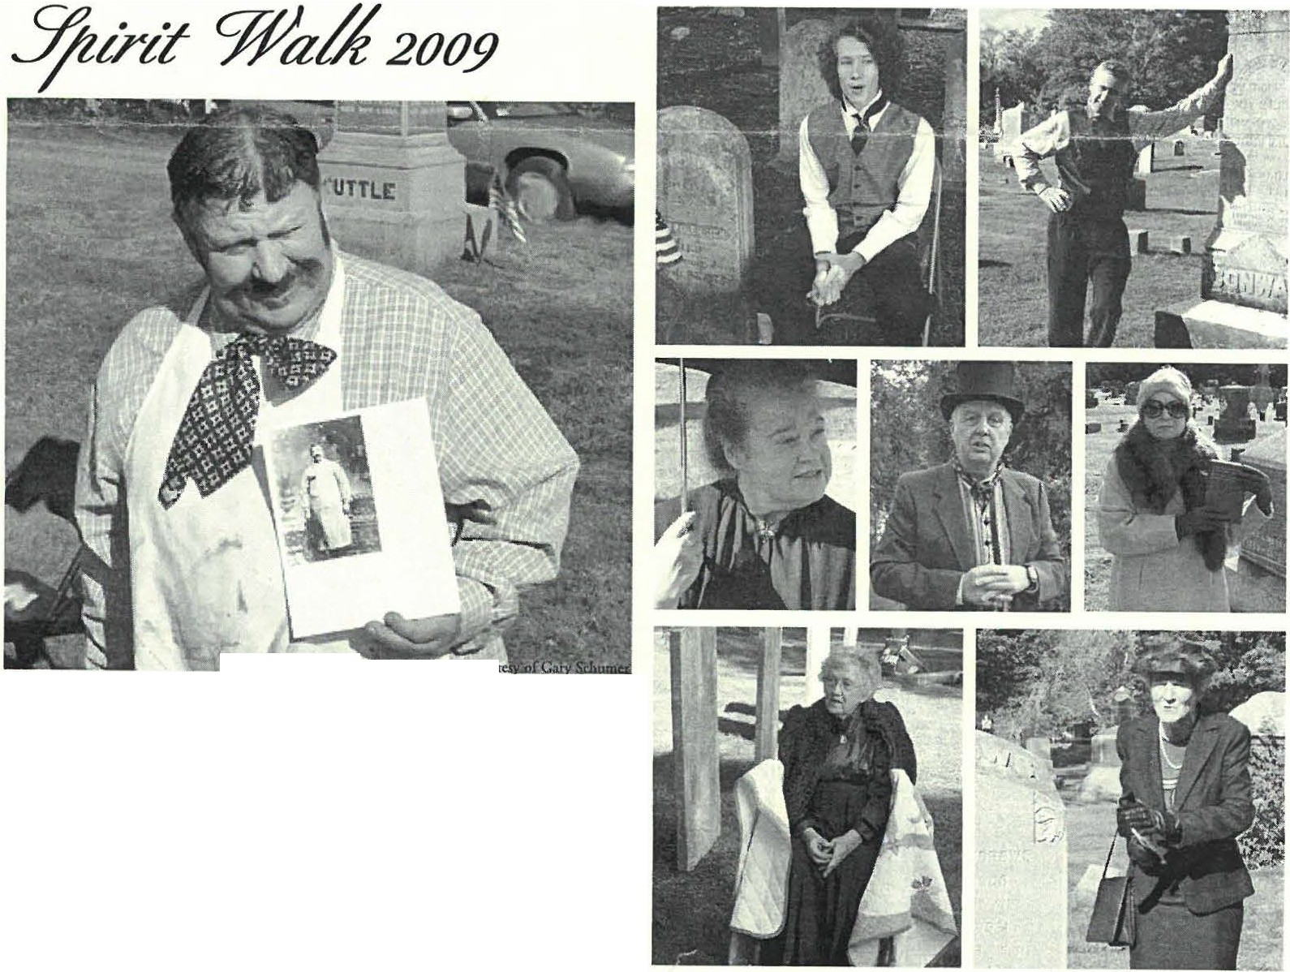
  - Sptr om• .c<>WJ
The 2009 Spirit Walk was held in Center Cemetery on an unseasonably warm day, and the October 4 event was well-attended Brian Levinsohn played the part of R.alston Little (above) who was a Sheffield but cher. R.alston Little was a member of the same Little family which will be the subject of an upcomingexhibit in the Dan R.aymond House Museum.

At top, Ethan Chamberlain starred as Edward Eli Ensign (left) while Neal Chamberlain (right) played the part of Patrick Conway whose house will figure into the From Sheffield to Egremont exhibit in the Old Stone Store.
Other participants were (midd l.e row ) Susan Pittman as Emily Rood; Dennis Sears as high sheriff, Graham Root; and Rene m.iod as poetJ Luella Dowd Smith.At bottom, Pauline Schumann was Prudence A. Smith Brl!Wer (left)
and Catherine Miller played Dorothy A. Cabis, past US. Treasurer (right).

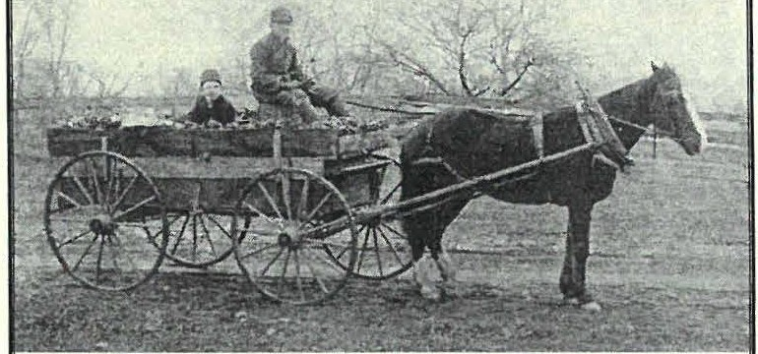2010 BOARD OF DIRECTORS
VOICES FROM THE FIELDS:
THE fAMILY f ARMS OF SHEFFIELD
Saturday, May 1--Sunday, June 6, 2010
ExHIBIT IN TIIE GALLERY AT TIIE OLD STONE STORE
CELEBRATING & D O CUM E N T I N G SHEFFIELD'S FAMILY FARMS F'ROM YESTERDAY TO TODAY
\
Spectacular Pasta Dinner
Saturday, April I 7, 5-7:30 pm
All the pasta you can eat!
Adults $10; Children 3-10 $5; Children under 3 free
AMERICAN LEGION HALL, RTE. 7, SHEFFIELD
.. "'t;
\l;7·/
I
1
rt
H.Dennis Sears, Prt.Iident Lois Levinsohn, Vice President Connie Cooper, Trea1urer Philip Detjens, Stcretary

Marcia Brolli Wray Gunn Joyce Hawkins Greig Siedor Kathy Tetro

SOCIETY STAFF
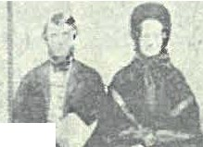
Joanna Jennings, AdminiJtrator Betty Chapin, Volunteer ArchiviJt James Miller, Volunteer ArchiviJI

•
/
I c
/J . ;ro.:"I
:Exfii6it of LiJCe :
& 'Nineteenth Century Corre1'ondence
'
etters· ·
2010 ExHIBIT SEASON IN TIIE DAN RAYMOND HOUSE

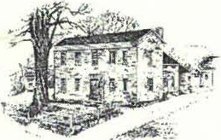
2'he
Y&/foU
.7/uttJrKal:¼ctefjt
Dnn Raymond House Museum • Mark Dewey &search Center
www.S H EFFI ELDHI S T O RY. ORG
The Sheffield Historical Society's mission is to promote a wider understanding of the people and events that preceded us in this area, and to preserve and transmit that heritage to current and future generations.
137-161 Main Street PO Box747
Sheffield, MA 01257

Phone: 413-229-2694
E-mail: shs@sheffi.cldhistory.org

1774 Dan Raymond House is open weekdays, Tuesday-Thursday, 11:00 a.m. to 4:00 p.m.
Or by appointment

Mark Dewey Research Center is open weekdays,
Monday & Friday, 1:30 p.m. to 4:00 p.m., or by appointment Phone: 413-229-3682.Email:mdl'C@shefficldhistory.org

Old Stone Store is open on weekends,
Saturday, 10:00 a.m. to 2:00 p.m., and Sunday, 11:00 a.m. to 3:00 p.m.

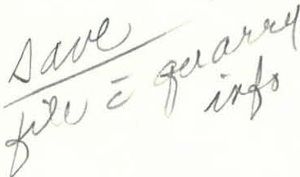
..

Natalie & Maree Funk (101 153 East Main Street Ashley Falls , MAO l222

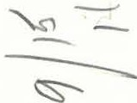

Closed January through April. Phone: 41)-.2 .:.l -Z ....., , .
. - .. -. a

;_\ l .:::.:.::: :±·-:t ,· J.. 1
01 ,•• ... H_: £.
11\.,,.. ,II ,,I,I,.\,II I I, II,\ II III,\ 111 i1,1II,Iii,,,I\,\111 II

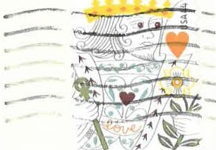

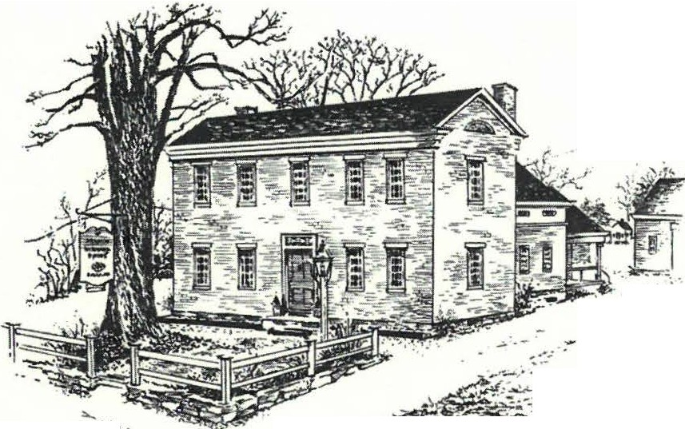:Yhe
.--- -
....-·
..,.:, •·
, ,-,- •- -
....,
. -:,;)- - - - . . ' .,......:·.
..,
3%elfo!tl
..7iut rtealSf,ae{?
Summer 2010

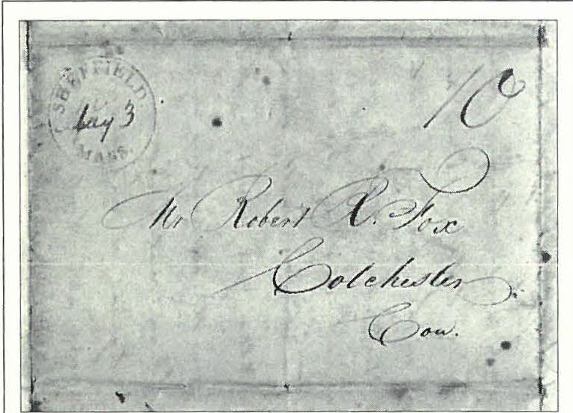Annual Meeting Program Inspired by Letter Writing Exhibits

A letter ftom the Little Family collection. Pre-stamp lettersheets used jwt one sheet of paper for economy. They were available in the 18th and 19th centuries as pre-paid postal stationary issued by postal operatosr. The letter was written on one side with the reverse side reserved for the address, folds, and seal.
Notice the relative formality and artful elegance of the address. The handwriting is by far the most cultivated in the collection. This hand belonged to that of the physician, S.R. Kellogg, who would have been the most educated of letter writers. Interestingly, today a physician's prescription is often shortened to "script," as if to reflect the notoriously illegible manner in which they are dashed off

B efore Facebook, before Twitter, before texting, we wrote lette rs. Much of the his tor y of our cultur e a nd civilization is known fro m the collected personal letters of indi vidu als. Some writers were famo usly prolific, such as Abigai l Adams and, here in the Berkshires, the Sedgwicks. Others, like the Little family in Sheffield, were ordinary citizens reporting on their daily lives to friends and relatives.
This spring and summ er the Sheffield Hi stor ical Society will be celebrating lette r writing in two exhibits and in our June program. On May 1st through October 31st the Dan Raymond House will feature The Little Family and 19th Century Correspondence, a display of the Little letters written from 1807 until 1837, t ied to a co llectio n of period antiques provided by part ic ipati ng Sheffield antiq ues dealers, private collectio ns, Berkshire H istor ical Society and T he Mount. On June 12 co Jul y 11 , the Stone Store will feature ABC's of Letter Writing: The History and Art of 19th Century Correspondence, related to the exhibit at the Dan Raymond Ho use. In conjunction with these exhibits, the Society's June 11th program will prese nt Susan Bacheld er, speaking on the history and art of letter writing and calligraphy.
Susan Bachelder, a resident of Egremont, was educated in New England private schools, atte nded the University of Kansas as a Fine Art major before moving to New York C ity where she studied at the Art Student' s Leag ue with Marcin Oberstein, a calligrapher o n the staff of Tiffany and Co., and began a 30-year career in advertising and international film production. Upon retiring to Egremont , she attend ed Bard College at Simo n's Rock and earned her magna cum laude Classics degree in 2003. Given che average age of Simon's Rock stud ents, she is certain she was the oldest graduate that year.
Susan is a member of the Medieval Academy of America, T he Dante Society and co ntinu es to pursue postgraduate studies at

Fordham, Harvard and Princeto n, as time allows.
Ms. Bachelder, being a " lefty," has always been fascinated by how we write. Atte ndin g Rudo lf Steiner elementary schoo l on Lo ng Island, she was allowed to create her own style of writ ing in a way chat was co mfortable for her. T his led to a keen int erest in the shape ofl etters and their histor y. Her interest in the tools and mate rials for writing was enhanced by the family myth that her German ancestors in Cologne had manu fact ured che ink used by G utenberg to print his Bible. The family there is in fact still in the
Arrick co111in11ed011 page 5

Y£e,#eU Y?ifttJrteal ctefft

Dear Members and Fr ie nds,
Sheffield Hi, torical Soci ry 2

FY 2010 SUPPORTERS' LIST
This list includes all forms of support received in fiscal year 2010 (7/1/09-6/30/10). The aggregate amount was wed to determine the level of fimding. This includes Annual Appeal/Membership 2009, Lighting Fund Appeal 2009, Autumn Party contributions, and in-kind donations. Please nou that donatiom to Annual Appeal 20 IO do not appear on this list. Thank you for helping make the Society all it can be!

BENEFACTOR ($1000+)
P & C Collins Fund The Sheffield Grange
Rene Wood & Dennjs Sears

SPONSOR ($500-$999)
Ic's amazing how fast a year as president of The Sheffield H istori cal Society has flown by! Ic has been a very busy year thanks co all the hard work of our team of Joan na, an active and engaged Board, our many membe rs, and especially our core of comm itt ees and volunt eers. I'd lik e co thank two of our trustees who will no t be o n the board for our 38th year beginnin g on Jul y I: Joyce Hawkins and G illian Hettinger. Gillian resigned earlier d ue to personal situations lim itin g the amount of tim e she could spend in Sheffield, but she has co ntin ued co help out as time permits a nd we loo k for her co nt inued help moving forward. Joyce Hawkins' term as a trustee is over after a great run as chair of our program committee. T he good news is Joyce has agreed co co ntinu e as program chair and we look forward co a continued flow of inte restin g programs!

O ur 37 th year of o perat io n p rom ised a "two -e dg ed swo rd " of great opportun ities and rewa rds in carrying out our m is sion while also offering the finan cial challenges of the cu rrent economic enviro nment. T hanks co che work

Marcia Brolli
Cynthia & Thomas Dixon Carolyn & Pattison Fulton Catherine & Jim Miller, in memory of Snily Proper
Noreene Srorrie & Wesley McCain The Joseph H.&
Carol F. Reich Fund
of chose ment ioned above, the Society has been successful with both the opportunities a nd che chal lenges. We've had wonderful programs ac Dewey Hall and out stand in g exhibits in the Old Scone Score. T his year the Society has two partn erships resu l ti ng in two great exhibits: che partne rship with the Sheffield Land Trust resulting in the \!&ices.from the Fields: The Family Farms of Sheffield

PATRON ($100-$ 499)
exhibi t end ing in che O ld Sco ne Sco re on Jun e 6 th and th e partnership wit h loca l

Sandra & Dale Alden Emily & John Alexander Mary Barrholomew,
in memory of Beth Bartholomew Barbara & Malcolm Bayliss John F. Bellinger
Robin Bercher Construction Pam Bloodworth
Jim Brandi Joan Brooks
Barbara & Patrick Burns Carlson Propane Elizabeth M. Chapin Constance M. Cincorra
K.C. Clow
Co nstance Cooper
Alic e Co rbin & Norma Edsall
Mrs. Franklin Curtiss Susan & Philip Detjens
Mr. & Mrs. Anthony J. Dibrita Parrci ia & Peter Eisbach
Rene Gibson
Joyce & Ross Hawkins Gillian & Norman Heninger John James & Kad1y Ness Mary Joch & Charles Joch, Jr. Athena & Rk hard W. Kimball Allison Lassoc
Lois & Brian Levinsohn Ca roline Y. Lindemann C hrisrine Ludurszewski & Greig Siedor
Alice Lustig
Jon A. MacC laren & Christopher Sink Dawn Massini
Linda & Jack McKdvey Jean & Gary Miller Martha Miller-Leveillee Ann & Dan iel Moulton Elizabeth H. O'Co nno r Anita & John Ormsbee
Charlorre A. Owens &
John F. O wens E(ajne & Fred Panin; Susan & Ted Pirrman Cora Porrnoff &
Wray Gunn Mr. & Mrs. Frank
Richardson Susan Ro thschild & Don Freedman
Ellen & Peter Rowntree Michael J. Saxto n Joanne Schmidlin Judy Schnurr Marcia & Myron
Sheinberg Nancy P. S mith Karherine E. Stook ey &
John Srookey Kathy & Tom Tetro Rebecca Myers Thomas & Robert M. Tho mas, Jr.
Ka.ren & Merle Varney Mary Vaughn & Judith Williams,
in honorofjoycr Hawkins Edith & Loet Velmans Elissa Williams & ruchard Zimmerman Nina & Don Worth
antique dealers, vario us m useums, cult ural inscicucions and ind ivid uals resulting in The Little Family & 19th Century Correspondence exh ib it op en in the Dan Raymond Ho use th ro ugh October 31st, and combi ning with ABCs of Letter Writing:The History & Art of 19th Century Correpsondencein t he Old Scone Store from June 12th throughJuly 11ch.

We also saw a new fund raisin g program thought up and chaired by Lois Levinsohn and Rene' Wood, the "All-You-C an-Eat Pasta Dinner" and silent auction held ac the Ame rican Legio n, with pare of the money going to fund che food banks of Sheffield and Great Barrington. Many of you have already responded to the Annual Appeal and I hope chat everyone will remembe r to do so during ch is busy season.

I'm pleased co report chat we have three members who have agreed co sta nd for election as trustees ac the Society's Annual Meeting chis year. These th ree new trustees will bring us co a total of seven, the maximum set by o ur by-laws after the change in 2009. New Trustees, if elected, will be Paul O ' Brien, Susan Pittman and Paul Baneviciu s. T hese three represent a wide range of backg ro und s and calencs tha t will strengthe n th e board in many ways. I' ll give more detailed backgr o und on them when I introduce chem at the Annual Meeting on Friday, June 11t h.

As we move forward together the Board and I look forward co yo ur s upp ort and appreciate any additio nal help, ideas and feedback you care co give.

H . Denni s Sears, President

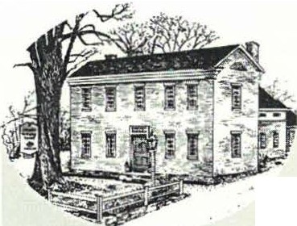
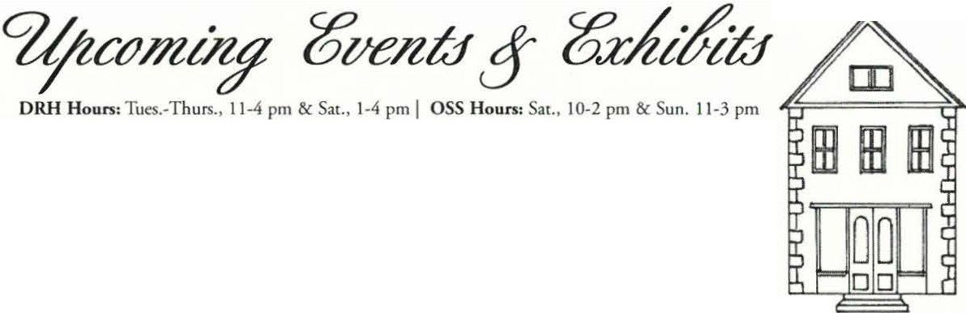
Sheffield HistoricalSocicry

NOW-Sunday, October 31, 2010. 19th Century Correspondence in Sheffield: The Exhibit of Little Family Letters
A newly acq uired collection of 19th century lett ers written from Sheffield to Con necticut by members of the Little family are related co th e Dan Raymond House,
where a later generation of the family lived. Period furnishings provided by local antiques dealers
and members of the community alongside man nequins and poignant excerpts from letters complete the scene.
Come learn how the letters shed a new light on the past and behold the parlors of the museum utt erly transformed!
The exhibit is kcated in the Dan Raymond Hoiese Mweum. There will be a reception on Satu rday, June 19, 3-5 pm.

Friday, June 11, 7:30 pm. Annual Meeting & The History & Art of Calligraphy C lassical scholar and lifelong calligrapher, Susan Bachelder, will discuss the art and history of the written word. (For more information, see feature article). The program will take place in Dewey MemorialHall
Saturday, J une 12- Sunday, July 11, 2010
19th Century Correspondence in Sheffield: The ABCs of Letter Writing
A retrospective exhibit of writing and related cools of com munication on loan from ant iques dealers, private collections, and other museum and cultu ral institutions, references the exhibit in the Dan Raymond House. The Little family letters will be on display alongside objects related to the art and histo ry of correspondence such as samples of calligraphy, samplers, fountain pens, inkwells, stamp collectio ns, lap desks, and writing tables. The exhibit will be installed in the Old Stone Store.
A reception for both exhibits will be held in the Old Stone Store on Saturday, June 19, 3-5 pm.
Friday, July 16-- Sunday, August 1, 2010. Five Friends Art Exhibit
The Five Friends: Walter Boga rd, Hans Heuberger, Sean Ryder, Lois Ryder, and Lois Van C lef return for their fifth year to the Old Scone Store with recent works. The exhibit will correspond with Housatonic Valley Art League's Juried Show in Dewey Memorial Hall, wlic::re more of the artists' work will be featured. There will be a reception on Saturday, July 17, 1-3 pm.
Saturday, August ?- Sunday, September5, 2010. From Sheffield to Egremont: A House's Journey Marsha Ginsberg, a photographic artist and stage designer from New York City and Egremont, has documented the rescuing and subsequent moving and restoration of the ca. 1840 Conway House from Bow Wow Rd., Sheffield to Ju g E nd Rd., Egremont. The house has compelling historic merit because it was once thought to be a stop on the Underground Railroad. T his multi-m ed ia exhibit wiU integrate a series of photographs and film clips edi ted by the artist and local history research prepared by the Society. The exhibit will be l.ocated in the Old Stone Store. Date of receptwn TBA.
Saturday, September 10, 7:30 pm. Berkshire Trivia Night
Local educator Phil Smith, author of the new " LoveThe Berkshires Quiz Game," a trivia game that challenges players to answer questions about local histo ry, will lead a round of Berkshire trivia in chis alternative to the Society's popular "What's It? Ni ght" program. The game's 2,447 questions vary from comical to challenging to impossible, but players are sure to come away illuminated about the regio n's past! The program will take place in Dewey Memorial Hali.
Saturday, September 18 & October 2, 11 am. Heritage Walks: Architectural Walking Tour of Sheffield Many well- built historic houses still adorn Sheffid d's Ma in Street, and this walking tour is designed to point them out and refer briefly to some of the illustrious Sheffield citizens who owned them. For a more derailed histo ry, visitors are referred to the Sheffield Histori cal Socie ty's Mark Dewey Research Ce nter. The tour will start at Shefjuld Historical Society, 15 9 Main St.
Saturday, October 2, 2 pm. Annual Sheffield Spirit Walk Join us in Center Cemetery for this popular event in a theatrical encounter with Sheffield history as memorable residents from our town's past are re-cast. Learn their stories as they are vividly brought back to life before you!
Center Cemetery is located on Berkshire School Rd., a stone's throw from DeVries Bui lding Supp/,y.

Friday, October 8, 7:30 pm. Songs of the Revolution Singer and historian Diane Taraz presents the "soundtrack" to the Ameri can Revolution, c::xploring th e Fascinating world behind the lyrics of the songs chat rallied both sides. fn colonial d ress, she sings and accompanjes herself on guitar and Appalachian mountain dulcimer, transporting her listeners back to the rurbulent time of our country's birth.
The program will take place in Dewey M emorialHail.

FAMILY/DUAL ($50-99)
Sheffield lfa rorical Society 4
..76inual!7tryttJr&

G inger & Ray Alexander Karin & Allen Altman
Doreen & Walter Atwood Paul R. Banevicius
Ann B. Barren
Anne Barsrow & Tom Driver Arthur J. Bacacchi,
in memory of Berty Batacchi
Ti mothy F. Beard
Paul Benjou & P.J. Birriel Blanche Bennett
Elizabet h Cary & Ricky Bernstein Mildred & Lo-Yi Ch an
Kathlee n & Ne il C hr isma n Ursula & Walte r Cliff
Dr. & Mrs. Noel L. Cohen Abbott Co mbes, III
Sue & Bob MacVeery,
in memory of Clarence Martin
& Floyd Woodbeck Marian & Antonio Malnati Barbara & Norman Margolis Gregg S. Massini Bus Co.
Jeanne & Norman Merrill Sha ron & George Milukas Par Molholr & Louis Levine Amanda Mo rgan &
Ch ris Coenen Veda & Rusry Mott Patrice Mullin
C. Twiggs Myers, in memory of Alice Ann Chase & Art Chase
Adrien ne Naessil &
Renee Voltm ann MaryEllen J. O 'Br ien &

Nominating Committee
Position | Individual | Tenn
Preside nt | H. Dennis Sea rs (incumbent) | 201 2
Vice Preside nt | Lois Levinsohn {incumbent) | 2012
Treasurer | Co nnie Coo per (incumbent) | 2011
Secretary | Philip Decjens (incumbent) | 2012
Trustee | Paul Banevicius | 2013
Trustee | Marcia Brolli (incumb ent) | 2012
Trustee | Wray Gunn {incumbent) | 2012
Trustee | Paul O' Brien | 2012
Trustee | Susan Pittm an | 2013
Trustee | Greig Siedo r (incumbent) | 2012
Trustee | Kathleen Tetro (incumb ent) | 2012

Jacqueline & William Con nell Dorot hy A. & Peter Crockett Dana D. Cummin gs
Kitty & Dick Cunningham Mrs. Francis Dallerr
Ann & Bob Dean
Nancy & Dwighr Dellerr Dorothy & William DeVori Anne & Kerry Doug las Audrey & John Downie Frances Eastbu rn
Margit Branch Elam Richard Esposito Joyce Freundlich & Norman Schnayer Betsy & Phil Garcia Ruth & Susan Gillette Elsie & John Gilligan David Goldman & Mark Schaffer Virginia Goldner & Stephen Rosenheck Sharon Gregory
Ada Hastings & George Raymond
Susan & Joseph Hurlbur t Dr. & Mrs. Jan1es R. Hu rley
Paul O ' Brien Kathy & Tom Orlando Andrea & Dan Patel Nancy O 'Do nohue & Richard W. Pearse Seymour "Ro b" Robins Mrs. Ted Romaine Family Alan & Linda Rosen
Amy Rudnick & Ben Hillm an
Annie Ryder Mary & Bob Safian
Shellie & Bernard Schneider Becky & Ken Schop p Pauline & Ca rl Schum ann Judy & Gary Schumer
Andrea Scott &
Robert Jemer Ann & Bob Shanks Barbara & James Shiminski
E. Bonnie Silvers Diane Smith & David Sm ith, Sr.
Hope & Howard J. Swanson Judith & Ron Timm Rosemary & Arthur Uffner
Hester Velmans & Peter Cherneff

H. Dennis Sears, President

Mark Dewey Research Center

T he research center is an arm of the Society associated most often with histori cal explor atio n and family histo ry alt ho ugh o ur work ofte n takes us beyond these boundaries. We receive inq ujries by e-mail, telepho ne, walk-ins and U.S. mail. T hey are researched by trained volunteers, che results sent on and copies of the work often retained for future use. In add ition to adding to o ur co llec tio n in chat way, we also actively solicit information from our many patrons, make occasional purchases and receive, gracefully, donations from friends and members.

Perhaps our most important additio n to our collectio n this past year was che acquisitio n of abo ut two dozen lett ers from the Litcle fam ily of Sheffield, some of whom lived in the Dan Raymond Ho use Museum. T h is cor respondence is the basis o f two exh ibit s chis year, one presently in the Museum and one, sched uled la ce r chis summer in the O ld Sto ne Sto re.

Nancy Jones & Gilbert Schrank Christine & Joseph KeUey Beverly & James Kimball
Ruth Kolberr & Fred Pomerann Nancy Kriegel
Maria G. Kubis & T haddeus B. Kub is
Wendy & Stephen Leigh Candida & Douglas Logan
Diana Vollmer & Henry Vollmer, III Paula M. Wardynski
Terry Welsch Elsie D. West
Marilyn & John Wightman Elizabeth C. Wilso n &
William Wilson
Volunt eers Betty C hapin and David Prouty, continu e to give faithful service to th e Society and its members and patrons. O ur regular hours are Monday and Friday, I:3 0 co 4:0 0 a nd by appoint ment provided a volunteer can be availa ble.

JamesMiller, Volunteer Archivist

Buildings & Grounds Committee

IND IVTO UAL T he Sheffield H isto rical Soc iety is headquartered at I 774 D an Raymo nd Ho use

Mark Bacheni Plumb ing Betty & Fred Bangs
Trumbe U Barrett Jean Blackmur Steven Borns Grace W. Brown Bill Browne
T homas Buckley
Allen Co un ry Public Library
Grace & Jo hn Campbell,
in memory of David Canine/Ii
Barbara A. Carr & Edwin Ca rr, J r.
Julie & Neal B. C hamberlain Sally C hamberlain Cook
Holly Coon Charles A.. DuC harme Nancy B. Emery
Museum , 159 Main Street, Sheffield. In addit io n it maint ains six ot her historic st ructures that dace from the 19 th century: T he Mark Dewey Research Center, the brick Ed uca tio n Ce nt er, th e Parker J. Hall law office, a carri age barn, a
Greek- revival smo kehouse, and T he Old Sto ne Score.

Last winter the Center for Ecolog ica l Technology (CET ) performed an energy aud it, assessing ways in which the Society buildin gs could become more energy­ efficient. As per the compan y's recommendation, an insulation upgrade was

installed in the attics of both the Research Center and the Museum , which also received a gable vent. The Society completed the work with the purchase of an energy-efficient refrigerator.

In ez S. Flinn
Sheffid J H istu rid Soc iety 5

INDIVlDUAL (Con'r)

Dorothy Marosy, in memory

This spring the Society compost bin was rebui lt and installed on the west end of the Society grounds with the help of Berkshire School students and volunteer herb gardeners Ann Riou and Helen Macy.

The grounds staff include: volunteer, Brian Levinsohn, who has created street signs for various Society benefits; Joe Buchte, who mows and grooms the lawn s; volunteers, Ann Riou and Helen Macy, who tend the herb beds; and gardener, Kathy Moore, who maintain s the flower garde ns.

T he Society's adm inistrato r continue s to live on the site and ove rsees its general operations. The Society is currently seeking a new chairperso n for ics buildings & grounds committ ee.

Joanna Jennings, Administrator

Co llections Committee

Members of the Collections Co mmittee for the current fiscal year were: Philip Detjens, Cat herine & Jim Miller, Kathy Tetro and Joanna Jennings (ex officio).

T he effort begun last year co trans cribe details from the Society's collection from paper inventory sheets onto a computer software program co ntinu es to be a major activity.
Sand ra & Jack French Marcia Fried man Maree & Na talie Funk
Maryanne & William G illooly Judith H. Gott
Richard L. G reene
Lindsay & Richard A. G reene Leo nard Graziano &
William Grief
Ar lene & Ed G rossman Marguerite Gulick Lovina Gulotta,
in memory of Santi Gulotta
Joan & John Hanlon Esther Heffernan Claire K. Height
Caj dyn Horaling Frani iska & Donald V. Kenney Beverly Kradel Wendy Linscott & James Lamme Alice Leason
Gary LeBeau
Susan & Philip Lcbowirz. Robe rt D. Ledlie
Sarah Macy
of Henry MtJJJini
Norma Moulron
!star H. Mudge Judy & Tician Papachristou Wesley Petersen , in memory of Kathryn K Gibbs
Ja net Plunkett Marsha & David Pottle Joan & Kenneth Powers,
in memory of Freddie Martin
Doris & Alfr ed Richardson
Ann M. Riou M uriel Rokos Jessica Roseman Anthony Sabatelli
Libby & Charles Schmidt
G illian Shallcross Evelyn Small
Betsy Smith, in memory of Mildred R. Smith
Mr. & Mrs. Peter Traub
A.J. Trocchi, in memory
of Edith Trocchi O lga & Bruno Vcrunesi Marion Whitman
Martha & Barry Williamson Susan & Tom Young

The consolidation of co llections storage and reclassification of the Society textile collectio n by category rather than by do nor is a noth er project und erway. The effort began last winter in the Dan Raymond H o use M useum horning room and will continue upstairs into the att ic storage bays in the fall.

The Soc iety has recently been notified of two significant donation s. O ne is an 18th century millstone from a mill on Sage's Ravine contributed by the estate of Ethel T. Storer, a former Sheffield resident. The other is a cart used to carry marble over a narrow gauge track from the Gooddale Quarry, which was dona ted by Barbara Demolino.

Philip Detjens, Trustee

Finance & Audit Committee

The Finance & Audit Com mitte e meets quarterly to revie w and monitor the Society's budget and portfolio. Year-to-date income and expense balances are compared to actual and any material variances are investigated. Portfolio allocations are reviewed with ad justments made, if necessary.

The Committee reviews rhe Annual Statement, Tax Return and budget and recommends their appr oval by the Board of Trustees.

The Co mmitt ee supports the wonderful work of the Society and its officers, board and administra tor and the quality profile and programs offered to the communi ty.
ArticlL continued.from page 1--------

ink and paper business. Susan's presentation will includ e the physical histo ry of letter writin g and how the tools we have used have in formed our alphabets. Materials, kinds of paper, quills and nibs, and our own Massachusetts histo ry of paper manufacturing will be touched on as we d iscov e r how the act of writing lett ers became its own social com mentary on American cultu re and where chi s enda ngered arr is leading us.
Finally, Ms. Bachelder will disc uss the future of writing and of recorded histo ry itself as fewer and fewer peo ple co mmit ink to paper and rely instead on electronic devices. H ow will futur e generations lea rn about o ur rimes if the on ly communi cation s d escr ibin g these rimes are stored in computers?
"T he H isto ry and Arr of Letter Writing and C alligraphy" will be held on Friday, June 11, at 7:30 p.m. at Dewey Memorial Hall in Sheffield. T he program will be preceded by the Society's annual meeting, and followed by an ice cream social. For further in formatio n, call the She ffield H isto rical Society at (4 I3) 229-2694.

Connie Cooper, Treasurer - JoyceHawkins, Program Chair

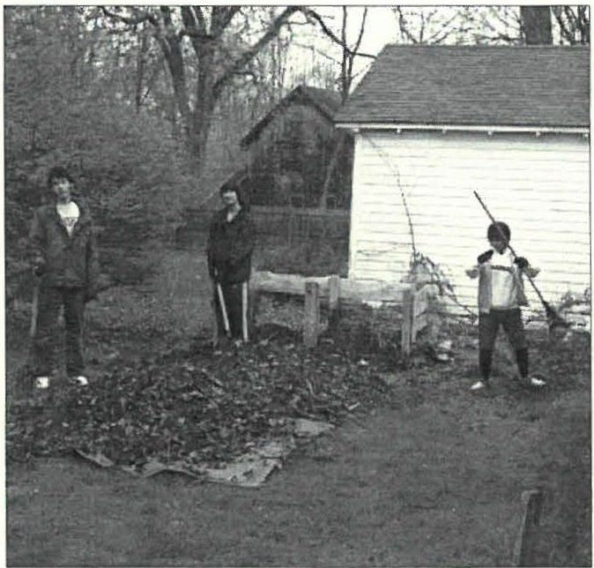2010 BOARD OF DIRECTORS

On April / 6 BerkshireSchool held its annual Gracious living Day, participating in spring clean-up at various locations throughoutthe community.The group of studmts who visited the Society helped clean out the compost bin (above) which volunteer herb gardeners, Ann Riou and Helen Macy, Later reconstructed. Other helpers were: MarciaBro/Li, Jqyce & Ross Hawkins, KC Clow, Philip Detjens,Dennis Sears, and Jim Shiminiski. Thank you to aLL who took part!
H . De nn is Sears, President Lois Levinsohn, Vice Pruidem Co nnie Coo per, Treasurer
P hilip D ecje ns, Secretary

M arcia B ro ll i, Trustee
Wray Gunn , Tm stee
J oyce H aw kins, Trmtee G reig Siedo r, T,wtee Kath y Tetro, Tmstee

SOCIETY STAFF
J oan na J e nn ings, Ad111i11iJtr ator Berey C hapin, Vo/11nteer Archivist J ames Miller, Vo/1111teer A,·chivist Dav id Pro u ty, Vol1111teerA rchivist

Hey there! Would you like to join us too?
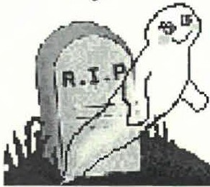The 2010 Sheffield
Spirit Walk needs the talent
of YOU!

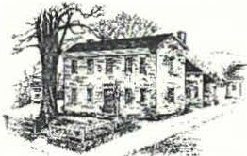
_%
%e;foU
sf2:tttJrteal cte
Dan Raymond House Museum • Mark De,vey &search Center • Old Stone Store
WWW.SHEFFIELD H ISTORY.ORG
TbeSheffield Historical Society's mission is to promote a wider ttnderstanding of the people and events that preceded _{tt.S} in this area, and to preserve and transmit that heritage to current and future generations.
159 Main Street
PO Box 747
She ffield, MA 0125 7

Phone: 413-229-2694
E-mail: shs@sheffieldh istory.org

177 4 Dan Raymond House is open weekdays,
Tuesday-Thursday, 11 a.m. to 4 p.m., Saturday, I-4 p.m. Or by appointment.

Mark Dewey Research Center is open weekdays,
Monday & Friday, 1:30 p.m. to 4:00 p.m, or by appointment. Phone: 413-229-3682. Email: mdrc@she ffieldhistory.org

Old Stone Store is open on weekends,
Saturday, lO a.m. to 2 p.m., and Sunday, 11 a.m. to 3 p.m.
Closed January through April. Phone: 413-229-2287

r ----- -

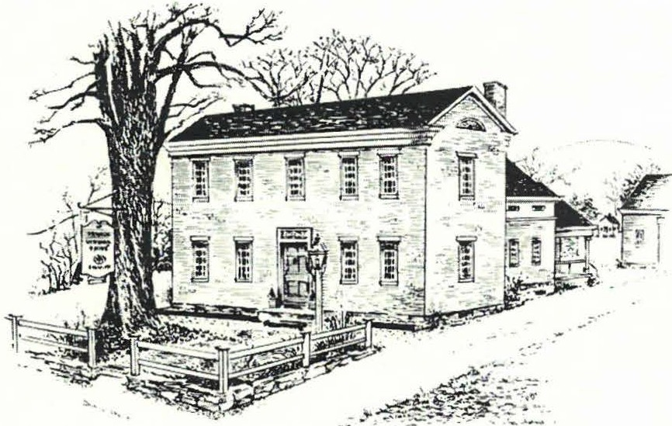
2he
.%tfFlal
.ffci:lt1Jrteal3i,ae
Autumn 2010

Old Parish Church Celebrates Its 27 5th Anniversary
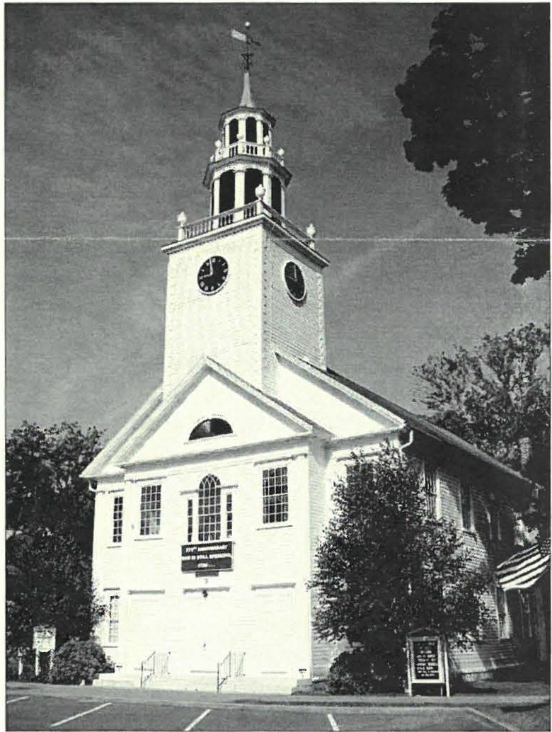
The S h e ffield H isto rical Society will help Old Parish C hurch celebrate its 275 th a nn iversary with an exhibit in the Old Scone
Score and through the Spirit Walk in O cto ber.
This fall Old Parish C h ur c h will celebrat e its 27 5 th annive rsary. The C om mittee has planned many events focusing around che actual dace of its beginning, October 22, 1735, when they o rdained the ir first m in ister, The Rev. Jo nathan H ubba rd. Also ac know ledged will be rhe 250th anniversa ry of the conscruc cion of the meeting house on the Sheffield G ree n. W hile th e co ngregat io n is the second oldest in Berkshire County, the church building itself is the oldest.
N umero us events will mark chis milesto ne. Beginnin g October 2, che C h ur c h a nd the Sheffield H is to rica l Soc ie ty wi ll co-spo nsor a commemorative exhib it at the S co ne Score, a nd o n Saturday, O cto ber 2, the A nnu al Spirit Walk in che Ce n ter Ce metery will feature notable peo ple who h ave be e n part of the C hurch's past.
The actual ann iversary of the fo u ndin g of the chur ch will be held on Friday, O cto ber 22, begin ning at 6:0 0 pm a t th e American Legio n with a dinner and entertainm e nt , hosted by John -Art hur a nd Trudy Weaver Miller. It will be open to the public. T ickets are $25 for ad ults; children und er 12 are free.
A C olo nial Wo rship Service will be held at I 0 : 00 am on
S und ay, O cto ber 24. Partic ipants are enco uraged co wear Colo nial clothin g a nd th e sermon will be typical of those hea rd

in the 18th century, delivered by The Rev. Jill Graham, pastor of Old Paris h.
Sheffield residents are enco uraged co share in the exhibit and related programs.

- Marcia Brolli and john Wightman,
275th Old Parish Anniversary Exhibit Committee
The original meeting house was built ca. 1735 and located on the Sheffield
Plain. Accordingto Lillian Preiss it was a "primitive building...foriy-fi11e by thirty-five, plasteredon the four walls up to rhe girts and plates, leaving the roof exposed." By 176 0 the town had outgrown this modest space and the center had shiftedfurthersouth. The 1760 Old ParishChurch started as the inner clapboard famed structure you see in the above photo. ln 1820 the church was moved back from the road to its presentsite. The side galleries were added, along with an elegant steepleand belfry. The installation of high chimneys and wood stoves also would have been a nice improvement ftom the unheated meetinghousoef yore.

Dear Members and Friends,

"History" is the result of change and historicalsocieties have history lik e everything else. The Sheffield Historical Society is now making history as change comes to rhe Society in form of rhe departure of our Administrator, Joanna Jennings. Over the last three and one half years chat Joanna has been with us, she has added to our history by utilizing her artistic skills to improve the graphic public _face of the Society. Our poster advertisements, newsletters and web site all show the results of application of her creative and artistic skills. We all thank her for all her cont ributions, wish her well, and hope she finds even greater opportunities for demonstrating chat creative ability wherever she goes next to make history.

Our 38th year of operation had a spring and summer of great exhibits using both the Old Scone Score and Dan Raymond House. The season started with a partnership with the Sheffield Land Trust resulting in the Voices from the Fields: The Family Farms of Sheffield exhibit ending in the Old Stone Store on June 6th. A partnership with local antique dealers, vario us museums, cultural institu tions and individuals
resulting in The Little Family & 19th Century
Correspondence exhibit continuing in the Dan Raymond House through October 31st and combined with ABCs of Letter Writing: The History & Art of 19th Century Correspondence in the Old Stone
Store. The current From Sheffield to Egremont: A House's Journey will run through September 26th and then be followed by an exhibit celebrating the 275th Anniversaryof Old Parish Church. Then, before you know it, we'll be into che Festival for the H olidays!

Thanks to all chose who have made contributions chis year. The Annual Appeal continues and if you haven't contributed to continue your membership, I hope you will do so before year-end.

A special thanks for rhe many hours of support and just plain work provided by the Board and volunteers. Without your efforts, there would be no change, no history and no Sheffield Historical Society.

- Dennis Sears, President Sheffield Historical Society
Shcftleld Histor ical \ocicty 2
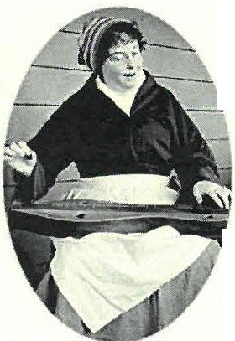
Songs of the Revolution
In 1776 New Englanders sang all the time, for many reasons. Soldiers sang marching songs,
mothers sang lullabies, youths sang melodies of romantic passion, congregations sang hymns in church. Songs carried the news of rhe day to people who could not read. And when the sun went down there was nothing better than a
40-verse ballad full of bloody derring-do to
while away the evening.
On Friday evening, October 8th, the Sheffield Historical Society will present Diane Taraz, collector of Colonial songs, exploring the fascinating world behind the lyricsof the songs that rallied both sides during the American Revolutionary War. In Colonial dress, she will sing and accompany herself on guitar and Appalachian mountain dulcimer, transporting listeners back to the turbulent rime of our country's birch.
Diane Taraz is an avid collector of old songs and the histo ry behind chem. She has taught Colon ial-era songs at the Lexington Historical Society and has performed at many historical organizations throughout Massachusetts. Diane Taraz loves the intersection of history and music, and enjoys sharing the fascinating sto ries of both extraordinary characters and common folk of the past. She has a bachelor's in education from Boston College and a master's in communication from Lesley, and has studied at the Longy School of Music. She is director of the Lexington Historical Society Co loni al Singers, and performs throughout New England both solo and with the Gloucester Hornpipe & Clog Society,
a band chat plays maritime, Celtic, and colon ial m usic.
The Historical Society program will feature such songs as:

  - "An American Frigate," a broadside ballad of 1780 about Capt. John Paul Jones, who cried in the heat of battle, "I hav e not yet begun to fight!"
•"Young Ladies in Town," created in 1769 to encourage fashionab le ladies co boycott British goods, asking chem to refuse marriage proposals from men wearing London fabrics,
- "The Drum," a recruiting song collected by a captain in rhe 11rh Pennsylvania Regiment in 1780,
•"Free America," written in 1770 by the beloved Dr. Joseph Warren, slain at the Battle of Bunker Hi ll, and
- "C hester," a patriotic 1778 ant hem by Wi lliam Billings meant to bolster the morale of a population facing the mightiest army in the world with few resources.
This delightful evening of colonial songs will be presented at 7:30 p.m. at Dewey Hall in Sheffield on October 8th. CDs of Ms. Taraz's traditional music and her own compositio ns will be on sale at the meeting.
For further in format ion, call (413) 229-2694. - articleby Diane Taraz, edited by Joyce Hawkins, Society Program Chair

SbeJIJd d Hi,rorical Socic:ry 3
&
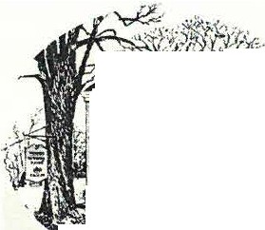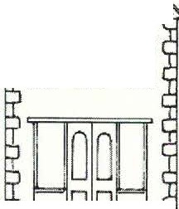ctJmOZjl 6ventf g 6.:dttfiu
. """ -
--inn,·•ll
Ji it t '.. ,
"· · ...:;. - ·: •
.
mmm
DRH Ho•m To .-Th••·• 11-4 pm & Su., 1-4 pm I OSS Ho , S0<., 10-2 pm & Soa. 11-3 pm
/ NOW-Sunday, October 31. 19th Century
Correspondence in Sheffield: The Exhibit of Little Family Letters
.,.._ A newly acquired collection of 19th century letters written from Sheffield
to Connecticut by members of the Little family are related to the Dan Raymond House, where a later generation of the family lived. Period furnishings provided by local antiques dealers
and members of the community alongside mannequins and poignant excerpts from letters complete the scene. '-'- -1- .w
Come learn how the letters shed a new light on the past and behold the parlors of the museum utterly transformed!
The exhibit is kicated in the Dan Raymond House Museum.
Saturday, August 7-Sunday, September 26. From Sheffield to Egremont: A House's Journey
Marsha Ginsberg, a photographic artist and stage designer from New York City and Egremont, has documented the rescuing and subsequent moving and restoration of the ca. 1840 Conway House from Bow Wow Rd., Sheffield to Jug End Rd., Egremont. The house has compelling historic merit because it was once thought to be a stop on the Underground Railroad.
This multi-media exhibit will integrate a series of photographs and film clips edited by the artist and local history research prepared by the Society. The exhibit will be located in the Old Stone Store.
Saturday, September 18 & October 2, 11 am. Heritage Walks: Architectural Walking Tour of Sheffield Many well-built historic houses stil1 adorn Sheffield's Main Street, and chis walking tour is designed to point them out and refer briefly to some of the illustrious Sheffield citizens who owned them. For a more detailed history, visitors are referred to the Sheffield Historical Society's Mark Dewey Research Center. The tour will start at Sheffield Historical Society, 159 Main St.
Saturday, October 2, 2 pm (Rain Dace: October 3). Annual Sheffield Spirit Walk Join us in Center Cemetery for this popular event in a theatrical encounter with Sheffield history as memorable residents from our town's past are re-cast. Learn their stories as they are vividly brought back to life before you!
Center Cemetery is located on Berkshire School Rd., a stone's throw.from DeVries BuildingSupply.
Saturday, October 2- Sunday,October 31. Old Parish Church's 275th Anniversary Exhibit
For more information about the Celebration, see article on front page. H ighlight s of the exhibit will include a number of documents from the Society archives including excerpts from the congregation's covenant, passages from some of Rev. Bradford and Rev. Keep's sermons, and a mid-20th century wage report of a parson's responsibilities. A fragment of raised­ field paneling from the original meeting house on the plain on loan from the Bushnell-Sage Library while benches and a silver plated communion set will be on loan from the Church. A detailed church history and 275th Anniversary timelines and new research prepared by church historian John Wightman will also be available. The exhibit will be kicated in the Old Stone Store.
Friday, October 8, 7:30 pm. Songs of the Revolution Singer and historian Diane Taraz presents the "soundtrack" to the American Revolution, exploring the fascinating world behind the lyrics of the songs that rallied both sides. In colonial dress, she sings and accompanies herself on guitar and Appalachian mountain dulcimer, transporting her listeners back to the turbulent time of our country's birth.
The program will take place in Dewey Memorial Hall.
Friday, November 12, 7:30 pm. Holiday Tastings from the Festival Come get in the mood for the holidays with this preview of this year's Festival for the Holidays. Enjoy tasty samplings of wine, cheese, and other Old Stone Store products.. The program will take place in Dewey Memorial Hall.
Sat urday, November 13- Sunday, December 19. 12th Annual Festival for the Holidays
Shop for everyone on your list at the Sheffield H istorical'sSociety's holiday bazaar. Featuring a wide array of handmade goods, including miniature trees, wreaths, ornaments, jewelry, holiday treats, gifts, raffles, and local crafts. Upstairs holidayt a g sale with Old Stone Store markdowns. The Festival will have special extended hours from 11 to 4 pm on Black Friday (November 26}.
Sunday, December 12, 4-6 pm. Annual Holiday Party
Come gather 'round the festive kee ping room fireside in the Dan Raymond House and enjoy some good ol' holiday cheer in
the spirit of yesteryear. Join friends new and old. Music, merrim ent, and more.
The program will take place in the Dan Raymond House Museum.
Friday, January 14, 2011, 7:30 pm. It's the Annual What's It? Night
The objects as ever have yet to be identified. Curious? Come find out! Have something strange of your own that you'd like
identified? Bring it along! The program will take place in Dewey Memorial Hall.

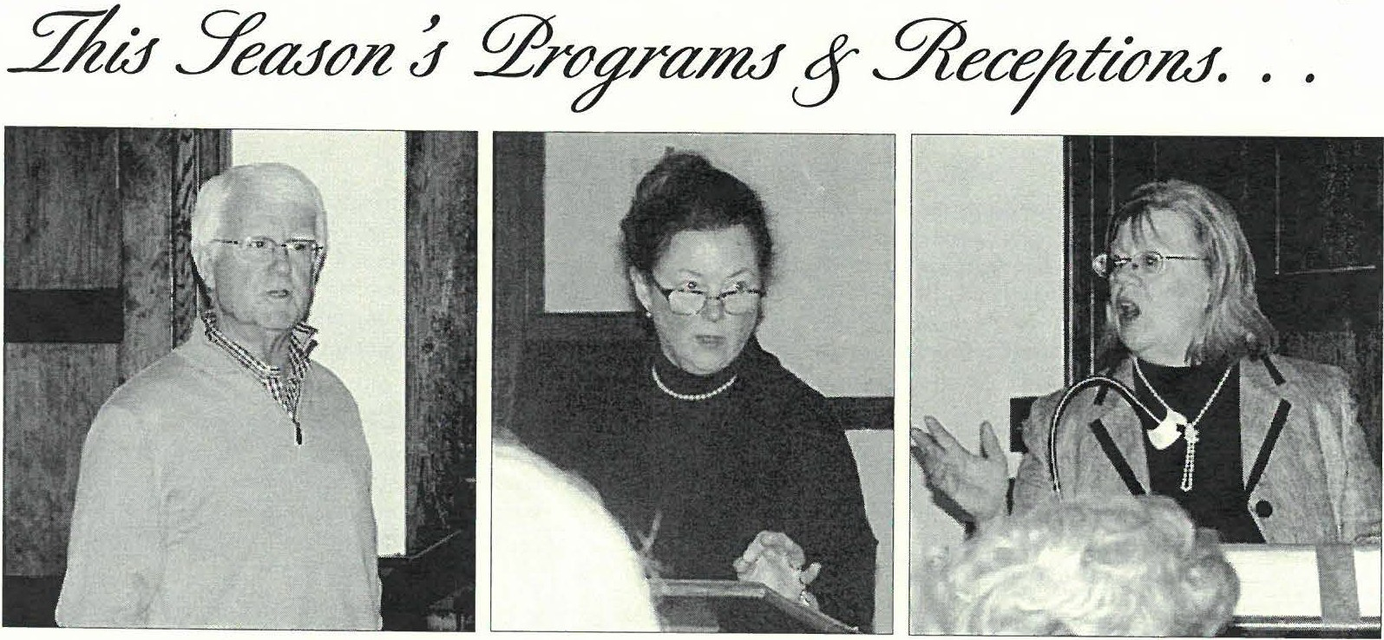
Shdfo.·ld J-fornrical Soci,ry 4
Above, three monthly meeting speakers. Greig Siedor (left) is an avocational WWJJ historian and a member of the Society Board. Researchmaterials in the Society archives and oral history in terviewshe gathered.from local residents culminated in his May program about what the Sheffield home.front was like during this era. Susan Bachelder of South Egremont (center) spoke at the Annual Meeting on the art and history of calligraphy and letter writing. Ms. Bachelder is a classical scholar and leads an annual calligraphy workshop sponsored by Massachusetts Cultural Council. Jacqueline O'Connell (right) a local restoration consultant and landscape architect, gave a slide presentation on architectural history and historic paint colors.

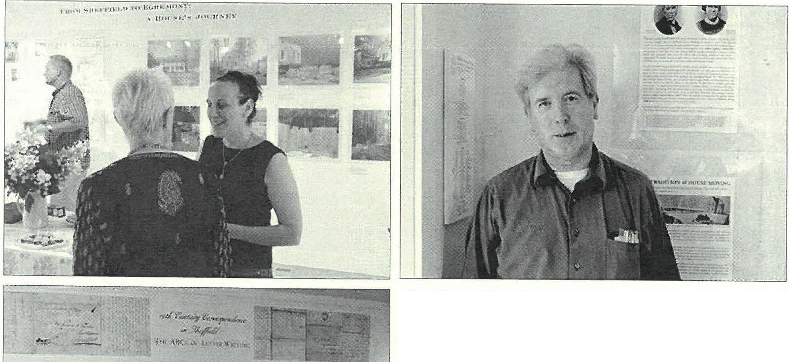
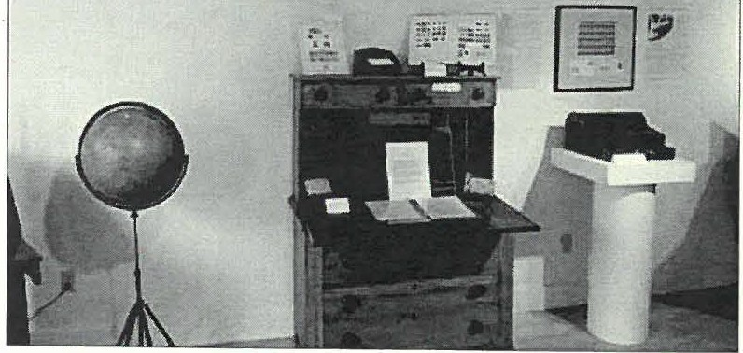
Above left, Marsha Ginsberg, the artist behind the photographic series on the historic Conway House moving and restoration, speaks with a.friend at the From Sheffield ro Egremont exhibit reception. Karl Radke of Pittsfield (above right) also attended the reception. Mr. Radke whose father and aunt resided in the Conway Houseafter the Conway family had interesting stories to share about the house.

From Sheffield to Egremont wasbrought to )'OU by BerkshireBank Foundarion-. \tnem·i,'s Most F...xc1i ing 8.ln• •l

At left, the second 19th century correspondence exhibit The ABCs of Letter Writing, on display i n the Old Stone Store in July, included a number of 19th century writing desks, inkwells, quill and nib pens on loan.from localantiques dealers and private collections. The Society's collection of Little family letters were showcased alongside letters written by famous Berkshire authors Herman Melville and Edith Wharton.

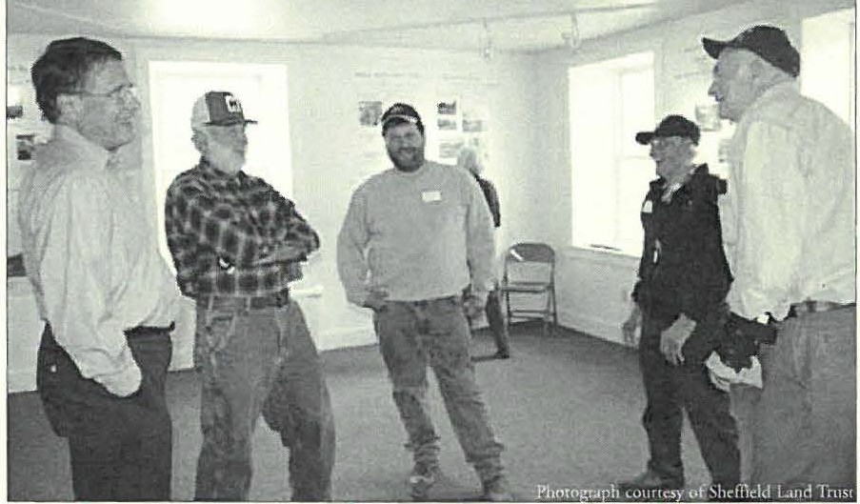
john Wightman, Jim and Jimmy Larkin, Art Batacchi, Sr. and \\,¼zrren Wilcox attended the Voices from the Fields exhibit reception at the Old Stone Store on May 1. Collaborative exhibits have brought greater numbers through the Society doors this season. The Voices from the Fields and T he ABCs of Letter Writing exhibits drew crowdsof250+ respectively, while visitation at The Dan Raymond HouseMuseum (see below) was up by 80 % ftom previous years.
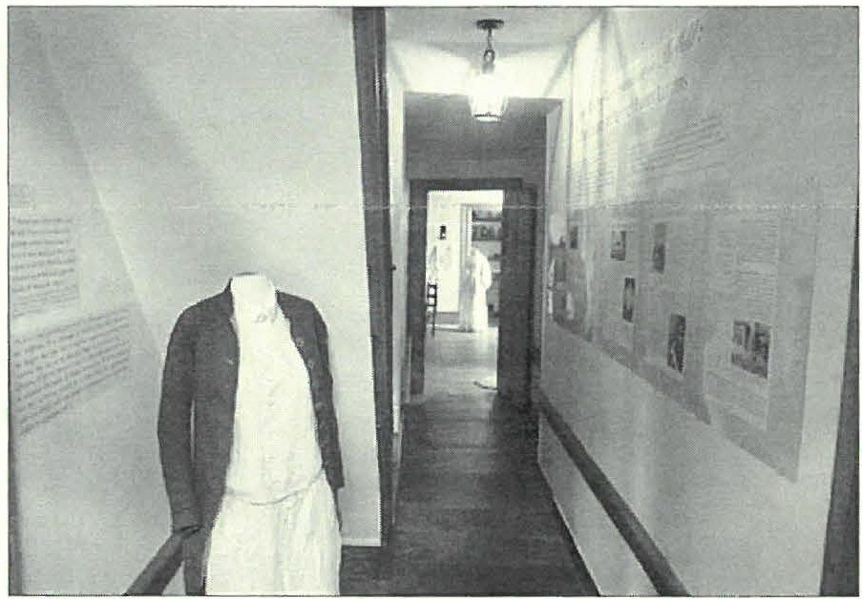
Have you been to see the new exhibit in the Dan Raymond House this year? Don't worry... there's still time! The Exhibit of Lit tle Family Lerrers will remain up through October 3 1, and the museum continues to be open on Sat11rday afternoons ftom 1 to 4 pm. The exhibit features fabulo11S 19th century selectionsftom local antiques dealers as well as textiles and communication tools ftom Berkshire and Sheffield historical societies. All of these collection objects bring the language and content of the letters to life!
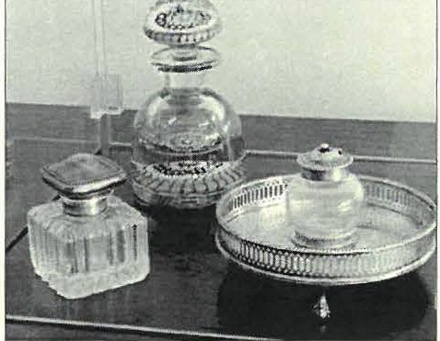At right, a collection of antique glass inkwells on loan ftom 11 local private collection were another highlight of the ABCs.of Letter Writing exhibit in the Old Stone Store.

The 19th Ct111ury Cormpo11dm cr i11 Sheff,,ld exhibit s were fimckd in part b)' Berkshire 8 ,111k Foundation and in pan by Sheffield Cuhural Co uncil, a local agency which is supporrcd h)' Massachusccrs C ultural Co uncil.

ShefficlJ Historid Society 5
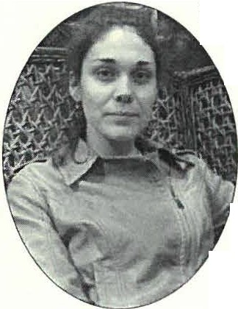
Dear Members, Friends,
and Colleagues,

It is with regret cha t I
an nounce my resignatio n from Sheffield H isto rical Society. I will be leaving the Society at th e end of September for a museum
positio n in the greater Boston area.

Throughout my three-year tenure, I have enjo yed th e challe nges of being the sole employee and of wearing many hats. I belie ve that working within a lim ited means has in some ways made my approa ch more innovative . Now it is tim e to put so me of that
ingenuity I have lea rned to a greater use. As I go back our into the work force, chis time I am envisio nin g a museum large eno ugh to have d ifferent peop le under those man y hats I have worn!

Wh ile the city of th e Boston is full of its own rich histo ry, in leaving Sheffield, the oldest town in Berkshire County, I think what I will miss most is the sense of community kindled among friends, colleagues, mentors, and the wonderful volunt eer supp ort which is uniquely Sheffield . You have helped teach me that it really doe s ' rake a village' as the
sayin g goes. In add ition, I will miss all the local
history and fam ily research that I had become so fond of completin g for Society exhibit s. Alas, I am not a Sheffield native, so that histo ry is abo ut you.
Int erestingly, my own Scottish ancestry, upon fulfillin g their inde nr ureship in Nova Scotia settled near Lynn, MA, so it is no coincid e nce that manifest destiny should bring me furth er... east!

Since I will be leaving th e area, my resign at io n also affec ts my position of Assistant D irecto r at th e Bidwell H o use Museum, where I have worked since 200 5. I am much ind ebt ed co both organizatio ns for offering me the equivalent of a five-year co urse of stud y in Early American lifeways a nd museum
management.

Leaving Sheffield is a bittersw eet th ing. I would like to thank all of you for making my time here as memorable and eventfu l as it was.
Yours sincerely, Joanna Jennings

13ERKsmREBAKKl►i,l· ll
A.mt•rk a \ \k,st fa.CIUIHo.1. B.1u),, Massachu>ens Cult,uralCounol

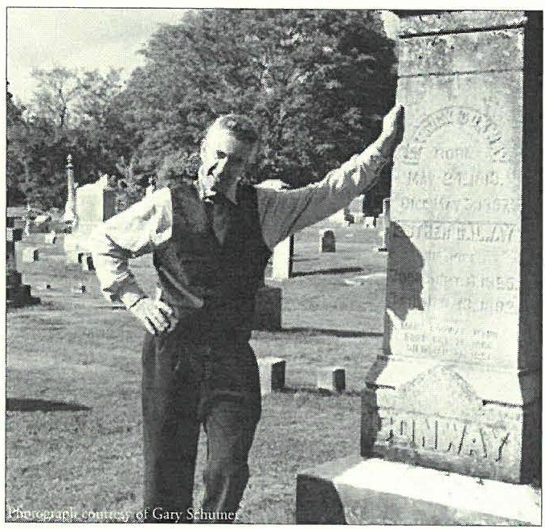2011 BOARD OF DIRECTORS

Neal Chamberlain played the part of PatrickConway in the2009 Sheffie/,d Spirit Walk in Center Cemetery. Patrick Conway was the owner of the historic Conway House, now the subject of the house moving exhibit From Sheffield to Egremont on view through September 26 in the O/,d Stone Store. While the 20 IO Spirit Walk will be he/,d in Center Cemetery again, the theme of this year's event will be on the lives of O/,d Parish Church congregationalists, a part of the Church's 275th Anniversary Celebration.
H. Dennis Sears, President Lois Levinsohn, Vice President Connie Cooper, Treamrer Philip Detjens, Secretary

Paul Banevicius, Trmtee Marcia Brolli, Trustee Wray G unn, Trnstee
P aul O' Brien, Trustee S usan Pirman, Trustee Greig Siedor, Trustee Kathy Tetro, Tmstee
SOCIETY STAFF
J oanna J ennings, Administrator Betty Chapin , Volrmteer A1·chivist J a mes Miller, Volunteer Archivist Dav id Prouty, Volu nteer Archivist
Hey there! Would you like to join us toof
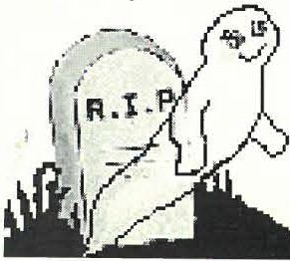The 2010 Sheffield
Spirit Walk needs the talent
ofYOU!

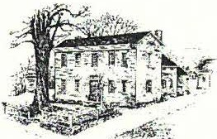
.Y1e
3%ejfteU
J/i:JttJrtcal.Yoctefy
Dan Raymond House Museum • Mark Dewey Research Center • Old Stone Store
W W W. SH EFFI ELDH ISTORY.ORG
The Sheffield Historical Society's m ission is to promote a wider understanding of the people and events that preceded us in this area, and to preserve and transmit that heritage to cttn·e1zt and future generations.
137-161 Main Street
PO Box 747
Sheffield, MA 0125 7

Phone: 413-229-2694
E-mail: shs@sheffieldhistory.org

1774 Dan Raymond House is open weekdays,
Tuesday-Thursday, 11 a.m. to 4 p.m., Saturday, 1-4 p.m. Or by appointment.

Mark Dewey Research Cente r is open weekdays,
Monday & Friday, 1:30 p.m. to 4:00 p.m, or by appointment. Phone: 413-229-3682. Email: mdr c@sheffieldhistory.org

Old Stone Store is open on weekends,
Saturday, 10 a.m. to 2 p.m., and Sunday, 11 a.m. to 3 p.m. Closed January through April. Phone: 413-229-2287

