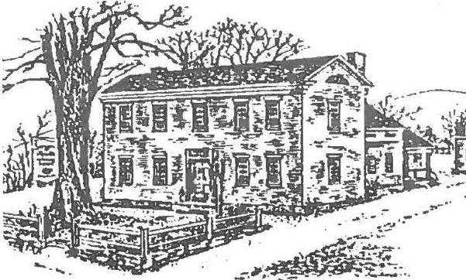

HOLIDAY HAPPENINGS

TWO-DAY HOLIDAY STROLL ACTIV IT IES

The Society's annual Holiday Stroll will be held on Friday evening, December 8, from 6:00 to 8:30 pm on Main Street, Sheffield. The Stroll will start at the Mark Dewey Research Center, where admission
stickers will be available; for members and children under 12 the event is free; the fee for nonmembers is $5.00. Everyone wishing to visit the houses must obtain an admissions sticker; houses will be open from 6:00 to 7:30 pm.

The Stroll this year will include three private homes plus Christ Church Episcopal and the Dan Raymond House. At the fina l stop, the Cong regational Church, there will be a presentation at 7:30 pm by the student choir of
Und er m ountain School under the direction of Anson Olds. Refreshments wil l follow, during whi ch time there will be keyboard entertainment and the public is invited to join in singing holiday tunes. A map showing the locations of all venues will be distribut ed wit h the stickers, and the way will be lighted with 21st -century
"luminari es."
SHEFFIELD HISTORICAL
SOCIETY FALL/WINTER NEWSLETTER 2000-2001

evening and Saturday between 11 :00 am and 2:00 pm. Also on Saturday, a miniature hand-sewn quilt, suitable for a lap robe, wall hanging, or table cover, created by Doreen Atwood, will be raffled. During Saturday's activities, a light lunch of soup, bread and dessert wil l be
available at the church.

MEMBERSHIP SANTA ALERT

Society members and friends are asked to bring a miniature Santa (no larger than three inches) to the November meeting. The Santas will be used to decorate a t wo-foot tree to be raffled off on Saturday, December 9. This is part of a fundraiser for the Society, so your help
is important. Make one, buy one, take one out of your collect ion. Just please be sure to bring a Sant a (or drop it off at the Dan Raymond House).
Special Holiday Workshops November 18!
See back cover for details.

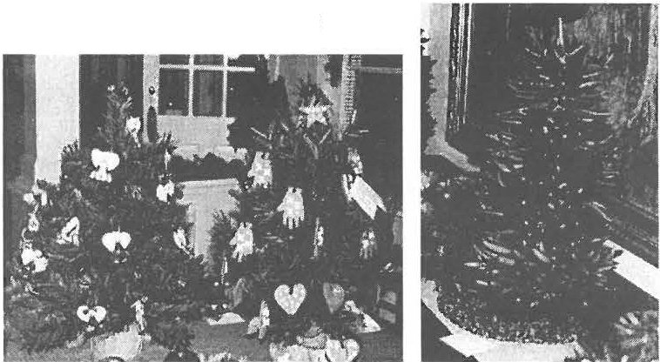A highlight of the evening and the following day, Saturday, will be a display of decorated miniat ur e trees. Some of the trees will be raffled on Friday night at the
Tree Styles from 1999
church, and the remainder will be sold in a silent auction that will run both Friday

Insights from a Hotel Register

The Mark Dewey Research Center of the Society has received an exceedingly important gift in the form of hotel registers from Joan Brooks of Ashley Falls, who is a longtime supporter. The eight volumes cover much of the period from 1867 to 1924 and illustrate in some interesting ways the dramatic changes in travel, tourism, entertainment, and use of leisure time in this area during those years. The registers also list the occasional person of historical importance or whose family name is well known nationally. It is gifts such as these that continue to illuminate the history of Sheffield and the surrounding area. The Center is always on the search for additional items for its collection, which spans over
300 years of local history in both primary
and secondary sources.
Most volumes of the Brooks gift are from the Maplewood Inn in Ashley Falls, presently the home of John James and Kathie Ness, but some are from other inns, probably brought to Maplewood by people
who had operated similar businesses elsewhere but later became associated with the Ashley Falls inn. For example, the earliest volume, 1867 to 1900, names Charles Merrell as proprietor and, later, an
M. M. Rice, followed by his wife, Mrs. M. M. Rice [Jennie B. Rice], and lists the inn's name as Railroad House. However, the owner of Maplewood during much of that time was actually Samuel Ferris, and his hotel was never known as Railroad House. Very possibly this register is from
Connecticut, somewhere along the Green Wood Turnpike, since one guest, A. B. Treat of North Manchester, Connecticut, registered in 18 79 with the notation,
" Buildin g chimney at Green Wood s, Ct." Jennie B. Rice, that is, Mrs. M. M. Rice, of Ashley Falls, is first listed as a taxp ayer in Sheffield in 189 7, when she paid $39.15 in taxes, including $25.00 for a hotel and barn in Ashley Falls. Thus, Maplewood Inn registers from the Brooks gift begin in
September 189 7 with Mrs. Rice and continue on to 1924. She was proprietor until 1909, followed by Frank P. Smith, who ran the inn until 1924.
Quite common up until 1910 or 1915 were traveling vaudeville troupes that came to town, usually for one-night performances. Almost always these groups
were preceded by an advance man who arrived to make arrangements a week or so before the performance and noted the day
and time of the event in the hotel register with a John Hancock-size flourish. One
such troupe was the Alabama Troubadours, who registered on April 6, 1898. Five in number, they included Charles H. Perkins, manager and tenor; Madame Perkins,
soprano; John F. Randolph, accompanist; Madame Randolph, contralto; and Billy Wilson, comedian and baritone. Similarly embellished in the register was the group's notation "Next Stand, Sharon, Conn." A few months later, in the early winter of 1899, the town saw a performance by another group, this time the All Star Novelty Company, J. Butts, manager, and enjoyed a "dance after show" sponsored by the
company as a further attraction. Many such troupes are li sted in the registers, and the entries, like those of the Alabama Troubadours and All Star Novelty Company, are usually colored and are frequently written in an elegant, heavily two­ dimensional script.
These programs were sometimes performed in the town hall, other times in Decker's Hall, or Depot Hall, both in Ashley Falls. By and large, the theatrical companies disappeared from the scene by the second decade of the 20th century, but a litt le before their demise, a new leisure­ time activity made its appearance as individuals, fam ili es, and parties began touring by automobile. Chauffeurs were a common fixture in the early days of the automobile and in 1909 Asa Coons "and chauffeur" of Hartford registered at the hotel. But Mr. Coons was decidedly outclassed by Mrs. A. Radel of "Bridgeport,

THE COMINGS AND GOINGS OF THE SHEFFIELD HISTORICAL SOCIET Y

The Smokehouse Arr ives!

On a sunny morning in mid-Oct ober, the smokehouse was safely moved from the grounds of Christ Church to its new location next to the Dan Raymond House. Restoration is underway.

A special thank-you goes out to all who have donated time, services, and financial resources to this project. Those who have contributed funds to date include:

Allen & Karin Altman Ann B. Barrett
Betty & Arthur Batacchi Blanche & Bill Bennett Grace Wallace Brown Sharon Casdin
Betty Chapin
Noel L. & Baukje P. Cohen Albert C. Combes, Ill
Mr s. Franklin Curtiss
John R. Downie--in hon or of Roger Dru ry Virginia J. Drury
Helen Bray & Frank Garretson Mark Lavietes & Rose Rosal
Ruth & Bob Ledlie--in memory of Florence & George D.A. Combes
Dorothy Marosy
Catherine McNeil--i n honor of Dorothy Marosy Mary Ellen McNeil--in honor of Dr. Abbott &
Gladys Combes Virginia Moskowit z Patrice Mullin
C. Twiggs Myers--i n memory of Arthur Chase Kathie Ness & John James
Elisabeth H. O'Connor Peter Rowntree
Waltor E. Stevens--in honor of Col. Thomas Stevens & Zebulon Stevens
Robert & Rebecca Thomas Marilyn & John Wightman
Marianne & Stephen Witdorchic--in honor of The New England Way
Rene Wood & Dennis Sears
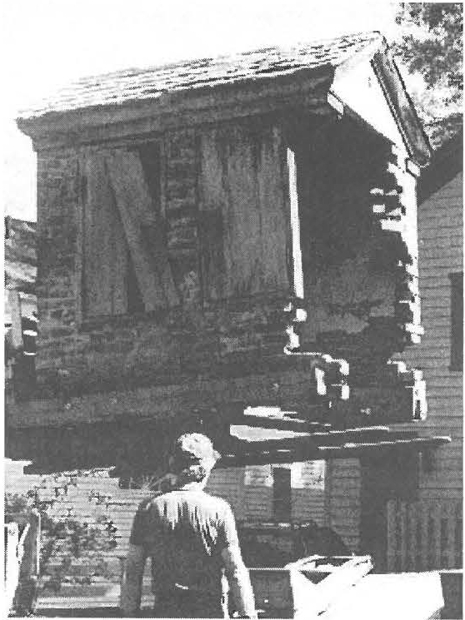
Ernest Sattler supervises the moving of the smokehouse, which appears here to be suspended in space. Look closely and you will see two ski-like prongs at the base of the building; they are in fact the forks of the lift, operated by Bill DeVries.

Very speci al thanks go to Dennis D. Picard, Wesley G. McCain, and James & Catherine Miller, who gave in honor of Mr. & Mrs. Milton Barnum.

For invaluable in-k ind contr ibu ti ons, we are grateful to Bill DeVr ies and Scott Mackenzie.

Spirits, both historic and modern, were recently on the move in the Center Cemetery. It was a cold and blustery night but over 60 people participated. Thanks to all involved for a chillingly educational exper ience!

Conn. and two chauffeurs." "And chauffeur" was a common notation in the registers. Almost as common were the automobile touring groups-travelers out simply for the joy of getting away. One such excursion in 1910 brought Lee H.
Campbell, J. F. Houser, Wm. Supples, Earl Baxter, and C. P. Gray to the Maplewood, where they proudly noted "Packard 30 Roy Ride" in the margin beside their signatures. And then there were the Ives , Rowlands,
Macfarlands, and Shumens of Prattsville, New York, out "on a tare" in June 1915, according to the register.
The size and importance of tourism are clearly evident from just one example, 1911. In the wintry month of February that year, only 14 people registered at Maplewood, a number that swelled in the heat of July to 12 8 from such places as Chicago, Philadelphia, Buffalo, Tenafly, New York City, Norfolk in Virginia, and Los Angeles and Pasadena. Before the days of
air conditioning, these visits often lasted two months or more, extending sometimes into the fall.
Tourism as a business began in earnest in Sheffield in 1842 with the coming of the Housatonic Railroad and the passenger train, but second-home owners were far less common than they are today.
Most visitors then spent their summers as guests in hotels, inns, and boardinghouses, as evidenced by the Maplewood registers, but their economic contribution to the local economy has been significant since the beginning of tourism in the 1840s and this is clearly evident from the registers.
As for the occasional famous person who wandered through the inn at Ashley Falls, consider Henry Ward Beecher of Brooklyn, a frequent visitor to Sheffield, especially to Sage's Ravine; Henry S. Fenimore Cooper of Cooperstown, New York; or Mrs. James Roosevelt of Hyde Park on Hudson. Surely there are others less known, still to be discovered among the hundreds of pages and thousands of autographs, including, possibly, ancestors
of present home owners. The volumes are fertile ground for additional research.
For these insights, our grateful thanks to Joan Brooks.

James Miller, volunteer, Mark Dewey Research Center

Dan Ravmond House Holidav Schedule

The house will be open for tours and viewing of the decorations on Friday December 1 st, Friday the 8 th, and Saturday the 9th from 11 am to 3 pm.

* * New exhibition: A Family's Tool Closet

Meeting Schedule 2001

January 12: The Annual "What's It"

February 9: "America's Forgotten Patriots: The Role of African American Soldiers in the Revolutionary War," which includes men such as Berkshire Count y's Agrippa Hull.
The program will be present ed by Jon Swan, whose lect ure on Mumbet is sti ll remembered by Society members.

March 9: "Rattlesnakes of Berkshire County," incl uding Sheffield's infamous snakes . Talk by Tom Tyn ing, a facu lt y member at Berkshire Community College.

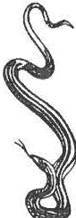
April 13: To be announced May 11: To be announced June 8: Annual Meeting

*-l<·Look for details in the March newsletter concerning the spring "Berkshire Cottages" tour.

November 18th Workshops

DECORATING GINGERBREAD COOKIES
Kids will create unique gifts from homemade cookies--all materials included. 10 am, Ages 7-12, $10 ($8 members).
Parents welcome.

NUT TREE CENTERPIECE
Adults will cover cone-shaped forms with inspiration through the use of nuts, mini pine cones, and artificial fruit--BRING A GLUE GUN, all other materials included. 1 pm, $18 ($15 members).

Held in the Society's Education Center-­ Registration Required.

Membership renewal reminder:

Ma ny SHS mem berships expire in Sep tember. Look at your ne wsle tter mailin g la bel. If there's a (9/00) after your name, it is renewal time. A ma ile r is
enclosed for tho se whose membership is past due.
Wish list

If you have any of the following objects in good cond ition, but you no longer need the item, consider donating it to SHS. Monetary contributions to be used in purchasing the items are also welcome.

Adding machine with tape, floor lights , screw gun, glue & staple guns, fold ing chairs, WWI & WWII info, old scrapbooks
SHS in the News!

The Society's exhibition Sheffield: Through the Lens of Carrie Smith Lorraine (1 8 68 -1935) was given a fu ll -p age spread in the recent Massachusetts Fou nd ations for the Humanit ies state ­ wide newsletter. If you would like to view the coverage, copies are available in the SHS Office.

Sheffield Historical Society
P.O. Box 747 Sheffield, MA

THE 1834 STONE STOR -NOVEM BER 10 HOLIDAY STROL L--DECEMB ER 8

On the move with the President and Director

During October, President Dorothy Marosy and Director Joanne Hurlbut were involved with outreach educat ional
pro g ramming. A presentation was given to the full staff of Undermountain Elementary on the offerings of the
His tor ical Society. With the assistance of James Miller and Marion Whitman, a new prog ram on loca l cem eteries was started with 5th-gr ade students. This program includes graveyard architecture and fir st ­ person act ivit ies. Marosy and Hurlbut also traveled to Connect icut to attend workshops on fundraising and management.

Society Happenings:

Five SHS historic quilts were exhib it ed at the Old Parish Qu i lt Show

SHS receiv ed a $600 grant from the local Cu lt ur al Council to support the Place in Time children's program

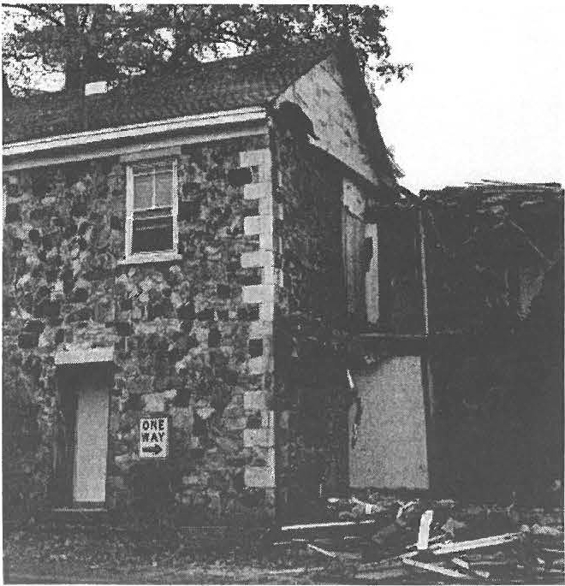
The Carrie Smith Lorraine exhib it is traveling to two new locations--Mt. Everett High School and the Mason
Library in Great Barrington

Local TV station CTSB - 11 will be air ing a segment on the Society and its programs

Several tr ees on the grounds have been removed and screening shrubs have be en planted
Dear Sheffield Hist orical Society ,

Greetings from Burlington! I am now almost three weeks into my first semester of coll ege, and enjoying it very much. I have good classes all around, and I especially enjoy my Canadian History class. We just finished Black Robe by Brian Moore, and this November the class is traveling to the capital Ottawa. I thank all of you again for your very generous scholarship, and wish you the best!
Sincerely, Douglas Campbell
9116100
Scholar's Corner
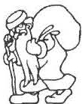

Are you looking for that special item to give this season? If so, stop in at the Dan Raymond House and view the it em s in our Museum Shop. Historic books, games, and many other items are available for sale. Proceeds benefit the Society's educational programs. Shop hours coincide with office hour s: Monday through Fri day, 10 am to 4 pm.

GOING OOWN.1 Only one corner of the wooden addition remains in this view. Come to the November 8th SHS meeting and hear more of the storv.

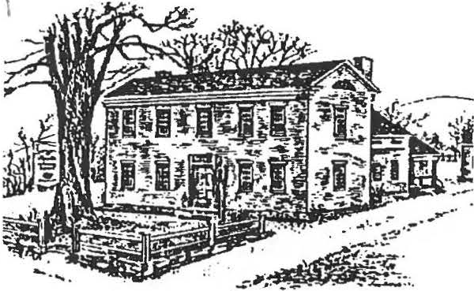
SHEFFIELD HISTORICAL
SOCIETY SPRING
NEWSLETTER
2001

SPRING EVENTS

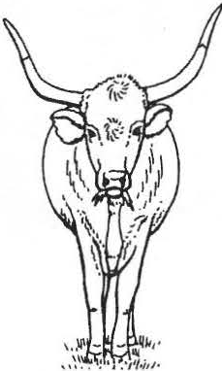
Monthly Meetings: 7:30 pm
Dewey Memorial Hall
Free and open to the public

"Vengeance Trail," will be shown on Friday, April 13, 2001. In the mid 1950s, the late Donald Worthington of Great Barrington and a sizable cast of area
residents made a movie entitled "Vengeance Trail." The film features melodramatic scenes of shoot-outs, barroom brawls, and damsels in distress, with extensive footage shot in Sheffield's Goodale Quarry, off South Egremont Road. Famed characters such as Deadeye, Sapphire Sal, Horsehide, Stud , and the Ca-n Can Girls will bring new meaning to the good olde days of Sheffield. The requisite popcorn will be provided.

The campy 2-r eel Western was stored away years ago and virtually forgotten. Gary Leveille, a local historian, recently rediscovered and then restored the film. "Vengeance Trail" was filmed in color, with occasional subtitles but no sound. Area residents who starred in or helped produce the film include Don Worthington Sr., Don Worthington Jr., George Membrino, Steve Collins, Skip Hall, Frank Rioux, Bill Latshaw, Zan Tidball, Jim Saunders, Henrietta Feldblum, Bev Latshaw, Alida Tidball, Marsh Giddings , Alan Macy, George Hayden, Louise Worthington, Harriet Collins, Corey Michaelyan, Jeanne DuVall, Nancy Dinan, and James Worthington .
"Restoration of the Gardens at the Mount" wi!I be presented by Stephanie Copeland on Friday, May 11, 2001. Historic research has
been underway for several years, and recent
archaeological digs have unearthed the original design of Edith Wharton's Italianate gardens. Using the information from the site work and historic photographs, pathways, border stones, and even the original planting holes for an allee of linden trees have been discovered . This spring , the re-creat ion will begin with the planting of a large number of eirloom a d contemporary plants. Copeland
Is the President and Executive Director of the Mount.

Spring Berkshire Cottages Tour:
In addition to her presentation on May 11, Copeland will lead a tour of the Mount on Wednesday May 23. Members will meet at the Society and carpool to the Mount, where the tour will begin at 10 am. This is a special previe to_ur _being offered just for the Society. Space 1s limited and registration is required· call the Office at 229-2694. Fee: $18 non- ' members, $15 members.

Participants will dine a la carte at a local restaurant before traveling on to their second destination, Ventfort Hall. A 1:30 pm tour will showcase the recent restoration work at the Hall. Both these mansions of the "Gilded Age" present life from a bygone era. Travel back in time to the days of stately homes, servants, and the relaxed atmosphere found by many in their summer Berkshire hom es.

Please note:
The March Meeting on Berkshire Snakes with Tom Tyning, cancelled due to inclement weather, will be rescheduled for the fall.

SMOKEHOUSE CELEBRATION Wednesday the 18th. Look for more details in the June newslett er.

Restoration of the Smokehouse is almost
complete. Before the snows set in, the majority of needed work was completed by Ernest Sattler; the final touches will be put on this spring. Join the members as they celebrate the rebuilding of this structure with an open house on Saturday, May 12 (rain
date--Sunday, May 13) , from 2 to 4 pm.

House tours will focus on food preparation and will conclude at the Smokehouse, which will be operational that day. The demonstration will include a sampling of foods preserved through smoking. Dennis Picard will be on hand to lead in the preservation process.
Space is limited and reservations are strongly suggested. Fee $10 non-members, $8 members.

A special thank-you goes out to all who have donated tim e, services, and financial resources to this project. The
contribut ions have fully funded the restoration! Those who have cont rib ut ed funds since the November newsletter listing include:

Mr. & Mrs. F. James Dallett Peter & Patricia Ruth Eisbach William Grief
Sallee Hardy
in memory of Neal J. Hardy Caroline Y. Lindemann
in memory of H. Stephen Casey, Jr.
Ronald & Judith Timm Alice M. Warren
in memory of J. Wesley Warren

NEW JOINT PROGRAMS WITH THE TRUSTEES OF THE RESERVATIONS:

The Society will join with the Trustees to present two special family programs during the month of July: an "18th-Century Day" on Saturday the 7th and a special presentation focusing on Mumbet on

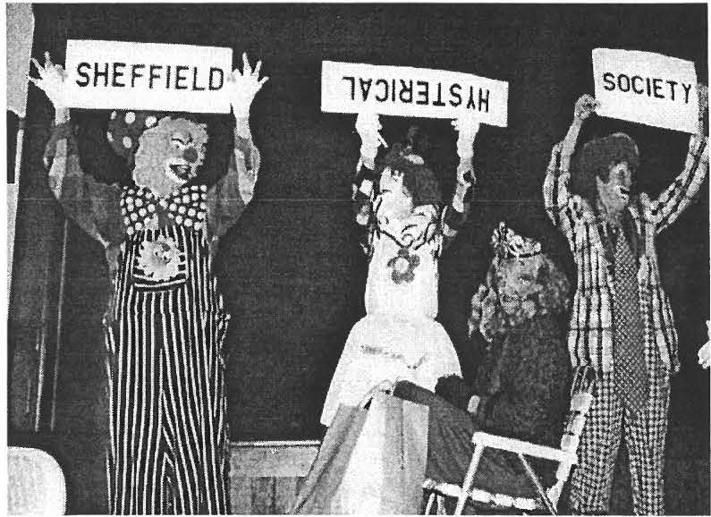

Memories from last year's Annual Meeting. Photograph by Kathy Orlando.

June 8th is the date of this year's Annual Meeting. Mark your calendars!

Dan Raymond House Act ivit ies:

A number of grant applications were completed during recent months, including the first Federal applications. Look for good news on this front in the June newslett er.

Spring cleaning chores at the site will soon be underway. The Society is seeking volunteers to help with this year's intensive site cleaning. Would you volunteer for half a day? If yes, please call the Office at 229-2694.

The House saw a number of visitors/groups by appointment during the winter months.

May 26 is the start of the summer season and the Thur sday through Saturday, 11am to 4pm hours resume.

OLD STONE STORE RESTORATION PROJECT UNDERWAY

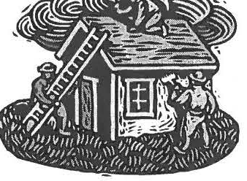

The Old Stone Store, the oldest existing mercantile building in Sheffield, was constructed aro und 1830 by Major Eli Ensign with material from a local quarry. It is the oldest and most significant 19th century stone struct ure in town, where historic stone buildings are exceedingly rare.
·
Sitting as it does in the center of
Sheffield, directly in front of the Town Hall (which dates from the same era) and adjacent to Old Parish Church, it holds a prominent place historically and geographically in the community.
The Society purchased The Old
Stone Store in the fall of 1999 and intends to restore the original stone portion. We plan to convert it to a space for permanent and rotatin g exhibits about Sheffield and the surrounding area, where the Society's extensive collection of
artifacts and documents can be displayed, interpreted, and shared with the public to further understanding and appreciation of the historic and cultural heritage of Sheffield. In addition, the Society would like to establish a visitor information center that would feature, in particu lar,
th e many aspects of the southern Berkshires, which are important to the area's tourism industr y.
A work plan, which divides the
restoration project into two phases, has been established. It is expected that the exterior will be addressed between May and September of this year. Those efforts will include st abilizing the structure, installing a septic system and
handicapped-accessible entrance, stripping the roof shingles and applying cedar shingles, replacing the windows and storefront, and repairing and repainting the stonework.
Finances permitting, the interior
work will begin in the fall. That will involve clear ing the basement floor of silt and pouri ng a concret e slab; insulating and sheetrocking all walls and ceilings; installing an interior stairway; installing electrical, heating, air-conditioning, and plumbing systems; painting; finishing the floors and adding interior trim.
The Society has applied to the
Special Projects Fund of MassDevelopment for a loan in the amount of $180 ,000 to finance this endeavor. The income from our investment portfolio does not provide a
sufficient revenue stream to meet both the annual operating budget of the Society and finance the Old Stone Store renovations. Hence the need for the loan, which will be amortized over twenty-five years. It is expected that between contributions and fund-r aising efforts, the loan wil l be repaid in advance of that time, and with no prepayment penalty.
A committee of l ocal citizens, some
of whom are Society members, has been established to (1) creat e an awareness of and support for the Old Stone Store, (2) identify individuals and businesses wil ling to support the restoration project, financially or otherwise, (3) identify components of a visitor inform at ion center to recommend to the Society's Trustees, and (4) consider participation in a community -wide endeavor to promote the attributes of Sheffield and Ashley Falls, and to garner support for the pro ject .
Suggestions as to how to further
the restoration effort are welcome and may be directed to Catherine Miller, Project Coordinator, Dorothy Marosy, Society President, or Joanne Hurlbut, Director.

'-f

EDUCATIONAL PROGRAMMING

The Society has a number of programs scheduled for the spring of 2001. Do you enjoy working with people, children through seniors? If so, please consider joining the Society's educational staff, who give tours, work with students, and share Sheffield's history with the public at large. The audiences are all around us. Now we need to ensure that there are enough volunteers to greet our visitors.

In May, elementary students will be educated through the "Place in Time" program. The Society will host the Southern Berkshire Chamber of Commerce's May "Business After Hours." June will see the Dan Raymond House open for "Discovering the Berkshires Week." All of these events will require several staff to guide visitors through the buildings. In addition to the Dan Raymond House's regularly scheduled Thursday-through­ Saturday hours, the May 12
Smokehouse Celebration and the July 7 "18th-Century Day" include site tours.

Training for guides in 2001 will take place over three sessions and will include reading materials and hands-on experiences. The sessions will be held at the end of April and the beginning of May, and will be scheduled to allow participation by all interested parties. For those with the gift of gab or the desire to share history with new audiences --this is your opportunity.
The Society will ask for a minimum time commitment, which can be easily fitted into your schedule.

Please call the Office to register for training or to learn more about the joys of guiding! Present guides will be happy to talk with you about the job.
RECENT ACQUISITIONS at the CENTER

The Mark Dewey Research Center has received an important gift from Oliver and Evelyn Willcox: alumni reunion programs for Sheffield High School from the turn of the 20th century. Much of their value lies in the student class lists they contain, which span many years of the high school's operation. The value of the programs is compounded by the fact that the names on the list are annotated with the graduates' most recent town of residence. This is a tremendous help to researchers trying to document when residents lived here and when they moved away. The years from the late 1800s to the present are the most difficult for researchers at the Center to
document because so many sources for that period are closed for privacy reasons. Oliver and Evelyn have now made the work a bit easier.
If you have an interest in Sheffield marble, especially as it relates to the Sheffield marble in the Washington Monument in Washington, D.C., you owe a hearty thanks to Natalie Funk, who recently made a significant gift of relevant material to the Center. It consists of copies of correspondence Natalie had with the superintendent of the recent renovations to the Monument and a book on the subject, which includes recognition of the Sheffield marble it contains. There are also some rare insights into local quarries, the Briggs Quarry in particular, which supplied the stone. Interesting reading it is. Like all of our collection it is non-circulating,
but drop by some Monday or Friday afternoon, 1:30 to 4:00 when we are open and browse through it. Very interesting, indeed.

THE SHORT-LIVED MASSACHUSETTS LIME COMPANY

For history buffs who would enjoy an industrial archeology excursion in an exquisite setting of nature, a trip to the Massachusetts Audubon Society's Mount Everett Wildlife Sanctuary, sandwiched between Barnum Street and Silver Street, would be worthwhile. The 215-acre preserve, home to an abandoned lime kiln, was a gift in 1990 from Edna Sheinhart (192 3-1995), whose ashes are interred there. For many years Miss Sheinhart, a retired mathematics teacher, had a home in a converted barn on Silver Street.
Adjacent to the industrial site is an open hillside meadow of several acres where you can enjoy a lunch while taking in some prize Berkshire views from the shaded bench that was placed there for that purpose. The distant, classic, Berkshire Mountain views are 180 degrees to the west, north, and east. It is a fine spot for enjoying nature or contemplating the history of the nearby kiln or whatever is on your mind.
The ruins are of the Massachusetts
Lime Company and they appear on a hillside, seemingly out of nowhere, along the trail that leads to the meadow. The monolith structure rises perhaps 30 feet into the air and is made of poured concrete, somewhat resembling an agricultural silo. From the top of this chimney wood fuel and chunks of local marble were loaded, and at the structure's base the finished product was extracted after the heating process. It is a curious thing to see in the middle of the woods, so overgrown by nature and yet still such an intrusion, even in the quietude of its abandoned and dilapidated condition. Its sudden appearance on the trail arouses questions of its origins and the story it has to tell.
Records at the Mark Dewey Research
Center provided some information. The kiln was operated by the Massachusetts Lime Company, which in 1909 purchased 90 acres of land where the structure was built, secured by a mortgage for $1,200 held by Alfred W. Minor of New Haven, who acted as conservator for one William C. Minor. The company's president was Edward E. Minor, who resided at 493 Edgewood Avenue in New Haven, Connecticut. Although there is likely a family connection among the three, their exact
relationships are unknown. Nor is it known why this remote spot was chosen for the kiln. By 1912 the company was out of business.
During its operation, stone quarried nearby was hauled to the kiln, heated, and converted to lime. The finished product was transported on a company-built road that went east through the Barnum Street Swamp to the Housatonic Railroad line near Route 7, a little over one mile distant. The raised roadway is not only clearly visible today, it is also still usable and provides a convenient and dry access through the swamp to the site. To pull the wagon loads of lime along the roadway, the company had two oxen and seven horses. Other than the president and Albert M. Turner, the treasurer, who lived in nearby Canaan, Connecticut, the small operation employed few others. James H. Bailey, Sr., his son James H. Jr., Henry Parsons, who boarded at the Bailey residence, and Harry P. Tripp, all residents of Silver Street, are the only employees whose names show up in a check of both Canaan and Sheffield records. Bailey, Sr. was clerk and manager and Tripp was employed as the operation's carpenter. In a 1910 ad the company advertised "High Grade Common and Finishing Limes." The days of the enterprise were few, however, and by August of 1912 the company had sold its 90 acres and a Barnum Street property they owned and were out of business. On a happy note, the record indicates that two mortgage holders, both the conservator of William C.
Mi or and Seth F. Dusenbury of Sheffield, were paid off on September 3 and 6 respectively of that year.
The site is equally accessible summer and winter by cross-country skiing, snowshoeing, or on foot, and takes from as little as 40 or 45 minutes, round-trip, to as long as you wish. Visitors have a choice of beginning at Barnum Street, Silver Street, or Root Lane, although Silver Street is the closest starting point to the venue. So, whether your interest is nature or history, a trip to the kiln and a visit to the meadow are well worth the time. The two attractions are, unfortunately, well-kept secrets even though they truly are two of Sheffield 's treasures. For those who know of them, however, the infrequent visitors make them even more special.

James Miller

Spring Workshop--June 9

CREATE YOUR OWN TAPED STOOL
Learn the art of Shaker chair taping while you complete a small stool for your home or ofJke. All materials included. 10 am, $50 ($,48 members).

Held in the Society's Education eenter-­ Registration Required 6y May 23rd.

Are you looking for th,at special something to do this fall? Do you have swggestions for
- workshops that the Society could offer? Call the Office at 229-2694 with your ideas.

Festival of Country Arts & Artisans:

Due to a number of factors, the Board decided to move the Festival date forward in August.
Unfortunately, many artisans had conflicts with the new date. In order to preserve the quality of the event, the decision was reached to cancel the event for 2001. Look for it again in 2002.
Wish List

If you have any of the following objects in good condit ion, but you no longer need the item, consider donating it to SHS. Monetary contributions to be used in purchasing the items are also welcome.

Television and VCR, floor lights, screw gun, glue & staple guns, WWI & WWII info, old scrapbooks
Spring Arrivals for the Shop!

A number of new items will be arriving at the Society Shop in the next few weeks. Stop in and check things out!

During the month of May, members in good standing will receive a 10% discount on their shop purchases.

Membership renewal reminder:
A mailer is enclosed for those whose membership is past due.

Sheffield Historical Society
P.O. Box 747 Sheffield, MA

SMOKEHOUSE CELEBRATION--MAY 26

ANNUAL MEETING--JUNE 8

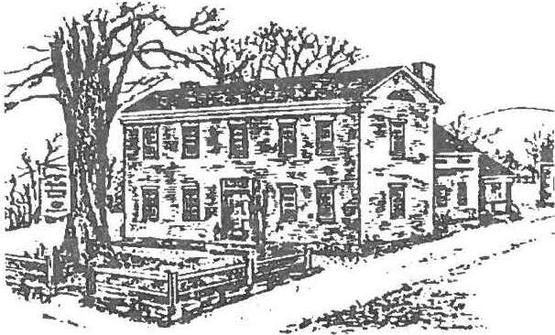

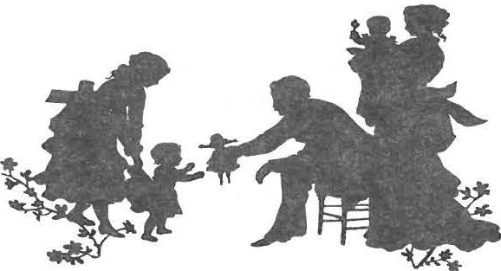
NEW JOINT PROGRAMS WITH THE TRUSTEES OF RESERVATIONS:
SHEFFIELD HISTORICAL
SOCIETY SUMMER NEWSLETTER 2001
carrying container, the basket. Hands-on activities and games such as hoop-and ­ stick wi ll also focus on wood.

Join the Sheffield Historical Society and the Trustees of Reservations as they combine their resources to celebrat e the Colon ial era in "Eighteenth Century Day-­ A Family Celebration, Saturday, July 7, 2001, from 12 to 5 pm . The Dan Raymond House and the Colonel Ashley House will be open for tours , demonstrations, and hands-on activities. Spend an hour or two at each site and discover the cont ribut ions made by our local founding fathers to the Revolutionary cause.

At the Sheffield Hi sto rical Society's 1774 Dan Raymond House, spec ial notice will be taken of forest resources. The
versatili ty of wood for the Rev olutionary home will be examined as families view the way cooking utensils , tools, furniture, and buildings were construct ed out of local materials. Demonstrations of woodworking techniqu es will be given by Boyd Hutchison , a skill ed craft sman in Shaker and period furniture including Windsor chairs. Dennis Picard will be on hand to operat e the Society's recently restored smokehouse, and he will also demonstrate weaving the all-purpose
car rying cont ainer , the basket. Hand s-on
The Colonel Ashley House, operated by the Trustees of Reservations , will offer programming that focuses on material
cult ure. A "What 's-It Tour for Children " will be offered. Hands-on act ivit ies include hearing the story of the Sheffield
Declaration, work ing with parchment papers and quill pens, and construct ing 18 th -century -style fans.

Travel time between the two sit es is ten minutes. Admission at each site is half ­ price for adult s, with
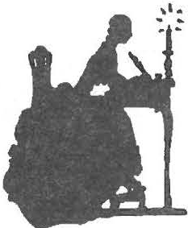
children and mem bers free.

Join Mary Wilds , an author for the Young Adult Series, as she presents a family program on Mumbet, The Life and Times of Elizabeth Freeman--The True Story of a Slave that Won her
Freedom, on Wednesday, July 18, 2001,
at 7 pm. The event wil l take place at the Bushnell-Sage Library. The event is free.

Mumbet is Sheffield's most renowned 18 th -c entury female. Her story is told
throughout the nation due to its impact on the abolition of slave ry, especially in Massachusetts. Mary Wilds ' recent publication paints a picture of the historic times through which Mumbet lived. Wild s' book makes Mumbet's story readily available to today's youth.

THE 29TH ANNUAL MEETING

P rogram Comm ittee

The programs committee consisted of Bruce Howden, Doreen Atwood , Dorothy
Marosy, Joanne Hurlbut, and Kathie Ness.

The monthly programs were well attended in
2000 -2001.

In September, Ronald Jones, president of the Falls Village - Canaan Historical Society , spoke about the history of the iron industry in the
tri-state area. This was followed two weeks later by a field trip to Beckley Furnace in Canaan, led by Ed Kirby .

For the October program , Carol Owens, author of The Berkshire Cottages, gave a slide show and talk about the general background of the Gilded Age.

In November , Catherine Miller gave a kick-of f report on the developments in
the renovation plans for the Stone Store.
December saw the Society enjoying another Holiday Stroll and a very successful silent auct ion of decorated Christmas trees, coordinated by Rene Wood and James Miller.

In January our annual What's -I t Night was especially well attended .

In February, Jon Swan, journalist and author , spoke to the Society about the role of Afr ican­ American soldiers during the Revolutionary War in a program entitled "America's Forgotten Patriot s." The March program was canceled due to inclement weather . We have arranged for the speaker to come in the fall of
2001.

In April we enjoyed an evening of home-grown cinema, presented by Gary Leveille •· a silent western , "The Vengeance Trail ," filmed In the 1950s, much of it shot in a Sheffield quarry and in other local spots, and featuring area resident s. Popcorn and root beer rounded out an evening of fun.

Stephanie Copeland, director of The Mount, was the speaker at the May meeting. She gave a slide program on the history of Edith Wharton and The Mount. This was followed ten days later by a field trip to The Mount and Ventfort Hall in Lenox, with lunch at Lenox 128.

The June meeting will be our regular Annual Meeting, followed by an "ice cream social."

Plans are under way for the upcoming year. The opening program on September
14 will feature Stuar t Murray, author of "A Time of War," a book about the role of Berkshire County residents during the Civil War .

As always, we are grateful to the volunteers who help set up the room and who
provide the exc ellent refreshments at the conclusion of the Friday evening meetings.

Respectfully submi tted, Kathie Ness

Mark Dewey Research Center

The Mark Dewey Research Center has had a busy and successful year. We are open Monday and Friday afternoons and by appointment. Our volunteers have given 1500 hours working at the Center.
Respec tfu lly submitted, Betty Chap in

Nominating Committee

The Board of Trustees for 2001-200 2 is as follows:

 | Position | Individual | Term Ex12ires
We have worked with a group of students from | President | Dorothy Marosy | 2002
Mt. Everett who took pictures of Sheffield as it | Vice -Pres | Katherine Ness | 2002
is today, as compared to pictures we have in | Clerk | Harry Conklin | 2003
our collection of Sheffield as it was in the | Treasurerx | Catherine Miller | 2004
1920 s. | Trustee•x | Wray Gunn | 2003
 | Trustee | Doreen Atwood | 2003
Members of a history class at Berkshire | Trustee | Marilyn Wightman | 2002
School visi ted Center Cemetery and each | Trustee | James Mill er | 2003
student selected a gravesite to research. We | Trusteex | Rene Wood | 2003

went to Berkshire School and gave them information about the person they had selected and some history of Sheffield.

We have worked with the Sheffield Land Trust and a committee from Our Lady of the Valley who will be using copies of our picture
collect ion.

Our collection has been added to from donations of books, letters, pictures, scrapbooks , and journ al s. We have also purchased some primary and secondary source m ater ial.

In the near future we will be moving our fiche readers and modem downstairs. This will make it better for researc her s and the voluntee r s and provide more worki ng and storage space up stairs .

We hav e been getting ready for a CAP evaluation , which will be help us in preservation, conservat ion, and when seeking grants in the future.

The Center helped 190 on-site visi tor s and an swered 25 e-m ails and many telephone inquiries thi s year.

Comm ittee: Doreen Atwood, Betty Dunk, Eleanor Griffit hs, James Mill er, Archivist, David Prouty, and Pauline Dennis Schuman n.
(' elected 6 / 8 / 01 )

Road Cleanup Report

Our Society continued its par ticipation in th e MA Highway Department "Adopt-a-Highway" Program. A hardy group of our members assembled at seven o'clock on several
m orn ings to keep our assigned m iles on Route 7 tidy and free of litter .

Many thanks to that clean-up committ ee, whi ch included: Catherine and Jim Miller, Rene Wood and Dennis Sears, Marilyn and John Wight m an, Kathy Orlando, Janny
VanHouwelingen , Harry Conklin, Fred Gordon , Sally Kelly, Kat hie Ness, Tom Garrett , Virginia Drury, (and myself, Nancy Elliott) .

Nancy Ell iott

Director's Report

At the conclusion of my second year here in Sheffield, I am happy to report that many of the stat ements I made in my report last year are still true. I can always find volunteer s to help me with the varied tasks that need doing , even when those tasks involve contact with creepy crawly things, the anim al web
kingdom , and tasks that are necessary but unglam orous. This year's spring-cleaning was a monumental Job! The stalwart crew was sent into every corner of every building of the

Treasurer's Report |  | SPECIAL EVENTS
Income July 2000--June 2001 |  | Publicity $2,876  Logistics 3,390
OPERATING FUND |  | Food 632  Souvenirs 1,083
Memberships | $2,298 | Entertainment 824
Donations | 14 ,945 | MARK DEWEY RC
Adm1ss1ons | 491 | Printed Supplies 38
Publications | 1,335 | Office Supp lies 1,020
Bank Interest Transfer from  Development | 102  98 ,500 | Reference " " 1,361  Conservat ion 362  ACCESSIONS
EDUCATION FUND |  | Preservat io n of Collections 425
Field Trip s/ Wkshp | 862 | STONESTORE
SPECIAL EVENTS |  | Fees / Taxe s 5,503
Grant s/ sponsors | 8,806 | Construction 40,563
Admissions | 2,956
Food | 1,664 | TOTAL: $123,016
Souvenirs | 2,214
MARK DEWEY RC |  | Respectfully submit ted,
Donation | 714 | Carl L. Proper, Treasurer
ACCESSIONS FUND
Deaccessions | 6,567
 |  | Development Fund

TOTAL: $141 ,4 54
Expenses July 2000--June 2001 OPERATING FUND

The Trustees upon the recommendation of the Finance Committee engaged PaineWebber to manage the Society 's portfolio. The funds were invested late in the summer in five managed

Grounds Care Building Upkeep Capital Building Utilities Housekeeping Printed Supplies Office Supplies Postage
Meeting Expense Insurance Security Accounting/ LegaI Membership Fees Books. Journals Salary of Director Fed & St Taxes Seminars
EDUCATION FUND
Field Trip/Wkshp Scholarship
$2,866 4,626
6,000
5,700
450
850
1,600
900
250
4,762
204
1.500
677
25
30,000
3,300
454

775
0
accounts-Brandes Partners, Groupama, Kayne-Anderson and Wentwort h, and a bond fund - all in accordance with the
Investment Policy that was developed. Three of the managed funds and the bond fund performed well in spite of the downswing in the market. The fourth fund had a less successful year but is beginning to turn around. As of May 21. 2001, the investment account totaled about $825,000. The Finance Comm ittee continues to monitor the funds and meets periodically throughout the year with the investment advisor from PaineWebber to make certain the monies are managed in accordance with the policies established by the Society. Since the Society is dependent upon earnings from the portfolio for its operation, it is important that prudent management is practiced.

Catherine Miller

Society's holdings-attics, basements,
collecti ons room s, and all the storage areas. waited two years (the buildings waited decades ) to clean out some of those areas, so my heartfelt thanks go out to the crew!
Doreen Atwood and Rene Wood readied the Dan Raymond House for visit ors. Catherine Miller and Jim Miller helped with the non­ coll ections areas. Jim gets the Transfer
Station award for all the runs he made to that facility . Julie Otty , the Society's new housekeeper , attacked the bugs in all the
exhibition at these site s. All these factors are raisi ng the Society's profile in the community.

This past year also brought a significant rise in the number of people attending programs and visiting the site. The visitors to the site have come in groups, such as t he Berkshire Choral Fest ival, or as indiv iduals . The Place in Time program for elementary students remains popular and thi s past year saw the first school group atte nd a new cemetery program . The students learned about

worst places with great vigor . President
cemetery architecture, had firs-t
person

Marosy readied the collections storage areas. The transformation is wonderful--stop in and check things out. For those of you who missed thi s year's cleaning-- we will do it again next year. Just asks anyone involved how satisfied they were with the results. The spirit of volunteerism by these and other Society volunteers continues to amaze my colleagues.

In add1t1 o n t o the regular events schedule of monthly meetings and programs such as the cemetery walk, a number of new outreach programs occurred. Society volunteers made these events a huge success. The Southern Berkshire Cham ber of Comm erce "After Business Meeting" brought 45 people on-site . Many were unfam iliar with our institution when they came, but they walked away impressed by what we have to offer . The Society participated in this year's celebration of Berkshires Week. A press conferen ce was held at The Mount with all participating organizati ons of the Cultural All ian ce, of which we are now a participating member. As a part of the conference, a Civil War lett er from our MDRC coll ection was dramatically read. The room grew sil ent as th is document was made aliv e for the audience . In general, press coverage for the Society for the year has been strong.

The Carrie Smit h Lorraine exhibit ion has sim ulta n eously been on view at the Mason
Library in Great Barrington and the Mt. Everett High School in Sheffield. Comments from both sit es have been posit ive and the audiences are appreciat ive of our collections breadth; hundreds of people have viewed the
encounters with past Sheffield residen t s, and made grave rubb ings.

The scope of act ivity for the year, which included the restorat ion and celebration of the Smokehouse along with the other previously mentioned events, is im pressive . It has impressed the agencies to which we have applied for grants--our success rate is remarkable . I cannot thank all of you enough for your help and support. Let's keep th is momentum up! I look forward to another year at the Society , a place that some are now calling a hidden gem in the Southern Berkshires.

Joanne Hurlbut

President's Remarks

During this first year of my term as president , I got my feet wet. Next year I will take the plunge.

It was deemed necessary by the Trustees to cancel the Artisan's Fest ival this year.
Although it was a suc cess in many ways, it did not turn a profi t.

Last fall the Smokehouse was moved from the Christ Church property to the Historical Society campus. As a result of the generosity of a number of donors, it was restored and used for the first time in May, and is now part of the Place in Time program.

As a result of receiving the IMLS grant, we were vis ited by a consu lt ant on June 6 & 7. In ant icipat ion of this on-site assessment, much cleaning and reorganizing was done. We were congratulated on the tine job we are doing in preserving our collect ions. However, improvements need to be made in storage of artifacts, controlling the environment, safety procedures, and more efficient use of space, to list just a few. My thanks to all who worked so hard .

Our monthly meetings, Cemetery Walk , and Holiday Stroll continue to draw an audience from neighboring communities, as well as Sheffield.

Through Joanne's efforts, the Society has been the recipient of approximately $9,000 in grants this year.

I want to thank Joanne and the Trustees tor supporting me and all our activities. They are a hands-on board, and always respond when help is needed. Volunteers from the general membership continue to contribute their time, and I look forward to working with you next year.

Dorothy Marosy

Stone Store Update
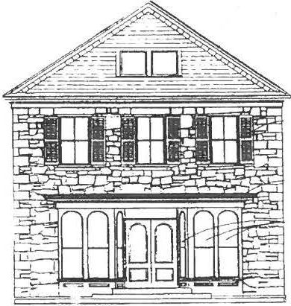
Restoration work on the Stone Store began this spring. Crews working on the interior have removed all materials to the point where the stone walls are now fully visible. Structural support work and work on the basement is also in progress. The "quiet phase" of the tundraising campaign is now it full swing . As a part of this effort, a bro chur e highlighting the Store's history has been cr eated and is available at the Society office.
Stone Store Raffl e

Grace Wallace Brown has made possible a fundraising project for the Stone Stor e.
Through her efforts, artist Regi Klein has provided the Society with one of her paintings at a signif ica nt ly reduced rate. The artwork features Main Street in Sheffield, including the Stone Store and the Dan Raymond House.

The Society is now raffling off this artwork tor $10 a ticke t; her art norm al ly sells at
$1,000 per painting. Support the Society and contemporary artists by buying one, two, or even ten tickets! The drawing will ₀ take place at this year's Holiday St ro ll.
Tickets can be obtained at the Society office.
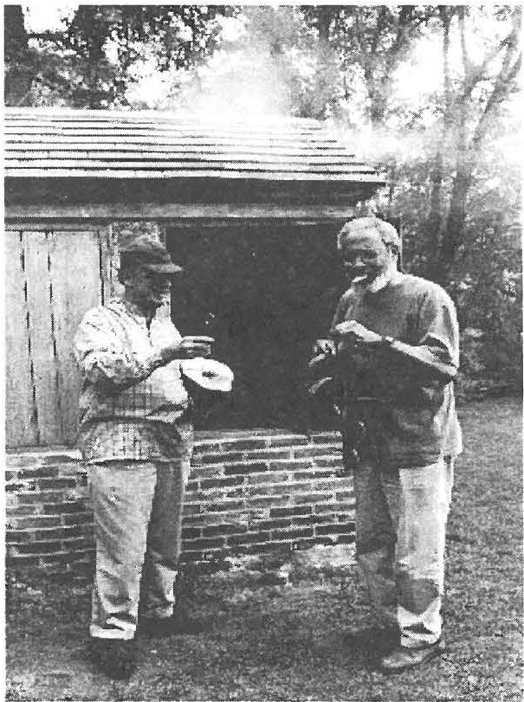
There's nothing qwte like that home smoked flavor'

James Miller and John James at the Smokehouse Opening Celebration . Photo: Kathy Orlando

Scholars' Corn er

This year's recipient of the Sheffield Historical Society Scholarship is Dylan Moult on. He will attend Muhl enberg College in Allentown, PA, where he will pursue a degree in political science.

Grant Awards

The Sheffie ld Historical Society has recently been the recipi ent of three grant awards, for our programming, bui!din g res to ratio n. and collections preservation effo rts.

The Sheffield Cultural Council has for the third consecutive yea r awarded a grant to the Society for its "Place in Time" program for ele men tary students. This yea r's award is for $100. The continu ed support of the Council enables the Societ y to purchase equipment for enhancin g the student's on-site visits. The Sheffield Cultu ral
Co uncil is a local age ncy, which is suppo rted by the Massachusetts Cultu ral Co uncil. a state agency.

The Lenox Garden Club awarded the Society a grant of $2,500 in order to create a land scap e plan for the Stone Store. The plan will be impl e mented in the open s pace, behind the Stone Store, adjacent to the Old Paris h Church gro und s. and in front of the Town Hall. The garden design will in clude varie d pl antings and benches in order to create a public space for res iden ts and visitor s alike to
relax and enjo y the hea rt of Sheffield. Jeffrey Steele of As hle y Falls Nurse ry is se rvin g as the garden consultan t for this project. Once the major phases of construction at the Stone Store are
completed , the garden w ill be installed.

Each yea r. the Le nox Garde n C lub mak es awards to loca l o rganizatio ns und ertakin g la ndsca pe projects such as the Soc ie ty. Funding for these awards comes from the Lenox Garden Clu b's
annua l Ga rden and Ho use tour. This yea r's tour will take place on Saturday, Jul y 14th .

,!" us , .,
The Society is a recipient of the 2001
Conservation Assess ment Program Grant (CAP). The Society was selected as one of 147 organizations across the nation to receive this
a ward, which is a building block in collections management and serves as a cornerstone for future collections/ prese rvation grant applications . CAP supports a two-day visit by conservation professional that reviews the overall condition of the museum's collection, the physical storage and exhibitions conditions, and the collection practices, among other factors. The assessment helps museums establish goals so that their holdings can be preserved and made available to the public.for years to come.

The Historical Society's grant award was $6,370; these funds will be used to bring CAP consultant s to the site. T he Society was fortunate to have two well-known experts in their fields agree to work with us on this assessment. Lori K. van Handel of Heritage Conservation Services of Williamstown, the collections reviewer, completed her two-da y site evaluation last week. Her formal written report on the presen t collections conditions and suggestions for future action will be received by the Society within the month . There is room for imp rovement in storage and environment, but the overall analysis of the job the Society is doing to care for its collection was highly positive . Hats off to the Society mem bers who have collected , organized, and maintained this collection over the years! The buildi ng's assessor, Andrea M. Gilmore of Buildin g Co nse rvation Associates Inc. from Dedham, MA, will be here in September.
The Soc iety seeks to join the over 95% of organizatio ns th at have received these awards and then have gone on to fulfill a majority of the
recomme ndati ons.

,.. l I I l -'"'
.
-
,.
..-.V.
..
I N S T I T U T E of MUSEUM
and LIBRARY SERVICES
The Society has also bee n selec ted for incl usio n in an IMLS survey. The Ce nter for Organizational Excelle nce is co ndu cting a "Technology Survey for Libraries and Museums" for IMLS. The

The Ins tit ute of Museum and Library Services. a federal agency tha t.fo sters innovation, leadership and a l( fetime < (learning supports the Sheffield Historical Society.
in formation ga thered will be presented to Congress and also used by o the r assoc ia tions to he lp de termine future plans, espec ia lly in the field of digi tiza tio n.

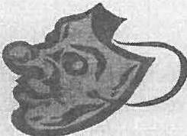
Are you willing to show that hiddenside of your personality? The Soc.iety is in search of first­ person characters for two upcoming events.

The Massachusetts Turnpike Authority has awarded a grant to the Berkshire Visitors Bureau to highlight local organizations. We will present the Society to the public at the Lee tourism center on Sunday, October 7, from 11 am to 2 pm. Those who have acted for us in the last two cemetery walks may reprise their roles. New roles such as the Raymond family will debut.
Those who will portray a character in the cemetery walk this fall can use this as a dress rehearsal. The Society will receive a significant contribution for this effort. JOIN US!

The Cemetery Walk will take place on Saturday, October 13, from 5 to 7 pm. We need those modern spirtts to help us interpret the past.

Call the Office at 229-2694 to sign-up for a role.
Wish List

If you have any of the following objects in good condition, but you no longer need the item , consider donating it to SHS. Monetary contributions to be used in purchasing the items are also welcome.

Cotton sheets, flashlights, scissors, floor lights, screw gun, glue & staple guns, WWI & WWII info, old scrapbooks

Barrington Stage Company Complimentary Tickets Available
Society members are invited to the
Barrington Stages' opening production On The Twentieth Century, a Tony award winning musical comedy. Tickets are available on a fir st come basis for the Friday , June 22, 8 pm show or the Sunday, June 24, 5 pm performance. Call their box office at 528-8888.
Membership renewal reminder:
A mailer is enc losed for those whose member ship is past due.

Sheffield Historical Society
P.O. Box 747 Sheffield, MA

EIGHTEENTH CENTURY DAY--JULY 7

MUMBET FAMILY PROGRAM--JULY 18

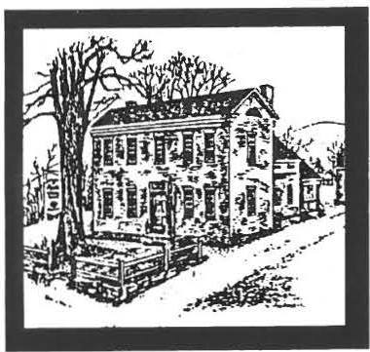
Sheffield Historical Sociery
Fall 2001 Newsletter

Artist's Work is Stone Store Fundraiser

Stone Store construction update:

The11e1v cedar shake roof has been completed

The masonry work is almost complete.

Ma,ry of the windows are in place.

T ake a walk b.J' the store a11d
How does one become an art­ ist? Regi Klein states, "I never decided to become an artist - I always remember be­ ing one. From an early age on it was a part of me, taken for granted, just like breathing. I did study at various art schools, both in this country (The Art Institute of Chicago and Bennington College) , and abroad (Paris and Mexico City), taking in what I wanted, rejecting what I did not want in order to develop my own personal, nai'f style of expres­ sion." The Regi Klein art­ work fundraiser was made possible through the efforts of Designs by Grace.

The artwork, The Town Com-
viewer of another regional art­ ist, Grandma Moses. The oil painting features Main Street in Sheffield, including the Stone Store, the Dan Raymond House, the Old Parish Church, the Sheffield Town Hall, and the Miller Hotel (now the site
of Gulotta Brothers gas station). In the foreground are several of the town's citizens, circa 1900, engaged in their daily activities. Klein's work has won a number of awards, hangs in private col­ lections such as The Red Lion Inn in Stockbridge, and has been exhibited across the coun­ try from the Universities of Mi­ ami and Notre Dame, to the Morris and Waverly Galleries in New York.

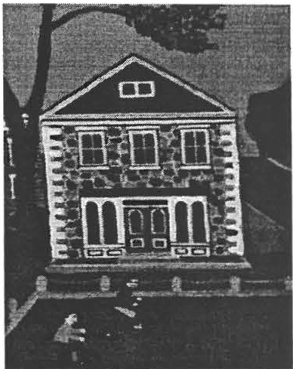
Regi Klein's rendition of the Stone Store from her wor1\"TheTown Common." Tickets available at the Society office, $10.

the Society and contemporary artists by buying one, two, or even ten tickets! The draw­ ing will take place at this year's Holiday Stroll in early December, just in time for

11ote the exterior
woodworking!
mon, is in the American Klein's art normally sells at primitive style, reminding the $1,000 per painting. Support
gift-giving. Tickets can be obtained by calling 229-2694.

 | Stone Store Ice Cream Social |  | on September 8th
 | A stroll down Main Street in |  | As a part of this | restoration of the Stone
Speclal points | Sheffield on Saturday , Sep- |  | Sheffield in Cele- | Store. Meet us in front of
of Interest | tember 8th, from 4 to 8 pm, |  | bration, the Histori- | the Store; you will see its
- Fall Calendar | will prove a most entertainin g |  | cal Society will be | progress and be able to en-
of Events | experience! Join your friends |  | holding an Ice | joy dessert at the same
- Sheffield in | and neighbors as they come | Cream Social. time!
Celebration | out to celebrate Sheffield, its | Funds raised through the selling Cookies will also be on
 | culture, its history and its citi- | of ice cream, especially a sale. Care to bake for this
 | zens. | brownie sundae, will go towards event, call 229-2694.

Page2 Sheffield Historical Society

September

Sheffield In Celebrat ion: A week- age eighteen was buried alongside the long town celebration, including an Mississippi? Surely you have heard ice cream social to support the res- of the Union army's chief engineer, toration of the Stone Store on Satur- General Barnard of Sheffield?
day, September 8. Look for further Whether or not you know these details in this newsletter. For addi- names, join the members of the Shef­ tional information and a schedule of field Histo rical Society as they en- events call the Society office at counter the lives of Berkshire county 229-2694. residents at war. (7:30 pm in Dewey
Memorial Hall.)

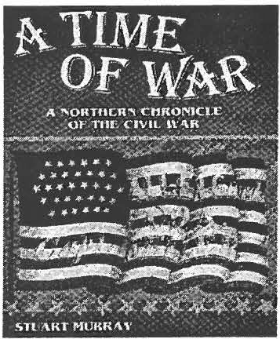
Monthly Meeting
September 14: "A Time of War: A Northern Chronicle of the Civil War" with Stuart Murray.

Have you heard the story of Charles Bartholomew from Sheffield who at

Drawing upon Berkshire County dia­ ries, letters, military reports, church journals, and even gravestones, Stuart Murray tells the stories of New Eng­ land Civil War families including men from the famed 54th regiment.

October
Mt. Everett Sanctuary Hike. Monthly Meeting-October 12:
October JO : Wednesday, "Where Did They Go?"
9 am to 12 pm. Have you ever wondered what it was Enjoy the local foliage while hear- really like in days gone by? At the
in g about Sheffieldin du s t ry! James turn of 20th century people lamented
Miller, Archivist at SHS will dis- t he modernage- in door plumbing cus s the lime kilnlocate d on the and a private outhouse ? There was

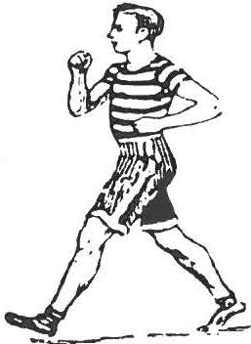
property. Laura Beltran of the Berk-
a sadness at the loss of the conversa­

shire Wildlife Sanctuaries will lead tions which used to take place in the tour and discuss the natural as- those multi-stall privies! Want to pects of the area. Bring a snack and learn more about dailyl ife ? Co me
..
dress appropriately. Fee $8 non- and listen as DavidD ashiell, Direc- mem bers, $6m em bers. tor of the Bidwell House, presents an
analysis of the outhouse (Friday at
\ Registration required. 7:30 pm).
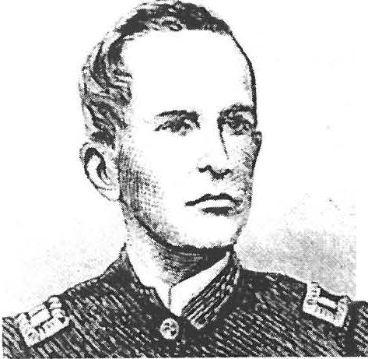
Spirits of Sheffield Cemetery Walk, Saturday, October 13 I

Roscoe C.Taft, aLtintheMassachusetts 49th Infantry duringthe CivilWar invites you to join himatthisyea(s Cemetery Stoll.
Spirits of Sheffield Cemetery Walk. Make contact with the voices from Sheffield's past in this evening of spiritual communications. Sack­ ett Cemetery, Ashley Falls, Satur­ day, 5 to 7 pm, fee.
Spirits are needed for this event! Volunteer to do a first person inter-
pretation or to guide those who come to take the journey back in time.
On October 7th the Society will be presenting a special program in Lee using this year' s spirits and reprising roles from yesteryear. Volunteers are needed. Please call the office at 229- 2694, and join in the fun!

Page3

The Civil War: Music and Writings of the Berkshires Sunday, October 21, 2 pm, Old Parish Church
A program to benefit the restoration tie, Mother , The Vacant Chair, Battle
of the 1834 Stone Store. Cry of Freedom, and Tramp! Tramp!
The music and words ofSh ef field's Tramp! His compositions will be

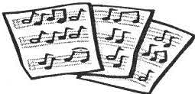
soldiers diaries and letters, in­ cluding descriptions by Robert Hale Kellogg who was impris­

Civil War residents will again be heard as performers including John­ Arthur Miller and Julianne Boyd take to the stage.
Sheffield native George Frederick Root was a composer of popular
given voice by John-Arthur Miller , a bass-baritone and an opera soloist with the Berkshire Choral Festival. His roles include touring with the
New York City Opera National Com­ pany.
oned at Andersonville.
Ticket s $15. A reception will follow.
Did you know: the clock tower of Old Parish Church was donated by Orville Dewey in honor of G.F. Root? Or that the funds raised from across the coun­
try purchased the clocked installed in

Civil War music. He authored songs such as Just Before the Bat-
Julianne Boyd of Barrington Stage the tower to perpetuate Root's mem-
will be among those reading from the ory?

November-Monthly Meeting
On Friday November 9, Snakes of Berkshire County with Tom Tyning will be back. This event was cancelled due to inclement weather this past spring. Tyning's presentation will introduce you to the 1O or so species of snakes found in the region, including the area's one venomous snake, the Timber rattlesnake. Tyning has just completed a six-year study of this creature!

Gala Holiday Events Planned
This holiday season will be made even more special with several SHS
holiday events:
·

Festival of Trees Silent Auction. Back again by popular demand, we' II be of­ fering a wonderful selection of unique trees - all created
by members and friends of the Sheffield Historical Society. It' s not too early to be thinking about creating a special tree. Call Rene Wood (229-2875) or Jim Miller (229-8668) if you'd like to donate a tree to this major fundraiser for the Stone Store. Also featured: lunch, holiday raffles, a holiday quilt and boxwood trees. Save Saturday, De­ cember 1 for a fun filled day.

Holiday Wreaths. This
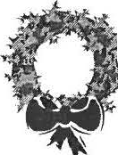
;;. year we' ll be taking pre­ paid orders for holiday wreaths. While more de­ tails will be announced in
the next newsletter, you'll want to make sure we're your source for all your wreath needs. Currently we're planning to offer 3 sizes and prices so we'll have a special wreath for every­ one's budget. Samples will be avail­ able so you' ll see exactly what you're ordering. We're confident you'll be just as excited about this as we are!
All proceeds will benefit the Stone Store.

Holiday Ties workshop. Ever won­ dered how they make those fabulous holiday bows? And wish you could? This workshop will teach you how to

make fabulous bows using both wired and unwired ribbon. You see how its done and then make three great bows to take with you for your holiday decorating.

Holiday Stroll. A wonderful stroll is being planned for this year. It will be our grand finale for the 2001 holiday season. It promises to be exciting and put us all in the mood for the rest of De­ cember and the New Year.

As always, many volunteer op­ portunities are available. These are·fun events, so call the Society at 229- 2694 and volunteer to be part of the holiday magic.

Page4 Sheffield Historical Society

Mark Dewey Research Center Archives

We marched over the

Sheffield Historical Society--Mark Dewey Research Center collection document. Letter written on De­ cember 20, 1864 by John B. Roys to his niece Martha Roys Scott.

John Roys was the son of Levi and Thankful Curtiss Roys. He was born in Sheffield in 1824. He left home as a young man; he partici­ pated in the California Gold Rush and the Civil War. Roys died in 1891.

Camp near Savannah, Ga. Dec. 20, 1864

My dear Martha,

Yours came duly to hand. I thank you for the trouble you are to in wriling to an old soldier, and as­ sure you that if it increases your own happiness, as I trust it does to make others happy, then you are well paid for the time and Laber ex­ pended on my account. The recep­ tion of a friendly letter when lying as I was when yours was received, in the trenches around a besieged city, with nothing to do but listen to the continual whizzing of bullets, and the roar of cannon, and the bursting of shell overhead, relieves Lhe oppression of the spirits, and makes the thoughts relurn Lo mor e pleasant scenes and associations.
You think Lhat Lhough my
hair may be grey, my heart is still young. It may be that I have not learned to distrust assurances of friendship, for I believe when any­ one says '/ like you, but alas, no
more no more, no never more on same route previously taken by me the freshness of the heart shall Sherman in his forward moveme,nt fall like dew. Which out of all the and after several days stopping at lovely things we see, extracts Kingston and Carterville we emotions, beautiful and new but reached Atlanta J00 miles from
though the day of my destinys' Dalton on the 15th of Nov. We tore over, and the star of my face hath up the railroad from Dalton to At­ declined, I am yet glad some fond /anta, and burned all public build- hearts refuse to discover the ings except churches. Many private faults which so many can find. I homes were destroyed by men with- would believe though I have out orders. The city of Atlanta was found them not, that there may be, almost entirely destroyed Gen. words that are true, hopes that Sherman tried to save private
will not deceive and virtues that houses, but the same men who were are merciful, nor weave snares employed to tear down a house to for the failing. I would also stop the fire, would set fire to the deem, or'e others faults that some next house and hence there was a sincerely grieve. That two or one general conjl.aga ration the night are almost what they seem that was the wildest I ever saw. Soldiers friendship is no name, and happi- and citizens, women children and ness no dream. negros were rushing hither and
I have no idea what would thither among the burning buildings be a suitable subject for composi- and none seemed to notice others. I tion in your circumstances. Your got upon the portico of an elegant thought of falling leaves is good, mansion which fronted a long street and I have no doubt of your abil- and watched the scene for hours. I ity to do it justice. I do not urge could write a volume of what I saw, you to send your photo in every but will not trepas too much on your letter, because although I should patience. J secured a few trinkets esteem it a great favor, too much from the general destruction, and solicitation might be disagreeable when the fire reached the mansion, I to you. Thank Graham for me for returned to camp disgusted with
his appendix. Tell him I voted for warfare. The next day we began the Lincoln because I think he holds march to Savannah, which will be to the principles of the Democ- known as one of the greatest
ratic of Douglas time, while the achievements of modern times. The present Democratic party are moving of an army of near 100,000 willing to do anything for power, men through an enemies country, a even to the destruction of the Un- distance of 300 miles in 20 days, is ion. something to wonder at. The only
I suppose you want to town of importance on our line of
know something of our move- march was Milledgeville, the capital ments as soldiers. We left Dalton, of Ga. All railroad and government Ga. I think the 28th of October. property there was destroyed. As

Pages

we proceeded south the weather grew warmer, and it is as pleasant as May now. We are encamped now in a beautiful pine forest. The hanging moss of the southland is pendant from every limb, its light blue min­ gling with the deep green of the pines
causes a softer though sadder ap­
pearance, and even soldiers rough as we are, are unusually quiet in such a temple. We were eight days on the advance line, not more than I/4 of a
it is better to do this than to ac­ knowledge our government a fail­ ure.
Give my love to a few and my respects to all.
Yours lovingly
J.B. Roys

IMLS CAP UPDATE
<!"'..''"'lo
r
I NS TIT UT e of M USE UM
;:;;.: ; .; --· :- .:,; ? ;:.;_/; -: : _{c::_-;} · f:
.

'-t.f Outreach 'if
: Committee seeks
.,,;-;9 Ideas &
,..J v...
{'r Volunteers ;:;.
µ.
?7
d
{I {21 {1 " f if {1 {: tf
The Outreach Committee works with the President, Vice­

mile from the rebel lines, and shoot­ ing back and forth was incessant.
/ ..........
•nd t J B R A R Y 5ERVJC2S
President and Society Director to
provide tours, exhibits, special

We were relieved by another division yesterday, and expect eight or ten days rest. We have nothing to eat but beef and not much of that. Ex­ pect rations today which have been promised every day for the last ten days. I do not known what the pros­ pect of taking Savannah is. Sherman seems to be working now to perfect communications and secure rations, while he holds the rebels in. We have them enclosed so that they must eventually yield. My term of sen1ic e expires on the 13th of August 1865.
I hope the war will end before that time, but do not expect it. If you want my real opinion in that respect I will
give it. I do not think the rebels will ever be conquered by us. They may quarrel among themselves, and join us out of spite to one another, but as long as they choose to keep united and do the best they can, they can never be conquered. Don't show this to any copperhead for it may be thought of some importance, as com­ ing from a seven years soldier. I do not see what we can do better than to keep.fighting and hope for the best. Butler's plan of an amnesty is good and may lead to some results.
We can exterminate them, and repeople their country in time, and
Both reviewers have now been on site. Lori van Handel's collection report has been received and the Society is at work responding to a number of her suggestions. Two major areas of concern, which will be addressed in the next year, are our collections record management techniques and environmental con­ ditions.

The Society will soon be purchas­ ing Past Perfect, a computer soft­ ware program, which is a standard in the museum community. This program will allow SHS to update its records and in tum to make the collections more accessible to the public. If you enjoy data entry and/or working with historic collec­ tions, this is a project for you!
SHS will also purchase data loggers to monitor the collections areas over the next year.

Andrea Gilmore conducted her buildings evaluation on August 16 and 17. We are awaiting her report. She too cited the significant work done by the Society members over the years! Call the office to find out more about the reports, or to get involved in their implementation.
events, monthly meeting, school
programs, field trips and work­ shops. In addition, the Outreach Committee wants to compile a database of members who wish to volunteer their time and talents.

There's a lot for this committee to do. Won' t you help? We'd love to hear your ideas on topics for the monthly meetings, work­ shops, special events etc. What would you like to see your Shef­ field Historical Societ y offering?

The committee is currently form­ ing subcommittees to address each of its areas of responsibility. If you are interested in helping to make any of these areas come to life, please notify Rene Wood (229-2875) or any committee member. Outreach Committee members are: Kathy Ness, Marilyn Wightman, Marion Whitman , Judith Timm and Rene Wood , chair.

- S. Special thanks to Inez Flinn who once again will be in charge of hospitality for the monthly meetings.

Page6
SHEFFIELD IN CELEBRATION
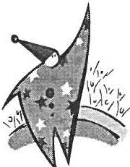
September 8th to 16th, 2001
A myraid of events all weeklong including, but not limited to:

  - "Anything and Everything About Sheffield and Ashley Falls" art show
  - Children's Programming
  - Nature hikes and activities
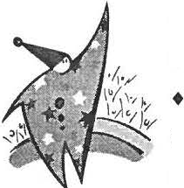
  - Tours of local landscapes and cultural sites
  - Sheffield & Ashley Falls Cottage Industry Showcase 5th Annual Heavenly Quilt Show
  - Celebration on the Sheffield Green-September 8, 4-8 pm
  - Ashley Falls Fair on the Green-September 15, 10 am-4 pm
Call the Sheffield Historical Society at (413) 229-2694 for a full list of events and times.

Telephone
Alternate Address _ _ _ _ _ _ _ _ _ _ _ _ _ _ _ _ _ _ _ _ _ _ _ _ _ _ _ _ T own/City Zip _ Dates this address is valid_ _ _ _ _ _ _ _ _ _ _ _ _ _
Membership entitles one to all the privile ges of the Society, including admission to the Dan Raymond House.
Checks are payable to the S heffield Historica l Socie ty. Contributions are tax deductible to the full extent of the law.
_ _ _ _ _ _
_ _ _ _ _ _
_ _ _ _ _ _
_ _
_ _
_ _
_ _ _ _ _
_ _ _ _ _
_ _ Zip _ _
INDIVIDUAL $10-$19
FAMILY/DUAL $20 -$34
INDIVIDUAL SUPPORT ING $35-$49
FAMILY /DUAL SUPPORTING $50-$99
INDIVIDUAL LIFE $100 or more
ADDITIONAL CONTRIBUTION
FOR EDUCA TIONAL PROGRAMS
Name (s) _ _ _ _ _ _ _ _ _ _ _ _ _ _ _ _ _
Mail ing Address _ _ _ _ _ _ _ _ _ _ _ _ _ _ _ Town/City_ _ _ _ _ _ _ _ _ _ _ _ _ _ _ _ _
The Sheffield Historical Society
thanks you for your membership contribution which helps with develo ping our ed ucat iona l programs, preserving and displ aying the buildings and grounds, and maintaining our collec tio n of historic objects and docume nts.
ANNUAL MEMBERSHIP

Page 7

The Sheffield His- Susan & Larry Agoglia Bernard & Suz.anne Eismann Tom Orlando
torical Society Sandra & Dale Alden Nancy Elliott Rena Orner

greatly appreciates
Ginger Alexander Peter & Patricia Eisbach Bruce & Barbara Person
Allen B. Altman Nancy Emery Dennis D. Picard

the support of its Grace Arzt Inez Flinn Lillian E. Preiss
members. Doreen & Walter Atwood Bruce & Marcia Fowle Sandra Preston Hareptia Ball Warner Friedman Carl & Sally Proper
The following is a Milton & Marion Barnum Natalie & Maree Funk David L. Prouty
list of those who Ann B. Barrett Dorothy Garfein Nancy & Bob Rathbun

supported SHS
Betty D. Batacchi Joanne M. Garland George B. Raymond Teresa J. Bellizzi Tom and Anita Garrett & Ada H. Hastings

through member- Paul Benjou Olive Gaylord Ann M. Riou
ship dues in 2000- William & Blanche Bennett Rene Gibson Walter M. Riou
2001, including life P.J. Bradley Frederic Gordon Mrs. Muriel Rokos
members. Jean Blackmur Leonard Graziano Rose Rosal & Marc Lavietes Eleanor Blake Sharon Gregory Peter & Ellen Rowntree
Ms. Pamela Bloodworth William Grief John Ryder
If your name is Roy Blount, Jr. Eleanor Griffiths Joanne Schmidlin
missing from the E. Shears Boardman Lovina E. Gulotta Bernie & Shellie Schneider
list, it may be that Grace Wallace Brown Wray M. Gunn & Cora Portnoff Charlotte L. Schneider
your membership Patrick & Barbara Bums Sallee W. Hardy Gladys S. Schofield

haslapsed. Please
Grace French Campbell Tiziana Hardy Charles & Pauline Schumann
Elisabeth Cary Claire Height Dennis Sears & Rene Wood

fill out the member- Aidan Cassidy Gillian & Norman Hettinger Tjasa Sprague
ship form provided Neal & Julie Chamberlain Bruce M. Howden Louise W. Stevens
and mail it in with Elizabeth Chapin Joanne Hurlbut John & Appy Stookey Fem & Elliot Chapnick Carol Ingber Jon & Marianne Swan
your contribution.
Jeanne & Richard Chemeff Kathie Ness & John James Ronald & Judith Thrun Neil & Kathleen Chrisman Elwyn L. Johnson Peter & Doris Traub
To see the ending Michael Cleary Donald Jurney Kate & Turt Turton
date of your current Carol Collins Kingsley & Sally Kelly Sabina Ullrich
membership, check Abbott C. Combes III Ursula Kilner Myra Ummel
the date in the ( ) on Harry E. Conklin Sheila Kotur Barbara A. Vacchiano

your mailing label.
William Conklin MaryM.Law Janny Van HouweJingen Sarah Cook Dr. & Mrs. George M. Lazarus Loet & Edith Velmans Gary & Janet Cooksan Olga Leafgreen Miss Jane F. Warner
J. Nicoll & Mary C. Cooper Gary LeBeau Alice Warren

Susan and Stuart Crampton Robert & Ruth Ledlie Frances Warren
Thank
Howard Crockett Mrs. Gertrude LeGeyt Marianne Webb-Witdorchic Jean & Franklin Curtiss Morton & Susan Levin & Stephen Witdorchic
y
Vincent J. Cuticello Sarah Light Stacey & Jeff Weber
Mr. & Mrs. F. James Dallett Connie Logan Barbara Roberts Weeks
Eliza beth Daly Thomas P. Lynch Ronald & Elsie West Anthony & Dana Dapolito Norman & Barbara Margolis Roberta L. Wheeler Robert & Ann Dean Dorothy Marosy Marion E. Whitman
0
Barbara De Lee Barbara Martin Thomas & Joan Wiehl Dwight & Nancy Dellert Wesley G. McCain John & Marilyn Wightman Susan & Philip Detjens & Noreene Storrie Oliver & Evelyn Willcox William & Dorothy DeVoti Deborah McCurdy Martha & Barry Williamson Thomas & Cynthia Dixon Catherine McNeil Elizabeth C. & William H. Ruthana Donohue & Mylan Jaixen Wilson
u
John & Audrey Downie Mary Ellen Combes McNeil Ms. Ali A. Winston Virginia J. Drury Thomas C. Mentzinger Thomas & Susan Young Charles A. DuCharrne James & Catherine Miller Donald & Ruth Ziegler Betty Dunk John Arthur & Trudy Miller Mark & Claudia Ziobro
'
Betty L. Duryea Mrs. Virginia F. Moskowitz
Frances A. Eastburn Patrice Mullin
•
Francine & John Eget Elizabeth O'Connor Bernard & Suzanne Eismann Kathy Orlando

D•• ,R , ..,o• 4 ,H ,., , /1,1,.1,,.,.,
M• • D1wr1 Rr r, o r r ll ,C . 11 ,

- - - -- - --- - - - - - - - - - -
1 5 9 Main Street
PO Box 747
Sheffield, MA 01257

Phone: 413 -229 -269 4
Email: shs@sheffieldhistory.org

Thursdays through Saturda ys-- I I am to 4 pm, tours of the Dan Raymond House, fee.

Mark Dewey Res earch Center open Monday and Frida y a fternoons , I :30 to 4 pm.

W E ' R E ON THE WEB
S HE FFJ ELD H ISTO RY. O R G

;J The proposed revisions to the Shef- Outreach- Rene Wood Chair,
Board of Directors field Historical Society By-laws Kathie Ness , Judith Timm,
were adopted by the Society mem- Marion Whitman, and Dorothy Marosy, President bership at the Annual Meeting on Marilyn Wightman. A num- Kathie Ness, Vice-President June 8. ber of sub-committees will as-
sist in various areas, espe-
Catherine Miller, Treasurer The Stand ing Committees for cially for special events.
Harry Conklin, Clerk 2001-2002 are:

Trustees:
Finance- Catherine Miller Chair,
Buildings and Grounds- Jim
Miller Chair, Robert Ledlie,

Patrick Bums, Wray Gunn, Wesley and Ann Riou.
Doreen Atwood McCain, and Peter Rowntree.
Wray Gunn Collections- Doreen Atwood
James Miller Chair, Betty Chapin, Joanne Save these dates:
Hurlbut ex-officio, Connie Logan,

Marilyn Wightman
and Carl Proper. Septembe r 8th for the

Rene Wood
Mark Dewey Research Center-
Ice Cream Social

Betty Chapin Chair, Doreen At- October 13th for the
Joanne Hurlbut, Director wood, Eleanor Griffiths, James Cemetery Stroll

l, rf
Miller, David Prouty, and Pauline October 21st for the
Schumann. Music of the Civil War

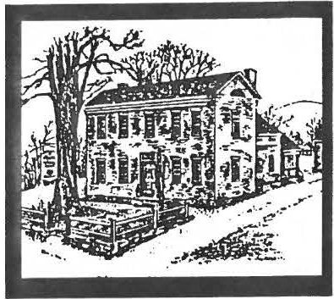
Sheffteld Historical Society
November 2001 Newsletter

Holiday Happenings at the Sheffield Historical Society

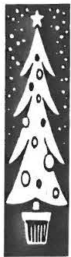The Sheffield Historical Soci­ ety will be hosting many holi­ day events this December.
,
The season kicks off with the 3rd Annua) Festival of Trees on Saturday, De­ cember 1 at Old Parish Church on the village green.
The event, which runs from
10 a.m. - 4 p.m., features a silent auction of custom decorated holiday trees and holiday raffles (drawings at three p.m.). The trees make great presents and hostess gifts! Lunch available, $5.00. Last year over 40 one-of-a-kind trees were purchased by delighted shoppers. Proceeds will go toward the Stone Store res­ toration. No admission charge - so come and do some holiday shopping and enjoy a hearty homemade
lunch. The event also includes:
0 Holiday Ties: a Bow Making Workshop taught by Dorothy Marosy. Never been able to make that holiday bow look right? This workshop's for you! Bows of
Holiday Wreaths
In addition, this year the Society will be selling three different models of wreaths for your holiday decorating. All wreaths feature
all shapes, materials and sizes will be demonstrated. Once you've gotten the basics, you' ll make three beautiful bows to take home - two of wired rib­ bon suitable for holiday wreaths or swags and a third bow suitable for a package. All materials incl uded,
I p.m.Fee: $20. Space limited, regis­ tration required. Call: 229-2694.
0 Customize your Holiday Wreath: a Demonstration by Judy Schnurr. Judy will show you how to take the basic wreath being sold by the Sheffield Historical Society and add special touches to make it uniquely yours. Judy's ideas are al­ ways creative and do-able with stun­ ning results. This demonstration is free.
0 Holiday Tapestry raffle tickets will be sold for the custom made, one of a kind tapestry. This beautiful, hand made 49" x 62", all cotton tapestry features 9-patch squares in holiday fabrics alternating with solid red squares decorated with gold poinsettias.

these wreaths will be fabulous! Wreath models will be available in early November for your viewing (in the Stone Store windows). Please

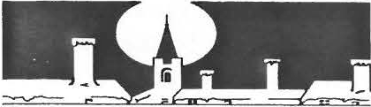
The Holiday Stroll will be held on Saturday, Decem­ ber 15 from 2 to 4 p.m.
The program begins at the Dan
Raymond House on Main Street in Sheffield, where there will be a members' holiday exhibition. After viewing this 1774 home , participants will visit four other historic hou ses decorated for the season. Christ Church Episco­ pal will serve as the gathering place at the end of the journey, where holiday music and re­ freshments will be available.
The drawing for the Regi Klein painting of Sheffield "The Town Common" will take place at 4 p.m. Proceeds from this drawing go to benefit the Stone Store. Members free, non­ members $8.

229-2875. Wreaths will be available for pickup in early to mid December to ensure their freshness. Proceeds benefit the

fresh evergreens, are custom deco­
rated and ready to hang on your door, mantel, or wall. With Judy Schnurr as our wreath consu ltant,
consider these wreaths for your home, Stone Store resto-
office or gift giving needs. Prepaid ration. o ·. t.,. .
orders may be placed by calling the See page 7 for an . Society at 229-2694 or Rene Wood at order form.

Page2 Sheffield Historical Society November2001 Newsletter

Mark Dewey Research Center Archives
Sheffield was the home from would be next to recite. Grading 1899 to about 1922 to a set of iden- them was often guess work on the tical twins whose individual identity part of the teacher but the boys was a puzzle to everyone in town never claimed to take tests for each except for their immediate family. other.

Apparently the young lady was not able to tell the difference.
Even visitors to their home were as puzzled as anybody else. Jennie P. Lockwood

Jesse R. and George M. Davis were the sons of Nathaniel E. and Alice
- Davis and brothers of Alice and Mabel. The family farmed on Boardman Street. News of the Davis brothers' ability to mystify their associates about their identity spread far and wide through na­ tional newspapers and, as a result, they received a letter from twin sis­ ters living in the Chicago area who wanted to make their acquaintance.
According to a series of arti­ cles in the Berkshire Courier, the young men took great pleasure in their ability to puzzle and for that reason wore identical clothing.
When one brother bought some clothes for himself, he always pur­ chased the same thing for his brother. They shaved the same time of day, cut their hair the same way and did nothing differently that could be used to set them apart.
The two boys weighed about the same, used the same words in con­ versation, had similar voices and their smiles were so alike that it was almost impossible to see a differ­ ence in them.
In school they were always
in the same class and did well in their studies. But they never had a problem in deceiving the teachers as to who was George and who was Jesse. If one knew his lesson better than the other they changed seats after mingling during recess or around the teacher' s desk and the one who had the better knowledge would get in a position where he
In sports they worked their boarded at the Davis home all one disguise on the baseball and foot- winter and was unable to tell them ball fields. They played both games apart. She hoped to distinguish but it was in baseball that they were them by where they sat at table able to profit from their appearance. but, of course, they changed seats. It was possible for one brother to Jesse was eventually hired bat in place of the other. They told as a substitute mail carrier. As
of games where their names were you have already guessed, nobody far enough apart on the batting list really knew who was carrying the so that one would not have to come mail.
to bat while the other was on base. About 1922 they left Shef-
Thus, if they wished, either could field. Their destination is not
do all the batting. When only one known, but if I had to find them, I position was filled by a Davis twin, would start looking in the Chi­ provided the other was on the field, cago area.
(and they nearly always were to­ gether) the better fielder did all the fielding and the better batter did all the batting.
Sheffield
Fatal Disease is Anthrax

"Dr. Austin Peters, chief of the cattle bureau, was in Sheffield recently with Dr. F. D. Landon of Great Barrington investigating the cause of death of several cattle.
The latest case was about two weeks ago, when a cow belonging to Willis Clark died suddenly.
Several others had died earlier in the summer. Dr. Peters is confi­ dent that the disease is anthrax, which generally proves fatal with cattle. He had previously made an examination of blood sent to him by Dr. Landon and from that secured positive proof. ... Dr. Pe­ ters will soon decide what is the best method to prevent any fur­ ther spreading of the fatal malady, for it means a great loss to the farmers in this section." Berk­ shire Courier , 21 October 1909.
The family belonged to the Friendly Union and they also de­ ceived people in performances held there on the stage. If one had a dif­ ficult part in a play, the other would learn a portion of it and come out during some acts, nobody being the wiser.
In social situations when one of the brothers received an in- troduction and the other was not present, the introduction worked for both. One simply told the other about the introduction and when the previously absent brother finally met the person, he took up as if al­ ready introduced.
During one winter both even kept the company of the same lady. Jesse would call one night, and fill George, who might very well make the next visit, in on the proceedings.

Page3

The Old Stone Store Rescue
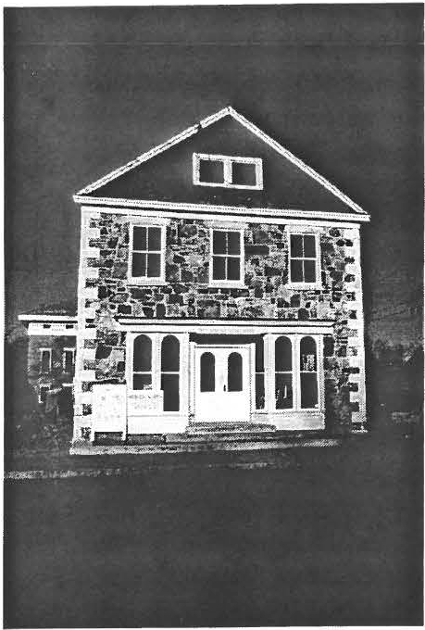
den Club. Architect John James has donated his professional expertise for the project and Reiner White, the contractor, has worked to ensure a restoration appropriate to the pe­ riod.
The Society secured a loan in the amount of $180,000 from the MassDevelopment Corporation and nearly that entire amount has been expended. Work on the project will cease until the loan is paid off and additional money is raised.
The Old Stone Store Resto­ ration Committee, a group of Soci­ ety members and citizens from the community has been working on fundraising since July. The re­

and information center. Pledges or other gifts are tax deductible to the fullest extent under the law and the Society is a 50 l (c)(3) cor­ poration. If you would like to support this project or wish addi­ tional information, please contact Catherine B. Miller at (413) 229-
8668.

Restoration work began in
earnest in early May on the Old Stone Store and, as is the case with old buildings, many problems were not evident until it was opened up for a closer look. The advanced de­ terioration we found has added to the cost of its rescue and extended the length of time necessary to complete the project.
The entire wooden interior has been gutted and rebuilt, effec­ tively creating a new wooden build­ ing within the existing stone work. It includes floor joists, partitions,
sponse from individuals and groups
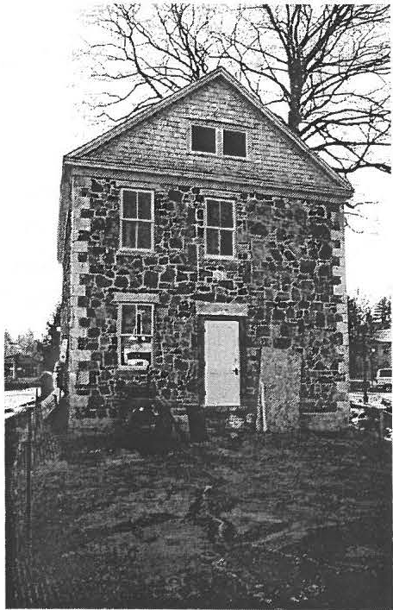
has been gratifying in that sligh tly over $100,000 has been raised.
However, there is some distance to go to meet the $180,000 obligation and the estimated balance of
$50,000 beyond that figure that is estimated to bring the project to its final conclusion. With persistence the challenge will be met so that one day the community will be able to enjoy the use of the Old Stone Store for its intended use as a mu­ seum of town history, exhibit space

stairs, cedar roof and new, rot resis- r- - - - - - - - - - - - - - - - - - - - - - - - - - - -

tant store front, doors, and win­ dows. The rough wiring and plumb­ ing have been completed and work
Contributors to the Old Stone Store July 1 - October 31

on the climate control is well under way. As a result, the first floor is nearly ready for insulation. In the space behind the Store where the wooden addition once stood, the septic system and underground fuel tanks are in place. In the spring that area will be landscaped with the help of a grant from the Lenox Gar-
$5,000+
Anonymous Anonymous Berkshire Bank
Lois Bradford & Joan Brooks
Paul & Carol Collins Jean Curtiss
James & Catherine Miller
$1,500- 4,999
Philip & Susan Detjens Virginia Drury
Lenox Garden Club Carl Schumann
$100 - 1,4 99
Doreen Atwood Grace Arzt
Neil & Kathlee n Chrisma n Mark Consolin i
Frie nds ofCBM Dorothy Marosy
Henry & Dawn Massini Katherine Ness Sheffield Tourism Rene Wood

Page4 Sheffield Historical Society November2001 Newsletter

Another successful stroll through the cemetery

The decision to move the cemetery stroll forward in date and time proved a pleasant one. Warm temperatures and sufficient light for strolling made this year's walk in Ashley Falls the best at­ tended stroll to date. Over 80 people joined us in Sackett Cemetery. This event boasted our largest cast as well.
Ricky Bernstein is pictured here por­ traying Roscoe Taft.
Thanks to all those who assisted with this event and all those who came out to join in the walk.
Call the office if you would like to be a spirit in next year's cemetery stroll at 229-2694.

'-. I

'
A \
L ,, J
- · :?). _{¼}

Hats off to the Civil War Concert Performers

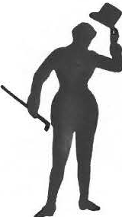
Sunday, October 21st witnessed one of the best musical perform­ ances to have ever taken place in Sheffield. Over
viewed or purchased. Let the So­ ciety know if you are interested in purchasing a copy of this program at 229-2694. The program will also run on CTSB. Check the sta-
performers and to James and Catherine Miller for all their ef­ forts in making this concert such a success.
A very special thanks goes out

160 people turned out to
tion' s listings for time and date. to John-ArthurM ill,re
who

hear the words and songs of Sheffield resi- dents from the Civil
War. A host oflocal talent, both pro­ fessional and amateur, provided the community an entertaining and in many ways very moving experience. For those of you who missed the event, the local access television channel CTSB- 11 filmed the concert. The Society will have tapes of the event which can be

Collaborative Programming
The Society will again be working with the Trustees of Reservations for pro­ gramming in 2002.
The joint 18th-Century Day is tenta­ tively set for July 6th. A series of joint tours with a focus on Sheffield's natural and cultural history is being developed for the summer months. Watch for de­ tails in the March newslette r.
Hopefully the program will air on Veterans Day.
Thanks go out to every one in­ volved in the concert from ticket sales and ushers, to those who prepared the reception, and to all who purchased tickets, which helped support the restoration of the Stone Store.
Special thanks go out to all the

In conjunction with the Bush­ nell-Sage Library, the Society will offer its first school vacation workshop, "History through Quilting," on Wednesday, Feb­ ruary 20, 2002 from 10 a.m. to 3
p.m. It is designed for 8 to 12 year olds.
The program will include read­ ings, viewing historical materials ,
originated the idea for the con­ cert and who carried the process through. His many hours of re­ search, rehearsing, and organi­ zation were evident in all as­ pects of the performance.
A job well done indeed!
Please note correction from the Faff News /e l/er : donations in Root's mem­ ory made to the Old Parish Church/ or the Clock were by the G.A.R. and the WR.C.

and the completion of an indi­ vidual quilt square. Participants are asked to bring their own bag lunch to this textile workshop.
Fee-$8 members, $10 non­ members.
Registration is required. Please register at 229-2694.

Page5

Calendar of Events 2002
Friday-January 11 What's It with Milton Barnum & Chris Coenen, 7:30 p.m., Dewey Memorial Hall
One of the Society's favorite annual

events is back again. Get out your stump the thinking caps in order to identify experts. objects that mystify the mind, and
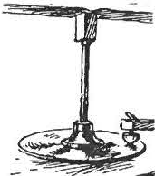
bring along that gizmo or gadget to

Monday-January 21--Sheffield's Heroes and Helpers, 1 to 3 p.m. at the Bushnell-Sage Library
A jointly sponsored event focusing on

Friday-February 8-The Massacl,u­ setts Quilt Documentation Project with Society and Quilt Guild members,
7:30 p.m.-Dewey Memorial Hall
An ongoing project to document quilts made in Massachusetts prior to 1950. Experts from this project visited Shef­ field this past year. The Berkshire Quilt Guild sponsored the team's visit to our
Friday-Marci, 8-"The Taking of East Sheffield" with John Sisson, 7:30 p.m., Dewey Memorial Hall
A presentation of this dramatic chapter in Sheffield' s 1870's history where politics, mills, railroads, and territory
Friday-April 12-To be announced
Friday-May 10-"Under the Quab­ bin: The Lost Towns" with Ed and Libby Klekowski-7:30 p.m., Dewey Memorial Hall
This huge reservoir in Central Massa­ chusetts covered over small towns and settlements during the construction and flooding of the Quabbin Reservoir. Ed
firefighters and other community members who are always ready to assist in times of need. There will be readings for children and lee-

area and paid for quilts in South County museums to be docu­ mented. Quilts from the Mission House, Bidwell House, Sheffield Historical Society, and private own­ ers were involved. The team photo­ graphed, evaluated, and produced a written report on each quilt. Five Society quilts were included in this

put in play a series of events that resulted in Sheffield losing a large portion of its eastern territory.
John Sisson is the President of the New Marlboro Historical Society, a member of the Historical Commis-
and Libby Klekowski from the Uni­ versity of Massachusetts researched and produced a WGBY program on the project.
The Klekowskis with the assistance of University of Massachusetts stu­ dents found fascinating stories dur­ ing their botany research. These discoveries led to the creation of a
tures and exhibits for adults. The event is free and open to the public.

project. Amongst the pri­ vately owned quilts were some from an early farmhouse in Ashley Falls.
SHS members will explain the procedures used and show the documented quilts. Some sur­ prising information will be re­ vealed!
sion, and the Project Manager of the New Marlboro Ceme­ tery Restoration Project. He is the great grandson of a piv­ otal figure in this drama.

television program for the Springfield PBS channel. The program is to be aired during the December fund drive.
Check TV listings to get an overview. We'll get the real inside "scoop" when this per­ sonable couple appear at our May meetings.

Friday-June 14-Annua/ Meeting, 7:30, p.m., Dewey Memorial Hall
In addition to those long awaited the festivities. There will be annual reports, the Society will be many surprises!
celebrating its 30th year! Join in

Page6 Sheffield Historical Society November 2001Newsletter
Gif1 giving never felt better!

A community of museums in the United States has joined together to launch Shopformuseums.com. This is a fundraising secure portal site, designed to benefit museums by generating revenue through on­ line consumer sales. The Shef­ field Historical Society is one of the organizations able to benefit

New Publication
James Miller, Archivist at the Mark Dewey Research Center, has spent innumerable hours delving into the history of Sheffield. His labors have born fruit and will be shared with the community in the Spring of 2002 by way of a new publication on Sheffield in the 18th and 19th centuries.
The Historical Society is taking advanced orders for this work.
from this collaboration.
The process is simple: Go to Shopformuseums.com and select the Sheffield Historical Society from the database. You select a merchant and make an order.
There are over 125 merchants to select from including upscale toys , gifts, apparel, and computer

The focus is on material culture and the publication will shed new light on the daily life of the founding generations of Shef­ field residents.
Watch for further details on the book in the Spring newsletter.
To reserve your copy, call the office at 229-2694.
providers. Each merchant will do­ nate a portion of your purchase to the Sheffield Historical Society.
This is an easy way to get the qual­ ity products you want and to finan­ cially benefit the Sheffield Histori­ cal Society at the same time.
Check out their website or call the office for more details

New Exhibit
The holiday exhibition for the Dan Ray­ mond House will be composed of mem­ bers collections, with a special concentra­ tion on Santa Claus and festive textiles.
Several members are contributing items from their personal collections which you may never have seen before! The exhibit will be open to the public from 11 a.m. to 4 p.m. Fridays, November 30, December 7 and 14; and Saturdays, December I rom 12 to 3 p.m. and on the 15th for the Holiday Stroll from 2 to 4 p.m.

SHS Updated Web Site
Visit www.sheffieldhistory.org and see our new and expanded web site. All information has been

Catherine Miller, James Miller and Rene Wood, the website committee that made it happen,
*************************
*
*
* ur IL. *n-lStl ISi *
** If you have any of the following ob-**

updated and new pages added on
Aidan Cassidy for his drawings, ! jects in good condition, consider !

Special Events, Directions , Volun­ teering, and Links to other sites. A Collections page has also been added for future display of Society holdings.

Special thanks to Betty Chapin, Joanne Hurlb ut, Dorothy Marsoy,
Gregg Siter, the designer of the original website, who gra­ ciously volunteered the many hours required to make all the changes and give our site its new appearance and Maria nne Swan, who will be doing future updates.
! dona ting the item to SHS. Mone- !
! tary contributions to be used in pur-*
* chasing the items are also welcome. !
*! A slide projector and laser pointer;!**
- cotton sheets; screw gun, glue & *
! staple guns, WWI & WWJJ info, old !
! scrapbooks !

************************

0 Sheffield Historical Society Holidav Wreath Order Form
Page 7
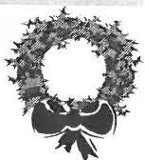

Wreath #1: $ 27.50. 12" wreath , Red & Gold or Burgundy & Gold bow and golden decorations. Bow Preference: Red &
Gold Burgundy & Go ld _

Wreath #2: $37.50 14" wreath , Burg undy /Go ld Multi-colored bow, large tear shaped ornament and additiona l g ol den decora- lions.
Ornament Color Preference: Gold Red White /S ilver

Wreath #3: $60.00 22" wreath, re-usable 13" Gold Reindeer Ornament and diaphanous ribbon of golden stars.

All wreaths will be made of balsam/evergreens. SHS reserves the flexibility to substitute another bow of comparable quality. Quantities are limited - please order early.
---...--...-----------------...--------------------------·--------·------------------------------·---·----·-·---------------------·---·
To order: please complete the form below and send it, along with your check made payable to Sheffield Historical Society, PO Box 747, Sheffield, MA 01257

Name: Phone #: _
_ _ _ _
_ _ _ Emai l:

Wreath #
Quantity_
_ _ Single Price: $
Total Amount: $

Pref nce Information , if any:

Wreath #

Quantity

Single Price: $

Total Amount: $

Preference Information, if any:

Wreath # _

_ Quantity

Single Price: $ _ _ _

_ Total Amount: $_ _ _

_ _ _

Preference Information, if any:

Grand Total and Amount Enclosed:$

Wreaths may be picked up at Sheffield Historical Society, J59 Main Street, Sheffield on the following dates or by special arrangement. We will phone or email you to confirm your pickup date. If special arrangements are needed, please call Rene Wood, 229-2875.
Wreath Pick Up Preference: Please note your I 51 and 2nd choices.
,

Sunday , Dec. 2nd Noon - 2PM _ Saturday, Dec. gt\ 10 A M - 4PM
,
Tues, Dec. 4th Noon - 2PM Sunda y, Dec. 9th Noon - 2PM

Thank you for your support. Proceeds go to the Stone Store Restoration fund.
,
0 0

Do 11 R 11 -. o• ' Ho wu u. ,,,.wi
M o t lt o,.,,,, lf , u o , r ll c,. ,,,

159 Main Street
PO Box 747
Sheffield, MA 01257

Phone: 413-229-2694
Email: shs@sheffieldhistory

Tours of the 1774 Dan Raymond House are by appointment during the winter months. fee.

Mark Dewey Research Center open Monday and Friday afternoons, I :30 to 4 pm.

WE'RE ON THE WEB
SH E F F I E L D H I ST O RY. ORG

Society Happenings the Office and become involved in
r '1:7
tt' collections record-keeping. It
Board of Directors The month of October saw a makes for a great winter project.
Dorothy Marosy, President number of school groups par-
ticipating in SHS programming, On October 7, the Society sent in-
Kathie Ness, Vice-President including two groups for the 5th trepid souls into the inclement
grade cemetery program and the weather to the Lee Visitors Center Catherine Miller, Treasurer first home-school class. The to introduce travelers to the Soci-
Harry Conklin, Clerk One-Room School program of ety and received $500 for this
the I8th-Century met the 21st- venture from the Massachusetts
Trustees: Century in the Education Center Office of Travel and Tourism via
Doreen Atwood and proved that learning truly is the Berkshire Visitors Bureau.
multi-generational!
Wray Gunn
James Miller The Sheffield Historical Society Save these dates:
is the recipient of a $200 grant December 1st for the Festival of
Marilyn Wightman from the Technical Assistance Trees
Rene Wood Fund of the Berkshire Taconic December 15th for the Holiday Community Foundation , Inc. Stroll and drawing of the Regi The funds assisted in the pur- Klein painting
Joanne Hurlbut , Director chase of a new computer soft- February 20th for History
ware program, Past Perfect, for through Quilting, a workshop
rf_l the Society' s collection. If data for youth
entry is your delight, please call

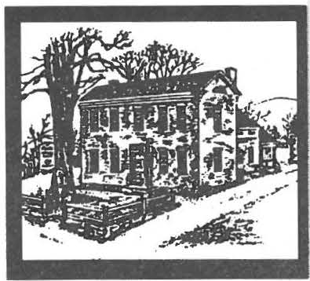
5heffteld Historical 5 ociety
June 2002 Newsletter

Summer Fun!
Don't forget the Summer Garden Party on Saturday, June 29th!
Call the office for information
and reservations.

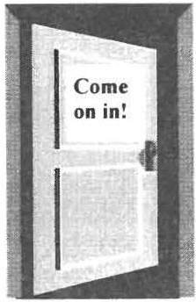
The Society in­ vites you to join us as we step into some of the finest homes in Shef- field. A Sum- 91er "Historic
-Sites and
Structures"
Tour is planned for Satur­ day, August 17th, from
11 a.m. to 4 p.m.

Enjoy a special visit to five Shef­ field home sites. In addition, the Society's seven historic structures will be open for viewing.

The day is yours for only $20 per person. Tickets can be purchased

through the mail and at the Society's headquarters. It is recommended that tickets be purchased in advance. For more information call 229-2694.

Eighteenth Century Day: A Family Celebration
Saturday, July 6
From 12 to 5 p.m.
Once again the Society is joining .. with the Colonel Ashley House, oper­ ated by the Trustees of Reservations, to celebrate the stories of our found­ ing families.

Spend an afternoon getting to know what life was like for those who walked down the streets of Sheffield and Ashley Falls in the 18th century. And walk they did, since there was only one horse for every six people in the area! Sheffield's first private car­ riage does not appear in the books un­ til 1800! Today, travel time between the two sites is less than ten minutes

via the horseless carriage.
At the Dan Raymond House, there will be a special focus on clothing styles of the period.
Dennis Picard will be on hand to demonstrate techniques of sewing and textile production. Other demonstrations include spinning and dyeing.

Both sites will offer house tours, demonstrations, and hands-on activities for the fam­ ily. Admission: Adults 1/2 usual price, children and mem­ bers free.

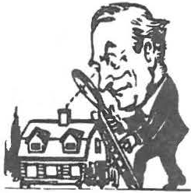
Summer is all about ex­ ploration and seeing new sites.
So join us right here at
home for some new adventures!

Special Joint Summer Tours

Saturdays-July 20 and August JO
Revolutionary Period Tours
Co-sponsored by SHS and the Trus­ tees of Reservations. Begins at I :30
p.m. at the Dan Raymond House.
Get a close-up view of the Revolu­ tionary Era through this afternoon
excursion: First a presentation on the social and material culture of Sheffield/Ashley Falls during the Revolution will be given by SHS staff. A tour of the Dan Raymond House follows. Then travel to the Col. Ashley House where Don Reid will describe the natural history of the
area during the Revolutionary Period and contrast it with to­ day. His talk will be followed by a tour of the Ashley House.
Size is limited to 20; members free, non-members $5. Reser­ vations suggested; call 229- 2694.

lections Manager should be the Society director. The director is in charge of receiving, inventorying, and daily care of the collection.
Scholar's Corner

This year's recipient of the Shef­ field Historical Society $1,500 Scholarship is Rebecca Garcia. She will pursue a B.S. in Archi­ tecture at Wentworth Institute of Technology in Boston.
The director is also responsible for items from the collection used in displays.

Grant Awards

The Sheffield Historical Society educational troupe will once again be off to the Lee Tourism Booth to dazzle the audience. This year members will spend July 27 and 28 at the booth, from 11 a.m. to 2 p.m., demonstrating and sharing information about the Society.
The Society will receive a total of
$1,000 for the two days thanks to the Massachusetts Office of Travel and Tourism and the Berkshire Visitors Bureau. If you are traveling that day, stop in and say hello.
* * *
Oral History Project wins Sup­ port from the Local Cultural Council (supported by the Massa­ chusetts Cultural Council).

Over the past several months the Society has worked in conjunction with a number of local organiza­ tions and individuals to preserve the history of the area through the recollections of its inhabitants.
The Cultural Council has sup­ ported the Society' s purchase of equipment ($325), which will be used to conduct the interviews. Funding was also provided to the Senior Center in order to hire an oral history consultant to guide in creating interview forms and in training interviewers. Watch for future updates on the process!

Annual Reports

Collections Committee Annual Report 2001-2002
Committee members: Betty Cha­
pin, Connie Logan, Carl Proper, and Doreen Atwood

The Collections Committee, along with SHS President Dorothy Marosy and SHS Director Joanne Hurlbut, has met quarterly over the past year.

It has been determined that the present collections policy is in need of review and updating. Cur­ rently policies of similar-size in­ stitutions are being studied, and a new "Collectio ns Management Policy" will replace the policy now in place. Along with a new policy will be the implementation of the software program "Past Perfect," which will greatly im­ prove the collection records.
Many items have been donated in the past without documentation or have lost their identification over the years. A thorough inventory of the collection is needed.

It has been decided that the Col-
A number of textile items have been received and added to the collection over the past year. In­ cluded are samplers and coverlets with Sheffield history. Conse­ quently new storage materials have been purchased for textiles and new equipment has been pur­ chased to monitor the atmosphere in the Dan Raymond House. The society received a Conservation Assessment Program (CAP) award and it is hoped that addi­ tional grant money will also be awarded to help with the purchase of a HEPA vacuum and other preservation equipment. (See di­ rector's report for more details on grants and awards). Long-range preservation is now being studied in order to properly care for the collection and in order to provide needed information for future grant applications.

Plans are being made for a collec­ tion appraisal, and the "fine arts" portion of the society' s insurance policy will be reviewed as well. In addition, emergency plans for the Society, including fire protec­ tion, will be established. Many policies are being studied and up­ dated in keeping with the growth of the collection and its care for the future.

Doreen Atwood, Chair

'\ .... ' " 'II. ,t,. \.
,. ,-,
,' ,._...,,,,t,. ,\.
,,'\,..... ' ,... ,.,.,
,\.
,,,,,,,,,

Place Your Book Order Now
'<,,',· Name ""\' .
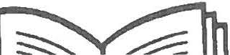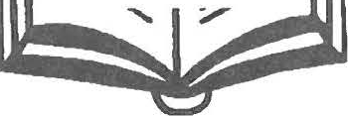"\ '
.,., "
'
Address
.'°'\
' - - - - - - - - - - - - - - - - -'

Early Life in Shef­
. ,... Phone
----------- '''\
"\.

field, Berkshire County, Massachu­
setts: A Portrait of
Early Life in Sheffield, Berkshire Coun ty, Massachusetts: A Portrait ,
of Its Ordinary People from Settlement to 1860, by James Miller.

Its Ordinary People
from Settlement to
1860
copy (ies) @ $27.50
,'--.,- .

Mailing and handling, $5 first book, $2 each additional.
"\
'"\_
'
'

< "\
-----

Send order and payment to Sheffield Historical Society, .,,,_
: ... P.O. Box 747, Sheffield, MA 01257-0747
-..,_....",\•• .. "\ . ,,...'"',_'\ ,.'\ ...,...' "\ ,,...'">."\ '"\..'.....· \',,...·--,..":._ ---......''°'\ ..·--..........'"\ .....·--..'

Treasurer's Report
Over the past couple of years, the Society has computerized its fi­ nancial record keeping. At this point in time, it is most logical to produce a report once the fiscal year has ended and all figures have been reconciled from July of 2001 through June of 2002.
Therefore, the Treasurer, Cath­ erine B. Miller, respectfully re­ quests that the final year-end re­ port be submitted to the Society through the September newsletter.

Director's Report

It is hard to believe, but I have now been at the Society for three years! We are a very active or­ ganization and the time has quickly flown by. Our most re­ cent grant reviewers have mar­ veled over the level of activity we engage in, and I will proudly ad-
mit, they are envious of the com­ mitment of our volunteers and members. I send my personal thanks to all who have made my time here so productive and pleas­ ant.

Together during this past year, we have provided educational pro­ grams to students from Sheffield to Lenox. In fact, it has been our busi­ est year to date and we look for­ ward to even more classes.

The level of collaborative program­ ming was on the rise as we worked with the Bushnell-Sage Library, the Cultural Alliance, the Tri-Corners History Council, the Trustees of Reservations, and the numerous groups involved in the oral history project and Sheffield in Celebra­ tion. Programming such as the 18th Century Day exhibited our col­ lection, including the newly re­ stored smokehouse, to eager and very appreciative audiences.
In addition to monthly meet­ ings, we have held our first school vacation workshop and events such as the members first preview for the Sheffield Fash­ ions exhibition. Press and tele­ vised coverage has been strong.

Our grant track record continues to be a positive one. The most extensive collections project completed over the last year was through the Institute of Mu­ seum and Library Services Con­ servation Assessment Program. The Society has and will con­ tinue to benefit on numerous levels from this grant.

There is too little space to re­ cord all of the accomplishments of the past year , including the Stone Store Restoration. Just ask anyone, it was a busy year!

Joanne Hurlbut

Sheffield Hisblrical Society .,._2001NI If ra

2002 Annual Report from the Outreach Committee

Members: Rene Wood , Chair, Kathie Ness, Judith Timm. Marion Whitman. Marilyn Wightman.
Ex-Officio Members : Joanne Hurlbut. Dorothy Marosy. Advisor to Commit­ tee: Doreen Atwood.

The Outreach Committee had a busy and exciting year working with the So­ ciety President, Vice-President and Di­ rector to provide to urs, exhibits, special events, monthly meetings. school pro­ grams. field trips. and workshops.

The monthly programs featured a wide
and will be repeated again. Soci­ ety members were once again generous in providing refresh­ ments for enjoyment after the pro­ grams. Special thanks to Inez Flinn and Norma Moulton for all their work as hospitality host­ esses.

Special events this past year in­ cluded a Saturday Holiday Stroll in the heart of Sheffield. with a lovely reception at Christ Church and a successful 3rd Annual Festi­ val of Trees, despite the summer­ like weather with which it had to compete. The 4th Annual Festival of Trees is scheduled for Satur­
.
the Wadsworth Atheneum Museum of Art in May. An October trip to Mills Mansion is planned. Outreach Commit­ tee members also assisted with other Society programs and events as requested.

Please join the Outreach Com­ mittee if you·d like to work on these exciting parts of the So­ ciety·s mission. We are also looking for one or two people who would like to volunteer to post Monthly Meeting posters in local stores.

Thank. you Outreach Commit­

range of topics, which attracted increas­
day, November 30th
Rene Wood
tee members for all your work

ing numbers of Society members and the comm unity. Fall 2002 and 2003 programs are set and promise an excit­ ing mix of history and culture. The for­ mat of a Friday program followed by a Saturday field trip was well received

The Mark Dewey Research Center has been kept busy this year with visitors, researchers, E-Mails, phone calls, and letter inquiries for a
total of 279 requests.
and James Miller will again chair the event and encourage members to begin thinking about designing a special tree or two for the event.

Members enjoyed a field trip to
in making this an exciting year!

Respectfully submitted,
Rene Wood, Chair

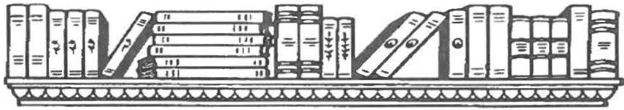
There have been requests for the history of early houses, church history
and photos, family records, a list of our
field's Heroes. pile a comprehensive list of our holdings at the Center.
In April we went to Mt. Everett

early antique dealers, information on the Ten Eyck murders, and Shay's re­ bellion. We also had two professors from the University of Oklahoma re­ searching "The Society of Horse Thieves" and a professor from SUNY­ Buffalo researching early agriculture of the area.

We worked with the library and ar­ ranged a display of our Fire and Police Departments for the program of Shef-
and spoke to the large sixth - grade class on "How to research your ancestors." There were many questions from this young group.

We have purchased some refer­ ence books and have been given some old scrapbooks, letters. pic­ tures, family histories, and books.

Our goal for next year is to com-
The Center is open Monday and Friday from l :30 to 4:00 and by appointment.
Respectfully submitted
Betty Chapin, Director of MDRC

MDRC Committee: Doreen Atwood
James Miller, Archivist David Prouty
Pauline Schumann

Report on the Old Stone Store

The past year has seen many changes in the Old Stone Store. The frame addition was removed in June 2001 and work on the original structure began in earnest in July. Once the building was opened, it was apparent that the interior bearing walls, and floor and ceiling joists, were in deplorable condition and structural soundness could be achieved only by total gutting and rebuilding a " building within a building." All that remained before reconstruction began were the four stone walls.

Ten months have passed and the Soci-
ety can now take pride in a reno­ vation that is nearly complete.
The interior, with the exception of carpeting and lighting fixtures on the second floor. is ready for use. Work on the garden on the west side of the building will begin shortly. In mid-July the Society will host a reception at the Old Stone Store for all those individu­ als who generously supported the efforts.

Financial support for the project has been gratifying, and while there is a distance to travel to meet the full cost of the project, to
date, one hundred and seven donors have contributed
$155 ,880. This is about
$30,000 less than what is needed to pay off the
$ I80.000 mortgage.
The total cost, exclusive of purchase price, is estimated to be $275,000 so it will be nec­ essary for the Society to con­ tinue to fundraise to meet the mortgage expenses and repay the endowment for money borrowed to make up the dif­ ference between the mortgage and the project expenses .

Catherine Miller

Report of the Nominating Committee | Trustee | James R. Miller | 2003
 | Trustee• | Marilyn Wightman | 2005
The Board of Trustees for 2002 - 2003 | Trustee | Rene Wood | 2003

Position Name Tenn ExQires
President* Dorothy Marosy 2003 Vice-President* Wray Gunn 2004
Clerk Harry Conklin 2003
Treasurer Catherine B. Miller 2004
Trustee Doreen Atwood 2003
Trustee* John-Arthur Miller 2005
  - Standing for election at the Annual Meeting, June 2002

Respectfully submitted.
Wray Gunn Catherine B. Miller
H. Dennis Sears

President's Report

As I reflect on the past year. I am as­ tounded by the Society's myriad activi­ ties. The monthly programs and field trips continue to attract people not only from Sheffield, but from the surround­ ing communities. Some highlights were the Civil War Concert, the Festival of Trees, and the Holiday Stroll.

In collaboration with the Bushnell-Sage Library, the Society presented "Heroes and Helpers" and a book signing by the author of "Mumbet," The Life and Times of Elizabeth Freeman. Commu­ nity outreach included the "Place in
Time" program for first and sec­ ond grades, a cemetery tour for the fifth grade, and a tour of the Dan Raymond House for
eighth-grade students. A work­ shop for 8- to 12- year-olds on quilts and their history was sponsored by the Bushnell-Sage Library and the Berkshire Quilters Guild. Under the tire­ less direction of Catherine Miller, the Stone Store renova­ tion has been completed and the building will be open to the public this summer. The first annual Garden Party will take place on June 29, when we will
celebrate the publication of James Miller's new book.

In reviewing the minutes and scrapbooks of the Society's past 30 years, I reali ze that those who preceded us set a fine ex­ ample. I salute them and all the dedicated volunteers who work so hard to fulfill the goals of the Society. My sincere thanks to the officers, trustees, and Joanne, who have supported and encouraged me over the past year.

Dorothy Marosy

D•• • •1• • •tl H•••t N■ o••• M• • D•••, ll•u••c• C•• tl •

159 Main Street
PO Box 747
Sheffield. MA O1257

Phone: 413-229-2694
Email: shs@sheffieldhistory.org

Tours of the 1774 Dan Raymond House are available Thursday through Saturday from I I a. m. to 4 p.m. and by appointment.

Mark Dewey Research Center open Monday and Friday afternoons. I :30 to 4 p.m.

The Office is open Monday-Friday. 10 to 4.

WE'RE ON THE WEB
SH E FF IE LD H ISTO RY. ORG

,-:t-' 't-j Society Wish List ample: late Friday afternoon and early evening, and Saturday or Sun-
Board of Directors To continue the Society' s 30th day afternoons. You can work one
Dorothy Marosy, President year anniversary celebration day a week or one day a month.
(1972-2002), an exhibition will Call the Society to join in the fun!
Kathie Ness, Vice-President open on August 31. If you have
memorabilia or memories that Membership Reminder:
Catherine Miller, Treasurer you wish to share, please drop The Society' s membership is self-
policing; reminder letters are never sent.
Harry Conklin, Clerk by or call the office. Please check the month and year next to
your name for information on when your

Trustees:
Soon the Old Stone Store doors membership expires, or call the office if

Doreen Atwood will be open to the public! This you have any questions. Thank you.
means we need your help to
Wray Gunn staff the building. The Store

Save these dates:
June l arden Party

July 6-18th Century Day: A Family Celebration

July 20 & August 10
-Revolutionary Period Tours

August 17-Summer House
Tour
James Miller will serve as a changing exhibi- tion space, information center,
Marilyn Wightman and a shop. If you enjoy spend- ing a couple of hours convers- ing with friends both old and new, please consider joining the
Rene Wood
Joanne Hurlbut, Director Stone Store staff. The hours are
flexible and variable. The goal
'"'_l is to have the building staffed at least two days a week; for ex-

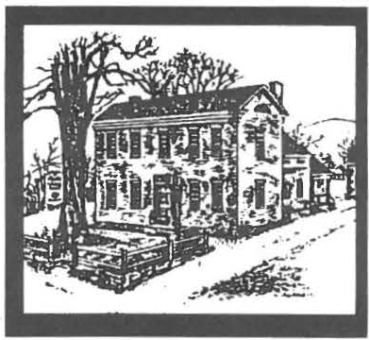
Sheffteld Historical Society

March 2003 Newsletter

Exhibitions at the Old Stone Store!

Cele brate Women's History Month by contemplating the handiw ork of loca l a rtists on display in the Sheffield His­ torical Society's Old Stone Sto re.
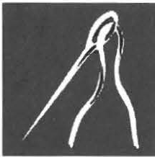
The exhibitio n Images From the Eye of the Need le and the Tip of the Hook encompasses three forms of textile art: hooked rugs.
samplers. and needlepo in t.

Members will recognize the names of ou r specia l female artists who are all longtime Society membe rs. Dorothy Marosy's hooked rugs have been pic­ tured in both books and magazine s.
Samplers from the private collec tion
I
of Muriel
- Rokos. many ' _ dating from
the 1920s. will be displayed a lo ngsi de samp le rs
that this expert quilter has herse lf cre­ ated over the years. Susan Young's needlepoint has received awards on the international le vel. Young is cre­ ating need le point kits of the Stone Store and other Sheffie ld buildings: they will be on sale in the Stone Store.

The public is invi ted to the opening reception to be held on Saturday, March 15 , from 2 to 4 p.m. The ex­ hibition will remai n on view through April 26. The She ffield Histo rical So­ ciety's Old Stone Store. lo cate d on
Main Street (Route 7) in S hef­ field. is open Saturday from 10 a.m. to 2 p.m. and Sunday from 11 a.m . to 3 p.m.

A full sla te of exhibits has been lined up for this year. Follow­ ing the textile exhibi tion will be one on ep hem era (paper materi­ als designed for short-term use and associa ted with a specific pe rson. object. topic. o r e vent). Watch the press for full deta il s.

O ur s umm er exhibit will focus on touris m. The Society is the recipient of the Scholars in Residence project in the amount of $2.500. a grant co­ sponsored by the Massachu­ setts Foundation for the Hu ­ manities and the Bay State Historica l League. The funds provide a stipend for local histo­ rian and auth or Bernard Drew to work within the Society's ar­ chives to research a topic cho­ sen by the Society. The project is Spend a Summer in Sheffield & Em•irons: The Tourism Trade in rhe Early Railroad
Era. The grant funds will also al low the Society to create a publication based upo n Drew·s findings .

The exhibition will be on view in the Stone Store durin g Ju ly and August. Drew will gi\·e a
special talk on his findings at the opening. Look to the June news­ lene r for further details .

O ur thanks to the organizations that participated in the creation of The Spirit of Sheffield Then and Now, an exhibition on dis play in the Old Stone Store through March 8. The Sheffield Land Trust. the Sheffield Tree Project. and Elm Watch have created an exhibiti o n that is both in forma tive and popular. A number of photo­ graphs from the Socie ty"s co llec­ tion are among the man y items on vie w. Members from all four or­ ganizations have staffed the Stone Store on weekends. presented a receptio n. and worked with the media to make thi s exhibitio n a successful community project.

Would you lik e to enjoy these ex­ hibitions firsthand ? If so. then you are invit ed to become a Stone Store Shop volunteer. Indi viduals are needed to staff the Store to keep the gallery open for the pub- 1ic and to raise funds for the Soci­ ety by se llin g items in the sho p.
To find out more about this oppor­ tunit). call the Office at 229-2694.

Have you noticed that the reno­ vated Stone Store is lacking a sign? If yo u are willing to help underwrite the cost of this critica l s ign. please call the Office.

Page2 Sheffield Historical Society March 2003 Newsletter

RESEARCH NEWS

DAN RAYMOND, A SECOND LOOK
by James R. Miller
Dan Raymond. whose pre­ Revolutionary residence is the home of the Sheffield Historical So­ ciety. has frequently been described
helped to round out the story. In 1799. Theodore Sedgwick. Esq.. obtained a Supreme Judicial
Court judgment against Raymond for a debt of $405.05. As a result. Raymond·s --Goods. Chatt le s [sic] or Lands.. were orde red seized
and the --House & Lot of Land

spent nearly seve n months in debt­ ors· prison as a result of these two debts.
Dan died in 1809. It was only then that the most telling evi­ dence of his financial sit uatio n eme rged. He died with neither a will nor an estate at a time when

in print as a prospero us country with the buildi ngs thereon. lying
merchant. Like much history that is on the east side of the Hig[wa]y handed down through secondary in Sheffield, & a little S[outh] of sources from writer to writer and. the Meeting house.. were taken to hence. generation to generat io n. this settle the cla im. It was already simple description does not hold up mortgaged to one Willet Seaman under scrutin y. The story of his but the cou rt-appo inted appraisers wealth. while true. was true only found enough additional value to 'for a time" cover the Sedgwick debt as well.
Dan married Anne Noble The property is today the home of and it is in the Noble genealo g y that John-Arthur and Trudy Wea ver an enticing clue about his finances Miller at I 04 Main Street. a brick is found. The book refers to him as structure that Raymond built at being a wealthy merchant "for a about the same time as the Soci- time.·· a phraseolog y that draws ety"s headq uarte rs.
one·s attention. The Sedgwick judgment The most famous Dan Ray- was not the only one to face Ray­
mond tale. however. has nothing to mond. The following year. 1800. do with his finances. It relates. in- Asahel P. Bennett pressed a simi- stea d. to the Sheffield Liberty tree lar claim for $188 .07. As a con- of 1776 and how he contrived to sequence. add itio nal Raymond
have an accomplice cut it down. real estate was seized. leaving Significantly. however, the author him with exceedingly mode st offers an additional allusion to holdings.
Dan·s financial ruin. His final sen- Raymond·s efforts to reor- tence concludes. --1n justification of ganize his finances and pay his
his punishment [for having the Lib- debts took time. During the in- erty Tree cut down] and in confir- te rim he was committed to the mation of his guilt.... therich county jail in Lenox, where he [Dan] died at least in the poor was held from October 11. 1799. house:· With this seco nd tease r. ··until he pay the full sums.. to Dan·s finances definitely call for a Sedgwick. He was not able to do second loo k. In fact. as the record so until January 13. 1800 . On
s h o ws. Raymond se rved time in that relea s e dat e. howev e r. he was debtors· prison in Lenox and died a recommitt ed. this tim e for his poor man. debt to Bennett. which was not
Some insightful facts found satisfied until May 5. Raymond. in the Southern Berkshire Registr y who was we a lth y "for a time.··
men. even of the ..middling sort:·
had their final affairs settled through probate.
This second look at Dan Raymond , who, for a time, .. was a prosperous frontier trader. is an ex­ panded interpretation of his life and times. But it also illustrates the per­ ils of blithely using other writers· work without verification and the
need for researching original sources in order to have a more complete and balanced picture of the past.

Bibliography
Boltwood. Lucis M ., History and Genealogy of the Family of Tho­ mas Noble of Westfield. Massachu­ sens . . .. Press of Case. Lockwood & Brainard Compa ny, Hartford: 1878. pp. 381-3 83.
Holland. Josiah Gilb e rt. His­ tory of Western Massachuse ffs. The Counties of Hampd en. Hampshire. Franklin and Berkshire.. Samuel Bowles and Co mpan y. Springfield: 1855. p. 584.
Raymond family fi le. Sheffield Histo rical Society, Mark Dewey Re­ searc h Ce nter.
Southern Berks hire Registry. book 36, pp. 332-334 and 362-364.

Upcoming Monthly Meetings

Can you picture in your mind's eye Norman Rockwelrs ··four Freedoms..? The images are fa­ mous locally and nationally.
Whether you have seen them lately or not at all. join the Shef­ field Historical Society on Friday. March 14, at 7:30 p.m., and ex­ plore the se images in a new light. Stuart Murray will present FDR's Ideas and Rockwell's Im­ ages. the story of the develop­ ment of Rockweirs painting of the Four Freedoms and the U.S. government·s response to the paintings- from initial disdain to incorporation into the war effort. This discussion of politics and art is as important in our communi­ ties today as it was decades ago.

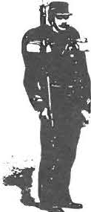
The Sheffield Histori­ cal Society invites the public to take another look at America's most divisive conflict.
Twiggs Myers will present Tlte Civil War in tlte East on Friday. April 11, at 7:30 p.m.
This spring journey will bring participant s through the full years of the war. from 186 I to I 865.
The points of exploration will in­ clude the major campaigns and battlefields of the Confederate Army of Northern Virginia and the Union Army of the Potomac. Military leaders Robert E. Lee and Ulysse s S. Grant will figure prominently in the presentation. Myers taught history for ove r 40 years at Berkshire School.

Springtime brings forth a sense of new beginnings. provides us with
the days of sun and warmth that we have been longing for. and makes us all wax poetic. So join us then in that vein for the May 9th meeting. Tire Apple Blossom Poets, with
Bernard Drew. 7:30 p.m. The poets are the loc a lly known Goodale sisters of Mt. Washington. The program will consists of both readin gs of their poetry and commentary by Drew.

June then ushers in the summer sea­ son and the break from month ly meeting s. but let us not forget to come together first. on June 13. to celebrate the successes of the past year at the Society"s Annual Meeting. 7:30 p.m.

The programs are free and open to the public and will take place in the
Community Roo ms of Old Paris h C hurch. Sheffield.

Special thanks go out to all those volunteers who have recently helped witlt the Society's collaborative pro­ gramming.

In particular : to those performers who helped with the Songs Sung in Sheffield program on Martin Luther King. Jr. Day. especially vocalist and emcee Robert 0-Keefe. Participa nts found the program moving and enjoy­ able; there were even a number of strong voices from the audience!
This was a joint program with the Bushnell- Sage Library.

February's joint program involve d the tale nts of the Berkshire Quilters· Guild along with the staff of the
Bushnell-Sage Library and the Soci­ ety. This year"s school vacation workshop. Hands-On Quilting, was
even more popular than last year"s ! The participants. 8 to 12 years of age. remained dedicated to their task throughout the day. As one of the adult superviso rs noted, ·'You could have heard a pin drop on the carpeted floor: it was that quie t!..

And a round of applause to those dedicated collections volunteers who attended SHS·s grant-funded National Endowment for the Hu­ manities· workshops in the fall.
The Society was fortunate to be able to offer the_workshops to our members, local organizations. and community me mbers . Partici­ pants benefited from the hands-on formats and the Society benefited from the participants· labor on our collections. We learned how to properly hang items , such as the Bradford portraits (re-hanging those objects was an experience
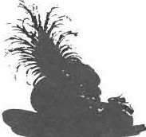
indeed!). We also worked within the textile collection. learning how to properly fold.
store. and care for the textile s in order to prevent gradua l deterorizatio n.

The ex perts were most im pressed with the collection and with the Society"s recent im provements in collec tions care. But there is much yet to do! Our members are putting into practice the skills they lea rned. We work in teams. sharing our knowledge while hav­ ing a good time. New team play­ ers are always welcome. This grant also enabled us to buy an appropriate vac uum and attach­ ments. So cleaning is a breeze!

tJo • lio , .. o o d Ho • ., 'l•st-.,
.If• •• fJ ,.,, , k , , ,, , r11 C,01,,

159 Main Stree t
PO Box 7-P
Sheffield. MA 0 1257

Phone: -113-229 - 269-l
Email: s hs iJ s he ffk ldhistor:, .o rg

Tours of the 1 77-l Dan Ran non d House are a, ailable Monda) through Frida) b) appointment.

Mark Dewey Research Center open Monda, and Frida) afternoo ns. t·30 to -l p.m.. and b) · appointment

The Office1s o pen Monda, through Frida, from IO a. m to -l.p m. · ~ ·

WE'RE ON THE WEB
H E FF J E L D H I T O R Y . ORG

t
Board of Directors Doro th y Marosy. President Wray G unn. I'ic e-President Ca therine Miller. Treasurer Harr y Co nklin . Clerk Trustees:
Doreen Atwood James Miller
John-Arthur Miller
Marilyn Wightman Rene Wood

Joa nne Hurlbut. Director
97 Albany Remembered Field Trip
On Thursday, May 8, a bus trip to the New York State capi­ ta l is o ffe re d to members and friends. The rich histo ry of this 17th-c e ntury Dutch settlement will be incl uded in o ur g uided tour. The Huds on River ca rried the French trappers. Dutc h fur traders. and then the English colonists. who renamed the area after the Duke of York and Al­ bany. Now the seat of state government. Alba ny is a gro w­ ing cultur e ce nte r of museums. theaters. and historic buildings. as we will see and lea rn from a professional guide. who will lead us on a I ½ - ho ur wa lkin g
to ur. (This is not a strenu o us
_ l hike.)

We plan to tour the Capitol building and the Governor's mansio n. and to enjoy views from the Corning Tower. There will be time to rest and refres h at the new cafe in the State Museum. Dutch treat. Our chartered bus will leave at 8 :30 a.m. and return at 4:00 p.m.

The cost for transportatio n. guided to urs. a nd entrance fees is $30 for me mbe rs and $35 for non-mem bers. A broc hure will be ava ila ble. and reservatio ns will be acce pted after Marc h 14th. For further info rma­ tio n. cal I Marion Whitman at ( 413) 528-601 3.
Save these dates:

March 15-- Te xtile Exhibition Opening and Reception

June 13- Annual Meeting
Li.

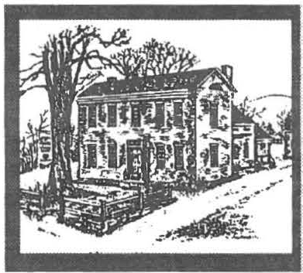
- - - ----- -------
Sheffield Historical Society
Fall 2003 Newsletter

►Baskets and More Baskets!◄

-.' • •

process. She has written and

black ash splint basketry techniques

', '
Did you know that some of America's
most prized baskets are made from
published 21 basketry patterns to date.
and modem expertise produces a basket that is both beautifuJ and useful. The Sheffield Berry Basket

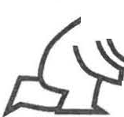
::::. black ash? Want to if lea rn more about ii this multipurpose
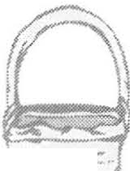household object? Then join us at our season-opening meeting on Friday, September 12, at 7:30 p.m. for a program on the Harvest of Black Ash
rt·_
I f
from Trunk to Basket with JoAoo Kelly Cat­ sos. This nationally hon­ ored basket weaver will tell the history, art, and culture of basket weaving
through slide and lec ture.
T he evening's event !s free L< /
and open to the public and ,::.....
will take place in the
Fellowship Room of Old Parish Church, Sheffield.

Catsos began teaching rattan reed basketry to children and adults throughout the Northeast in 1986. Currently she is teaching her original black ash basketry designs at basketry conventions and craft schools around the country, and exhibiting her one­ of-a-kind pieces. Catsos and her hus­ band, Steve , process the black ash splint , make molds , and do the wood­ working involved with her black ash baskets . Formerly an elementary school teacher, she loves teaching basketry and meeting people in the
Her work has been published in the 1999 edition of Splint Woven Basketry by Robin Tay­ lor Daugherty; in the July / August 1999 issue of Early American Homes magazine; in Directory of Traditional Ameri­ can Crafts; and in the Fall 1999 and Winter 1999/2000 issues of Shuttle, Spindle & Dyepot. She was honored to have a woven black ash ornament selected for the White House Christmas
Tree in 1999 . In 2003 she re­ ceived the Certificate of Excel­ le nce, Level I: Technical Skills in Basketmaking, awarded by the Handweavers Guild of America.

Spend an enjoyable day weav­ ing a Sheffield Berry Basket made of black ash splint that was harvested in the Berkshires. The Sheffield Historical Society is sponso ring a basket workshop on Saturday, September 13, from 10 a.m. to S p.m., with master basketmaker JoAnn Kelly Catsos. The Sheffield Berry Basket is designed as a functional basket similar to what would have been made in New England 100 years ago.
The combination of traditional
is 6½ inches in diameter and 8 inches tall with handle. No experi­ ence needed - just bring a desire to learn how to weave with wood.

Catsos states: "Making baskets of black ash satisfies some of my most basic inner needs. Working with wood keeps me in touch with na­ ture, while creating the basket satis­ fies my artistic need to express my­ self. Weaving high-quality minia­ ture baskets is definitely a chal­ lenge . My goal is to maintain the highest level of craftsmanship pos­ sible in both my miniature and full­ size black ash baskets."

The expert basketry of Catsos has won many awards - including Viewer's Choice at the North Caro­ lina Basketmakers Association, As­ sociation of Michigan Basketmak­ ers, and the Indiana Basketmakers Association Annual conventions.

The workshop fee is $75, which includes all materials.

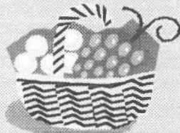
Pre­ registration is required.

Call the office at 229-2694.

Page2 Sheffield Historical Soelety Fall 2003 Newslettet

Fall Schedule, cont'd

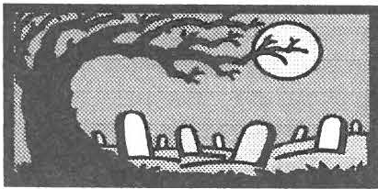
Saturday-October 4-Cemetery Walk with James Miller at 10 a.m. (part of Upper Housatonic National Heritage Area weekend). The Shef­ field Historical Society is offering a
tour of two of Sheffield's oldest cemeteries, where stones of unusual interest, importance, or distinction will be pointed out and discussed. Our own historian James Miller will conduct the tour. The walk be-

postponed from an earlier date.) The evening's event is free and open to the public and will take place in the Fellowship Room of Old Parish Church, Sheffield.
Saturday-October 18-The Spir­ its of Sheffield Cemetery Walk from 4 to 6 p.m. One of the Soci­ ety's favorite programs! This year the visitations with local inhabi­ tants from Sheffield's past will take place at the Barnard Ceme­ tery, located on Route 7. Men and women from the 18th and 19th centuries will recount the struggles they encountered in war and peace. Each has a unique

November newsletter for details .

THANK YOU for another success­ ful summer season! The opening event was the annual Garden Party, and what a day it was! If you liked rain, then this was the party to at­ tend. Mother Nature shared her moisture with us all afternoo,n but there were no soggy spirits at this party. Thanks to the Browns' gen­ erosity, the party was moved in­ doors and even those walking or touring about in the rain thoroughly enjoyed the day.

A number of new faces joined us this year for both Family Day and

gins at the Society's Dan Raymond story to tell. If you are interested
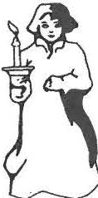
House headquarters, 159 Main in playing a leading Street (Route 7), Sheffield. Partici- role in this year's pation is limited and advance regis- event or if you wish tration is suggested. The tour will to help with the logis- last about 1 to 1½hours.Comfort- tics of the program,
able walking shoes are recom- please call the office
at 229-2694. Re­
mended. Call( 413) 229-2694 to re- freshments. Free to
servea place. Free and open to the mem bers, $4 generalpu b lci. general public.
Wednesday--October 22-Fall
the Revolutionary Period tours. The summer ended with fine foods at the Pig Roast. All of these events could not have occurred without the tal­ ents and services of so many mem­ bers. A job WELL DONE!

Thank you to all those who have given to the Society's first Annual Appeal, which began in April of 2003. In addition to the listing in
the June newsletter, contributions

Friday--October 10-Under the Ouabbin: The Lost Town with Ed and Libby Klekowski at 7:30 p.m. The creation of this huge reservoir in Central Massachusetts sub­ merged small towns and settle­ ments. Ed and Libby Klekowski, from the University of Massachu­ setts, researched the construction and flooding of the Quabbin Reser­ voir and produced a WGBY pro­ gram on the project. The Kle­ kowskis, with the assistance of Uni­ versity of Massachusetts students, found fascinating stories during their research. (This program was
trip to a mystery location. De­ tails will be revealed at the Sep­ tember meeting or you may call the office.

Saturday- November I­ Festival of Trees exhibition opens at the Old Stone Store.

Friday-November 14-Arlo, Alice & the Anglicans with Laura Lee at 7:30 p.m., Old Par­ ish Church.

Saturday-November 29- Festival of Trees. Look to the
have been received over the sum­ mer months from:
Neil and Kathleen Chrisman Mr. and Mrs. Paul Collins Mr. Abbott Combes
Robert Duncan Corser Hilde Guttenplan
Joyce and Ross Hawkins Kingsley and Sally Kelly Rev. John S. Lis
John-Arthur and Trudy Miller Bob and Nancy Rathbun
Ann M Riou
Howard Justus Swanson Don and Claire Ward
in honor of James Welch Jr.

WHERE ARE WE GOING?
Dear Members and Friends:

The Society is beginning to chart its course for the next five years and seeks community input for that planning proc­ ess. Please feel free to offer your suggestions on ways in which the Society would be the logical organization to fill a need that will better serve the community. Your input is a critical part of planning for that future.

Please keep in mind that the Sheffield Historical Society was formed in 1972, through the efforts of many community members who sought to preserve their local heritage for future generations. The Society's collection focuses on the 1700s through about 1950. The Society has grown in every direction, to the point where it now maintains seven his­ toric structures from the 18th and I9th centuries and carries out year-round programming.

The Society held an initial planning meeting in June. The following areas for future consideration were raised: Educational Programming--includes school age and adult, Financial--includes annual appeal, fundraising, rents . grants, Collections and Facilities--includes buildings & gro unds. maintenance, inventories. Stone Store-includes shop, exhibits, rentals, Mark Dewey Research Center--includes equipment, cataloging. publications.

The following are questions the Society wishes to have public responses to (but feel free to address other issues).
►Are there new ways in which the Society can raise the level of its active membership and involve more members of the community in its programming?

►Are there programs that you would like to see the Society offer?
►Are there workshops that the Society should be offering to the public?
►Are there ways in which the Society can increase its revenues and secure financial stability? Please use the back of this form to provide additional comments.
Choose the response form that is easiest for you. You may call the Society at 229-2694, drop this form in the mail to
the Sheffield Historical Society, PO Box 747, Sheffield, or e-mail us at shs@sheffieldhistory.org. Feel free to call the Society if you have questions. or if you would like to work with us in a greater degree, as we develop this plan.
THANK YOU! (Please feel free to send in this form anonymously if you prefer.)

Name Address

Phone

I would like to participate in a focus group on one of the above five topics_ _ _ _ _ _ _ _

The focus group I am most interested in is _ _ _ _ _
_ _ _
_ _ _
_ _ _ _
_ _ _ _ _

Reports
President's Report

As the new president of one of the most active Historical Societies in
Page3

I look forward to sharing with you at CHANGE IN NET ASSETS
the September meeting the successful BEFORE OTHER ITEMS
tale of the first major event of my ten- < 63- 548 )
ure, the Pig Roast, which took place Investment Income

Berkshire County, I feel honored to have been selected as your President for the next two years. It will be a truly challenging task for me to follow in the footsteps of Dorothy Marosy, the outgoing president, who led the Society through a time of both difficult endeavors and impressive growth. Dorothy put in countless, tireless hours for the benefit of keeping the Society on its feet and moving forwards, with the help of the many volunteers and our execu­ tive director Joanne Hurlbut. I only hope that I can do half as well as she did. Thank you, Doro­ thy, for a job well done.

I am grateful for the presence of such dedicated volunteers. Man­ ning the Stone Store on Saturdays and Sundays is one of the biggest
on Saturday, August 23.

Fund raising over the next year will be a major emphasis for the Society. Right now, we are continually run­ ning in the red and trying to keep our head above water. We are fortunate in that we do have some funds to draw upon and that our annual appeal will help bring in new revenues.
So with that all said, let's get on with the work that has to be done.

Wray Gunn

Treasurer's Report

Sheffield Historical Society, Inc. Statement of Activity of the Year Ended June 30, 2003

REVENUE
Annual Appeal, Grants | 22,943 | recommended to the Board of
Donations - Stone Store | 8,557 | Trustees, three possible courses of

24,407
Realized Gains(Losses) Investments
(90,844)
Interest Expense
(3,451)
Net Change/Unrealized Gains(Losses)
53,324

CHANGE JN NET ASSETS
(80,112)

NET ASSETS - JULY l
1,461,337

NET ASSETS - JUNE 30
1,381,225

Finance Committee Action

Concerned with a growing deficit for the past several years that threatens the survival of the Soci­ ety, its Finance Committee has

cha!lenges for our members. I am a regular Stone Store volunteer, so I speak firsthand when I say that it's a task you will enjoy do­ ing! I am counting on more mem­ bers to help work at the Store, so call me (229-2668) or the office (229-2694) to find out more about
Donations - In Kind
Store, Book Sales, Programs TOTAL REVENUE

EXPENSES
Salary & Taxes Program Expenses Special Events Scholarship Utilities
the job or to sign up. | Maintenance | 6,525 | Stone Store is $77,000.00.
 | Insurance | 3,761

10,588
18.579
60,667

36,271
10,976
3,869
1,500
7,347
action: 1) reduce expenses even further; 2) increase fund raising;
3) redeploy assets, which could include selling or renting Society real estate. In spite of containing expenses, the Society ended this year with a $35,000.00 deficit. In addition, the mortgage on the Old

As of now, we will continue to offer the educational programs that we have had in the past, and we will try to get additional grants for new programs and ac­
tivities. Other projects that will be carried on are the daily tours, spe­ cial cemetery tours, and the up­
,;oming Festival of Trees event.

Supplies Postage/Newsletter Meetings

TOTAL EXPENSES
Professional Fees | 2,730 | ture of the Society. A page is en­
Miscellaneous | 1,889 | closed on the Strategic Planning
Investment Fees | 3,023 process. Please be sure to take
In-Kind Expenses | 9,288 the time to fill it in and return it
Depreciation | 31,992 with your ideas. You are wel­

2,138
1,914
992

124,215

The Society hopes its members will take time to consider the fu­

come to participate at any stage of the process.

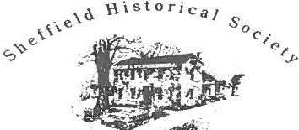

Oo" /10 7,,.• • d Ho1111 M111111M
Ma,. Du,r1 RuuHclt c,,.,,,

159 Main Street
PO Box 747
Sheffield, MA O1257

Phone: 413-229-2694
Email: shs@sheffieldhistory.org

Tours of the 1774 Dan Raymond House are available Thursday through Saturday. I I a.rn. to 4 p.m. and by appointment.

Mark Dewey Research Center open Monday and Friday afternoons, 1:30 to 4 p.m.. and by appointment.

Stone Store hours are Saturday 10 a. m. to 2.p.m. and Sunday 11 a.m. to 3 p.m.
WE'RE ON THE WEB
SHEFFI E LD HISTORY .ORG

MDRC Archival In 1905 the Conway House, a hotel
i
:1""
7'1
Board of Directors
Wray Gunn, President
John-Arthur Miller, Vice- President
Catherine Miller, Treasurer James Miller, Clerk Trustees:
Harry Conklin Barbara Delmolino Cory Hines
Rene Wood
Joanne Hurlbut, Director
l_:i,
rf
on the present site of Gulotta Broth-
Facts ers Mobil Station, could accommo-
date 75 tourists. Room and board In 1901 Sophia Curtiss, proba- was $9.00 per week for adults, bly the first car owner in Shef- $5.00 for children. field, brought her new machine,
large enough to carry several of EXHIBITIONS
her friends, to Sheffield. It was
purchased in New York and she The exhibition now in the Stone was able to ride the entire dis- Store is Spend a Summer in Shef- tance in one day. field & Environs:The Tourism
Trade in the Railroad Era. The The Berkshire Street Railway new exhibition in the Dan Ray- came to Sheffield on May 29, mond house is Sheffield's Cha-
I
1911, when a car carrying com- peaus:- Hats from A Bygone Era.
pany officers stopped in front of b uL;,, . . ·- - -- - -- .
George Scott's drugstore through Octou.... (Bartholomew Block). Eventu-
ally it was possible to travel by
streetcar from Canaan, Con- Save these dates:
via Bennington, Ver-
/

necticu, t
October 4-Cemetery Walk
October 18--Spirits of Sheffield

mont , to Hoosick Falls, New November 29-Festival of Trees
York.

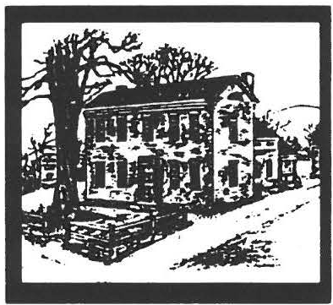
Sheffteld Historical Society June 2003 Newsletter
►New Tourism Publicat ion!◄

Summer is for tourism in all its sple n­ dor. both for those who travel to a new region and for those who leave their ho mes to enjoy the specia l places in their own backyards.
Therefore. the Sheffield Historical Society invites all tourists to join in the exploration of the Berkshire re­ gion. The Society's project Spend u Summer in Sheffield & Enr irons . The Tourism Trade in the Railroad Era encompasses a talk. an exhibit. and a publication on tourism.

. The Society, as the recipient of the Scholars in Residence project, a grant cosponsored by the Massa­ chusetts Foundation for the Hu­ manities and the Bay State Histori­ cal League, has been able to study in depth over 100 years of local tourism. The funds provided a stipend for local historian and author Bernard Drew to work within the Society·s archives to research the topic. The project ana­ lyzed the changes in a community as it transitioned from a walking town to one heavily affected by mechani za­ tion and mass transit. In tum. it stud­ ied how people responded to these outside pressures through the adapta­ tion of their liv ing environments.
Among the many to pics covered dur­ ing the research were the construction of the Housatonic Railroad in the 1840s. the growth of country inns and taverns. the advent of farm and home boarding facilities. and the popula rity of natural land marks ( among them
Sage's Ra \·ine and The Dome ).

Bernard Drew has extensive re­ search. writing. editing. and publishing qualifications. in particular on maner s o f local signi ficanc e . He is one of the Berkshire s' no te d speakers. on a wide range of histo rica l to p ic s. Drew's work for this project on tourism will be available at the end of June. To reserve your copy, please call the Society at
(-+1 3 l 229-2694 .

The exhibition will open at the Old Stone Store with a recep­ tion on July 19 at 2 p.m. and will remain on view until the end of August. Drew wi ll
s pea k on the topic at the open­ ing reception. The talk will be given outs ide ( unl ess we are driven inside by Mother :\ia­ ture ): so bring your lawn chair and sit back to liste n to Dre\.\ as he relates the stories of Shef­ field·s past tourists. This out­ door gathering will also give
yo u a chance to view the new garden area of the Stone S to re. Refreshments will be served.

The exhibition. based on the re­ search findings. will include photographs and memorabilia from a number of once popular destinations . Did you know that if you su ffered from Scro fula
Dyspepsia. C hronic Rheumatis m.
or Gout. a sure cure could be found in the ··Poo l:·· In the _{J} 850s- l 870s. man y a tourist vis ited the Sheffield spring s to take the natural cure .
The pool was labeled ··unsurpas sed for medicinal virt ues: · In fact. its mineral waters were served in the Co lli ns House sanitari um. located on Maple Aven ue. by Dr. Clarkson
- Collins.

Drew is following in the footstep s of many who have su ng the praises of the Southern Berkshires. often with the direct intention of increas­ ing local tourism . Rev. Orville W. Dewey·s daughter Mary composed the following lines over I 00 years ago: ··Jn following the course of the Housatonic through Berkshire. the southe rnmost of the villages strung like beads upon its sh ining thread.
is Sheffield. lying in a peaceful breadth of valley. where every thing speaks of calm and repose:·

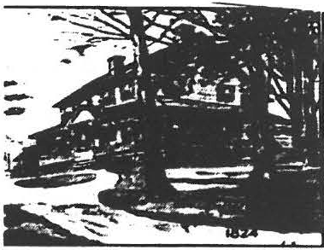
Take time this summer to see the beauty of this region by visiting the exhibition or relaxing with this new publication on tourism .

Sheffield Historical Society June2003 NNslettet

ANNUAL REPORTS
Collections Committee

tit · and record information on

formation on Sheffield·s Gen. Bar-

Committee Members: Betty Cha­ pin. Connie Logan. Carl Proper and
each item in the collection. An in- nard . Another came from the formal appraisal of the collection Smithsonian Institution. looking for has taken place for insurance pur- information on the Saxton Family.

Doreen Atwood Also present
  - Pres ide nt Doroth., Maros.\' and Di-
poses.
In June we had a group of students from Mt. Everett tour the Center to

rector Joanne Hurlbut

The Sheffield Historical Society has
Several exhib its at the Stone Store learn about all the resources we have been wel l attended. A.n ex- ha\e availa ble.
hibit or farm equipment from the

benefited greatly from the grant funded by the National Endowment for the Humanities for two work­ shops. We met in October 1002 with Gwen Spicer. who presented a workshop on textile conservation. Society mem bers learned to prop­ erly store quilts. coverle ts. and clothing using the techniq ues taught at the workshop. We also met !\.\lice with Lori van Handel. who pre­ sented workshops on mounting ob­ jects. As a result the Bradford por­ traits have been rehung. a very large map from the law office was prop­ erly protected. and other ite ms in the collection have been remounted.

I would like to thank the following members of the Society who at­ tended workshops and followed up with conservation work on the col­ lec tion: Dorothy Marosy . Jim Miller. Marion Whitman. Boyd Hutchison. Cory Hines. Connie Logan. and espec ia lly Anne Riou. all with the guidance of Joanne Hurlbut. The collection will benefit in the future with the ongoing con­ servation of its varied items.

Dorothy and I have begun photo­ graphing the co llection with a digi­ tal camera so as to record the col­ lection. with it eventually entering into the Past Perfect collection soft­ ware program. This wil l better iden-
collection or a society member and a private collector took place in the fall. Currently there is a fine exhibit of early Sheffield and Mas sac huse tts ephemera. again from the soc ie ty·s co llectio n and from a private collector. The Stone Store has also been made
availa ble to local groups outside the SHS for exhibits.

Several ite ms have been donated to the Society over the past year by a number of local res idents. Many donatio ns are textiles . a s well as a \·arie ty of other Shef­ field items.

Doreen Atwood Chairman

The Mark Dewey Research Center has been kept bus y this year with many inquiries and \ isi­ tors. The volu nteers ha\ ·e worked over 1600 hours at the Center. which is open Monday and Friday from 1 :30 to •+:00 and by appoint­ ment.

Among the many requests we re­ ceived was one from the Appo­ mattox Court House seeking in-
We ha\'e put three picture disp la ys at the library. on Sheffield·s Irish. Blacks. and farms. In No vembe r we had a dis pla y at the monthly meet­ ing on S heffie ld· s Veterans.
At the Stone Store we have dis ­ played pictures and journals on the early farms. with the tools displayed b Vlilton Barnum and Tony Car­ lott o. The Paper Trail exhibit at the Stone Store. organized by James Miller and Tony Ca rlotto. will run through mid-July.

Bernard A. Drew has done research at the Center for a book about the
to uris t trade in Sheffield in the early railroad era. This book will be published and for sale by the Soci­ ety. This was made possible by a grant.

We have been given the follow in g. vvhich are great additions to our collection :
Greenwood Family papers VlcNeil Genealogy and
C i\ ·il War Journal Schellenger family research Wright family research Dewey Genealogy
Inger sol Genealogy Parso n Genealogy
A collection of WW I picture section of newspapers
An antique watch which belonged to a Kellogg

Annual Reports, continued

Just recent ly we were given by Bernard Dre\.\ a collection or about 500 Couriers from the 1960. s and 19 70. s. It has taken
us about two months to read. clip. copy. and file information about Sheffield and its people .

Comminee: Doreen ..\twood
James Miller. Archi\·is t David Prouty

Respectfidly suhmi11ed. Berry Chapin. Direcror

Outreach Committee:

This last yea r featured nin e memorable programs and our An­ nual Meeting. Society members and friends enjoyed a variety of programs ranging from our annual What's It? Night. which featured
a truly unique family heirloom. to Civil War history. a mo ving e \·e­ ning of local war memories. and readings of famous Berkshire au­ thors and the poetry of two young girls from Mt. Washington. Pro­ grams for the upcomin g year promise to be just as interesting and unique .

Co mminee mem bers: Dorothy Maros y. Marion Whitman.
Marilyn Wightman and myse lf. with our informal advisors Do­ reen Atwood and James Miller. all worked hard to provide the \·a­ riety that has made this monthl: event so popula r. Thank yo u for an outstanding job!

Respectfully submined.
Rene Wood. Chair
Treasurer's Report

The annual year of the Sheffi eld His­ torica l Society is from July I - .lune
30. S inc e the books ha ve not closed for the current fiscal year. the Report of the Treas urer will appear in the late s ummer or earl: fal I nc\\ sk tter.

- ( a1herine .\,filler

President's Report

The past three years ha\ e been chal­ le nging. interesting. and successful. There have been a variet: of pro­ grams and activitie s . so me of which ha,e been ongoing for 30 years. and others are ne\.\. Two special e,·ents.
"The Music of Geor£...e Wash in-inon"s Time" and "The Music and Words or
S heffie ld's Ci\ ·il War Reside nts." were exciting additions. The monthly programs. workshops. field trips. and cemeten stroll co ntinu e to anract people from outside S he ffield .

The Smokehouse \.\a s acquired and restored. and is no w part of the ..Place in Time.. school program. C lasse s from other school d istrict s no\.\ par­ ticipate in the program. fulfillin g our community outreach goal. Co ll a bora­ tive programs with the Bus hne ll Sage Library and Trustees of Reservations ha ve helped to establish the socie ty as part of the com munity .

The Stone Store renovation is 95% com ple ted and has been the site for special exhibits and an expanding gift shop. Two ce lebrations "were held : the I0th anniversary of the Mark Dewey Research Center and the 30th anni­ versary of the Society. The book "Early Life in Sheffield" was un-
veiled at the first annual Garden Party. Many visitors toured the H is tor ic Sites and Structures as part of the House Tour in Ashle y Falls and Sheffield.

The Festi\ ·a l of T ree s. highlight­ ing decorated trees and holida:, decorations. continues to grow in sco pe and attenda nce .

Through grants received. the col­ lect ion s are being properly stored and cata log ued.

The mailing list has been ex­ panded and updated. and all cor­ respondence efficiently hand led . Ho s pitality cha irpe rso ns and their comminee s have provided re­ freshments. which have alw avs been an important aspect of the Societ: . These succe sse s are due to the many \·olunteers who have responded when the call went out for ass is tance . I thank the officers and trustees who over the past three yea rs have been supportive. unde rstandin g. and always hands on. A specia l thanks to Joanne. whose sense of humo r and protes­ sio nalism has made the job so much easier. It has been a privi­ lege to serve as president.

DurUlhy .'vfaro5y

Nominating Committee:
Inez Flinn. Pauline Schuman. and Ma rilyn Wightman o ffer the fol­ lowing names for elec tio n at the Ann ua l Meeting:
Wray Gunn. President Jim Miller. Secretary Trustee:
Harry Conklin and Cory Hines

Page4

ANNUAL REPORTS cont'd
Directors' Report

The Sheffield Histo rical Society 1s

Rene Gibson
Ruth A. Gillette
John and £1.\ie Gilli,:an
Bill Gil/oo{r

Davit/ Sepsenwo/
.Wyron and .Warcia Sheinberg Barbara and Jim Shiminski.
in memory of Mildred T. Roys

very fortunate to ha\·e a number of lo yal s uppo rters. Vo lu nteers often
give of their time. ta lents. and finan­ cial reso urces. Thank you to all those who haYe given to the Soci­ ety's first Annual Appeal, which began in April of 2003. To date, contributors are:

Emi{r and Jo/rn Alexander Doreen and Walter .--ltwood Betty and Fred Bungs
Ann Barrett
Dana and Bet/r Bartlwlomew Paul Benjou and P.J. Bradley
in memory of Robert Forman Mr. and J1rs. Charles Bennett Richard Bernstein
Robin Bertllet Jean W. Blackmur
Pamela Bloodworth
Gardner Botsford Ricllard and Joan Brooks Lucy Brotman
Bill and Penny Browne Paul and Tanya Buckner Thomas F. Buckley, Jr. Grace Campbel/
Sharon and Jeff Cusdin
Aidan Cassidy and Cllar/es Teti George and Dorothy Caul Elizabeth .W. Chapin
Rose Cllupin
Gerry and Barbara Clow
Chris Coenen and Amanda Morgun Dr. and Mrs. .'Voe/ L. Cohen William and Jacqueline Connell Connie Cooper
Howard and Dorothy Crockett Miss Jean Curtiss
.'.-fr and .Wrs. Francis J. Dal/ett Richard and Sheila Drill
Mr. Charles A. DuCJ,arme, Ill Janet and Bart Eisbach
Peter and Patricia Eisbach Elaine Friedman
Warner Friedman
Frank Garretson and Helen Bray-Garrest.soll
William Grief and Le11nard Gru:.iano Wray .W. Gunn and C11ru Portnoff R11hert llllll Deann Halp e r
Sam uel and Sal{r Herrup
.'.-fr. um/ .Hrs. James R. Hurler
Keitll T. Hyatt
.H r. and .Hrs. Charle.\ H. loch, Jr.
.--lt llellu and Ric/rurd Kimball
.Yum .:i· Kriegel
.--11/i.wm G. Lu.u oe
.War e L111•ietes anti Rose Rosal Gary LeBeau
.Wr and .Hrs. .Worton Levin
.Wrs. Bo/rn C. Lindemann
Roy Lindstrom anti .\'anc_r Elliott Connie L11gan
Susan Lushing
in h11n11r ,1·Wu/lace Kaminsky B11h and Sue .Wac ·I ee r
ill lwmJr of F/11ytl U ·o(J{/hec k
.Wr. anti .W rs. .-1,. J fa fnuti
Barbara and Sorman .W11r g11/is Dorothy J1aro\. y
Barbara Martin Christopher .Warti11
Dawn 1111d Henry .Wu.u illi
.Wary Ellen .Wc .\'ei/
James and Catherille .'viii/er Dalliel alld .-t1111e .Houlton
.\'orma .'v/oult 11n Patrice .Wullin
C. Twigg.\ .\' frers
in memory of .-lrt llur C. Clta.\ e Judith .-•-1 .\'elson
Katllie .\'e.n Ulll! Jo/rn James
.Vaill '\.' F. .\ irenher ;: Elisubet/r H. O'Connor Tlroma.s W Orlando
Johll and C/rur/otte Owem
.--1/ex under Pupudrristou Richard Pear.\e alld
.Yanq O'Donohue David allll .Wars lla Pottle
Susall Rotllschiltl and Don Freedman Peter ulld Ellen R11wntree
Bob Rueger
Judy and Bill Schnurr Becky anti Kell Schopp
Charle.\ alld Pauline Scllumann
Gary and Judy Schumer
.--llldrea Sl·ott alld Rob }enter
Susan Silver George T. Smith Janet G. Stanton
John and Katherine Stookey Ethel T. Swrer
in memory of .Wildred Roys Rohen and Rerbecca Thomas Ronald and Judith Timm Peter Traub
.'.-f r. and .Wrs. Albert Trocchi
.Werle and Karen I ·arn e_r Loet and Edith I ·elmun s
in honor of PJ Schafer Paula Wardynski
Jane F. Warner
.Has sage Therapy .--ls s oc .l Jonathan Weinress David and Barbara West
F. Robert Wheeler, Jr. Roberta L. Wheeler Thomas and Joun Wieltl
John and .Wari{vn Wightman
.Yan c:r and Don Williams William and Eli:.ubeth Wil.son
.--Iii A:.urva Winston Jim and June Wolfe
Rene Wood and Dennis Sears Tom and Susan Young

This appeal has met with great success!

In ad dition to the financial dona­ tions. there is an e no rmo us amount of work reg ularly ca rried out by Soc iety vo lunteers. I wish to thank in particular those who have worked with me dur­ ing the past yea r for school pro­ gramming. The number of groups has continued to in­ crease- this spring the number
doubled! Several sc hoo l systems outside of Sheffield visited SHS. The length of time spent here by se veral groups has increased. some visits were four hours!

Paee5 Sheffield Historical Society June2003New5'eaa

More Summer Happenings

As a result of the National Endow­ ment for the Humanitie s grant. a number of workshops have been held to provide training and the re­ sult ing opportunity for impro, ·ing our collections care. Thank you to the intrepid collections voluntee rs. who have been willing to take on many challenging tasks.

During the past year. the Society celebrated its 30th yea r with a num­ ber of festivities . In addition. a number of new co lla borat iv e pro­ grams such. as Songs Sunx in She/
bers will celebrate the season at the Annual Garden Par · on Saturda ·. .June 21, from 3 to 6
p.m. Me mbers are still talking
about last year's firs t-e, ·e r garden part:. and this:e;,ir's e, ent, \. ill be j us t as s pectac ula r. The party wi II take place in the gardens at Ash­ le: Pond. a priv ate home on the site of the histo ric Ashley Fa lls quarry.

Attendees will ha,·e the o p portu­ nity to stroll around the pond. hea r about the quarry in its hey­
dees will be able to go on a plant
, \. a lk on the grounds and make an herbal sachet. Among the activities at the Col. Ashley ho use will be the
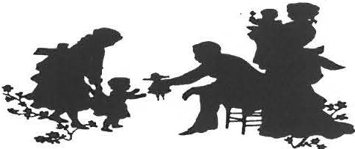

making of cornhusk dolls. Admis­ sion: Adults I1:2 us ual price. chil­ dren and mem bers free .

fiel d and the schoo,l
- aca tio n work­
day. and viev. an e:--:hibit o n the
The joint programs continue with

sho p. were he ld . The Society con­ ducted a ho use tour. its a nn ua l
Ce metery Stroll. special walks. along with its regular monthly pro­ grams. The Stone Store has nov. offered a num ber of exce lle nt exhi­ bitions. from farming to textiles to paper. A specia l thank s to all tho se who haw s taffed the Stone Store and to those who have helped de­ velop the ex hibit s.
quarry. Fine food and beverages will be sened al fresco. and guest perfo rmers will pro, id e musical acco mpan imen t. (Comfortable flat shoe s are s ugg es ted . )
Reservations are required . Be
sure to reserve your ticket soon: directions v.ill be provided upon regis tratio n. Tickets are S25 per person.

Revo lutiona · Period Tours to be offered on Saturdays July 26 and August 23. The tours begin at the Dan Raymond Ho use at l :30 p.m .

What was the material life of our founding families really like 0 An e:--:ploration of their times begins
\\ith, ·iewi ng of a number of 18th­ century documents from the Mark Dewey Rese arch Center archives. The group then moves on to visit

It is clear that thi s is one very busy
organization! After four years here. I will mention the same im pres s ive conclusion: my collegues and the public are amazed at all that we do and how well we do it! I wish to extend a specia l tha nks to Dorothy Marosy. who it has been a pleasure to work with the se pa st thre e years.

Joanne Hurlhw
For the third summer in a row. the material objects now on view in T rustee s of Reservations and S HS both the Dan Raymo nd and Col. will co-sponsor three specia l Ashley homes. Size is lim ited :
e \·e nt s. Family Day will be held me m bers free. no n-me mbers $5. on Saturday, July 12, from noon Reser\'ations suggested:
to 5 p.m. call 229 - 2694 .

The Dan Raymond House and
the Col. Ashley House will offer !TEJ1S SOCGHT FOR SCMMER
a number of hands-on acti, ·itie s. EXHIBIT
demo ns tratio ns. and to urs. T his

The summer solstice will soon be upon us. and this year mem-
year·s focus is on everyday plants. which were suc h a s ig nifi­ cant part of life in early America. Disc uss io ns of the plant s used in cooking will be offered at the Dan Raymond House. and the smo ke­ house will be in operation. Atten-
The Society is seekin[:; to aug me nt its exhihitiv n on tourism. which will open in July. Do you have any
I Yth- or early 20th-century souve­
nirs/i-om Sheffield and environs:) If you are willing to lend themjor this summer. please call the of fice .

'f••· (•) ..,., ,,.,.... ... c . , , .

159 "1a1n Stn.:t:t
. PO Bo-' 7-n
S hd fo: ld. "1A O12 57

P ho ne: -I 13-229-2694
Email : shs a shd tiel<lhis tn r;- .o rg

Tours of the 177-1 Dan Ra,momJ I lnu s t: art: .J,ailahk rhursda: throu g h Saturda: . I I a . m . to -I p . m anu r" a ppo1nlmem .

\.iarl, De"<=: Rc:sc:a rc h Cc:nter op en Munda: anJ Frida: afternoons. I : 30 lO -1 p.m.. and h: appointment.

Stont: Store hours are Saturda: IO a.m . to 2.p.m. amJ S unda: I I a. m. to 3 p.m.

W E ' R E O T H E
.\\
F. B

:-; H E F F I F: LD H J :-;T <> R Y . < > R G

Pig Roast
Board of Directors Dorothy Marosy. President Wrav Gunn. Vice-Presiden1 Catherine Miller. Treasurer Harry Conkl in. Clerk Trustees:
Doreen Atwood James Miller
John-Arthur Miller Marilyn Wightman
Rene Wood
Joanne Hurlbut. Director
l.
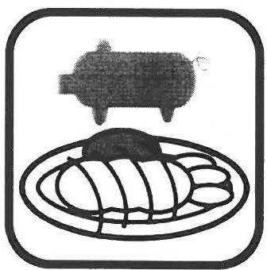
Take a break in yo ur busy sum­ mer schedule and join Society members this summer for a Pig Roast. Saturday, August 23, is the date for this ne\\ event. which will take place at the American Legion in Sheffield.

The afternoon·s activities in­ clude marve lo us foodstuffs. en­ tertainment by Tom Ingerso ll. artisan·s booths. and more .
Scott Ryan will be in charge of serving up the pig roast.
Ticket prices will be ad ult s $15. children $8: childre n under 8 will be free.

The Society is now taking reserva­ tions for artisans who wish to oper­ ate a booth during the festiv ities.
Please call the office at 41 3-12 9- 2694 if you would like more infor­ mation about reserving a booth.

Events such as this require the ef­ forts of many hands . If you would like to volunteer to help out with the day. please call the office.

-- I ""_l

Save these dales:

June 21-Garden Party July 12 -Family Day July 19-Exhibil Opening August 23-Pig Roast

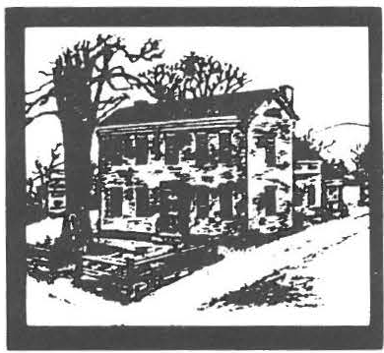
Sheffteld Historical Society
November 2003

New Adventures!
\JEWLY STOCKED SHELVES in the OLD STONE STORE

Looking for jus t the right presents for yo ur ho lida ::, g i, ·i ng·: Well. look no further than
the Socie ty·s o wn Shop. Sheffield res id e nts sho pped there during the good old Victorian holidays and nov. you to can keep up that tradition' Volunteer Shop 'v1a nager Doroth::,
Marosv and he r sta lwart assis ta nt Do-

December 3 at I I am. The Shef­ field Art Leag ue is s ponso rin g the sho v.. which will include
..The Artis ts· Ex pression s of Whoe\ er. Whate \ er. Wher e\ er.. displa:-ed in a pproximate!:, tort:, paintin gs and s ma ll sc ulptures.

f he o pening rece ption takes place between the hours of I :30 and p.m. o n SalUrda::, . Decem­ ber 6.

Ed iso n developed a ne"" a nd innova tive re­ cording process that v.,as the Ro lls Roy ce of the recording i ndustr:
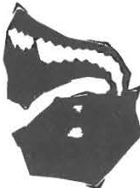
betv.,e e n I 888 and I 929. The air ""ill he tilled '-"ith the ama zin g sound of these historic recordings.

Sunda:. Janua r:· 18th. 2:00 PM Wine and Opera on the Old Ed ison

S unda::,. Feb ruar:, 1 5 th. 2:00 Pvt

reen Atwood have bee n '-"Orking hard The sho \.\ runs for the month o r Wine. Choc ol ate. and Love So ngs

to bring you ite ms of high qua li t:, at reasonable prices. The:, have tra, -
eled to trade sho ws. use d the mode m surfing technologies of on- li ne sa les. and searched regional!:, for the '-"Orks of local artists . They stocked the
December. Ho urs: Weekda:, -
I I to : Saturda y . 10 to 2: S un­ da:,. 11 to . Close d on the ho li­ days.

""ith Yo ur Va lentine

Sunda:. \i1a rch 28th. 2:00 PM 'v1arch Out Like a Lamb ""ith Jo hn Philip Sousa on the O ld Edison

she lves in October and yo ur response has been of such goo d chee r that you
O.l
R FIRST CONCERT
SERIES...
'v1inimum contribution for the series:
$75

even bought out some item s as fast as
the: could get them on the she l\ es ! Ylo re orders have been placed and a lI of the Stone Store volunteers are ready to lend a he lping hand with
yo ur sho pping. Items ne v. for this yea r include folk a rt prints. bobbin lights. vario us orname nts including
the hand-pai nted Old Paris h Church . the third in our coll ec to·r s se ries. and hand-made textiles .

HOLIDAY ART SHOW
rN THE STONE STORE

··rNT IMAT E
'v1ark : o ur v. inter cale ndars'. '.

Spend thre e ""intr: Sunda: after­ noo ns enjo ying warm friend­ ship s. grea t mus ic. e nlightening his to r:,. and appealin g refresh­ ment s.

John-.\ rthur 'v1iller. Sheffield resident a nd mus ician. will pre­ sent three programs. each in a different She ffie ld home. T he programs will be fashioned on the earl y sa lon mu sica les. but with a n interesting tv.,is t- music
heard thanks to the earl::, tec hno l-
'v1inimum contributi o n per single
concert: $30
Seating Limited! Reserv e Early! COLLECT IO. ·s 0 T HE WEB
The Society· s portraits of the ReY.
James and 'v1argaret Brad ford were just put on li ne on the ¼e bsite de­
, ·oted to their creat o r. "ielso n Cook. an artis t of some prominence in the 19th centu r:·. The only known sin e rs from Massachusens were the Brad­ fords ( painted in 1847). Check o ut W'w"'-. nelso ncoo k.com to see detail s of ..'v1rs. Bradford. t he best single

TREAS CRES.. opens o n Wedne sda::,. o g:- or T ho ma s Al\a Ediso n. portrait rendering on the s ite:·

Slle•etttll t icalSec:iely Na l H2003N 1 M

Calendar of Events 2003-2004

The Sheffield His­ torical Soc iet: an­ nounces its 5th .-\ n­ nual FESTIVAL OF TREES. a fa­
vorite event in Shef­ field·s cele bration of the ho lidays.

The HOLIDAY SHOWCASE is
no\,\, on vie\,\, in the
Old Stone Store on the Green in Shef­ field. David Walker­ Price has again cre­ ated a handso me window display. and the ever popular community-inspired miniature tree s await
yo ur viewing and purchase. Rafne items this year include a candy rep­ lica of the Congregational Church. a freshly cut Christmas tree. and a locally created quilted wall hang­
December 12-Holiday Music with the Mt. Everett Madrigal Group, at 7:30 p.m., Fellowship Rooms of Old Parish Church.
\iancy Loder \,\,ill direct the stu­ dent ense mb le as the::, perform a number of selec tions: most of the se lec tio ns will be a cappella . The singers are from grades nine
through t\,\,ehe and t he ::, lc)\e to sing Renaissance music .

.January 9-What's It? !'light with Milt Barnum & Chris Coenen, at 7:30 p.m.. Fel lo wship Roo ms of Old Parish Church.
The e\'er popular program is on again-get outyour gadgets to stump the experts'

January 19-Martin Luther King. Jr. Day-- A Special Family Event, I p.m., a joint program
\,\,ith the Bushne ll-Sage Librai: to be held at the Libra1:.
Berks hire Quilters· Guild . A popu­ lar annual project: a hands-on pro­ gram that allo ws today·s youth to join in an age-old process of self­ discovei: and fun' :\ program for
8- to l 2-year-olds. l O a.m. to 3 p.m. Bring a bag lunch. Registration re­ quired. Fee.

\'larch 12 - T he History of the American Elm and the Sheffield Plantings, with Tom Zetterstrom, at 7:30 p.m., Fellowship Roo ms of Old Parish Church. Zenerstrom has been a leading figure in the national El m Watch program.

Sheffield's Kiwanis Club Cele­ brates 50 Years of Service will be the March exhibition in the Stone Store. This internatio nal organiza­ tion began in 191 5 and no\,\, e xist s in 82 natio ns and geographic areas. Come and see ho \,\, loca l me mbe rs of this communit::, -se f\ ·ice o rganiza- tion have made a difference in our

ing. \iew this year are classic holi­ February 13-Ancient Cairns of region 1

day stockings made by local resi­ dents. and hoIida::, jewel1: .

Early Bidding for the Silent Auc­ tion of miniature trees and meno­ rahs will take place on Frida , November 28, from -t to 6 p.m .
Ot her items availa ble that da\ in­ clude boxwood trees and orna­ ments. The Silent Auction hours on Saturday, November 29, will be IO a.m. to 3 p.m. Both events will take place at the Stone Store.

Come and ge t in the mood for the
our'.'iative American Land­ scape Heritage, with George B. Emmons, at 7:30 p.m., Fello \,\,­
s hi p Roo ms of Old Parish
C hurch. :\ n oral and pictorial presentation desc rib in g the land­ marks and monuments of indige­ nous people of the Woodland pe­ rio d- including the \.fahicans and
\llohega ns- 1.'. ith a disc uss io n of their buria l customs. alive America n items recent!: donated
10 the Societ: b: Rodne: Palmer will also be on vie \.\. .
----------
Thank you! '.'iew contributors to the Annual Appeal since the Fall newsletter are:
.\t/ic hael and Wend ,· .-ldrncate
.\andra and Dale .-l Iden
.-lnn Barrett
Barhara £. Delmolino lne::: Flinn
..\ atalie H. Funk
.-4nita und Tom Gurrefl
.-l nthon_, · Sahatelli in honor o/
Daniel Suhutelli
- C ath n. n ( ·tun-- und Ed Schll'ei:::er Dlffid .I Walker-Price

holida ys- and sho p for decoration s
February I 8--School vacation

and gifts. Keep in mind that the Soc iet: · is aga in o ffering Hol ida: Wreaths - see the order form.
worksho p: "'Kids C ra · for Quilting," a joint program \,\,ith the Bushnell-Sage Librai: and th e
On-line shoppers, don't forget you can help out the Society b · using Shopformuseums.com.

Sheffield Historical Society 2003
Holiday Wreath Order Form

Quantities are limited - please order early.

Wreath #1: 12-inch wreath. Burgundy & Gold bow with gold decorations.

Wreath #2: 12-inch wreath. Double Gold bow with gold decorations.
AII wreaths made of balsam1e-,ergreens. HS reserves th e flexibi Iit to substitute another bov. of comparable qual it: .

To order: please mail this completed form, along with your check, to:
Sheffield Historical Society, PO Box 747. Sheffield. MA 01257-0747 or fax to 413-229-7761.

Name: Address :
---------- -----------------
(Required if you request local delivery.)

Phone #:--------

Email---------------------

Wreath # 1 Quantity Wreath# 2 Quantity
@ $ 27.50 each

@$ 27.50 each
Total Amount: $-----
Total Amount: $-----

Grand Total & Amount Enclosed: $-----
You may request delivery if you live in the Sheffield and Ashley Falls area. By mutual agreement, deliveries will be made the week of Dec. 1st. Otherwise, wreaths may be picked up at the Society headquarters, 159 Main Street. Sheffield, M-F between 10 and 4. We will phone or email you to confirm your delivery or pickup date.

•• Thank you for your support & Happy Holidays!

\O \-\ i s t o r i c ,..,

- ._,,\e •.
.
-.;
S,,c,

-, .,,. .. ·- .
- .. _;'f .1
--
.• ' . ,i -
.,.
"·/ .,_

"'"h, .,,. , _{il•••o•} •

159Ylam Street
PO Bo, 7-!7
Sheffield. \1A IJ12 5 7

P ho ne: .!1 3-229- 209 4
Email. ,hs a sheftiddh1stor\.org

Tours of the 177 .! Dan Ra, mond House are a, ailahk
\llonda) through Frida, h, appointment

"1ark Dewe, Ro.:search Ce nter open "1onda, and Fnda, afternoo ns. I .31J 10 .! p m and h, · appointment ·

', tone Store hours are '>aturda, I 11 a m ₁₁₁ 2 p rn and
',unda I I a m 10 3 p m

\X" E' RF O \: TH F \\TB
H E F f- l r. l. D H l T < > RY . < >RC,

Board of Directors
Wray Gunn. Presidem
John-Arthur \1i Iler. I' ic e­ President
Catherine B. Miller. Treasurer
James Miller. Clerk Trustees .
Marcia Brolli Harry E. Conklin Barbara Delmolino Allison G. Lassoe Rene Wood

Joanne Hurlbut. Director
't-i MDRC Archival Facts
Frederick Augustus Porter Bar­ nard. Sheffield born. became the tenth president of Columbia College ( nov. LniversitY) in 1864. He filled that office for
1_⁻) years and dun.ng that time
was a firm advocate of women·s educatio n. Barnard Co llege was later named for him.

In 1866 the Sheffield China Clay Company was formed b, Archibald Taft to capitalize o the fine white clay beds in the southeastern part of Sheffield. The concern manufactured pot­ tery and fire brick.

Sheffield·s original Catholic Church. the C hurch of the As­
sumption. was built in 1884. It
burned on August 18. 1904. the \ic­ tim of a lightning strike . By Sep­ tember 1905. the nev. buildinQ.
Our Lady of the Valle\. was d;di- cated. ·

Southern Berkshire Regional School District was the fir st re­
g io na l school in \1 assac huse ns and it opened in September 19 5 5. To­ day it consists of the towns of Shef­ field. \1onterey. \.iew \'1arlbo ro u2:h. Eg re mont. and Alford .

A lych-gate. designed bv Ro£er W Dru:Y. was added to the.pro;rt.of Chnst Church in 1970.
I-
:t'
't J
Save these dates:
'liovember 28--E:arl:v Biddin,:! 'liovember 29---Festiv:al of Trtts December 6--Art Show Openin,:?
Reception

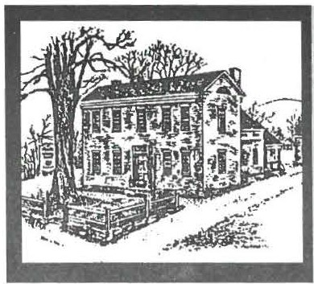
Sheffield Historical Sociery June 2004 Newsletter

"Pieces of History," Saturday, July 10,
Silent Auction
& Tag Sale,­
j Quality AND Quantity
What do you need? What would you like? W ha t are you giving your niece for C hrist mas? What would look n ice ove r the fireplace or on the dining room table? What would sell well in your antique shop?

Come to the Giant Silent Auction & Fantabulous Tag Sale- o n Saturday, July 10, at the Sheffield American Legion Hall from 9 a.m. to 3 p.m., to find the perfect ite ms.

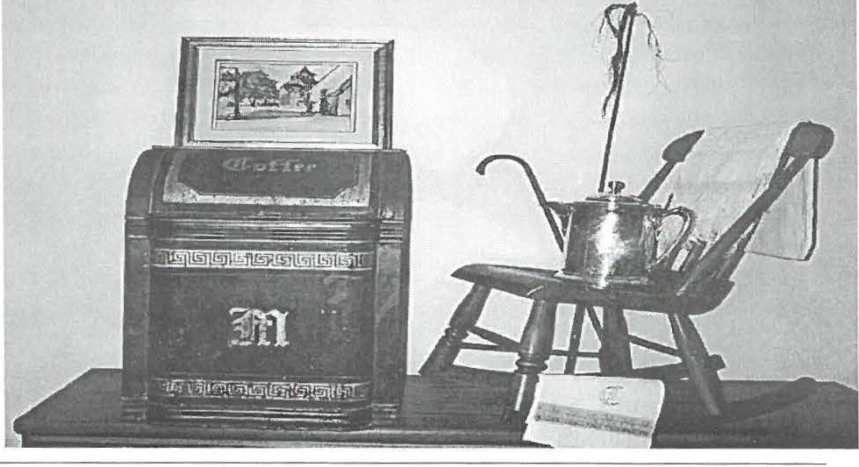Titled "Piece s of History," the sale will benefit the educational programs of rhe Sheffield Histo rical Soc ie ty. Ite ms from around the world have been donated: a l0-day stay in a private home on a Greek lsland, a watercolor of a French village (c. 1930) by David Humphr eys, an Royal Crown Derby Imari 10" bowl, an e normo us antique coffee tin, Staf­ fordshire, Italian glass, French yarn, and more from Venice, Japan, England, Burma, Mexico, and G er many. From the United Sta tes co me household items such as furniture, linens, silver and glass, dish sets, and kitc hen ware. Also in the silent Auction will be ite ms of loca l int eres t such as a vintage beige cutwork d ress (with provenance), pri­ vate historica l research and tours, and art work.
And it is not too late to donate ite ms. Co-cha irs Rene Wood (229-2875) and Jim Miller (229-8668) are st ill accepting 'fine' goods and 'good' goods to be sold at this one-day sale.
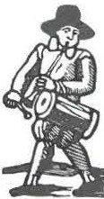Call them or the Histo r ical Society (229-2694) to ar range pickup.

_

Wray Gunn (229-2668) and his com­ mittee have co llected certificates for meals and services, wine selectio ns, travel and vacation arrangements, movie tickets, evaluations, car wash, liq uo r, and mo re.

THE SILENT AUCTION. Come
at 9 a.m. to place your first bid. Check in d uring the day to sec how your bid is faring. Return at mid­ afte rnoon to place your final bid; last bidding takes place at 3 p. m.

W hile you aim for that special auc­ tion item, peruse the fabu lous Tag Sale at rhe same time.
THE TAG SALE. Nor quite special enough for the silent auction, but fabu­ lo us none-the-less, zillions of item s will be available to take home right away. If you don't have that competitive spirit and just want to take your booty and go home, this is your part of the event.

SPECIAL EARLY BIRD BONUS
SHOPPING will be held fro m 7:30 - 9:00 a.m. for a do natio n of$I0.
LUNCH under the auspices of Chef
Harry Conklin will be available from l1:30 a.m.- 2 p.m.

PICK-UP DETAILS. Items will be avail­ able for pick-up from 6-8 p.m. on Satur­ day and 10 -a.m . to 2 p.m. on Sunday and thereafter at the Sheffield H is tor ica l Soci­ ety office.

DONORS: All items given to The Shef­ field H istorica l Society for this sale a re tax ded uctible. Please request a "Donor Con­ tributi on Form" when your goods are picked up.

Annual Reports
Sheffield Historical Society
June 2004 Newsletter page 2

Collections Committee helped over two hundred people th is Sto n e Sto re
year.

C ommittee Member s: Betty C hapin, Co nnie Logan, Dorothy Marosy, Carl Proper, and Doreen Atwood

T his past year, Director Joa nn e Hu rl­ but, applied for the Nat iona l Endow­ ment for the Humanities Preservation Assistance Grant to assist th e Society with the proper care of the collection. The gran t, valued at $5,000, was award ed to the Socie ty in December.
T his is a contin uatio n from the CAP and the previous PAC repo rts. Informa­ tio n fro m the survey Gwen S pice r pro­ d uced under the PAC is now bein g im­ plemen ted . Under the grant, new shelv­ ing, aci-d free boxes, and muslin have been purchased for storage preserva­
tio n. The textile collection will be re­ housed ove r the next several mo nths.
Ma ny thanks to Anne Riou for her help in settin g up the shelving syste m.

Several exhibits at the Stone Store have involved items fro m the co llection.
Tho se exhibit s included item s fro m Sheffield Inn s for the summer exhibit, ice cutting materials for the win ter ex­ hibit, and redware and kitchen items for the recent collaborative exhibit with the Bidwell Hou se of Monterey and the C ol. John Ashley Ho use of Ashley Falls. An exhibit of historic hats and associ­
ated mate rials has been on going in the exhibit room of the Dan Raymond
House. Three large glass cases were pur­ chased from Bradford's Auctio n House

We have put up two picwre displays at the library, one o n the Sheffield
q uarries and the other on schoo l groups dating from the 1890s.

W e were give n a great used computer and we pur chased a color printer
which produces fine q uality prints. Also, we purchased a book of the publis hed sermons of the Rev. Eph­ raim J udson, the third ministe r at
O ld Parish C hurch from 179 1-1813,
and an autograph of George F. Root.

Two very inte resting diaries of Emily H ulett Sheldon from the early 1930's about farm life on Hewins St. have been given to the Center. We have also received two scrapboo ks which belonged to Mildred Roys, and a copy of the d iary of Dr. Elisha C leave land, a native of Lakeville, CT., whic h starts in 1852.

We did the research for the fall ceme­ tery walk, a nd Ja mes Miller took 20 srudents for a cemetery walk at Ce n- ter Cemetery.

Bernard A. Drew has started to re­ search the history of Blacks in Berk­ shire Co unty as the result of a grant. We held a reception for him when his book "Spend a Summer in Shef­ field & Environs" was publis hed.
T he Gift Shop in the Stone Store con­ tinues to flo ur is h . S hopping at the trade show twice a year enables us to offer a variety of tasteful ite ms. The acquisition of three display cabinets al­ lows us to showcase the work of local artisans, and we now have lovely bags in which to place custo me rs' purchases.
T hank you for your s upp or t, encourage­ ment, and comme nts.

Respectfully submitted,
Doreen Arwoo d and Dorothy Marosy

Tr easurer's Comm en ts

T he annual report of the treasurer will be available after the close of the fisca l year o n Ju ne 30 and the completion of the audit in August. Preliminary results are reaso nably positive. W h ile the Soci­ ety will end the year with a deficit, it should not be as great as projected as fund raising revenue has increased. ln addition, the investment portfolio
whic h is about half of what it was four and a half years ago, principally due to market conditio ns, has begun to re­
bound. W ith prudent management and good stewardship th is trend should con­ tinue and provide some inco me from earnings over the years.

Ca therin e B. Miller

OutreachCommittee

to be used for displaying valued pieces T he Ce nte r has received $827.50 in of the co llectio n when on exhibit at the d o natio ns.
Stone Score.
Respectfully submitt ed ,

The Co mmitt ee was pleased with the
variety of programs at o ur month ly meetings this year . ln Septem-

Doreen Atwood,
C hairman , Collectio ns Committee

Mark DeweyResearch Center

The Center, staffed by voluntee rs, has
Betty C hapin, Director

Committee: Doreen Atwood, David Pro uty, and James Mille r, Archivist.
ber ,Joanne and Steve Catsos' presented Black Ash to Basket, a program sho wing the comp lete pro cess from the harvest­ ing of the tree to the award-winning bas­ kets prod uced.

Page3

This local co uple gave us information on the true American art of weaving baskets.

Ed and Libby Klekowski of UMass gave a video/lecture on "Under the Con­ necticut". This film, later shown on PBS, gave us a look at the life in the
Co nnecticut River now as well as the signs of the earlier life in the Connecti­ cut Valley.

C h ris Coe nen, past president of the Society, had prepared a video of the 250th celeb rati on of Sheffield in 1983. His film showed the huge parade, as well as activities of the Society in that period. It brought many fond memories to residents who attended.

The Madrigal Singers of Mt. Everett High School sang winter solstice music for our December meeting. Their fine costumes matched the fine quality of the ir music.

In January, the popu lar "What's It?" night featured Milt Barnum, past presi­ dent, leading us in a learning experi­ ence about ite ms brought to the meet­ ing. This program always is a winner - no matter the winter weather.

George Emmons talk on the Indian Bur ial Caimes in the area was very well
received. Residents of North County as well as many from South County came to hear him.

"The Battle of Bennington and the Ger­ man Prisoners" talk by Lion Miles was fascinat ing. Most of the audience was not familiar with the fact that German prisoners from the Revolutionary War were hired o ut to farmers as workers, , including to the Ashley family of S hef­ field.

In April, T om Zetterstrom, founder of

Elm Watch, spoke about the history of the great planting of elms in Shef­ field and the newer, disease-resistant elms being planted now. His slide presentatio n showed early Main Street wirh the canopy of elms as well as pictures and locations of the great elms still standing.

In May, James Miller spoke about the Sheffield tombstone carvers. On the following Saturday morning, Jim led a tour of tv.ro ce meter ies to see some of the stones today.

The Jun e meeting was a presentation by our director, Joanne Hurlbut , about our present collection. Empha­ sis was on the on-going preservation of our textile collection. A recent grant, secured by Ms. Hurlbut, of
$5000 will allow more of the collec­ tion to be cared for in the proper stor­ age containers and atmosphere. For the second year, a professional conser­ vator was on site to train volunteers on proper hand ling and storage of
art ifacts. The June meeting was held on the grounds of the Dan Raymond House. Those present then visited the space dedicated to the proper storage.

Respect fully submitted, Marion W hit­ man, Chr.
Members: Wray Gunn, Rene Wood, Sandra Preston , Joanne Hurlbut.

The President's Report

I believe that we have just survived a critical period in the existence of the Society. We have all pulled together rhrough financial challenges that in the lo ng run will leave us in a strong position for the future.

During the year, we initiated several exciting yearly events that should

bring in higher revenues with each new presentation. Specifically, John-Arthur Miller began his Win­ ter Concert series with the Edison
phonograph as the focal point. The Fund Raising Committee began the Pigge Roast dinners with Marcia Brolli guiding the leadership. Be­ ginning this July, Rene Wood and Jim Miller will spearhead the Silent
Auction &Tag Sale. These 3 pro­
jects sho uld net the organization at least $10,000.

The Finance Committee co ntinues to give us guidance for the use of the Endowment. We have been advised by th at committee of the maximum amount the Socie ty
sho uld consider withdrawing from the endowment yearly without terri­ ble consequences. They advised us to pay down the mortgage on the Stone Store because of the higher interest rate and to pay that same mon thly amount back each month to the Society's Endowment.

The STONE STORE is our main attraction on the Village Green. The duo of Doreen Atwood and Do rot hy Marosy have given time and effort to gathering appealing and salable ite ms for the STORE.
During this year, we have had better sales. With the in crease in inventory and more varied prod ucts, rhere is an expectancy of greater revenues for next year.

I be lieve that it was un fortun ate that the Society had to reduce the posi­ tion of the Director from full-time
to part-time. However, it was neces­ sary in order to maintain the stabil­ ity of the Society. The Society is
fort una te, however, that Joanne, the present Director, has agreed to stay on and work with the us for the

Sheffield Historical Society June 2004 Newsletter page 4

Historical Society Recipient of Matching Grant

A challe nge matching grant to retire the mortgage on the O ld Stone Store has been offere d to th e Sheffield Historical Soci­ ety by an anonymous Sheffield couple. If success ful, the dollar-for-do llar challenge will yield $2 4,000, a sum sufficien t to retire the indebtedness on the historic structu re.

The O ld Stone Store was purchased by the Society for the express purpose of preserving it and making it available for a range of comm uni ty and Society activities and services w hich have come to include children's ed ucational programs, revo lv­ ing exhibits, meeting space, and information center. It has seen use extensively by local organ izatio ns and the Society for these activities.

Most of the renovation cost of approximately $250,000 has been raised, leaving a balance of $24,000 on the mortgage. "T his is a very generous gift and we hope people in the com munity will help the Society ac h ieve the match," said Wray G unn, president of the Society.

People inter ested in supporting the effo rt are invited to se nd gifts to the Sheffield Historical Society, Box 747, Sheffield, MA 01257, with a not ation "O ld Stone Store mortgage."

President's Report continued

coming year to test the new arrange­ ment. I bel ieve that once the kinks are ironed out, it will work.

Already, we are looking at a better 2004 - 2005 year. T he Society has been offered a matching grant of
$12,000 against a ny and all dona­ tions to the STONE STORE mort­ gage. I think that this is an excel­ len t incen tive for the Society to pull together in promoting fund rais ing pr o jects and develop ing new educa­ tional programs.

Director's Report

Read ing through the pages o f this newsletter, it is obv io us that the Sheffield Historica l Society co nt in­ ues to be a highly active orga niza­ tion. In addition to the many activi­ t ies already mentioned, I would like to add my thanks for all of those who once again helped with the youth-re lated programming. O ur fall was filled with 5th graders at-

tending programs in Cen ter Ceme­ tery. The Febru a ry school vacatio n workshop was filled, making it our most heavily atte nded workshop to date. Springtime saw a full slate of
school groups fro m several Berkshir e Co un ty sc hoo ls.

Our collaborat ive activities co nt inued apace with programs such as Family Day and the Revo lu tio na ry Period tours presented by SHS and The
T rustees of Reservations. The Spir it of Freedom in Sheffield, a Mart in Luther King Day program, presented by SHS and the Bush nell-Sage Library was both moving and our best at­
tended holiday eve nt to d ate

The ann ual October cemetery pro­ gram saw a large turnout and some mighty fine acting as well. The spirits were wit h us on all levels, including the good weather spirit.

Exhi b its in the Sto ne Store provided members and the commun ity with much to think about and app reciate. T he to pics ra nged from Summer to

Win ter Me mories to th e Fest ival of Tress to Garden ing through the Years. The Kiwan is create d an ann iversary exh ib it and loca l artists have rented the space twice for their own gallery show ­ ings. A numb er of communi ty mem­ bers have loaned their objects for SHS based exh ibits. Yo u have until to June 27 to sto p in a nd see Claire Height's Floral Frogs. SHS was also jo ined by other historical sites for its Redware
exh ibiti on. THANK YO U to all chose who have worked with SHS to create
these varied, informative, and well­ rece ive d exhi b its.

The upco ming year looks to be a busy o ne as well. I am hopeful of the con­ tinuation of that excellent commun ity support that has made my five years here so enjoyable. My tha nks go out to all th ose other volunteers who perform the many othe r necessary tasks such as those who help with newsletters, press mater ials, and s itting the Stone Store.

Look for the July opening of the exhibit Life Along the River. See also housa­ tonicrivers ummer .org for information on other related activities.

THANK YOU!
For the second year now, the Soci­ ety has cond ucted an An nual Ap­ peal. Last year's drive ended on a high note, exceeding our expecta­ tions . This year's drive is o ff to a great start! Contributors include:

Ginger Alexander
John and Emily Alexander
Sebastian Anselmi
Wa lter and Doreen A twood
Fred and Betty Bangs
Ann Barrett Trumbull Barr ett Anne Barstowand
Tom Driver
Betty D. Bat.acchi
Edward and Linda Bazinet Paul Benjou and P. ]. Birriel Mr. and Mrs. Charles Ben nett Richard Bernstein a nd
Elisabeth Cary
in honor of Vi rginia Drury
Robin Berthet
Jean W. Blackmur
Douglas and Honor Blume Lois E. Bradford
Jim Brandy Marcia Brolli
Richard and Joan Brooks
Mr. and Mrs. S. Brady Brown William and Pe nny Browne Tanya Buckner
Elizabeth M. Chapin
Neil and Kathleen Chrisman Walter and Ursula Cliff
Constance E. Cooper Mary and James C ooper Dorothy C rockett
Mrs. Jean E. Curtiss Dwight and Nancy Dellert BarbaraE. D el molino
M argaret Dessau and Robert W heeler, Jr.
Mr. and M rs. Anthony]. Dibrita Kerry and Anne Douglas
John and Audrey Downie
L. Robert Duffy

Norma ]. Edsall and A lice R. Corbin
Bart and Janet Reich Eisbach Peter and Patricia Eisbach Nancy Emery
Marcia Fowle
Jack and Sandy French Warner Friedman Natalie Funk
Phil and Betsy Garcia
Frank and H elen Bray- G arretson
Rene Gibson Ruth A. Gillette
John an d Elsie Gilligan Joel Goldstein
Richard L. Goodwin
in honor of Mike M cGuire
Leonard Grazianoand William Grief Martha Greene
Stephen Greens pan Luis Guerrero Lovina E. Gulotta
Wray Gunn and Cora Portnoff Na ncy M . Hahn
Joyceand Ross Hawkins Claire K. H eight
Gillian and Norman Het tinger Dr. James a nd Donna Hurley K eith H yatt
Mary and Charles H. Jock, Jr.
Felecie and Kevin Joyce
Tom and Bev Kradel
Thaddeus B. and Maria G. Kubis
A llison G. Lassoe
M arc Lavietes and Rose Rosal Susan and Philip Lebowitz Susan and Robert Ledlie Susan B. Levin
A n-n Ma rie Light Candida Logan Susan Lushing
M s. Sue Ma c V eety
Toni and Ma ria n Ma lnati Dorothy Marosy
Barbara M art in
Dawn and H enry Massini Bette and Charlie M cNamara James and Catherine Miller Dan and Ann e Moulto n Patrice Mullin
C. Twiggs M yers

in memory of Arthur R. Chase Katherine Ness and JohnJames Paul and Mary Ellen O'Brien Kath y Orlando
Thomas Orlando
John and C harlotte Owens David and M arsha Pottle
Joseph H . and Carol F. Reich Fund
Ann M . Riou Jessica Rosema n
Susan Rot hschild and Don Freedman
Kate and GeorgeW . Rowe Peter and Ellen Rowntr ee Mi chael ]. Saxton
Beata and Stephen Schi ffman Beck y and K.C. Schopp & Family Gary Schumer
D ennis Sears and Rene Wood Robert and Ann Shanks Myron and Marci e Sheinberg Shiels Builders
Susan Silver GeorgeT. Smith Nikki and Sig Spiegel
Peter and Tjasa Sprague
John and Katherine E. Stookey
N oreene Storrie and
W esley G. M cCain
Howard Justus and Hope Swa nson Thomas and Kathleen Tetro Robert M. Thomas, Jr.
Ronald and Judith T imm Irene and John To ffey Peter Traub
Mr . and M rs. A lbert Trocchi in memory of Mi llie Smith M r. and Mr s. Arthur Uffner M erleand Karen Va rney Loet and Edith Velmans Diana and Henry Vollmer Stacey and Jeffrey Weber Jonathan W einress
M a ry A lice and James W elch David and BarbaraWest Elsie D. W est
Roberta W heeler
M ari on Whit man
Ma rilyn and John Wightman Evelyn L. and Oliver C. W illcox Ruth and William W uori
R. Zimmerman and E. Williams
Page5

Sheffield Historical Society June 2004 Newsletter Page 6

Historical Society receives several grants for special projects.

Scholars in Residence Grant

The Sheffield Histo rical Soc iety and The Trustees of Reservations have been awarded a collaborative Scholars in Reside nce grant, a joint award made by the Massachusetts Founda­ tion for the Humanities and the Bay State Histo r ical League. Bernard Drew, the scholar for this project, will pursue the ropic
ORI GINS O F THE AFRIC AN ­
A MERICA N PO PU LAT IO N IN SHEF­
FIELD AND ENV IRO NS

S HS and The Trustees will o pe n their archival collectio ns in order to glean in formatio n about the African­
Ame rica ns who lived in Southern
Berkshire Co unty. From the stories o f S heff ield's Elizabeth Freeman
(Mumb et), to Great Barrington's Tom Burghardt and W. E. B. Du Bo is, to
S toc kbridge's Agrippa Hull, the lives of local African-Americans are increas­ ingly co ming to the foreg round of national studies. D rew will co n tinu e the research into these individ uals as he seeks to place them in the wider histo rical context. In additio n, he will explo re th e lives of the many oth er African-Americans who lived here in the 18 th and 19t h cenw rics, but whose stories remain untold . By ana­ lyzing the financ ial, legal, and family reco rds, the everyday livesof th is
n early invisible group will be revealed. Areas for st udy include rhe iss ue of sub-cultu res and the develo pme nt of free versus slave sectio ns of the Black commun ity. Th e study will analyze
th ese groups through the Revolution­ ary and Civil Wars and thr o ugh the movement from an agrarian to an
ind ustrial economy.

The majo rity of the $ 2,500grant will be given as compen satio n to the
scholar for his weeks of research and writing. Drew will present his find­ ings to the public thr ough a talk. He is already h:ud at work on the projec.t, whic h has a completion deadline of November. The research find ings will also be printe d in pamph let form Look in future newsletter s for addi­ tional in format io n. (T ake note- This g rant was one of o nly thr ee awarded across rhe Stare.)

Preservation Assistance Grant from the National Endowment for the Humanities

T he Society co n tin ues its success with Federal gran ts with its third collec tio ns grant award in late 2003. O f t he 376 ap plicatio ns
subm itted fro m acr oss t he country, the N EH selec te d o nl y 39% as grant recipie nt s. Fo r add itional details o n th e SHS g ra n t see th e
C o llect ions and O utreach commit­ tee ann ual re po rts.

Under th is year's award of $5,000, t he Society installed modern col­ lectio ns-appro priate metal shelvin g units in the room o n the first floor of the Dan Raymo nd Ho use that was formerly th e sho p and befo re
t hat the born ing roo m exhibit .
O n Mo nd ay, Jun e 14, t he Soc iety was again vis ited by text ile co nse r­ varnr Gwen S picer, who worked with members interested in textile preseivati o n. New syste ms for
sto rin g hat s, q uilts, and object s
s u c h as gloves were put into place. Over the course of the next seve ral mo nths, the hat exhibit will be fully d is man tled, catalogued, and
st o red. Other objects will be
moved from the u pstairs rooms into the new textile sto rage. The u psta irs roo ms arc the hottest
rooms in the entire house and the new area will o ffe r a bette r climate and greater accessibility Anyone in terested in workin g on any phase of this pro ject sho uld call
th e office .

Grant awarded for Press Materi­ als from the Berkshire Taconic Community Foundation, Inc.

T he Society is creatin g its first four-colo r rack card , which will be
d istr ibuted throughout the coun ty. T he card will featu re the Socie ty grou nds and all its bu ild ings, fo­ cusing o n to u ring the Dan Ray­ mo nd House and shopping in the old Sto ne Sto re. It will also in ­ clude inform atio n o n all th e ser­ vices offe red by th e Soc ie ty.

T he gra nt award is fo r $1 ,000, and it was thro ugh th is same process that the Society ob tained its new d ig ital ca me ra. T he co mbinat ion of the camera im agery a nd the
rack card will sig nifica n tly raise the profile of SHS in th e co m mu nity. Ma ny d ig ital images taken from the came ra have already appeared in th e local press. U pd ates will be made to th e Socie ty's web page
and the ca mera will figu re promi­ nently in doc ume ntin g o ur co llec­ tion.

Thank you to The Sheffield Pottery, which made a $500 con­ tribution to help underwrite the purchase of the new exhibit/ shop glass cases.

Page7

LIGHT FARE & FRIVOLITY
Members and friends of the Society spent a leisurely afternoon on May 22 at the home of John and Appy Stookey on the Egremont Road. Their residence, which served as an ea rly 18th century tavern and inn, was the venue for the third annual spring party which this year focused on the role of that institution in the soc ial and cultural life of Sheffield. The event was co-chaired by Barbara Delmolino and Catherine Miller.

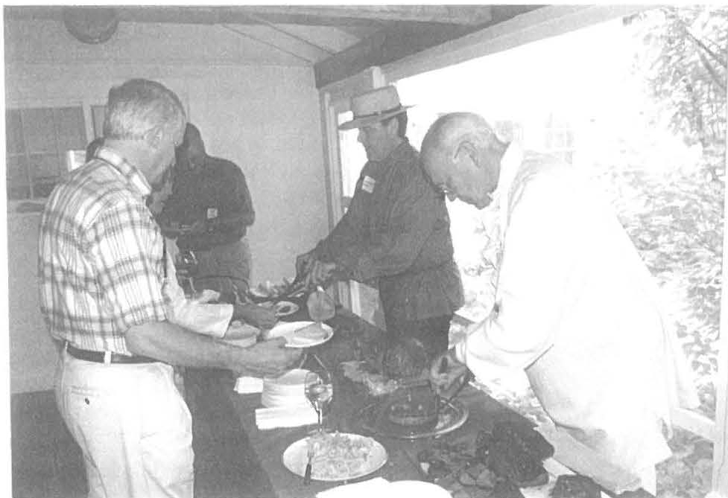
Period fare included wild venison sausage and roast supplied and prepared by Barbara, pheasant provided by Doreen and Bud At­ wood, plus local turkey, ham, fine breads, ice cream with rhubarb sauce, beer and wine. These fine vict­ uals were enjoyed by about 100 guests as they listened to rousing fiddlin' music by Anson Olds and his guitar accompanist, while they toured the grounds and house.

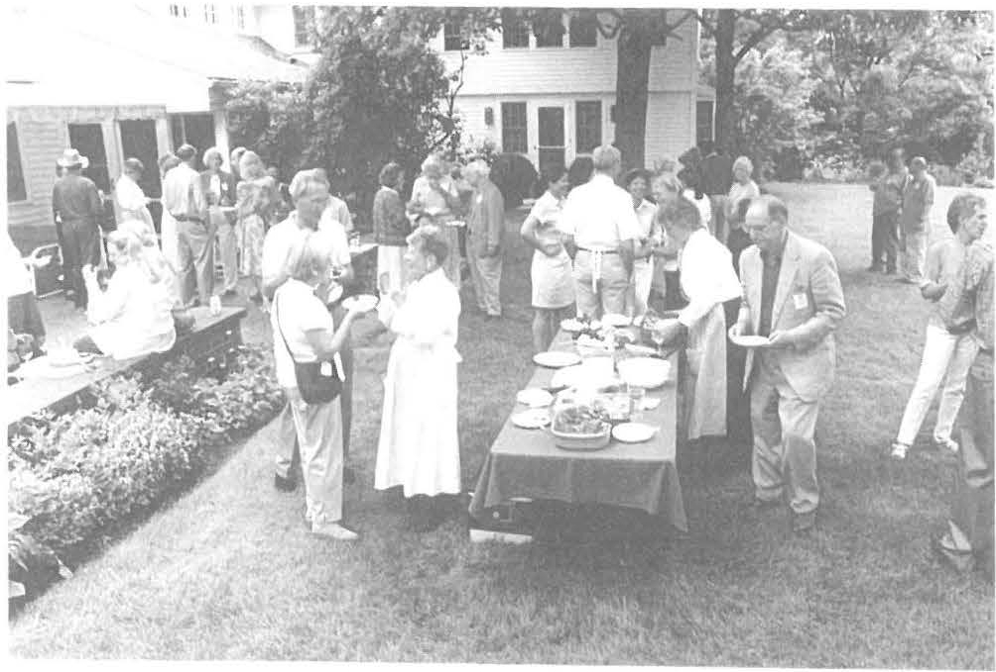

About 15 Society members helped with preparation, serv­ in g and cleanup with Carl Proper, John-Arthur Miller, Bud Atwood, Harry Co nklin, Wray Gunn, Dennis Sears and host Joh n Stookey appearing in period costume. They were
augmented by help from Doro­ thy Marosy, Doreen Atwood, Marcia Brolli, Annie Ryder, Joanne Hurlbut along with co­ chairs, Barbara and Catherine.

The weather cooperated to make it an unhurried and memorable community event, with people lingering in con­ versation, amusement and mirth.

0 • 11 • • 1• • • 11 H• ,." N•.,,."'
.w.,1 D, ,. , 1,., ., ,,. Ct• l#r

I59 Main Streel
PO Box 747
Sheffield. MAO1257

Phone : 413-229-2694
Email: shs@shcflicld hislo ry.org

Tou rs of the 177 4 Dan Raymond House are available Thursday through Saturday, 11 a.m. to 4 p.m.

Mark Dewey Res earch Cenler open Monday and Friday afternoons, I:3 0 to 4 p. m., and by appointme nt

Stone Slore hours arc Saturday 10 a.m. lo 2.p.m. and Sunday 11 a.m . to 3 p.m.

Jam es & Catherine Miller PO Box 7
Sheffield MA 0125 7

1t'
WE'RE ON THE WEB
S IIE F FI ELD HIST O RY .ORG

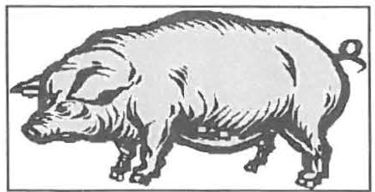
;-1 Pigge Roast Reprise
Board of Directors 2004-2005

Cl.
Wray Gunn, President
John-Arthur Miller, Vice­ President
H. Dennis Sears, Treasur er James R. MiJler, Clerk Trustees:
Marcia Brolli Harry E. Conklin Barbara Delmolino Leonard Graziano Allison G. Lassoe

Joanne Hurlbu t, Director

r-l 1

Scott Ryan and the Piggc Roast arc coming to Sheffield o n August 28, 2004. The Second ann ual Pigge Roa st will be held at the Sheffield Legio n Hall at the comer of Cook Road and Route 7 in Sheffield from 3 - 6 p.m.

At 3 again this yea r Mari on W hit­ man and friends will ho ld a blue­ berry pie caste-off to find the best pie-baker in the area. At 3:45 serv­ ing will begin. On the menu are pork or fried turkey and all the fix­ ings, baked beans, salads, corn-on­ the -cob, an d bluebe rry pie.

Adults $ 15, child ren $8, child ren under 8 free. Adult take-outs avail­ able.

CRAFTS: Barbara Delmolino has
bro ugh t together a group of crafts peo­ ple who will be exhibiting and selling all day on the grounds of the Legion Hall.

Come early to shop at the crafts booths and stay for the fun of the pie contest and then eat a delicious meal.
I
Save these dat es:
July 3-River Exhibit O pens July 10-S ilent Auction and
Tag Sale August 28-Pigge Roast
+, rf_l

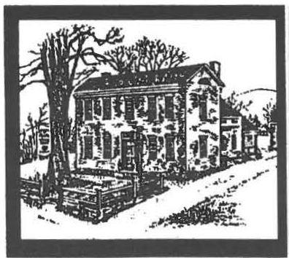
Sheffteld Historical Society
Fall 2005 Newsletter

New Exhibition: SHEFFIELD SEATING FURNITURE

The examples in this exhibit rep­ resent only a few of the types of seating that were used in Shef­ field from its settlement in the 1720s down to the end of the 19th century. Among the earliest and most primitive seating was the slab bench - which was an enlarged domestic version of the dairyman's three-legged milking stool, such as the diminutive stool from the Barnum family, on dis­ play. Chairs were a symbol of dignity and authority - not an item in general use - in early
Sheffield. However, as wealth and sophistication advanced, the once ubiquitous bench was replaced by more fashionable seating styles,
such as Sheraton and Windsor chairs, particularly in the 19th cen­ tury.

This exhibit includes several pieces made in Sheffield or nearby South County. Other ex­ amples, while not made here, were used in Sheffield by succes­
--;1,11 ill i;.i"""'!""".l,.-:':'II sive gen­
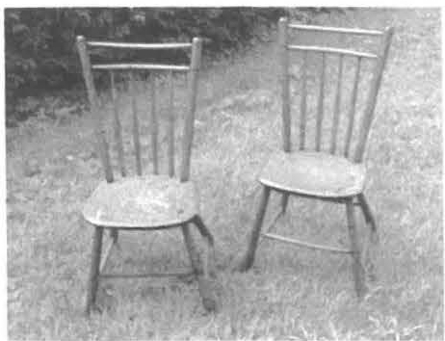

in the family for as long as 200 years.

For the most part, local chair mak­ ers were farmers who turned to nonagricultural endeavors in the off-season, when they built seating furniture for their families or for trade or sale. The Baldwin Com­ pany chairs in the exhibit, how­ ever, are true Berkshire County production pieces, made in large numbers in a factory setting.

Thus this small exhibit presents an authentic slice of Sheffield ' s furni­ ture history- items made and/or used right here in Sheffield.
Hours: The exhibition opens on Sat­ urday, August 27, and runs through
S unday, October 30. Regular exhibi­ tion hours are Saturdays lO to 2. and Sundays 11 to 3.

Special Sheffield in Celebra­ tion Day activities, Saturday, September l 0, include extended Stone Store hours (3 to 7 p.m.) and:

Exhibition curator James Miller will give short talks on the elements that went in to designing and creating SHEFFIELD SEATING FURNI­
TURE. The talks will be offered at
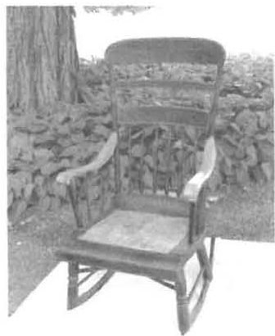4 p.m. and 6 p.m.
--

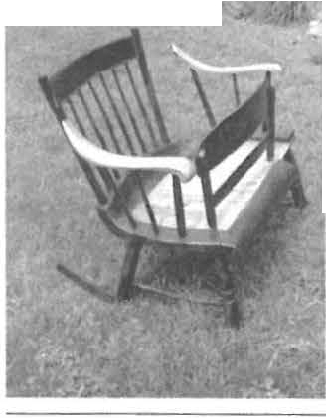
erations of local families (Chapin, Willcox/ Cande, Curtiss) ­ in some cases re-
:..oos.-.. -- maining
- James R. Miller
Riddle: when is a chair not a chair? Clue: did you note any similarities between the image on your left and the image on your right? Look again! (Answer: when it 's a cra­ dle.) It's thesame piece of furni­ ture in two different positions.
Throughout the day's activities
(3 to 7 p.m.), craftsman Boyd Hutchi­ son will demonstrate techniques used in chair construction, in particular techniques used in the creation of Windsor chairs, which were popular from the late 18th century into the early 19th century.

Calendar of Events
Monthly Meeting THE STORY OF THE
ASHLEY FALLS MILL
Friday, September 9
NOTE CHANGE OF TIME AND LOCATION
This is a special meeting com­ prised of both a tour and a presen­ tation. Feel free to come for both segments or for just one segment. Meet at 7 p.m. to tour the Ash­ ley Falls Mill and view the wa­ terpower site and remaining mechanicals. There will be dis­ plays of related memorabilia and

There will be a number of projects to do, and all ages and skill levels are welcome. Painting will figure heavily among the tasks, but there will be many other projects to work on. Call the office to let us know you will be attending.

ARCIDTECTURAL WALK­
ING TOUR, Saturday, October 1, 10:00 a.m.
This is a part of the Heritage Walks Weekend.

The Sheffield Historical Society is offering a tour of the center of
-
Sheffield Historical Society

tional Church of Great Barring­ ton. He was a disciple of Jona­ than Edwards, one of the leading preachers of the 18th-century's Great Awakening. Hopkins was also one of the country's early abolitionists. The presentation of these historical moments and many other personal aspects of the life and times of Samuel Hopkins will be given by Rever­ end Charles Van Ausdall, pastor of the First Congregational Church in Great Barrington since 1986.

photos. The tour includes the first
Sheffield, focusing on its 18th
and
ANNUAL CEMETERY

floor and basement. (Call for di­
19th
century homes and busi­
STROLL

rections to the Mill.)
-

Meet at 8 p.m. at the nearby Trinity Methodist Church Par­ ish Hall for a panel discussion of the Mill and its operations.
Speakers on the panel include Fred Hall, a 98-year-old local his­ torian, relating stories from his ex­ periences in the mill; Jim Miller, author of Early Life in Sheffield, Berkshire County speaking to the historical significance of this site as the industrial center of the first settlement in the county; Amy Fish, retelling the stories from her mother, who was the last to run the mill as a business; and How­ ard Chezar, the current owner, as he talks of what the future brings. The panel facilitator will be Neal Chamberlain.

WORK BEE
Saturday, September 17, 10 a.m. to approximately noon.
(Rain date--Saturday, Septem­ ber 24)
Meet at the Dan Raymond House.
nesses. Hear the stories of the men, women, and children who resided in these structures. Learn about the special features that make each building a key to un­ derstanding the past. When the tour was offered earlier this sum­ mer, it was fully subscribed. If you missed it then, plan to join us now. Call (413) 229-2694 to re­ serve a place. Comfortable walk­ ing shoes are recommended. The walk begins at the Society' s Dan Raymond House headquarters, 159 Main Street (Route 7), Shef­ field. Approximately I hour , ½ mile.

Monthly Meeting
SAMUEL HOPKINS, MAN FROM YALE
Friday, October 14, 7:30 p.m. at the Bushnell-Sage Memorial Li­ brary
NOTE CHANGE OF LOCATION
The Reverend Samuel Hopkins was the first settled pastor of the Sheffield North congregation, later called the First Congrega-
Saturday, October 22,
4 to 6 p.m.
Hewins Cemetery (from Route 7 in Sheffield, take Maple Ave­ nue, turn right onto Hewins Street and drive 2.5 miles)

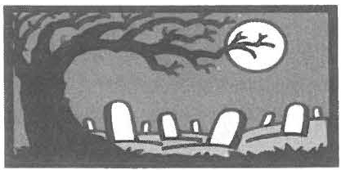
This year's journey takes us to a smaller cemetery, away from the bustle of the center of town.
Here we will encounter personal stories often left untold. There will be members of the Hewins family present, along with many others such as Lieutenant Theo­ philus Spaulding and Jabez Keep. Get to know Sheffield's ancestors at this historically en­ tertaining event. Please dress for the weather and wear com­ fortable shoes; the terrain is un­ even. Refreshments wi11 be pro­ vided. Free to members, $4
non-m embers.

Page3

Look what's right around the comer-plan to be a part of one of our most successful activi­ ties!

The 7th Annual Fes­ tival of Trees
will be held again in the Stone Store on the Green
in Sheffield for the four weekends of November. Saturday hours are 10-3; Sunday hours 11-2.

Festive miniature trees, holiday decorations, and sweets will be for sale throughout the month. These are the perfect gift for someone in a small apartment. Festival of Trees committee members encourage peo­ ple to think of shut-ins, both family members and friends, who have lit­ tle room for holiday decorations, and spark their holidays with the gift of a unique miniature tree.

New designers are eager to delight prospective buyers with beautifully crafted miniature trees. They will try to match the wit and beauty of the work of past contributors.

Raffles will be held for several items, including another handsome holiday quilt hanging created by Society member Doreen Atwood.

As always, fresh green wreaths will be decorated to order for deliv­ ery at the beginning of December. Origami light strings and orna­ ments, so popular last year, made by Society members will be avail­ able while they last. Gift packages of holiday sweets may be ordered or purchased throughout the festi­ val.
In response to requests, this year's hand-painted ornament of a Shef­ field landmark, Center School, and a limited number of the series from past years will be for sale.
These beautiful glass balls, hand­ painted in Austria, have become highly prized by local collectors. Ensure that you get yours by mail­ ing full payment of $21, tax in­ cluded, to the Sheffield Historical Society. Ornaments may be picked up during the Festival of Trees open hours.

The Stone Store gift shop has ex­ panded its offerings this year and will repeat its highly successful up­ stairs holiday tag sale.

Come get in the mood for the holi­ days- and shop for decorations and gifts and an early taste of holiday treats. For more information, call the Society at 413-229-2694 or Marcia Brolli at 229-2624.

Monthly Meeting
A CONCERT BY "THE CARD SHARKS"
Friday, November 11, 7:30 p.m. at Dewey Memorial Hall
NOTE LOCATION
Join us for an evening of American music to celebrate Veteran's Day, with the barbershop quartet known as The Card Sharks. This group performs in four-part harmony, a style that has made them New Eng­ land's favorite sons. Composed of area residents, the group has been winning awards for some time.
They took second place.in the Northeast Region four-part barber­ shop competition. Come and sing along.
Don't Forget to contact us at 229-2694 regarding your contri­ butions to the December heir­ loom exhibition. We truly need your pieces to make this a worthwhile exhibition.

We are looking for any item that has been handed down from gen­ eration to generation, and which is very special to you. December is a month where sharing family memories is a major part of the reason for celebrating. So join our historical family by lending us an item or two and telling us the tale behind the object. We welcome all types of items and stories.

The Society is one of the sponsors for: UPPER HOUSATONIC VALLEY AFRICAN AMERICAN HERITAGE
TRAIL1 A project of the Upper Housatonic Valley Heritage Area

The Upper Housatonic Valley African American Trail will hold a series of community meetings to introduce and receive comment on its newly pub­ lished guide to the African American Heritage in the Upper Housatonic Valley. The guide brings together the efforts over many years by local scho l­ ars, historians, educators and commu­ nity leaders to preserve the region's rich African American heritage.

On Monday Sept 12, 7:00 p.m., at the Clinton African Methodist Epjscopal Zion Church, 9 Elm Court, Great Bar­ rington, project members will discuss the making of the guide and the story of African Americans in South Berk­ shire County. The panel will include Rev. Esther Dozier, David Levinson , Bernard Drew, Elaine Gunn, Wray Gunn and Rachel Fletcher.

For information about the African American Heritage Guide, contact Ra­ chel Fletcher, 413-528-339 1, afam­ trail@hotmail.com, or visit the web­
s ite at www.uhvafamtrail.org

D11• R•1"'"" ff• ••• M•u•..
M•,-1 Dut t 1 Ru1•rd C••lfr

159Main Street
PO Box 747
Sheffield. MA 01257

Phone: 413-229-2694
Email: shs@she ffieldhistory.org

Tours of the 1774 Dan Raymond House are available Thursday through Saturday, 11 a.m. to 4 p.m.

Mark Dewey Research Center open Monday and Friday afternoons, I :30 to 4 p.m., and by appointment.
Email: mdrc@sheffieldhistory.org

Old Stone Store hours are Saturday, 10 a.m. to 2 p.m. and Sunday, 11 a.m. to 3 p.m..

WE'RE ON THE WEB
SH E F F I E L D H I ST O RY. ORG

rr 7,
Board of Directors 2005-2006
Wray Gunn, President
John-Arthur Miller, Vice­
Fall Automobile Outing to Hill-Stead Wednesday, October 19, 9:30 a.m.
Meet at the Dan Raymond House
Travel back with us to 1901 and Theodate was a survivor of the sub-

President
H. Dennis Sears, Treasurer James R. Miller, Clerk Trustees:
Marcia Brolli Harry E. Conklin Leonard Graziano Allison G. Lassoe
the creation of one of the coun­ try's finest examples of Colo­ nial Revival domestic architec­ ture, known as Hill-Stead. This 36-room house sits on 152 acres of fields and woodlands in Farmington, CT, near Hartford. The structure was designed as a retirement home for the parents of Theodate Pope Riddle, who was one of Connecticut' s first licensed female architects.
marine attack on the Lusitania. At the age of 49, she married the American diplomat John Riddle. Theodate Riddle died in 1949, leav­ ing a will that stated nothing should be removed or added to the house; thus it stands exactly as it did when her family lived there (1901-1946).

Fee: $15 members, $17 non­ members. Lunch (a separate cost) will follow the tour at a place TBA. Reservations requested.
Open

Joanne Hurlbut, Director
l:i..
The house is furnished with her father's collection of French Im­ pressionist paintings, particu­ larly Monet and Degas, Japa­ nese prints, and works by Durer and Whistler.

Septemb er IO-Special Chair Exhibit
programming September 17-Work Bee October 22-Cemetery Stroll

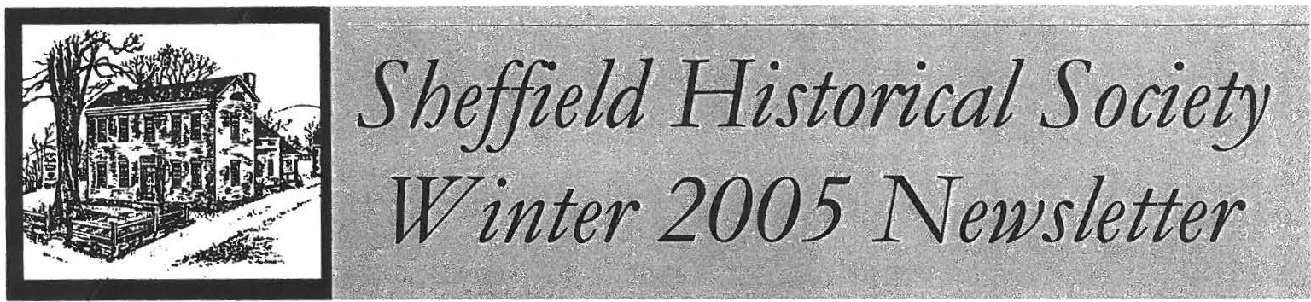
CALENDAR OF EVENTS

The Festival of Trees runs now through November 27. See page 3 for further details.
♦
Don't forget!
The CHORD SHARKS, an
award-winning male quartet from the Southern Berkshires, will pre­ sent the program for the Sheffield Historical Society's November meeting on Veterans Day, Fri­ day, November 11 at Dewey Memorial Hall in Sheffield.

Members of the quartet include Maurice Brazie, Ray Johnson, Jack Mann, and Dan Burkhardt. For the second year in a row the group placed second in the North­ east District Contest. This year's event was held in Halifax, Nova Scotia. The 7:30 p.m. program will include some of the music from the Northeast contest as well as spirituals and patriotic Ameri­ can music.
♦
From Saturday, December 3, through Sunday, December 18, the exhibition Heirloom Stories will be on view at the Old Stone Store. Hours arc Saturdays from 10 to 2, Sundays from 11 to 3, and by appointment.
There is still time to join us in put­ ting this exhibition together! We are looking for any item that has been handed down from genera­ tion to generation, and which is very special to you. We welcome all types of items and stories.
Please contact the Society at (413) 229-2694 by November 19th, if you have an item or items to share.
♦
Monthly Meeting
Friday, December 9, 7:30 p.m. Dewey Memorial Hall
Robert Law will present a pro­ gram on Fifty Years of The South­ ern Berkshire Regional School District

2006

Monthly Meeting
Friday, January 13, 7:30 p.m. Dewey Memorial Hall
What's It Night: the perennial fa­
vorite of members and friends.
♦
Special Event
Monday, January 16, 1 p.m. Bushnell-Sage Library
For several years the Society has worked with the Library to present a special program honoring Martin Luther King, Jr. and local heroes. We have enjoyed songs, readings, presentations, and more. Join us for an event that always lifts the spirit.
Monthly Meeting
Friday, February 10, 7:30 p.m. Dewey Memorial Hall
Ivan Newton will speak about Rev. Harrison, an early civil rights leader, Civil War chaplain, and prominent Pittsfield figure. A drive is underway to turn his Pittsfield home into a mu­ sewn.
♦
A February School Vacation Workshop is in the planning stages. Call the office in January if you are interested in enrolling a youngster. These workshops fill up fast, so make a reservation early!

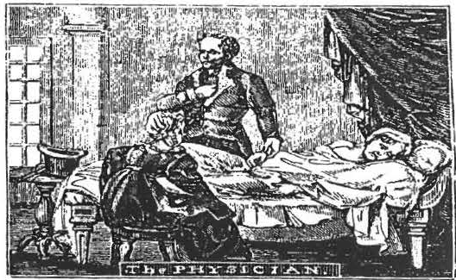

Monthly Meeting
Friday, March 10, 7:30 p.m. Location to be announced
Dr. Brian Burke, of Fairview Hospi­ tal, will tell the story of Dr. Whiting, Berkshire's forgotten leader of the Revolutionary Era. The talk will fo­ cus on early medicine in this area. Dr. Burke is President of the Great Bar­ rington Historical Society, and advi­ sory member of the African Ameri­ can Heritage Trail Committee.

Recent Happenings at the Society

new system installed.

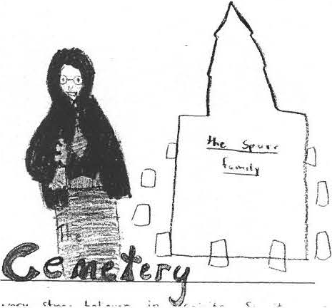
Once again this October, the spir­ its of Sheffield have been afoot. Pictured above is Mrs. Moses Spurr; drawn by Zoe, one of our 5th-grade students. Below is Kel­ sey's version of the Spurr pie.
Each year the students visit with SHS staff and volunteers at Center Cemetery, where they learn about grave sites and their architecture. They also hear the stories of life long ago as told by local residents.
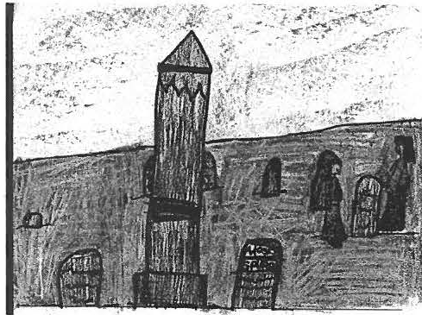
Our other traditional family ceme­ tery program, scheduled for Octo­ ber 22, was postponed due to in­ clement weather. It was resched­ uled for Sunday, November 6, 4-6
p.m. If weather is problematic, the event will be held in the Soci­ ety buildings. We are never ones to let a good story go without be­ ing told!
Building and Grounds Updates

The Society held two Work Bees in September. Each day saw a solid turnout of workers and suc­ cessful strides in upkeep activities. Basic chores, such as cleaning gutters and trimming tree limbs away from buildings were com­ pleted, as was some interior clean­ ing.

In addition, two significant work projects were finished. The exte­ rior project was the Barn: Work was done on the large front door, which included replacing deterio­ rated wood, scraping, and paint­ ing. Painting of the back addition on the Barn was also completed.

The interior work took place in the Dan Raymond House, on the second floor: The room used for changing exhibits had suffered water damage to the ceiling as a result of the leaking roof. With the new roof in place, local high school students and their instruc­ tor came in the spring and worked on repairing the ceiling. During the last Work Bee, volunteers painted both the ceiling and the
walls. The space will house a new exhibition in the Spring of 2006.

As I sit here at my keyboard, I feel something creeping about the room. It is in fact a wonderful thing- heat! The Dan Raymond House (where my office is lo­ cated) was in need of a new fur­ nace system. For the last four days, the heat has been off as the old system was dismantled and the
The two old boilers and the two old tanks were replaced by one boiler and one tank. The new system is far more efficient and will give great service. In addi­ tion, the technician working on the project notes that the smaller system makes the basement much more spacious!

The installation of the furnace system was made possible through a number of volunteer efforts. In particular, Kim Kim­ ball was able to reduce an
$8, l03.56 cost to an actual
$2, L 7 5 fee for the Society. This was done through the generosity of Burnham (the makers of the boiler), S &A Supply, and Kim­ ball Fuel. In addition, $500 from the recent Massachusetts Cultural Council GOS grant (see back cover for details) will be applied to the cost, leaving only
$ l,675 out-of-pocket expenses
for the Society. That is a re­ markable effort by the commu­ nity to work with the Society to preserve the history of the area; keep in mind that a large per­ centage of the Society's collec­ tion is housed in the Dan Ray­ mond House.

Have you noticed the front win­ dows of the Old Stone Store seem different somehow? An ultraviolet film was added to protect objects on display from damage caused by sunlight.

THANK YOU to all those in­ volved in working to maintain the Society's holdings!

Page3

7th Annual
Festival of Trees 2005

Stone Store New holiday gifts Upstairs Tag Sale

Ornaments Origami light strings Fresh wreaths
Hand-painted ball- Center School

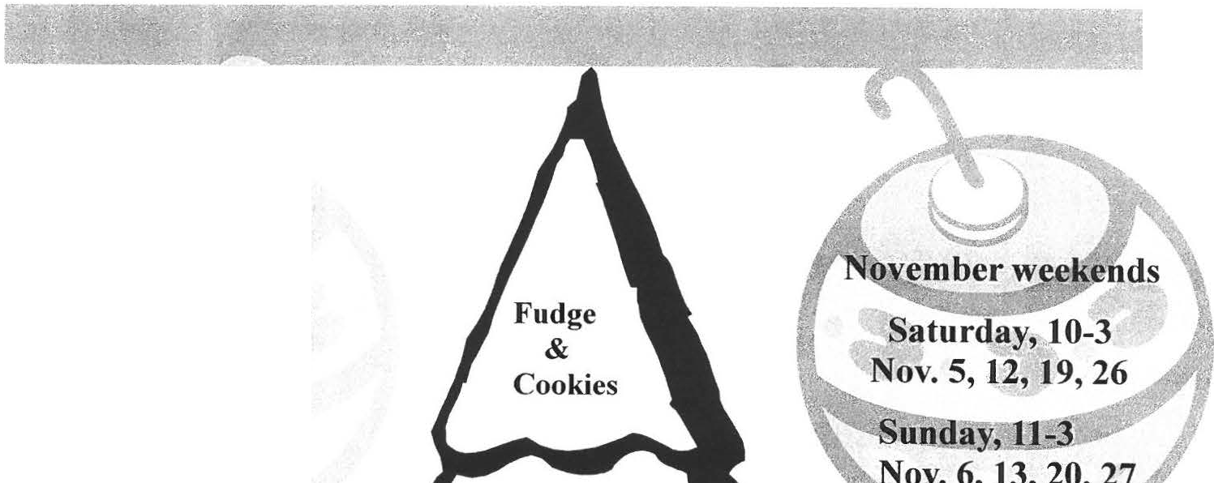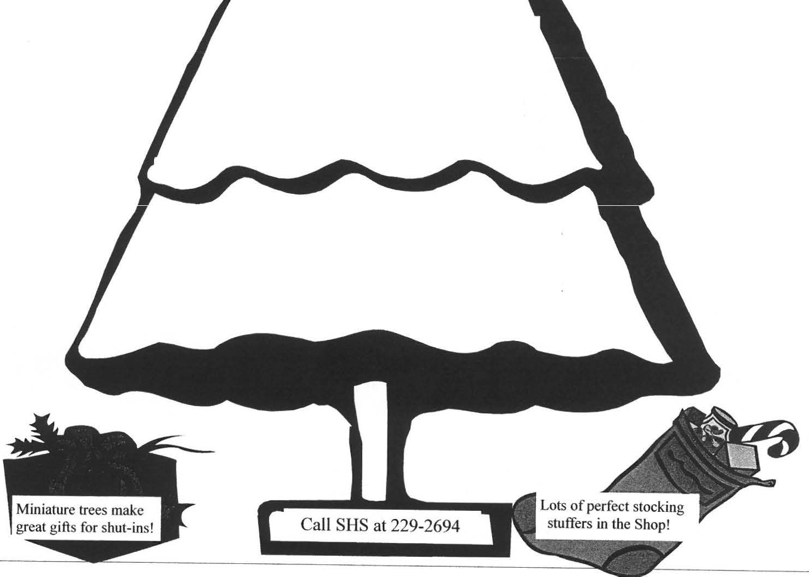

Raffles: lap quilt created by Doreen Atwood, Old Mill gift certificate, decorated wreath
Miniature Trees decorated by members & friends of the Sheffield Historical Society

O•• lt•1• ••" If•••• M•••••
Na,• D• • •1 lh u •" • C•• lo

159 Main Street
PO Box 747
Sheffield , MA O1257

Phone: 413-229-2694
Email: shs@s heffieldhi story .org

Tours of the 1774 Dan Raymond House are available by appointment during the winter months.

Mark Dewey Research Center open Monday and Friday afiemoons, I:30 to 4 p.m., and by appointment
Email: mdrc@sheffieldhistory.org

Old Stone Store hours are Saturday, 10 a m. to 2 p.m. and Sunday, 11 a.m. to 3 p.m..
Closed December 24, 2005 through Marc h 3 1, 2006.
WE'RE ON THE WE B
SI I EFFJ ELD H ISTO RY.ORG

Sheffield Historical Society Receives a Massachusetts Cultural Council GOS Grant

Board of Directors 2005-2006
Wray Gunn, President
John-Arthur Miller, Vice­ President
H. Dennis Sears, Treasurer James R. Miller, Clerk Trustees:
Marcia Brolli Harry E. Conklin Leonard Graziano Allison G. Lassoe

For the first time, the Society is the recipient of a General Oper­ ating Support Grant from the MCC. The award is for $2,000 per year, for a total of three con­ secutive years.

These state grants are awarded through a competitive process. Receiving a MCC GOS grant signifies that the Sheffield His­ torical Society provides a high level of quality in its programs, community service and admin­ istrative capacity.
Brian Levinsohn
L:i.
Joanne Hurlbut, Director
The mission of the MCC is to promote excellence, education,
_l access, and diversity in the arts, humanitie s, and interpretive sci-
Festival of Trees­ Every weekend in November
Saturdays 10-3
Sundays 11-3
ences in order to improve the qual­ ity of life for all Massachusetts resi­ dents and to contribute to the eco­ nomic vitality of our communities.

The Society will use a portion of the funding for the new furnace and will apply the remaining funds to­ wards its varied programming.

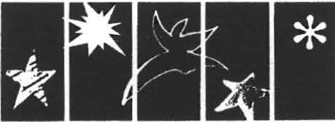
MAsSACHUSETIS CUlTURAL COUNCIL

