.• ..
j •

SHEFFIELD HISTORICAL SOCIETY NEWSLETTER
Fall 1997

The President's Comer:

What a terrific beginning we have had to this our 26th year! The Berkshire School hockey rink was transformed in to the setting for our Antiques Show in late June and the grounds of the Society came alive in August with the Early American Crafts Festival. Society members and friends were actively involved in both ventures. Behind the scenes. the Board of Directors and several committees have been thinking and working to develop some wonderful programs and activities for this year. It is going to be a very good year and I look forward to seeing the familiar faces as well as some new ones. There is room for everyone to play a part, large or small, frequent or infrequent, in the activities. Won' t each of you invite at least one other person to join you in one of the Society' s functions? See you there!

Calendar of Events:

September 12: ORNAMENTATION OF CLOCK CASES: Chris Bailey, Horologist of the American Clock and Watch Museum, Bristol, CT, author of numerous books and articles and editor of the publication. "Timepiece Journal" will provide an illustrated talk on clock cases.
7:30 p.m. Dewey Hall, Sheffield

October 10· EARLY GLASS AND ITS IDENTIFICATION: Mason Dutcher, collector, and authority on glass will discuss glass objects - identifying characteristics, use and value.
Participants are encouraged to bring pieces of their own to the meeting.
7:30 p.m. Dewey Hall, Sheffield

October 26- 20TII ANNUAL TURKEY DINNER with proceeds to benefit educational
programs, grants and scholarships administered by the Education Committee.
12:00 p.m. & 1:30 p.m. seatings at the Sheffield American Legion

October 30: MR & MRS. DAN RAYMOND'S Masquerade Party.
7:00 - 8:30 p.m. Dan Raymond House (details inside newsletter)

November 12· FIELD TRIP TO LUNT Sll..VERSMITHFACTORY AND
SPRINGFIELD MUSEUMS (details & registration form follow later in newsletter)

November 14· CE!vfETERIES OF SHEFFIELD: Cynthia Tryon Hoogs, researcher and author of Sheffield, Massachusetts Cemetery Inscriptions will provide an illustrated program on the historical cultural and social history of some of Sheffield's thirteen cemeteries.
7:30 p.m. Dewey Hall, Sheffield

November 4 & 5: CONSTRUCT AN OVAL SHAKER BOX: Boyd Hutchison, local craftsperson and student of Shaker artifacts will conduct a workshop in two evening sessions. (details & registration form follow later in newsletter)
6:30- 9:30 535 Home Road, Sheffield

December 12: HOLIDAY POTLUCK & READING OF DYLAN TIIOMAS'
A Clffi,,I)'S CHRISTMAS IN WALES by Tom Driver. Bring a dish to pass, your own place setting and your holiday spirit. Dessert & beverage provided by the Society.
6:30 p.m. Dewey Memorial Hall

December 14 · HOLIDAY OPEN HOUSE & DISPLAY OF ANTIQUE MINIATIJRE
FARM ITEMS: Join your friends and neighbors in front of the fire and enjoy some holiday egg nog and yule goodies. Bob Ledlie will share some of his collection of over 800 antique miniatures of farm figures. The annual town tree lighting follows on the green at 6:00 with an ecumenical service in the Old Parish Church to follow.
4:00 - 6:00 p.m. Dan Raymond House

Field Trips and Workshops and Other Activities:

•••••••••••••••••••••••••••••••••••••••••••••••
.llR. AND MRS. DAN RAYMOND

request the honour of your presence at
a
MASQUERADE PARTY

Thursday, October 30, 1997
7:00 - 8:30 p.m.
The Dan Raymond Residence 159 Main Street, Sheffield, MA

Costume Appropriate to the Period &freshments, Prizes, Period Games

RSVP by October 1 Dorothy Marosy 129-2129
•••••••••••••••••••••••••••••••••••••••••••••••

i

Silver, Art. History and a Trip to the Stars1
Join a field trip to Greenfield and Springfield on Wednesday, November 12. The bus will
leave Dewey Hall at 8:30 a.m. and return by 5:30 p.m.
The first stop willbe the Lunt Design Center in Greenfield where there willbe a one-half hour guided tour of a hundred year old silversmith factory, followed by a visit to the showroom and Christmas shop. Upon departure from the Center, each participant willbe provided with a gourmet box lunch which willbe eaten at the second stop, the Springfield Museum where four distinctive buildings surround an attractive New England green. The group will have guided tours of the Springfield Science Museum, the Springfield Museum of Fine Arts, the Connecticut Valley Historical Museum and the George Walter Vincent Smith Art Museum.
Following the tour, there willbe an opportunity to see the new planetarium show, "Oceans of the Sky" during which the group will be transported from the oceans to the stars.
1bis fun filled day will cost $30 per person which includes bus, lunch, admission to all museums and the planetarium show.
Reservations must be received by September 20 Cancellations must be by October 27 in
order to receive a full refund. Complete the reservation form (at end of newsletter) and mail with a check payable to the Sheffield Historical Society to Dorothy Marosy, P.O. Box 608, Sheffield, MA 01257.

Construct an Oval Shaker Box - You Can Do It!
Boyd Hutchison willlead a workshop on the construction of an oval Shaker box November 4 & 5 from 6:30 - 9:30 p.m. Each participant will make an oval box (approximately 4 to 6 inches) in two evening sessions. The workshop will be limited to five (5) individuals, so early registration is recommended. The cost is $50 per person. Call Bob Dean at 229-2608. Once accepted the registration form (at end of newsletter) and a check payable to Hutchison Woodworking must be mailed to Bob Dean at P.O. Box 832, Sheffield, MA 01257. Do Not Delay, If Interested!

"One Teary Eye------One Smiling Eye"

It is hard to admit that Father time is telling me that my body just can't stand the pace that is required to take charge of our Turkey Dinner (October 26), but nevertheless, it is the truth. I really enjoyed working withso many willing people and hearing the many kindremarks from the public. Of course, our connection with the 8th grade class and the proceeds going to our education programs was the icing on the cake.
Now for the happy side; we are very fonunate to have Bill Preston and Harry Conklin step up and be willing to take charge of the dinner. Let's get behind them and make our 20th year as good, if not better, than the past dinners. I know I will help them.
Many thanks from out in the pasture,
Mihon Barnum

Let's make this the best dinner yet, to honor Milton for his many years of turkey calling! Call Bill Preston at 229-2077 to indicate your willingness to assist with this event. And call229- 2569 to make reservations for either seating. We know we can count on you for both

r
., I

News from the Family llistory Center:

The Family History Library added a new slant to our recent craft fair. offering genealogical assistance from our extensive files on local families plus the use of Internet research. Dennis Sears was chief technical engineer for the cyber aspect, bringing his personal computer to the site
and overseeing its operation throughout the day, making data bases containing over 100 million names available to local genealogists. Regular Library staff handled the local research files. The
event was oversubscribed with a waiting list for research that often extended up to an hour or more. The facility is open on Monday and Friday from 1:30 to 4:00 or by appointment and you do not have to be a member to do research . Get the word out. (The Internet aspect was for the Craft Fair only.)
A recent gift of Sheffield tax records dating to the l760's was given to the Library through
the efforts of the town assessors' office, Ruth Gillette, assessor chairman, being responsible for this single most important research source in the Family History Library. About sixty lineal feet of steel shelving had to be added to hold the collection which covers over 200 years to the l970's. The collection is presently being catalogued and will be available to the membership and public in the near future. The importance of these records can not be overstated. What we are now able to do is research year-by-year the town ' s taxpayers , the amount they paid, and, in some cases, the property taxed, thus being able to reconstruct Sheffield's economic hierarchy, almost from its inception. The records not only close significant gaps where town vital records are missing, but cover the years between the regular ten-year federal census.

Society Supports Hannah Pixley Project:

The Education Committee and the Board of Director voted to provide a $2,000 grant to the Barrington Stage Company to support two performances of Hannah Pixley· The Autobio&raphy ofa Berkshire County Woman 0862 - 1953). This is a one-woman play based on the autobiography of a woman who lived her entire life in Monterey and its environs. Hannah Pixley's formal education ended when she was nine, and yet she went on to become a poet, writer
and epic story-teller. She was an independent, strong-willed woman who managed to survive and even flourish during a difficult time. As a dramatic work, Hannah Pixley's true life experiences illustrate the social history and demonstrate how one individual was able to sustain herself in times
of hardship and poverty.
The grant will cover two performances at the Consolati Performing Arts Center at Mt.
Everett as well as a study guide and traveling exhibit, each of which willbe used throughout Berkshire County schools.

' ' .,
•

Early American Crafts Festival:

The grounds of the Society came alive on August 16 as nearly 800 people enjoyed the activity of the festival. Twenty craft persons, each proficient in a seventeenth or eighteenth century craft demonstrated and discussed their trade. Horse rides, scarecrow making and clothespin doll making continued throughout the day for children. Two lambs and two goats, all five months old, grazed nearby for kids, large and small, to enjoy. Music and food accompanied all the activity. About 200 persons toured the Dan Raymond House and the Family History Center was overwhelmed with requests to trace ancestral roots through the use of the Internet and the
records available in the Center. The educational mission of the Society was truly in evidence on this day.

N_ otes from the Curator of the Dan Raymond House:

As summer wanes the exterior of the DRH. FHC, Carriage Barn, Law Office and fences are being spruced up with some painting. Property owners know that something is always in need of attention and the Society's property is no exception.

Many people attended the Early American Crafts Festival, enjoyed tours of the Dan Raymond House and the ambiance of the home. as well as the stories told by the various docents. The old house heard compliments regarding its history, its furnishings, the activities the Society sponsors in the house, and the tales it holds.

Lillian Preiss, a founding member of the Society and its first president and for so many years a faithful worker at the DRH has " retired" and is living in Housatonic. Her presence as the Society's and the Town's historian willbe missed. However. Lillian willbe with us whenever her schedule permits.

Marion Barnum, also a founding member along with her husband Milton, also dedicated many years to the care and development of the Dan Raymond House. She. too, has "retired" and looks forward to some young blood following in her footsteps.

The Dan Raymond House/Museums Committee is in need of three or four individuals who would like to assist with the programs at the house and /or provide tours to visitors. If you would like to enjoy yourself and learn a bit more about Sheffield history please let the President or the Curator know of your interest.

Membership, Membership, Membership:

'its the season to renew your membership in the Society . Please complete the application inthe enclosed envelope. Wouldn't you like to help in some way? Let us know your interests so we can invite you to be more involved.

- ·J l
'· •
\·

Food, Food, Glorious Food:

Refreshments have long been a part of the activities of the Society. Our monthly meetings are no exception . We need groups of three or four people to provide the refreshments for October, November, January, February, March, April and May. Please consider a commitment in this way and let the President know, so that we can be assured of having refreshments at each meeting.

Board of Directors:

President : Vice President: Vice President:
,··. tary: f'reasurer: Trustee: Trustee: Trustee: Trustee:
Catherine B. Miller Morton Levin Betty Chapin Eleanor Griffiths John Huegel Marion Barnum Harry Conklin Dorothy Marosy Kathie Ness
229-8668
229-7972
229-2000
229-2015
229-2531
229-2569
229-3149
229-2129
229-3368

Appointed Officers:

Investment Manager: Dennis Sears Director/Archivist-FHC: James Miller Curator - DRH Penny Browne

Standing Committees:

Finance:
John Huege4 Chairman
DennisSears Fred Gordon Wesley McCain Bill Preston

Education:
Marion Whitman. Chairman
Grace Arzt Marie Erwin Susan Huegel

Programs:
Virginia Drury, Chairman LuAnnAllen
Ann Dean Bob Dean Rene Gibson
Bobbie Goodman Fred Gordon Kathy Hutchison
Interactive Programs: Dorothy Marosy , Chairman Ann Dean
BobDean Inezf1ynn Bob Ledlie
EdithMcAusland
Rene Wood

' - 6 .
' f

Family History Center: James Miller, Chairman Betty Chapin
Pauline Clark Pauline Dennis Betty Dunk Claire Height Kathy Hutchison

Membership: Grace Arzt Bill Preston Kathy Orlando
Property:
Milton Barnum. Chairman
John James
Penny Browne (gardens)

Public Relations:
Kathy Orlando

Museums:
Penny Browne Volunteer Needed Volunteer Needed Volunteer Needed Volunteer Needed

*************••········R··E·S·E·R··V·A··T·I·O·N··F·O··R·M····································
Name---------------------
Address -----------------------------
Telephone Number
Amount of Check Included _

PLEASE CIRCLE APPROPRIATE ACTIVITY

Oval Shaker Box Workshop November 4 & 5
Return to Bob Dean
P.O. Box 832 Sheffield, MA 01257
Lunt Workshop/Springfield Museums November 12
Return to Dorothy Marosy
P.O. Box 608
Sheffield, MA 01257

. \;

Sheffield Historical Society
  - Box 747 Sheffield, MA 01257

·"

SHEFFIELD HISTORICAL SOCIETY
Spring-Summer 1998

CALENDAR OF EVENTS

May 7: WORKSHOP ON SCHERENSCHNITTE: Pamela Dalton, well known in this art form, participated in the Society's 1997 Early American Crafts Festival. She will teach participants about the early art form of cutting designs and pictures from paper. Bring an X-acto knife and package of# 11 blades, a cutting mat, sharpened pencils, scissors and a rubber cement glue. To reserve a space, mail a check, payable to Pamela Dalton, for $35, to Dorothy Marosy, P.O. Box 688, Sheffield, MA 01257. Bring a bag lunch as the class will run through the noon hour. 10:00 a.m.-1:00 p.m. Sheffield Library.

May 8: CIVIL WAR: BATTLEFJELDSOFTHEARMYOFTHEPOTOMAC: C. Twiggs
Myers, a teacher at Berkshire School for 42 years, will present a program on the War of the Rebellion, his interest inspired by the fact that his great-great grandfather was a Confederate general in the Army of the Confederacy. As an adjunct, the Society will have a display related to Sheffield residents who served in the military during the conflict. The famous Massachusetts 34th Regiment, an all black unit, had eleven Sheffield residents, among them, Milo Freeland, the first Black to enlist following the Emancipation Proclamation. 7:30 p.m. Dewey Hall, Sheffield.

June 2: ANNUAL VISIT OF 8TH GRADE TO SOCIETY: Each year the eighth graders visit the Society where they tour the premises, learn from Milt Barnum about the tools and equipment in the Carriage House and visit the Dan Raymond House. Several volunteers are needed to assist in this important program. 8:30 a.m. - 10:30 a.m. Dan Raymond House.

June 9: ANNUAL MEETING. ARTISTIC VISIONS OF THE PAST: Visual delights from Sheffield's past will be on display. Use your imagination to create a dish to feed six people because you are part of the show. Your culinary creation will be viewed by a panel of judges who will honor the funniest, the most original and the most decorative. The Society willprovide all desserts and beverages. Please bring your own place setting. 6:30 p.rn. Dewey Hall, Sheffield.

August 22: FESTIVAL OF COUNTY ARTS & ARTISANS : Join other Society members, friends and neighbors at this event which will feature a basket maker, weaver, blacksmith, stone cutter, cooper, wheat weaver, tinsmith, broom maker, furniture makers, a country store, entertainment, genealogical workshops, demonstrations/workshopson shingle making, ruler construction, children's activities, food, fun and more fun. Your interest and participation and that of your friends is not only welcome, but encouraged. 10:00 a.m. - 5:00 p.m. Society Headquarters.

A NOTE FROM THE PRESIDENT

The annual meeting in June will mark the beginning of the Society's 26th year. This is remarkable. Twenty six years ago a small group of dedicated volunteers, a few of whom are still active in the Society, joined together to establish the Sheffield Historical Society.
Since that time the membership has grown twenty fold. More than two hundred monthly programs have been presented, nearly twenty antiques shows and the same number of turkey dinners sponsored, several thousand dollars of scholarships have been awarded, field trips and educational programs at the school have occurred, several craft festivals, a house museum and genealogical and research library established. Numerous hand made quilts have been created for raffles in the earlier years, countless visitors to the property in the center of Sheffield and a myriad of other activities and programs enjoyed by young and old. These programs just touch the surface of what the Society has contributed to the community. And, the most amazing part of all of this is that is has been accomplished by volunteers! This is unique in the county. Congratulations and thanks to all of you who have made this incredible journey possible. It is a testimony to the indomitable spirit of the volunteers over the years.
Now that we are about to move into a new era, with a professional director to assist us in our mission, let's not lose sight of that vision, that energy, that enthusiasm we have shared these twenty-six years!
Berkshire Courier. 1876 (Before women won the right to vote)

"The town meeting for the yearly election of officers occurred last week, and Messrs. Andrus, Bronson and Boardman were elected as select men. B.N. Clark, SH. Bushnell and J.C. Smith, Assessors. Alford H. Hoadley, School Committee. Five ladies voted; viz Mrs. Roys, Smith, Boardman, Noble and Miss Dewey.
Others would have done the same had not necessary absence from town prevented. One man made an idiot of himself by making a notice that 'the town vote that the wimman stay at hum and mind their own businesses. ' The ignoramuses of Sheffield wUI not scare the Commonwealth of Massachusetts"

PAST EVENTS

8th Grade Breakfast: On March 10 a dozen eighth graders and their teachers, Bill Gillooly and Paul Menin, gathered around the table in the keeping room of the Dan Raymond House and enjoyed a colonial breakfast of pancakes, scrambled eggs, bacon, toast, spiced fruit, hot chocolate and coffee. Much of the food was cooked over the open hearth by Milt Barnum. Penny Browne. Cathy Hutchison and Catherine Miller assisted in the kitchen. Chris Coenen challenged the knowledge and imagination of the students with a modified "What's It" Program.

Mad Hatter's Tea Party: About 30 people gathered at the Dan Raymond House on March 15 for an interesting and amusing talk on the history of tea. Participants enjoyed several kinds of teas provided by tea merchant, John Harney of Salisbury, along with a variety of sumptuous desserts. There also was a display of items associated with the storing, preparing and serving of tea.

THE SEARCH COMMITTEE

The Committee placed advertisements in several newspapers and professional journals in early March for the position of Director of the Society. A person trained in museum studies and experienced in working with volunteers is being sought to assist the Society in fulfilling its educational mission and raising its profile in the community. Many resumes have been received, and the Committee has begun the process of prescreening and checking references. It is anticipated that on-site interviews will occur during May and June and that an individual will be joining us no later than early autumn, preferably earlier.

WORD FROM THE FAMil.,Y IDSTORY CENTER

Another spectacular acquisition.
Just when the volunteers at the Family History Center think they have it all, another archival coup comes along. This time it is a Sheffield family record that encompasses virtually the whole of the 19th century, the Giles Andrews family papers, 1802-l 890's. It seems the Andrews threw no scrap of paper away. Among the approximately 600 documents are extensive family correspondence of Giles with his five sons Franklin, Nelson, Orville, George and Dwight and his son-in-law Solomon Hall, plus voluminous deeds and business correspondence, court proceedings and decisions, guardianship and genealogy along with travel schedules and ticket prices for state coach travel out of Sheffield and barge and packet travel from Albany westward on the Erie Canal to Utica, Auburn, Syracuse and Buffalo. Exactingly pertinent to Sheffield's agrarian history are crop, animal, farm life descriptions and commodity prices that can be generalized to most Sheffield family histories of that era.
What family or social historian would not be excited about the following quotation from a letter by son Franklin, living in Dupage County, Illinois, to his father, Giles, in Sheffield, September, 1851.

Dear father I now take pen in hand to inform you of ... health which is good... [and] to inform you... [that] I found a girl... [and] we took a load of oats yesterday, went to Chicago, got married, and took a load of boards and went home just as any man of business would."

Life should be so simple.

THE SOCIETY IS "ADOPTING" PART OF ROUTE 7

The Society was approached about doing a bi-annual cleanup along a portion of Route 7 between Sheffield and Great Barrington. (just south of Limey's Restaurant to just north of the Pine Tree Restaurant) There was not an overwhelming response to the idea, but it has gathered some support in recent weeks. The Board of Directors voted at its last meeting to accept the challenge. Milt Barnum has volunteered his pickup truck so all we will need at the appointed time are some able bodied volunteers! The state will provide the orange vests and bags for the debris.

MEMBERSHIP

Have you paid your annual dues for membership? The year runs from September 1 through August 31. If there is an envelope in this mailing, our records indicate that you have not renewed your membership. We look foiward to receiving it soon.

ANNUAL MEETING

The membership will receive reports from committees and elect a president, vice president, treasurer and two trustees (pending by-law change).
Morton Levin and Dorothy Marosy have agreed to serve as the Nominating Committee.
The slate of nominees will be presented at the May meeting, with election to follow in June.

PROPOSED BY-LAWS

It has been eight years since any by-law revision. The hiring of a fill-time director prompted the Board of Directors to do a review. Harry Conklin spear-headed the effort and at the last meeting of the Board, changes were adopted.

The principal changes are:
* President's and Vice President's terms to two years each with the option to be reelected for a third year.
- eliminate one Vice President
- add one Trustee
- change name to Board of Trustees
- combine Director and Archivist/Historian of Family History Center into one position Director/Archivist
- clarify role of President and Board of Trustees with respect to Director
- delete the Curator's position (responsibility of new Director)
- delete Town of Sheffield as specific beneficiary in the event of the Society's dissolution and leave decision regarding any asset disposition to the Board and membership.

The proposed by-laws follow. The present (and proposed) by-laws call for any changes to be mailed to the membership at least fourteen (14) days in advance of the meeting at which the vote will be taken. This is that mailing. That vote will occur on Friday, May 8. Two-thirds of those members present and voting can approve these changes. They are recommended by the Board of Directors.

SHEFFIELD HISTORICAL SOCIETY INC., BY-LAWS

ARTICLE l. PURPOSE: The Sheffield Historical Society, Inc., is a non-profit organization, designed to foster interest in the history of the Town of Sheffield, including the hamlets of Sheffield and Ashley Falls, and the region of which they are a part, and in related educational, charitable and antiquarian purposes approved by either the membership or its Board of Trustees.

ARTICLE 2. MEMBERSHIP is open to any person interested in the purposes and activities of the Society, upon payment of dues (individual, joint or life membership), the amount of which will be set by the Board of Trustees.

ARTICLE 3. MEETINGS of the Societ: will be on the second Friday of each month, from September through June. Members in good standing will be eligible to vote and twenty-five (25) such members will constitufe a quorum.

    - The ANNUAL MEETING of the Society will be the June meeting. At that time the Society will

  - Receive annual reports from officers and committees;
  - Vote on matters of general policy previously proposed by the Board of Trustees or the membership;
  - Elect officers as follows:

President and Vice President; a two-year term, with option to be elected for one additional year; i.e., to serve not more than three consecutive years;

Treasurer and Secretary (Clerk), three-year term, not to serve more than three consecutive years;

Five Trustees, two to be elected in even numbered years and three to be elected in odd numbered yenrs, to three-year terms not to serve more than three consecutive years.

-Elect officers to finish out terms in offices vacated during the year.

    - SPECIAL MEETINGS may be called by the Board of Trustees, either at the President's direction or upon petition to the Board by ten (10) members, provided seven
- days notice is given to members .

ARTICLE 4. A NOMINATING COMMITTEE of three current members will be appointed by the Board of Trustees by April 1st of each year and will be furnished at that

time with a list of offices due to be filled in June. The Committee will bring a slate of nominees to the May meeting to be voted on in June.

ARTICLE 5. ELECTED OFFICERS: A President, a Vice-President, a Secretary, a Treasurer and five Trustees will be elected as described in Article 3-A.

Duties of Officers:

  - The President:

- Presides at all meetings of the Society and Board of Trustees
- Appoints any committee chairmen not otherwise appointed by the Board of Trustees;
Supervises the Society's life and activities and serves as the direct supervisor of any employees ;

The President will meet with the Vice-President and other elected officers as soon as practicable after the Annual Meeting and begin to delegate specific responsibility for overseeing certain of the Society's custodial and educational tasks (including the President ' s right to be an ex officio member of all committees).

  - The Vice President will assist the President in overseeing the Society's assets and outreach, custodial oversight (e.g., museums, family history center, accessions, property maintenance, finances, fund-raising, membership records) and educational oversight (e.g., programs, public relations, newsletter, educational events, field trips, guides, etc.).

  - Five Trustees, elected to three-year terms, will assist the officers in overseeing the Society's operations, as they may decide among them.

  - The Secretary, elected for a three-year term,

- Records and maintains the minutes of the meetings of the Society and the Board of Trustees;
- Conducts the Society's correspondence;
- Performs the corporate functions of Clerk .

E . The Treasurer, elected for a three-year term, as chief financial officer,

- Oversees all financial affairs of the Society, including the investment portfolio and the Operating Fund;
Sees that members are notified when dues are payable;
- Deposits all funds of the Society in reliable financial institutions;

- Pays valid bills of the Society for current expenses up to $1,000., and secures an additional signature from the President or the Vice-President on checks of larger amounts;
- Presides at Finance Committee Meetings;
- Provides the Board of Trustees and the membership with timely information about the Society's financial activities.

- The BOARD OF TRUSTEES will consist of nine (9) members, namely the Society's President, Vice-president, five Trustees, Secretary and Treasurer, meeting at least six times per year at the call of the President. The Board

- Conducts all affairs of the Society which do not require general membership approval, or which cannot be acted upon at a meeting of the Society;

  - Fills any vacancies until the next Annual Meeting ;
  - Appoints Standing Committees and Appointed Officers;
  - Hears and acts upon recommendations of committees;
  - Arranges for annual audit of the Society' s books ;
  - Sets policies and oversees programs, including the hiring and supervision of any employees (and the terms and conditions of employment).

Special meetings of the Board may be called at the request of four (4) Trustees. A quorum will be six (6) Trustees.

ARTICLE 6. SUCCESSION TO THE PRESIDENCY. In the case of the continued absence, incapacity or resignation of the President, the Vice President will exercise the duties of the President; and in the President's and Vice President's absence or incapacity, the Secret ary, or in his absence, the Treasurer will call a meeting of the Board of Trustees to elect an acting president, to serve until the return to duty of the President or Vice­ President, or until the next annual meeting.

ARTICLE 7. APPOINTED OFFICERf , An Investment Manager, and a Director/Archivist, neither of whom may also be an elected officer, will be appointed annually by the Board of Trustees. They will meet with the Board, when requested, having a voice but no vote in the Board's decisions. None may serve more than three consecutive years in the same position.

  - The INVESTMENT MANAGER, under the direction of the Treasurer, will be responsible for the Society's capital funds, investing them according to policies approved by the Finance Committee and Board of Trustees . The Investment Manager

- Maintains a checking account for uninvested Development Funds, on which checks may be drawn only for new investments or for transfer of funds to other accounts of the Society, in amounts not to exceed $5,000. Checks for larger amounts will be countersigned by the President or Treasurer;

Renders a monthly income and expense statement to the President and Treasurer;
- Renders an annual report to the membership .

  - The DIRECTOR/ARCHIVIST, acting in accord with policies approved by the Board of Trustees

- Calls meetings required for conduct of activities and programs of the Family History Center;
- Has charge of the cataloguing, care, use and display of all manuscript, printed and pictorial research material;
- Keeps records of the acquisition-value of all such property;
- Reports at least annually to the Board of Trustees and membership.

ARTICLE 8. STANDING COMMITTEES: (members of which may serve up to three consecutive years on the same committee.)

- FINANCE. The Treasurer will chair, and the Investment Manager will be a member, of the five-member Finance Corn'llittee (at least three members) , which

- Receives and reviews the annual audit of an i dependent auditor;
- Recommends financial policy to the Board of Trustees;
- Has authority to act on policies approved by the Board, within limits, the Board may set;
Gathers information for the annual budget and presents it to the Board of Trustees.

The remaining members of the Finance Committee will be appointed by the Board of Trustees.

- ACCESSIONS. A five-member committee, including the Director ex officio and three others appointed annually by the Board of Trustees, will administer the Collections Management Policy of the Society and allocate Accessions Fund monies.

- MUSEUMS. A committee consisting of at least five member, including the Director ex officio and four others appointed annually by the Board of Trustees

- Plans and organizes exhibits or special programs in the Society's museums;
- Has charge of housekeeping anJ staffing of the museums.

- FAMILY IDSTORY CENTER. A committee of at least five members, consisting of the Director/Archivist and four others, will be appointed annually by the Board of Trustees, to

Supervise the development of the historical research library;
- Plan for staffing and use of collections.

- . EDUCATION. The Board of Trustees will appoint annually a committee of at least five members to

Plan programs, field, trips, workshops, etc.; Administer scholarship awards;
Allocate disbursements from the Education Fund.

- PROPERTY. A committee of at least three, appointed annually by the Board of Trustees will be responsible for the care, maintenance and improvement of the Society's buildings and grounds.

ARTICLE 9. ROBERT'S RULES OF ORDER will be the basis of procedure at all meetings of the Society and its Board ofT.ustees .

ARTICLE 10. DISSOLUTION OF THE SOCIETY: If the Society is dissolved by its own action or any legal procedure, all assets then in its possession, after satisfaction of all obligations , will be transferred or paid over to one or more non-profit organizations which then appear best able to carry forward the aims and programs of the Sheffield Historical Society, Inc., and which qualify under Section 501©3 of the United States Internal Revenue Code of 1954 and the amendments thereto. If the circumstances require dissolution, the Board of Trustees shall by majority vote recommend to the membership the entity or entities to so receive assets, and the terms and conditions of such transfer of assets.

ARTICLE 11. AMENDMENTS: Amendments by these By-laws will take effect if approved by two-thirds of those members present and voting at a regular meeting of the Society. The text of a proposed amendment must be mailed to all members at least fourteen (14) days in advance of the meeting at which a vote thereon will be taken .

ADOPTED:

·,

Sheffield Historical Society
P.O. Box 747 Sheffield, MA 01257

\

SHEFFIELD HISTORICAL SOCIETY NEWSLETTER
SUMMER, 1998

Dennis Picard Appointed Director of Society

Upon the recommendation of the Search Committee, the Board of Trustees unanimously agreed to appoint Dennis D. Picard the first professional director of the Society. Dennis, whose duties began July 13, comes to the position with twenty years of experience, having served most recently as Program Coordinator of Storrowton Village Museum in Springfield and, prior to that at Old Sturbridge Village. An extensive background in developing and implementing programs for school age children, senior citizens and the general public as well as experience with historic house museums and their collections provide a good fit with the Society' s needs. In addition to his keen interest in history, Dennis finds time to pursue 18th and 19th century shoemaking, restore 18th and 19th century textile machinery and firearms and participate in historic military re­ enactments.

A Few Words from Dennis Picard

Entering my new position as Director of the Sheffield Historical Society has been a wonderful experience. Catherine Miller, other Board of Trustee members and volunteers have gone out of their way to make me feel welcome and help me begin to learn about the unique qualities of Sheffield and the Society. I am grateful for all the kind assistance each person has so willingly offered.

I believe this coming year will witness the presentation of a unique group of programs centered on the historic Dan Raymond House as well as some of the other structures on the Society's site.

The annual Festival of Country Arts & Artisans holds the promise of not only showcasing some of the best crafts people in New England, demonstrating unique skills, but also an event that will introduce many visitors to the value of Sheffield and the Historical Society. I hope this program will help to invigorate the enthusiasm of Society members and our neighbors. To make any event run smoothly, many volunteers are needed. If you have not beard from Nancy Elliott, won't you please call her at 229-8338 and let her know when you could help.

The Dan Raymond House has been receiving some attention. A new office is being constructed at the rear of the kitchen, and I expect to move into that space by the middle of August. Some of the furnishings are being shifted among rooms to enhance the story of the house and its early residents. There is a small core of volunteer interpreters who will share the house with visitors.
Howeve,rin order to expand the hours throughout the year, more volunteer interpreters are needed. Anyone who is interested in learning more about this important part of the Society's life is urged to contact me at 229-2694 between 9:00 a.m. and 5:00 p.m. There will a training session and handbook to assist you in sharing the life and times of the House with others. It will
be fun and interesting and I hope you will consider becoming a member of this team.

Please join us in the coming months for as many of the events as your schedule allows. A calendar of activities will be available shortly. I look forward to meeting all of you and invite you to stop by the Society's headquarters to see for yourself the changes that are occurring. I believe there is a wonderful future ahead for us as we look into Sheffield's past!

Business & Professional Community Invited to Meet Dennis Picard

Toe Trustees will host a reception for business and professional people from the Sheffield and Ashley Falls areas on August 18. This will be an opportunity for people in the community to visit, many for the first time, the Society's headquarters and meet Dennis Picard.

Dennis will be introduced again to the Society on Friday, September 11, (first meeting of the new year) so those who were unable to attend the Annual Meeting will have an opportunity to talk with him then. He also will be actively involved in the Festival in August, so please introduce yourself to him.

The Spirits of Sheffield Will Walk Again

This October, the Society will offer a new and unusual program. Using one oftbe local cemeteries as a teaching resource, visitors will be invited to partake in a guided tour of one of the historic burying grounds to meet the spirits of a few of the 18th and 19th century residents.

Research bas begun and there appear to be any number of fascinating stories. One interesting anecdote concerns Elizabeth Allen who resides in the Barnard Cemetery. She died in January, 1821 at the age of 67, a victim of yellow fever while visiting New York. There is Timothy Boardman who slumbers near Elizabeth Allen. He died in the l780's at the age of 15, from a fall from a horse. Both of these stories would provide an opportunity to talk about the uncertainties of rural life in Sheffield.

Anyone of any age who would like to be involved with this program is most welcome. Individuals are needed to play the parts of the historic residents of the cemetery. Others are needed to serve as guides, ticket takers and the like the evening of the program. Voluntee s should plan to attend some planning sessions and a rehearsal. Please let Dennis Picard know (229-2694) if this is something with which you would be willing to assist. It promises to be fun and educationa1.

Festival of Country Arts & Artisans, August 22

Toe Planning Committee has been hard at work laying the groundwork for the fourth Festival. It will be August 22 from IO a.m. - 5:00 p.m. on the grounds of the Society. Approximately two dozen craft persons from throughout New England will demonstrate their 18th or 19th century trade. A country store, overseen by Dorothy Marosy, will feature items created by the craft people as well as books and pamphlets of the Society. Children's activities will include ruler making workshops with Milton Barnum and clothes-pin dolls and tee shirt painting with Lisa Caputzal and others. There will be a variety of food and beverage as Rene Wood has organized a wonderful assortment. Home made pies are still needed, so please consider creating one for the

event. Those associated with the Antiques Show in the past will remember that the homemade pies drew people from afar! Pauline Dennis and volunteers from the Mark Dewey Research Center will offer two workshops on various aspects of genealogy. Dennis Sears and James Miller will have the Internet connected for other research. And, Betty Chapin will present a display of early tax and excise tax records of Sheffield, along with photographs of antique vehicles. Kathy Orlando and Dennis Picard will oversee tours of the Dan Raymond House, and Sandra Preston will orchestrate the evening meal for the craft persons and those Society folks who are willing to contribute $3.00 to help defray expenses. Ann Riou has masterfully laid out the grounds and arranged for the various logistical aspects of the day. H you have not been contacted by Nancy Elliott who is handling the scheduling of the work force, please do not hesitate to contact her at 229-8388. She would love to hear from you and learn what you would like to do for a few hours on August 22. See you there!!

September 10- First Meeting of the New Year

The year will begin with a warm welcome to Dennis Picard, and a business meeting which will provide members and guests with insights into the activities and educational programs that are planned for the year. Dorothy Rowe of Pittsfield will present an informative program on Shay's Rebellion. Ms. Rowe has taught for many years in the Pittsfield school system and became interested in the Rebellion when she realized that many people had heard of Shay's Rebellion, but few seemed to have any understanding of the event. Ms. Rowe will make a connection between Shay's Rebellion and other agrarian revolts, such as Rhode Island's Dorr Rebellion and Pennsylvania's Whiskey Rebellion of the late 18th century.

Society's 26th Annual Meeting

Members and guests of the Society gathered at Dewey Hall on Friday, June 13 for a potluck supper and to receive reports from officers and committee chairs, as well as to elect officers and trustees for the ensuing year. Several members were presented with prizes for having provided either the most creative, most humorous or most attractive dish.

Our new Director, Dennis Picard and his wife Joanne were introduced.

The meeting marked the 26th year of operation by the all volunteer organization. The scope and breadth of activities and programs during 1997 - 1998 was impressive, as highlighted in the reports that follow. Their length precludes publication of the full reports; they are available at the Dan Raymond House for any member that wishes to read the complete version.

Mark Dewey Research Center (formerly Family History Center)

Volunteers staffing the Center on Monday and Friday afternoons and other times by appointment donated 875 hours this past year. Questions were answered for private citizens, national media, authors and school children. The subjects ranged from simple points of interest to architecture, genealogy and photography.

A major goal was to increase publicity and to that end the Center enjoyed being the subject of an article in the Berkshire Eagle, a radio interview on WSBS and an article in the Berkshire County Family History Association Bulletin. The Center is also listed in Everton' s Genealogical Helper, a national publication devoted to helping family history buffs solve their research problems.

The collection underwent voluminous expansion during the year with some of the more important acquisitions being a complete set of cemetery records; original copies of the Berkshire Courier beginning in 1865; a large collection of indentures of poor persons, Sheffield, 1752-1849;
reports on the construction, condition and repair of bridges in Sheffield, 1830-1847; Sheffield town financial records , including canceled checks, 1879-1882; journal of Marriah Candee showing genealogy of many early Sheffield families; personal correspondence and family business papers of Giles Andrews family, consisting of 650 items covering virtually all of the 19th century, There are many, many more additions; conservatively speaking, well over 1,000 documents were catalogued. James R. Miller, Director/Archivist

Programs (Friday meetings)

The monthly programs were varied and spanned many subjects. They included: Chris Bailey, horologist of the National Watch and Clock Museum, Bristol, CT- Ornamentation of Clock Cases; Mason Dutcher, Sheffield, MA - Early Glass and Its Identification; Tom Driver, Sheffield, MA and New York - A Reading of A Child's Christmas In ; Milton Barnum and Chris Coenen, Sheffield, MA- What's It; Cynthia Hoogs, Great Barrington, MA - Cemeteries in Sheffield; Barbara Darlin, Philadelphia, PA - Unlacing the Victorian Woman; C. Twiggs Myers, Sheffield, MA- Battlefields of the Potomac; Sheffield residents - Artistic Visions of the Past.
Virginia J. Drury, Program Chair

Interactive Programs

A variety of interactive programs were woven into the fabric of the year. Mr. & Mrs. Dan Raymond invited members and their guests to a Masquerade Party at their home on Main Street in Sheffield. Twenty guest enjoyed games, dancing and hilarity! In November eighteen members traveled to the Lunt Silver Design Center and the Springfield Quadrangle (museums and library). Friends and neighbors joined members at the Dan Raymond House in December for the annual holiday open house. The house, decorated for the season, featured in the north parlor an extensive display of miniature lead farm animals (and some toy soldiers!) provided by Bob Ledlie.
During March, the Dan Raymond House was the site of the Mad Hatter' s Tea Party. Paul Harney of Harney & Sons Fine Teas discussed tea and its origins. Thirty guests enjoyed a sampling of several teas and sweets along with an exhibit of tea related items. In April eight participants enjoyed a wonderful workshop on the art of vinegar staining. Each person left the session with a decorated piece that was completed during the program. Each of the programs was well received by the participants, and demonstrated that there is interest and enthusiasm for such activitie.s Dorothy Marosy, Chair

Education Programs for School Children

A variety of opportunities were provided for the eighth grade students to become more acquainted with local history. Milton and Marion Barnum entertained eight eighth graders and two teachers in October. They made chicken pot pie in their brick bake oven, along with ginger bread. Potatoes were boiled in an iron pot on the crane in the fireplace, and apple pies were baked in the Dutch oven on the hearth. The students were fascinated to see the amount of time involved in preparing a meal one hundred or more years ago.

The Society's Annual Turkey Dinner (4th Sunday in October) once again saw eighth grade students and their teachers serving as wait staff during the first seating. The proceeds of the event are directed to the Society' s Education Fund, a portion of which funds eighth grade activities that are related to Sheffield and its history.

In March, the students who assisted with the Turkey Dinner were treated to a full breakfast at the Dan Raymond House . Society members in period costume prepared a colonial breakfast which included scrambled eggs, pancakes, bacon, spiced fruit, orange juice, hot chocolate. Milton Barnum cooked the pancakes on the hearth and students tried their hand a making toast in front of the hearth as well. This was followed by a mini What's It, presented by Chris Coenen.

Following this, there was a What' s It session in the eighth grade classroom. Objects were held up and Milton Barnum would answer questions with "yes" or "no". It was interesting to see how many of the objects the students were able to identify.

In May, Milton was invited to the "Old Time Days" at the school. There were many objects and animals on display. Milton, with the use of Boyd Hutchison' s shave horse, demonstrated how to make wood roof shingles. Students were provided with an opportunity to try their hand at the same.
In June, the eighth grade made its annual visit to the Society' s grounds. Interpreters in period costume provided tours of the Dan Raymond House, a visit to a one room school house, the law office and the Carriage House where the old tools and three bole back house held great fascination for the students.
Milton Barnum, Chair

Education Committee
The Society sponsored a Barrington Stage production of Hannah Pixley, Ihe Autobiography of a a Berkshire County Woman, 1862 - 1953 for the students in the local school district, as well as a traveling exhibit and a study guide which were used by schools throughout the county.

The Society continues to provide a $1,500 scholarship to a graduating senior who plans to pursue studies that are broadly related to history and/or its preservation.
Marion Whitman, Chair

Search Committee

The Search Committee convened in October, 1997 with a challenge of finding a suitable candidate to recommend to the Board of Trustees for Director of the Sheffield Historical Society . The Committee spent several weeks reading articles and other background material from the Bay State Historical League and other sources; interviewing other directors and members of search committees, and individuals with valuable experience; and refining and describing the necessary qualifications, and the job itself -- a lengthy and thought-provoking process.

Advertisements were placed in several professional publications at the end of January. In addition a press release was prepared and information packets, cover letter and job descriptions finalized. Numerous applications were received and the Committee selected seven for follow-up. Two committee members conducted telephone interviews with each of the seven. References were checked, and finally five candidates were invited to Sheffield for the interview process . On June 4, at a special meeting of the Board of Trustees, the Board agreed unanimously to make a formal offer to Dennis Picard. Mr . Picard agreed to the terms that were spelled out in a contract.
Katherine G. Ness, Chair

Report of the Curator

Early in the year, Lillian Preiss presented the Society with a number of history oriented books to be housed in the Sally Scanlon Library of the Dan Raymond House. These are a fine addition to the collection which covers the history of the area and its people, furniture styles and architecture.

The Trustees determined that the house should be furnished to reflect the mid 18th century through the early part of the 19th century. Near the end of the year, several Victorian items were deaccessioned. The Society was able to purchase an 18th century highboy which resides in the north parlor, and a small desk which replaced the larger one in the south parlor. Several items have been relocated to other rooms in order to provide a new look and a story for each setting.
With the advent of a Director who will serve as curator, it is expected that the wonderful old house will come to life as we step backward in time in a forward looking manner.
Penny Browne, Curator

Endowment (fonner/y Development) Fund

The development fund continues to perform extremely well. In addition to having provided nearly
$20,000 to the operating account, the fund appreciated about 14% in the last year. The fund consists of two elements: fixed income funds from which the Society derives monies for operating needs, and equity funds with the interest and dividends reinvested for future needs. At the end of Fiscal Year, 1998, the funds were approximately 30% fixed income and 70% equity.

Changes in the portfolio during the year were minor. The Society changed its money market fund from BankBoston to Berkshire Bank in order to maintain local access to funds.
H. Dennis Sears, Investment Manager

7

Operating Fund
Income: July 1, 1997 - June 30, 1998

Antiques Show | 6,192
Turkey Dinner/CraftFestival | 4,893
Donations | 990
Transfer from Endowment | 19,000
 | 31,875

Expenses: July 1, 1997 - June 30, 1998

Grounds Care | 1,666
Utilities | 3,270
Building Upkeep | 3,957
Meetings/Speakers | 730
Accounting Services | 3,080
Insurance | 2,421
Supplies, Printing, Postage | 4,450
Turkey Dinner/Craft Fair | 5,700
Education (Hannah Pixley) | 2,000
 | 29,853
Carl Proper, Treasurer pro tern (outgoing treasurer relocated June 1, 1998)

Elections
President Vice President Treasurer Trustee Trustee

Continuing Board Members Secretary
Trustee Trustee Trustee

Catherine B. Miller Sandra Preston Carl Proper
Grace Arzt
Nancy Elliott

Eleanor Griffiths Harry Conklin Dorothy Marosy Katherine Ness

2 Years
- Years
- Years
3 Years
3 Years

2 Years l Year 2 Years
2 Years

The End!

SHEFFIELD HISTORICAL SOCIETY NEWSLETTER
Winter, 1998

CALENDAR OF EVENTS:

January 9: ANNUAL WHAT'S IT AND SHOW ' N. TELL: Milton Barnum and Chris Coenen test the wit. wisdom and intellect of participants with an array of objects from throughout the years. Sheffield tax records from as early as 1761 and stories accompanying these records presented by James Miller. 7:30 p.m.. Dewey Hall. Sheffield.

February 13: THE CEMETERI ES OF SHEFFIELD: Cynthia Tyron Hoogs. researcher and author of Sheffield, Massachusetts Cemetery Inscriptions will provide an illustrated program on the historical, cultural and social history of Sheffield's thirteen cemeteries. (Program rescheduled from November. 1997 due to inclement weather) 7:30 p.m.. Dewey Hall. Sheffield.

March 13: 19th CENTURY HISTORJC FAUX FINISHES AND DECORATIVE PAINTING:
Barbara M. L. Willner of the Historical Society of Early American Decoration will present an illustrated program on faux painting. (see April 16 workshop) 7:30 p.m.. Dewey Hall. Sheffield

March 15: MAD HATTER'S TEA PARTY: Paul Harney of Harney & Sons Fine Teas will discuss teas and their origins. Following the lecture. attendees may feast on sumptuous desserts provided by the Mad Hatters and sample several of Mr. Hamey's teas. A small exhibit of tea related items will also be on display. 2 :0 0 p.m.. Dan Raymond House. Sheffield. R.S.V P. to Dorothy Maro sy (229-21 29) by February 28 1f y ou l\ish to attend.

April 10: UNLACING THE VICTORJAN WOMAN: Barbara Meyer Darlin will chat about a life long ago while she slips in to and out of undergarments, corsets and silken gowns worn by a Victorian woman. Costume changes will see Ms. Darlin in a handmade corset, layers of cotton and silk finally emerging as a Victorian lady. 7:30 p.m., Dewey Hall, Sheffield.

April 16: WORKSHOP ON THE ART OF VINEGAR STAINING: Barbara M. L. Willner. member of the Historical Society of Early American Decoration (see March 13 program) will lead participants in the art of vinegar staining. Participants should bring one or two sma/l 'MJoden items (small stool, boxes. tray, tea caddy) which should be painted red or bright yellow (semi gloss paint) before the workshop. The instructor will provide other supplies. 10 a.m. - l p.m., Sheffield Library. To reserve a place. mail a check in the amount of $20 payable to Barbara Willner along with your name, address and telephone number to Dorothy Marosy, P.O. Box 608, Sheffield, MA 01257 by March 30. Bring you own lunch and a beverage as the class will run through the noon hour

,\1ay 7: WORKSHOP ON SCHERENSCHNITTE: Pamela Dalton. well known on the craft show circuit. demonstrated her talent at the Society's Early American Crafts Festival this past summer. She will teach participants about the art of cutting designs and pictures from paper. One should bring an Exacto knife. a package of #11 blades. a cutting mat. sharpened pencils. Alene' s Tacky Glue (or similar rubber cement glue) and a pair of scissors. lO a.m. - I p .m. Sheffield Library.
To reserl'e a place. mail a check in the amount of $35, payable to Pamela Dalton. along with your
name. address and phone number to Dorothy Marosy, P.O. Box 698, Sheffield. MA 0125 7 by April 22. Bring a lunch and a beverage as the class will run through the noon hour.

May 8: Monthly Meeting - Program To Be Announced Later.
7:30 p.m., Dewey Hall, Sheffield .

May (Date To Be Announced Later): FIELD TRJP TO HISTORJC WETHERSFIELD. CONNECTICUT: This interesting town is the largest historic district in the State of Connecticut and is home to nearly one-hundred and fifty homes built before 1850 . Date and details of the trip will follow shortly.

June I 2: ANNUAL MEETING AND SURPRJSE PROGRAM : Annual reports from officers and committees, election of officers and a potluck supper are the events of the evening. Bring a place setting for yourself and a dish to pass. Dessert and beverage will be provided by the Society.
6:30 p.m.. Dewey Hall. Sheffield.

According to a handHritten notation in and old book. Dan Raymond ,ms six feet three inches tall. His name \vt:iS Dan. not Daniel and he was for many years a man of note and high standing in the town.

PRESIDENT'S CORNER:

The first six months have been active ones with lively monthly programs. a successful turkey dinner. a Halloween Masquerade Party with costumes not to be believed(!), a terrific field trip to the Lunt Silversmith Factory and Springfield Museums and a wonderful holiday open house at the Society's headquarters with Bob Ledlie's display of miniature lead farm figures.

The Board of Directors has been working diligently on the present and planning for the future. Toe membership will be asked to endorse the hiring of a professional museum person to assist the Society in fulfilling its mission of educational programs and outreach. Kathie Ness and the Search Committee have been hard at work and will report on progress to date at the February meeting.

Toe Board has also engaged Johnson/SKD a marketing and public relations firm to assist in two areas. One is to develop a stronger image and identity for the Sheffield Historical Society, and the other, the initial reason for hiring the firm, to develop objectives, strategies and a promotional

SHEFFIELD HISTORICAL SOCIETY

WINTER/SPRING NEWSLETTER, 1999

CALENDAR OF EVENTS

January 8: Annual What's It night with Milton Barnum and Chris Coenen. Bring in old tools, gadgets and gizmos and try to stump the "experts". Dewey Hall, 7:30 p.m.

February I0: Itinerant Painters - Deborah Taite, retired art teacher and presently a docent at the New Britain Historical Society will present a slide presentation on itinerant painters and their work. Dewey Hall, 7:30 p.m.

February 22: Ice Cutting Demonstration - Phil Whitney and Dennis Picard will bring their expertise to Ashley Falls where the eighth grade class from Mt. Everett will experience the tools and tasks associated with cutting ice for the ice house. Join us for this fun event.
Call the 229-2694 in late January for details. Ashley Falls Quarry 9:00 a.m. to noon.

March 12: Women and Their Quilts - March is Women's History month, and the second Saturday is National Quilt Day. Connie Logan, well known quilter and teacher will present a lecture/slidedemonstration on the influence of women and their quilts in the social, economic,and political development of their times. Dewey Hall, 7:30 p.m.

April 7: History of Irish People in America Through Their Music - William Hare of Storrs, CT will perform music from the 17th and 18th centuries, reflective of the experience of the Irish coming to the New World. Dewey Hall, 7:30 p.m.

May 14: Genealogy with Chris Bailey - Author, lecturer, genealogist, horologist, Bailey's talk will be "Understanding the Mormon Church's Genealogical Collections and Family History Library''. Dewey Hall, 7:30 p.m.

June 11: Annual Meeting - Program to be announced. Dewey Hall, 6:30 p.m.

According to manuscripts at tbe Mark Dewey Research Center, our town got electric street lights and lighting for town buildings in 1915 . The first electric bill of $618.10 was paid in 1915. At the town meeting of 1914, article 23, "To see if the Town will vote to raise and appropriate any sum of money to pay for lighting Town buildings and streets" was positively voted. Selectmen were Fred M. Ford, E.W. Bartholomew and G.H. Blodgett.

RECENT PROGRAMS

The last four months have witnessed an unusual amount of activity. A very successful Festivalof Country Arts & Artisans no sooner ended than the fall season commenced with an informative program on Shays' Rebellion by Dorothy Rowe of Pittsfield. The following weekend. Dennis Picard lead a group of stalwarts to the Shays Rebellion monument on the Egremont-Sheffield Road. Picard talked about the events surrounding the battle on that site and displayed clothing and equipment that would have been used by the citizens defending themselves against Sbaysites.
The regular October program on 17th & 18th Century Felt and Hat Making was followed by The Spirits of Sheffield Will Walk Again when fifty-two people visited the historic Barnard burial grounds to listen to some of the spirits of 18th and 19th century Sheffield residents. Caleb Barnum, a Revolutionary War Veteran, Charles Bartholomew who died in the Civil War, and Captain Stephen Dewey the genial host of one of Sheffield's 18th century taverns, were among the spirits present. Groups of participants were escorted around the lantern-lighted cemetery and later mingled over cider.
The Annual Turkey Dinner, chaired by Harry Conklin and ably tutored by Milton Barnum, was again a success, netting just shy of $1,000 for our scholarship program.
The Reverend Dr. Rick Floyd presented a program, The Legacy of Puritanism, at the November meeting and December brought the Yuletide Stroll. Dorothy Marosy arranged for six homes on Main Street to be open to view holiday decorations. Nearly ninety people enjoyed the stroll and concluded their evening with dessert and holiday music at Dewey Hall. Participants came from Pittsfield, Lenox, Stockbridge, Great Barrington, Hillsdale, Copake, Canaan and Salisbury. Many expressed the hope that the event would be repeated next year.

Agriculture production in Sheffield. 1885. Butter 53,242 pounds; milk 568,036 gallons; eggs 27,648 dozen; cabbage
15,635 heads; apples 44,835 b ushe ls; pumpkins 183,3 10 pounds; chord firewood (used) 2,77 1 (sold) 598 ½; 55 ice houses in use; 340 plows; 1,484 milk cows; tobacco 94,680 pounds. Tobacco? There were also 23 tobacco barns. Does anybody know of any photos or ex.islin g to ba cco b arns? The Mark Dewey Research Center would like to hear
about either.

ACTIVITY ON THE SOCIETY'S GROUNDS

Dan Raymond House Museum: It was reported in the last newsletter that much of the house had been reorganized to reflect its 18th and 19th century heritage. This fall the house was open Thursday through Saturday for tours, and interpreters, trained earlier in the season, greeted visitors for the holidays. Dennis Picard supervised volunteers in making swags, milkweed pod stars and hydrangea accents to make the house festive for the Yuletide Stroll. A Della Robbia created by Dennis hangs over the front door. (A workshop on Della Ro bbia construction will be conducted by Dennis next Decem ber).
Carriage House: The whitewashing in display areas is completed and the tools and equipment tagged with identifying cards and electrically illuminated.
Parker Hall Law Office: The Berkshire Bar Association has awarded a $500 grant for the restoration of the law office according to Paul M. Vrabel, President of the Association. The circa l820 building was saved from demolition through the efforts of the Society in the mid

l 970's and moved to it present location at that time. The structure was considered significant enough to be professionally photographed and blue printed in the l930's under the Department of the Interior's Historic American Buildim s Survey, one of only two structures in Sheffield to receive such attention. While the 175 year old structure is basically in sound condition, its wood shingle roof and some of the interior woodwork is in need of attention. The generous gift of the Bar Association will be used to fund some of this work and to electrify the building to make it more useful for educational programs.

GRAVE MATIERS

Carl Proper has moved a gravestone, rescued from destruction years ago by Milton Barnum, from the grounds to the Carriage House for preservation. Deciphering the carving with the use of a raking light, revealed the following inscription:

Here Lies Buried The Body Of
l.ebulon S[tevens] Who Died Of The Small Pox
June The 9th 177[6) & In The [Year) Of[His Age)

Through the efforts of Jim Miller at the Mark Dewey Research Center, a little more of Zebulon's story came to light. Zebulon "Stevens" or "Stephens" appears on the tax lists from the l 760's and l 770's and is noted as being in the "West Squadron". In 1776 "Wd. [widow] Rhoda Stevens" appears on the town tax lists. Likely she was Zebulon's wife. Miller also found that in the same year John Spoor and his wife, Christina, who lived in the same part of Sheffield, likewise, died of small pox. There is a curious story about John Spoor's burial. His brothers were returning John's body to town for burial when the Selectmen interceded and refused to permit the diseased corpse to enter the village. Hence, John Spoor was buried along the side of the road, in a place not far from Zebulon Stevens. What turmoil, fomented by pestilence and war, there must have been in Sheffield in that fateful year, 1776.
The presence of the gravestone in our collection will provide many opportunities to talk about life and death in Sheffield over the past two hundred years.

Dam construction brings suit. The flooding of farm land of Messrs. Andrus, Hughes and Griffith of Sheffield resulting from the construction in Falls Village of a dam on the Housatonic by Berkshire Power Company of Canaan is an ex.ample of history repeating itself. According to a newspaper article of 1906, "Away back in the early part of the last century a company of northern Connecticutcapitalists built a big dam almost exactly on the spot now occupied by the dam of the Berkshire Company, intending to utilize the water power (9 ,promotion of largeindustries at Canaan.
The result. so far as the Sheffield bottom lands was concerned, was the same as in the later instance. Fanns were flooded, considerable damage was done and there issued bitter disputes between the dam promoters and the farmers. Here, however, the parallel between present conditions and those of the early days ceased.... [In the early l800's] Sheffield took the law into its own hands. The people of the town, after endeavoring to protect what they believed to be their rights by protest and futile appeals to the law, finally decided upon the use of force. One night a big posse of Sheffield men started south, equipped with a heavy supply of gunpowder, fuses and determination. Before morning the dam was gone. Gunpowder did, in those days, the work that dynamite does now and in this case quite as effectively.
There has never been a darn at that point since until the erection of the [ recent] one...."

SHEFFIELD HISTORICAL SOCIETY
SPRING NEWSLETTER, 1999

TRUSTEES NAME NEW DIRECTOR

At the recommendation of the Search Committee, the Board of Trustees appointed Joanne Hurlbut of North Adams as Society director. Joanne, whose duties begin June 7, comes to the position with nearly twenty years' experience, most recently as Director of Education and Public Programs at the Watervliet Shaker Community in Colonie, NY and the Shaker Museum & Library in Old Chatham, NY. She is a doctoral candidate in history at University of New Yor Albany. In addition, she has served as an intern, tour guide and faculty member in a number of other museum or educational settings including Holley-Williams House, Lakeville, CT, Historic St. Mary's City, MD, Berkshire County Historical Society, Hammond Castle Museum in Gloucester and the Wenham Historical Society, Wenham, MA. Joanne' s extensive background in educational programming for persons of all ages, fundraising and grant writing mesh well with the Society's objectives.

ANNUAL TOWN MEETING, April 3, 1826. The warrant called for an assessment of $750 to support schools, $1,500 to repair highways and $700 for the poor. It was so voted, the total sum being $2,950.

CALENDAR OF EVENTS

May 14: Chris Bailey, a graduate of Brigham Young University and a specialist in the family history library of the Mormon Church, will speak on Understanding the Mormon Church's Genealogical Collection and Family History Library. Some may remember that Chris presented a program last year on the ornamentation of clock cases. Dewey Hall 7:30 p.m.

May 4, 11 , 18, 25 &June 1: A Place in Time, an experiential learning program for first and second graders from the Undermountain Elementary School is currently taking place on Tuesdays mornings. Society's Headquarters 9:00-11:00 a.m. ·

June 2: A field trip to Wethersfield Farm and Museum (Amenia, NY) will include a two hom tour of the house, gardens and carriage museum, plus lunch at Segalla' s County Club.
Reservations required. See details elsewhere in this newsletter.

June 11: The Annual Meeting will provide an opportunity to hear about the activities of the Society this past year and plans for next. Our new Director will be in attendance so members and guests will have an opportunity to meet her. Dewey Hall 7:30 p.m.

August 21: The Festival of Country Arts & Artisans will be held. This marks the fifth year of a similar event. Separate newsletter item follows. Society's grounds 10:00 a.m. - 5:00 p.m.

THE 18th CENTURY BERKSHIRE EXPERIENCE

Our Dan Raymond House, in collaboration with three other period houses in South County, is taking part in The 18th Century Berkshire Experience, a self-guided tour designed to give visitors a unique window in to 18th century life in our area. In addition to the Dan Raymond House, participants include the c. 1739 Mission House in Stockbridge, the c. 1750 Bidwell House in Monterey, and the c. 1735 Colonel Ashley House in Ashley Falls.
The Sheffield Historical Society, Bidwell House and Trustees of Reservations have joined together to produce a brochure and promote the tour (from the end of May until the end of October) with area inns, bed & breakfasts and chambers of commerce.

NEW STONE STORE IN SHEFFIELD. "The subscribers are now receiving an extensive assortment of New Goods, consisting of Dry Goods, Groceries and Hard-ware, which they willsell kD!,. All kinds of produce taken in payment. E.F and R. Ensign, Sheffield, 20th June 1836". AND, "Miss M. Rood, having
just returned from New York with the LATEST FAS/llONS, and a beautiful assortnlent of Goods will be happy to see the ladies at her room over the [new stone store] of E.F. and R. Ensign. Sheffield, June 20, 1836".

FESTIVAL OF COUNTRY ARTS & ARTISANS

Save the date of August 21 and plan to attend this annual event. Ah'eady over twenty artisans have signed up to demonstrate their 18th or 19th century trade/craft and more are expected. Planning is well underway for the myriad of activities associated with the function.
The food tent, under the auspices of Rene Wood, will continue the Society's tradition of wonderful homemade pies. So, if you are able and so inclined, please make a pie or two. Virginia Drury has graciously agreed to handle the evening meal for the artisans and Society fo]k who wish to attend. Both of these ladies will be seeking assistance, so if the telephone rings, please say, "yes".
Ann Riou who did an amazing job with logistics last year will do a repeat performance this year and Dorothy Marosy will again oversee the country store. Kathy Orlando will organize tours of the Dan Raymond House while Pauline Schumann will orchestrate the volunteers of the Mark Dewey Research Center. Kathy Hutchison has agreed to do computer generated sign.age, and Ann Riou and Kathy Orlando, those painted by hand. Kathy Ness volunteered to handle press releases for the event and children's entertainment will continue under the guidance of Lisa Caputzal and company. Keeping the planning committee on budget willbe the charge of our treasurer, Carl Proper!
We need your continuing support in promoting the event in advance of that day and we need your help at the event. Please plan to attend and bring your friends and neighbors. And, when you are called to assist, we know we can count on you!

1850 . The number of farm animals tn Sheffield included horses, 528; oxen, 290; cows, 1,277; young cattle, 1,123; sheep, 3,347; and swine, 675, their total value $46,500.

OCTOBER 17, 1895. "Last Saturday afternoon, at the town clerk's office, l I women registered preparatory to voting at the coming election on the " Woman's [sic} Suffrage" question, Mrs. Sarah L. Boardman being at the head of the list. It was a rainy, unpleasant afternoon, but it is expected that next week Saturday afternoon, Oct. 26, very many others will be present to register. There is nothing unwomanly in this act, so let us have a large number." Berkshire Courier

JUNE FIELD TRIP

Join other Society members and friends June 2 for an outing at the Wethersfield Farm and Museum in Amenia, New York. Participants, following lunch at Segalla's County Club willhave an opportunity to tour the house, gardens and carriage museum (reputed to be one of the finest). Transportation willbe by car pools, to be arranged.

$20.00 Tour and Lunch for Members
$22.00 Tour and Lunch for Non Members
RESERVATIONS REQUIRED

Make checks payable to the Sheffield Historical Society and mail them along with the reservation form to MarionWbitman, Box 608, Sheffield, MA 01257. Hope to see you!

RESERVATION FORM
Name Address
Town Zip _
Phone _ Number Attending _ Total Amount Included _

OLD STONE STORE FIRE. February 28, 1901. Fire was discovered in the old [Ensign} stone store by one of the tenants, a shoemaker, who had recently located there. The bell in the Congregational church, which is next to the stone block, is used as a fire alarm but the door was found to be locked and a little delay was caused before entrance was gained. [The store] was occupied by a barber, James Wallace; milliner, Miss Cassidy; a dressmaker, Mrs. N.E. Scott; a shoemaker, George A. Pfahl; butcher, Peter Cassidy ; and one room was used as a billiard hall, the tables belonging to Samuel Fox. Mrs. Scott saved much of her stock but Jost all her furniture. . . . Miss Cassidy did not live in the building and hence was unable to save any of her millinery stock. The billiard tables were covered with rubber blankets and escaped injury. The barber's loss was not large as the room used by him was on the ground floor. Mr. Pfahl lost much of his stock although his tools were saved. . . . Mr. Wallace has re-opened his barber shop over W.D. French's store. Mrs. Scott and family are at the home of Peter Cassidy. The shoemaker is at present located in a room in the town hall building. Mr. Cassidy has opened a meat market in the green barn opposite the hotel. Miss Cassidy has not arranged for rooms yet. Berkshire Courier

\

SHEFFIELD HISTORICAL SOCIETY

SUMMER, 1999 NEWSLETTER

NOTES FROM JOANNE HURLBUT

Thanks and hello are the two most pressing thoughts I have to share withyou after completing my first month at the Sheffield Historical Society. Thanks to all those who have made my days so enjoyable andproductive. People have stopped in to s-;zy hell o , share their insights and help out with various projects. I agree with the comments that I have heard from local community members about the enthusiasm andpositive efforts of the Society's memb ership . Hello to those who I have yet to meet I am sure I will see many of you at the Festival on August 21. I am at the DanRaymond House Tuesday through Saturday so please feel free to stop in and share withme your hopes and dreams for the Society's future.
Attending the final session of "A Place in Time" school program, the receptions at the Bidwell House andDanRaymond House for the ''18th Century Experience'' and the AnnualMeeting of the Society providedme with some insights into the Society's programs and activities. I am working now on getting the word about us out to a wider audience. A press release about the opening of the DanRaymond House for the season has received attention, and the Society is now in several calendar listings.
If you would like to share history with others, the opportunity is at hand. The Dan
Raymond House, Carriage House andLaw Office are open Thursday, Friday and Saturday for guided tours through the end of October. A training session for interpreters was held onJuly 7, but I would gladly provide training for anyone who is interested and was not able to attend at that time. Interpretive materials have been updated to include more information about the history of the house andits inhabitants.
Research on the house and the collection will be an ongoing project; are there any r esearchers out there?
The Program Committee has been working diligently and will have aninteresting
array of Friday evening programs, the first of which will be September 10 at 7:30, with Bernie Drew , whose talk is titled "Local History CanBe Fun".
The holiday exhibit, "Toys Over Time", in December will showcase the differences in toys of the 18th, 19th and early 20th century. We will hope to find Society members who have toys that they wouldbe willing to lend for that exhibit.
I look forward to meeting each of you in p erson; at the moment I have begun to learnnames as I am installing the new membership pro gr am. It will be great to match names and faces.

FESTIVAL OF COUNTRY ARTS & ARTISANS

The Society's grounds willbe the scene of the fifth annualFestival Saturday, August 21 when 24 craft persons from throughout New England willbe onhand to demonstrate their 18th or 19th century trade. A country store, overseen again, by Dorothy Marosy will feature objects made by the crafters as well as other items pertaining to the period. Rene Wood and company willman the food tent where a variety of sumptuous items willbe available for every taste. Homemade pies are a hallmark of the Society, so if you are able to make one, please let Rene (229-2875)know. There willbe activities for children, again appropriate to the 18th and 19th centuries. Tours of the Dan Raymond House willbe conducted throughout the day under the auspice of Kathy Orlando and the eveningmeal for artisans and their families will be orchestrated by Virginia Drury andher committee. The logistics for the entire event are being handled by Ann Riou. See you on August 21st! Six dollars admission.

The SPIRITS OF SHEFFIELD WILL WALK AGAIN

The Sheffield Plain Cemetery will be the site of the annual "Spirits of Sheffield" program at 7:00 p .m., Saturday, October 23. Dennis Picard, our former director andlife member of the Society, has begun the planning for this program. Those who attended a similar event in the Barnard Cemetery last autumn will recall what aninteresting and fun experience it was. More details will follow in the next newsletter, but do mark your calendars now, so as to be able to attend. Free to members, $5.00 for others.

THE TURKEY DINNER

Harry Conklin and others are thinking about turkey, mashed potato, squash, gravy, dressing, coleslaw andpies, pies, pies. Sunday, October 24 is the date, with seatings at 12:00 noon and 1:30 p .m. As always, assistance will be needed for set up, clean up, turkey roasting, squash andpotato peeling and of course pie b aking. This will mark the 25th time the Society has sponsored the dinner. All proceeds go toward educational programs and scholarships.

In 1787, Abigail Fosket was apprenticed toJohn Fellows and his wife Mary. According to the agreement, Abigail must faithfully "serv e in all lawfull (sic) household b usiness" until aged 18. John and Mary, for their part, must provide Abigail "suitable convenient & su.iicient meat, drink. washing, lodging & appanal (sic) also will instruct said apprentice in read well & will also give to said apprentice a good, new Bible... two good suites of apparr el, the one shall be proper, suitable & convenient for the Holy Day the other .it & conveni ent for eve.ry
d ay."

TRUSTEES ESTABLISH ADDITIONAL MEMBERSHIP CATEGORIES

Enclosed withthis newsletter is a Society membership envelope and a blank membership card. The Trustees, after hearing a report on membership dues of other historical societies, decided to broaden the number of categories and to increase the fees. The fee structure, in place for nearly twenty years, did not cover the cost of printing andmailing the newsletter, much less support any other activity.
The categories and amounts are detailed on the membership envelope. When payment is received, it will be recorded in theoffice and the mailing label for each member will be coded with themonth amembership expires. For example, dues paid in July, 1999 willmean membership untilJuly, 2000. Therefore, the code on the mailing label willbe (7/00). Membership willrun for a full year from the date the payment is received. If you have any questions about this change in procedure, please call the Society 's office at 229-2694.

SOCIETY TO UNVEIL WEB PAGE SOON

Greg Siter , a Sheffield resident who came to us through his use of the resources of the Mark Dewey Research Center has graciously volunteered to develop a web page for the Society. Greg has done a good deal of work andnow theSociety must address some of the other details. We expect to be able to announce its completion very soon.
This leap into the 21st century willenable us to share our programs and activities with a
muchlarger audience.

The Bow Wow ReadingSociety meeting of February 17, 1859 was called to order at the home of Frederick Brown by vice president Webster Crippen on account of the absence of the president Miss Emily Roys.

SOCIETY SEEKING VIDEO TAPING ASSISTANCE

We would like to air abrief segment about the Society and/or the Festival on the local cable television station. If there is a member or friend of the Society who has professional expertise in this area and would be willing to be of assistance, please call Joanne Hurlbut at 229-2694. Any help would be gratefully appreciated.

The Berkshire Courier announced on May 17, 1876 that Gr ove C urtiss has re turned to his old occupation of mending pins and clocks, cleaning watches and extracting teeth. (I wonder if this was received as good news.)

Does themother doher full duty toher daughter when she oavsfor piano lessons andneglects to teach her to
This was the weighty program topic of theSheffield Grange onJanuary 19, 191S. Leading the discussion
were Mrs. Mary Thomson and Mrs. Gertrude Cande.

THE 27TH ANNUAL MEETING

A small group of members and guests gathered at Dewey Hall onJune 11th to receive reports from officers and committee chairs regarding the activity of the past year, and to elect a trustee for the ensuing year. Our new director, Joanne Hurlbut was present and introduced to the group andthe following reports were given.

Mark Devrey Research Center

The center has been staffed by Betty Chapin, Claire Height, Kathy Hutchison, Betty Dunk, Eleanor Griffith andPauline Schumann and is openMonday andFriday afternoons andby appointment. Based on this schedule, a minimum of 875 working hours has been donated by the volunteers who usually meet on the first Monday of each month to plan activities, review new material and discuss problems related to research questions submitted from the public. We are interested in having more volunteers.
Questions on every topic from simple ''points of information'' to architecture, genealogy andphotography have been answered. They arrive by walk-in, E-mail, U.S. mail and frequent referrals from the Sheffield public library and town clerk. In addition, we have worked with students from two area schools and contributed to an exhibition on black history at Simon's Rock College. We received a computer as a gift and are now buying books and vital records on cd roms to get the best value for our money.
The collection has continued to expand this past year. Some of the more important acquisitions have been:

Primary source material
- Several vital records of neighboring towns on microfiche
- Sheffield militia lists, 1828-1918
- Sheffield jury lists 1825-1860
- Constable andtax collector warrants 1784-1790
- Fence viewers records 1821-1845
- Assessors' certifications 1786-1849
- Highway surveyors' assessment lists 1849-1853
  - Papers of overseerers of the poor 1816-1871
- Papers related to highway and bridge maintenance 1841- 1887
- Sheffield selectmen financial transactions 1832-1870
- Papers relating to the 13 one room schools and high school 1822-1871
- Lists of students in Sheffield schools, 1889-1894

Secondary source material
- Austin genealogy
- Kellogg genealogy

Gifts

- Maps of Tyringham fromLynn Wood, 1794 and 1831
- Map of Mt. Washington, early 19thcentury, Virginia Drury
- Book usedin Sheffield and signed by Titus Thorpe, 1799
ct. Diploma of Mary Conway, Sheffield high school, 1885
- Collection of genealogy books from Olive Gaylord
- Collection of books usedin Sheffield by George Cowles from Betty Chapin
- Severalimportant collections of family histories from researchers we worked with

Conservatively speaking, about 1300 items have been catalogued this past year and added to our collection. We have received about $800 in contributions frompeople we have helped. And to raise additional money we are sending letters topeople in town who live in houses more than 100 years old, offering to do a house history for $20. The response has beenvery good.
In spite of our good fortune, we are always looking for donations related to the families of Sheffield so let me know if you have something. We will copy the original,
whether it be a photograph or written material and return it to you. This is an excellent way to preserve your heritage for future generations.

Respectfully, submitted,
James R. Miller, Director/Archivist

Program Committee

Committee members Doreen Atwood, Robert Ledlie, Pauline Schumann and Dennis Picard organized an interesting array of programs for the monthly program series. The season opened on September 11 with anhistoricalperspective on Shay's
Rebellion, presented by Dorothy Rowe of Pittsfield. This was followed a week later by a recreation of the march of General Ashley's troops to repulse the insurgents under the command of CaptainDaniel Shays. Marchers, under the direction of " Captain Dennis Picard" retraced the three mile route leading to the last armed engagement between the volunteers loyalto the Commonwealth and the insurgents.
In October, William Wigham of Westfield discussed and demonstrated the
techniques ahatter used to form felted fur hats used in the 11th and 18th centuries. That same month, Barnard Cemetery was the site of a tour where visitors could meet and hear from the spirits of some of Sheffield earliest residents. Guides withlanterns led the way, and each spirit spoke briefly of life in Sheffield during the 18th or 19th century.
On November 13, the ReverendDoctor Richard F1oyd presented a program on ''The Legacy of Puritanism: The Contribution of New England Congregationalism to the Making of the American Mind from 1620 - 1833".

The holiday season began onDecember 11, with a Yuletide Stroll whichincluded several private homes in the center of town, plus the Dan Raymond House andthe Parker HallLaw Office. All were beautifully decorated and lighted for the public.
Following the stroll, participants were invited for desserts andbeverages in Dewey Hall and enjoyed musical accompaniment.
Regrettably, the Annual What's It Night scheduled for January 8 was canceled due to inclement weather. Deborah Taite, a retired art teacher, presented a slide/lecture on February 8 on Itinerant Painters. This was accompanied by a small exhibit of folk art
p aintings.
March, was Women's History Month and the second Saturday was National Quilt Day. In recognition of these two dates, Connie Logan, quilter andteacher from Great Barrington presented a lecture and slide demonstration on the influence of women and their quilts on the social, economic andpolitical development of their times. Several beautiful quilts were on display.
Janet Taylor of Taylor Memorials, Pittsfield, discussed the care andmaintenance of cemetery memorials at the April meeting. Information about the historical origins of memorials, their construction, composition, methods of care, cleaning andpreservation were among the topics covered. A lively question and answer period followed the presentation.
The May meeting witnessed a return of Chris Bailey, author, genealogist and horologist, who this time spoke about the genealogy collection and family history library of the Mormon Church.

Respectfully submitted, Dorothy M arosy, Chairman

Education Committee

The principal effort of the Committee, Grace Arzt, MiltonBarnum and Twiggs Myers, was recruiting assistants and gathering equipment and supplies for the implementation of' 'A Place in Time'', the educational program for 182 first and second graders from Undermountain Elementary School. This program introduced children to life in the late l 700's through participation in chores, school and leisure activity.
Those who trained and assisted Dennis Picard were Doreen Atwood, Grace Arzt,
Milton Barnum, Dorothy Marosy, Catherine Miller andMarion Whitman. The children and their teachers were very positive about the experience. The Society looks forward to continuing this next spring and adding the third and fourth grade curriculum to the series.
Milton Barnum cooked breakfast over the openhearth at the DanRaymond House
for a few of the eighth grade students. Those assisting in the twentieth century kitchen were MarionBarnum, Cathy Hutchison, Catherine Miller andMarion Whitman. James Miller conducted a "What's It" program withitems from the Dan Raymond House. In June, another group of eighth graders returned for tours of the Carriage House, Law Office andDanRaymond House.

A fieldtrip to the Wethersfield Farm and Carriage Museum in Amenia, NY, along withlunch at the Island Green Country Chili was sponsored by the Society. The group of eleven had a guided tour of the mansion, carriage house and gardens. The next field trip willbe to Storrowton Village in December.
The annual $1,500 scholarship to aMt. Everett graduate was awarded to Brian Ketchen of Alford who will begin his studies in architecture at SUNY at Delhi.

Respectfully submitted, MarionWhitman, Chairman

Dan Raymond House Museum

Dennis Picard, the Society's first director, developed a trainingprogram which included written materials about the house and collection. Doreen Atwood, Dorothy Marosy. Catherine Miller,Kathy Orlando andMarionWhitman were trained as interpreters for the house and assisted with guidedtours during the fall of 1998. The house was closed for the season, except for special functions, on November 1. It
reopened at the beginning ofJune andJoanne Hurlbut. the new director. has provided a refresher course to the returning interpreters and trained new ones.

Search Committee

The Search Committee (Morton Levin, James Miller. Marion Whitman) reconvened in September, 1999 at the request of Catherine Miller. President of the Board of Trustees. as soon as she received word that Dennis Picard wouldbe leaving at the end of December . The new search was officially opened in December with advertisementsplaced in the journals of the "American Association for State and Local History" and the "New EnglandMuseum Association". Several runners- up from the first search were invited to re-apply, andDennis Picard was asked for recommendations. as well .
The Committee reviewed seventeen applications for the p osition. Of those. five were selected fo-r telephone interviews, conducted by the committee as a group, using a speaker phone. Subsequently, all five were invited for on-site interviews. This was after each had received a detailed job description and other materials about the Society and the Berkshire areain general. The interviews were also attended by the president.
Two applicants withdrew before the in-person interview, one because the salary did not meet her needs andthe other because of aninability to relocate within an acceptable period of time.
On the basis of the interviews and excellent references, the Search Committee recommended to the Board of Trustees that Joanne Hurlbut be offered the position as Director of the Society . The Board approved the recommendation and the offer was made and accepted. Ms. Hurlbut began work onJune 7.

Respectfully submitted, Katherine G. Ness, Chairman

The Sheffield Woman 's Chili was founded in 1904. The program for October 17, 1906 was on Ancient Mexico and Aztec Monarchy, sculpture and ruins. Emma G. Bliss was hostess .

Nominating Committee

The Nominating Committee of Harry Conklin and SandraPreston placed the name of Bruce Howden in nomination for the position of trustee for three years, to succeed Harry Conklin whose term expired. The membership voted unanimously for this. The Board of Trustees for 1999 - 2000 is a foll ows:

Position Individual
President Catherine B. Miller
Vice President Sandra Preston
Clerk Eleanor Griffiths
Treasurer CarlProper
Trustee Grace Arzt
Trustee Nancy Elliott
Trustee Bruce Howden
Trustee Dorothy Marosy
Trustee Katherine Ness
TermExvires
June , 2000 June,2000 June, 2000
June, 2000
June, 2001
June, 2001
June, 2002
June, 2000
June, 2000

Endowment Fund (development fund)

The Development Fundcontinues to do well. While providing $49,000to the Society's operating fund, the Development Fund appreciated fromJuly 1, 1998 to June 30, 1999 at a rate of 12% before reduction by transfers to the operating account.
The Fund consists of two elements: fixedincome funds fromwhich income is derived for Society operating needs and equity funds withthe accumulation of dividends and interest for future Society needs. At fiscal year end the split of funds was 70% equity and 30% fixed andmoney market.
During theyear, changes in Fund investments, made to keep themin line with changing market conditions, produced excellent results. This is due to the stewardship of the Society's President. Catherine Miller, andthe fine work of the other members of the Committee, CarlProper, Morton Levin, Wesley McCain andFred Gordon.

Respectfully submi tted, Dennis Sears, lnvestment Mgr .

In local business news, 1866. the Sheffield China Clay company of East Sheffield sold about S00 tons of day at
$2S.00 to $30.00 per ton.

7

Treasurer's Report

Income: MY 1. 1998 - June 30. 1999

OPERATING FUND
Membership | 1,810
Donations | 868
Miscellaneous | 204
Transfers fromDevelopment | 54,000

EDUCATIONFUND
Turkey Dinner Workshops
CRAFT FESTNAL
Admissions/Food/Sales
MARK DEWEY RESEARCH CTR.
Donations/Sales, etc.
ACCESSIONS
Deaccession of Items
TOTAL:

1.701
442

5,359

810

ll5.Q
66,344

A post office was established in 1794 and Elisha Lee, Esquire was appointed the .irst post master, followed by Dr. William Buel, Dr. Nathaniel Prester and Edward F. Ensign, Esquire. In 1829 amail stage linepassed back and forth through town on theroad from Hartford toAlbany every day, Sabbath excepted, for about halfthe year. During the other half, it passed every other day. Weekly mails were also received and sent out from the Sheffield post office by additional routes. Few townsin the county have more travel.

Ex;penses fuly 1. 1998 - June 30, 1999

OPERATJNG FUND
Grounds Care | 3,819
Building Upkeep | 321
CapitalExpense (bldg) | 6,222
Utilities | 4,633
Housekeeping/Suppli es | 229
PrintedMaterials/Photo | 723
Office Supplies | 1,569
Newsletter | 423
Postage | 617
Publicity | 336
Meeting Expense | 1,199
Insurance | 2,459
Security | 444
Accounting/Legal | 2,810
Membership Dues | 485

Subscriptions/Books Special Events
Bank Charges (checks) Search Committee Special Donations Salary
Fed/State Taxes EDUCATION FUND
102

145
50
523
275
12.180
4,402

Turkey Dinner | 731
Scholarships | 2,250
Children' Program/Field Trips  CRAFT FESTNAL | 587
Promotion | 3,892
Food | 706
Entertainment | 1, 150
Logistics | 1,960
Store  MARK DEWEY RESEARCH CTR. | 402
PrintedMaterials | 129
Office Supplies | 595
Reference Materials | 954
Conservation | 327
Other  ACCESSIONS FUND | 1,449
Accession of Items | _li8
TOTA: L59,846

Respectfully submitted, Carl L.Proper, Treasurer

Sheffield owners ofstock in the Mahaiwe Bank in1851 w,ere Orrin Bills,John Bush, Herman Callender, David Clark, Orren Curtiss, Elijah Deming,John L. Dodge, Asel Moss, Gilbert Smith andJosephWilcox.

Officers of the Ashley Falls Village Improvement Society in 1948-49 w,ere Mrs. Oh·veGaylord, president; Mrs. Esther Kradel, vice president· E. Wesley Newton, treasurer; and Mrs. Alice Hurlburt, secretary.

,J. ,.,,'<..:,_j· 1 ....i ,:-,,•,.,.
'' -
_, ..
, •• • 11 -

. •lto -

-. o
SHEFFIELD HISTORICAL SOCIETY
FALL NEWSLETTER
lllllll

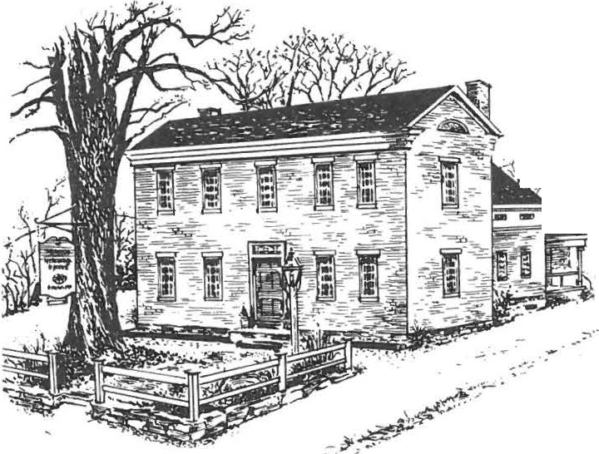

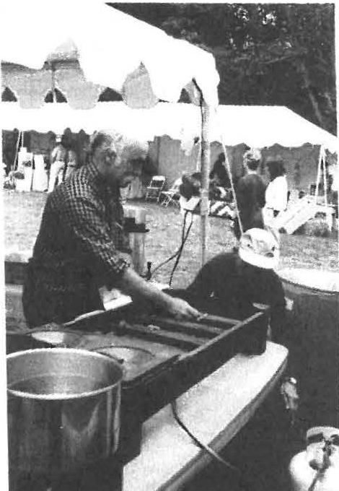
A Successful 5th Annual Festival of Arts & Artisans

Throughout the day, amid the rain drops, people kept coming to the fair; by the end of the day 350 had come through the gate! Comments from craft demonstrators, visitors and the volunteer staff were all extremely positive. No soggy spirits here. There was a new physical layout which worked well and provided a cozy atmosphere; the tents kept everyone dry and in close contact with each other. Demonstrators found a high level of interest by patrons who asked in-depth
questi ons. The rain even helped to keep the visitors shopping in our Country Store, located in the Carriage Barn this year. Smells of onions on the grill wafted all around the site and brought many a mouth watering person to the food tent. A sound system provided background music to lift the spirit s. For several hours, WSBS did a live broadcast of the Festival. House tours were popul ar, especially at the beginning and end of the
day. Children 's activities kept all age levels busy. t J
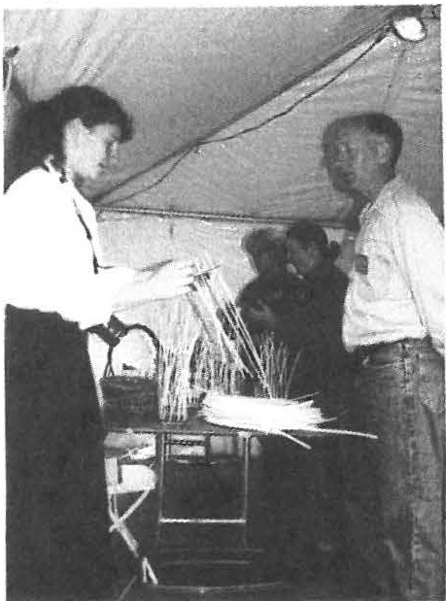
Baskets were the popular craft of the day, with corn husk dolls a close second . Weaving and 18th century games also delighted the young. A survey was conducted to learn how visitors heard about the Festival. As people left, many stopped to give a word of thanks for the high quality of the demonstrators, the great food and a rainy day made enjoyable by our efforts. The Festival is a success because of the hard work and dedication of so many volunteer s; to everyone involved THANK YOU!!

Above: Hany Conklin and AnnRiouse t things on fire at the Food Tent.
Left: (moving left to right) Kathy Orlando, Chris Kelley. Gail Anderson and Jim
Ande rson p repare baske t bases for childr en to weave . Photogr a phs by Catherine Mille r.

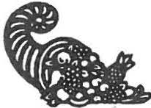
1999 FALL SCHEDULE

September 10: "History Can Be Fun" with Bernard Drew
Friday 7:30 pm, Dewey Hall, Monthly meeting , Free and open to the public
Drew' s presentation will examine three ways of compiling local history information: paper research, personal interviews and field investigation. He will use as illustrations the violent end in 1898 of a former state prisoner and one-time Sheffield resident Frederick Webst er, and " Bullet" Kline's reminiscences of Egremont Plain when it was an onion field. Drew will also present the result of his summer outdoor research, the pattern of charcoal hearth sites on Monument Mountain in Great Barrington and how it can change our perception of a mountain as industry
and as literary inspiration.

Drew is a past president of the Berkshire County and the Great Barrington historical societies . He is the author of Great Barrington: Great Town * Great History and The Berkshire Photo Album: Historic Images 18 70s-1990s.

October 8: "Unredeemed Captive Eunice Williams" by Nancy Knipe
Friday 7:30 pm, Dewey Hall, Monthly meeting , Free and open to the publi c
Storyteller, guide at Historic Deerfield, and retired school teacher, Nancy Knipe will relate through first person interpretation the harrowing experiences of Eunice William s. My memories of Deerfield were of gunshots, screaming, fire and blood. I wished never to return. I spoke as a Mohawk. I thought as a Mohawk. Theses were my people. I was an Indian. These were the words of Eunice Williams who as a seven year-old child was violently taken from her Deerfield home in February of 1704. Come and hear her life story.

October 23: "The Spirits of Sheffield Cemetery Walk" led by Dennis Picard
Saturday, 7pm, Sheffield Plain Cemetery, Free to members, $3 non-members
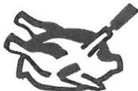
Make cont act with the voices from Sheffield's past in this evening of spiritual communications. Meet at the cemetery located on the west side of Route 7, just north of the center of Sheffield.

October 24: 25 th Annual Turkey Dinner to Benefit Our Scholarship Fund
Sunday 12 :00 noon and 1 :30 pm, Ameri can Legion Hall, Route 7
Adults $8, Children under 12 $3 .50 (all you can eat, except for dessert)
Join us for the 25th annual Turkey Dinner to rai se funds to benefit the Society's educational programs and scholarship s at the Southern Berkshire Regional School. Our expert in culinary turkey delights, Harry Conklin , under tutelage of the original turkey master, Milton Barnum, is again chairing this event. We can use your talents in baking pies, peeling vegetables, roasting those birds and of course in setup and cleanup. Mark your calendars for the feast, and be sure to bring along a friend.

November 12: "Decorative Painting" with Barb ra Willner
Friday 7:30 pm, Dewey Hall, Monthly meeting, Free and open to the public
Willne r, a member of the Historical Society of Early American Decoration , will present an illustrated program on faux painting .

November 20: "della Robbia Workshop" with Dennis Picard
Saturday 10 am to 12 pm, Reservations required, $15 members, $20 non-me mbers, supplies included Remember the lovely decoration over the Dan Raymond House door last season? That was della Robbia. Prepare your home for the holiday season. Using hard fruits such as apples, various trims and household ingredients, create a beautiful centerpiece or a hanging arrangement for your fireplace, wall or door. (Fall Sched ule Continued)

II 7 e cordially invite you to enter
YY the 19th century and visit the
Storrowton Village Museum, a per­ manent reminder of New England life in bygone days.
Nestled in a quiet corner of the Eastern States Exposition in West Springfield, Massachusetts, Storrowton is an authentic recreation of a 19th century village withnine historical buildings assembled around a traditional Green.
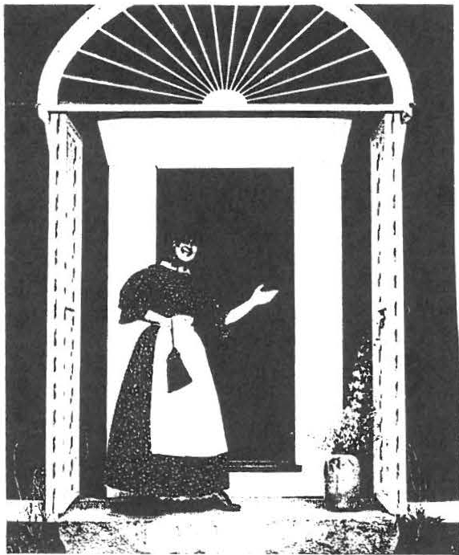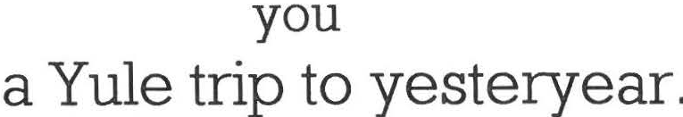Cost: Members $35.00 Non-membe rs $40.00

Storrowton Village Museum
and
Storrowton Tavern offers
''A Taste of History''
Wednesday-December 8, 1999
Leave from the American Legionparking area at 9:00 AM
Returning about 2:30-3:00PM

RESERVATION FORM --- STORROWTON
Name(s) Tele . No. _
Address.
Enclose d: $ _

Sample Menu
Cranberry Shrub Herb Rice Pilaf
Baked Scrod or Yankee Pot Roast Maple-Laced Butternut Squash Deep Dish Apple Pie or Indian Pudding

Please make check payable to: SHEFFIELD HISTORICAL SOCIETY
and circle choice of Baked Scro d or Pot Roast/Apple Pie or IndianPudding.
Please return to: GraceArzt. P.O. Box 484, Sheffie ld , MA 01257 by Novem b er 17, 1999

NEWS FROM THE MARK DEWEY RESEARCH CENTER

Rene Wood has donated four very important 19th century readers, spellers and arithmetic books used in Sheffield public schools. The volumes date from 1816 through 1874, and, significantly, are signed by their student owners including Joseph S. Wilcox and Eliza A. Sage. The books shed insight into the curriculum taught in Sheffied during that time and the signatures guarantee their connectionto the town' s heritage . Further research will make it possible to pin point in which of the thirteen one room schools the books were actually used. These volumes are a quantum leap forward in understanding the history of education in Sheffield.
Does anybody have similar books?

► DID YOU KNOW? ASHLEY FALLS CEMETERY.
According to the Berkshire Courier of April 19, 1876, available at the Mark
Dewey Research Center, the Ashley Falls Cemetery Association moved remains from the old cemetery to the new one. About one dozen bodies were removed in one week.

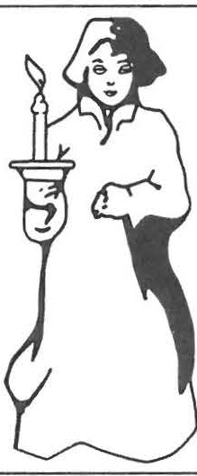
You are needed!

Our Cemetery Walk needs people to host the admissions and refreshment tables.

We especially need those of you with a sense of the dramatic­
yes we are looking for people who would be willing to be spirits for the evening. Information and costuming help will be provided by the Sheffield Historical Society. You provide the voice. Male, female
and children's parts are available. If interested,
please call! (229-2694) The cast should be set by the end of September.

► THE KELLOGGS OF BATTLE CREEK, HADLEY AND SHEFFIELD. Will Keith Kellogg who established and gave his name to the W.K. Kellogg cereal company of Battle Creek, Michigan is a member of the sa me Kellogg family still living in South Berkshire County, under that name and related surnames including Austin, Beebe, Root, Cowles, and Chapin, among others. One of the burial grounds in Sheffield is known by some as Kellogg Cemetery and to this day is maintained by local members of the family.
The Sheffield branch is descended from Deacon Silas Kellogg who was born in Westfield, April 7, 1714 and died in Sheffield January 2 4 , 1792. He is buried on the Plain in Sheffield. He married Ruth Root in Westfield May 10, 1 739 and they had a total of 65 grandchildren. Thus, the family is widely distributed.
The common ancestor of Deacon Silas and Will Keith is Lieutenant Joseph Kellogg, baptized in Great Leighs, England, April 1, 1626 and died in Hadley, Massachusett s sometime between June 27, 1 70 7 , when his will was dated and February 4, 1 708 , when it was proved.
Deacon Silas was second generation American, grandson of Lieutenant Joseph. Will Keith was sixth generation and fourth great grandson of Joseph.
Additional Kellogg and related families information is available at the Mark Dewey Research
Center.

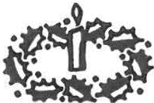
(Fall Schedule continued)

December Dan Raymond House Holiday Festivities
Sunday 5f h , 2 to 5 pm, Free and open to the public
Experience the joys of childhood with the opening of our exhibition "Toys over Time." What were the most popular toys of the 18 th, 19 th and early 20 thcenturies? Come and view the Dan Raymond House decorated for the season, and learn about the toys of yesteryear. Join us for steamy beverages, 19 th century desserts and entertainment.

Friday the Jrd, 10h, and ll"h, 11 am to 4 pm, Free to member s, $5 adult s, $4 seniors,
$1 ages 6 -16 Enjoy holiday guided house tours and view the exhibition "Toys over Time."

December 8: Yule Trip to Storrowton Village "A Taste of History"
Wednesday 9 am to 3 pm, $35 members, $40 non-members, reservations required by 11 I 17 /99 Bus trip to Storrowton, an authentic recreation of a 19 th century village, located at the Eastern States Exposition in West Springfield, MA. View nine historical buildings assembled around a traditional Green and have lunch in the Storrowton Tavern . (See enclosed sign- up sheet.)

December 10: Yuletide Stroll and Dessert in Ashley Falls
Friday 6 pm, Free to members, $5 non-memb er s
Visit Ashley Falls, viewing the lights and decorations, and enjoy holiday refreshments at Trinity Methodist Church.
Additional details on the holiday season and next year will appear in the November newsletter . **7<'fhe Newsletter is under construction-comments?***

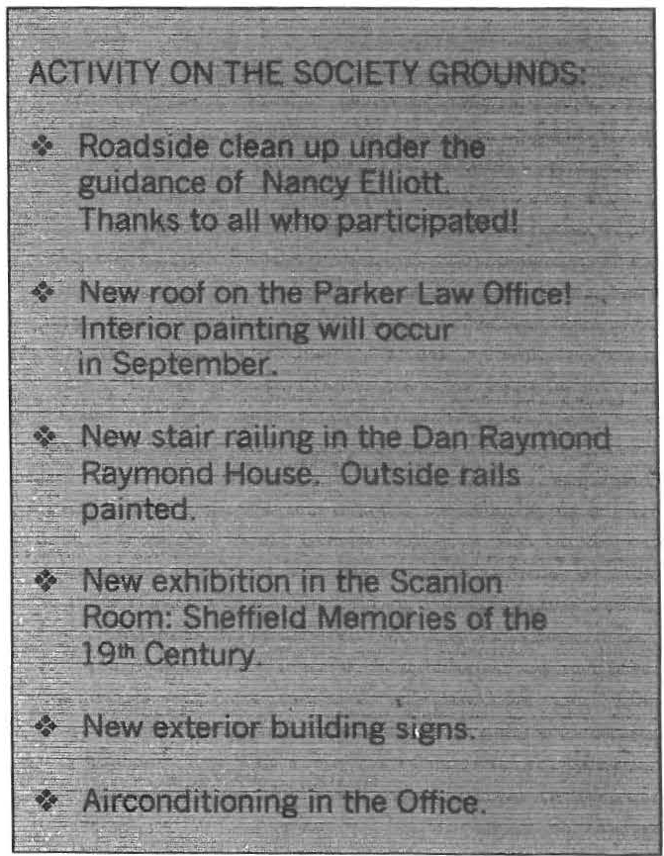
► 1826 ANNUAL TOWN MEETIN G.
At the annual town meeting, 1826 , $1 ,500
was voted to repair highways, $750
to support schools. The original town warrant is on file at the Mark Dewey Research Center.

Toys, Toys, Toys- we are searching for items for "Toys over Time" our holiday exhibit. If you have an item you would like to loan, please call us at 229-2694.

► GEORGE FREEMAN. According to the Mark Dewey Research Center, Freeman sett led in Sheffield ca. 1845 and on a town document of 1854 he listed his age as 93, giving him a birth date of ca. 1761. But the most interesting part of his birth was the location, noted on the document as "on the Ocean."
George, a black man who first came to Massachusetts in 1 8 1 0 , was born in bondadge aboard a slave ship.

The Sheffield Historical Society Newsletter is published quarterly. For further information contact Joanne Hurlbut. Dire ctor , Sheffield Historical Society, 159-161 Main Street, P.O. Bo x 747 , Sheffield , Ma, 01257, (413-229-2694). The Society's fax is up and running (413-229-3682); since the fax works through the computer, p le ase call to confirm the computer is ready to receive your fax.

Sheffield Historical Society
P.O. Box 747 Sheffield , MA 01257

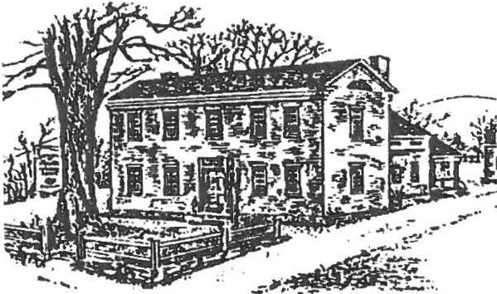
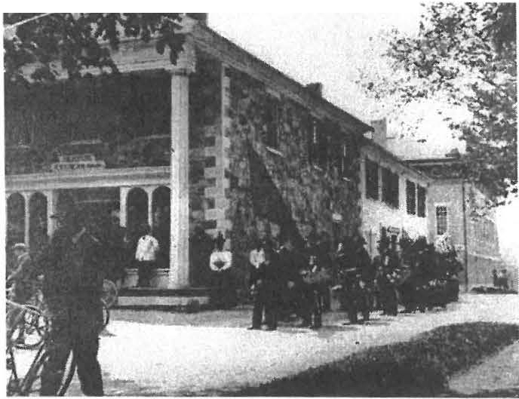
SHEFFIELD HISTORICAL SOCIETY FALL/WINTER NEWSLETTER 1999

Society Acquires Old Stone Store

The Society was presented with an unusual opportunity late in the summer; the Old Stone Store, the longest continuously operated business establishment in Sheffi eld, was available for purchase. The owner had given Berkshire Bank a deed in lieu of foreclosure, and the Bank, interested in assisting the Society and ultimately the town, agreed to sell the building for
$30,000 and return a $10,000 contribution to the Society to assist in its restoration . Harry Conklin generously contributed his legal services, and the closing took place in early October.

The Trustees have agreed that the later frame addit ion at the rear of the building will be removed and only the original stone section will be restored. The first floor will become permanent and rotating exhibit space for the Society, and a visitor information center. It is expected that the increased visibility provided by •
the exhibit space will enhance the number of visitors to the main campus of the Society. The second floor will be converted to rentable office space to provide income to maintain the structure.

John James has agreed to oversee the restoration and will assist the Society in applying for a grant from the Massachusetts Historical Commission. Joanne Hurlbut, our Director, is also pursuing grant possibilities . There will be very little work on the building until the status of the grant applications is known because one of the major grants will not fund work retroactively.
Decoration Day 1900
In the meantime, however, Joe Wilkinson and crew Civil War veterans marching by the _{Old} Stone store. have removed the mid -20 th -century porch, rebuilt a
portion of the foundation, reset the marble steps, and tied the front of the building into the new land scaping being done to the town green. Plans call for cleaning the front of the building before winter and repainting some of the masonry.

This is an exciting opportunity for the Society and for Sheffield. The building, constructed of stone from the Hewins quarry, was built circa 1835 by the Ensign family. It has had an important heritage in Sheffield and strategically forms the cornerstone of the north end of the green. When the frame section is removed and grass is planted in that area, the Town Hall, also built by the Ensigns, will be more visible.

Society Monthly Meeting Schedule 20 00*
Agnes Boardman Memorial Gifts

Agnes Boardman , an early Society member who served as a Trustee and Secretary, passed away recently in Granby, CT. Her family requested that memorial gifts be made to the Sheffield Historical Society and over $1,000 has been received to date . Agnes , who loved people, and children in particular, was a dedicated teacher and early in her career taught in Sheffield's Brush Hill School. In view of that fact, the m emorial will be used to support the school programs held at the Society.

January 14: "What's It" with Milton Barnum
Join us for the annual "stump the expert s" evening. Share your unusual treas ures, large or small, with your neighbors.

February 11: "Mysteries of Title Searching" with Lynn Wood
Discover the st ories of Sheffield' s p ast as you learn abo ut settlement in areas such as Bow Wow Roa d.

March 10: American Period Gardening

April 14: "All to the Tune of a Hickory Stick: A Look at Education in the One Room Schoolhouse" with Dennis Picard
Using peri od cost um ing and art ifact s, Dennis Picard wil l take you back in t im e to the school
days of mult i-generational education and classroom manners.

May 12:

June 9:
"History of Tea" with John Harney Annual Meeting

-x•AII m eetings wi ll be held at Dewey Mem orial Hall at 7:30 pm and are free and ope n to the
public.

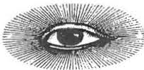
Look for special programming in 2000 relating to women's history, in particular exhibitions and programs based on the photographic work of Sheffield's artist Carrie Smith Lorraine (1868-1935). Projects are contingent upon receipt of pending grants.
► 1776. Samuel Church, born in 1721 in Wethersfield, CT, married Thankful Hewitt and settled in Sheffield. His children were all born in town but in 17 74 or '75 he traded his Sheffield farm, valued at $3,000, for 3,000 acres of land in Hubbartown, VT, where he moved, cleared a place, and built a house. His family suffered so much in July 1776 from an attack by a party of Tories and Indians that they started to return to Sheffield, a trip, by a roundabout way, that took them some 350 miles, reaching Sheffield in about three weeks. Two of his sons were prisoners of the British until liberated by American forces in October of that year.

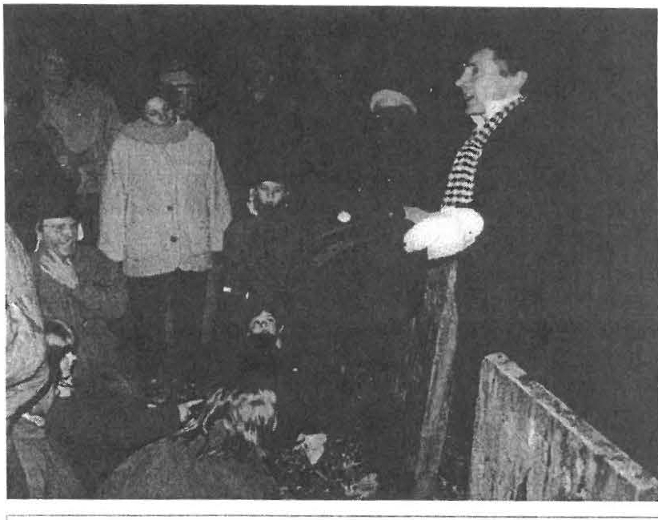
Recent Programs

The Spirits of Sheffield Cemetery Walk

This year's progra m in the Plain Cemetery saw a cast of seven spirits, from Revolutionary leaders and wome n who suffered from Sheffield's plagues to a
19th -century preacher and an Ir ish immigrant. Over 60 visitor s attende d and gave rave reviews of the perform ers. A special thanks goes out to everyone who helped wit h the event from actors to ticket s and re freshments volu nteers. Our guides were especially indispensable as they led the guests nimbly through the
cemetery from spirit to spirit. Participants stand near the grave of Ralph Little (1785-1856), a Sheffield I
merchant and par-t owner of the 'm eadow quarry," portrayed by Neal Chamberl ain. Photo bv: Kathy Orlando
The Annual Turkey Dinner

Under the skilled leadership of Harry Conkli n wit h Milton Barnum 's guiding touch, this year's Turkey Dinner was anot her resounding success story. Close to $1000 was raised for our annual schola rship program. One connoisseur of tu rkey dinners proclaimed this the best one in the tri-state area! Success st ories like th is happen only wit h t remendous tim e and effort expended by a large and multi -t alented group of volu nteers. Thanks to all involv ed including the cooks, bakers, pie people, ticket takers, hosts, servers, scrapers, dishwashers, and student s. A job well done!

► 1773. Edward Cornwell, nearly five years old, and a "poor child,• was appren t ic ed by the Sheffield Overseers of the Poor to Joseph Ferre, Senior, and his wife, Sarah. Edward was to be taugh t "the common business of husbandry & also learn ... to . . . write a fair hand . . . & likewise . . . arithmetick that he shall well understand the rules of addition, subtraction multiplication and division if he the said servant be capable of learning the same & also provide the said servant . . . meat, drink, washing & lodging & all other things necessary in sickness & in health.· For his part, Edward was required to faithfully serve the Ferres in all lawful business according to his best
power and ability and to behave "ho nestly , orderly and obediently" in all things.

► 1865 ELECTION RETURNS. In March town officials were elected, all Republican without
SHS Volunteer opportunities:
- Decking the Halls for the Open House: Thursday Decembef 2'd
- Assisting with collections inventory over the winter months
- Assisting with the Carrie Smith Lorraine exhibition and related programming
- Festival 2000 Planning
Call (413)229-2694 for details
opposition. John 0. Burtch was elected clerk and treasurer; selectmen, Emmons Arnold, Grove R. Griffith and R. Dwight Andrews; assessors, James Bradford, Tillinghast 8.
Strong and M.H. Wickwire; school committee, the Reverend J.W. Beach and H.T. Candee.

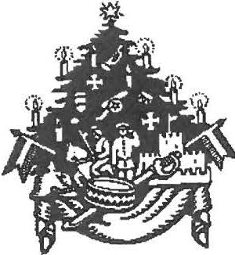
Dan Raymond House Holiday Festivities:
"Toys over Time" exhibit, & holiday decorations

* Open House, Sunday December 5th, 2 to 5 pm, refreshments, hands-on activities and entertai nment , free
--l( Friday tour s, December 3r d, 10t h, & 17th , 11 am to 4 pm, member s fr ee, adults $5, senior s $4 , ages 6 -16 $1

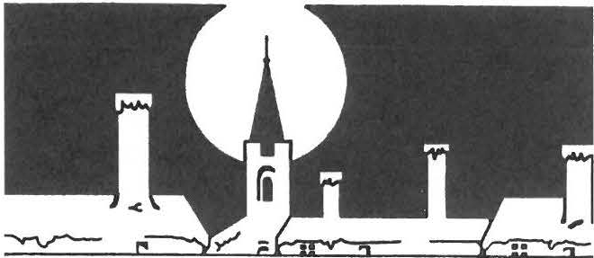
Yuletide Stroll and Dessert in Ashley Falls Friday, December 10 at 6 pm
- Four historic buildings
' Sounds of holiday music at the Trinity Methodist Church
f Entertainment, Refreshments
Festival of Miniature Trees and Della Robbia decorations, for sale and by raffle
- < Members free; non-m embers $5

The Sheffield Historical Society Newsletter is published quarterly. For further information contactJ o anne Hurlb ut , Director, Sheffield Historical Society, 159-161 Main Stre et, P.O. Box 747, Sheffield , MA 01257 (413-229-2694) . The Society 's fax is up and running (413-229-3682); since the fax works through the computer. please call to confirm that the computer is ready to receive your fax.

Sheffield Historical Society
P.O. Box 747
Sheffield, MA

DAN RAYMOND HOUSE HOLIDAY FESTIVITIES YULETIDE STROLL AND DESSERT IN ASHLEY FALLS

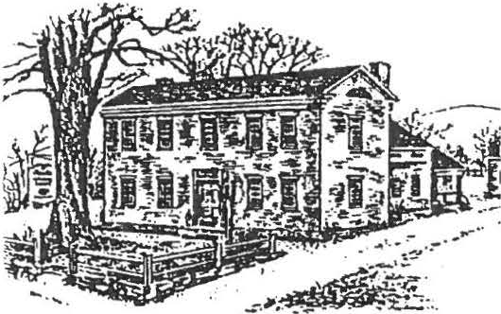
SHEFFIELD HISTORICAL SOCIETY SPRING NEWSLETTER
2000

Sheffield: Through the Lens of Carrie Smith Lorraine (1868-1935)

The Sheffield Historical Society's traveling exhibition of photographic works by Sheffield native Carrie Smit h Lorraine will open in April. The images preserved by Lorraine on glass plate negatives create a window into life in Sheffield at the turn of the 20th century.

The Sheffield Historical Society is the recipient of two grants for this project; the Berkshire Taconic Community Foundation awarded $1000 and the Massachusetts Foundation for the Humanities awarded
$2,465 to SHS to underwrite the exhibition. The Massachusetts Foundation for the Humanities receives support from the Massachusetts Cult ur al Coun cil and is an affiliate of the National Endowm ent for the Humanities .

Sheffield: Through the Lens of Carrie Smith Lorraine (1868-1935) will be divided into
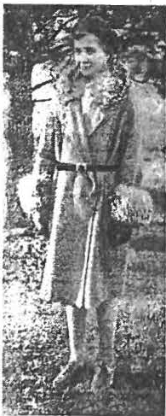
three segments, to highl ight Sheffield structures, individuals, and daily events. The opening reception will be
held at Dewey Memorial Hall on Saturday, ApriI 15th, at 3pm. Nationally and internationally known local
photographer Ann Shanks will present a lecture on women and photography of 1900.
Can you 1dennfy UllS I 2 year -old p ho togr aph ed b y Lorr aine?
Hmt: She lS an SHS membe r

The exhibition will then travel to the Bushne-ll Sage Library, opening on the 1st of May. A school project in conjunction with th is exhibition will result in local student works being added to the library showing.
Jim Miller will present a lecture on May 20th entitled "Material Culture of Sheffield at the Turn of 1900. " Additional exhibition programming include summer workshops for youth.

Documentary Heritage Grant Award

Discovering Local Resources, a collaborative endeavor by the Sheffield Historical Society, the Egremont Historical Commission, and the Town of Sheffield, has been awarded
$3,801 through the Documentary Heritage Grant Initia ti ve. The program is sponsored by the Massachusetts Historical Records Advisory Board, the Secretary of the Commonwealth, William Francis Galvin and the National Historical Publicat ions and Records Commission.

During Apri l, records management consultants Peter J. Parker and Cynthia G. Swank of New Hampshire will survey the local historical records and create a comprehensive study of the resources availab le at each location . This informati on will then be disseminated to the public through a "Records Access Workshop" to be held on May 10 th from 1 to 3 pm. An all -day follow-up workshop , "Getting Started with Preservation " will be presented on May 18 th by the Northea t Document Conservation Center . Both workshops are free and the public is encouraged to attend· reservations are required . Call 229-2694. '

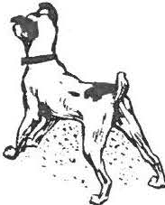
Dog Tale from the Mark Dewey Research Center
( From a CT family genealogy)

Captain Abijah Ranney of Sheffield, Mass., was a son of one of the first settlers. The Captain lived in Cromwell until he had grown to manhood. He married for his second wife Mrs. Annah Stillman Tallcott of Glastonbury, grandmother of Judge Thomas H. L. Tallcott of that town. Captain Ranney was the owner of a dog remarkable in many ways, and who once saved the Captain from being robbed, and, perhaps, murdered. Judge Tallcott often heard the story in his youth, and related the tale to a reporter recently. The story runs as follows:
Early one morning a man called at the
Captain's house and said the Captain's dog was killing his sheep. Captain Ranney said it couldn't be his dog, as the canine was shut up in the woodshed and had not been let out that morning. They visited the woodshed and found the dog in his bed. The man said: "It isn't your dog that is killing the sheep, but one that looks just like him." Other complaints were made, but on going to the woodshed the dog was always there. Finally one morning a man drove up at top speed and said to the Captain: "Your dog is in my sheep; I left him there and raced my horse to get here before he did."
"Well," said Captain Ranney, "we will look
in the woodshed."
They went to the shed. The dog was there, but covered with blood and licking himself. The only way out of the shed, except by the door, was a small opening just a little larger than the dog's body and about four feet from the floor and the same distance from the ground outside. Through this small opening the dog had leaped in and out in his trips to the sheep field. The idea that the dog could use the opening to enter and leave the shed had not occurred to the Captain, and he was greatly surprised. Turning to the visitor he said: "It is my dog that is killing sheep! I won't keep a dog
that kills sheep." He told his sons to tie the dog up back of the barn, and that after breakfast he would shoot him. The boys put a rope on the dog, and evidently tied it very loosely, as they felt bad at the idea of losing the dog, who was much liked by the family. When the Captain and the boys went out after breakfast the dog was gone. He was not seen again in Sheffield that summer, and no more sheep were killed.
Captain Ranney sold his cheese and other farm products to a merchant over the New York State line. It was the custom to collect in the fall for the product taken. The fall of the same year in which the dog left his home, Captain Ranney went on horseback to the New
York town, made a settlemen t with the merchant and was then ready to start for home, intending to go to the next village, where he would remain over night. It was nearly dark, and the merchant and others tried to persuade him not to start until morning. There was a long and dark piece of woods between the two villages, and several persons, who had started to go from one village to the other, had never been seen after entering the woods. It was supposed that they had been murdered.
Captain Ranney said he had a good horse and thought he would get through all right. He had proceeded well into the woods when a man sprang into the road from behind a large rock, and grasped the horse by the bridle. A large dog followed the man. The man said to the dog, "Seize him!" The dog looked up at the Captain and whined. The man repeated,• Seize him, I tell you seize him!" Still the dog would
not obey the man. Captain Ranney looked at the canine and saw it was his old dog. He turned to the man, who still held the bridle, and said:
"You have tried your luck with the dog, now I'll try mine." He called the dog by his old name and said, "Seize him!" The dog instantly jumped at the robber and had him by the throat, tearing open his jugular vein. The dog looked up at
Captain Ranney and whined. The Captain said to him. "You can go home with me. /'II keep you now if you kill all the sheep in Sheffield." The. dog leaped about in an ecstasy of joy at meeting his old master again and the permission to return home with him. Captain Ranney
continued on to the next village and reported to

the officers. A posse started at once and found the dead body of the man near the rock. The next day there was a general turning out of the men of the village, who made a thorough search of the woods to find the quarters of the robber.
They found the place about a mile from the road. There were evidences of graves of several persons, the skeleton of a horse, and a peddler's
wagon, accounting for the mysterious disappearance of a peddler some months before and also of other persons.
Evidently the man had trained the dog to aid him in killing his victims.
Captain Ranney continued home the day after his adventure, taking his dog with him.
Great was the joy of the family at seeing the animal again, and it is not stated that he was ever again guilty of killing sheep.

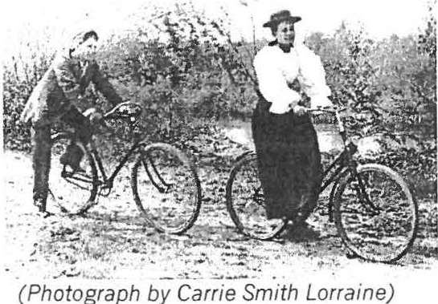
Spring Travels
Twiggs Myers at 229 -28 11 . Drivers are needed!

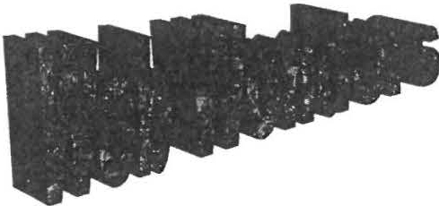

The Sheffield Historical Society web site is now operat ional! Click on
sheffieldhistor y.or g and you will arrive at the home page. From here you can go to the new e-mail address sheffhs@bcn.net with a click of your mouse, or you can contact the Office directly via the Internet. A big thanks goes out to Gregg Siter, who was instrumental in getting SHS on line!

Volunteer Opportunities

- Looking forward to the summer? Help us organize this year's Artisans Festival.
- School groups will soon be here--can you
help with the A Place in Time program?
- Do you have that artistic flair? Join us for the Carrie Smith Lorrraine exhibition.

Get ready for that Spring touring trip! On Wednesday, May 17 th, travel thr ough the Hudson Valley region to di scover the lifestyle of the "landed gentry," stopping first at the Clermont State Historic Site . View the home of the socially and politically prominent Livingston family of New York for over 230 years. Then travel on to Montgomery Place for a box lunch on the squash court. Finish with a tour of the 1804 Federal-style home of Janet Livingston Montgomery, remodeled in the 1860 s into a Classical Revival mansion. Car travel, admission to the museums, and the box lunch are all included for approximately $20. For further information or to register for the trip call SHS at 229- 2694, Marion Whitman at 229 -2129, or
New Education Brochure Available for Teachers

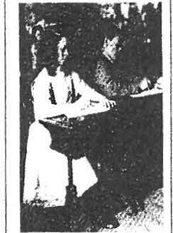SHS's first such brochure is being distributed to local teachers. If you know of any educators in the area, such as home school leaders, who could benefit from our programs including the MDRC archives, please call the SHS Office with the contact name and address.
SHEFHELD IHSTORIC \I. SO(')ETY

rn lJL \TI O PIW(iK\i\lS 2000-l.00I

'llembership Renewal Reminder
Wish List

If you have any of the following obJects in good condition, but you no longer need the item , consider donatin g to SHS. Monetary contributions to be used in purchasing the item s are also welcome.

Floor lights , Screw gun, Glue & Staple guns, Folding chairs, WWI & WWII info, Old scrap books

- leas e keep in mind that as of September l 999, your membership expiration date, .
nonth, and year are indica ted in ( ) to the right
)f your name on the mailing label. If you still 1ave a (9/99) next to your name, that means
,our membership has lap sed. Please use the
!nclosed membership mailer to update your nembership.

Upper Housatonic Valley National Heritage Area designation being sought to preserve and enhance our local resources.
Upcoming Meetings:

April 14--''All to the Tune of a Hickory Stick" with Dennis Picard
May 12 --"Historyof Tea" with John Harney June 8--Annual Meeting
George Washingto'!,n concert by nation l!Y_
Special vent: 11.!Iy 1(;1h.• "The World of
known David & Ginger Hildebrand , plus actmlles
{look for more details in the June newsletter}

Join the Tri-Corn ers History Council and local community organizations to seek government approval of this national treasure. Learn about the process and goals for this proposal on Saturday, April 15th, from 10 am to 1 pm at the Mt. Everett High School. A lecture by Ed Kirby, author of "Echoes of Iro n," will be presented.
Cultural organizations will be there to showcase their offerings to the public. Call the SHS Office at 229-2694 for further details on ways to get involved, especially in the local political realm.

Sheffield Historical Society
P.O. Box 747 Sheffield, MA

SHEFFIELO:
THROUGH THE LENS OF CARRIE SMITH LORRAINE

OPENING RECEPTION & LECTURE on "Women and
Photography"-•APRIL 15 TH
LECTURE on "Material Culture of Sheffield at the Turn of
1900 "- •MAY 20"'

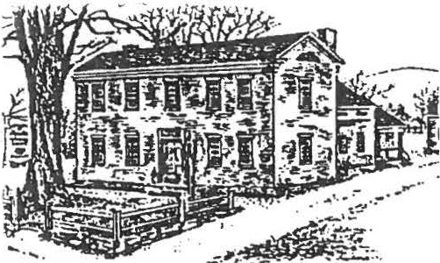

The World of George Washington
Join the Sheffield Historical Society and the
SH£FF/£LO HISTORICAL
SOCIETY

SUMMER--N£WSLETT£R
2000
less refined aspects of music associated with our War for Independence and our First President. There will be plenty of opportunity for questions after the program.

Old Parish Church in celebration of life in early
America, on Sunday, July 16 , 2000 . The events will include tours, hands-on activities, and a Colonial concert.

The Sheffield Historical Society's 1774 Dan Raymond House will be open for guided tours and family hands•on activities. Events will start at 12 pm, and run before and after the concert.

The concert, featuring "The Music of George Washington's Time" by D avid & Ginger Hildebrand, will take place at 2 pm in the Old Parish Church. The Hildebrands will recreate a wide range of musical styles, focusing on the 1770s .. from popular theater songs and dance tunes to military ballads and "Liberty Songs" of the Revolution. There will be a special emphasis on music related to George Washington and tunes heard in early Massachusetts.

The Hildebrands, speciali sts in
colonial/ Revolutionary•era music, will perform on authentic and reproduction early American instruments •· violin , Baroque guitar , English guitar, hammered dulcimer, harpsichord, and English flute; they also sing. Costumed appropriately, they intertwine their musical and historical offerings in an entertaining and educational fashion. This program will include a ballad composed in honor of George Washington to the tune of "The British Grenadier s,· as well as several popular songs for The Beggar's Opera and dance tunes like
the "Whi te Cockade." The music and
explanations will highlight both the formal and

The Hildebrands served as period music consultants for the PBS series Liberty! The American Revolution, and contributed to the soundtracks of Jefferson: A View from the Mountain and C·SPAN's American Presidents series. They have performed at the National Portrait Gallery, the Smithsonian Institution , and at numerous other historic sites. Among their recordings is the recent George Washington: Music for the First President.

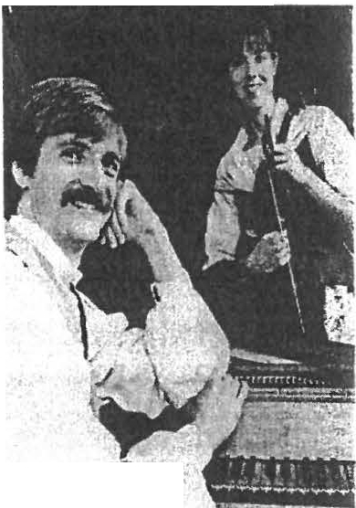Ginger earned her B.A. in music from Dickinson College, and an M.M. in guitar performance from the Peabody Conservatory.
''-
She currently teaches classic al guitar and does special solo outreach programming for the Baltimore Symphony Orchestra. David received his Bachelor's from Dickinson, an M.A. in musicology from George Washington University, and a Ph.D. from Catholi c University. He
teaches American music history at the Peabody Conservatory and is finishing a history of music in Maryland.
- -· •r.• I"'' ...... ......-.,,....,..,. • - '""':'..
The Dan aymo a House activttie.s 'free,. \ Concert, t c ets ar 1O/adult and $?l youth ( -r and under). Contact SHS at (413) 229-2694 <? 1, the Old Parish Church at (413) 229-8173.

Festival of Country Arts & Artisans

The Festival will soon be upon us and our dedicated volunteers are working hard to put the event together. Crafters have signed up for the day. Still, we need you to lend your assistance in whatever way best suits your time and talents. Keep the date in mind: Saturday, August 19 th.

Could you assist Rene Wood and Barbara Burns in the realm of culinary treasures? Our production of the famed pies known throughout the county is critical.

Do you have that shopping mania? Dorothy Marosy will oversee the country store, which will showcase items by crafters and contain numerous other period items. Other areas in need of volunteers include guiding visitors through the Dan Raymond House, youth activities , and the evening meal for crafters.

Special Features for 2000 included expanded offerings of activities for youth and magic presentations. The youth activities will have a "sheep to shawl" flavor. Dominick Polumbo will bring sheep for the day. Hands-on activities will include carding and more.
Pictured to the right is our entertainment guest for the day.

The day holds great promise, and we need not worry about logistics since Ann Riou will keep us all in good order. But we still need your help. Call the Office at 229-2694 and let us know in which way(s) you can help to ensure the success of the Festival.
f ""1'1 it'·
Tbe Festival iss;always a· Qositive experience, but it h sy Ho pea (fnanc_ial success; i,n fact, if has lost
money every year. ,Please consider underwriting one
. 'Of th e.items listed bel9.w and h. eIp us prove good
. stewardsof all of the Society•s'resources.
,.'"" •;
Could ypu give: $60 for a tent
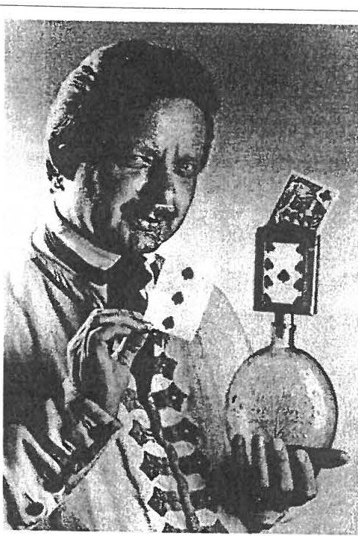
Robert A Olson

Robert A. Olson will bring magic from the past to create pleasures for the present.

Clad in knee breeches, red waistcoat, and a trico rn hat, Robert Olson will reincarnate Mr. Bayly, an eighteenth­ century magician.

Bayly, an actual magician, first performed in New York City in 1767. He advertised in New York, Baltimore, and Virginia, stating that he would present his feats of magic "without the use of Pockets, Bags, or Sleeves." At one show in 1782, money must have been in short supply, as potential customers for the show were told that they could use flax, wool, beeswax, or cotton as the price of admission.

Bayly's tricks are done with cards and coins, cups and balls, and a vanishing soldier, called "The Bonus Genus."

. , ;. ,• $25 foi you,thactivities ' ·i " 1 I/

.· u.t·IAl{/Y :J,sP for (ood costs ' r
·:.;.,.;t ;. .;
,\i:tfi 1.$1 o_ofoi th'e portafettes '(
'?W:i!·!; • •, $200 for.t e magic;i an
,.j
:i: tc
Robert Olson, from Old Sturbridge Village, has spent 30 years studying and recreating magic shows of history.

  - ,, :!
)
-i' , Buy an Ad--variedpricing
.. ' .
Through the use of period magic books,

- We/ e d several pons s tor tht tents, Y !1{ activ ti s,
. faoq, and ads. We need 2 sponsors for both the pflv1es
  - a,:J •thema iciaa: •Your.c_h aritablecontrif:/uti on·s are tax
, l g eq_uct1bfe. Sponsors w_i/1be fiste·d on the day of the Festival. THanR You!
letters, and diaries, he is able to recreate the mannerisms of a bygone era. Olson enables Mr. Bayly's magic to take place right in the hands of today's audience.

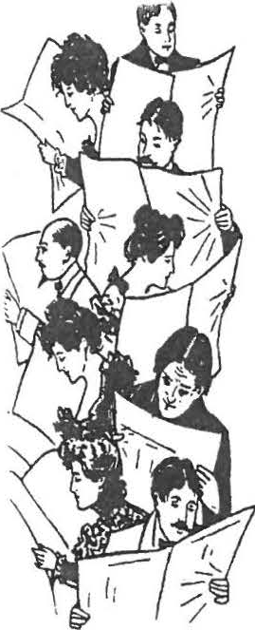
TH£ 28TH ANNUAL MEETING

Education Committee

The Education Committee sponsored two historical field trips this year. In December, Grace Arzt led us on an excellent tour of Storrowton Village. We not only had luxurious bus accommodations ,
excellent lunches, and good guides, but also made a profit of $270 for the Society.
(37 participated)

In May we sponsored a trip to Clermont and Montgomery Place in the Hudson Valley.
Twiggs Myers made all the arrangements for the tours of both properties and a catered lunch. The Livingston family histories in these two sites was fascinating to all. A modest profit was made on this excursion al so.
(11 par tic ipated)

"The Place in Time" program continues for first and second graders. The response is positive from all students and teachers who visit our property. The Educati on Committee recruits and schedules for the visits.

The 8th graders who helped at the Turkey Dinner fundraiser were treated to the annual breakfast cooked by Milt on Barnum. Chris Coenen worked with Milt on the meal and the What's It lesson.

More 8 th graders toured the property in June and learned more local history.

Many thanks go to all who work ed and contributed to the successful Turkey Dinner for our scholarship fund. This year's award goes to Douglas Campbell of No. Egrem ont, who will receive the $1,500. after successfull y comp leting his first year at the University of Verm ont.
\
Respectfully submitted, Marion Whitman, Chr. Members: Grace Arzt, Milton Barnum
Muriel Rokos, and Twiggs Myers'

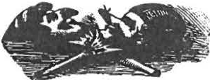
Program Committee

Comm ittee members Jeff Steele, David
Prouty, Dorothy Marosy, and Sandra Preston scheduled an interesting variety of monthly and special programs for the year.

The Fall 1999 season began September 10th with "History Can Be Fun ,• featuring Bernard Drew as the speaker. Mr. Drew is a past president of the Berkshire County and Great Barrington Historical Societies .

October 8 th.. Nancy Knipe presented "Unredeemed Captive Eunice Williams ." Nancy is a ret ired teacher and guide at historic Deerfield. Nancy told the story of Eunice Williams, who was captured in a Mohawk Indian raid on Deerfield in 1704 and taken to live wi th the Indians in Canada.

On October 23rd we held our second "Spiri t of Sheffield Cemetery Walk," led by Dennis Picard in the Sheffield Plain Cemetery.

November 12 th·-Barbar a Wil ln er, a member of the Historical Society of Early American Decoration, presented "DecorativePainting." We all had an opportunity to try our hands at stenciling.

November 20th--Dennis Picard again shared his many talents with a "Della Robbia" workshop. Participants made centerpieces and wall or door decorations, which were raffled off at the Christmas Yuletide Stroll.

December 10 th was the Yuletide Stroll in Ashley Falls. The participat'ing homes were beaut ifully decorated and the walk ended at the Trinity Methodist Church with music and refreshments.

The January meeting featured our annual What's It Night. On February 11th Lynn Wood

:ave a very informative talk on "Your Tool Box or the Registry of Deeds." And on March 10th, left Steele presented a beautiful slide show on Am erica n Period Gardens."

\pril 14th.. Dennis Picard took us back in time vith "All to the Tune of a Hickory Stick: A Look 1t Educati on in the One Room Schoolhouse,"
)ringing back memories to many in the iudience.

Vlay 1 2th.. John Harney, of Harney Tea in
:ialisbur y, CT, gave a most interesting and ntertaining talk on the "History of Tea,"
'ollowed by delicious samplings of tea.

Respectfu lly submitted, Sandra Preston
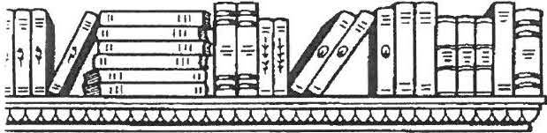

Mark Dewey Research Center

The Center this past year has been staffed by Betty Chapin, Kathy Hutchison, Betty Dunk, Eleanor Griffiths, Dorothy Marosy, and Pauline Dennis Schumann and was open Monday and Friday afternoons and by appointment. A special thanks to the volunteers who covered for the three months I was away, and especially to Betty Chapin, who was acting Director during that time.

Inquiries have come from across the United States and from Mexico and Canada by U.S. mail, e-m ail, and walk-ins, with many referra ls from the Sheffield Public Library and Town Clerk's Office.

A maj or goal for the year was to have e-mail and a web site, and through the volunteer services of Gregg Siter that goal has been achieved. So our Library now has the entire, rich historical resources of the Internet available .

Another milestone was a needs assessment done through a grant Joanne Hurlbut was able
to get that pointed out some of the strengt hs and weaknesses with in our system. The recommendations will be evaluated and some incorporated in to our procedures. The grant also included funding for a daylong workshop on archival work that was held with the Egremont Historical Commission and the Town of Sheffield. Betty Chapin, Joanne Hurlbut, and I attended the session for the Society.

In addition to the internet resources, major additions to the collection the past year have been pho tographs from Holly Coon; an anthology of children's literature written in Sheffield by A.O. Tower of Sheffield from Inez Flynn; numerous World War I items from Norma Moulton, including a diary of Eugene Reed written from the Western Front ; 19th. century textbooks used in Sheffield and photographs and glass negatives from the estate of Millie Smith. We continue to look for donations to our collection.

This year marks the 10th anniversary since the founding of the Center. During that time its collection and the resources it provides to the community have grown far beyond anybody's expectations. This year also marks the end of my tenure as Director , but I will continue as archivist, cataloger and as a volunteer researcher.

Respectfully submitted, James Miller

Nominating Committee

The Board of Trustees for 2000-200 1 is as follows:

Position Individual | Term Expires
President' Dorothy Marosy | 2002
Vice-Pres.* Katherine Ness | 2002
Clerk·" Harry Conklin | 2003
Treasurer Carl Proper | 2001
Trustee Grace Arzt | 2001
Trustee* Doreen Atwood | 2003
Trustee Bruce Howden | 2002
Trustee James Miller | 2003
Trustee Rene Wood | 2001
(*elected 6/ 9 / 00)

Development Fund

I'm pleased to report the Sheffield Historical Society Development Fund continues in excellent condition. The Developmen t Fund
Food Souvenirs
MARK DEWEY RC
Donation ACCESSIONS FUND
980.93
1,337.85

487.60

will close the year with total assets of around
$939,634 . In spite of a downturn in the market this year, the Development Fund will provide $79,000 funding to the Society's Operating Fund with only a year-t o-year reduction of $35,000 in assets.

The Sheffield Historical Society Developm ent Fund consist of two elements: fixed income funds from which income is derived for
Society operating needs, and equity funds with accumulation of inter est and dividends for future Society needs. At fiscal year-end 2000, the split of funds will be approx imate ly 27% fixed income or money market and 73% equity.

Thanks to the benevolence of current and past members coupled with great stewardship of too many members to mention, the Society continues to be blessed with a strong portfolio to support future programs for years to come.

Respectively submitted,
H. Dennis Sears, Investment Manager.

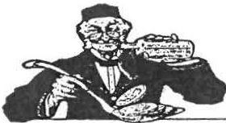
Treasurer's Report

Income July 1999..June 2000

OPERATING FUND
Deaccessions 4,320.00
TOTAL: $103,940 .8 2
Expenses July 1999..June 2000 OPERATING FUND
Grounds Care $1,551.51
Building Upkeep 1,68 4.14
Capital Building 4,916.4 2
Utilities 4,281.08
Housekeeping 213.62
Printed Supplies 992.96
Office Supplies 2,683.44
Postage 561.83
Meeting Expense 550.00
Insurance 3,780.00
Security 204.00
Accounting/Legal 1,500.00
Membership Fees 526.24
Books, Journals 15.00
Salary of Director 20,058.94 Fed & St Taxes 9,352 .59
Seminars 297.50
EDUCATION FUND
Field Trip / Wkshp 1!979.13 Scholarship 2,139.67
SPECIAL EVENTS
Publicity $3,227.12
Logistics 5,493.82
Food 1,050.76
Souvenirs 559 .58
Entertainment 463 .99
MARK DEWEY RC

Memberships Donations Admiss ions Publications Bank Intere st Transfer from
Development EDUCATION FUND
Field Trips / Wkshp Admission
SPECIAL EVENTS
Grants / sponsors Admissions
$3,184.00
2, 236.78
158.00
142.50
57.43

79,082.49

1,938.74
1,607.50

5,844.00
2,563.00
Printed Supplies 97.00
Office Supplies 409 .11
Reference " " 1,736.79
Conservation 164.30
Housekeeping 75.00
STONE STORE
Fees/Taxes 3,989 .58
Construction 31,865 .20
Other 8.32
TOTAL: $106,428.64

Respectfully submitted, Carl L. Proper, Treasurer

Road Cleanup Report

Under the leadership of Nancy Elliott, numerous intrepid volunteers have faced the early morning hours and the traffic along Route 7. Their job was to clean up a designated section of the highway. This . endeavor falls under the Massachusetts Adopt ­
-A Highway-Program. The task was successfully completed several times during this year.

Director's Report

Dear Members, my first year at the Sheffield Historical Society has certainly been a fast­ paced one. The amount of work accompl ished by this volunteer Society clearly evidences
your interest and dedication to preserving local history . A major challenge of working in a voluntee r organization is working with a volunteer staff. I have found to my delight that there are many people I can call on for help on a daily (as needed) basis. My colleagues in the museum wor ld are amazed at the continued support I receive from you as we undertake project after project. Over the past year together , we have presented
monthly meetings, school programs, workshops and several special events. Even though Mother Nature often shared her raindrops with us, events were successfully completed, including the Festival of Country Arts & Artisans and the Yule Stroll.

Two new projects were added to the Society's accomplishments as a result of grant funding : the "Discovering Local Resources"
collaborative endeavor between Egremont and Sheffield, and the exhibition Sheffield: Through the Lens of Carrie Smith Lorraine (1 8 68-1 935). Both projects exemplify the trend to extend beyond the Society's normal boundaries and to reach the wider community. Judging by the survey comments from the exhibition, we are reaching members and non-m ember s, many of whom were unaware of these resources.
People are responding with pleasure at the depth and breadth of the Society's resources.
New technology , including the web page and computerized membership & finan cial records, will enable the Society to effectively reach a wider audience. Collections records had previously been computerized and over the winter months a thorough room- b-y room, piece-b-y piece inventory has been undertaken. This crew deserves special mention for their willingness to work under cool conditions; they are Dorothy Marosy, David Prouty, Grace Arzt, Doreen Atw ood, and Rene Wood. A working fax in the Office has allowed us to dissem ina te information quickly, and the press has responded wi th strong coverage of our events.

The opportunity that awaits and challenges us in all of these areas is the restorati on and development of the Stone Store. The Society's goal is to tell the Sheffield story, and our audience, which continuously asks me where are we going with the Store, is eager to know that story. I look forward to learning and sharing that local history with members and the community.

I offer my sincerest thanks to everyone who has assisted me in my first year, from those whom I met only once to those I encountered on a regular basis. Space does not permit me to list all those who gave their time and talents so readily , but a special thanks for all of their help goes out to Betty Chapin , Bruce
Howden, Dorothy Marosy, James Miller, Kath ie Ness, Kathy Orlando, Carl Proper, and Marion Whitman. A very special thanks goes out to Catherine Miller for her undefeatable energy, enthusiasm, and guidance.
THANK YOU ALL!

Joanne Hurlbut
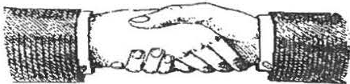

President's Remarks

Those in attendance at the Annua l meeting three years ago were challenged to join with the Trustees to breathe new life into the

Society, which seemed to be floundering. Three goals were stated at that time: (1) to develop a variety of programs and activities to appeal to a variety of people; (2) to establish the Society as a more integral part of the community, and; (3) begin the search for a professional director.

All three of those have been accomplished to varying degrees. A review of newsletters and newspaper clippings of the past three years reveals a myriad of activities and programs, some of which have been part of the fabri c of the Society for many years, and others which are new and innovative. Some which come to mind are the sponsorship of the Hannah Pixley project, the workshops on vinegar staining and Della Robbia, the unlacing of the Victorian woman program, the cemetery programs on the spirits of Sheffield, the crafts festival, the Carrie Smith Lorraine exhibit, and the acquisition of The Stone Store. These are but
a few of a long list of activities and programs
which the Society has provided the past three years.

Community outreach has been addressed by the "Place in Time" program for elementary school children, collaboration with the Bidwell House and the Trustees of Reservations on the "18th Century Experience," and soon a collaborat ive effort with the Sheffield Land Trust to mount an exhibit on the history of agriculture and land use in the area. The Carrie Smith Lorraine photographic exhibit
including the Dan Raymond House Museum, the Carriage House tool museum, and the Mark Dewey Research Center, is always a center of activity. We are on the web; we have an i nter prete r' s group for the DRH; we have volunteers in the MDRC; we have volunt eers who respond when invited to assi st with a variety of task.

It has been a challenging and interesting three years and our success has been due in no small measure to those of you in this room and many who are not able to be with us. We have worked together to meet the challenges. I would like to thank all those who stood by me these three years with patience, understanding, support and good ideas: all those people who have served as officers and trustees over the past three years; the search committee, without whose efforts (twice) we would not be blessed with Joanne; all the
people who have chaired and/or served on one of the standing committees (education, finance, MDRC, program, etc.); all the people who have assisted in some way with the festival, turkey dinners, cemetery programs, yule strolls, field trips, workshops, special events, and Joanne. We are alive; we are thriving; and I have every confidence that we shall continue to rise to meet the challenges ahead. Thank you all for the opportunity to work with you.

Catherine Miller
- • - • r • -- • - • - • - - - • - T - •-- • - •-•-•- •;, - ,- f_-11'°_.._ --- •- • - "I '

and two lectures are two highlights of this past year. Those have attracted much positive response from the community, as has the Documentary Heritage Grant on "Discovering
A rCw Word from th'e New·Presiden ,
• ,, ' l:ij ,._ ' •
.i i \
-an
The year 2000,2001 promi es to be
exc,iting o. . ;,.'t he activit}is tlJ_at are
nn

1:,!

Local Resources ."
pla ed will requjre hard work, ana many 1·_· :
h ' l.; •. ' ,-1''
,
:r
a -.. :,"

an s.···
itri
. - - .., .=:;

Dennis Picard, initially, and now Joanne Hurlbut were and are the fulfillment of the goal to engage a professional director to guide
and assist the Society as it moves into the 21st
century.

Our monthly programs have attracted many
• ,• _ :-· I I ,t . ,it I'm asking you to tliink about .where:youi : ;; int er e- liel na how yo.u could vol4 t r your time. · • : ,i;.rs'!
V. JI':. i,. ·
I w uld aiso like; o hear a·boutany·ia rt j
the.year
s ugg·e t io ti! i o have fg[' _m a ing . a.,:1
ho

people from outside Sheffield, as have several of the workshops and field trips. The Society's
s uccessfu
'
ne •
. l'!P.,;
- : 1
"'1;

campus, with its many attractive aspects
Dorothy
ij< ;;..! i t
Ma(osf
' .......1. 1': i

.- -· . -
- . .- .
. - . ,. - ·- ·-. -. -·- .-.. - -·-·-.-·-·-·-.-·- ._· ; .-·-·-. "

Summer Workshops for Youth in Conjunction with the Carrie Smith Lorraine exhibition
Wish List

If you have any of the following objects in good condition, but you no longer need the item, consider donating to SHS. Monetary contributions to be used in purchasing the items are also welcome.

Re frigerator--needed specifically for the Artisans Festival, floor light s, screw gun, glue & staple guns, folding chairs, WWI & WWII info , Old scrapbooks

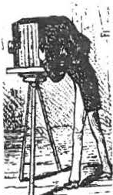
Through a Child's Lens July 19, Ages -6 9

Photography for Youth August 16, Ages 10 -1 4

Time: 10 am to 12 pm
Cost: $2/ child, Registrat ion required.

Sheffield: Through the Lens of Carrie Smith Lorraine (1 8 68 -1935 ) will remain on exhibi ti on in the Bushnell-Sage Library through August.

The Garden Club has invited the Sheffield Historical Society membership to assist in caring for the flowers on the town green. While the SHS Board felt it could not commit the Society to this project, the Board
Upcoming. eetinps/E,_vef1ts:

September _B --Tfie•st one Store and You
' t
September 10--Mark Dewf!Y Reeearch penter
·
Sunday, 2 to 4:mp . '
Tenth'"Anni versary Celebration
encou rages individual members wi th the time and inclination to volunteer by contacting Barbara Person at 229 -6625 .

Shef fi eld Histor ical Society
P.O. Box 747
Sheffield, MA

THE WORLD OF GEORGE WASHINGTON--July 16 FESTIVAL OF COUNTRY ARTS & ARTISANS--August 19

/

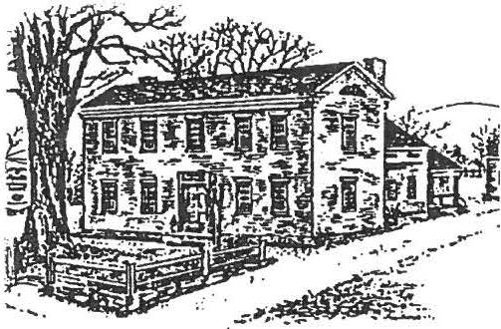
SHEfflELD HI I Ulf/(.;AL

SOCIETY

FALL NEWSLETTER
2000

MARK DEWEY RESEARCH CENTER 10TH ANNIVERSARY

During the past 10 years, individu als seeking to learn of their own past, to research the history of their homes, or to explore life in Sheffield have made the journey to the Mark Dewey Research Center. In celebration of the remarkable success of this local history repository, the Sheffield Historical Society is holding an Open House at the Mark Dewey Research Center on Sunday, September 10, from 2 to 4 pm.

Over the years, the MDRC has mounted a number of exhibits including the recent presentation on maps shown at the Festival. For the anniversary celebration , Sheffield's Lost Buildings will be on display, an exhibit highlighting buildings no longer standing , including homes and industrial and agricultural structures. The public is encouraged to attend, and refreshments will be served.

When the doors first opened ten years ago, the goal was to provide family history materials to the community. Since that modest beginning, the Mark Dewey Research Center (aka: the Family History Center) has expanded on all levels and now regularly serves local, national, and international researchers. The collection has grown to include information from the 1730s to the 1950s. The all-volunteer staff responds to questi ons on genealogy,
house histories , and special topics ranging
from ethnic history to the lives of
from ethnic history to the lives of rattlesnakes in the Southern Berkshires. In additio n to the archival materials , an impressive pho tographic collection has been acquired by the Center. These materials made possible the Carrie Smith Lorraine exhibition and are a major component in an upcoming collaborative exhibit on Sheffield's natural world.
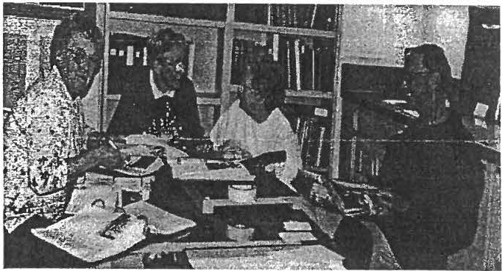
(Left to right: MDRC volunteers Betty Chapin, Eleanor Griffiths, Pauline Schumann, James Miller.)

The MDRC materials als o provide the historical data that occurs throughout the newsletter, such as th e following from the 1950 Sheffield Town Report:
In the summer of 1896, water from springs on the John
- Smith Farm had been piped to the Village and into a few houses in the center of Town. Hydrants, limited in number, were installed which presented to the young men of the community a desire to form a real Fire Company. A few meetings were held and by-laws were formulated by which the organization, known as Hose Company No. 1, was governed.
The Charter members were: James Wallace, Harry S. Stone, Edward Brewer, William D. O'Connell, Philip King, John Williams, Charles Andrus, Edward Cahill, John Cook, Peter Cassidy, Michael Cosgriff, Fred Crippen, John Ferry, F.B. French, William Graham, Harry Hiland, Malcolm Little, Martin O'Connell , Charles Williams, and Roland M. Smith.

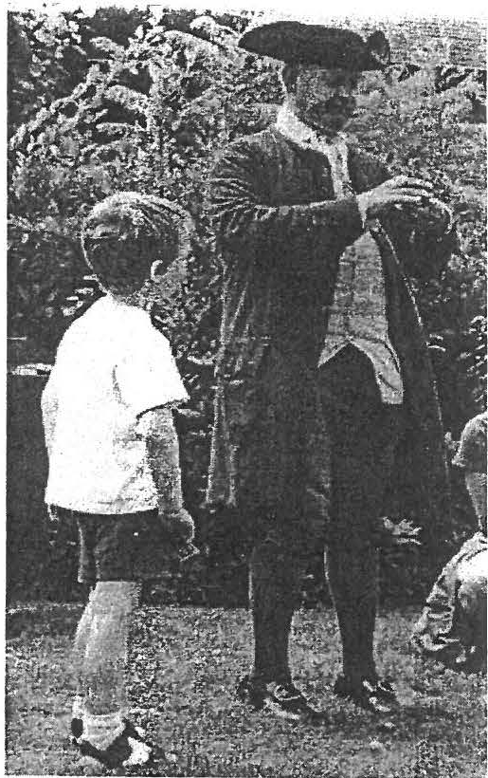
SUMMER AT THE SHEFFIELD HISTORICAL SOCIETY

George Washington and Carrie Smith Lorraine programming
Two new ventures were undertaken this summer. In July the World of George Washington brought many visitors to the Dan Raymond House. The well-attended 2 pm concert by David and Ginger Hildebrand, at the Old Parish Church, enthralled an audience while sharing the musical history of our nation. In addition to their superb quality as musicians, they brought an awareness of our present culture through song.

This summer, the Society also offered its first youth workshop. The project focused on photographic images of Sheffield yesterday and today. The membership is a critical component of the Society's efforts to expand its programming for young people. Please call the Office if you have an interest in helping with such programming.

Mystification at the Festival of County Arts and Artisans

A highlight of this year's Festival was the magic shows performed by Robert A. Olson, seen here with a young member of the audience. Olson's portrayal of 18th • century magician Mr. Bayly kept the

Moon on the Pond Organic Farm, met with everyone's approval.

Dan Raymond House Shop

The Country Store created for the Festival has been moved to the Dan Raymond House and is open to the public. The Society encourages members to patronize the shop; that special item you have been looking for may be located here!

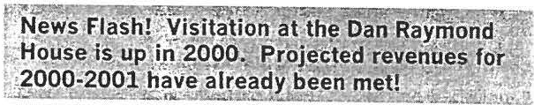

audience guessing and proved that the magic of 200 years ago can bewitch an
audience as easily as today's special­ effects performances.
Scholarship Corner:

Dear Sheffield Historical Society,
August 2000

This year's Festival occurred on a picture perfect day and the craftors, food, and children's activities, including sheep from
I would like to take the opportunity to thank you all
deeply for your very very generous scholarship. It means a lot to have your support. This fall / will major in History at the University of Vermont in Burlington.
I appreciate your support in making my dreams an adventure that is soon to be.

Sincerely,
- Douglas Campbell

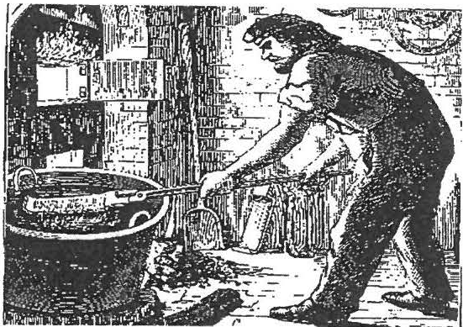
FALL CALENDAR

September 8: The Iron Industry in the 14th Colony, with Ronald Jones. Learn about the iron industry and the iron ­ making process in the tr i-state area.
Dewey Memorial Hall, Sheffield, 7:30 pm, refreshments provided.

September 10: Mark Dewey Research Center 10 th Anniversary-- an exhibit Sheffield's Lost Buildings will be on display. View items from 1770 to 1950.
Refreshments.

September 23: Field trip to Beckley Furnace with Edward Kirby. Meet at the furnace for a tour of the site, 9:00 am. (See box at right)

September 28: "May I Help You?" -­ Managing Patrons in Archives. A workshop sponsored by the Bay State Historical League through the Documentary Heritage Grant Program of the Massachusetts Records Advisory Board. (Registration required, fee)

October 13: Berkshire Cottages and the Guilded Age with Carole Owens--Special focus on Ventforth Hall. Dewey Memorial Hall, Sheffield, 7:30 pm, refreshments provided. A special follow-up trip will occur in the Spring of 2001 --watch for details.

October 28: Spirits of Sheffield Cemetery Walk. Make contact with the voices from Sheffield's past in this evening of spiritual communications in the Center Cemetery at 7 pm. Refreshments provided. (non-members fee of $3)

November 10: The 1830s Stone Store. Hear about the progress on the restoration of the building and the plans for future development s. Dewey Memorial Hall,

Sheffield, 7:30 pm, refreshments provided.

November 18: Holiday tree/wreath workshops (youth and adult, fee).

December 8: Yuletide Stroll, including Dan Raymond Open House.
View the lights and decorations, listen to musical selections by local students, and enjoy holiday refreshm ents. (fee)
PLEASE NOTE:
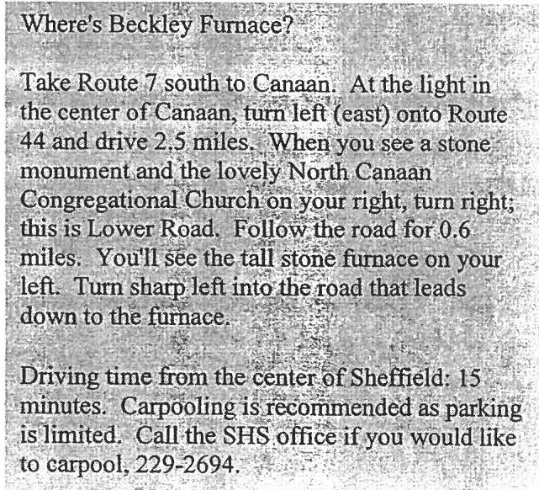
Due to the demanding physical effort required of members and the diminishing revenues received, the Annual Turkey Dinner has been discontinued. We thank everyone for their support in the past, and we look forward to new ways to socialize and raise funds for the student scholarship.

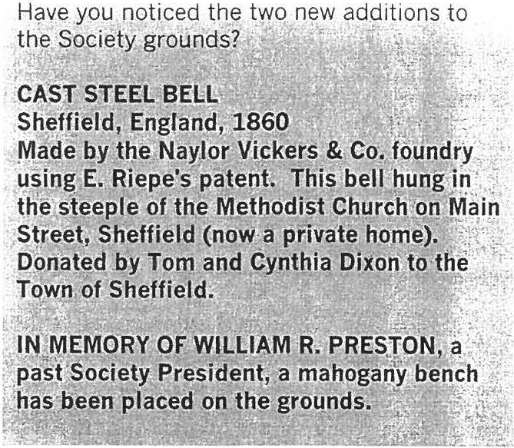

Membership renewal reminder:

Many SHS memberships expire in September. Look at your newsletter mailing label. If there's a (9/00) after your name, it is renewal time.
Wish list

If you have any of the following objects in good condition, but you no longer need the item, consider donating to SHS. Monetary cont ribu tio ns to be used in purchasing the item s are also welcome.

Floor light s, screw gun, glue & staple guns, folding chairs, WWI & WWII info, Ole scrapbooks

1861. According to the freight ledger of the Housatonic Railroad, in September, 1861, T.B. Strong received shipment of a barrel of crackers for his general store in
Ashley Falls. The weight was 60 pounds, freight charges 30 cents.

Sheffield Historical Society
P.O. Box 747 Sheffield, MA

IRON INDUSTRY IN THE 141H COLONY--·9/ 8

MARK DEWEY RESEARCH CENTER lQTH ANNIVERSARY-- 9 / 10

