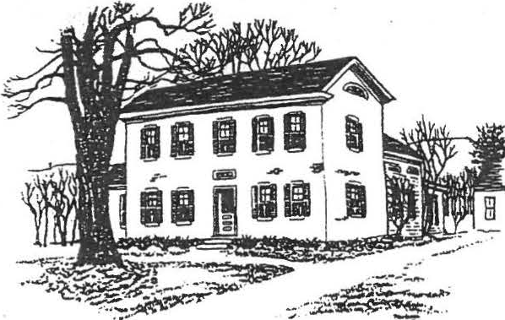
SHEFF!ELD HISTORICAL SOCIETY
SHEFFIELD, MASSACHUSETTS
01257

President's message
NEWSLETTER Vol. XVI, No. 2

. July 1990

I feel honored that you have chosen me to again serve as your President. My hope is that we can have an enjoyable and productive year, increasing our knowledge about local hist.ory and sharing what we're learning with the community--and especially with the ever-growing number of schoolchildren visiting the Dan Raymond House. With your help, we can accomplish this-and have a good time doing it!
Remember to set aside July 22 for our annual picnic at the Dan Raymond House at 4:00 p.m. Bring a covered dish, place setting, and lawn chair. Beverages and dessert will be supplied by the Society. Also, by popular demand, that dynamic thirst-quencher •switchel will be available for the daring.·
Another date to remember is our open house on August 9, 10, and 11. There will be a crafts exhibit on the lawn of the Dan Raymond House, and punch will be served.
I sincerely thank everyone who worked so hard to make our antiques show such a great success. We don't have the final figures yet, but it looks very promising. We also want to recognize these members who are serving on committees this year for the first time. It is very encouraging to see these friends willing to fill in as·we older onas have more and more aches and pains. The Society truly appreciates your efforts: Edith MacAusland, Grace Arzt, Kathie Ness, Rene Gibson, Evelyn Willcox, John James, Bill Preston, James Lecakis.
-Milton W. Barnum
·- -- - - - - - - ---- - -·--- - -------·- - - - - - - - --- - - - - -

Of ficers,committees,•••and members

Attached you will find the list of the elected and appointed officers and committee members for 1990-91.
We always welcome help! Anyone who is interested in assisting a committee,
in general or for a particular event, is encouraged to call that chairperson or any other committee member. Do you have ideas about committee projects? Let us know! (That includes suggestions for topics to be covered in the newsletter-of which this is an "irregular" catch-up edition. You'll be hearing from us again in August.)

Family History Center Update

We've been admiring from afar: the shoring up, the new windows, the attractive new colors••• but we have to wait a little longer for the full tour. The official opening of the Family History Center will take place in late September-stay tuned for details.

Mark your calendars! July 22: Annual picnic - Aug. 9, 10, 11: Open house

SHEFFIELD HISTORICAL SOCIETY 1990-1991

President Milton Barnum 1st Vice-President Sallee Hardy
2nd Vice-President Christopher Coenen Secretary Nancy Lecakis
Treasurer Morton Levin

Directors Grace Arzt, Sandie Cuoco, Virginia Drury, William Preston

Investments Charles Schumann
Curator Marion Barnum Archivist/Historian Lillian Preiss Director of Family Roger Drury
History Center

Committees (*Chairperson)

Finance Accessions
Museums Education

Morton Levin*, Charles Schumann, John carmichael, Roger Drury, Neal Hardy

Christopher Coenen*, Marion Barnum, Penny Browne, Katherine Miller, Edith MacAusland

Marion Barnum, Penny Browne, Agnes Boardman,
Lillian Preiss, Evelyn Willcox, Sandie CUoco, Roger Drury

Sallee Hardy*, Rene Gibson, John James, Amanda Morgan, Martha Williamson

Newslette/rpublicity Kathie Ness, Sallee Hardy, Lillian Preiss

Property

Family History Center

Membership Refreshments Turkey dinner Christmas meeting Antiques show
Milton Barnum*, William Preston, James Lecakis

Roger Drury, Dir.; Betty Chapin, Holly Coon, Lillian Preiss, Milton Barnum (ex officio)

Grace Arzt

Marian Willcox, Gertrude LeGeyt Milton Barnum
Marion Whitman

Christopher Coenen, Coordinator

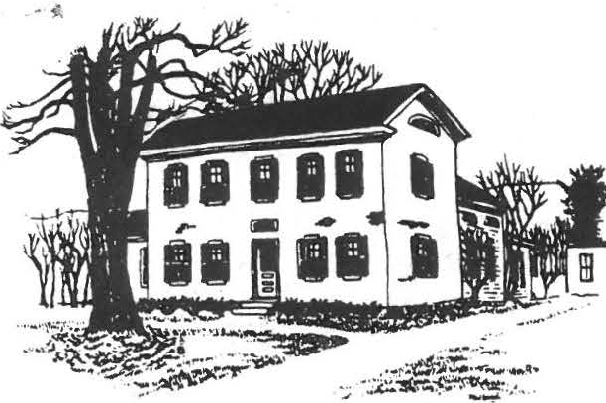
SHEFFIELD HISTORICAL SOCIETY
SHEFFIELD, MASSACHUSETI'S
01257

SPRING AND SUMMER ACTIVITIES
VOLUME XVI, NO. 3
t; _oq
1)

FROM THE DAN RAYMOND HOUSE
MARCH 16. A SELECTED GROUP OF 8TH GRADE STUDENTS FROM MT. EVERETT REGIONAL SCHOOL ANO THEIR TEACHERS, BILL GILLOOLY AND PAUL MENIN WERE SERVED A COLONIAL BREAKFAST, THE MEAL PREPARED BY MEMBERS
OF THE HOUSE COMMITTEE. MUCH OF THE FOOD WAS COOKED OVER THE KE EPING ROOM FIRE. THIS EVENT IS A VERY SPECIAL DAY FOR THE SOCIETY ANO THE D.R.H. COMMITTEE. EACH SUCCESSIVE YEAR BRINGS DIFFERENT STUDENTS TO THE HEARTH AND WE ARE HAPPY TO MEET ALL OF THEM AND INTRODUCE THEM TO SOME DOMESTIC ASPECTS OF AMERICAN HISTORY.
APRIL 23. A NEW EXHIBIT OF TOYS AND GAMES OPENED AT THE 0.R.H., ANO IT ENJOYED A GOODLY NUMBER OF VISITORS WHO CAME TO VIEW THE DISPLAYS ANO BRING BACK HAPPY MEMORIES OF CHILDHOOD. A "THANK YOU" TO ALL OF THE MEMBERS AND FRIENDS WHO EXHIBITED.

COMING EVENTS
JUNE 9, ANNUAL MEETING, DEWEY HALL, 6:30. BRING A COVERED DISH LARGE ENOUGH TO SERVE SIX. BRING YOUR OWN PLACE SETTING. DESSERT ANO COFFEE WILL BE PROVIDED . ELECTION OF OFFICERS.
JUNE 14, TRIP TO HILLSTEAD AND STANLEY-WHITMAN HOUSE MUSEUM, FARMINGTON, CT, LED BY MILTON BARNUM. MEET AT 0.R .H., 9:00 A.M. SEE EDUCATION COMMITTEE, BELOW.
JUNE 21. THE S.H.S. DREAM TEAM WILL MAKE BEDS AT BERKSHIRE SCHOOL
FOR THE ANTIQUES SHO,W 6:00 P.M.
JUNE 23, 6:00 TO 9:00 P.M., PREVIEW PARTY FOR OUR ANNUAL ANTIQ UES SHOW, BERKSHIRE SCHOOL , $10.00 FOR MEMBERS, $25 FOR THE PUBLIC.
JUNE 24 ANO 25, S.H.S., ANTIQUES SHOW, BERKSHIRE SCHOOL.

JULY 23, 4:00. Ir's THE ANNUAL PICNIC OF THE SOCIETY ON THE GROUNDS OF THE 0.R.H. JOIN US FOR A VICTORIAN GARDEN PICNIC. BRING A COVERED DISH, YOUR PLACE SETTING ANO A FRIEND WHO MAY BE A POTENTIAL MEMBER OF THE SOCIETY. HELP TO MAKE THIS A NOSTALGIC TIME BY DRESSING FOR THE OCCASION IN PERHAPS A FLOWERED BONNET OR GARDEN HAT FOR THE LADIES AND A STRAW HAT OR "BOATER" FOR THE MEN, OR ANY OTHER SUITABLE ATTIRE YOU WISH. DRESS UP OR DOWN OR DRESS AS USUAL, BUT BE SURE TO COME! WE CAN REMINISCE AND MAY BE EVEN SING A FEW OF THE OLD SONGS WE KNOW. ANYBODY FOR CROQUET?
AUGUST 10 , 11, AND 12, D.R.H. OPEN HOUSE, 11 :00 TO 3:00 EACH DAY , IN CONJUNCTION WITH THE SHEFFIELD ANTIQUES SHOW. THE D.R.H. COMMITTEE WILL PRESENT EXHIBITS, CRAFT DEMONSTRATIONS AND SERVE LIGHT REFRESHMENTS.
SEPTEMBER 8, 7:30, REGULAR MONTHLY MEETING OF THE SOCIETY, DEWEY HALL, ON THE GREEN.
SEPTEMBER 13, TRIP TO SAR ATOGA SPR INGS, NY LED BY ROBERT LEDLI. SEE EDUCATION NEWS BELOW.

SOCIETY PLANTS TREE

IN CELEBRATION OF ARBOR DAY THIS YEAR THE SOCIETY HAS PLANTED A 12 FOOT MAPLE TREE ON THE NORTH SIDE OF THE WESTERN APPROACH TO THE COVERE D BRIDGE. IT IS TO REPLACE A TREE FROM THAT LOCATION WHIC H HAD TO BE REMOVED A YEAR AGO WHEN THE ARMY CORPS OF ENGINEERS RIP-RAPPED THE BANKS OF THE HOUSATONIC: WE HOPE IT WILL THRIVE ANO GROW AND BRING BEAUTY TO THE SURROUNDINGS OF OUR OLD BRIDGE.

REPORT OF THE CURATOR
SINCE JANUARY 1, 1989, THE FOLLOWING ARTIFACTS HAVE BEEN ACQUIRED BY THE SOCIETY:
- A TIRE REGROOVING TOOL DONATED BY ALBERT TROCCH I
- THE HUBBARD FAMILY GENEALOGY DONATED BY DAVID HUBBARD
- A COPY OF A P ORTION OF THE 1800 CENSUS DONATED BY HOWARD
CROCKETT
- A SURVEY OF BARTHOLOMEW'S COBBLE PROPERTY SIGNED BY JO HN ASHLEY DONATED BY THE MOTT FAMILY
- GLASS INKWELL
- . SIEVE
- . CREEPERS
- WATERING JAR FOR POULTRY
- "THE RESHAPING OF EVERYDAY LIFE IN AMERICA 1790 -1840 "
- C ARV ING KNIVE S, CARV ING FORKS ANO SHARPENERS DONATED BY ARTHUR CHASE
11 . "HOME MADE" A COOKBOOK, DONATED BY ELIZABETH SCOTT

... •• ,t

. - .

12. AREA RUG DONATED BY JOAN SAWYER
13. DWIGHT 80 ARDMAN 'S LEDGER, DONATED BY LORING ANO AGNES BOARDMAN
14. SEVERAL BOOKS WERE PURCHASED BY THE SOCIETY FOR THE SALLY
SCANLAN LIBR AR Y.

ANNUAL ANTIQUES SHOW

BERKSHIRE SCHOOL ARENA WILL AGAIN BE THE SITE OF THE SOCIETY'S ANNUAL ANTIQUES SHOW FRID AY, JUNE 23 THROUGH SUNDAY JUNE 25.
KICKING OFF THE ANNUAL EVENT WILL BE A GALA PREVIEW PARTY ON FRIDAY EVENING WHICH WILL FEATURE LIVE ENTERTAINMENT, A BUFFET CATERED BY CROSBY'S OF LENOX, ANO A CHANCE TO LEISURELY INSPECT THE THOUSANDS OF ANTIQUES BEING OFFERED BY LEADING DEALERS OF THE NORTHEAS T WITHOUT THE HUSTLE ANO PUSHING USUALL Y ASSOCIATED WITH THE CROWDS OF SAT URD AY AND SUND AY. EVERY ANTIQUE WILL BE ON SALE BEGINNING FRIDAY EVENING. WHILE TICKETS WILL BE $25.00 AT THE DOOR TO THE GENERAL PUBLIC, MEMBERS' PRICE IS JUST $10.00 IF PURCHASED IN ADVANCE. CALL OR SEND YOUR MONEY TO ROGER DRURY, TREASURER, SHEFFIELD HISTORICAL SOCIETY, Box 1733, SHEFFIELD, MA 01257. OR IF YOU WISH, BRING YOUR PAYMENT WITH YOU TO THE JUNE MEETING. TICKETS WILL BE HELD AT THE DOOR. IF YOU ARE UNABLE TO ATTEND, DONATIONS IN ANY AMOUNT WILL BE GRATEFULLY APPRECIATED.
VIRGINIA DRURY, CHAIRMAN OF THE Fooo COMMITTEE FOR THE SHOW IS REQUESTING CONTRIBUTIONS OF "TEATIME SNACKS". TASTY .25 ANO .50 TEATIME SNACKS, SARAN-WRAPPED, FOR AFTERNOON NIBBLING AT THE ANTIQUES SHOW ARE NEE DED. SHE SUGGESTS BROWNIES, HERMITS, COOKIES, CUPCAKES OR CAKES. A CAKE BAKED IN A 13" X 9" PYREX CUTS NICELY INTO 32 PIECES OF JUST THE RIGHT SIZE. JUST MAKE YOUR FAVORITE RECIPE, WRAP THE PIECES INDIVIDUALLY FACE DOWN ON A SARAN -WRAP SQUARE. CONSIDER MAKING THEM EARLY AND FREEZING THEM TO MAKE IT EASIER ON YOURSELF. BRING YOUR BATCH EITHER ON SATURDAY OR SUND AY, JUNE 24 OR 25.

LILLIAN PREISS HONORED

LILLIAN PREISS, A FOUNDER ANO FORMER PRESIDENT OF THE SOCIETY WAS HONORED BY THE STATE HISTORICAL COMMISSION WITH A LIFETIME ACHIEVEMENT PRESERVATION AWARD FOR "DEVOTING SO MANY YEARS TO HISTORIC PRESERVATION IN SHEFFIELD. " ONLY FOUR LIFETIME AWARDS WERE GIVEN STATE WIDE. HER WORK IN SHEFFIELD IS WELL K NOWN, ANO INCLUDED PLAYING AN IMPORTANT ROLE IN RAISING MONEY FOR PRESERVATION OF THE COVERED BRIDGE, AUTHORING "SHEFFIELD FRONTIER TOWN" ANO HOLDING VARIOUS OFFICES ANO POSITIONS OF RESPONSIBILITY IN THE SOCIETY ANO THE SHEFFIELD HISTORICAL COMMISSION.

)
)
EDUCATION COMMITTEE ACTIVITIES

IN ADDITION TO ITS CONTINUING EDUCATIONAL PROGRAMS WHICH INCLUDE SCHOLARSHIPS, LOCAL HISTORY TRIPS FOR MT. EVERETT STUDENTS ANO SPONSORING GIRLS ' STATE PARTICIPANTS, THE COMMITTEE IS PLEASED TO ANNOUNCE TWO ADDITIONAL PROJECTS.

THE GROUP WILL ORGANIZE TWO FIELD TRIPS FOR MEMBERS THAT WILL TAKE US TO THE HEART OF OUR NATIONAL HISTORY. THE FIRST IS WEDNESDAY JU NE 14 AND WILL BE A VISIT TO FARMINGTON, CT TO VIEW HILLSTEAD ANO THE STAN LEY-WHI TMAN HOUSE MUSEUM UNDER THE LEADERSHIP OF MILTON BARNUM. MEMBERS INTERESTED IN GOING ARE AS KED TO COME TO THE D.R.H . BY 9:00 A.M. TRANSPORTATION WILL BE PROVIDED BY AUTOMOBILE. FOR FURTHER INFORMATION, CALL MILTON AT 229-2569 OR MARION WHITMAN, CHAIRMAN OF THE EDUCATION COMMITTEE, AT 229-2129. THERE WILL BE A SMALL CHARGE FOR ADMISSION TO THE MUSEUMS. THE SECOND JOURNEY WILL BE TO HISTORIC SARATOGA, NY, UNDER THE GUIDANCE OF ROBERT LEDLIE WHO IS A MEMBER OF OUR SOCIET Y AS WELL AS THE SARAT OGA SPRINGS HISTORICAL SOCIETY.
SCHEDULED FOR WEDNESDAY , SEPTEMBER 13, THE COST FOR THIS BUS TRIP IS $1 5 . 00 . RESERVATI ONS CAN BE MADE BY CONTACTING MARION. MORE
INFORMATION ON BOTH OUTINGS WILL BE AVAILABLE AT THE JUNE MEETING.
THE SECOND MAJOR PROJECT OF THE COMMITTEE IS THE CREATION OF A VIDEO HISTORY OF SHEFFIELD. A CONTRACT HAS BEEN SIGNED WITH CLIFF AERIE OF MONTEREY WHO IS A NATIONALLY KNOWN PRODUCER OF FILMS ANO VIDEOS TO PRODUCE A PRODUCT THAT WILL BE A VALUABLE EDUCATIONAL TOOL FOR BOTH THE SOCIETY AND TEACHERS OF THE AREA WHO MAY WISH TO MAKE USE OF IT IN SCHOOL. AMANDA MORGAN WILL CHAIR THIS SPECIAL PROJECT ANO WORK CLOSELY WITH AERIE. CURRENT MEMBERS OF THE COMMITTEE, IN ADDITION TO MARION ANO AMANDA ARE WILLIAM BROWNE, LILLIAN PREISS, ANO JAMES MILLER ( EX OFFICIO).
_',.C .M ' - - -· -

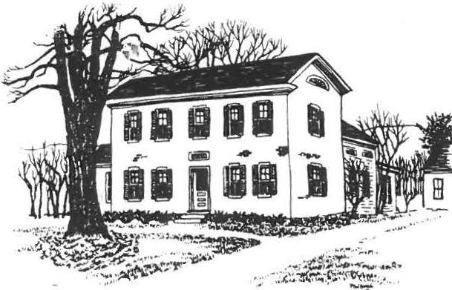
SHEFFIELD HISTORICAL SOCIETY
SHEFFIELD, MASSACHUSETTS
01257

VOLUME XVI, NO. 3

FALL AND EARLY WINTER ACTIVITIES

SEPTEMBER 8, 7:30, DEWEY IIALL
THE EXPERIENCE OF THE 250TH CELEBRATION OF TYRINGHAM WILL BE SHARED BY FOURTEEN OF OUR MEMBERS WHO PARTICIPATED IN THEIR RECENT PARADE . (DID YOU CATCH THE PICTURE OF ROGER DRURY IN HIS OUTFIT, WHICH ACCOMPANIED A FRONT PAGE ARTICLE IN THE SUNDAY SPRINGFIELD REPUBLICAN?) EIGHTY-SEVEN YEAR OLD ARNOLD HALE, WHO SERVED AS GRAND MARSHALL AND ALICE HALE, FORMER TOWN CLERK AND ACTIVE MEMBER OF THE
TYRINGHAM HISTORICAL SOCIETY WILL BE OUR SPECIAL GUESTS. THE HALES ARE A FOUNDING FAMILY OF TYRINGHAM. PICTURES OF THE PARADE AND A BRIEF HISTORY OF THE TOWN WILL BE PART OF THE PROGRAM.
OCTOBER 13, 7:30, DEWEY HALL
JUNE SPRIGG, AUTHOR AND CURATOR OF COLLECTIONS AT HANCOCK SHAKER VILLAGE WILL DISCUSS THE SHAKER COLLECTION AND SHOW SLIDES AS PART OF HER PRESENTATION.
OCTOBER 29, 12:00 AND 1 :30, AMERICAN LEGION
OUR ANNUAL TURKEY DINNER WILL BE HELD AT THE AMERICAN LEGION BUILDING ON ROUTE 7. SITTINGS WILL AGAIN BE AT NOON AND
1:30. THIS IS AN EXTREMELY POPULAR EVENT. BE READY TO BE CALLED ON TO HELP. MAKE YOUR RESERVATIONS BY CALLING 229- 2569. PROCEEDS FROM THIS EVENT FUND THE SOCIETY'S EDUCATIONAL ACTIVITIES FOR AREA YOUNG PEOPLE.
NOVEMBER 10, 7:30, DEWEY HALL
REGULAR MONTHLY MEETING. WHAT PROMISES TO BE AN UNUSUAL PRESENTATION IS STILL BEING PLANNED. WATCH FOR FURTHER DETAILS.
DECEMBER 8, 6:30, DEWEY HALL
OUR ANNUAL HOLIDAY AFFAIR WILL BE ORGANIZED BY VIRGINIA DRURY, WHO HAS AGREED TO REVIVE OUR HOLIDAY DI NER, SPECIAL MUSIC WILL BE PROVIDED. BRING YOUR OWN PLACE SETTING.

DECEMBER 10, 3:00 TO 6:00, O.R.H . ANNUAL HOLIDAY OPEN HOUSE.
JANUARY 12, 7:30, DEWEY HALL
MILTON BARNUM HAS ONCE AGAIN AGREED TO MC OUR POPULAR JANUARY REGULAR "SHOW AND TELL"--"WHAT'S IT" PROGRAM. START SEARCHING FOR A STUMPER.

COMMITTEE TO RECOMMEND BY-LAW REVISIONS

ROGER DRURY AND CATHERINE MILLER HAVE AGREED TO UNDERTAKE THE TASK OF COLLECTING AND WORKING WITH CHANGES IN THE SOCIETY BY-LAWS THAT ARE RECOMMENDED BY THE MEMBERSHIP. WHEN DID YOU LAST SEE THE BY-LAWS, AND WHAT'S IN THEM? WONDER NO LONGER. WE WANT EVERY MEMBER TO BE A PART OF THIS REVISION PROCESS, SO A COPY OF THE BY-LAWS IS INCLUDED FOR YOUR READING. AFTER CAREFU CONSIDERATION, MAKE YOUR IDEAS KNOWN TO THE COMMITTEE, OR TO A MEMBER OF THE EXECUTIVE COMMITTEE. ALL OF YOU SHOULD KNOW WHAT OUR BASIC GUIDELINES ARE AND BE A PART OF ANY CHANGES.

SHEFFIELD HISTORICAL SOCIETY
l . PU RPOSE. THE SHEFFIELD HISTORICAL SOCIETY, INC. IS A
NON-PROFIT ORGANIZATION, DESIGNED TO FOSTER INTEREST IN THE HISTORY OF THE TOWN OF SHEFFIELD, MASSACHUSETTS, ANO THE REGION OF WHICH IT IS A PART, AND IN RELATED EDUCATIONAL, CHARITABLE, AND ANTIQUARIAN PURPOSES APPROVED BY THE MEMBERS OR THEIR BOARD OF DIRECTORS.
- MEMBERSHIP IS OPEN TO ANY PERSON INTERESTED IN THE PURPOSES AND ACTIVITIES OF THE SOCIETY, UPON PAYMENT OF INDIVIDUAL OR JOINT DUES, THE AMOUNT OF WHICH WILL BE SET BY THE BOARD OF TRUSTEES (SEC. 4-E), A LIFE MEMBERSHIP DONATION, IN AN AMOUNT DETERMINED BY THE BOARD, WILL EXEMPT THE DONOR FROM PAYMENT OF ANNUAL DUES.

- MEETINGS OF THE SOCIETY WILL BE ON THE SECOND FRIDAY OF EACH MONTH, FROM SEPTEMBER THROUGH JUNE. ONLY MEMBERS IN GOOD STANDING WILL BE ELIGIBLE TO VOTE, ANO TWENTY-FIVE (25) SUCH MEMBERS WILL CONSTITUTE A QUORUM.
  - THE ANNUAL MEETING WILL BE THE JUNE MEETING. THE SOCIETY WILL RECEIVE ANNUAL REPORTS FROM OFFICERS AND COMMITTEES, ANO VOTE ON MATTERS OF GENERAL POLICY PREVIOUSLY PROPOSED BY THE BOARD OF TRUSTEES OR THE MEMBERSHIP. AFTER HEARING THE REPORT OF THE NOMINATING COMMITTEE (SEC. 7) AND ACCEPTING FURTHER NOMINATIONS FROM THE FLOOR, THE SOCIETY WILL ELECT OFFICERS, TO SERVE FOR THREE (3) YEARS, AS FOLLOWS: IN YEAR A, THE PRESIDENT AND TWO TRUSTEES; IN YEAR B, THE VICE-PRESIDENT, SECRETARY, AND ONE TRUSTEE; IN YEAR C, THE TREASURER AND TWO TRUSTEES. THE SOCIETY WILL ALSO ELECT OFFICERS TO FINISH OUT TERMS IN OFFICES VACATED DURING THE YEAR.

\
\ i. SPECIAL MEETINGS MAY BE CALLED BY THE BOARD OF TRUSTEES, EITHER AT THE PRESIDENT'S DIRECTION OR UPON PETITION TO THE BOARD BY TEN (10) MEMBERS, PROVIDED SEVEN (7) DAYS NOTICE IS GIVEN THE MEMBERS.

- ELECTED OFFICERS; THE PRESIDENT, VICE-PRESIDENT, SECRETARY, TREASURER, AND TRUSTEES SHALL BE ELECTED AS DESCRIBED IN
SECTION 3-A, AND MAY NOT SERVE TWO TERMS CONSECUTIVELY IN THE SAME OFFICE.
  - THE PRESIDENT SHALL PRESIDE AT ALL MEETINGS OF THE SOCIETY AND BOARD OF TRUSTEES; HAVE EXECUTIVE SUPERVISION OVER THE SOCIETY'S ACTIVITIES; APPOINT ANY COMMITTEE CHAIRMEN WHOSE APPOINTMENTS ARE NOT MADE UNDER THESE BY-LAWS, BY THE BOARD OF TRUSTEES; AND BE AN EX OFFICIO MEMBER OF ALL COMMITTEES.
8. THE VICE-PRESIDENT SHALL ASSUME THE DUTIES OF THE PRESIDENT IN THE EVENT OF THE LATTER'S ABSENCE, INCAPACITY, OR RESIGNATION; AND SHALL ACT AS CHAIRMAN OF ANY PROGRAM COMMITTEE AND APPOINT ITS MEMBERS.
- THE SECRETARY SHALL KEEP MINUTES OF MEETINGS OF THE SOCIETY AND THE BOARD OF TRUSTEES; MAINTAIN A CURRENT LIST OF MEMBERS; CONDUCT THE SOCIETY'S CORRESPONDENCE; AND
.PERFORM THE CORPORATE FUNCTION OF CLERK.
- THE TREASURER SHALL COLLECT ANNUAL DUES, DEPOSITING THESE AND ALL OTHER FUNDS DESIGNATED BY THE BOARD OF TRUSTEES AS OPERATING FUNDS, IN THE NAME OF THE SOCIETY, IN A
RELIABLE BANK; SEE THAT MEMBERS ARE NOTIFIED WHEN DUES ARE PAYABLE; PAY BILlS FOR CURRENT EXPENSES APPROVED BY THE PRESIDENT; AND PRESIDE AT MEETINGS OF THE FINANCE COMMITTEE.
- THE BOARD OF TRUSTEES SHALL CONSIST OF NINE (9) MEMBERS INCLUDING THE SOCIETY'S PRESIDENT, VICE-PRESIDENT, SECRETARY, ANO TREASURER. THE INVESTMENT MANAGER ANO CURATOR (SEC. 6-A AND 6-B) SHALL BE APPOINTED BY THE BOARD ANO SHALL MEET WITH IT WHEN REQUESTED, HAVING A VOICE BUT NO VOTE IN THE BOARD'S DECISIONS. THE BOARD SHALL MEET AT THE CALL OF THE PRESIDENT, AS OFTEN AS NEEDED TO CONDUCT ALL AFFAIRS OF THE SOCIETY WHICH DO NOT REQUIRE GENERAL MEMBERSHIP APPROVAL, OR WHICH CANNOT BE ACTED UPON AT A MEETING OF THE SOCIETY; FILL ANY VACANCIES IN OFFICE
UNTIL THE NE XT ANNUAL MEETING; APPOINT THE CHAIRMEN OF STANDING COMMITTEES, ANO HEAR AND ACT ON RECOMMENDATIONS OF THOSE COMMITTEES; ARRANGE FOR ANNUAL AUDITS OF THE SOCIETY'S BOOKS; AND SET A SCHEDULE OF MEMBERSHIP DUES ANO LIFE MEMBERSHIP. SPECIAL MEETINGS OF THE BOARD MAY BE CALLED AT THE REQUEST OF FOUR (4) TRUSTEES. A QUORUM SHALL BE FIVE (5) TRUSTEES.
- SUCCESSION TO THE PRESIDENCY. IN CASE OF THE CONTINUED ABSENCE OR INCAPACITY, OR THE RESIGNATION, OF BOTH THE PRESIDENT AND THE VICE-PRESIDENT, THE SECRETARY,. OR IN HIS ABSENCE, THE TREASURER, SHALL CALL A MEETING OF THE BOARD OF TRUSTEES TO ELECT AN ACTING PRESIDENT, TO SERVE UNTIL THE RETURN TO DUTY OF THE PRESIDENT OR VICE-PRESIDENT, OR UNTIL

THE NEXT ANNUAL MEETING. '' (
- APPOINTED OFFICERS. AN INVESTMENT MANAGER AND A CURATOR, WHO MAY NOT ALSO BE ELECTED OFFICERS, SHALL BE APPOINTED OR REAPPOINTED ANNUALLY BY THE BOARD OF TRUSTEES.
  - THE INVESTMENT MANAGER SHALL HAVE CARE OF THE SOCIETY'S
§A ifAb YN§§, iNVE§fiN§ T EM A§e§ §iN§ f§ §biei§§
APPROVED BY THE BOARD; MAINTAIN DETAILED ACCOUNTS OF PRINCIPAL AND INTEREST; AND RENDER A MONTHLY INCOME AND EXPENDITURE STATEMENT TO THE PRESIDENT AND AN ANNUAL REPORT TO THE SOCIETY. CHECKS IN THE AMOUNT OF $500 OR MORE, DRAWN ON ANY CAPITAL FUND ACCOUNT SHALL BE COUNTERSIGNED BY THE PRESIDENT OF VICE-PRESIDENT.
8. THE CURATOR SHALL HAVE CHARGE OF THE SAFEKEEPING, PRESERVATION, AND EXHIBIT OF ALL MOVABLE ANTIQUITIES OWNED BY, OR ON LOAN TO, THE SOCIETY; AND SHALL KEEP A RECORD OF ACQUISITIONS, OF OBJECTS LOANED TO OR BY THE SOCIETY, AND OF PROPERTY DONATED OR SOLD. THE CURATOR SHALL REPORT AT LEAST ANNUALLY TO THE MEMBERSHIP.
7. A NOMINATING COMMITTEE OF THREE SHALL BE APPOINTED BY THE PRESIDENT AT THE MAY MEETING, AND SHALL BE FURNISHED AT THAT TIME WITH A LIST OF OFFICES DUE TO BECOME VACANT IN JUNE ACCORDING TO THE ROTATION DESCRIBED IN SECTION 3-A (BEGINNING WITH"YEAR C" IN 1983), AND ANY OTHER OFFICES WHICH HAVE FALLEN VACANT DURING THE CURRENT YEAR. THE COMMITTEE SHALL
BRING A COMPLETE SLATE OF NOMINEES FOR THESE OFFICES TO THE ANNUAL MEETING IN JUNE.
- STANDING COMMITTEES.
  - FINANCE. THE TREASURER SHALL BE CHAIRMAN OF A FIVE-MEMBER FINANCE COMMITTEE, TO RECOMMEND FINANCIAL POLICY TO THE BOARD OF TRUSTEES. THE INVESTMENT MANAGER SHALL BE A MEMBER OF THIS COMMITTEE, AND THE REMAINING THREE MEMBERS
SHALL BE APPOINTED, ONE BY THE PRESIDENT AND TWO BY THE BOARD OF TRUSTEES.
  - A DAN RAYMOND HOUSE COMMITTEE OF SEVEN MEMBERS WILL ARRANGE FOR SPECIAL EXHIBITS AND FUNCTIONS AT
THE SOCIETY'S HEADQUARTERS; AND OVERSEE THE MAINTENANCE AND IMPROVEMENT OF THE GROUNDS, AND OF THE BUILDINGS EXCLUSIVE OF THEIR CONTENTS. THE COMMITTEE CHAIRMAN, APPOINTED OR REAPPOINTED ANNUALLY BY THE BOARD OF
TRUSTEES, WILL SELECT SIX ADDITIONAL MEMBERS, ONE OF WHOM SHALL BE THE CURATOR.
c. AN ACCESSIONS COMMITTEE OF FIVE MEMBERS SHALL ADMINISTER THE ACCESSIONS POLICY APPROVED BY THE SOCIETY. THE COMMITTEE SHALL INCLUDE THE CURATOR, THE PRESIDENT OF THE SOCIETY, THE CHAIRMAN OF THE DAN RAYMOND HOUSE COMMITTEE AND TWO MEMBERS AT LARGE
APPOINTED BY THE BOARD OF TRUSTEES AND SHALL ELECT ITS OWN CHAIRMAN.

'r
, l
9.' ROBERT'S RULES OF ORDER SHALL BE THE BASIS OF PROCEDURE AT ALL MEETINGS OF THE SOCIETY ANO ITS BOARD OF TRUSTEES.
- IF THE SOCIETY SHALL BE DISSOLVED BY ITS OWN ACTION OR ANY LEGAL PROCEDURE, ALL ASSETS THEN IN ITS POSSESSION, AFTER SATISFACTION OF ALL OBLIGATIONS, SHALL BE TRANSFERRED OR PAID OVER TO ONE OR MORE NON-PROFIT ORGANIZATIONS WHICH THEN APPEAR BEST ABLE TO CARRY FORWARD THE AIMS AND PROGRAMS OF THE SHEFFIELD HISTORICAL SOCIETY, AND WHICH QUALIFY UNDER SECTION 501(C)3 OF THE UNITED STATES INTERNAL REVENUE CODE OF 1954 AND AMENDMENTS THERETO. IF, AFTER REASONABLE DELIBERATION, THE SOCIETY IS UNABLE TO REACH MAJORITY AGREEMENT UPON SUCH BENEFICIARY OR BENEFICIARIES, THEN ALL SUCH ASSETS SHALL BE TRANSFERRED AND/OR PAID OVER TO THE
TOWN OF SHEFFIELD.
- AMENDMENTS TO THESE BY-LAWS WILL TAKE EFFECT IF APPROVED BY TWO THIRDS OF THOSE MEMBERS PRESENT AND VOTING AT A REGULAR MEETING OF THE SOCIETY. THE TEXT OF A PROPOSED AMENDMENT MUST BE MAILED TO ALL MEMBERS AT LEAST FOURTEEN (14) DAYS IN ADVANCE OF THE MEETING AT WHICH A VOTE THEREON WILL BE TAKEN.

OFFICERS AND COMMITTEE ASSIGNMENTS FOR 1989-90
PRESIDENT, JAMES MILLER VICE PRESIDENT, VACANT · SECRETARY, NANCY LECAKIS TREASURER, MORTON LEVIN
TRUSTEES, CHRISTOPHER COENEN, JOAN SAWYER, MARION WHITMAN, VIRGINIA DRURY, SANDIE Cuoco
FINANCE COMMITTEE, MORTON LEVIN (TREASURER) CHM., CARL SCHUMANN
(INVESTMENT MANAGER), ROGER DRURY, JOHN CARMICHAEL, NEAL HARDY
CURATOR, VIRGINIA MOSKOWITZ
DAN RAYMOND HOUSE, PENNY BROWNE, CHM. ACCESSIONS, CATHERINE MILLER, CHM. EDUCATION, MARION WHITMAN, CHM. REFRESHMENTS, MARION WILLCOX, CHM. PROGRAM, SALLEE HARDY, CHM.
TURKEY DINNER, MILTON BARNUM
LIAISON WITH BERKSHIRE SCHOOL, CHRISTOPHER COENEN NEWSLETTER, VACANT
BY-LAW REVISION, ROGER DRURY AND CATHERINE MILLER MEMBERSHIP, MARION WHITMAN
CHRISTMAS MEETING, VIRGINIA DRURY ANNUAL MEETING, DOROTHY MAROSY

THE VARIOUS CHAIRMEN WILL APPOINT MEMBERS OF JHEIR RESPECTIVE COMMITTEES. IF YOU ARE INTERESTED IN SERVING ON A SPEC IFIC COMMITTEE, CONTACT THE CHAIRMAN. THERE IS WORK FOR ALL PEOPLE, AT ALL LEVELS OF ACTIVITY.

1
ARZT AFGHAN ENHANCES EDUCATION FUND

AN AFGHAN, HAND MADE AND DONATED BY SOCIETY MEMBER GRACE ARZT, HAS NETTED $176.50 TO BE ADDED TO THE EDUCATION COMMITTEE FUND. CHANCES WERE SOLD AT THE SOCIETY'S ANTIQUES SHOW AND
o. .H.
gY IN THE EN H Y§E Ebg IN AU@U§i. o g w A E,
AND "THANK YOU" TO THE MEMBERS WHO GAVE THEIR TIME TOWARD THE SALE OF TICKETS.

VOLUNTEER(S) NEEDED
DURING THE NEXT FEW WEEKS, THE EXECUTIVE COMMITTEE WILL BE MAKING MAJOR DECISIONS FOR THE DIRECTION THE SOCIETY WILL TAKE NEXT YEAR. AMONG THOSE DECISIONS WILL BE "IF AND HOW" TO RUN THE ANTIQUES SHOW FOR 1990. A MAJOR PROBLEM WE FACE IS A FOOD CHAIRMAN FOR THE SHOW, A JOB SO ABLY HANDLED BY VIRGINIA DnURY THE PAST FIVE YEARS. SHE HAS RETIRED. ARE THERE ANY VOLUNTEERS OUT THERE?

ANNUAL DUES ARE DUE

PLEASE TAKE A MOMENT TO SEND IN YOUR DUES IF YOU HAVE NOT ALREADY DONE SO. MARION WHITMAN IS THE MEMBERSHIP CHAIRMAN. MAIL TO SHEFFIELD HISTORICAL SOCIETY, MARION HITMAN, Box 1733, SHEFFIELD, MA 01257
NAME

MAILING
ADDRESS

PHONE NUMBER

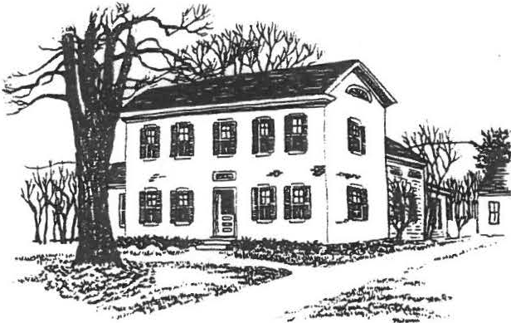
SHEFFIELD HISTORICAL SOCIETY
SHEFFIELD, MASSACHUSETTS
01257

FALL/WINTER ACTIVITIES
Vol. XVII, No. 2
September 1990

September 14, 7:30 p.m., Dewey Hall
Discovery Night with David LeBeau, professional antiques appraiser, owner of an antiques store in Sheffield, and assistant professor of fine arts at NYU. Bring in some­ thing you've always wondered about--a silver serving spoon, a porcelain vase, a photo of a piece of furniture, an old ring--for a free appraisal. You may discQver you have a treasure!
October 6 & 7, Dewey building, Main Street
Opening of the Family History Center. See page 3 for a description of this special program.
October 12, 7:30 p.m., Dewey Hall _
Boyd Hutchison, local cabinetmaker whose work has been featured at Hancock Shaker Village, will discuss Shaker Oval Boxes and demonstrate how they are made with examples of his own work.
October 28, 12 and 1:30 p.m., American Legion Hall
Annual Turkey Dinner. See the President's Column for details about this popular event.
November 9, 7:30 p.m., Dewey Hall
A special program by the Family History Committee.

December 14, 7:30 p.m., Dewey Hall Annual Holiday Party.
January 11, 7:30 p.m., Dewey Hall
Milton Barnum's annual What's It? program.

Other fall plans:
* * *

Plans are under way for a bus trip to historic houses in the Hudson Valley.
The Education Committee is arranging a cemetery walk for students in the regional school district. They are currently "digging up" a selection of interesting and unusual information about Sheffield's cemeteries. Anyone with suggestions is urged to call Martha Williamson at 229-8110.

-2-

THE PRESIDENT'S COLUMN
The latest figures on the Antiques Show, courtesy of treasurer Mort Levin, is a net profit of $8,045. We thank each and every one of you who worked so hard for the success of the show.
And while we're on the subject, I'd like to give special thanks to Catherine and James Miller, who have the operation at their fingertips--all the information about the dealers and the attendance. The third one in that trio is Chris Coenen. How fortunate we are to have Chris so calmly coordinating all the details between the Historical Society, the Sidelis, and Berkshire School. In addition, of course, the Society is very grateful to Berkshire School for the generous loan of their facilities.
The Open House on August 9-11 was not as successful as we would have liked, but it was certainly enjoyed by those who came by. Special thanks to Agnes Boardman, Lillian Preiss, Penny Browne, and Marion Barnum, who all worked so hard preparing the house and grounds.
How about Grace Arzt making that beautiful afghan by hand, with her own material, and then donating it to the Society! We received $75 in donations from it, and the lucky winner was Eleanor Ahlbaum of Buffalo, sister of our own Lucia Davidson.
Thank you very much, Grace!
Don't forget our Turkey Dinner on October 28. As you know, the proceeds go entirely toward scholarships. It will take many faithful members to bake 40 pies, roast and carve 13 turkeys, peel and cut 3 bushels each of squash and potatoes--after which we serve 160 people in 10 minutes! So when you are called, I hope you'll say , "Can't wait to help. What can I do?"
Thanks to a wonderful group,
Milton Barnum

* * * * *

Welcome to new members!
From Great Barrington: Jennifer Berryhill and Arnold & Jean Blackmur. Also Sheffield residents Donald & Amy Haworth, Bernhard & Shellie Schneider, and Mark & Claudia Ziobro.

Anyone else who's interested in joining the Historical Society is urged to send in the form at the end of this newsletter.

Missing: Our green 32-cup coffee maker and one insulated coffee pitcher. Any ideas?

-3-

OPENING OF THE FAMILY HISTORY CENTER

The formal opening of the Family History Center, in the 1816 Dewey building next door to the Dan Raymond House, will be marked by events and exhibits designed for all tastes and ages on Saturday, October 6, and Sunday afternoon, October 7. Circle these dates on your calendars and stay tuned for details.
The program will include: Dedication of the Center; a Historic House Walk led by Lillian Preiss; a special exhibit about the talented Smith Family of "Orchard Shade"; an opportunity to Stop Your Forebears From Fading by bringing in a valued family photograph or document for copying without charge; tips on How to Get Started on a Family Tree and fill in empty branches; a puzzle, Where in Ashley Falls Did William Jennys Spend the Night in 1795? and much more, including a sampling of reference materials that will be regularly available in the Center.
In addition, the Museums Committee will exhibit some items typical of those used or sold in the Hatter's Shop that occupied the building for 50 years.

This opening celebration has seemed to be a long time coming, but the committee has had its hands full of details to be considered and decisions to be made over the past 18 months. Not least of these concerns has been the renovation of the building-­ not as a restoration but as an adaptation to new uses.
The genesis of the Center came during a study of 10-year goals for the Society in 1988. To James Miller goes credit for setting that study in motion. Major credit also belongs to Lillian Preiss, town historian and unofficial family researcher for the Society, who knew the need and had long advocated an enlarged and organized family history effort; to genealogist Ursula Kilner, who dropped a hot spark into the tinder by suggesting use of the Dewey building for that purpose; to Virginia Moskowitz, Ruth Degenhardt, Guy McLain, and Helen McLallan, our guides through local history libraries in the region; to Penny Browne and Greg Farmer, consultants on the Hatter's Shop exhibit space; to John James, for architectural plans and advice; to Boyd Hutchison, designer/builder of the reading room table; and to many others.
The Committee members'have set policy, winnowed ideas and suggestions, and thereby earned credit for the overall results (still evolving) as well as blame for any blunders or oversights. The following have all shared enthusiastically in the work: Lillian Preiss, Bill Browne, Virginia Moskowitz, James Miller, Betty Chapin, Holly Coon, and Roger Drury. Chris Coenen, representing the SHS Executive Committee,- is our principal adviser on photo archives.

After the opening, we intend to have the Center open at least one evening and one afternoon each week, and at other times by request. Volunteers will be recruited to staff the Center for additional hours as demand requires.

-4-

A TREASURE OF TOWN HISTORY

The Society recently received from Alice Warren one of the early street lamps used in the town. This treasure from our past stood in front of "Orchard Shade" for many decades, surviving the assaults of weather and
the changes of fashion long after others of its type were replaced. It is un­ restored and in sotmd'"·con dition, except inside the conical shield which covers vents at the top, where fumes from the burning oil caused some severe rust.
Can one of our members tell us how those conical caps were attached over the vents? Better still, is there another unrestored old street lamp in existence which could serve as a guide for correct repair? Please call Roger Drury (229-2687) if you have information which might be of help .
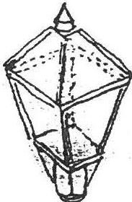

Have you looked at your SHS membership card lately? When did you last pay your annual dues?

To continue your membership for 1990-91, or to join for the first time, please fill out this coupon and send it with the proper amount to: •
Membership, Sheffield Historical Society
P.O. Box 1733, Sheffield, MA 01257

Name------ ----------
Address

Tel. Amount Renewal New member

I/we are especially interested in

I/we are willing to help out as volunteers for

Annual dues: Family $5, Individual $3

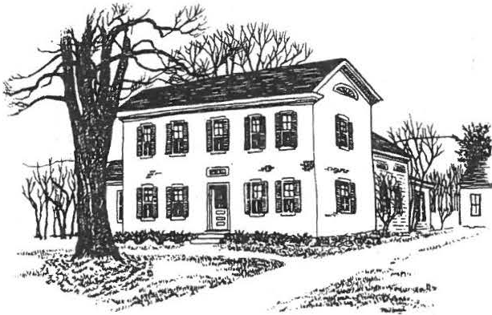
SHEFFIELD HISTORICAL SOCIETY
SHEFFIELD, MASSACHUSETTS
01257

WINTER ACTIVITIES
Vol. XVII, No. 4
November 1990

December 9, 3 to 6 p.m., Dan Raymond House Annual Holiday Open House -- see page 3.

December 14, 7:30 p.m., Dewey Hall Annual Holiday Party -- see below.

January 11, 7:30 p.m., Dewey Hall
"What's It" Night. Bring in historical artifacts you can't identify, to see if Milton Barnum and our other experts can. Or bring in something you can, but think they can't! Now's the time to find out about that odd bit of ironwork out in the barn, or that strange-looking old tool that's been rattling around in the kitchen. See how many of the other entries you can identify!
February 8, 7:30 p.m., Dewey Hall
A special program on notable Sheffield women, past and present. (If you have ideas/suggestions/inspirations on the subject, please call Sallee Hardy, program chairperson.)
March 8, 7:30 p.m., Dewey Hall
Grace Snyder, who with her husband operates Elliott & Grace Snyder Antiques in South Egremont, will present a program on textiles. She has a special interest in samplers, hooked rugs, needlepoint, and quilts.
ANNUAL HOLIDAY PARTY
Both tradition and novelty will make up the program of the December 14 meeting, starting at 7:30 p.m. in Dewey Memorial Hall.
A program of holiday music will be presented by the Friendly Chorus, directed by Betty Long and accompanied by Hilda Banks Shapiro. Both are well-known musicians in the Southern Berkshires.
A traditional component of the December meeting is Art Chase's not-to-be-missed rendition of "The Night Before Christmas." A semi-tradition (three years old) is a festive dessert buffet, for which Marion Whitman and Catherine Miller are in charge.
Come and enjoy!

2

THE PRESIDENT'S COLUMN

We are grateful to everyone who contributed in any way to our recent Turkey Dinner. Everyone worked together and had fun doing so. Mort tells us that we came close to $1,500--many thanks!

Don't forget our open house on Sunday, December 9 from 3 to
6 p.m., immediately before the town's tree-lighting ceremony. If you have never been to the Society's holiday open house, treat yourself and come by. The house committee does a great job: all the candles will be lit, the fireplaces glowing, the house fragrant with the gentle aromas of times gone by--and there are refreshments to top it off. Don't miss it!
Then on December 14 you can treat yourself again, to our annual holiday party. Marion Whitman and her committee have a great evening in store.
We'll be starting the New Year off with our regular show­ and-tell and "What's It" program. It's a fun evening, so look in your attic, cellar, barn, or top left drawer of the kitchen cupboard and see what you can come up with. Art Chase is getting rather proficient at this game, so let's see what we can bring in to stump him!

A Special Note: Too often we take for granted someone who has worked hard for a cause they believe in. I think that might be the case with Agnes Boardman. In her own quiet way she has always come through with tasks to aid the Society. Fifteen years ago she and the other volunteers scrubbed dishes to help us get an extra dime at the auctions. She has worked hard with the quilting group, takes care of calling people to bake pies, was secretary of the Society for several years--and has always done just about anything she thought would help. If you have not heard the tape Agnes made about her first teaching position--at the Brush Hill school--! urge you to ask her to play it for you. With Loring at her side at all times, giving her all the help he can,
they make a fine, loving couple. Thanks a lot, folks--we love you!

We wish each of you a happy holiday season, and a prosperous and healthy new year. Blessings to all--
Milton

WELCOME!
New Members:

Dr. and Mrs. Noel Cohen, and Gordon and Claire Height, from Sheffield. From Ashley Falls, Nancy and Bob Rathbun.
Ors. William and Eileen Evans, and Stanley and Diana Feld, from Lee.
And from Grosse Pointe Park, Michigan, Charles Ducharme, who writes that he is enjoying renewing his acquaintance with the Berkshires now that his son, Charlie, is a student at Berkshire School, his own alma mater.

3

WE MISS YOU, ED

Hardly a week goes by in Sheffield that someone doesn't ask, "Who was supposed to take care of that?" And the answer, "I don't know who was supposed to take care of that, but Ed Warren always did it."
It's high time to say how much we miss Ed Warren.
He was a charter member of the Historical Society and was active with the town Historical Commission, bringing his expertise as contractor, engineer, and carpenter to bear wherever it was needed.
He had enough faith in the fledgling Society to want to purchase the Dan Raymond House in hopes that the Society could eventually buy it. His labor and planning furthered the restoration.
He was the overseer of moving and restoring the Law Office, which his firm had donated to the Society. Many will remember Ed's clambering on the roof as the building settled on its new foundation. He worked on the carriage barn, the brick building, and the tool shed--busy shingling the roof as the first winter snowflakes fell.
And who can forget Ed's "dead men• and cables to straighten the Old Covered Bridge? His strategy didn't quite get the bend out, but it kept the bridge from sailing downstream like Noah's Ark.
Ed's contributions to Sheffield were too many to list here.
As superintendent of Center Cemetery he brought order out of chaos. An active member of the Friendly Union, Ed worked toward maintaining Dewey Hall and in preserving the goals of the society. He served the Grange, the Regional School Committee, and was a charter member of American Legion Post 340. And what a clock expert he was, as both collector and designer!
In his family and in his town, Ed was quick to see a need, generous with his skills and help, ready with a smile, quick of wit, and possessed of a great capacity for deep and abiding friendship.

OPEN HOUSE-•
--Art Chase

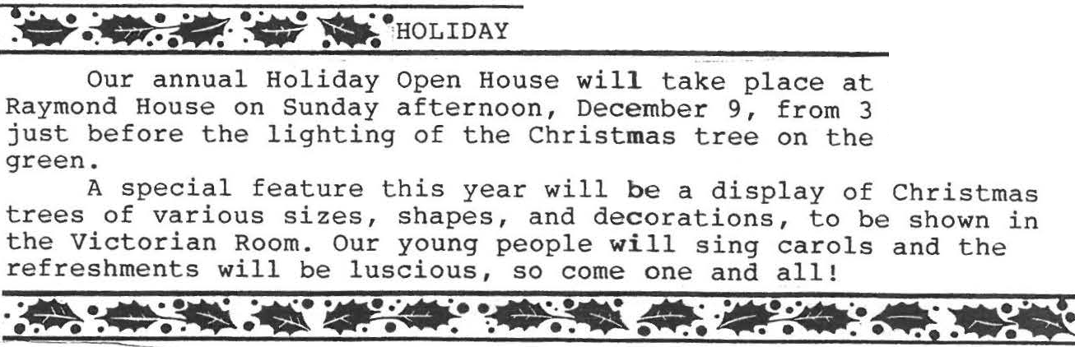
-AJiilll"• -.
the Dan to6p.m., village

Sorry you missed the .November program about two old Sheffield ' families, the Malnatis and the Bartholomews? Wish a friend could have been there? Come to the Family History Center, where we have a tape of the whole fascinating discussion.

4

UNK and Other Notes

(from the Family History Center)

Among your family photographs, are there a few you can't identify? Oh yes! The Family History Center can tell you who that stern old gentleman is, or who that lady is, leaning against the porch railing so fetchingly.
He is dear old UNK. She is UNK too, for sure!
Their pictures are in every family's archives. Their names were never penciled on the backs of the photos while anyone still knew them--so now you look at them in dismay and no one is left to tell you who they were. Are they kinfolk, or only friends of your great-grandparents, or who?
Too late. Their names are UNKnown.
Don't put it off! Some evening soon, get your family pictures together and write identifications on the backs of all the ones you know!

Open hours at the Family History Center have been re-set for the winter months: 1:30 to 4 p.m. ondays and Fridays--and other times by special arrangement.
The staff is presently engaged in sorting and cataloging a large collection of 18th- and 19th-century legal documents given to the Historical Society by Mr. Garrett H. Payne of Housatonic. The documents (some as early as 1740) include land deeds, indentures, court actions, etc., pertaining to several South Berkshire families from whom the donor traces descent.

ACQUISITIONS

The Sheffield Historical Society has received many acquisitions in the past few months:

A top hat and leather box, from Virginia Moskowitz.
Richard Combes's ink drawing of his mother, and a notebook of secret codes written by a child, both from David LeBeau.
A ledger book with many Sheffield names in it, from Helen McGoldrick. (Does anyone have her address? I need it.)
Two diaries that belonged to Lizzie Sage, dated 1879-1880 (more Sheffield names here), from Stanley Willcox.

The carriage barn's collection of old tools and other items is growing, too:
A broad ax and wood plane, from Lawrence Kervan.
A wooden bushel basket, old rake, corn knife, small ice tongs, 12-quart pail, and rug beater (remember the old beaters?)
--all from Marge Cahill.
Two saws and a horse blanket, from Mason Dutcher.

It's very gratifying to have these gifts, and we want to thank all of you.

--Marion M. Barnum, Curator

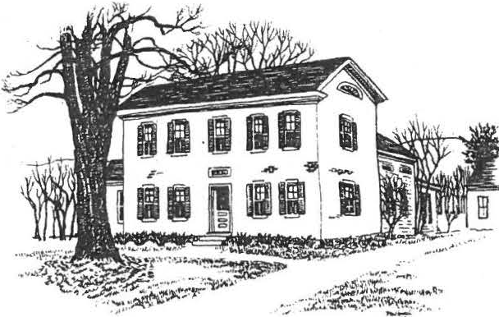
SHEFFIELD HISTORICAL SOCIETY
SHEFFIELD, MASSACHUSETTS
01257

Vol. XVII, No. 5
February 1991

SPRING'S COMING!

March 8, 7:30 p.m., Dewey Memorial Hall

Samplers and Needlework. Grace Snyder, a specialist in textiles, will discuss samplers and needle w ork up to the 1830s, relating their history to the sociological and historical changes in our society and country. Mrs. Snyder and her husband, Elliott, operate an antiques shop in South Egremo nt. She will bring a few samples from her own collection, and the audie nce is encouraged to bring examples of antique needlework they may own.

* * *
April 6, 2 to 4 p.m., Family History Center Boardman/Hewins Exhibit see page 3.
* * *
April 12, 7:30 p.m., Dewey Memorial Hall
Indian Artifacts. Michael and Rose Mary Quenneville, residents of Sheffield, will discuss th eir experiences as "surface hunters"--amateur seekers after archeological materials. The Quennevilles work closely with David Parrett, who gave a stimulating talk last year about his o wn work on archeological digs in this area. Parrett says that the Quennevilles have "one of the finest collections of artifacts in this region." They will display examples of their finds.
* * *
May 10, 7:30 p.m., Dewey Memorial Hall
Shaker Architecture . John James, an architect in Sheffield with a longtime interest in Shaker architecture, will discuss several Shaker communities, illustrating his presentation with photographs and slides. A field trip to the Shaker Museum in Chatham, New York, is being planned for a later date in May. Stay tuned for developments!

2

THE PRESIDENT'S COLUMN

For those of you who haven't been able to make the last few meetings, I'll try to bring you up to date.
Our December Holiday Party was a great dessert buffet with entertainment by the Friendly Chorus. This was put together by Marion Whitman and Catherine Miller--a fine job.
Our January meeting was our annual "What's It" and "Show and Tell." The weather that evening was treacherous, but there still was a good-sized group who enjoyed a fun evening. Thanks, Chris.
The February meeting was well attended by a large group who enjoyed the program "Sheffield Women of Action." Kathie Ness, Lillian Preiss, Claire Height, and Marion Barnum did a fine job. Fellas, if you didn't attend that evening, you missed an enlightening program!
Not only did we lose our green coffee maker--now we're losing our Secretary! Nancy Lecakis has other more pressing things to do at this time. We thank her for doing a great job-­ she'll be hard to replace. If anyone would be willing to help us out, please come forward.

In this letter I would like to acknowledge a member who was also the founder of this Society. A year or two before the Sheffield Historical Society was formed, a meeting was called for anyone interested in Sheffield history. A good group attended, but that was the last we heard of it. After some time passed, Lillian Preiss called for a meeting for anyone interested in forming a historical society. The meeting was held at the Grange Hall and a good group attended. They appointed Lillian temporary president. She took the reins and immediately created interest in meetings, which were attended by more and more people each month. We were organized, chartered, and have worked our way up to the present. Due to her devotion to history and to preserving it for the future, we now have a very active, growing Society. Thanks,· Lillian--we appreciate it!

Now, to prove to you just how deep I can delve into the well of knowledge only to come up dry, I'd like to quote a little advertisement that tickled my fancy.

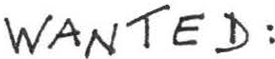
Good woman who can cook, sew, & clean house. Must be able to clean fish and dig worms.
Must have boat and motor.
Please send picture of boat and motor.

NOTES FROM THE FAMILY HISTORY CENTER

A new exhibit will open at the Family History Center on April 6, to run through he month of May. Continuing our series highlighting Sheffield families, this exhibit will focus on the Boardman and Hewins families.
Members of the two groups will be the special guests at the April 6 opening, from 2 to 4 p.m., to which everyone is invited. The exhibit may be viewed after that through May 31 during the Center's regular hours. Don't miss it!

The change in scheduling announced in the last newsletter is wor ing out well. The Center is now open Monday and Friday afternoons from 1:30 to 4. We are fortunate to have three additional experienced and talented members to help with the research: Jean Blackmur, Claire Height, and Fran Warren.
Although we are not deluged with visitors during the winter months, we are all kept busy answering requests that have come to us by mail or through local referrals. Since the Center opened in October, we have responded to requests for information from the following states: Alaska , California, Florida, Massachusetts, New Jersey, New York, North Carolina, Pennsylvania, Texas, Vermont, and Washington .
One source of information that is helpful is town reports, of which we have a burgeoning collection. If anyone can help us complete the collection, we would be most a ppreciative. The missing reports are all prior to 1946.

* * *

ACQUISITIONS
Fran Warren has given the Society a fabulous group of molding planes and other hand tools. Milton Barnum and two boys from Berkshire School have been cleaning and polishing them . I am in the process of accessioning them at this writing. They will be on display in the spring. Thank you, Fran. We are indebted to you for such a gift.

Marion M. Barnum, Curator
* * *

MEMBERSHIP

WELCOME! New member Phyllis Zucco, from Great Barrington. Turn to page 4 for a membership application.

4

MEMBERSHIP APPLICATION

Please fill out this coupon and send it with the proper amount to:

Membership, Sheffield Historical Society
P.O. Box 1733, Sheffield, MA 01257

Name- - - - - - - - - - - - - - - - - - ^{Tel.}
Address Amount-----------
Renewal New member I/we are aspecially interested in------------------

I/we are willing to help out as volunteers for

Annual dues: Family $5, Individual $3

NEW EQUIPMENT FOR THE SHS

Thanks to the initiative of the Education Committee, the Historical Society is the proud owner of a new projector and screen. These will be used for the Sheffield slide show and for other programs.

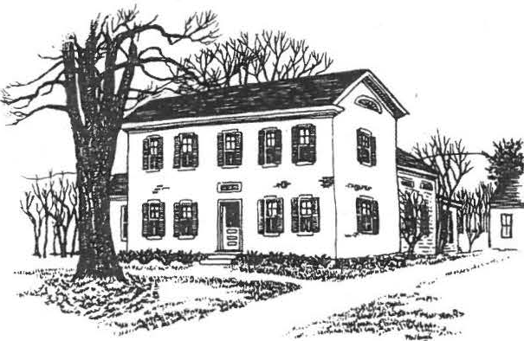
Vol. XVII, No. 6
May 1991

SHEFF! ELD HISTORICAL SOCIETY
SHEFFIELD, MASSACHUSETTS
01257

SPRING/SUMMER ACTIVITIES

CURRENT
Bringing in the May Exhibit at the Dan Raymond House. The Boardmans and the Hewinses. Exhibit at the Family
History Center (see page 3).
TUESDAY, MAY 28
Tour of The Shaker Museum at Old Chatham, N.Y., and Shaker sites at Mt. Lebanon and Hancock.

Leading this tour will be architect John James, who generated considerable interest when he spoke on "Aspects of Shaker Architecture" at our May meeting. We plan to depart from the American Legion Hall by car caravan at 10 a.m. After touring the museum, we will have lunch at the museum restaurant--inside or in an outdoor covered area, depending on the weather. The route home will take us through Mt. Lebanon and past Hancock Shaker Village. We should be back in Sheffield between 4 and 5 p.m.

Please call trip organizer Sallee Hardy at 229-3523 before May 20 to reserve a place. It will facilitate arrangements if you will indicate whether you will be willing to accommodate additional riders or if you would prefer to ride with someone. (Museum admission and lunch costs will be paid on an individual basis.
A number of people signed up at the May meeting--we hope you will too!
FRIDAY, JUNE 14 , 6:30 p.m., Dewey Memorial Hall
Annual Meeting and covered dish supper. Election of officers (see page 3) and committee reports. Bring your favorite covered dish and a place setting. (Note the 6:30 time.)
FRIDAY, JUNE 21 - SUNDAY, JUNE 23, Berkshire School
The annual Sheffield Historical Society Antiques Show.

On Friday evening there will be an Early Buyers Preview from 6 to 9 p.m. Admission is $15 per person, refresh­ ments will be served, and the Paradise City Blues Band will entertain us. This evening will be less formal-- and less expensive--than past previews, giving more people an opportunity to get a first look at the displays and to make purchases ahead of the weekend throngs. The antiques show is the primary income­
producing event for the SHS, so we count on your support.

2.

Memorandum from the Square Office

Thank you for the privilege of serving as your President for the past year. As this is the last newsletter for the year, I want to thank all the officers who worked in any capacity and all the members who helped us to accomplish the goals set before us. I also wish the new officers for the coming year well. Let's give them the best support possible in their endeavors.
The Antiques Show is coming up shortly. The committee is working hard and with all of us pulling together, we'll make it a success.
The Society is a great group of people doing a fine job, and I'm mighty proud to be a part of it.
Thank you.
--Milton w. Barnum

Invitation to Our Fiftieth Wedding Anniversary •
Marion and Milton Barnum cordially invite members
to an open house celebration of their 50th wedding anniversary on Sunday, May 26, from 3 to 6 p.m.
at their home on Cook Road

No gifts please. Your friendship and presence will be our cherished gift and we respectfully request no other.

--Marion and Milton

An Appreciation
I would like to take a little space in this newsletter to remind you of one of Sheffield's finest citizens and one of our Society's first supporters -- that's right, Arthur Chase.
Art's busy life has taken him to many parts of the country, but we are happy that he decided to settle here in Sheffield. How gratifying it must be for Art to reflect on the many students he has helped in the guest for knowledge. At his home he enjoys explaining to young and old alike the workings of his sugaring operation and honey gathering, or taking a walk to his quarry.
When our Society was first organized, he was one of the first to pitch in and work at whatever task we undertook--working on the roof of the brick building and at auctions, or entertaining with his guitar at our picnics. When Sheffield observed its 250th anniversary, he worked hard to make it a success. He wrote and produced a very successful play, "All This Freedom Talk."
One newsletter doesn't allow enough room to mentio n even
a small portion of Art's accomplishments. One thing he still does today, and that everyone looks forward to, is his rendition
of "The Night Before Christmas" at our annual holiday party. We love and appreciate you, Art.

--M. W.B.

.:,
And We Thank You!

As the year draws to a close and we approach the 20th anni­ versary of the founding of the Sheffield Historical Society, we salute our outgoing President, Milton W. Barnum.
Milton was among the small group who met to lay the foundation for the Society and went on to serve on the first Board of Trustees. In 1976 he was elected President, serving four years. He and his good friend Ed Warren purchased the Dan Raymond House and held it until the Society had raised enough funds to buy it from them at the original purchase price.
Over the years Milton has been involved in just about every aspect of the functioning of the Society--frequently behind the scenes, but always with a good nature and gentleness. He has presented us with opportunities to help recognize some important aspects of our past while also contributing to improving our present.
Last year the nominating committee prevailed upon Milton to offer his quiet personality and expert knowledge of the inner workings of the Society as our President. So it was that a
reluctant Milton Barnum became President of the Sheffield Historical Society again.
Asked to describe Milton, members who have worked with him this year and in the past have called him: qtiiec, gentle, good­ natured, a good adviser, a confidant when needed, a fighter, a
man of quiet wit. A man of dedication and commitment to our Society, his family, and the community .•• but enough accolades, lest it
go to his head. For just as has been said about another Barnurn-­ P.T., that is--"Barnurn was neither a total. sinner nor a total saint." What our Barnurn- - Milton Barnum--surely is, however, is a total nonreplaceable ASSET. Thanks, Milton, for a job well done!

--Sallee Hardy
First Vice-President
Director -at-Large Secretary
Boyd Hutchison Edie MacAusland
President
First Vice-President Second Vice-President
Chris Coenen Marion Barnum Kathie Ness
NOMINATIONS FOR OP'FICE

The Nominating Committee has placed the following names in nomination for office. The election takes place at the annual meeting on June 14, when nominations from the floor will also be accepted.

The Boardmans and the Hewinses: Two Family Histories
If you ever wondered (or thought you knew) why one of our principal north-s uth roads starts as Hewins Street at the south end of town and ends as Boardman Street at the north end, a visit to the Boardman & Hewins exhibits at the Family History Center will give you reasons a-plenty. The memorabilia of these two families offer a rare opportunity to see how certain names have become inextricable from the fabric of the town.
Entering the exhibit you are greeted inside the door by Walter Hewins's goat cart , with a snapshot of W.D.H. riding in the cart
80 years ago. You go on from there to the upstairs display of family treasures of every sort, including the handsome cradle made by the carriage-maker brothers of Sarah Loring Boardman for her child Edwin L. Boardman ("Gramp"), born in 1872--a cradle of astonishing length, as befits many Boardmans then and since!
The exhibit includes family trees and many photographs , to give you a glimpse of who is related to whom, and how. Don't
miss it! The Center is open Monday and Friday afternoons , 1 : 30-4.

4.
A Word About the Sheffield Historical Society Gardens
Another spring has rolled around and our gardens have been cleaned out and spruced up, ready to bloom again.
I think not too many of you have taken the time to walk around the grounds. Things look so pretty in season We are lucky to have these historic buildings and we should keep the gardens looking well as a setting for them. We believe they add to the appearance of the Historical Society complex.
The viburnum near the lamppost in front of the Dan Raymond House is flowering and the perennials are coming along--all a bit ahead of schedule after our strange winter. The border along the stone wall on the south side of the property looked really nice last summer. For a couple of years Kathy Moore, our landscaper, has been nursing the gardens along, and they are now beginning to
show for it.
By late spring we hope to erect a fence along the north side of the Family History Center. It will match the one in front of the Dan Raymond House. And so, gradually we accomplish the
things we want to do. We feel this addition will add to the pleas­ ing picture of our complex.
If you have a plant you can spare, either for the herb garden or for the flower beds, it would be appreciated. We like to stay with the old varieties that would be suitable for a late 18th -centur y or early 19th-century garden if possible, although we do add an annual here or there for color. If you have a plant donation, please call Penny Browne at 229-8598. Perhaps we can pick it up.

--Penny Browne

Who's Doing What

Boyd Hutchison, worker of wood and Shaker adaptations, has received a commission to reproduce eighteen pieces of Shaker furniture for Coach Leatherworks' new store in East Hampton, Long Island, scheduled to open in late June.

Architect John James has been selected to guide the restoration of the first black meeting house on Nantucket. The property, presently in disrepair, is owned by the Museum of Afro American History in Boston.

Acquisitions
Mr. and Mrs. Tinker ha ve donated a wedding gown worn by Mr. Tinker's mother. We hope to have a display of wedding gowns in our possess­ ion during the summer.
Checking all the items in the Dan Raymod House for identifi­ cation has been completed, and the list will be typed up soon. It was a time-consuming job: it took two of us one day a week all winter to complete the task. I want to thank Lillian Preiss
for her help, which was greatly appreciated.
--Marion M. Barnum, Curator

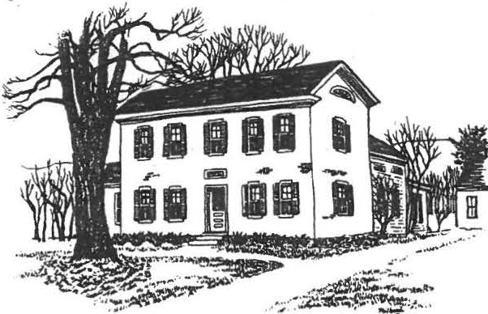
Mr . & Mrs . Mil ton Barnum Cook Ro ad
S he ffie ld , MA 01257

SHEFFIELD HISTORICAL SOCIETY
SHEFFIELD, MASSACHUS TIS
01257

Vol. XVIII, No. l
July 1991

SUMMER ACTIVITIES

SUNDAY, JULY 28, 4:00 p.m., Dan Raymond House grounds
Annual Picnic. Bring a covered dish to share--and a place setting and lawn chair for yourself. The SHS will provide refreshments (including Milton Barnum's famous, or perhaps notorious, switchel) and watermelon for dessert. ·
SUNDAY, AUGUST 4, 2 to 4 p.m., Family History Center
Opening of the Willcox Family Exhibit. The exhibit will run through September 27. See page 3 for details.
THURSDAY - SATURDAY, August 8 - 10, 10 a.m. to 4 p.m.
Annual Open House. Three-day open house at the Dan Raymond House and the Family History Center. Displays will include a wedding dress exhibit.
***************************************************************
BEST-EVER ANTIQUES SHOW
Despite an electrical failure on Sunday afternoon, which forced an early closure, the annual Antiques Show was a resounding success. Mort Levin, our treasurer, reports that we brought in $11,544--$3500 more than in 1990! Much of this increase is attributed to the less expensive preview on Friday night. Congratulations to all who worked so hard.

OFFICERS, COMMITTEES • • • AND YOU!
Attached you will find the list of elected and appointed officers and committee members for 1991-92. Please let us know if you are interested in serving on a committee or in helping out for a specific event--we are always looking for volunteers! And let us know if you have ideas for committee projects, too.

2.

LETTER FROM THE PRESIDENT

Welcome to the 1991-92 season of the Sheffield Historical Society! Once again I have the privilege of leading the Society in its mission of education and preservation. Educating the younger generation about their cultural past and assisting adults in tracing their roots are two very important functions of any historical society, and I'm proud that the Sheffield Society has been a leader in this mission in our small corner of Massachusetts.
Preserving the past serves as the first function. Without artifacts and documents, history just becomes a cerebral exercise without any substance to it. We must not, however, dwell solely on our past performances but must also look to the future.
Acquiring more "things" is useful only if it helps fulfill our stated goals. What can we do to make history more alive and tangible to our constituency? One of the programs I hope to initiate this year is an oral history project. There is a vast, and fascinating, storehouse of knowledge in our community that has gone untapped for too long. How often have we listened to Milt Barnum and Loring Boardman talk about the "old days" and wished we could remember some of those stories. It is my earnest hope that we can start preserving some of those memories on tape. I'm sure we all have old family anecdotes that have been handed down through the generations. Oral tradition has a long and rich history. Wouldn't it be marvelous to have the very words spoken by your grandmother, describing her first day of school! This is something tangible that we can do for our children and their descendants. As this project gets under way, we will be looking for your support.
As always, we will be presenting enlightening programs for your edification at our monthly meetings, as well as occasional social gatherings such as the Annual Picnic, to take place next week.
Finally, I'd like to thank Milt Barnum and Sallee Hardy for their fine leadership last year. It's safe to say that there might not be a Sheffield Historical Society without Milt, and Sallee worked tirelessly to put together many of the programs and functions that we enjoyed so much. The Society has a tradition of hard work that is the envy of many of our larger counterparts.
I'm proud to be part of that tradition.

Sincerely,
Chris Coenen

3•

NEWS FROM THE FAMILY HISTORY CENTER

Five generations of the Willcox family will be featured in a new special exhibit opening at the Family History Center on Sunday, August 4.
Not only has the Willcox family produced many personalities noted in Sheffield annals, but through branches its heritage is largely shared with the French, Candee, and Smith families as well.
The Willcox name is linked to landmark buildings on three Sheffield farms where the family made significant contributions to the history of farming in this town, from 1800 to World
War II. The first Willcox to come to Sheffield built the brick farmhouse on Boardman Street at Covered Bridge Lane (most recently the Lund sheep farm). Later, a Willcox operated the old Aaron Root farm (the "1750 House") at South Main and Silver Streets and, still later, the Spurr farm, where Berkshire School Road and Undermountain Road intersect (long known as Walter Prichard Eaton's "Twin Fires").
After the formal opening on August 4, the Willcox Exhibit may be seen during the Center's regular open hours--Monday and Friday from 1:30 to 4 p.m.--until September 27. Visitors to the Family History Center will also be able to see Katherine Kelly's remarkable eighth-grade project on the history of the Cary family, which is on loan through the summer.
* * * * * *

BAY STATE HISTORICAL LEAGUE VISITS SHS
The Sheffield Historical Society is one of eight organizations chosen by the Bay State Historical League to be included in a list of places of interest for League members. Members of the League will be visiting the Dan Raymond House and Family History Center on August 9, during the Open House, as part of their program to see what other historical societies are doing.

* * * * * *

SHS SCHOLARSHIP GRANTED
The Sheffield Historical Society, through its Education Committee, has awarded a $1,000 scholarship to Mount Everett graduate Brooke Loder, who will be attending Connecticut College this fall.

\

4.

A CHANCE TO SAY THANK YOU

On Sunday evening, June 2nd, Wes Peterson, the superintendent of buildings and grounds at Berkshire School, called me and described the havoc that the storm of May 30th had raised at the campus. The small, quiet brook that winds through the school property had suddenly decided to play the part of a wild torrent, disrupting everything in its path. The hockey rink, where the Historical Society antiques show is held, was all set up for the school graduation, with 1200 chairs, rubber floor mats, and stage in place. When the water roared through with a vengeance, there wasn't a chair left standing. Everything was buried in mud. The playing fields were a mess of debris and some of the driveways were undermined. Wes said that his men were working overtime and they had put on extra help besides. The next thing that the rink would be used for would be our antiques show, and he wondered if there was any chance of us giving him a hand with picking up the chairs.
Well now, I assure you I hate to see anyone in trouble, but this time I thought what a great opportunity for us to give back a little favor for all the good will and kindness that the school has shown us in the past few years by opening the rink for our show. I immediately called and received the o.k. from ten men to report at 8 a.m. the next morning.
By late afternoon the 1200 chairs had been taken out of the mud, brought to the garage, cleaned, dried, and stacked. We were a mess from head to toe, but every one of us was thankful that we could give a hand to someone who had done so much for us. The following men thank the school for that opportunity: Bill Bennett, Bill Browne, Correll Chapin, John Downie, Roger Drury, Don Haworth, Gordon Height, Larry Kervan, Dennis Sawyer, Carl Schumann, Milton Barnum.
Thank you--
Milton Barnum

President
1st Vice President 2nd Vice-President Secretary Treasurer Directors
Investments Curator
Archivist/Historian
Director of Family History Center

Christopher Coenen Marion Barnum Katherine Ness Edith MacAusland Morton Levin
Grace Arzt, Virginia Drury, Boyd Hutchison, wi11iam Preston
Bill Browne Marion Barnum Lillian Preiss Roger Drury

Committees (*Chairperson)

Finance Accessions Museums

Sheffield Historical Society 1991-1992
Education
Programs Newsletter &
publicity
Property, grounds

Family History Center

Membership Refreshments Turkey dinner Christmas meeting Antiques show
Morton Levin*, Bill Browne, Roger Drury, Neal Hardy, John James

Marion Barnum•, Penny Browne, Edie MacAusland, Muriel Rokos, Joan Sawyer
Marion Barnum•, Agnes Boardman, Penny Browne, Roger Drury, Lillian Preiss, Evelyn Willcox
Kathie Ness*, Grace Arzt, Renee Gibson, Marion Whitman, Claudia Ziobro
Kathie Ness*, Mason Dutcher, Lillian Preiss, Edie MacAusland, James Miller
Kathie Ness

Milton Barnum*, Penny Browne, Jim Lecakis, Dorothy Marosy, William Preston
Roger Drury*, Jean Blackmur, Betty Chapin, Holly Coon, Claire Height, Lillian Preiss
Grace Arzt Virginia Drury Milton Barnum Virginia Drury
Chris Coenen, Coordinator

- .
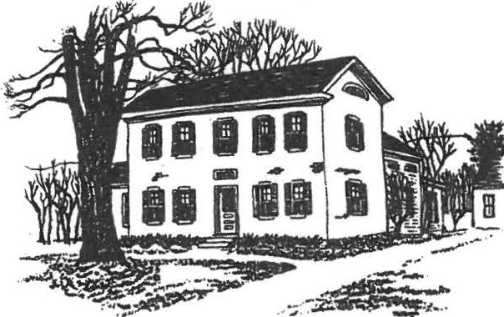
IJAl(IINJIOIC-

SHEFFIELD HISTORICAL SOCIETY
SHEFFIELD, MASSACHUSETI'S
01257

Vol. XVIII, No. 2
September, 1991

FALL ACTIVITIES

FRIDAY, SEPTEMBER 13, 7:30 p.m., Dewey Memorial Hall
The History of Photography; or, Bow I Spent My Summer Vacation. Chris Coenen will give an illustrated talk about early photography. Included will be some of the 600 glass plate negatives, owned by the Society, that he developed over the course of the summer.

FRIDAY, OCTOBER 11, 7:30 p.m., Dewey Memorial Hall
The Bidwell Bouse. Shirley Klute, director, will describe the establishment and development of Berkshire County's newest historic site• .Located on 190 acres in Monterey, the Bidwell House offers fine examples of 18th and early 19th century New England furniture and household furnishings. As a follow-up, there will be a field trip to The Bidwell House later in October.

SUNDAY, OCTOBER 27, 12 and 1:30 p.m., American Legion Hall Annual Turkey Dinner. See page 3 for details.
FRIDAY, NOVEMBER 8, 7:30 p.m., Dewey Memorial Hall
The Vanderbilt Houses. Robbe Stimson, co-author of "The Vanderbilts and the Gilded Age: Architectural Aspirations 1879-1901," will give an illustrated talk about the Vanderbilt mansions, including Elm Court in Lenox. You may have seen articles about the authors in the local papers this summer.

FRIDAY, DECEMBER 13, 7:30 p.m., Dewey Memorial Hall Christmas Program. Feasting and festivities.

2
THE PRESIDENT'S COLUMN

Greetings! As I write this there are ony two days left to summer vacation before I must disappear into the academic life of Berkshire School. Looking back, it has been a very pleasant summer. Our Antiques Show was a huge success despite some fireworks late Sunday afternoon. Everyone took it all in stride and we did better financially than we have ever done. We thank all who contributed to its success. It's one time of the year when so many of our members come by to help out and everyone has a good time. To me, the camaraderie of so many people working towards a common goal is what the Society is really all about.
Our annual picnic was also one of the nicest in memory. The weatherman cooperated, and the picnickers partook of jovial conversation and fine food. Even Milton's switchel garnished rave revues! We also took time out to say good-bye to Irene Cranmer, who will be dearly missed. And I found out that I grew up about a mile from her house in Westchester--small world!
The Program Committee has been scouring the countryside in search of the finest entertainment that can be procured, so I'm sure I'll see you at all the fall meetings. We also have some other ideas, such as craft workshops and trips planned for the fall and winter, so keep looking and listening for announcements.
If you haven't stopped by the Family History Center lately, you've missed some outstanding displays on our local families.
Currently the Willcoxes are being highlighted, and it is well worth a visit.
Finally, we are looking for someone who would like to work with Marion Barnum as a curatorial assistant. It's not time­ consuming and would be a great help to the Society. Just let Marion or me know, or stop by the Dan Raymond House some Friday afternoon.
See you all on September 13th --

Chris Coenen
****************************************************************

AT THE DAN RAYMOND HOUSE
The current exhibit at the Dan Raymond House features an interesting variety of wedding dresses, some from the Society's collection and others loaned by members.
Included are a green dress and a black one, worn by Sheffield brides in 1862 and 1884 respectively. Also on display are a satin and lace dress from England, an intricately decorated dress belonging to Mrs. Harry Warren, as well as traditional gowns from 1917 to 1950. A wedding picture of Mr. and Mrs. John Gaskill accompanies the latter's 1932 dress.
The exhibit will run through September 13 and may be seen on Friday afternoons from 1:30 to 4 or by appointment by calling

3

FAMILY HISTORY CENTER OFFERS GENEALOGY CLASSES
The Family History Center is sponsoring a series of genealogy classes designed to introduce participants to the methods and resources available to those interested in doing their own family histories. .
Kathleen Reilly, a professional genealogist and former research assistant in the Local History and Genealogy department of the Berkshire Athenaeum, will conduct the six-week series at the Family History Center. Classes are scheduled for Tuesday mornings from 10 to 12, starting on October 1. Subjects to be covered will include how to get started in tracing a family history, the use of published and microfilmed records, and the utilization of church, cemetery, court, land, military, and immigration records.
There is a fee for the course and class size is limited. Contact Roger Drury (229-2687) or Jean Blackmur (528-1371) for further information.

* * * * * * *

THE TURKEY TROT'S COMING!

It's that time again -- circle Sunday, October 27, on your calendar because you won't want to miss this annual event.
The first Turkey Dinner we served was on November 4, 1979, and the proceeds went to the restoration of the covered bridge. Each year since then, we have given the entire proceeds to our education fund for student field trips and scholarships.
We will be in contact with you later to make sure you don't miss out on the fun of preparing, serving, or cleaning up after serving over 300 dinners.
Getting excited? Just can't wait!
--The Old Gobbler

* * * * * * *

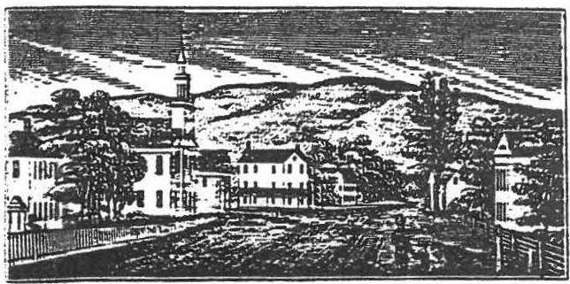
Have you renewed your membership for 1991-92? If not, please do it now -- just send in the form enclosed with this newsletter.
Thanks!

\
\
l

4

OUR GROWING COLLECTION
Now that the checking of all items in the Dan Raymond House for tags and numbers has been completed, the acting curator's job has slowed down. Articles have been coming in slowly and I am able to keep up with them.
In August William Meyer gave the Society two books: "The Appledore Cook Book," published in 1877, and "Cram's Unrivaled Atlas of the World," printed in 1891. He also gave a nutcracker to add to the buttery collection of old kitchen utensils, and an old wrench for the carriage barn. -
Grace Arzt has loaned the Society a Chippendale-style mirror that was given to her by her grandmother. It is hanging in the north chamber.

--Marion M. Barnum, Acting Curator

* * * * * * *

FAMILY HISTORY CENTER
September offers four more weeks of the Willcox Family Exhibit at the Family History Center--open on Monday and Friday afternoons until September 26.
Come and see Caroline Sage Willcox's melodeon, Colonel Joseph Willcox's spontoon, William Sage Willcox's demonstration model of an adjustable ox-yoke, silver prize spoons won at the fairs of the Housatonic Agricultural Society {and dented by teething Willcox infants seventy years ago}, the Willcox family cradle {in use for 130 years), and a river diagra of the families that have joined to form the Willcox heritage, like tributary streams entering a river, during the last 200 years-­ all of it illustrated by many photographs of Willcoxes living and dead.

* * * * * *

We are always looking for volunteers. Are you interested in working on a committee or helping out for a specific event? Don't be shy! Just speak to any of _t he officers or committee members, or write a note on your membership renewal form. And let us know if you have ideas for committee projects, too.

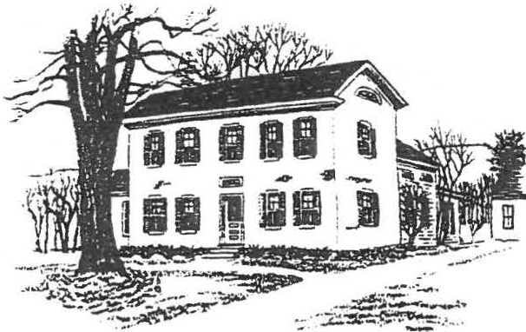
SHEFFIELD HISTORICAL SOCIETY
SHEFFIELD, MASSACHUSETTS
01257

.Vol . XVIII, No. 3
November 1991

WINTER ACTIVITIES

SUNDAY, DECEMBER 8, Dan Raymond House, 3 to 6 p.m.
$. Annual Holiday Open House: The Dan Raymond House will be beautifully decorated for Christmas, a collection of Santa Clauses will be on display, and delicious refreshrnents--hot mulled cider, coffee, tea sandwiches, cookies, cakes--will be served. We look forward to seeing you there!

FRIDAY, DECEMBER 13, Dewey Memorial Hall, 6 p.m.
5 Holiday Celebration -- gala roast beef dinner, musical accompaniment, and a surprise presentation. Corne at 6 o'clock
and bring a place setting (silverware, dinner plate, and
coffee cup). Call 229-3368 for reservations, please. See page 3 for details.

FRIDAY, JANUARY 10, Dewey Memorial Hall, 7:30 p.m.
*
What's It Night: Milt Barnum's popular evening of guesswork and ingenuity. We'll have a selection of items to challenge your knowledge, and if you have any mystery items around your home or barn, do bring them in--whether or not you know what they are!

FRIDAY, FEBRUARY 14, Dewey Memorial Hall, 7:30 p.rn•

- A program on Black History -- details in the next newsletter.

?• 2
We Did It -- Thank You! 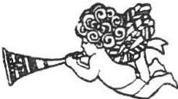
The Turkey Dinner Committee thanks all who contrlbuted and worked so hard to make our recent dinner such a great success. It was because of your many hours of devoted labor that we ended with a profit of $1,527.26.
We received many fine remarks from the diners--and how great it was to see the eighth-graders doing such a fine job.
Many thanks.

-- The Old Gobbler (Milton Barnum)

- n id you see the article in the "Berkshire Record" about the Turkey Dinner? Our fame is spreading! It's reprinted on page 4.

. * * * * *

Antidote for the Winter Doldrums

The Education Committee is working on plans to offer a selection of workshops during February and March. These will range from half-day to several-day projects, offering members a chance to learn how to hook or braid rugs, make baskets or herb wreaths, construct Shaker-style boxes, bake bread in a wood-fired oven •.•

If you have a special request or suggestion for a workshop topic, let us know. And if you have some expertise to offer, we'd love

to hear from you! Contac-t any of the committee members--Mar on
Whitman, Rene Gibson, Claudia Ziobro, Grace Arzt, or Kathie Ness.

* * * * *

Christmas Shopping

If you're looking for a gift that features Sheffield and the Berkshires, don't forget the Berkshire County Historical Society calendars for 1992. They're available at the Dan Raymond House and cost $6.95 (from which the SHS receives $3.50).
And if you're thinking of giving a present--the Family History Center is sorely in need of a typewriter. If you have one you aren't using, please call Roger Drury and be our Santa Claus!

p.

- THE HOLIDAY DINNER -

Virginia Drury and crew will be putting on a gala Holiday Dinner for our December program on the 13th. We know there will be a big turnout, but the space in Dewey Hall limits us to 100 diners. Please call Kathie Ness at 229-3368 as soon as possible to make your reservations--we certainly don't want to have to turn anyone away at the door.

The evening will have a Victorian flavor. If you are so inclined, come in Victorian dress--or even with a touch of Victoriana in your outfit. We can't tell you if this has anything to do with the surprise presentation, because we don't know what the surprise is! All we can tell you is that certain secretive Historical Society members are preparing a very special "tableau" for us all to enjoy at the conclusion of the meal.
And speaking of the meal, can you resist cranberry juice followed by roast beef, baked potatoes, mixed salad, and rolls--and sorbet and cookies for the finale? All accompanied by live piano music? Better make those reservations now!

Membership Application

Please fill out this coupon and send it with the proper amount to:
Membership, Sheffield Historical Society
P.O. Box 1733, Sheffield, MA 01257

Name- - - - - - - - - - - - - - - - - - Tel.
Address Amount- - - - - - - -

I/we are specially interested in---------------- I/we are willing to help out as volunteers for- - - - - - - -

Annual dues: Family $5, Individual $3

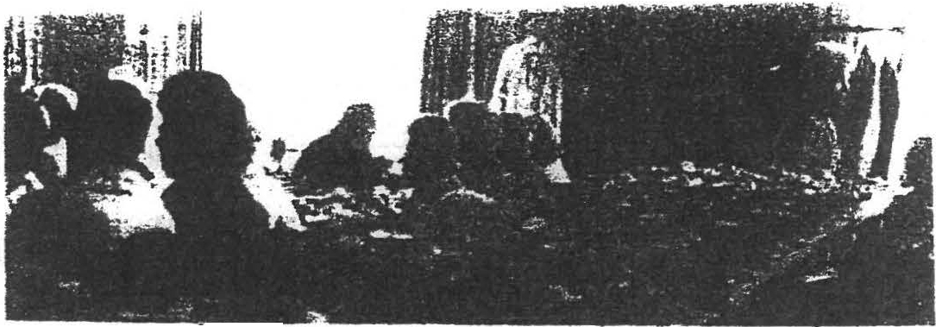
- 4

Pift,-.IP.t home •lllllcle apple cmuab pie• were GJUY' part of the menu.
Turning· ·Turkey Into SchQlarships

, By 'nae!ma O'Brien

SHEFF.IELD-Everaomany turkey diimers- later, to be semi-aact, a M.L.Evem t' High School.se nior is $1,000·cJoserto paying for college. and a whole number of eighth graders are cloaertoa deeperunderstanding
of the region's colonial anteced- enta.• - . - .
' Th e 18-yeai -old Shef'1eld Historical Society made $1,514 thisyear tohelpsenda seniorto
collece and to.pay for historica·l
tours for Southern Berbhire
School District.eighth graders.
Long-time IOCiety' member and former president'·Milton Barnum said the gronp,"heacl quartered in the 1776·Dain Raymond Howie, hii.i beenllost-.
a fund-raising turkey hmch/ dinner aince '1979 .when 10- cietyneeded to meet inatching
a
the
a.rant
stat.e to have the old cov­
ered bridge repaired. .;
Thatfirateffortyieldednearly
mem­
$1,500 and the 260-plm benhavebeenrai moneyfor onefhinrand another everiince. The earnings, which average
right a.round $1,300 annually, are now applied to scholarships and field tz:ipe, according to cur­
rent President Christopher
Coenen.Thisyearsmeals,served
  - in two shifts, were served in' the American Legion Hall.
Among those sittingdown for the $7 pre-Thanksgivingrepast ofcoteslaw, whiteand darkmeat from 12, 26-pound turkeys, eranbe:9" ! a e·e, s tuffing,
. squa.sh;muh edpotatoes,gravy, rolls and butter, coffee and tea, and 58homel!Wle apple(c:ro.mb
and a:ust) _ d kin pies, were Rntb ·Filkins of South Egremont whosa)'5she comesto the annual event because:
"You see people you don't or­ dinarily aee..And, when you live alone yon can't cook. a turkey
and Stouffer's can't cook a meal
like t.ms.•
She was sitting with friends, Barbara and Marion Cronk, sis­ ters who live together in Great Barrington. ·
"Weconie because we like the food m1d the atmosphere." said Barba:ni. Cronk. "It's fun."
Alsoattending were Ruth and
Mason °'11cher of Sheffield who have been.members of the soci­ ety for eight years and usually lielp serve, but not this year.
'The historical society is one ofthe best thin_gsever to happen to Sheffi ld," said Mason Dutcher,are.tiredtravelingman in the hosiery business. "We're
- learning more·about ourselves
and it's all to the good. Self­ awanness is valuable and it's
- valuableforthetowntoknowits history.
Sittingopposite the Dutchers were Vera and William Conklin of Ashley Fall, also members of the society . A retired dairy farmer,William Conklin said the cowsare goneno froi;ihis land but his grandson has gone into the sod business andusesabout half the 100 acres for that.
Sitting to .bis left was DurwardWillcox, also of Ashley Falls, who retired in the mid- 1970s from the state Depart­ ment of Public Works after 39 years with the highway depart­ menL He is a member of the society, along with ·his wffe Marion who was sitting up at the pie table
She reported on tiie number of pies and was responsible for marshaling the bakers. "Most people baked two: she said. "Some just baked one."
Up from Terryville Connecti­ cut,or from their cabin on Twin Lakes, were Elizabeth and Rob­ ert Bandish, a retired steelworker's union representa­ tive.
•rmretiredfrombell,"hesaid.
addingthathe's been coming to this meal for ,everal years.
; •Everyone's friendly, and we come for the food and to mee t people.• Hesaidalsohe wasvery concerned about the economy, about' the high unemployment ratesin his part of Connecticut. 'Tm a big nardener: he said, "and nowadays I give half the
rm
stuff away to senior citizens.
telling you, there's gonna ' be a revolution in this country if things don't change.• He said he thought George Bush ought to bemunaedforaboutsixmonths "not let oaf.of the country ."
On hand was Mt. Everett so­
cial studies teacher William Gilooley, who was supervising eighth graders as they served dinners, bused tables and gen­ erally added youthful enthusi­ asm. For their troubles they get tOeat second shift.and be se?"Ved by society mernbe?"S. They also are served a so--:ailed coloniai
:ire i<fas t ' n · he ! _{'Or:} _{::1£} .

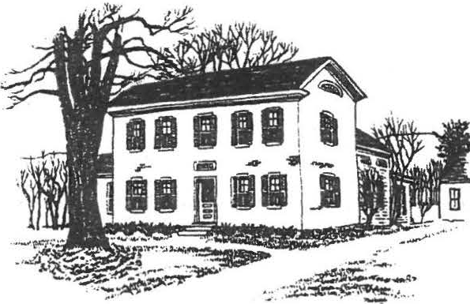
SHEFFIELD HISTORICAL SOCIETY
SHEFFIELD, MASSACHUSETTS
01257

Vol . XVIII , No. 4
January 1 99 2

WINTER - SPRING

SUNDAY , JANUARY 26, l to 4 p.m.
Tour of the Torborg house. See below .

FRIDAY, FEBRUARY 14, 7 :30 p .m., Dewey Memorial Hall
Program on black history in the Berkshires by Jon Swan,
p layw right , journa lis t, and author of several articles on Mum Bet.
TUESDAY, FEBRUARY 25 - Crafts classes begin . See pages 2 and 3 . FRIDAY, MARCH 13 , 7 :30 p.m. , Dew y Memorial Hall
Donald McGrory, of McGrory Oriental Rugs in Great Barrington, will present a program on oriental rugs, illustrated with examples from his co llection .
THU RSDAY , APRIL 9 - Genealogy classes begin . See page 4 . FRIDAY , APRIL 10, 7:30 p.m. , Dewey Memorial Hall
Historic gardens. Stephen McMahon , superintendent of the Trustees of Reservations properties in this area, will discuss early gardens--and in particular the historic garden at the Mission House in S tockbridge , which is currently being redes igned.

*** A VERY SPECIAL INVITATION ***
Na n cy and Gery Torborg have invited the members of the Sheffield Historical Society to tour their home on Sunday, January 26, from l to 4 p.m. This fine center-hall colonial, built around 1760, originally belonged to the Hubbard family
<Jonathan Hubbard was the first minister in Sheffield) . It is on the west side of Main Street <Route 7), just north of the Sheffield Plain Cemetery and opposite Dovetail Antiques. The Torborgs have recently renovated and restored the house, and they'll have plenty of "befo re" pictures for us to e xamine .
Please note that this generous invitation is open to SHS members only. We hope you will be able to attend.

2 .

PRESIDENT'S COLUMN
Well, here we are, with the winter in full swing and everyone starting to feel the pangs of "cabin fever ." I hope you can attend some of the workshops we have planned to fight off some of the effects of the long win ter. It's always fun to get together to work on projects with others who have the same interests. It's also a chance to make some new friends or renew acquaintance with old chu ms.
I would also invite you down to the Family History Center on a Monday or Friday afternoon to see what is going on or to take in the exhibi t. You might even find yourself getting involved in a research project. If you like detective stories, this is the place to be!
Once again we had some stumpers at the annual What's It program. There was a fine turnout, with many new faces, and a lot of fun was had by all. The· Program Committee has planned some very interesting programs for the spring, and I hope you get to attend them a ll . Finally, remember that the Antiques Show is only five short months away! This will be our bigge t and best show yet, in the newly refurbished Berkshire School Field House. Mark it on your calendars: June 19, 20, and 21 .

WORKSHO.P
Mon. | Tues. | !Jed . |  | Thu rs. | Fri . |  | Sun .
Feb 24 | 25 . '  pi\  '" ,o,,i | 26 |  | 27 | 28 | 29  1r;.',; | Mar |  | 1
2 | 3 - - o  ,ff . \  \O' | 4 |  | 5 | 6 YP,.,.,s  , :31> | 7 »-r-  vP ';  \O" | 8
9 | 10  :;t;' 'J;'!f  \0, | l | 1 1 | 12 | 13'(('"-4v  #\1•,'?P | 14 | 15
16 | 17  "3,tll  \O' | 18 |  | 19 | 20 | 21 | 22
 |  | '11'11-
23 | 24 | 25 |  | 26 | 27 | 28 |  | 29
 | '""")} |  |  |  |  |  | -
 | \O'\

CALENDAR

Sat .
't',

°''

3 .

* * * CRAFTS WORKSHOPS * * *
The Education Committee is offering the following workshops in historic crafts during late February and March .
Please note: We expect that these classes will be very popular, and we urge you to send in the enclosed fo rm , with payment, as soon as possib le. Enrollment will be limited to
Historical Society members until February 10 . After that date, any openings will be announced in the local papers. Clf we are heavily over-subscribed, we may be able o offer extra sessions of some class es :)

SPI,..ING. Students will learn how to select and prepare wool for hand spinning -- including carding, spinning, plying, blending fibers, dyeing, and spinning exotic fibe rs . Note: Spinning wheels are req uired . If you do not have one, let us know when you enroll, and we'll arrange for ren ta l . No wheel is necessary for the first c lass . The class fee includes a fiber pack .
Instructor: Linda Becker
Dates: 5 Tuesdays, Feb .25 Mar .24 Time: 10 a .m.-12 : 30 p . m.
Location: Dan Raymond House Fee: $67 .50
BREAD BAKING. Bake bread the 18th-century way: in a wood-fired brick bake oven . You will learn about preparing the dough, will enjoy a cup of tea and a taste of bread hot from the oven, and will take home your own sample of delicious country-style bread .
Instructor: Virginia Drury :

Date: Saturday, February 29
Location: Barnum residence, Cook Road
Tiine: 2 to 5 p.m. Fee : S3

SHAKER OVAL BOXES. Make classic Shaker oval boxes ith a master cra fts man . After this one-session class, you will have completed your own box to take home. The fee covers all supplies .
Instructor: Boyd Hutchison
Date: Friday, March 6 Time: 6 :30 to 9:30 p.m.
Location: Hutchison Woodworking, Route 7 Fee: S25
RUG HOOKING. Learn the basics of this popular needle craft by creating a hooked-rug doorstop Ca cover for a bri ck ). The fee includes all supplies . Bring your own lunch, and a pair of scissors, to this all-day c lass .
Instructor: Babs Barrett

Date: Saturday, March 7
Location: Dan Raymond House
Time: 10 a.m . to 3 p .m.
Fee: $40

BASKET l'IAKING . You ' ll learn about basketry while creating your own candle basket--a reed basket designed to hang on the wall, originally used for storing tapers. Bring an pron if you like; the fee includes all supplies .
Instructor: Jo Ann Catsos

Date: Wednesday, March 18
Location: Dan Raymond House
Time: 9 a.m. to 12 noon
Fee: S15

4 .

FAMILY HISTORY CENTER

The Family History Center recently received two volumes on the genealogy of Long Island families, donated by Ursula Kilner in memory of Arthur Chase . We are very grateful to Mrs . Kilner for honoring Arthur in this way .

GENEALOGY CLASSES PLANNED FOR SPRING

There has been so much interest in the subject that the Family History Center has decided to sponsor a second series of genealogy classes .
Kathleen Reilly, a professional genealogist and former research assistant in the Local History and Genealogy Department at the Berkshire Athe naeum , will conduct the six-week course .
Topics include getting started in tracing a family history, the use of published and microfilmed records, and the utilization of church, cemetery, court, military, and immigration records .
Classes are scheduled for six Thursdays, from 1 to 3 p.m., starting on April 9 . One session will take plate at the Athenaeum, where its collections will be introduced and guidance provided for using them.
There is a fee for the series, and class size is li mited.
For information, call Roger Drury at 229-2687 or Betty Chapin at 229-2000.

HOLIDAY THANKS

The annual Holiday Dinner was a fe s tive evening--the result of the dedication and e f fo r ts o f ma ny SHS members. We w re delighted to have such a fine turnout , and we especially want to thank the Sheffield Market and Astro Beef for their help in making the dinner a s uccess .

COMINGS AND GOINGS

We miss some longtime members who've moved away recently, including Irene Cranmer and Neal and Sallee Hardy. At the same time we welcome new faces, among them Fern and Elliot Chapnick and William Mitke .
As it approaches its 20th anniversary, the Sheffield Historical Society boasts over 250 members!

COMPUTER WOES

No doubt about it--this newsletter isn't as easy to read as earlier ones . That's because it was created on. a new computer, and the old printer doesn't work on the new machinery ...yet. We think we'll have everything hooked up and running properly for the next edi tio n, and then we can go back to a better-looking typeface . Keep your fingers crossed'

{
',
)

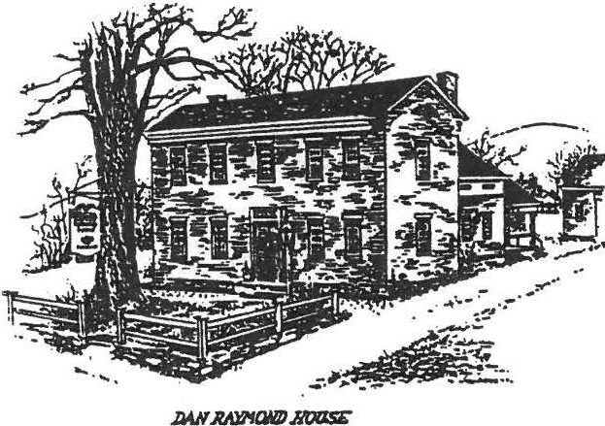
Sheffield Historical Society
Sheffield, MA 01257

Volume XVIII, No. s
April 1992

SPRING/SUMMER ACTIVITIES

FRIDAY, MAY 8, 7:30 p.m., Fellerman Glassworks, South Main Street

Steve Fellerman will demonstrate glassmaking techniques. See page 3 for details on this special "field trip" meeting.

FRIDAY, JUNE 12, 6:30 p.m., Dewey Memorial Hall

Annual meeting and covered dish supper. Election of officers for 1992-93 and presentation of committee reports. Bring a place setting and a hot casserole, salad, or dessert. We will celebrate the Society's 20th anniversary with a special program, so be sure to attend! (Note the 6:30 time, please.)

FRIDAY, JUNE 19, THROUGH SUNDAY, JUNE 23, Berkshire School

The annual Sheffield Historical Society Antiques Show. On Friday evening, there will be an Early Buyers Preview from
6 to 9 p.m. Admission is $15 per person, wine and cheese will be served, and a classical guitarist will perform. This is your chance to get a first look at the displays (and to make an early purchase), before the crowds arrive on the weekend. The hours on Saturday and Sunday are 11 to 6. The antiques show is the Society's primary income-producing event, so we count on your support.

AND LATER IN THE SUMMER • . •

We'll have our annual picnic on the Dan Raymond House grounds. The date witl be announced in the next newsletter.

I
2 '

THE PRESIDENT'S COLUMN

As I sit down at my desk on a beautiful spring day (finally!), I am tempted to reflect on this past year in the Society. Since this is my second term as president and my fourteenth year as an officer, I have gained some perspective.

In many ways this has been a good year for the Historical Society. We are in a sound financial situation because of the wise investment policies of the Financial Committee and the generosity of past donors. The Dan Raymond House looks better than ever, thanks to the guiding hands of Marion Barnum and Penny Browne and their committees. Most exciting has been the work of the Family History Center, with Roger Drury and Lillian Preiss at the helm. Probably more than anything else we are doing right now, the Family History Center will be appreciated by future generations. As a repository for genealogies, it will be an invaluable resource for the community. But even more than that, the photographs, audio tapes, and artifacts that are being collected and preserved will give our children, and their children, a real picture of what Sheffield was like in the past. I hope you will make good use of this Center and support their efforts.

Another satisfying sign that the Society is prospering has been our monthly meetings. One of my goals this year was to present programs with wide-ranging appeal. On several occasions we had overflow crowds in attendance. Our next meeting will be a departure from tradition as well. For the first time we will meet on location instead of at Dewey Hall. This next meeting will gather at Fellerman Glassworks on South Main Street for a glassblowing demonstration. You won't want to miss this one! The Program Committee has done a wonderful job organizing these meetings.

Before I finish, however, there is one area that concerns me. The Sheffield Historical Society has always been known as the hardest-working group in the county. It's what makes us special. Unfortunately, and this is typical of small societies like ours, it is getting harder and harder to fill the ranks of officers.
Many of us have served in several capacities and are ready to turn the reins over to others who are just as well qualified. The tasks are not difficult and require very little time commitment. I sincerely hope that many of our new members, as well as longtime members, will feel comfortable in helping the Society in this way. It's a lot of fun and very rewarding.

I'm looking forward to seeing you at the next meeting.

-- Chris Coenen

r
t
{' 3

THE MAY MEETING

We are offering an unusual and exciting program at the May meeting: Stephen Fellerrnan, well known for his contemporary art glass, will demonstrate glassmaking techniques and will create several traditional pieces as we watch. Steve also has a 19th­ century glass press on display, and he'll discuss some of the history of glassmaking.
Please note that we will not meet at Dewey Hall. The entire meeting--including the usual announcements and refreshments--will take place at Fellerman Glassworks, which is about 1/2 mile south of town on Route 7. There is ample parking there, but we do encourage you to carpool if possible, as we're expecting a large turnout for this very special program.

* * * * *
Interested in Historic Gardens?

The size of the audience for the April program on historic gardens tells us that many of you are interested in the subject. Now here's a chance to put your enthusiasm to work!
Many of us have admired the herb garden that the Sheffield Garden Club has created at the Colonel Ashley House. The club is now looking for some volunteers to help maintain the garden through the growing season. It's a small plot, so it will take only about half an hour, one day a week. If five or six people sign up, the assignment can be rotated, so each person would be committed to only two or three sessions during the whole summer. The club will provide a training session for all volunteers.
This is a pleasant way to enjoy a lovely historic garden close up--without having to take much time away from your own pursuits. Please call Barbara Person at 229-6625, or Kathie Ness at 229-3368, to volunteer some time or to get more information.

* * * * *
Who Will Win the Afghan?

If you missed the April meeting, you haven't yet seen the beautiful "Summer Seashells" afghan Grace Arzt has made, to be raffled off to benefit the Historical Society's scholarship fund. This is the fourth year that Grace has donated an expertly handmade afghan. We'll have it on display at the May meeting and at the antiques show. Please make sure you pick up a raffle ticket, along with several extras to sell to your friends. The drawing will take place in August.

4 (
}

Something New

Have you noticed something new around the corner at the Dan Raymond House? Come take a look at our handsome new well house, constructed and installed under Milton Barnum's supervision.
Modeled on a well house at Sturbridge Village, it was built by Walter Agar and set in place with the help of Bill Preston, Dana Barnum, and the crew· at Gulotta's Mobil. The timbers are hand­ hewn, and the wide boards were sawn with a vertical saw to represent old boards. We think you'll agree that it's a fine addition to our complex of historic buildings!

* * * * *
Workshops a Resounding Success

Fifty people attended crafts workshops sponsored by the Education Committee during February, March, and April. The rug­ hooking and basket-making sessions were well attended and thoroughly enjoyed, and the bread-baking and Shaker box workshops had to be repeated to accommodate the numbers who signed up.
If you'd like to see more workshops offered in the future, and if you have suggestions about other crafts to be explored, please let us know.

* * * * *
Students Enjoy •Historical• Breakfast

The annual breakfast for Mount Everett eighth-graders was held at the Dan Raymond House on March 20. It was a great success, attended by twelve students and two teachers. Milton Barnum cooked over the open fire--and just to make you wish you'd been invited, here's the menu: spiced fruit, scrambled eggs and bacon, pancakes with maple syrup, homemade applesauce, and hot chocolate. Some of the children made their toast over the open fire, and for dessert they enjoyed strawberry shortcake.
Chris Coenen held a mini "What's It" program--which was a lot of fun, evoking some wild answers. And Lillian Preiss introduced the students and teachers to the Family History Center.
It was a pleasure to have the boys and girls as guests at this event.

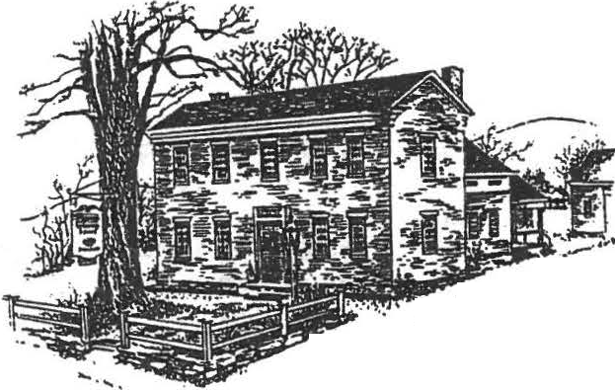
..&r·
..,...
..,:-.#,- -- - • . . ...

Sheffield Historical Society
Sheffield . MA 01257

Vo1. X I X , No.
July 1992

* SUMMERTIME ACTIVITIES*

SATURDAY, JULY 18, 10 to 4 , American Legion, Route 7 .
Tag Sale: on the la wn, or indoors if it rains . Rent a table for $10 ( br ing your own, please) and take advantage of this great opportunity to clean out your attic or garage. The Society receives ¥Our rental fee and the rest goes into your pocket--along with the fun of joining in on a multi-family sa le . If you have just a few items, you can bring them that morning and donate them to the Historical Society table. And i f you know someone who'd like to take part, go ahead and invite them. This is not limited to members . Call 229-2569 for more info rmation .

SUNDAY, JULY 19, 4 p.m., Dan Raymond House grounds.
Join us for our Annual P icnic . Bring a covered dish to share, along with a table setting and lawn chair for
yourse lf . The Society will provide the beverages, including the ever-infamous switchel, Milt Barnum's spec ia lt y. This is always a fun, relaxed event--a chance to celebrate another successful antiques show and the beginning of a new year .

THURSDAY, JULY 23, 7 p.m. , Dan Raymond House .
Executive board mee ting .

THURSDAY - SATURDAY, AUGUST 6 - 8, 11 to 4. Dan Raymond House .
Come enjoy our Annual Open House. Tentative plans include a display of Victorian and other early flower vases.

A Letter from the President

Following in the footsteps of our past presidents will be a giant step for me. I have been involved in the growth of the Historical Society since the beginning in 1972 . I held the office of treasurer for seven years and have been curator, "house mother," and substitute secretary on many occasions, as well as trustee and refreshment cha ir man . It is now time to assume my office as president, to help further the goals of the So c ie ty.

The help of all Society members is needed so that we may still be a leader in Berkshire County. When someone asks how and what we do to accomplish so much, I always answer that "working together and having fun" is the secret . Pursuing the historical education of the Society in the future will be both exciting and rewa rd ing .

So with a new year beginning, let us keep the foundation solid and keep building for the futu re.

* * * * *
-- Marion M. Barnum

ANOTHER GREAT ANTIQUES SHOW

The figures aren't complete, but we do know that we had another successful antiques show this June -- close to last year's financially, and with many improvements in the renovated hockey rink and especially in the attractive new cafe quarters.

Many thanks to all the volunteers who helped with food, at the gate, and else where. It's fun -- and it's hard work. We couldn't do it without you!

* * * * *
NEW OFFICERS
At the June meeting, the following new officers were e lected : President: Marion Barnum
Vice-president: Virginia Drury Treasurer: Bob Dean
Trustee: Claudia Ziobro
In the next newsletter we'll provide a complete list of officers and committees for the 1992-93 year . (Now's your chance to
vo lunteer . Isn't there a committee you could donate some time to? It doesn't take much effort, it's a lot of fun -- and it's your organ iza tion . Let's spread the work around ')

.FAMILY HISTORY SLEUTHING

Can any newsletter reader give help to the Family History Center in responding to two recent inquir ies ?

One person asks if her ancestor Joel Thorp did indeed marry an Indian woman in Sheffield around 1800 , as family tradition
c la ims.

Another is looking for information about the Sheffield years of a skilled cabinetmaker named Silas Butler, who was apparently in Sheffield in the early 1770s and died here about 1778 . His wido w, Jerusha, married Joseph Huggins .

If you have any clues , please contact Roger Drury or Betty Chapin, or stop by the Family History Center on Mondays and Fridays between 1 :30 and 4 p.m. In fact, even if you don't recognize these names, stop by to observe the fascinating research that's goes on

It's Renewal Time

To renew your membership for the 1992-93 year, please fill out this coupon and send it to:

Membership
Sheffield Historical Society PO Box 1733
Sheffie ld , MA 01257

Name Tel.
Address

Family $5 Individual $3

I am/ We are interested in helping with _ _ _

would like to attend programs/works hops about _

II
r

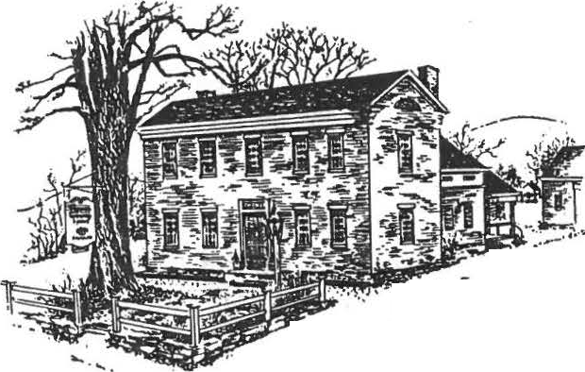Sheffield Historical Society

:•- :, :--•'
Sheffield, MA 01257

Vol 19, No. 2

A MESSAGE FROM THE PRESIDENT
Since our last newsletter, the Societies gatherings and the monthly meetings have been well attended. Thirty three people took the bus trip to Kinderhook, New York. There are many lovely , old homes in that area. We have Grace Arzt to thank for arranging such a pleasant and relaxing trip that was enjoyed by all the pa rticipa n ts .
Now that the holidays are fast approaching, mark your calendars for these special events. The Christmas open house on December 6th will have a special glow this year. Make plans to attend and then go on to the tree lighting ceremony on the village green. Also coming up is the Christmas Dinner meeting on December 11th.
The live Christmas tree craft project was held with eight people making a lovely mini tree. Everyone was very happy with their finished t ree.
Don't forget the "What's-It" program in January. Everyone always has a good time and you may learn something new.
Happy holidays to all!
Marion M. Barnum
''YUP! YOU DID IT AGAIN"

You came through for the 14th time in great fashion. Those who say we have nothing to do here in the country sure don't look around.
All the turkeys and gravy are gone and the potatoes and the rest of the vegetables went with them, and 303 satisfies customers left us with a profit of$ 1,325.00. Now I call that a good show and well worth the effort of many faithful members and friends. How about those students! Didn't they do a fantastic job, and Sgt. Catherine and her troops put out the first sitting of 153 dinners in 14 minut es- that's remarkable! We thank each and every one of you who helped in any way .
Thank you for a job well done.

Sincerely,
From the Empty Turkey Pen

,,

NOTESFROMTHEFAMILYHISTORYCENTER
The big news from the Family History Center continues to be the Roys Family Exhibit which enjoyed a crowded opening on November 1 and will stay on view throughout the winte r. Members of the Society are encouraged to make a unhurried visit to this fine exhibit on a Monday or Friday afternoon, between 1:30 and 4:00. Allow plenty of time to savor the rich assemblage of family artifacts, photographs, books, and other papers provided by Miss Mildred Roys for the display. Better yet, come twice!
Throughout our town's history, the Roys Family has produced noteworthy individuals, staying attached to the same farm lands along the Undermountain Road where the first Roys settled in the eighteenth century.
The work of the Family History Center and the research services it offers were described in a a well-received talk at the Grange last month by Betty Chapin, and again will be the subject when Lillian Preiss speaks before the Roeliff Jansen Historical Society in Copake on November 17.

HOOSACTUNNELDRAWSLARGECROWD
The October meeting played to a standing room only crowd. Combining local history with railroadiana always brings out a large audience. Charles Cahoon, former president and of the North Adams Historical Society and local expert on the Hoosac Tunnel , kept the audience spellbound with his tales of engineering fact and fancy. Begun in the 1850's as a way to get manufactured goods from Fitchburg to the West, the tunnel took nearly thirty years to complete and cost 195 workers their lives. Begun at either side of the mountain, the twmels joined with less than an inch of deviation from each other . One of the major problems was water . Nearly 650 gallons a minute gushes out of the mountain tunnel. Despite the difficulties involved, including working with highly explosive nitroglycerine, the tunnel was completed in 1883 and signalled a rapid growth of indu st ry and commerce in Northern Berkshire Count y. The tunnel is still in use today for commercial service and an occasional tourist trip.

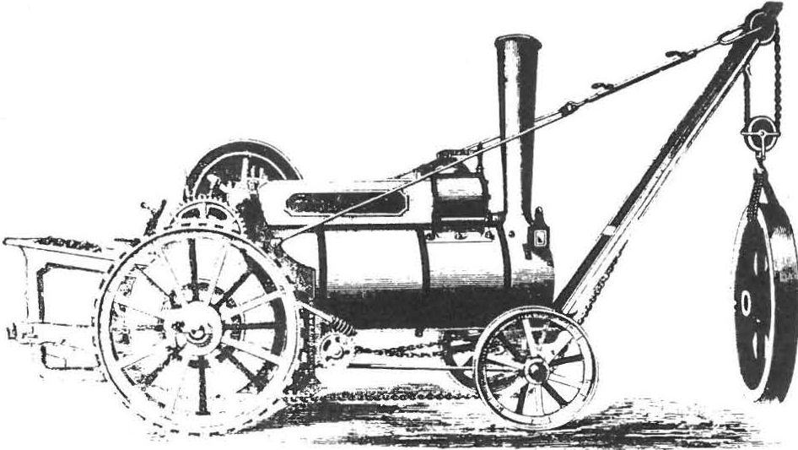

•• ! I t '1 •• ,•,, , ,1 1v 1. 1 1 , , r. , , ,.1:,.,.1
H I : \ I K I I '"'
\\ 1 1 11 l' \ I L ;'\ f --11, f; - l•LA' l h

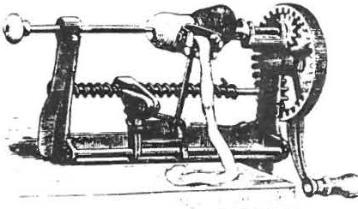..
I

CALENDAR OF COMING EVENTS
Sunday, December 6: Hollday Open House, 3-6 PM
The Dan Raymond House will be glowing with "The Magic of Red and Gold" - the theme of this year's Christmas decorations. Come and enjoy the house at its festive best and partake of the refreshments (cookies, coffee, hot mulled
cider, holiday cakes) before going on to the carol singing on the town green.

Friday, December 11: Covered Di,sh Hollday Di,nner, 6:30 PM
Bring a place·setting and a covered dish to share. We11 supply the beverages, the dessert , the decorations, and the musical entertainment for this annual celebration. This is always an especially happy get-together. If your not a cook, bring some fruit, or some olives or a relish and join us.

Frida y, January 8:What's-It Night, 7:30 PM
Search those attics! Ransack the barn! Can you find an old widget, gadget or gewgaw that can stump Milt Barnum and his crew of mechanical triviologists? This is also an opportunity for you to tell an interesting story about some long lost family relic. Also on this year's program will be a special contest that you won't want to miss. Bring the kids and come early and stay late.

The Dan Raymond House Committee is always looking for volunteers to be docents. Why not spend two hours a month learning about the house and showing visitors around? Talk to Marion Barnum, Penny Browne or Lillian Preiss or just stop by. They'd love to see you!

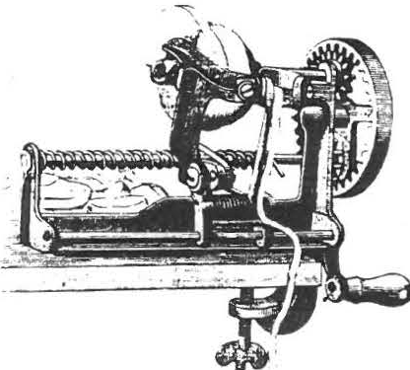
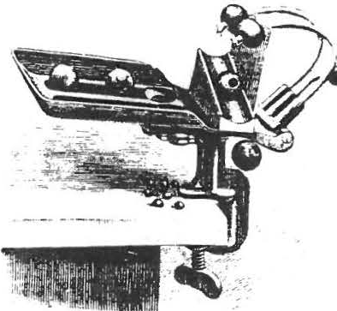

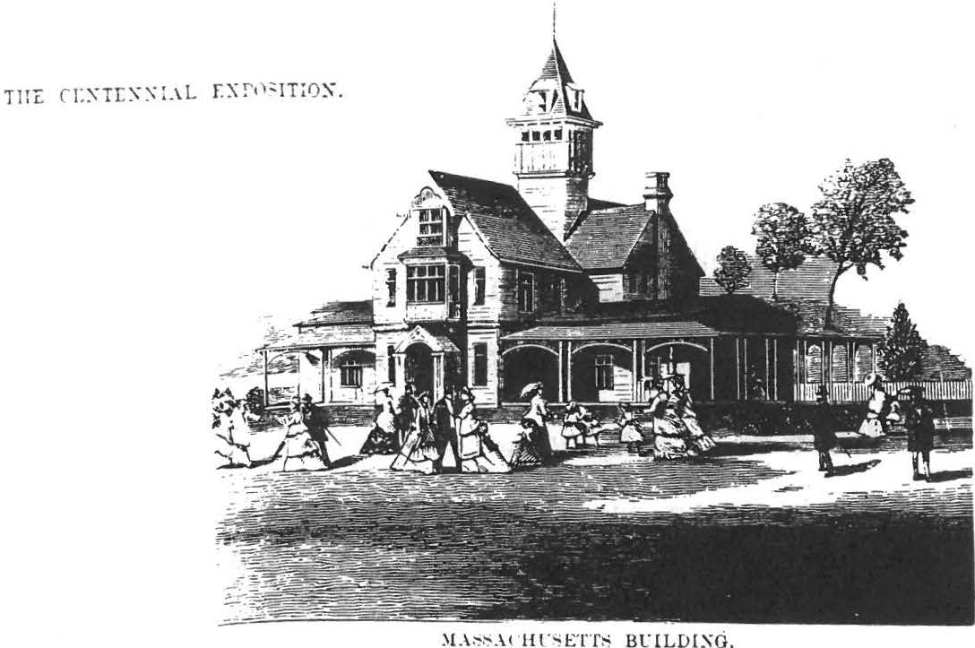
l

Massachue;etts,
Massachu se tts brought before the world, as her State Buildin g, a specimen of Colonial arcliitecture, quaint­ looking, derived partly from the English and partly from the French, and it attracted considerable atten­ tion. T his wns one of th e few of the State buildings which adopted as their model the sty le of hou ses com­ mon to Colonial times. It is one of the lar gest and best appointed State buildings on the grounds, and consiste d of one f'quare section with annexes at the ends and a tower witli nPakPcl rnnf r i, illrr frnm thP centre. It was colored in brown with stripes of chrome green. The grounds were very prettily laid out, with different colored flowers tastefully arranged in beds and patterns. In front of the building stood a little fountain fed by a hose. In front of the entrance was a pretty porch flanked by long piazzas, which were pro­ vided with cane-seated benches, and had baskets of flowers hanging from the roof. The main entrance hall was cool and spacious, with rows of comfortable seats, and a large old-fashioned fire-place with mantel of wood . T he hall also contained an organ, and " bookcase filled with standard works. At the north end of the hall was an office with a register and post­ office, and on the right of the entrance was the Gov­ ernor's reception-room, very richly fu rnished, with paintings on the walls, a handsome J a pa nese screen and a n umber of ot he r ornamenta l objeds. On the left was the ladies' parlor, some wha t simila rly fur­ nished, anrl provided with a grand piano. fassachu­ i;etts had her Sta te day on September 11 th, on which occasion the a tt e ndance of vi$itors amounted to 97,808.

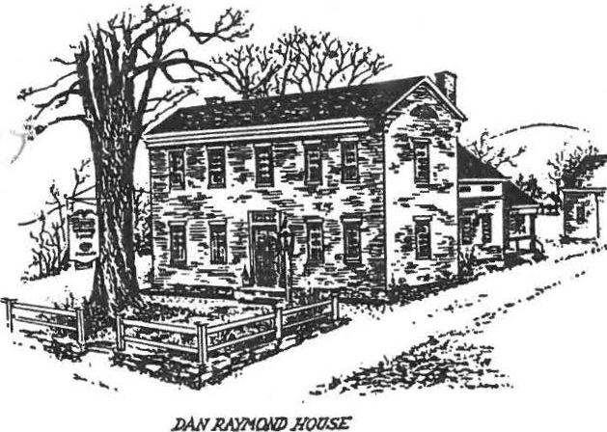
Sheffield Historical Society
Sheff ield , MA 01257

A MESSAGE FOM THE PRESIDENT
Vol. XVlV No. 4
JUNE, 1993

l..
Now that my year as president has come to a close, I want to thank all who have helped in any way during this time to make my "job" a wonderful experience. ·As the new officers take over their duties for the coming year, let us wish them well and give them our support. I will still be in the background doing whatever is necessary to help further the ideals of the society.
The annual dinner is coming up on Friday, June 11 at 6:30 P.M. Come and enjoy a delicious meal and then listen to the chairmen's reports telling of what has been accomplished during the year. Reports will be short but will tell of the work of the society building and going forward . Harmony and fellowship are two important ingredients in maintaining the growth of our society. Working together helps us reach these goals.

Marion Barnum, President

NOl\flNATIONS OF OFFICERS

The following members have been nominated as officers for the coming year: President- Katherine Ness
1st Vice-president- Virginia Drury 2nd Vice-president- Biil Preston Trustees- Esther Kininmonth
Theresa Brazie Martha Williamson

ANNUAL MEETING

The Annual Meeting will be held on Friday, June 11th at 6:30. This is a potluck dinner so please bring a dish to share. The Society will provide the beverage and dessert. After dinner there will be committee reports and a few surprises. Don't miss it and remember to bring a place setting.

ANrIQUES SHOW

The annual Antiques Show is less than two weeks away!' Held on June 18, 19, 20 at the Berkshire School, we certainly hope to see everyone·there. Friday night at 6:00 is the opening for the Society. All the proceeds from the Early Buying session go to the Historical Society so please try to attend. Admission is $15\an q. wine and cheese will be served along with live musical enterta inment . This is always a very pleasant affair and it affords you an opportunity to peruse the antiques before the general public on Saturday.
One of the characteristics of our Society that hasalways distinguished it from other societies in the County is the willingness of our members to contribute their time and energy. We need many volunteers to donate a little of their time during the Show to make it run smoothly. It's always a lot of fun so please say "yes" when called upon.

TAG SALE

The.Sheffield Historical Society will sponsor a tag sale on Saturday, July 17th from 10-4 at the American Legion on Rt. 7. Anyone may participate and dealer space is $10. Bring your own tables.

PICNIC

This summers picnic will be held on Sunday, July 18th at the Dan Raymond House. Bring something edible to share with your fellow members and have fun. The festivities begin at 4 P.M.

BIDWELL HOUSE

Lisa Simpson, director of the Bidwell House, has offered free admission to anyone who was unable to wait for the tour during the May 19th field trip ( our group was too_large to take the tour as a single group ). Just mention it to Lisa when you arrive at the house.

AUGUST OPEN HOUSE

This year's Open House will be on August 13th and 14th from 11-4 to coincide with the Antiques Show. Come by and see the Dan Raymond House in all its summer splendor.

Sheffield Historical Society
Sheff ield , MA 01257

A MESSAGE FOM THE PRESIDENT
Vol. XVlV No. 4
JUNE, 1993

l..
Now that my year as president has come to a close, I want to thank all who have helped in any way during this time to make my "job" a wonderful experience. ·As the new officers take over their duties for the coming year, let us wish them well and give them our support. I will still be in the background doing whatever is necessary to help further the ideals of the society.
The annual dinner is coming up on Friday, June 11 at 6:30 P.M. Come and enjoy a delicious meal and then listen to the chairmen's reports telling of what has been accomplished during the year. Reports will be short but will tell of the work of the society building and going forward . Harmony and fellowship are two important ingredients in maintaining the growth of our society. Working together helps us reach these goals.

Marion Barnum, President

NOl\flNATIONS OF OFFICERS

The following members have been nominated as officers for the coming year: President- Katherine Ness
1st Vice-president- Virginia Drury 2nd Vice-president- Biil Preston Trustees- Esther Kininmonth
Theresa Brazie Martha Williamson

ANNUAL MEETING

The Annual Meeting will be held on Friday, June 11th at 6:30. This is a potluck dinner so please bring a dish to share. The Society will provide the beverage and dessert. After dinner there will be committee reports and a few surprises. Don't miss it and remember to bring a place setting.

ANrIQUES SHOW

The annual Antiques Show is less than two weeks away!' Held on June 18, 19, 20 at the Berkshire School, we certainly hope to see everyone·there. Friday night at 6:00 is the opening for the Society. All the proceeds from the Early Buying session go to the Historical Society so please try to attend. Admission is $15\an q. wine and cheese will be served along with live musical enterta inment . This is always a very pleasant affair and it affords you an opportunity to peruse the antiques before the general public on Saturday.
One of the characteristics of our Society that hasalways distinguished it from other societies in the County is the willingness of our members to contribute their time and energy. We need many volunteers to donate a little of their time during the Show to make it run smoothly. It's always a lot of fun so please say "yes" when called upon.

TAG SALE

The.Sheffield Historical Society will sponsor a tag sale on Saturday, July 17th from 10-4 at the American Legion on Rt. 7. Anyone may participate and dealer space is $10. Bring your own tables.

PICNIC

This summers picnic will be held on Sunday, July 18th at the Dan Raymond House. Bring something edible to share with your fellow members and have fun. The festivities begin at 4 P.M.

BIDWELL HOUSE

Lisa Simpson, director of the Bidwell House, has offered free admission to anyone who was unable to wait for the tour during the May 19th field trip ( our group was too_large to take the tour as a single group ). Just mention it to Lisa when you arrive at the house.

AUGUST OPEN HOUSE

This year's Open House will be on August 13th and 14th from 11-4 to coincide with the Antiques Show. Come by and see the Dan Raymond House in all its summer splendor.

I • '>

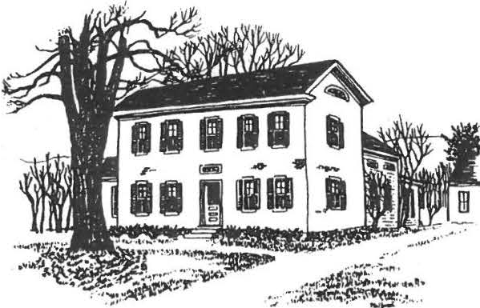

SHEFFIELD HISTORICAL SOCIETY
SHEFFIELD, MASSACHUSETI'S
01257

Volume XXI No. 3 F ruary 1994

FUTURE PROGRAMS :

February 11th: ANTIQUES FOR THE TABLE
Sheila Chefetz, owner of the Country Dining Room Antiques in Gt. Barrington, will speak to us about the art of using antiques for the table. She has written a book that represents her lifelong interest in antiques and many years experience in creating entertaining dining experiences. She lectures frequently on the art of dining with antiques, and her book ANTIQUES FOR THE TABLE was published by Viking Studio Books in 1993. Ms. Chefetz will have autographed copies of her book available following the meeting..

March 11th: NEW WORLD DUTCH BARNS
A talk with slides on the preservation of Dutch barns. Lou Caputzal is a board member of a group dedicated to preserving Dutch barns. He is also a member of our Society. His enthusiasm is contagious. Be sure to not miss this one.

APRIL 8th: BERKSHIRE COUNTY AUTHORS
Hilary Russell, head of the English Dept. of Berkshire School, will present a program on Berkshire authors. Also, a group of students from Undermountain School and their teacher Jo Ann Callahan will tell us about their project of producing a Sheffield History coloring book. Our SHS Education Fund contributed $150.00 to cover their expenses.

MAY 13th: HISTORY OF QUILTS
Award-winning quilter Marsha Schulte will teach you some things you probably never knew about the American art form of quilting. Marsha is a teacher well known throughout the area for her quilting classes. Another program you will not want to miss.

r '

A MESSAGE FROM THE PRESIDENT:

It is a pleasure to be involved in planning our 1994 Antiques Show during this dramatic winter weather. Remember green grass? Flowering lilac and mountain laurel? Sandals and
short-sleeved shirts? All this snow and cold will be a distant memory on June 25th and 26th!

We are looking forward to an excellent show with our new managers, Donald and Joyce Coffman. They have some innovative ideas for us to consider, one of which is the possibility of SHS members hosting show dealers. This would involve providing a guest room for one or two nights, and maybe a cup of coffee in the morning - nothing more. The dealers would pay for their room with a check to the Historical Society. If you would like to offer your hospitality and by doing so make a significant contribution to our income from the show - please fill in the coupon in this newsletter.

Do come to the meeting on February 11th - it promises to be a fascinating program. In fact, so do all the programs in the following months. Our Program Committee has been working hard this year - with great success.

WINTERFEST

As you may have read in the local papers, WINTERFEST 1994 will take place during the week of February 21st (President's Day). The Southern Berkshire Chamber of Commerce has arranged an array of festivities and entertainment, and Wednesday the 23rd will be Sheffield's special day. The Dan Raymond House and the Family History Center will both be open from 10 to 5, and a demonstration of early crafts (candlemaking, spinning, quilting) will take place at the Dan Raymond House from 3 to 5.

We look forward to seeing you there, and at the other area events!

THE STEEPLE FUND

The Historical Society encourages its members and friends to contribute to the Old Parish Church Steeple Fund. One of Sheffield's most important historic buildings, the church holds a special place in our hearts, whether we are members of the congregation or not. We were all dismayed by the sight of the exposed steeple structure this Fall. The fact the repairs have been made does not mean the fundraising is over. Let's all try to help if we can.

I

AT the History Center we are collecting information on Sheffield Men in the Civil War for our spring exhibit. You may leave anything you might have on your ancestor---letters, diaries, pictures, etc-- at the Center . We are open Monday and foriclay. I :30--4:00 .

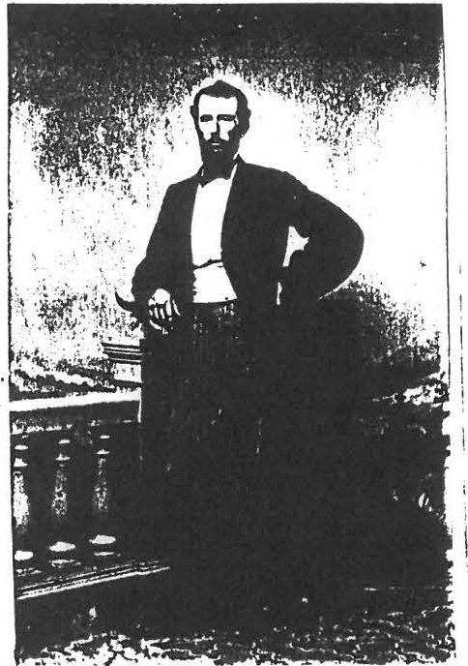
Nov . 1862
"Went home about Thanksgiving and the people of Shemeld sent back by me
500 lbs.of poultry and other Thanksgiving eclihles"

from the diary of A. N. Cowles '19th Mass. Co. E..

-------------------------------------------------------------------------------------------------------

ANTIQUES SHOW HOSPITALITY

I can offer _ _ _ room(s) to dealers at the Antique Show for the nights of Friday, June 24
, Saturday, June 25 , and/or Sunday , June 26th .

name - - - - - - - - - - - - - -
address- - - - - - - - - - - - - -

phone - - - - - - - - - - - - - -
(You will be contacted for more information as show plans develop)

J
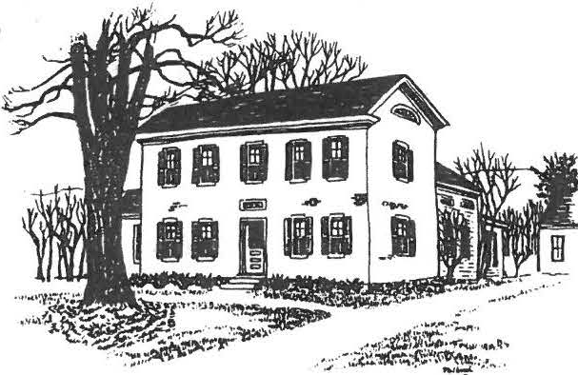
1

SHEFFIELD HISTORICAL SOCIETY
SHEFFIELD, MASSACHUSETTS
01257

Volume XXI No. 4 Mayl994

CALENDAR

May 7: 2 to 5 PM OPENING OF THE CIVIL WAR EXHIBIT at the Family History Center. An exhibition of photographs, newspapers, letters, and artifacts belonging to Sheffield soldiers will be on exhibit. Anyone who would like to learn more about the "War of Rebellion," as it was called, will not want to miss this exhibit curated by Betty Chapin.

May 13: AMERICAN QUILTS will be the topic of the program. Marsha Schulte, quilting teacher and designer , will speak on the history of quilting. She will illustrate her talk with samples of quilts and quilt blocks from her own collection. 7:30 PM at Dewey Hall.

Ju ne 10: ANNUAL MEETING; 6:30 p.m., Dewey Memorial Hall. Potluck supper. Bring your own place setting, please. We will supply beverages and dessert. (If you don't cook, come anyway; your contribution can be a monetary one, to help cover the costs of coffee, tea, milk, and so on.) See "Notes from the President" for more information about this meeting.

June 25 and 26: THE ANTIQUES SHOW!

Saturday: Preview 8 to 10 a.m.
Show 10 a.m. to 6 p.m.
Sunday: Show 11 a.m. to 5 p.m.

The nominating committee has proposed the following slate of elected officers for the 1994-95 year. We'll be voting on this slate at the Annual Meeting.

President: Virginia Drury Vice-President: Fred Gordon Secretary: Esther Kininmonth
Treasurer (1 year, to fill out term): Grace Arzt

Trustee: Lou Caputzal, Harry Conklin (2 years, to fill a term)

WE ARE NOT THE ONLY ONES RAISING FUNDS

As you may have read in the local papers, the Sheffield Historic Commission is working to raise funds to restore the town clock in the steeple of Old Parish Church . Many people probably assume that the church maintains the clock, but that's not the case. It was a gift to the town from the Grand Anny of the Republic and the Women's Relief Corps in 1903 as a memorial to George Root, composer of many well-known Civil War songs, and the town has been responsible for it since then. The Commission is planning to hold a fundraising event on July 2nd, on the town green. Table spaces are available for anyone who wants to sell arts and crafts, food, or other items. Bill Preston is the contact person for this (229-2077).

NOTES FROM THE PRESIDENT:

During discussions at Board meetings this past year, there have been many instances when we wished we had a clearer "mission" as a Society. We've passed the 20-year mark and we need to review our purpose and goals: What is the primary purpose of the Sheffield Historical Society? What are the appropriate ways of achieving our mission? What direction should we be headed during the next 20 years? Obviously these are not easy questions to answer, so the Board turned to Roger Drury, whose wisdom has always been so valuable to us. Roger and his committee have wrestled with these questions and have prepared a Mission Statement. And at the annual meeting o·n June 10, we'll be asking you what you think (all members will receive a copy of the proposed statement before that meeting). This means that the Annual Meeting will be even more important than usual, since in addition to voting on a slate of officers for 1994-95, we'll be voting on a statement of purpose for the indefinite future! So please do attend the meeting if you possibly can
-- we'd like to have a good discussion about these issues.

Two weeks after the Annual Meeting, it'll be time for the Antiques Show! We expect this year's show to be new and exciting--and a good fundraiser--and as always we rely on you to make that happen. We'll be calling! And even if you can't volunteer, we do hope you'll be able to attend the preview and/or the show. See you there!

Kathie Ness

WE WILL BE CALLING SOON!

The steering committee for the Antiques Show is hard at work, so you know you can expect to get a phone call soon, asking for help in one way or another -- in the cafe, at the admissions desk, at the preview, and so on. This is always such a fun event that everyone turns out -- and we're counting on you to do so once again. The more hands the merrier!

We'll also be getting in touch with those who have so generously offered a guest room.

PREVIEW TICKETS

As you know, this year's preview for the Antiques Show will be a festive Champagne Breakfast from 8 to 10 a.m., before the show opens on Saturday. We'll be selling the Preview tickets for $15 apiece, and we hope many members will purchase them. Twelve of those fifteen dollars go straight to the Society, so the Preview is an important fundraising element for us. Even if you don't want to go anywhere at 8:00 on a Saturday morning, you can make a contribution by buying a ticket! And you can always enjoy the show later in the day, siiice the Preview tickets are good for the entire duration of the show. They'll be available at the May and June meetings, and from Kathie Ness (229-3368).

HELP WANTED

Donald and Joyce Coffman, managers of the Antiques Show, say they will need a crew of "porters" --helpers to work with them setting up and breaking down the show. Any able-bodied individuals who are interested in earning some extra money should contact the Coffmans at
528-9282.

SUMMER HOURS AT THE DAN RAYMOND HOUSE

We are hoping to be able to open the Dan Raymond House to the public on Saturdays this summer. In order to do this, we need to find two individuals who would like to be trained as docents in June, and then to work at the house -- receiving visitors and conducting tours -- in July and August. This would be a great summer job for a qualified student or for anyone else who's interested in historic places. If you, or your child or grandchild, or your neighbor might be a good candidate, please let us know. We'll be advertising the job in area papers, too. For information; call Kathie Ness 229-3368.

'•

ANNUAL DUES

Our calendar year is from June to June. When preparing to pay your annual dues, please check the mailing label on your newsletter. If this is not the official post office mail address, please correct and return to us. A reminder: dues are $3.00 per individual or $5 .00 per family.
They may be paid to P.O. Box 1733 or paid at a meeting.

• • •

Please detach and return to Virginia Drury - 742 Barnum Street, Sheffield 01257

YES! I WANT TO HELP AT THE ANTIQUE SHOW

Preparing food for Preview and/or Cafe _

Selling food at Preview and/or Cafe_ _ _

Selling tickets at front door _

Directing traffic in parking areas _

Acting as guards at side entrances (a sit-down job)_ _

Painting roadside signs _

Making up dorm beds at Berkshire School

I can work on JUNE 25--- June 26---

NAM_E_ _ _
_ _ _ _
_ _ _
_ _ PHONE_ _
_ _ _ _ _

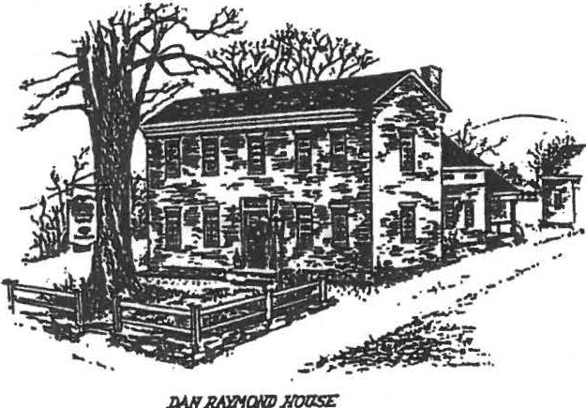
NOTES FROM THE PRESIDENT:
Sheffield Historical Society
Sheffield, MA 01257

Volume XXII No. 5 September 1994

The Society has grown remarkably. We began with a handful of enthusiastic founding members and the Dan Raymond House, and look where we are now! We have more than 100 paid up members,
240 on our newsletter list, we have added satellite museum exhibits in the Barn, the Law Office, and the Hatter's Shop. We put on an annual Turkey Dinner to raise educational funds, and sponsor the Antiques Show to raise accessions funds. We operate the Family History Center as a public service for genealogical and historical researchers.

The Dan Raymond House has been the nucleus of the Society from the beginning. Acquired through the generosity and labor of such as Milt Barnum and Ed Warren, and the money-raising efforts of so many others, it has been nurtured through the years by a committee of three: Marion Barnum, Penny Browne, and Lillian Preiss and many others. It has been beautifully cared for and
has attracted many visitors, by yearly workshops, programs for school children z.:·,.. special exhibits. Yet it is beginning to be clear that volunteers are not easily found to keep up the pace.

For example, we have discovered that the only way to keep
r.,1.e Dan Raymond House open on weekends, when people are most easily able to enjoy visits there, was to train and pay docents. Perhaps this is a sign that we, like many museums, are facing a need for professional guidance in the carrying out of our museum program.

I have therefore appointed a study committee to consider this question. They will gather suggestions for forward-looking museum methods and bring their recommendations to the Board of Directors, along with their estimate of the Society's ability to carry the
e:-: •e nse of a part-time professional Director to guide us toward the goals we recently re-stated in our Statement of
purpose. Members of the committee are: Boyd Hutchinson, Chairman, Marion Barnum, Roger Drury, Catherine Miller, Kathie Ness, and Lillian Preiss.

Virginia Drury

...

DIRECTORY OF OFFICERS AND COMMITTEES 1994-95

OFFICERS:
President 1st V.P.
2nd V.P.
Secretary Treasurer Directors
at large

Virginia Drury William Preston Fred Gordon Esther Kininmonth Grace Arzt
Therese Brazie Martha Williamson Harry Conklin Lou Caputzal

FINANCE:
Grace Arzt, Chr.
Catherine Miller, Investment Mgr. Bill Browne, Consultant
Mason Dutcher Dennis Sears Hallem Turton

C O M M I T T E E S ACCESSIONS:
Bill Preston, Chr. Karen Altman Dorothy Marosy Lillian Preiss Judith Timm
ANTIQUES SHOW:
Catherine Miller, Co-Chr. Kathie Ness, co-Chr.
Bill Browne Penny Browne Chris Coenen Dorothy Marosy Bill Preston
EDUCATION:

Fred Gordon, Chr.
Marion Whitman, Consultant Teresa Brazie
Boyd Hutchinson Harry Conklin

FAMILY HISTORY CENTER:

James Miller, Archivist/Historian Betty Chapin , Director of Center Betty Dunk
Eleanor Griffiths Cathie Hutchinson Kate Turton
MEMBERSHIP:
Fran Warren MUSEUMS:
Lillian Preiss Marion Barnum Penny Browne
MUSEUM STUDY:

Boyd Hutchinson, Chr. Marion Barnum
Roger Drury Catherine Miller Kathie Ness Lillian Preiss

NEWSLETTER:
Marion Whitman NOMINATING:
Kathie Ness, Chr. Chris Coenen Virginia Drury
PROPERTY:

Bill Preston, Chr. Milt Barnum
Ann Riou Lou Caputzal

PUBLICITY:
Kathie Ness REFRESHMENTS:
Teresa Brazie

SATURDAYS AT THE DAN RAYMOND HOUSE

There is still time to take advantage of the new Saturday hours at the Dan Raymond House. Alison LeBeau and Kathy Orlando have been working as docents since the July 4th weekend and will be on duty through Labor Day. They will answer your questions and provide tours of the house and grounds. We are very pleased with the response to these extended hours. Kathy and Alison have been doing a great job. Anyone who has volunteered at the house knows how much there is to learn before you can be a guide!

We hope to be able to continue this program. If you haven't stopped by,we hope you will!!!

THE HISTORIC COMMISSION MET OUR CHALLENGE

As you know, earlier this summer the Historical Society issued a challenge grant to the SHEFFIELD HISTORIC COMMISSION to raise up to $2,5000.00 in donations to the Town Clock Fund and we would match it dollar for dollar. Well, the Commission lost no time in getting to work, and on July 25th we handed over a check for the full amount. The Commission has done an excellent job of fundraising for the clock repair work. The Society is pleased to have been able to play this role.

1994 ANTIQUES SHOW NETS $3,596.83

Perhaps not as good money-wise, but still a SUPER show.
We were pleased with the management of the Coffmans for the show and they have agreed to do it next year. Kathie Ness and Catherine Miller will co-chair the 1995 show.

SUMMER TAG SALE NETS $13.00

Perhaps we were all too tired from the antique show and the summer picnicto properly prepare for it. Maybe we will have it in the Fall next year?

A TRI•STATE HISTORY PROJECT

A regional local history effort is underway involving groups from Canaan, Cornwall, Falls Village, Norfolk, Northeast, Salisbury, Sharon and Sheffield. Under the guidance of Whitney
North Seymour, Jr., the TRI-CORNERS HISTORY COUNCIL plans to work on cooperative projects, such as a brochure on area historic house museums (including the Dan Raymond House). Also in the works is a revised and expanded book length edition of "Arsenal of the Revolution", slated for publication in May 1995. Our own Lillian Preiss was one of the authors of the original pamphlet,
published by the Lakeville Journal for the Bicentennial.
Future projects include a "History Trail" brochure, cooper­ ative open house weekends , and circulating exhibits. This is a very exciting undertaking, one that is sure to be mutually beneficial, to engender new ideas for the individual historical societies, and to attract both residents and visitors to the Nealth of historical sites in the area.
Lillian Preiss will be the SHS representative on the Tri-Corners Council.

SHEFFIELD MOURNS LOSS OF COVERED BRIDGE

We are saddened to report to our out-of-town members, who may not have heard, that Sheffield's covered bridge was completely ost to fire early on the·morning of August 13th. Long recognized as the oldest covered bridge in the Common­ wealth of Massachusetts, the bridge had been restored and been the source of great pride by many of the members of our
Society. The investigation as to the cause of the fire continues and a reward of $5,000.00 has been offered for any information
as to the cause of the fire.

Gov Weld has pledged $300,000 to re-build the bridge with state funds.

. ....

CALENDAR

SEPTEMBER 9 7:30 PM
-

A T QUES AT THE_TABLE Sheila Chefetz, owner of the Country Dining Room Antiques in Gt. Barrington will speak to us.
Mrs. Chefetzs book Antiques for the Table with color photography by_Joshu Green , was published by Viking in May 1993 and re­ ceived high praise. She will share her expertise with a slide
-
presentation. Autographed copies of her book will be available for purchase.

OCTOBER 14 7:30 PM

NATIVE AMERICAN DEEDS Shirley Dunn, a Sheffield Historical Society member who has recently published a book on Native American deeds will speak to us about her research in preparing this book. Watch local newspapers for more information.

NOVEMBER 11 7:30 PM

THE NIGHT SHEFFIELD FARMER RILEY CHASE FELL INTO THE
ICY HOUSATONIC RIVER Bernard Drew, Great Barrington historical writer and reporter,will_tell us.th e story hich he found in the 1 March 1906 Berkshire Courier that triggered his research into Farmer Chase's adventure. Tracking the stories of those who pulled Chase from the river led him to the story we will hear.

DECEMBER 9. ANNUAL HOLIDAY MEETING
See November Newsletter for further details

TO ALL CHAIRPERSONS: The deadline for the next Newsletter
is Nove mber 12th.

WHO WANTS THE DRUMSTICK?

After a scorchinq summer, let's turn our thoughts to October with the beautiful fresh fallen leaves and a little refreshing nip in the air. It makes you feel like getting up-and-at-em, doesn't it? At least I hope so because we are going to be getting in touch with our friends to help with our 16th turkey dinner. The
students who help us now weren't even born when we started annual event.

It doesn't seem possible we have been having so much fun for that many years. If you have been with us a few years, you know what I mean. If you have just recently favored us with your membership, please come and help out. If you feel· that it is
time for you to retire from this e ve nt, we certainly thank you fol' all you have done in the past and wish you congratulations on
your 93rd birthday.
Please tell your friends to come to the Legion Hall on
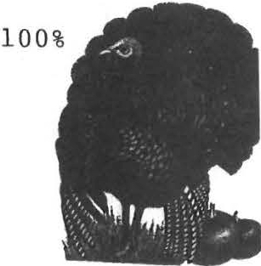
on Sunday, October 23rd to see how Catherine Miller and her troops can feed 145 people in 13 minutes (and most of the help has been getting Social Security for a few years). See how well they blend with the students from Mt. Everett who help us out every year. It is nice to see them working for their own cause.
As you know, the total proceeds from the dinner for student programs and scholarships.
Oh yes, we are planning on your wanting seconds.
See you there, Milton Barnum

I.,_

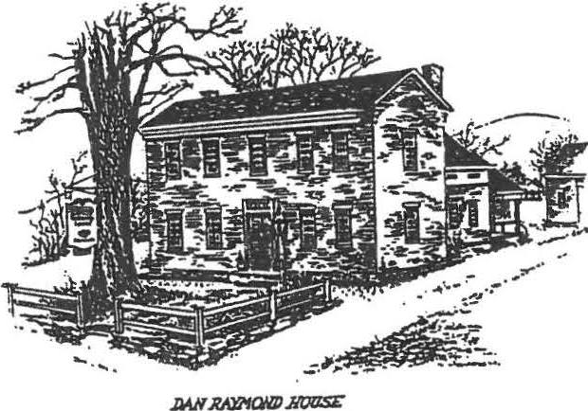
Sheffield Historical Society
Sheffield, MA 01257

AUGUST 1993

A NOTE FROM HEADQUARTERS:
Your Board of Directors has been working busily on plans for our 1993-94 year, as you can see from this newsletter.

A new exhibit has opened at the Family History Center, programs have been scheduled for the Fall, and we are already discussing our Christmas holiday celebration - which takes a bit of an effort in these "dog days" of August! I can see this is going to be a productive and exciting year! We are counting on you to pitch in when we ask for help, as you have always done so generously.
Do come to the Open House on the 13th and 14th to enjoy all the Historical Society has to offer: the Dan Raymond House with its special displays, the Parker Hall law office and the Brick Building, "The Coming of the Green" at the
Family History Center AND our lovely gardens. We look for­ ward to seeing you there!

Kathie Ness
CONGRATULATIONS TO ALL!
We are happy to announce that the Antiques Show netted approx­ imate $9,000 for the Historical Society. Many thanks to all
of you who worked so hard to make this another successful snow. Thanks to the ticket takers, the gate watchers, the car parkers, and special thanks to the army of cooks, servers and members of the food committee. The profits from the food cafe make up a substantial portion of the total. Of course, none of this could have been accomplished without Chris Coenen as coordinator and liaison (and night watchman). We are very fortunate to have the beautiful facilities of the Berkshire School for this event.

SHEFFIELD HISTORICAL SOCIETY 1993-94 OFFICERS, COMMITTEES, APPOINTMENTS

OFFICERS

President 1st V.P.
2nd V.P.
Trustees

Treasurer Secretary Investment

Kathie Ness Virginia Drury Bill Preston Boyd Hutchison Teresa Brazie
Martha Williamson Esther Kininmouth Bob Dean
Betty Dunk

Manager Bill Browne
Curator Lillian Preiss Family History Center
Director Betty Chapin Archivist James Miller

COMMITTEES

Finance Accessions
Museums Education
Property & Grounds
* denGtes acting chair
Bob Dean*, Bill Browne, Mason Dutcher, Catherine Miller Penny Browne*, Virginia Drury, Lillian Preiss, Gery Torborg, Judy Timm, Milt Barnum, Catherine Miller Marion Barnum*, Lillian Preiss, Grace Arzt, Betty Dunk, Penny Browne
Bill Preston*, Martha Williamson, Marion Whitman, Kate Turton, Grace Arzt, Lillian Preiss

Milton Barnum*, Bill Preston, Boyd Hutchison Garden: Penny Browne

Family
History Center
Betty Chapin*, James Miller, Roger Drury, Lillian Preiss, Claire Height, Holly Coon, Jean Blackmur Photographs: Chris Coenen

Program Virginia Drury*, Martha Williamson, Cathy Hutchison, Dorothy Marosy, Sandra Preston

OTHER
Newsletter Marion Whitman
Publicity Kathie Ness,·Marion Whitmsn Membership Secretary
Refreshments Marion Barnum Turkey Dinner Milton Barnum Christmas Meeting Virginia Drury
Antiques Show Coordinator Christopher Coenen

J '

FALL PROGRAMS ANNOUNCED:

Virginia Drury, Chairman of the Program Committee, has announced these exciting programs for the Fall season. Mark your calendar.
SEPTEMBER 10th 7:30 PM
NATIVE AMERICAN CULTURES & PERSPECTIVES THROUGH THEIR MUSIC
David McAllester is Professor Emeritus of Anthrpology Music at Wesleyan University in Middletown, CT. His primary studies have been in Native American ceremonialism & music. He will present cultural & historical information about the Mahican Indians of the Berkshires and other Native American cultures. He will illustrate Native American perspectives through their music.
OCTOBER 8th 7:30 PM
WITCHCRAZE:HUNTING THE DEVIL IN THE SHAPE OF A WOMAN
Ann Barstow taught European History and the State University of New YorkCollege at Old Westbury for 21 years. She taught courses in religion and women's history.
Her books are:Joan of Arc: Heretic, Mystis, Shaman (1986)
Witchcraze: A New History of the European Witch Hunts - to be published in November
NOVEMBER 12th 7:30 PM
DENS AND QUARRIES OF THE BERKSHIRES
Ed Kirby is a Geologist in the process of writing a book that will be a roadside guide for Northwest Connecticut and Southwest Massachusetts. The emphasis will be on the historical significance of the iron ore industry, active and in-active marble quarries and other geological points of interest. He will give a slide presentation followed by
a question and answer period.

*****************MARK YOUR CALENDAR****************************** ANNUAL TURKEY DINNER TO BENEFIT THE SCHOLARSHIP FUND
OCTOBER 31, 1993 Many hands make light work.
*****************************************************************
HISTORIC CLEANUP PLANNED
The Sheffield Land Trust invites members of the Historical Society to join in on the "Source to the Sound" cleanup of the Housatonic River to be held on Saturday, September 18th from 1 to
3 PM. No doubt you have read about the terrific work undertaken recently along the riverbanks in Gt. Barrington and Sheffield. Here is an opportunity to take part on a day when volunteer groups will be clearing out trash and debris along the entire length of the river. If you do not own a canoe, low-cost rentals are avail­ able. Contact the Land Trust at 528-5599 for more information.

.-

OPEN HOUSE AUGUST 13 & 14
On Friday and Saturday, August 13 and 14, the Historical Society will host its annual Summertime Open House, from
11 a.rn. to 4 p.rn. each day.

At the Dan Raymond House, the period rooms will be on display and a special exhibit, "Victorian Teatime," will feature antique
teapots and chocolate pots. The brick building and the law office will also be open, with their own exhibits. And next door,
the Family History Center's new exhibit, "The Corning of the Green," will be the feature attraction.

Everyone is invited to come and enjoy all the attractions at our "complex" on Main Street -- including the herb and perennial gardens, which have been doing especially well this year.

FAMILY HISTORY CENTER FEATURES EARLY IRISH SETTLERS
Currently on display in the Family History Center is a new
exhibit entitled "The Coming of the Green'' -- genealogy, photographs, and memorabilia of Irish families that settled here in the 19th
and early 20th centuries. These include the Cassidy, Conway, Gilligan, Hughes, Costello, McConnell, O'Connell, King, Landers, Cleary, and Buckley families.

The Family History Center is open on Mondays and Fridays from 1:30 to 4:00.

HAVE YOU FORGOTTEN?

IF YOU HAVE NOT PAID YOUR HISTORICAL SOCIETY DUES (DUE IN JUNE) YOUR RENEWAL IS OVERDUE. PLEASE SEND IT TO:

Membership, Sheffield Historical Society PO Box 1733 Sheffield, MA 01257
NAME--------------------PHONE----------- ADDRESS-------------------

FAMILY $5
_ INDIVIDUAL $3------

Because of postage costs, we cannot continue to send the newsletter.­ to non-members.

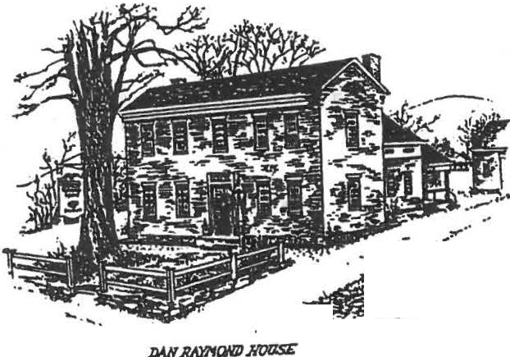Sheffield Historical Society

. . --:-: :-·
..:,.11,-. - .. -.-..·•
Sheffield, MA 01257

Volume XXII No. 6 November 1994

NOTES FROM THE PRESIDENT

We are trying to locate old records of Historical Society activities. Perhaps past officers or committee chairmen have them at home for safe-keeping. We would like to make copies for use in the SHS office.
The Great Barrington Savins Bank safe deposit key cannot be found. Anyone remember seeing it or using it?
The Ice Cream Social was great fun as well as successful.
1=· you are one of those who requested my pie crust recipe, look
at the following page. We are grateful to Irwin Braverman for uo·:,ating ice for the churns.

Also, thanks to all who fringed the napkins and a special thanks to Millie Smith, who not un2y did many napkins but also much of the tablecloth. The tablecloth fits both the table at Dewey Hall and the DRH keeping room.
Our December 9th Holiday Party plans are underway.
The party committee includes Edith Velmans, Louise Stevens, Rene Wood, Lois Ryder, Susan Rothschild ancv'myself.

It is with deep regret we accept Lillian Preiss' resign­ ations from the Curator's positi::rn and as a member o·f the Museum Study Committee.
Lillian's address is:
Northeast H:!habilitation Hospital
70 Butler Street Salem, NH 03079

W 2 looking for someone to fill in as inter{ Curator.
We are hoping Lillian will re-consider. Lillian's work cannot be matched, but one could work toward her e ' llence .
Fred Gordon has been appointed to the vacancy on the Museum Study Committee.
Thanks to you all for the Turkey Dinner netting $1418.00!!!!

Virginia Drury

SECRET RECIPE REVEALED

The Pie and Ice Cream Soc:ial at the Dan Raymond House was a very happy and successful afternoon. Several people asked about the delicious pie crust. Here it is:
,. I ... •
'

VIRGINIA'S NEVER-FAIL PIE CRUST
(Makes one double crust)
2 Cups all-purpose flour
1 scant teaspoon salt
1/2 Cup corn or canola oil
1/4 Cup cold milk
Stir the ingredients together, combining them in order given.
Divide the dough in half and flatten one half on a large piece of waxed paper.

Take another piece of waxed paper and put your pie plate on it upside down. Scratch a circle around the plate, making it one inch larger all around. Place this paper over the dough and
roll the dough out until it meets the scratched circle. Peel off the top paper• ibut ssave it).
Invert the crust onto the pie plate and peel off the paper.
Gently lower the crust into the pie plate.
Repeat with the second half of dough, rolling it out to the same size. Peel off the top paper and make some slashes in the crust with a sharp knife. Lay the top crust over the filled pie, peel off the paper, and crimp the edges of the two crusts together.
APPLE FILLING: 6 Cups of apples heaped up with 1/2 to 2/3 Cups of sugar and½ tsp. each of cinnamon and nutmeg plus 1 Tbs. flour sprinkled over all. Dot with 2 Tbs. butter bake for five minutes n!; 425, then reduce to 350 till apples are soft when : ­ prisked with skewer. The top may need to be covered with a circle of brown paper for the last 15 minutes.

NOTE: Top can be brushed with milk and sprinkled with cinna­ mon sugar.

ANY QUESTIONS: Call Virginia Drury at 229-2687.

PEPTO BISMO, ANYONE?

WOW! They came..... thev stuffed..... they left full..... and we smiled! We had a riyht to grin, we earned $1,418!

The Turkey Dinner Committee t:ia nks you one and all for all your work baking, peeling, cooking, roasting and then serving that brought this about. The students did a terrific job under the close guidance of Catherine Miller. It took Army Sergeants
12 weeks to put me through my basic training. Catherine lined the students up and gave them their instructions. In exactly 5 minutes they served 154 people! I feel sorry for the kids she gets next year.
At this time, our Society has raised over $18,000 on Turkey Dinners for our Scholarship fund, thanks to the faithful members.
Milton Barnum, Chairman

FAMILY HISTORY CENTER
Betty Chapin, Director of the Family History Center, reports the receipt of the up-dated genealogy of THE DESCENDANTS OF JOHN KEEP OF LONGMEADOW, MASSACHUSETTS.

John Keep, his wife Sarah and infant son Jabez were slain by Indians while walking to church from Longmeadow to Springfield on March 26, 1676.
There are many descendants of John and Sarah Leonard Keep living in Sheffield today. Betty invites you to come in to find your ancestors.
The Center is open Monday and Friday 1:30 to 4:00 PM.

ANNUAL OPEN HOUSE

The Society will host the annual Christmas Open House on December 4th from 3 to 6 P.M.

Join us to enjoy the festivities - the soft sounds of music, the glow of candlelight, the warmth of the open fire, children's Christmas carols.

Special holiday refreshments will be served in the keeping room. Free admission.

, .
- •

MARK YOUR 1995 CALENDARS
JANUARY 13th, 7:30 PM THE ANNUAL WHAT'S IT? NIGHT
It isalways fun and always informative. Brinq articles to stump the experts.
NEWSLETTER DEADLINE: January 14, 1995

SAVE THE WEEKEND OF JUNE 24th .8':)R OUR ANNUAL ANTIQUES SHOW AT BERKSHIRE SCHOOL. WE NEED ALL HELP TO MAKE THIS A SUCCESS.

ACCESSIONS

The Accessions Committee continues to search for appropriate items for our Museums. From t{me to time this newsletter will list something from the wish list.
If you know where we might secure a tied canopy, sometimes called fishnet , for the 3/4 tester bed in the north bedchamber, please call Bill Preston, Chairman of that committee.

MEMBERSHIP

Fran Warren, Membership Chairman, is handling the mailing of our newsletter this year. If you find a notice of membership payment due with this, please send dues to assure continued receipt of all our activities.

HOLIDAY MENU ANNOUNCED

After seeing the holiday invitation to be inserted in this issue, we asked the committee for a preview of the food to be served. We were given the complete menu and share with you:

Roast turkey Roast beef
Rice & bean casserole Squash
Tossed salad Hot rolls Apple crisp
Be certain to make your reservations early.
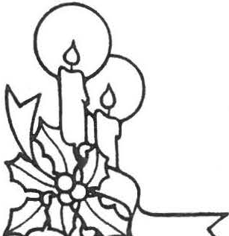

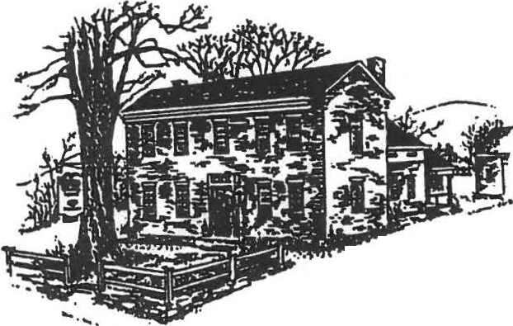Sheffield Historical Society
-· ,. --
-..
' J
;.,i '
- _,,,,.. .
x ...
... ••
Sheffi eld , MA 01257

Volume XXII No. 7 February 1995

NOTES FROM THE PRESIDENT

Plans are being made for an entrance for the handicapped, required by law, at the Dan Raymond House. John James is working with the Board to find the best and least conspicious solution to this difficult requirement.

Lillian Presiss has sent warm thanks to us all for the Christ­ mas card of the tree adorned with ornaments made by Alice Warren
- J inscribed by so many friends. Lillian is gaining strength and is benefittingfrom the rest she so needed. Her bsence is constantly showing us how much she had been doing and the
gaping hole there is without her. We shout to her, "Hurry back!"

Kathie Ness has agreed to represent our Society at future meetings of the Tri-Corner Project. Thanks, Kathie!

Isn't it wonderful news that our 1840 Town Hall will continue to serve the community? My spirits rose when our Town Meeting approved the renovations and re-use of the Center School, Bushnell-Sage Library and the Town Hall.

Virginia Drury President

--CALENDAR
FEB. 10th 7:30 PM

MARCH 10th "

APRIL 14th "

MAY 12th "

JUNE 24th WEEKEND

CLACIERS AND ANCIENT SEAS
Frank Lowenstein of the Nature Convervancy will tell us why Sheffield is the way it is.
WORLD WAR I CARTOONS
Fred Gordon will share his collection with us.

BUMBLE BEES, YELLOW FEVER, AND A SLEIGH TO SHEFFIELD 20.YEARS AGO
A dramatic reading by Roger Drury and others.

THE ROLE OF THE CONSCIENTIOUS OBJECTOR IN WORLD WAR II
James Tracy, teacher at Hotchkiss School, PHO in America11\History, will speak

SHEFFIELD HIS ORICAL SOCIETY ANTIQUES SHOW
J e sure to keep this weekend free! We need youl

COLORING BOOKS HAVE ARRIVED

The coloring books featuring historic sites in Sheffield is now available. It was a big hit at the January meeting. If
you have not yet seen a copy of the book ,contact Grace Arzt at
229-2110 or find them at Society meetings. This project by students of the OMEGA program at Mt. Everett was underwritten by the Education Committee of our Society.

FROM THE FAMILY HISTORY CENTER

Art and Barbara Delmolino have allowed us to copy pictures of the Lime Kiln showing men who worked there. Many of the men have been identified for us.

Alice Warren has given us more glass plate negatives from her family collection. These early photographs add valuable information about Sheff e ld.

We have purchased a book by Cynthia Hoog which contains obituaries from the Berkshire Courier from 1843 to 19870. It is fascinating reading and wonderful genealogy research material.

DAN RAYMOND HOUSE NEW
The Stockbridge Historical Society will be touring both the
Dan Raymond House and the Family History Center on Friday, Feb. 17th.

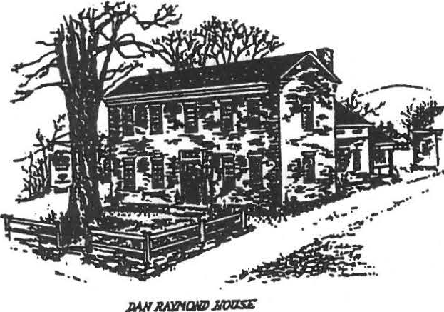
Sheffield Historical Society
Sheffield. MA 01257

Volume XXII No. 8
Mayl995

NOTES FROM THE PRESIDENT
A year ago we were working on a mission statement to help us in planning. We now have it. We also have a Museum Study Committee under the chairmanship of Boyd Hutchinson. This committee has made some recommendations to the Executive Board. With the Board's go-ahead, plans are being developed for bringing to life more Sheffield history. Soon, as date and activities have been firmed up, you will hear about these plans. Be prepared to pitch in and have fun.
The position of second vice-president is still open. This job needs someone especially interested in our outreach efforts i.e.: programs, newsletter, educational events, field trips, etc. I'm quite sure there are unrecognized members who would enjoy working with the Board.
Previous experience is not necessary, but enthusiasm is requested! Get in touch with me and I will tell you more.
We will have guides at our buildings on Saturdays throughout the summer again. We are pleased to have Alison LeBeau and L,,dia aa:,se!l as our guides this year.

::•_, r 1,..,
J
oil
.- -i d
...I

. -1... tJ

Virginia Drury
President

NEW OFFICERS

The nominating Committee has prepared the following slate for the 1995-96 year. We will vote on the slate at the annual meeting in June.

President (one year) William Preston
2nd Vice President (two years) to be announced Treasurer (three years) John Huegel
Trustee (three years) Nancy Elliot

TRI-CORNERS HISTORY COUNCIL

Kathie Ness, our representative to the Tri-Comers History Council has reported on the many projects of this group. Herc are some notes of particular interest to the members:
They continue to co-ordinate publicity for sites in all the towns represented.
The Arsenal of the Revolution, a book on the ironworks industry, will be re-printed,
re-packaged, and up-dated. Lillian Preiss contributed to the original publication. Pre-publication orders are being accepted.
A grant to create historic markers will include the Sedgewick House (now Ledlie) in Sheffield.
A regional historic sites map is in the works. Also, a map of Ethan Allen's trail through
North West Connecticut and Sheffield.

ANNUAL DUES ARE DUE IN JUNE

Time marches on...and with it, postal rates increase, supplies cost more, maintenance is more expensive, and now membership dues are going up. At its March 27 meeting, the Board of Directors voted to increase the annul dues to $5.00 for an individual and $10.00 for a couple, effective July 1, 1995. This is the first increase since the Society was established more than twenty years ago.
The dues are of course deductible, so perhaps you'd like to consider a life membership - only $100.00! You may mail your dues to:
Sheffield Historical Society PO Box 1733
Sheffield, MA O1257

Welcome to our newest members:
Peter and Camilla Flemming of Great Barrington Carol Ingber of Great Barrington
Vicici Ross of Norfolk, CT

CALENDAR

April23
An exhibit of Old Sheffield photographs, many from glass plate negatives, opened at the Family History Center and will continue through the summer.

May 13 - 7:30 PM Dewey Memorial Hall
"The Role of the Conscientious Objectors in World War 11" will be the topic of historian and author, James Tracy. Mr. Tracy's book on pacifism in America 1940-1970 is being published by the University of Chicago Press.

June 9 - 6:30 PM Dewey Memorial Hall
Pot Luck Supper and Annual Meeting. Bring a dish to share and your own place setting. We will furnish dessert and beverage. If you don't cook, come anyway. Your contribution can be monetary to help defray costs.

June 23, 24, 25
The annual Antiques Show at Berkshire School. This fund raiser is featured elsewhere in this newsletter .

July 15

Annual Tag Sale. Marion Barnum, Chairperson

August 20
Annual Society Picnic. Bill Preston, Chairperson

1 ' I

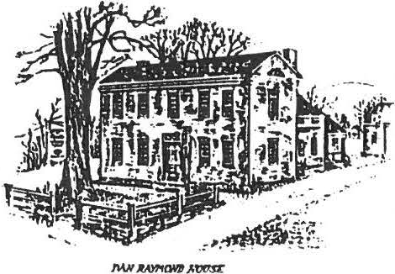

' '

Hello Fellow Society Members:

ShdfiPlrl I lisl11rical S11ci pl _y
S h ,. fri r ld . Mt\ II I ?.!i 7
Volume XXIII, No. 2 October 1995

First, we want to thank the Fall Festival Committee for a great beginning of what we hope will be a tradition, with a larger Festival in the planning for 1996. If you didn't have a chance to attend, it was a fun and interesting day. The Committee report is attached.

Programs for the remainder of this year are as follows; please mark the dates on your calendar. See you there!

OCTOBER 13 -- speaker MARGARET KINGMAN

- -Now an innkeeper in Richmond, she was an intelligence officer in World War II. "Wild Bill" Donovan, the first director of what is now the CIA, was her boss. As a senior engineering draftsman, her assignment was to make maps for our armed forces. She resides at Pienon Place in Richmond, which was built as a commercial building where boots were manufactured for soldiers.

OCTOBER 22 -- 17th annual TURKEY DINNER chaired by MILTON BARNUM
'•

Two seatings, noon and l:30, at the American Legion Hall. Call 229-2569 for reservations, and to ask Milt for a job assignment if you would like to help.

NOVEMBER 9 - speaker RORY O'CONNOR

Well known in the community, Mr. O'Connor will speak of his experiences as a boy growing up on Hewlitt Hill.

DECEMBER 8 - speaker JIM DOUGLAS

New England's history, people, and traditions will be brought to life through traditional folk songs. With Mr. Douglas, we will celebrate the holiday season with songs from early New England Christmases.

This will be a supper meeting and Virginia Drury will be contacting you for help.

Bill Preston President

MUSEUM STUDY COMMITTEE REPORT

The first annual Sheffield Historical Society Fall Festival was held September 16 and was well attended. Demonstrations of herbal crafts, spinning, and cider pressing, and activities for children (scarecrow making, pumpkin carving, and pony and horse-drawn wagon rides)
were well received.
'
The "Day in the Life of Sheffield" photographic contest did not materialize as expected. Further discussions with teachers and students at the Mt. Everett School indicate that there is considerable enthusiasm for this activity, however. Consequently, the photo submission date has been rescheduled to November 17. Photos submitted will be hung in the Dan Raymond House for the Christmas Open House, and judging will be by Ann Shanks.

