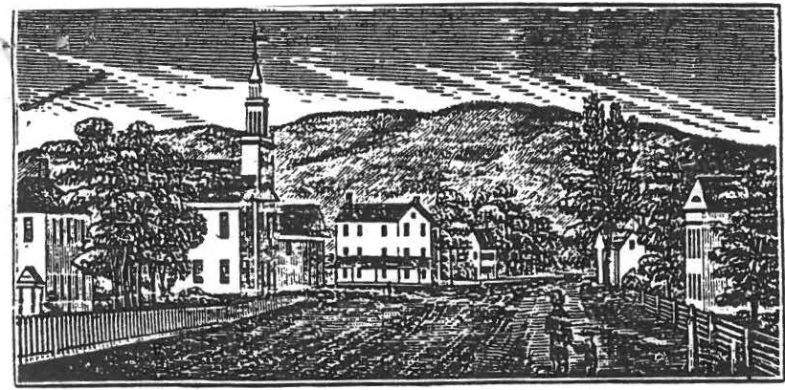
Su'IU!um vim> of ShtJ!itld, (central part).

NEWSLETTER
Vol. 13 , No.2
Jan. l 98.6

SHEFFIELD HISTORICAL SOCIETY

As the Winter doldrums give way to thoughts of S pring and flowers, it is time once again for an update by your Historical Society.
From The Desk Of The Curator
Gregory Farmer of Springfield,president of New England Historical Services,Inc. and vice-president of the Bay State Historical League,has completed a comprehensive report on the history and occupants of the Dan Raymond House.
Using both primary and secondary sources,Mr. Farmer investigated the families and occupations of the owners from the mid-1770s to 1945,when Jenny Little Minard bought the house from Clara Little for "less than $100." He found that Dan Raymond moved to Sheffield in 1763 at the age of 27 and married nineteen-year-old Anne Noble,granddaughter of Matthew Noble,Sheffield's first permanent settler.
Mr. Fa-rmer appended to his report inventories of the estates of Captain Ezra Fellows,who owned the house from
1793-1800,and Robert J. Rogers,the occupant from 18 28-1866. The appraisal of Capt. Fellows'estate included such items as two pairs of breeches for SO cents,one old trunk for 12 cents and one dung fork for 67 cents. His most valuable possession was "one span of Gray Horses" valued at $140 .
A detailed inventory of Rogers' assets at his d eath listed not only a "lot of fishlines" at 31 cents and nine papers of tacks at 18 cents but,more importantly,the appraisal of his "homestead containin g about 1/2 acre with the buildings appraised at twenty- one hundred dollars." S uch probate records afford valuable insights into the lives of the previous occupants of the house and the development of the town.
Raymond,a merchant,and Fell ows,a "farmer and gentleman," were two of the wealthiest men in the com muni ty. Succeeding owners included a tailor,a lawyer,two hatters ,a manufacturer,an innkeeper,a doctor and a merchant.
Mr. Farmer suggests that the Society continue to document the historey of the community into the 20th century and to extend the interpretation of the house to at least 1860. His specific recommendations are being studied by the Dan Raymond House Committee and the Executive Committee and will be used as a guide to further acquisitions and interpretation.

The report concludes,"The Sheffield Historical Society is a healthy and active organization with a solid building,an admirable collection and an important role in the community. The commitment and planning that have brought the Society to this point should continue to guide the Society in the future."
News Of The Dan Raymond House

The members of the Dan Raymond House Committee have been replanning our storage areas. As the Society acquires new items,the need for extra storage areas is acute. ow that we have the use of the recent addition to the barn,certain bulky and less frequently used items will be moved there giving us more space in the house. Also to be stored in the addition will be the tools used or t he upkeep of the grounds as well as many of the large signs used by the society for our yearly events.
A special thank you to Grace Arzt,Ruth Dutcher,Virginia Drury,and Fran Warren who contributed special articles for display during the exhibit of weaving by Hazel Warren which ran through Dec. and Jan. at the D.R.H.. Penny Browne would welcome any collections that could be displayed at the house this Spring or Summer.
On permanent loan from Charlotte and Holger Oleen are a set of 6 old tin spice boxes and a.charming lace and silk parasol with ivory handle. Thank you to the Oleens !

Breakfast anyone? On March 13th some of the Mo unt Everett Regional School 8th graders will be served a "Colonial" breakfast cooked over the open fire in the keeping room of the D.R.H •. As in the past,the students attending this annual event will be chosen by their teachers after writing an essay on "Colonial Living". Exposing the local youngsters to their rich historical past is one of the functions of the Society and it is hoped that one day these same children will be the stalwarts of the Socie ty.
News From Gramps Carriage House

The new storage shed on the West side of the carriage house is nearly completed and will be as soon as the weather permits. As the first flakes of winter snow arrived in the Berkshires,workers attached the very last roof shingle. Ten minutes later the roof was a carpet of white. The grading is being taken care of by Loring Boardman,Dirk Willcox and Carl Schuman. The building was erected by Ed Warren,Chris Coenen, Bil l Browne and Milt Barnum. We are very anxious to put it to use as we need the room in our barn for our newly acquired one horse cutter and doctor's buggy. The cutter needs a little attention but the carriaRe is in finP h n°

../ On The Wind
Another item of interest to the Soc ety is the disposition of the old High School, The uilding is in need of repair and would have to be moved if 'twas purchased by the Historical Society. Currently,we are short of display space as well as a climate-controlled ar a for the storage of fragile items that would deteriorate th erwis e. The old High School could meet those needs but ati a substantial cost to the Society . If you have any words of jwis d om or strong opinions,feel free to communicate them t the members of the Executive Committee,

Calendar Of Events

The annual "What's-It" program was a great success with Art Chase once again taking top honors. This years prize was a book on identifying more "what's-it" items. Surprize item was Susan Young's spectacular needlepoint depicting
Sheffiel d . The work is almost 3'x5' and illustrates various aspects of life in Sheffield. Numerous local "characters" are seen going about their daily tasks in the picture.
February 14 - Matters Of The Heart-The Valentines day program will feature old and new ways to express love. Members are urged to bring all sorts of Valentines, hearts,songs,old love letters,etc. for this unique show and tell program. Don't miss this one!!
arch 14 - Bells Around The World Through The Years- Lillian Preiss will discuss the history of bells using her fine bell collection to illustrate her lect re,
April 11 - Old Glass- Mason Dutcher will alk about old

glass-free blown,molded,pressed,cut,pa tern,lacy cut Art Nouveau glass and the differences etween them.
May 9 - Old Tools/Old Furniture- A l ecturL presented by Robert Sutter on old tools and their u e in furniture
and

maki,ng. I
1
June 13 - Annual Meeting- This is a cover d dish affair and will include the annual elections. I

June 27,28,29 - Sheffield Historical Soci ty Antiques Show­ Our second year will be even better anj bigger than last year.

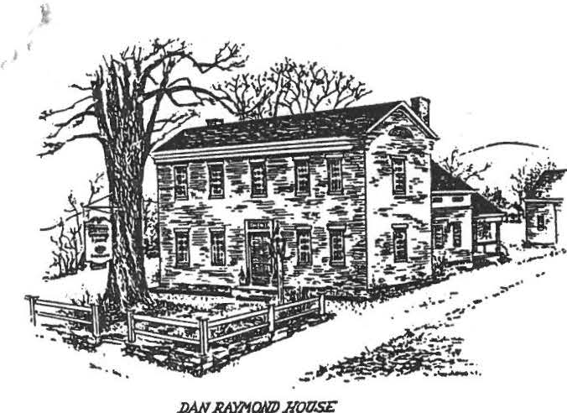
Sheffield Historical Society
Sheffield, MA 01257

MESSAGE FROM THE PRESIDENT
Vol. 13, No.3
June 1986

The year 1985-86 has been one of transition for the Sheffield Historical Society. New faces have appeared at the meetings and we have mourned the loss of some old friends.
We have purchased the little house to our north and expanded the old carriage house in preparation for a tool and barn museum. Our educational programs have increased and we have exchanged our old antiques market in May for a beautiful indoor show in June. This is all as it should be. A vibrant, healthy Society must progress. This small group of dedicated souls is the envy of every other historical group in the County. Through the beneficence of Sally Scanlan, Helen Hurlburt, Charlotte Oleen and others we have been fortunate to have the resources to instigate and complete many projects of historical significance. A Society,however,only reflects its membership and the members reflect the town they love. Thank you for a wonderful two years and let's look forward to many more.
FROM THE CURATOR
Thanks to the thoughtful generosity of Helen Hurlburt of Hartford,we have inherited a desk and other furniture which make the south parlor look much as it might have looked during Dan Raymond's occupancy of the house. Other bequests include a blanket chest,tables,chairs,glassware, etc. We are very grateful.
Mason ·and Ruth Dutcher have donated an 18th century traveler's case with five bottles used to hold "spirits'' for the journey. Howard Mott has given us a book, "Little Brown Bessie",by Mrs. L.D.Shears, a native of Sheffield. From Alice Warren have come pencil drawings by her grandfather, M.J.Smith, depicting 1887 views of Orchard Shade. We have purchased from a rare book dealer "An Act for erecting the lower Plantation at Houssatonnock into a Township,by the Name of Sheffield" dated 1733.
ANTIQUE SHOW
Once again the Sheffield Historical Society Antiques Show,featuring dealers from 15 states, will be held on the campus of Berkshire School. The Preview Party (all of whose proceeds go to the Society) will be held on Friday,June 27th from 6-9 PM. Tickets are $20 in advance and $25 at the door.

\

There will be plenty of hearty food and traditional American music will be provided by Southwind.
The remainder of the Show will be held Saturday,June 28th from 11 AM-7:30 PM and Sunday,June 29th from 12 PM-6 PM Any time that you could donate to help make the show a success would be greatly appreciated.
REPORT FROM THE DAN RAYMOND HOUSE
On May 29th-a-group of twenty six third grade students arrived at the Dan Raymond house accompanied by their teacher Laura Ponkos. Their visit tied in with their study of how early towns had their beginnings and developed.
The month of June is the time for the annual historical field trip by the eighth graders of Mount Everett Regional School. Once again they will visit the DRH,"drink in some history" and present their reports to their teachers William Gillooly and Paul Mennin.
The Society is pleased to receive a special gift from Peter Cook,a student at Mount Everett. As a school project,he constructed a very fine model of Old Parish Church. Those of us who have seen it admire the quality of his work. It will be on display at the DRH for all to see.
As of May,a new flagpole is in place on the DRH grounds. Thanks to Milton Barnum who procured the pole and the flag and rigged it. Old Glory is flying once again !
A note on summer hours - during July and August the house will be open on both Friday and Saturday from 1:30 to
4 PM and of course always by appointment if you would like to bring guests.
QUILTERS
The quilting group is proud to announce that another 9 patch quilt is ready to be raffled. The group also has voted to give the Historical Society $500. This will be a total of
$3,500 given to the Society since the group was formed.
1 Congratulations !
We were saddened by the recent death of one of our faithful workers,Charlotte Oleen. She will be missed.
FROM GRAMPS BUTTERY
Do you remember years ago how Mother prepared Saturday night's supper? She had to sort over the beans to make sure there were no stones left with them,then she would soak them overnight,cook them and finally bake them for hours so you could enjoy a fine supper. Well, now we're offering you a deal. On Saturday evening,July 26 you are going to be able to bring the whole family to a fine old-fashioned bean hole bake supper at the American Legion Post Home. We will have been working on this for two days in order that you might enjoy your finest supper of the season. Bring your family and friends to the supper on Saturday,July 26th from 5 to 7. If your friends happen to be away,come anyway and make new friends,all for onl y $4.50. You wonder how we could give you all this and still have a few cents left over for our Dan

I

Raymond House Committee? Well,come and see. Now if you are a stickler for statistics,here is a good argument on why you shouldn't miss this meal.

WHY NOT USE BEANS INSTEAD?
Beans make an excellent, nutritious substitute for rice, and adults need daily. Here's how navy beans (the most potatoes. or spaghetti. The National Academy of common kind) stack up against rice, potatoes, and Sciences-National Research Council has set a Recom- spaghetti la providing the daily allowance of seven mended Dietary Allowance for nutrients that children important nutrients.

Na'f'J beam White rice Baked potato Spaghetti
(1 cup cooked) (1 cup cooked) (l larse) (1 cup cooked)
Cbllcl Male F-.1• Cblld Male Female Cblld Male Female Clalld Male Female
1-lt 13-51 23-51 1-10 23-51 13-50 1.11 23-50 23-51 1-11 23-50 13-51

Protein | 41% | 27% | 32% | 8% | 5% | 7% | 11% | 7% | 8% | 20% | 13% | 16%
Thiamio | 36 | 31 | 43 | 13 | 11 | 16 | 13 | 11 | 15 | 2l | 19 | 26
Vitamin B-6 | 31 | 19 | 19 | 6 | 3 | 3 | 31 | 19 | 19 | 3 | 2 | 2
Iron | 52 | 52 | 29 | 14 | 14 | 8 | 10 | 10 | 6 | 16 | 16 | 9
Caldum | 12 | 11 | 11 | 2 | 2 | 2 | 2 | 2 | 2 | 2 | 2 | 2
no.,borm | 35 | 35 | 35 | 5 | 5 | 5 | 11 | 11 | 12 | 11 | 12 | 12
Mqneslam | 45 | 31 | 31 | 5 | 3 | 4 | 10 | 15 | 17 | 11 | 8 | 10

Attention
We are also offering you a chance of a lifetime. For the person who guesses how many baked beans in a pound,we have a special prize for you. You will win a free baked bean supper for your Mother-in-law. The only hitch is that she must come in on a skateboard.

Oh yes,did I tell you that recently Gram and I celebrated our 45th wedding anniversery. Bless her heart. I don't know how the little lady put up with my nonsense all that time,she deserves a medal. Well anyway,we thought we would enjoy going to Maine,New Hampshire and Vermont for a weekend. On our anniversery day,we came into Gorham,N.H. ,a nice old town with lots of old buildings. We saw several places to eat and lots of motels there. Well,this being a
- special occasion,we thought we could leave the tent in the car and get an upper-crust motel. After the clerk explained to me what we were getting to make the room so expensive,he gave me the key. Now the good part ! I pulled up to room
#125,but first I must tell you this - wait Gram,please don't take my pen !
JUNE MEETING
Don't forget the meeting on June 13th. This is the Annual Meeting and dinner of the Sheffield Historical Society. Election of new officers will be held and we will have as a special treat a display of the Macy Family Genealogy by sixth grader Sarah Macy. There may also be a few surprises so don't . miss the 6:30 start and remember to bring a covered dish and place setting. See you there !

DATES TO REMEMBER
June | 13 | Annual meeting and dinner at 6:30 at Dewey Hall
June | 21 | Fourth Annual Covered Bridge Ramble - the only race  to help Mandy Morgan organize the race and hand out water if you are not the running type.
June | 27 | Preview Party for the Sheffield Historical Society Antiques Show,6-9 PM
June | 28 | Sheffield Historical Society Antiques Show, 11-7:30
June | 29 | Sheffield Historical Society Antiques Show, 12-6
July | 26 | Tag Sale on the grounds of the American Legion. Bean Hole Bake at the American Legion, 5-7 PM·.

over two covered bridges. Plenty of opportunity

August 3 Summer Picnic at the Dan Raymond House, 5 PM. Bring your covered dish.

************************************************************
ANNUAL DUES
The 1986-87 year begins with the Annual Meeting in June,so once again it is time to enrich the treasury. You may wish to pay at the June meeting or,if you are unable to attend, send the form below with your payment to:
SHEFFIELD HISTORICAL SOCIETY
P.O. BOX 1733 SHEFFIELD, MASS.01257

The dues,which have been kept low so that all may join, are $3 for a single membership,or $5 for a family.
NAME (S) MAILING ADDRESS
TELEPHONE

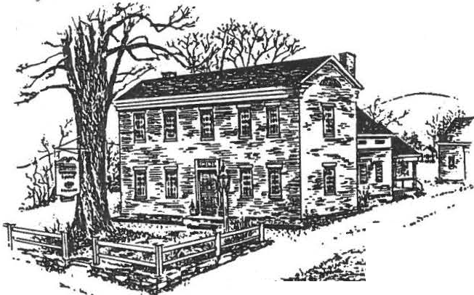Sheffield Historical Society
.
/ ·
1
.·..,..,...- · ,,..-
. ,-;
.,,:,11-,.. ..
.... •• .
­..
Sheffield , MA 01257

WELCOME
Vol. 14, No.l
Fall 1986

Although we,ve had a busy summer since the Annual Meeting in June, I tend to think of the September mee tin g as the beginning of the new eason. There are the usual events planned for the upcoming year, as well as a few surprises.
Keep track of your calendars because there will be something for everyone this year,

IN THE GOOD OLD SUMMERTIME

The summer's activities kicked off with the Fourth Annual Covered Bridge Ramble. This is the race that began in 1983 as part of our 250th celebration. As usual, the turnout was excellent and the runners had the rare experience of racing across two different covered bridges. In light of recent bridge misfortunes, it might be a rare event indeed
Next on the calendar was the Sheffield Historical Society Antiques Show held at the end of June at Berkshire School. It's hard to imagine that any show could have been prettier than the one in 1985 but, by golly, this topped it, With almost eighty dealers from fifteen states, this year's show was a smashing success. Your Society netted $8,272 thanks to the hard work of all involved. Special kudos go to Roger and Virginia Drury who organized the manpower and food respectively, To give yo u an idea of how good this show was, let's compare it with recent shows. In the last outdoor show in 1984, we made $2,883 and last year with the first indoor show we made $3,753. Even with this vast increase, we discovered that there are still ways to improve.
Congratulations to all who participated.
The Tag Sale and Bean Hole Bake occured on the last Saturday of July and, unfortunately, like most of the weekends this summer, we had rain. Spirits were not dampened although the crowds were small and the beans and franks were just as good as ever. Good job Milt !
The weather did hold out for the Annual Picnic that was held in the back ya rd of the Dan Raymond House in early August. This gathering seems to be gaining in popularity if the size of the crowd is any indica tion. One of the highlights was a rousing croquet match with participants ranging in age from 1 to 81. Loring Boardman and Peter Coenen were a formidible team although many of their moves were questionable.

,_

Finally, the Open House during the Old Parish Antiques Show attracted many visitors and Penny, Lillian and Marion had the House as pristine as ever. Everyone that toured the grounds was very impressed and few came away without learning something new about Sheffield.

TRIP

Some interest has been expressed about taking a trip this Fall. If you have any suggestions, let us know at the Sept. meeting. In the meantime, the Massini Bus Co. is
arranging a trip to the Shelburne Museum in Vermont for Oct. 3,4 & 5. It might be nice if a group from the Society went together. For further information, call Sheff ield Tours at
229-8498.

-NEWS FROM THE SEWING CIRCLE
Ihope you all had a ch nce to see ( and win) the lovely 9-Patch Quilt made by the quilting group this year. The drawing was held at the end of the Open House and this year's quilt was won by Mrs. Ney of Mt. Washington. Over
$200 was raised and the group is already planning another patchwork quilt for next yea r. Buy your chances early and often ! '

GOBBLE GOBBLE GOBBLE

Once again it's that time of year when we reap the harvest and have a big dinner to cele bra te. We from the Society want to get together also and have a dinner. So, on Sunday October 26 we are going to have our annual Turkey Dinner, the proceeds of which go to school scholarships, field trips, etc. Last year we made over $1,350. It's going to be hard to beat that but we can try. I hope when someone calls you to bake, work, or whatever, you will be glad to help again. The Fall with Thanksgiving and thinking a bo ut
the Pilgrims and what they went through always makes me feel a little bit more proud of our heritage. How about you? Oh yes, did you happen to watch the Statue of Liberty rededication this summer? I tell y o u , I couldn't get enough of it. It was so inspiring, made you feel like your shirt buttons would bust. I am so proud of our coun try . I don't know how many times I heard "America" played and watched the flags flying in the breeze. Still, each time my eyes would tear up at the beautiful sight. How fortunate we are to be able to call this Country home. I just love it when I write my return address.
Cook Rd.
Sheffield, Massachusetts United States of America

OFFICERS ELECTED AND APPOINTED

The Society's elected officers for the current year are: PRESIDENT- Christopher Coenen; VICE-PRESIDENT- Mason Dutcher; SECRETARY- Marion Whitman; TREASURER- James Miller; DIRECTORS-Penny Browne, Catherine Miller, Edward Warren, Marion Barnum and Robert Dean.
Appointments for 1986-87 are: CURATOR- Lillian Preiss; ASSISTANT CURATOR- Marion Barnum; INVESTMENT MANAGER­ William Browne; DAN RAYMOND HOUSE COMMITTEE CHAIRMAN-Penny
Browne; ACCESSIONS COMMITTEE- Carl Proper and Muriel Rokos (plus the president, curator and DRH Committee chairman); FINANCE COMMITTEE- Roger Drury,Grace Arzt and Carl Schumann (plus the president,treasurer and investment manager); EDUCATION/SCHOLARSHIP CO I TEE- James Miller, Lillian Preiss and Martha Williamson; TURKEY DINNER CHAIRMAN- Milton Barnum assisted by Catherine Miller; CHRISTMAS DINNER ORGANIZERS- Catherine Miller and Marion Whitman
CALENDAR OF COMING EVENTS
SEPT.12- Bill Bradford will speak on buying, selling and auctioning antiques.
OCT.1O- Jesse O'Hara will entertain us with anecdotes of history of Lower Berkshire County and Conn.
NOV.14- Dana Blackwell of the Bristol Clock Museum will give an illustrated talk on time telling through ages.
DEC.12- Annual Christmas Dinner- this is a covered dish affair and begins at 6:30. Carols are the order of the day and a jolly time will be had by all.
JAN.9- What's-it Show and Tell: emcee Milt Barnum has already been gathering his "stumpers" so be ready.
FEB.13- A special slide presentation on Shay's Rebellion by Michael Paulin. This is the 200th anniversary
of the event which makes this a very timely program.
All programs are held at Dewey Memorial Hall and begin at 7:30 with the exception of the Christmas Dinner.
DEWEY HATTER'S SHOP UPDATE

As most of you know by now, the Historical Society purchased the little house just to our north last J une. The house was originally built and used by Mr. Dewey, who lived in the Dan Raymond House at the time, as a hat shop. In the months to come, there will be a lot of discussion about the disposition of this house and the grounds. If you have any strong feelings about how we might best use this property, please talk to any member of the Executive Committee.

r V.l\\J.C.l !

The fiscal year began with the Annual Meeting in June and if you were unable to attend, or forgot to pay your dues- here's your chance. If you have already paid, then sign up a friend !
Dues are $3 for a single membership and $5 for a family.
TO: Sheffield Historical Society
  - Box 1733 Sheffield, Mass. 01257
NAM E ADDRESS
TELEPHONE--------

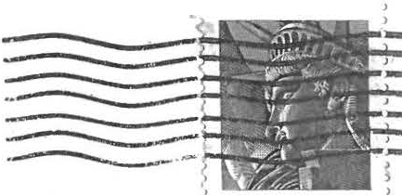
1886-1986

SHEFFIELD HISTORIC AL SOCIETY SHEFFIELD, MASS.
01257

/} JIJu. V ) } )U,

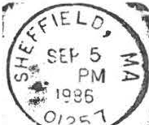

uJ . ); }LA-e_,[;;-n
/fl.
/ #-el
)7u

' Li bert y

USA22

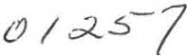

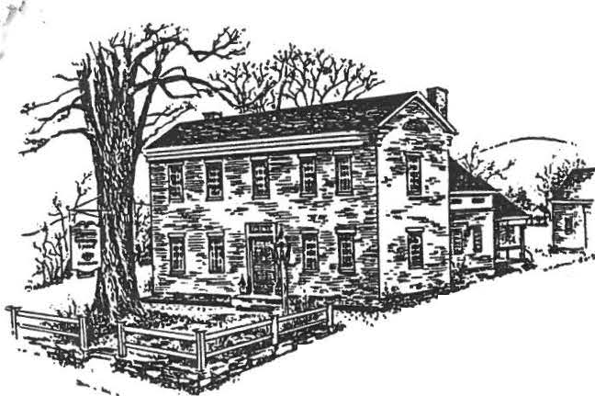Sheffield Historical Society

:_ / •"
.: ,II',-. ·- • . • ...
Sheffield, MA 01257

Vol. 14, No.2
Winter 1986

LETTER FR-OM-

THE PRESIDENT

As you all know by now, the Historical Society purchased the little house just to the north of the Dan Raymond House last June. We are now in the midst of a debate about the fate of this building and I felt it was important as a Society that you be apprised of the situation and have an opportunity to participate in this important discussion. To give you some background on the house, it was built in 1816 by Mark Dewey who purchased the Dan Raymond House in the aame year. It served as his hat shop until he sold the property to Robert Rogers who also used it as a hatter's shop until the 1860's. At some point, an addition was added to the rear of the building and the front porch was added.
We have been trying to b y the property for several years and were finally able to do so this past summer for the sum of $50,000. At the present, the original part of the house is in need of extensive repairs. It is the task of the Executive Committee to make a recommendation as to the disposition of the house to the Society as a whole and we welcome your input before we make a final recommendation.
To complicate matters, Sheffield's first public high school is lying idle next to the Town Hall and many people think we should be focusing our attention on this building rather than the Hat Shop.

Here are the major points of the discussion: PR0-
    - The little house is historically related to the Dan Raymond House. It was built by the second owner of the DRH, Mark Dewey, and owned by the third occupant of the DRH, Robert Rogers. For both it served as a place of business.
    - There is an early 19th century feel to this part of Main St. which cannot be found elsewhere. The people didn't mind having their houses close together.
    - In the near future the center of Sheffield may
become an Historic District. We should be trying to maintain the historical integrity of this part of town, not tearing it down .
    - If restored, the house could serve as an income producing property for the Historical Society or it could serve as a residence for a future Executive Director. It could also provide badly needed exhibit space.
    - We spent a lot of money to obtain the house. We could protect our investment by restoring the house rather than turning it into a lawn.

CON- J
- The schoolhouse has greater historical significance to the town and should be preserved first.
- The schoolhouse would give us more space for the money we would spend.
- As we add more buildings, we add to the financial responsibilities of the Society. Are we ready to maintain more buildings?
- We could tear down the Hat Shop and erect a plaque on the site noting its former presence.
- Are we becoming property bound or should we be looking at increasing the number of programs that we offer instead.

There is also the possibility of a third option for the Hat Shop. That would be to move the house to a site next to the Parker Hall Law Office and restore it in its new location. This would open up the space next to the DRH and, if we eventually move the old schoolhouse, this would make a nice little historical enclave.
Obviously, one of our major concerns has got to be the financial stability of the society. After the last Financial Committee meeting, Chairman Jim Miller issued the following statement. "After extended discussion the consnsus of the Finance Committee was; that any renovations (on either building) should be accomplished over a period of time long enough to avoid any erosion of the Society's finances; that any major project be reviewed and evaluated annually to see that our financial situation remains sound; that a combination of fund raising, mortgage and capital expenditure be considered; that $200,000 over a period of ten years would be a sum that would not impare our financial standing if some creative combination of the above financing ideas were put in place."
It seems, unless our financial picture changes
drastically, that we can afford to fund both projects as long as we move in stages over the next ten years. Most of this money comes from interest earned on the investments from the Scanlon bequest plus the Annual Antiques Show.
The Executive Committee will reach its decision in late January. We will then make a recommendation to those present at the February Meeting for a vote of approval. However, before that time we would like as much input as we can get. Please feel free to contact me or any of the Committee members ( Mason Dutcher, Jim Miller, Marion Whitman, Penny Browne, Catherine Miller, Bob Dean, Marion Barnum, Ed Warren) and voice your opinion. This is your Society and we welcome your participation.

Chris Coenen

NOTES FROM THE GOBBLER

To all you lucky friends who had such a good time at our recent Turkey Dinner and came away stuffed, thank you. To those who missed the fun, we'll catch you next year. Who would think we could have that much enjoyment out of feeding
300 dinners and still make $1268.75? Many, many thanks for a fine job well done by all of you. I'll not try to mention all who helped for fear of missing someone . I'm sure the scholarship Committee will be grateful, as well as the students. By the way, did you realize the sweet cider was pressed with our own press ?
Wish all of you the very best Holiday season and a healthy New Year.
How about the refreshments for the December meeting?
Can you imagine eating nothing but the best desserts people can make? WOW!
Thank you,
Right Drumstick
DAN RAYMOND HOUSE NEWS

The date of our Holiday Open house has been set for Sunday,December 14 from 3 to 6 PM. This timing coincides with the town Christmas tree lighting.
As usual, we at the DRH are looking forward to the Holiday festivities. The house will be full of Christmas and candlelight and our table spread with goodies including hot swilled cider.
The Society's latest acquisitions will be on display in each Holiday decorated room. One of the treasures you will see is the recently restored portrait of Rev. James Bradford, minister of Old Parish Church in the mid-1800's.
Come one, come all! We look forward to seeing each of you,your family and your friends.
MANY THANKS
Dorothy Dinan, the first and only historian of our Society, has submitted her resignation after fourteen years of faithful sevice. She has been collecting newspaper publicity and Society newsletters since our founding in 1972.
In recognition of her many contributions, including membership in the original quilting group as well as other committees, Dorothy has been presented a certificate of appreciation from us all.

'TIS THE SEASON TO BE JOLLY

HOLIDAY HAPPENING!! Come to Dewey Hall at 7:30 PM on Friday, December 12 and enjoy the tidings of the season. The evening will feature an elegant array of desserts, coffee and tea along with a program bound to touch your heart. It

will be a festive evening full of fun and holiday spirit. Do join us!

TRAVELING TOYS

Four of the cast iron toys that the Historical Society received from the Smithsonian were recently borrowed by Chesterwood for their Christmas Open House. Director Paul Ivory was very much impressed by the job we have done in Sheffield when he came to pick up the toys. He feels we are a good role model for small historical societies everywhere. It's nice to be recognized for a job well done by someone in the field.

CALENDAR OF COMING EVENTS

DEC. 12- Annual Christmas Festivities- at Dewey Hall at 7:30 for a delectable dessert buffet and holiday extravaganza.

DEC. 14-
JAN. 9-

FEB. 13-

MAR. 13-
APR. 10-
Holiday Open House at the DRH from 3 to 6 PM. What's-it Show and Tell: emcee Milt Barnum has been combing the countryside and has left no barn unexplored in an effort to stump us all. Bring your oddities or just tell a story.
A special slide presentation on Shay's Rebellion by Michael Paulin. This is the 200th anniversary of the event.
Theodore Atkinson will speak on New England Churches.
Louise Stevens will give a delightful talk on old dolls.

MAY 8- Our own Milton and Marion Barnum are cooking up a
program that will be entertaining for all who come.
JUN. 12- Annual meeting and election of new officers.
JUNE 19,20,21- Sheffield Historical Society Antiques Show at Berkshire School. We need your help!

***********************MEMBERSHIP************************* If you are not a member of the Historical Society or
know someone who would like to join, the dues are $3 for a single or $5 for a family.

TO: Sheffield Historical Society P.O.Box 1733
Sheffield, Mass. 01257

NAME--------------------------------
ADDRESS--------------------TEL.-------

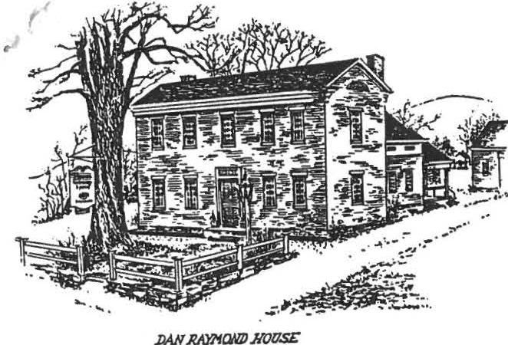
Sheffield Historical Society
Sheffield, MA 01257

Vol. 14, No. 2
June, 1987

THOUGHTS FROM THE PRESIDENT

With the coming of this June's meeting , I will be completing my three year term as Pres id ent. It has been a period of growth and consolidation. We have increased the size of our property by adding the Hatter's Shop. We have seen our endowment grow considerably due to careful management and a favorable economic climate. We have seen the membership of the Society climb well over the two hundred mark and we have wat ched our Antiques Show become one of the premier events of the season.
Obviously, this is not the work of one person but of a large group of dedicated volunteers. Working tirelessly at the Dan Raymond House or various activities, they are th e ones that make the Society go. I thank them all for their support and help .
While I see the membership of the Society as a vibrant and caring grou p , I am co ncerned that more people have not been willing to get involved at the executive levels of the organization. There has been a dynamic cor ps of officers over the past fourteen years but we need to have more of our new members be co me part of this co mp any. Prom experience, I ca n say that it is not a time consuming task but the rewards are
mul t it ude . The coming years will need to see new faces a t the hel m of th e society and I encourage everyone to get involved.

'
DAN RAYMOND HOUSE NEWS

It's June again and here at the Dan Raymond House we look forward to the summer activitie s.
Starting the season on June 4th. the students of the 8th grade of Mt . Everett Regional School will make their annual visit to the House in conjunction with their historical field trip in Sheff ield . Each year we have the privilige of exposing a new group of young people to the "treasure" of the Sheffield Historical Society - the Dan Raymond House . It's really wonderfully satisfying to think we might be helping to create some new history buffs and perhaps adding some future members of the society (down the road apiece, of course). Also in June , we expect one or two of the lower grades to vis it . Can't start them too early!
Milt Barnum has been shaping up the barns for the season.
The carriage and cutter are in order and the farm tools in place for the viewing by visitors to events on the grounds this
su mm er. INSIDE NEWS -
During the winter new bookshelves have been added to the l ibrary by utilizing the space in the former coa t closet.
At the mom ent , Jonathan Hubbard's 18th century cupboard is
out being restored but will be back on the premises sometime in J un e. This cupboard had been languishing in the Town Library until last Fall when we acquired it .
For those of you who lov e "mi niatures" , a new exhibit has been set up in the keeping room . In c l uded are furnitur e , book s, wood carvings, ceramics, bas kets , etc. Al so some unique it ems such as a lighthouse, complete with it s light are on vi ew. You wi ll be surprised at some of the fin e workmanship on displa y. Do come and see i t.

r'
I

SOME DATES TO REMEMBER -

During July and August, the House will be open both Friday and Saturday from 1:30 to 4:00 PM.
While the Sheffield Historical Society Antiques Show is going on , the House will be open Saturday June 20th and Sunday June 21st, 1:00 to 4:30. Before or after the show, bring your friends to see the "sponsor's" house.
The Sheffield Historical Society picnic will be held on the grounds of the ORH on Sunday, August 2 at 5:00 PM. Bring a covered dish and your place setting and sharpen up your croquet eye. Peter Coenen and Loring Boardman are set to defend their title. At this time, we also plan to take note of the 200th Anniversary of the Constitution by presenting a suitable
program .
As always through the year, our thanks go to Milt Barnum and Bill Browne , steadfast members of the DRH Committee, for the many tasks they perform to help keep the house functioning. You name i t , they do it!

ANTIQUES SHOW

This year's version of the Antiques Show is set to go on June 19,20 and 21. The Preview Party will have the added bonus of catering by Crosby's of Lenox. It is hoped that this change will free up more people to work on Saturday and Sunday as well as allow members to fully enjoy the Party Friday night . Preview
tickets can be reserved by calling Jim Miller at 229 -8668 or 229-
8777.
If you haven't called to volunteer your time at the Antiques Show, please call Marion Whitman at 229-2129 as soon as possible . There are a few spots remaining to be filled.

CALENDAR OF COMING EVENTS

June 12 - Annual Meeting at 6 :30 PM at Dewey Hall . This will be a covered dish supper. The Society will
provide desserts and beverages . Remember to bring a place setting .

June 19 ,20,21 - Sheffield Histori ca l Society Antiques Show Preview Party, Friday 6-9 PM; tickets are $20
in advance
Saturday 11-7:30 PM
Sunday 12-6 PM

July 25 - Tag Sale at the Legion 10-4

Au gust 2 - Picnic at the Dan Raymond House - bring a covered dish and a place setting; 5:00 PM

****************************************************************
MEMBERSHIP

The Annual Meeting begins our fiscal year. You may pay your dues to Jim Miller at the meeting or send them in to the
Socie ty . Dues are $3 for a single and $5 for a fami ly.

TO: Sheffield Historical Socie ty P. O. Box 1733
Sheffield, Mass. 01257

N AM E : _ _
_ _ _ _ _
_ _ _ _ _
_ _ _
_ _ _
_ _ _
_ _ _ _
_ _ _ _ _
_ _ _ _

ADR ESS:---------------------------------- TEL .

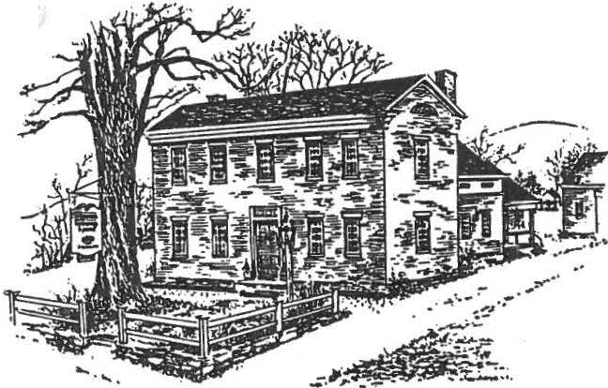-1 I
(
/'

Sheffield Historical Society
Sheffield, MA 01257

.JWOW'lo/CWJJHOllSE

FROM THE PRESIDENT
NEWSLETTER
Volume 14 Number 3
August 28, 1987

I am looking forward to the opportunity to serve as president of the Society for the next three years.
Our task will be made easier by the accomplishments and plans laid out by others who preceded us. We have many completed projects to look upon with pride. We have projects in progress and we have the ones in the planning stage. Past officers and the membership can take pride in their accomplishments. They serve as examples and goals to those of us who set out this fall with our own agenda.
Among the goals I have set for myself and the Society are:
- greater participation by the membership in general in estab­ lishing Society policy and philospphy
- the establishment of new and imaginative activities that will make greater use of the Society's resources
- a dynamic accessions program that will make the Dan Raymond
House one of the premier museums of its type in New England.
- a determination of the use of the Hatter's Shop and a movement toward the realization of that use
- a decision on whether the Society will acquire the high school
building and, if it decides to do so, movement toward developing it
- creation of a written •society Philosophy" of long term goRls
of where we would like to be ten years from now
?. membership goals that will dl.ouble the number of members in the next three years.

Many years ago I decided the people who were its members. are realistically within our solid foundation which makes the area. Thank you for the
best thing about the Society was the
With that in mind the goals I have listed reach. Let us continue to build on that our group the envy of every society in opportunity to serve.

OFFICERS
A ROSTER OF POSITIONS (_.,
TRUSTEES

President James Miller Vice president Mason Dutcher Secretary Marion Whitman
Treasurer Roger Drury
SOCIETY PHILOSOPHY COMMITTEE
Marion Barnum Christopher Coenen Robert Dean
Joan Sawyer
Edward Warren

Lillian Preiss Roger Drury Marion Whitman, others as announced

CURATOR
Lillian Preiss
ACCESSIONS COMMITTEE
ASSISTANT CURATOR
Marion Barnum

Milton Barnum Catherine Miller Lillian Preiss Penny Browne
PROGRAM COMMITTEE

Mason Dutcher Virginia Drury Lillian Preiss Marion Barnum
EDUCATION COMMITTEE
Catherine Miller

Marion Whitman Martha Williamson Lillian Preiss William Browne
NEWSLETTER

Mason Dutcher
TURKEY DINNER
Milton Barnum
ANTIQUES SHOW

Christopher Coenen Ann Dean Robert Dean

Berkshire School Liaison Preview Party Attendance

FINANCE COMMITTEE
Christopher Coenen Christopher Coenen Catherine iller

Marion Whitman

Roger Drury William Browne Carl Schuman
HATTERS SHOP COMMITTEE

Milton Barnum Michael Briggs William Browne
INVESTMENT ADVISOR
William Browne
REFRESHMENTS
to be announced

The quilting group would like to thank everyone involved in any way for the success in selling chances on the beautiful quilt the roup made this year. We realized $JOO. and the quilt was won by Mr;.
Adolph (Jane) Pekrul ,formerly of Barnum Street, now living in Pittsfield. Again, many thanks to all!

;

) DAN RAYMOND HOUSE NEWS
Our open house which took place August 6-7-8 was blessed with fine weather and a goodly number of visitors. The quilt exhibit presented and arranged by Agnes Boardman with the assistance of Marion Barnum was very well received. There were 38 quilts on display and many were the compliments on the quality of the work and the variety of designs, both old and new.
Our · thanks to the following:
the many sitters who "mannedn the house
Milton Barnum in the barn, and his relief for a day, Ollie Willcox
the gentlemen who were on duty in the law office Art Chase for the exhibit on beekeeping
to Muriel Rokos special ·. thanks for demonstrating her quilting
prowess on all three days.

Again as the new season begins we are looking for exhibits to be displayed at the DBH. Let us know of your interesting collections
Recent visitors to the DRH included a couple from Sheffield, Iowa. They toured the house appreciatively, took pictures, bought books and left a donation so we can •keep up the good work.n They promised to send information on other Sheffields they have visited.
Warner Friedman has finished the conservation work on the portrait of Mrs James Bradford. The bespectacled wife of Sheffield's fourth minister has a kindly, rather enigmatic expression which was entirely hidden from view before the conservation. The portraits of Mr. and Mrs. Bradford are appropriately han ing in the Rogers Room of the Dan Raymond House.Robert Jarvis Rogers and his wife Sally owned the
house from 1829 to 1866 and were admitted to the Congregational Church in 1831. The portraits were painted in 1847. Do stop in and visit this appealing couple.
The cupboard belonging to Sheffield's first minister, the Rev. Jonathan Hubbard, which is on permanent display and loan from the Bushnell-Sage Memorial Library in Sheffield has been faithfully restored by Sue Connell of Clayton. The cupboard was given to the library by Arthur Tuttle, a direct descendant of Mr. Hubbard. It is now located where everyone may see and appreciate this interesting piece of Sheffieldiana.
We are grateful to our faithful docents, Irene Cranmer, A es Boardman, and Roger Drury, who serve on the 2nd, 3rd and 5th Fridays respectively. The 1st and 4th Fridays of the month are still available for the first eager volunteers to enlist. We don't pretend to be overrun with visitors, but when we have a docent on duty, the regulars are free for housekeeping duties which although not always exciting are essential.
We had a fine picnic this summer· August 2, held in the DRH due to inclemency. Not many carne;those that did were blessed with good food, fine comradeship, a touching nod to the yea:r of the American Constitution-- Roger reading the Preamble and the baker's dozen (what a felicitous expression!) of us joining in smme heartfelt singing of
3 patriotic songs. We joined hands and hea:rts in tribute to our land
and our heritage.

.'

Yes, that's right, August is nearly gone and before you know it we'll cover up the tender plants that haven't given us all that we think they could. The corn will be cut, just waiting to dry and be husked. The potato bin will be full, as will the crocks. The wood
shed and the hay mows have no more room. Now you are looking forward to Thanksgiving with your family and friends. This is all very well, but it's still a time between now and Thanksgiving, so let's prime the pump a bit, say about October 25th. I'm talking about the fun
Turkey Dinner when we all get together and see what we can do for the scholarship fund. Last year we awaraed $500. for one student who attended Hobart College, and we financed the 8th grade field trips which sent eight groups thru the Historical Society area, to other places such as Old Parish Church, Col. Ashley House and the old covered bridge.

Oh yes, does anyone know where we can pick up 4/ 5 to press out for the dinner cider. As you know we an old hand press given to us by Art Chase, and it If you know of any windfalls, please let us know. dinner.
bushel apples used last year worked real well. See you at the

The program committee has been at work and we believe we have another good year in prospect. Please keep these dates in mind come to all events.
Sept. 11 Henry T. Callan of Sandwich, dealer and appraiser. Slide show on Antique Furniture styles of New England,1620-1835. Bring an article for identification and appraisal. Cost per item $2.00 and we get to keep all the proceeds, for the Society.
Oct. 9 Betty LeGeyt speaks on the Grange Movement in America.
Nov. 13 A slide show by Cynthia Hoogs on Sheffield Cemeteries.
Dec.11 A gala party with special music, heavenly food and all the seasons best wishers.
The next newsletter will carry the 1988 programs, but the January meetin will be you know what? I got a couple of stumpers.

MEMBERSHIP
Members of the SHS are often uncertain about when the membership year begins-- June, or September, or maybe January. The answer i June,
at the time of the annual meeting. If you slipped up on renewing then, you are not alone. You may give your dues to Roger Drury at the September meeting or mail them to the Society. Dues are $J.for a single
$5. for a family. Mail to: Sheffield Historical Society
PO Box 1733,Sheffield,MA 01257
Name
Address Telephone

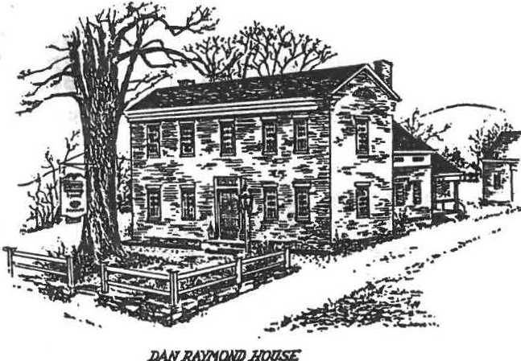
f.

Dan Raymond House News

Sheffield Historical Society
Sheffield, MA 01257

NEWSLETTER

Volume 14,Number 4
December 28, 1987

On December 5 twelve members of the Sheffield Historical Society took a delightful candlelight tour of 1 MaseacohPlantation• in Simsbury, Connecticut. This is a complex of nine buildings that are maintained by the Simsbury Historical Society. 'Twas a lovely moonlight night and we walked by candle and lantern light from house to house. As we opened the door of each one a •scene• was in progress with live costumed characters. The scenes included: a town meeting in the 17th century meeting house; in the old schoolhouse a class of children being instructed by the school
•marm•; at the Phelps Inn a lively tavern scene with a saucy bar­ maid a chamber scene with two maids making up a four-poster and wishing they could attend the ball that evening; through another door we entered the ballroom-- masked couples were dancing the new and daring •waltz•; a eeping room scene where a grandfather sitting in front of the fire told a story to his grandchildren; a Victorian family scene·with father reading •A Visit from St. Nicholas•, and in C'aJDe the Saint himself'. Regretfully we stepped out of the past and into the present. We hope you will all try to attend this event next year. We do plan a.Dother trip to the Plantation when it opens in May, 1988. Keep it in mind.
The Dan Raymond House •open House• took place December 13. All was in readiness for the holiday visitors. Those who came enjoyed a candlelight old Sheffield Christmas. This year we added 5 young carolers and a •Night before Christmas• scene in the Victorian Room. We regret the turnout was less than last year, and that so many of our members failed to come. The DRH committee works hard on this event and we hope you will support us next year. In the winter months ahead we will work on some new interesting changes at the DRH. So, peek in once in a while to see what goes on.
FROM THE CURATOR'S DESK
The library on the second floor of the Dan Raymond House has been named the 'The Sally Scanlan Library" as a memorial to our great benefactress, many of whose books on history, literature, and art are aYailable for research or for lo9n.
The Education Committee has voted·to use $400. to purchase additional books for the Sally Scanlan Library and $400. for books of a historical nature for our town library, the funds to come from the

education budget. Sug estions from members concerning books to \
be purchased may be addressed to the president or to any member of'' the education committee: Marion Whitman,Bill Browne, Lillian Preiss, or Martha Williamson. John Campbell, town librar.ian, will also welcome suggestions.
Although we are eager to expand our collection, especially in the area of Berkshire County history, we should not belittle our present stock of books. How many of our members are aware of the wealth of information available on the library shelves? Here you can find books on antiques, furniture, pottery, pewter, china, quilts, dolls, herbs, baskets, architecture, churches, and Sheffield cemeteries.
Biographies, cookbooks, old copies of American Heritage, and Antiques as well as town reports, school reports, and .old scrapbooks may be consulted here, or, 1n most cases, may be borrowed. As the library evolves in usefulness, we urge members and friends to become familiar with its resources. The Dan Raymond House is open Friday afternoon from 1:30 to 4:00 year round. Do stop in.
***********************
The Education Committee met recently and now make the following announcements:
A) the scholarship to a Mt.Everett graduate has been increased from
$500. to $1000.

&) $500. is allotted for school field trips each year.
- $100 is allotted to send a girl to.Girls State each year from Mt. Everett High School
- The Education Committee will pay for a bus trip to historic sites for our membership.
- $400. has been allotted for this year to the Bushnell Sage town library for books.
- $400 has been allotted for this year to the Sally Scanlan
Library in the Dan Raymond House.
- All this is accomplished through the combined efforts of the membership in fund-raising. Your continued good works are
appreciated.
Education Committee
Bill Brown, Lillian Preiss, Martha Williamson, and Marion Whitman, Chr.
**************************
Many thanks to all who helped in any way to make our Turkey Dinner
a big success. We came through with a net profit of $1616.13, which is the most yet. There areso many who did so much and in so many ways that I'm not going to attempt to name them for fear of missing someone. There is one thing I would like to ask you to do, and that is if you or someone you lmow has a suggestion how we can make the Dinner better, please let us lmow. Now I ask you, when is the last time soneone wanted to have you complain.? Thanks again, and we hope you and your family have a healthy and happy holiday season and a safe and prosperous New Year.
Oh yes, in case you think that the season has got ahead of you, cheer. up. In a few days you'll have a whole year to catch up!

.I .

FROM THE PRESIDENT
A pile of old Sheffield Historical Society newsletters dating back to 19?9 provided some early winter reading this December• There is ncthing like a review of dated original documents to appreciate how far we have come as a roup and to see how very much we have to be proud of. My purpose in perusing the news­ letters, however, was not to see where we have been but to see
where we might go, because a major emphasis of the Society for this late winter and spring will be long range planning to cover the next ten years
In reviewing some of our great past accomplishments I have no doubt about our ability to define and implement the next steps in our development toward a more productive and successful society. Beginning in early February a committee made up of some past . presidents and officers will be setting up procedures to tap the member-ship for their thoughts. With no preconceived notions
the committee's task is to translate members• ideas into goals and objectives that will guide our group toward the year 2000. Just some of the important questions to be addressed will be:
building acquisition and use; accessions and preservation; investment philosophy and goals; education function for both membership and the public; volunteer training; the social respon­ sibility or our group, and the question of full-time staff. Boger Drury has agreed to chair this very important committee which will include Lillian Preiss, Christopher Coenen, Catherine Miller and Marion Whitman. Please be prepared to convey your hopes and aspirations for the Society to these·peopleboth informally as you may have the opportllnity to do so or formally as they seek guidance from the membership as a whole.

Ir we can use the resources and the vigorous energy and talents of ou people on well defined and focussed objectives and goals, our Sheffield Historical Society will be able to enrich the life of our community even more. That, after all, is our purpose. Let's look forward to the work of the committee.

1988 SPRING PROGRAM \

January 8 The annual stumper time called Whats It?, wherein we bring artifacts we think are good objects to puzzle our resident experts as to their use or origin. The evening also includes a Show and Tell and for this you bring interesting objects you think will intrigue your fellow members
February 12 Susan Young, who made the well-known needlepoint tapestry of Sheffield town will talk about its making and the story of pictures in needlework. This is your chance to see it a ain and marvel at its detail.
March 11 "Sheffield by Lamplight" A talk by Boger Drury about what it was like to live in a country town 200 years ago.
April 8 Carolyn Banfield, Executive Director of the Berkshire Historical Society, will speak to us.
May 13 Herbs and potpourri. Dorothy Marosy will lend some
spice to our lives by presenting a program on the subject.
June 10 Dinner and Annual Meetin
June 24,25,26 A notable event in the Berkshires, our own prestigious antique s ow at Berkshire School, managed by Sidell and S1qel1.
More information later in the Spring about our summer picnic,and tag sale,and antique show and other wondrous events

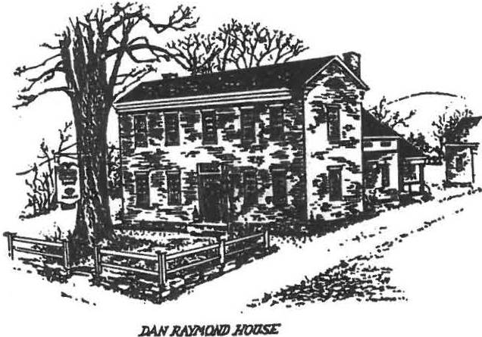
' .,

Sheffield Historical Society
Sheffield , MA 01257

NEWSL!TTl:':R
Volume 14, Number 5
April 18, 1988

From the President
At this writing, planning for the June Antiques Show has long been underway. The contract with Sideli and Sidell was inked in December and Shris Coenen early this year negotiated a retum to the popular fourth weekend in June for the show. Virginia's food committee has been meeting,,regularly to plan new Ide • and Robeet Dean and Joan Sawyer have volunteered to gather labor for the food and myriad other committees whose work is yet to start.
This · show has been our primary source of funding for fumishing the Dan Raymond House,carriage house and law office. Great financial strides have evolved from our beginning in those first flea markets put together by Carl Proper in a hay field. But we have reached a plateau in our eamings from the show. The only way we have to improve our profit ia through increased attendance at the Friday evening Preview Party. Membership support of that event over the years has been disappointing. In order to stimulate attendance by all Society members, the Executive Committee at its March meetang took two steps. They appealed to the membership to attend and they voted a price reduction for tickets purchased in advance by members from $25. to $10. Best
yet, every penny of the $10. goes to the Society. As President
I am setting a goal for the Society of selling 100 tickets to members which will translate t• $1000. for us. Please! Search your soul and your budget for this worthy ause, support your Executive eommittee, and enjoy, at the same time, a pleasant evening. Let•s make this, -:.show the most profitable yet. Please contact Roger Drury for tickets.

The usefulness of the Sally S anlan Library in the Dan Raymond House will be enhanced by an offer we have received from a member to catalog and organize the books in a more systematic arrangement. We are grateful for Elizabeth Daly's work in getting started and appreciate the recent offer to ;continue the job. Recent additions to the library are two Sheffield books: Family Reflections, by Ruth (Barnum) Leffingwell, and Sheffield Ceaetery Inscriptions by Cynthia (Tryon) Hoogs. We also have the new Massachusetts history From Colony to Commonwealth by Judith Freeman Clark.
For the month of-April the library will also be used for the fan exhibition, which has already attracted many enthusiastic visitors.
The library is for browsing as well as for lending, so come and enjoy it.

(
SHS 4-18-88 2

April 11, 1988
Dear Members & Friends,

Once again - our Annual Antique Show is almost here!
June 25th and 26th.

Your cooperation in the past has made this affair more successful each year. ,-Je ::; r e looking forward to an even better Show this year.
We have begun scheduling volunteers for t e Shcn•1.
?lease indicate below, or by phone, how you will help this year.

We are asking· for two hours minimum contribution of time from each member. Please let us know your preference of service and time availability.
THANKS l

Bob Dean & Joan Sawyer Volunteer Service Chairmen
-----------------------------------------------------------------
Name---------------------------------
Addr ess-------------------------------

Phone---------Prefer to work
Service preferred-----------

SUTN.(26th)

You may mail toa Sheffield His.torical Society, or phone Bob et 229-2608 or Joan at 229-2908. We need folks to help serve food, direct parking, cashiers, dining room host/hostesses, etc.

SHS 4-18-88 3
./

SAVE_THIS_DATE!_
THE HISTORICAL SOCIETY WILL SPONSOR A TOUR OF SHEFFIELD ON SATURDAY, SEPTEMBER 24, 1988. JA ES MILLER AND MARION WHITMAN WILL CHAIR THIS EVENT AMO ASK YOU TO MARK YOUR CALENDAR TO SET THE DATE ASIDE NOW. MORE INFO LATER!

*********************************************************

-E-D-U-C-AT-I-O-N--C-O-M-M-I-T-T-E-E--R-E-P-O-R-T-
The Education Committee has recommended and received
approval for the following implementation of the Education outreach of our organization:
- Tncrease the scholarship at Mt. Everett from $500 to
$1000.
- Arrange and pay for a field trip of historic interest
for our members.
3• Continue to pay for the local history project for 8th graders at Mt. Everett.
4. Donated $400.00 for the Sally Scanlon Library at
the Dan Raymond House.
5 • Donated $400.00 to the Bushnell-Sage Sheffield Town Library. Part of this was spent to have the OLD HOUSE JOURNAL in the library.
Several new projects are under consideration and will be announced as they progress.

Marion E. Whitman, Chairman

************************************************
Listen up all you friends who like to take short, interesting trips. Would a ride up to Manchester, Vermont help heal your winter blues? If we have enough interest, we may be getting a trip up to Hildene,Robert Todd Lincoln's home.
From there a nice treat would be lunch at the ₀ 1d Equinox in town or some other
place of your choice.There is no end to the amount of shops to visit. Some people might enjoy spending the rest of the afternoon at the •jelly mill.• Think about it and we will discuss it at the May meeting.
iHHHHHHHI IIIIIIIIIIIIIIII II1111 II II II II 11-iHHHt¼it·IHHHl"*iHHHHHHHHHHtII II II II II II II*

Dates to remembers 14ay 13 Dorothy llarosy speaks on herbs June 10 Dinner and Annual Meeting
June 24,25,26 Our antiques show at Berkshire §chool
July 24, 5FM Picnic at the DRH. Bring place setting and a "dish to pass.11

SHS 4-18-88 4
.,
WHERE WILL s··w·s·· BE IN 1998?

A Sheffield Historical Society without a set of long-range goals could easily become like a ship without chart or compass, always on the move but never arriving. To save the S.H.S. from that fate a so-called 10-year Goals Committee was fonned in January, made up of Lillian Preiss, Marion Whitman, Catherine and James Miller, Chris Coenen, and Roger Drury. The committee will weigh the Society's achievements up to now and recommend what it should try to accomplish by 1998.
Members of the Society are invited to register their opinions by filling in and returning the questionaire which accompanies this newsletter. A substantial response will help the committee and the Society
l. to know what are the strong and weak aspects of our
present program;
- to define the goals owards which we should be aiming;
- to take into account the skills and enthusiasms of the
S.H.S. members. On them, in the end, our program will stand or fall.
Please hand your completed questionaire to any committee member at our May meeting, May 13, or mail it promptly to the Sheffield Historical Society, P.O. Box 1733, Sheffield, MA 0!257.

DRH NEWS

On March 24 we served our annual colonial meal to 12 Mt.Everett students and their able and inspiring teachers, William Gilooly and Paul Menin. After all had partaken of the "country breakfast" which included pancakes cooked over the open fire and topped with maple syrup from Art Chase's sugar house, A "what's it" guessing game took place-- always a challenge for the yoQng people and sometimes their wiser teachers.
During the Month of April we are proud to present an exhibit of fans old and new. Some of them are of 19th Century vintage. A great many are on loan from the Berkshire Historical Society and the remainder are from our members and friends.
We who put the exh bit together were surprised and pleased at the quality and variety of these lovely fans. Our "opening" took place March 27; it was so gratifying to see the oodly nu ber of visitors. A highlight was a demonstration of the Language of the Fan." In earlier times words were not neededithe various subtle and meaningful motions a lady made with her tan "told all."
Do come and enjoy this exhibit. Fridays 1:30 to 4 PM.. or by appointment.

Sheffield Historical Society
Sheffield. MA 01257 .
Vol. XVI No. 1
ACTIVITIES
SEPTEMBER
The September meeting was well attended and very timely since it•featured Jeff Casdin who talked about the history and renovation of the General Ashley House. The following day the building was among those featured on the Historical Buildings Tour.
OCTOBER 14, 7:30, Dewey Hall
Stephen Budrow of Williamstown will discuss "Using cl Cemetery, fcµ- Relearning Our Heritage". Mr. Bud1·ow, a former member of the Board of Directors of the Berkshire County Historical Society. will show gravestone rubbings as part of his presentation, This 1neeting will,be excellent background for the cemetery tour the following day.
OCTOBER 15, 1:00, Cemetery Tour
Milton Barnum will lead a tour of some of Sheffield's historic cemeter ies , including Candee Cemetery off Route 41, Center Cemetery, and svme of the ancient buri-l grounc.ls
along Route 7. Everybody must provide his/her own transportation. Wear comfortable shoes and clothing. Meet at the D.R.H at 1:00.
OCTOBER 30, 12:00, Turkey Dinner
The Tenth Annual Turkey Dinner will be held at the American Legion building on Route 7. Sittings will again be at noon and 1:30. This event is extremely popular, so make your reservations early by calling 229-2569/8668/8064. The price is stil·l· a reasonable $6 for adults and $3 for children under 12. Proceeds from this event fund the Society's educational activities for area young people.
OVEMBER 11, 7:30, DEWEY HALL
The November meeting will feature a presentation by Dallas Cline on the "Origins of the Dulcimer". She will treat us to several melodies as well as give us an historical background on the instrument.
DECEMBER 9, 7:00, DEWEY HALL
- . Our annual holiday affair . with specific details yet to be developed. Keep this date open and prepare for a good time .
DECEMBER 11. 3:00 to 6:00, D.R.H.
Annual Holiday Open House and Doll Exhibit
JANUARY 13. 7:30. DEWEY HALL
traditionally the most popular meeting of the year, our
..annual "What's It", will again be MCed by Milton Barnum.

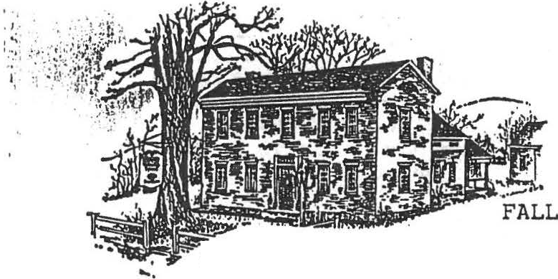
.-..
· · D ig into your cupboards, closets and barn fo lhose stumpers which seem to be harder and harder to come by as the years pass .

QUILTlHG GROUP DISBANDS
The quilting group which was started in 1973 by members of the Society, and during its
- lifetime created twenty quilts, has terminated its activities. During its active years the Group has donated a total of
$3889.50 from raffled articles of which $2500 went to the

for D.R.H. renovations;
$500 for the purchase of pewter plates; and over $500 to the Scholarship Conimitt.ee.
In addition to quilting, the active membership made.all the draperies for the D.R.H. and assisted in those for Dewey Hall: made a crewel embroidered Sheffield·Town Seal which hangs in our headq arters; and arranged two quil shows.
A special thanks to the members of· the Group who. over the years have contributed so much to the Society.

DAN RAYMOND HOUSE NEWS HISTORICAL STRUCTURES TOUR
At the D.R.H. on September 24th we were fortunate to share in the wealth of visitors passing through Sheffield due to the very successful SHS Tour. The number of interested and interesting people going through ouF portal filled our guest book and we acquired some new
embers. It was a truly i!\c.tisfying day.
STENCILLING CLASS PLANNED
TI1e Society plans to
- present a class in stencilling to be held in the brick workshop on the headquarter's grounds sometime du1•ing the week of October 24-28, the exact ·time to be announced. Classes will be conducted by Jude Kent of "Primrose Cottage". Ashley Falls. If you
: e interested, please
-·.call Penny Browne at 229- 6598 for information.
HOLIDAY OPEN HOUSE
Keep in mind the date of the annual Open House at the DRH, December 11. 3:00 to 6:00. Along with the usual festivities will be an exhibit. "A Doll's World" which will include dolls, doll houses and related items.

SHEFFIELD HISTORIC STRUCTURES
TOUR
The Society held its first historic structures Tour on September 24. with stops at eight buildings important to the history of early Sheffield. Lucky ticket holders were treated to visits to the homes of Milton and Marion Barnum. Robert and Ruth Ledlie, Jeff and Sharon Casdin as well as the IDRH. Colonel Ashley House. Christ Church Episcopal. Old Parish and the Upper Covered Bridge.
According to Tour Co­ chairpersons Marion \&litman and James Miller the events'of the day were a sellout, with many disappointed people turned away. Early and extensive coverage in lo cal, regional and national publications contributed to heavy demand for the limited number of tickets available. and. although the event was billed as an educational event, its heavy turnout resulted in a fine profit.
Fan mail began to arrive as early as the following Monday. A letter received from north county began. "This.. . is t u congratulate the Sheffield Historical Society on its
µresenLatjo11 uf an 0utst':lncting
house and museum touiA. The buildings and collections were superb and its representatives most cordial and gracious."
We are indebted to the many Society members who worked as guides at all the venues. the people who did refreshments. flowers and art work. and especially to thpse who opened their homes fo1A the advancement of local history in our area.

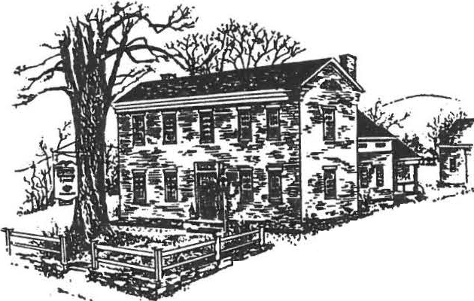\·

-.·, .:.,- .... ·
..-;:,II>,-. -- • - ... :t....,..-. ,
I

\
'
Sheffield Historical Socie ty
S heffield, MA 01 25 7

VOLUME XVI, No. 2
/fJ?7
WINTER AND SPRING ACTIVITIES

FEBRUARY 10, 7:30, DEWEY HALL
HERBERT S. WHITMAN OF CORNWALL, CONNECTICUT WILL SPEAK ON HIS NEW BOOK EXPLORING TijE BERKSHIRES.
MARCH 10, 7:30, DEWEY HALL
EUNICE THOMEN, PRESIDENT OF THE CAROUSEL DOLL CLUB, WINSTED, CONNECTICUT WILL GIVE A TALK ON DOLLS AND TEDDY BEARS.
APRIL 14, 7:30, DEWEY HALL
RUTH DEGENHARDT OF THE BERKSHIRE ATHENAEUM WILL GIVE A PROGRAM
ON FAMILY GENEALOGY.
MAY 12, 7:30, DEWEY HALL
LILLIAN PREISS WILL SPEAK ON THE NATIONAL HISTORIC REGISTRY, FEATURING SPECIFICS ON SHEFFIELD ENTRIES.
JUNE
ANNUAL MEETING, JUNE 9, DEWEY HALL, 6:30.
ANTIQUES SHOW PREVIEW PARTY, JUNE 23, BERKSHIRE SCHOOL, 6:00.
ANTIQUES SHOW, JUNE 24 AND 25, BERKSHIRE SCHOOL.
JULY
ANNUAL PICNIC, DAN RAYMOND HOUSE. TIME AND DATE TO BE
ANNOUNCED.

SOCIETY BENEFICIARY OF O'CONNOR ESTATE

OUR SOCIETY. IS A BENEFICIARY OF THE ESTATE OF THE LATE GABRIELLE GILPIN O'CONNOR WHO WAS A LIFE MEMBER OF OUR GROUP AS WELL AS BEING THE OLDEST MEMBER AT HER DEATH AT 103 THIS FALL. MEMBERS OF HER FAMILY (BERNARD) WERE INSTRUMENTAL IN
THE ESTABLISHMENT OF CHRIST CHURCH EPISCOPAL IN SHEFFIELD AND BARNARD COLLEGE IN MEW YORK CITY. MRS. O'CONNOR MAINTAINED A SUMMER HOME IN SHEFFIELD ON SOUTH MAIN STREET, THE LITTLE RED COTTAGE NEXT TO THE HISTORIC BARNARD CEMETERY. HER DAUGHTER, ELISABETH (LIBBY) O'CONNOR IS A LIFE MEMBER OF OUR ORGANIZATION. -

THE EXECUTIVE COMMITTEE, AT ITS OCTOBER MEETING, VOTED TO USE THE $1,000 GE UEST TO PURCHASE BOOKS FOR THE SALLY SCANLON LIBRARY AT THE uA : RAY ONC HOUSE. THE BOOKS WILL BE CLEARLY MARKED AS TO TH IR OR!GIN AND MEMORIAL STATUS BY A BOOK PLATE INSCRIBED W:iH THE NAME OF MRS. O'CONNOR.

I

SOCIETY RECIPIENT OF HUBBARD FAMILY HISTORY
DESCENDANTS OF JONATHAN HUBBARD, FIRST MINISTER OF THE CONGREGATIONAL CHURCH IN SHEFFIELD HAVE PRESENTED THE SOCIETY WITH A COPY OF THE HUBBARD FAMILY GENEALOGY. FAMILY MEMBERS TRACING THEIR ROOTS IN SHEFFIELD THIS FALL MET SOCIETY MEMBERS MARION WHITMAN, DOROTHY MAROSY, AND PENNY BROWNE, TOURED THE DRH, AND VISITED OTHER HISTORIC SITES INCLUDING THE GRAVE OF THE REVEREND HUBBARD. THE RESULT WAS THE FINE GIFT TO THE SOCIETY WHICH WILL BE AN IMPORTANT PART OF A GROWING COLLECTION OF HISTORIES OF LOCAL FAMILIES.

TEN-YEAR GOALS COMMITTEE FINAL REPORT
A SPECIAL COMMITTEE WAS APPOINTED LAST SPRING TO STUDY THE SOCIETY'S ACTIVITIES AND RESOURCES AND TO RECOMMEND GOALS FOR THE NEXT TEN YEARS. EIGHT PRODUCTIVE MEETINGS WERE HELD AND A SURVEY DISTRIBUTED TO THE ENTIRE MEMBERSHIP OF THE SHS IN APRIL.
THERE WERE TWENTY-SIX REPLIES TO THE SURVEY, MANY OF THEM VERY THOUGHTFUL. HOWEVER, THAT SAMPLE IS TOO SMALL FOR THE LAW OF AVERAGES TO OPERATE DEPENDABLY, AND IT IS PROBABLY ALSO TOPHEAVY WITH THE OPINIONS OF THE MOST ACTIVE AND ARTICULATE MEMBERS. TABULATION, MOREOVER, WAS COMPLICATED BY THE OPEN­ ENDEDNESS OF THE QUESTIONS ASKED.
YET THE SURVEY REPLIES OFFERED A GOOD DEAL OF USEFUL OPINION AND MANY HELPFUL SUGGESTIONS. THEY GAVE SUBSTANCE TO IMPRESSIONS WE HAVE GATHERED FROM OTHER SOURCES ALSO-­ CONVERSATION WITH MEMBERS, DISCUSSION IN DIRECTORS' MEETINGS, AND OUR OWN EXPERIENCE IN THE SHS. WE INVITE MEMBERS TO STUDY THESE RECOMMENDATIONS AND TO BE PREPARED TO DISCUSS THEM.
PRESENT PROGRAM AND STRUCTURE:
THERE IS BROAD SUPPORT FOR THE SOCIETY'S MAIN ONGOING
PROGRAMS:

OPERATION AND DEVELOPMENT OF THE ORH MUSEUMS, INCLUDING THE CARRIAGE BARN, LAW OFFICE AND BRICK WORKSHOP.
      - MONTHLY EDUCATIONAL/SOCIAL/BUSINESS MEETINGS.
      - OUTREACH TO SCHOOLS THROUGH LOCAL HISTORY FIELD TRIPS, VISITS BY SCHOOL GROUPS TO THE DRH, AND THE COLLEGE SCHOLARSHIP PROGRAM.

(
\
THERE IS WIDE APPRECIATION OF THE NEWSLETTER AND THE OCCASIONAL FIELD TRIPS TO PLACES OF HISTORIC INTEREST.

THE POPULARITY OF OUR TWO ANNUAL BENEFIT FUND-RAISERS, THE TURKEY DINNER AND ANTIQUES SHOW DEMONSTRATES THAT THE MEMBERS ENJOY WORKING TOGETHER AS WELL AS SITTING, EATING, LISTENING, AND TOURING TOGETHER. THE FELLOWSHIP WITH LIKE­ MINDED PEOPLE IN THESE TWO BIG EFFORTS MAY BE AS IMPORTANT TO US AS THE USE MADE OF THE PROCEEDS. BUT NOT MANY MEMBERS BIND THEMSELVES TO MORE FREQUENT DUTIES SUCH AS ASSISTING AT THE DRH.

IN GENERAL, THE SHS IS VIEWED AS A STIMULATING BUT NOT TOO DEMANDING SOCIAL/EDUCATIONAL FELLOWSHIP. ITS OUTREACH TO THE SCHOOLS IS APPLAUDED. THE SATISFACTIONS AND BENEFITS OF MEMBERSHIP ASK LITTLE EFFORT FROM MOST OF THE MEMBERS. A
MINORITY IS PERMITTED TO CARRY THE LOAD.

IMMEDIATE NEEDS:
THE SOCIETY HAS NOW HAD SIXTEEN YEARS OF RAPID GROWTH. IT IS NO SURPRISE TO FIND OUR GROWING MATURITY NOW SOMEWHAT CLOUDED BY FEELINGS OF IMPATIENCE AND A SENSE OF BEING STALEMATED. WE ALL SEE A NEED FOR RENEWAL OF OUR VISION AND SHARPENING OF OUR GOALS. ABOVE ALL, THERE IS AN URGENT DESIRE FOR THE SHS TO REACH A CONSENSUS ON USE OF THE MARK DEWEY 8UILDING--PREFERABLY FOR A BIG, UNIFYING PROJECT WHICH OVERRIDES CONFLICTING INTERESTS AND WINS THE ENTHUSIASM OF THE MAJORITY. THE GOALS COMMITTEE SPECIFICALLY SUGGESTS THAT THE MARK DEWEY BUILDING BE PUT TO USE AS A SHEFFIELD FAMILY RESEARCH CENTER, A WORKING FACILITY FOR RESEARCHING, RECORDING, AND SAFE-KEEPING MATERIALS HAVING TO DO WITH THE HISTORY OF SHEFFIELD'S FAMILIES-- THEIR LINEAGE, OCCUPATIONS, SOCIAL AND BUSINESS LIFE, LAND, BUILDINGS, PUBLIC INSTITUTIONS, ETC. THE POSSIBLE SCOPE OF SUCH A SERVICE TO THE COMMUNITY APPEARS TO BE UNLIMITED. IF THE SUGGESTION WINS GENERAL APPROVAL, THEREFORE,PRIORITIES MUST BE CAREFULLY THOUGHT OUT, AND USE OF THE AVAILABLE SPACE PLANNED STEP BY STEP.

FOR THE NEXT TEN YEARS:
        - BRING OUR EXISTING MUSEUMS TO THE FULLEST USE, SELECTING
PROGRAMS FOR STRENGTH AND FRUITFULNESS
        - COMMIT THE MARK DEWEY BUILDING TO WORK OF RECOGNIZED UTILITY TO THE SOCIETY AND THE COMMUNITY
        - GREATLY ENLARGE OUR ATTENTION TO SHEFFIELD HISTORY THROUGH SUCH ACTIVITIES AS SUPPORTING THE SHEFFIELD TIMES, CONTRIBUTING TO THE DEWEY MEMORIAL HALL ROOF FUND, HISTORIC BUILDINGS TOURS, CEMETERY TOURS, BOOK DONATIONS, ETC.
        - KEEP OUR EDUCATIONAL PROGRAMS LIVELY AND RELEVANT, ADDING SEMINARS, WORKSHOPS, FIELD TRIPS, AND KINDRED
ACTIVITIES

        - ESTABLISH A CALENDAR FOR SOLICITATION OF SOCIETY VOLUNTEERS, HELPING INDIVIDUAL MEMBERS TO BE AWARE THEIR CONTRIBUTIONS OF SKILLS, LABOR AND TIME ARE NEEDED
        - REACH OUT TO ATTRACT YOUNGER MEMBERSHIP
        - MAINTAIN AND STRENGTHEN THE ENDOWMENT AS THE UNDERPINNING OF THE OPERATING BUDGET AND A TOOL FOR FUTURE GROWTH. IN THIS REGARD, WE CALL ATTENTION TO A
JUDGMENT OF THE FINANCE COMMITTEE IN NOVEMBER, 1986,
THAT THE SOCIETY WILL BE FINANCIALLY ABLE TO UNDERTAKE FUTURE BUILDING RENOVATIONS PROVIDED THAT l)PAYMENT BY A PRUDENT COMBINATION OF FUNDRAISING, MORTGAGE, AND CAPITAL EXPENDITURE IS CONSIDERED, AND THAT 2)ANY MAJOR PROJECT IS SPREAD OVER A PERIOD OF YEARS, WITH ANNUAL REVIEW AND EVALUATION TO ASSURE THE CONTINUING SOUNDNESS OF OUR FINANCIAL POSITION.
        - MAKE THE MOST OF OUR PRESENT BUILDINGS AND COMMITMENTS, AND THEN REEXAMINE THE MERITS OF THE
PROPOSAL TO ACQUIRE THE ORIGINAL SHEFFIELD HIGH SCHOOL BUILDING-- AT THAT TIME FRESHLY MEASURING THE STRENGTH
OF SENTIMENT PRO AND CON. INTERESTINGLY, IN OUR SURVEY, NINE OF OUR 26 SURVEY REPLIES FAVORED
ACQUISITION OF THE BUILDING, BUT ONLY FOUR RESPONDENTS BELIEVED THE SOCIETY SHOULD ACQUIRE MORE HISTORICAL PROPERTY.
MEMBERS OF THE GOALS COMMITTEE ARE CHRISTOPHER COENEN, CATHERINE MILLER, JAMES MILLER, LILLIAN PREISS, MARION WHITMAN, AND ROGER DRURY, CHAIRMAN. THEY WOULD LIKE TO KNOW WHAT YOUR THOUGHTS AND IDEAS ARE!

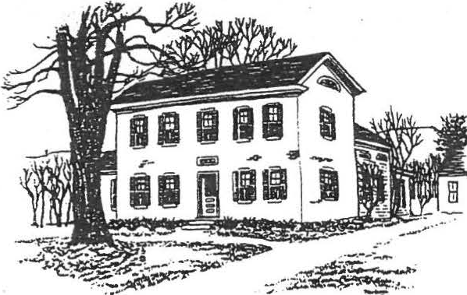
SHEFF!ELD HISTORICAL SOCIETY
SHEFFIELD, MASSACHUSETTS
01257

President's message
NEWSLETTER Vol. XVI, No. 2

. July 1990

I feel honored that you have chosen me to again serve as your President. My hope is that we can have an enjoyable and productive year, increasing our knowledge about local hist.ory and sharing what we're learning with the community--and especially with the ever-growing number of schoolchildren visiting the Dan Raymond House. With your help, we can accomplish this-and have a good time doing it!
Remember to set aside July 22 for our annual picnic at the Dan Raymond House at 4:00 p.m. Bring a covered dish, place setting, and lawn chair. Beverages and dessert will be supplied by the Society. Also, by popular demand, that dynamic thirst-quencher •switchel will be available for the daring.·
Another date to remember is our open house on August 9, 10, and 11. There will be a crafts exhibit on the lawn of the Dan Raymond House, and punch will be served.
I sincerely thank everyone who worked so hard to make our antiques show such a great success. We don't have the final figures yet, but it looks very promising. We also want to recognize these members who are serving on committees this year for the first time. It is very encouraging to see these friends willing to fill in as·we older onas have more and more aches and pains. The Society truly appreciates your efforts: Edith MacAusland, Grace Arzt, Kathie Ness, Rene Gibson, Evelyn Willcox, John James, Bill Preston, James Lecakis.
-Milton W. Barnum
·- -- - - - - - - ---- - -·--- - -------·- - - - - - - - --- - - - - -

Of ficers,committees,•••and members

Attached you will find the list of the elected and appointed officers and committee members for 1990-91.
We always welcome help! Anyone who is interested in assisting a committee,
in general or for a particular event, is encouraged to call that chairperson or any other committee member. Do you have ideas about committee projects? Let us know! (That includes suggestions for topics to be covered in the newsletter-of which this is an "irregular" catch-up edition. You'll be hearing from us again in August.)

Family History Center Update

We've been admiring from afar: the shoring up, the new windows, the attractive new colors••• but we have to wait a little longer for the full tour. The official opening of the Family History Center will take place in late September-stay tuned for details.

Mark your calendars! July 22: Annual picnic - Aug. 9, 10, 11: Open house

SHEFFIELD HISTORICAL SOCIETY 1990-1991

President Milton Barnum 1st Vice-President Sallee Hardy
2nd Vice-President Christopher Coenen Secretary Nancy Lecakis
Treasurer Morton Levin

Directors Grace Arzt, Sandie Cuoco, Virginia Drury, William Preston

Investments Charles Schumann
Curator Marion Barnum Archivist/Historian Lillian Preiss Director of Family Roger Drury
History Center

Committees (*Chairperson)

Finance Accessions
Museums Education

Morton Levin*, Charles Schumann, John carmichael, Roger Drury, Neal Hardy

Christopher Coenen*, Marion Barnum, Penny Browne, Katherine Miller, Edith MacAusland

Marion Barnum, Penny Browne, Agnes Boardman,
Lillian Preiss, Evelyn Willcox, Sandie CUoco, Roger Drury

Sallee Hardy*, Rene Gibson, John James, Amanda Morgan, Martha Williamson

Newslette/rpublicity Kathie Ness, Sallee Hardy, Lillian Preiss

Property

Family History Center

Membership Refreshments Turkey dinner Christmas meeting Antiques show
Milton Barnum*, William Preston, James Lecakis

Roger Drury, Dir.; Betty Chapin, Holly Coon, Lillian Preiss, Milton Barnum (ex officio)

Grace Arzt

Marian Willcox, Gertrude LeGeyt Milton Barnum
Marion Whitman

Christopher Coenen, Coordinator

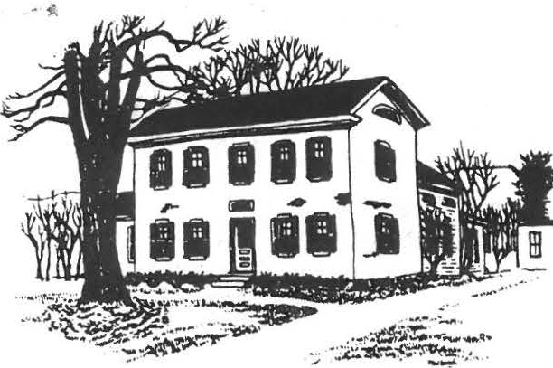
SHEFFIELD HISTORICAL SOCIETY
SHEFFIELD, MASSACHUSETI'S
01257

SPRING AND SUMMER ACTIVITIES
VOLUME XVI, NO. 3
t; _oq
1)

FROM THE DAN RAYMOND HOUSE
MARCH 16. A SELECTED GROUP OF 8TH GRADE STUDENTS FROM MT. EVERETT REGIONAL SCHOOL ANO THEIR TEACHERS, BILL GILLOOLY AND PAUL MENIN WERE SERVED A COLONIAL BREAKFAST, THE MEAL PREPARED BY MEMBERS
OF THE HOUSE COMMITTEE. MUCH OF THE FOOD WAS COOKED OVER THE KE EPING ROOM FIRE. THIS EVENT IS A VERY SPECIAL DAY FOR THE SOCIETY ANO THE D.R.H. COMMITTEE. EACH SUCCESSIVE YEAR BRINGS DIFFERENT STUDENTS TO THE HEARTH AND WE ARE HAPPY TO MEET ALL OF THEM AND INTRODUCE THEM TO SOME DOMESTIC ASPECTS OF AMERICAN HISTORY.
APRIL 23. A NEW EXHIBIT OF TOYS AND GAMES OPENED AT THE 0.R.H., ANO IT ENJOYED A GOODLY NUMBER OF VISITORS WHO CAME TO VIEW THE DISPLAYS ANO BRING BACK HAPPY MEMORIES OF CHILDHOOD. A "THANK YOU" TO ALL OF THE MEMBERS AND FRIENDS WHO EXHIBITED.

COMING EVENTS
JUNE 9, ANNUAL MEETING, DEWEY HALL, 6:30. BRING A COVERED DISH LARGE ENOUGH TO SERVE SIX. BRING YOUR OWN PLACE SETTING. DESSERT ANO COFFEE WILL BE PROVIDED . ELECTION OF OFFICERS.
JUNE 14, TRIP TO HILLSTEAD AND STANLEY-WHITMAN HOUSE MUSEUM, FARMINGTON, CT, LED BY MILTON BARNUM. MEET AT 0.R .H., 9:00 A.M. SEE EDUCATION COMMITTEE, BELOW.
JUNE 21. THE S.H.S. DREAM TEAM WILL MAKE BEDS AT BERKSHIRE SCHOOL
FOR THE ANTIQUES SHO,W 6:00 P.M.
JUNE 23, 6:00 TO 9:00 P.M., PREVIEW PARTY FOR OUR ANNUAL ANTIQ UES SHOW, BERKSHIRE SCHOOL , $10.00 FOR MEMBERS, $25 FOR THE PUBLIC.
JUNE 24 ANO 25, S.H.S., ANTIQUES SHOW, BERKSHIRE SCHOOL.

JULY 23, 4:00. Ir's THE ANNUAL PICNIC OF THE SOCIETY ON THE GROUNDS OF THE 0.R.H. JOIN US FOR A VICTORIAN GARDEN PICNIC. BRING A COVERED DISH, YOUR PLACE SETTING ANO A FRIEND WHO MAY BE A POTENTIAL MEMBER OF THE SOCIETY. HELP TO MAKE THIS A NOSTALGIC TIME BY DRESSING FOR THE OCCASION IN PERHAPS A FLOWERED BONNET OR GARDEN HAT FOR THE LADIES AND A STRAW HAT OR "BOATER" FOR THE MEN, OR ANY OTHER SUITABLE ATTIRE YOU WISH. DRESS UP OR DOWN OR DRESS AS USUAL, BUT BE SURE TO COME! WE CAN REMINISCE AND MAY BE EVEN SING A FEW OF THE OLD SONGS WE KNOW. ANYBODY FOR CROQUET?
AUGUST 10 , 11, AND 12, D.R.H. OPEN HOUSE, 11 :00 TO 3:00 EACH DAY , IN CONJUNCTION WITH THE SHEFFIELD ANTIQUES SHOW. THE D.R.H. COMMITTEE WILL PRESENT EXHIBITS, CRAFT DEMONSTRATIONS AND SERVE LIGHT REFRESHMENTS.
SEPTEMBER 8, 7:30, REGULAR MONTHLY MEETING OF THE SOCIETY, DEWEY HALL, ON THE GREEN.
SEPTEMBER 13, TRIP TO SAR ATOGA SPR INGS, NY LED BY ROBERT LEDLI. SEE EDUCATION NEWS BELOW.

SOCIETY PLANTS TREE

IN CELEBRATION OF ARBOR DAY THIS YEAR THE SOCIETY HAS PLANTED A 12 FOOT MAPLE TREE ON THE NORTH SIDE OF THE WESTERN APPROACH TO THE COVERE D BRIDGE. IT IS TO REPLACE A TREE FROM THAT LOCATION WHIC H HAD TO BE REMOVED A YEAR AGO WHEN THE ARMY CORPS OF ENGINEERS RIP-RAPPED THE BANKS OF THE HOUSATONIC: WE HOPE IT WILL THRIVE ANO GROW AND BRING BEAUTY TO THE SURROUNDINGS OF OUR OLD BRIDGE.

REPORT OF THE CURATOR
SINCE JANUARY 1, 1989, THE FOLLOWING ARTIFACTS HAVE BEEN ACQUIRED BY THE SOCIETY:
- A TIRE REGROOVING TOOL DONATED BY ALBERT TROCCH I
- THE HUBBARD FAMILY GENEALOGY DONATED BY DAVID HUBBARD
- A COPY OF A P ORTION OF THE 1800 CENSUS DONATED BY HOWARD
CROCKETT
- A SURVEY OF BARTHOLOMEW'S COBBLE PROPERTY SIGNED BY JO HN ASHLEY DONATED BY THE MOTT FAMILY
- GLASS INKWELL
- . SIEVE
- . CREEPERS
- WATERING JAR FOR POULTRY
- "THE RESHAPING OF EVERYDAY LIFE IN AMERICA 1790 -1840 "
- C ARV ING KNIVE S, CARV ING FORKS ANO SHARPENERS DONATED BY ARTHUR CHASE
11 . "HOME MADE" A COOKBOOK, DONATED BY ELIZABETH SCOTT

... •• ,t

. - .

12. AREA RUG DONATED BY JOAN SAWYER
13. DWIGHT 80 ARDMAN 'S LEDGER, DONATED BY LORING ANO AGNES BOARDMAN
14. SEVERAL BOOKS WERE PURCHASED BY THE SOCIETY FOR THE SALLY
SCANLAN LIBR AR Y.

ANNUAL ANTIQUES SHOW

BERKSHIRE SCHOOL ARENA WILL AGAIN BE THE SITE OF THE SOCIETY'S ANNUAL ANTIQUES SHOW FRID AY, JUNE 23 THROUGH SUNDAY JUNE 25.
KICKING OFF THE ANNUAL EVENT WILL BE A GALA PREVIEW PARTY ON FRIDAY EVENING WHICH WILL FEATURE LIVE ENTERTAINMENT, A BUFFET CATERED BY CROSBY'S OF LENOX, ANO A CHANCE TO LEISURELY INSPECT THE THOUSANDS OF ANTIQUES BEING OFFERED BY LEADING DEALERS OF THE NORTHEAS T WITHOUT THE HUSTLE ANO PUSHING USUALL Y ASSOCIATED WITH THE CROWDS OF SAT URD AY AND SUND AY. EVERY ANTIQUE WILL BE ON SALE BEGINNING FRIDAY EVENING. WHILE TICKETS WILL BE $25.00 AT THE DOOR TO THE GENERAL PUBLIC, MEMBERS' PRICE IS JUST $10.00 IF PURCHASED IN ADVANCE. CALL OR SEND YOUR MONEY TO ROGER DRURY, TREASURER, SHEFFIELD HISTORICAL SOCIETY, Box 1733, SHEFFIELD, MA 01257. OR IF YOU WISH, BRING YOUR PAYMENT WITH YOU TO THE JUNE MEETING. TICKETS WILL BE HELD AT THE DOOR. IF YOU ARE UNABLE TO ATTEND, DONATIONS IN ANY AMOUNT WILL BE GRATEFULLY APPRECIATED.
VIRGINIA DRURY, CHAIRMAN OF THE Fooo COMMITTEE FOR THE SHOW IS REQUESTING CONTRIBUTIONS OF "TEATIME SNACKS". TASTY .25 ANO .50 TEATIME SNACKS, SARAN-WRAPPED, FOR AFTERNOON NIBBLING AT THE ANTIQUES SHOW ARE NEE DED. SHE SUGGESTS BROWNIES, HERMITS, COOKIES, CUPCAKES OR CAKES. A CAKE BAKED IN A 13" X 9" PYREX CUTS NICELY INTO 32 PIECES OF JUST THE RIGHT SIZE. JUST MAKE YOUR FAVORITE RECIPE, WRAP THE PIECES INDIVIDUALLY FACE DOWN ON A SARAN -WRAP SQUARE. CONSIDER MAKING THEM EARLY AND FREEZING THEM TO MAKE IT EASIER ON YOURSELF. BRING YOUR BATCH EITHER ON SATURDAY OR SUND AY, JUNE 24 OR 25.

LILLIAN PREISS HONORED

LILLIAN PREISS, A FOUNDER ANO FORMER PRESIDENT OF THE SOCIETY WAS HONORED BY THE STATE HISTORICAL COMMISSION WITH A LIFETIME ACHIEVEMENT PRESERVATION AWARD FOR "DEVOTING SO MANY YEARS TO HISTORIC PRESERVATION IN SHEFFIELD. " ONLY FOUR LIFETIME AWARDS WERE GIVEN STATE WIDE. HER WORK IN SHEFFIELD IS WELL K NOWN, ANO INCLUDED PLAYING AN IMPORTANT ROLE IN RAISING MONEY FOR PRESERVATION OF THE COVERED BRIDGE, AUTHORING "SHEFFIELD FRONTIER TOWN" ANO HOLDING VARIOUS OFFICES ANO POSITIONS OF RESPONSIBILITY IN THE SOCIETY ANO THE SHEFFIELD HISTORICAL COMMISSION.

)
)
EDUCATION COMMITTEE ACTIVITIES

IN ADDITION TO ITS CONTINUING EDUCATIONAL PROGRAMS WHICH INCLUDE SCHOLARSHIPS, LOCAL HISTORY TRIPS FOR MT. EVERETT STUDENTS ANO SPONSORING GIRLS ' STATE PARTICIPANTS, THE COMMITTEE IS PLEASED TO ANNOUNCE TWO ADDITIONAL PROJECTS.

THE GROUP WILL ORGANIZE TWO FIELD TRIPS FOR MEMBERS THAT WILL TAKE US TO THE HEART OF OUR NATIONAL HISTORY. THE FIRST IS WEDNESDAY JU NE 14 AND WILL BE A VISIT TO FARMINGTON, CT TO VIEW HILLSTEAD ANO THE STAN LEY-WHI TMAN HOUSE MUSEUM UNDER THE LEADERSHIP OF MILTON BARNUM. MEMBERS INTERESTED IN GOING ARE AS KED TO COME TO THE D.R.H . BY 9:00 A.M. TRANSPORTATION WILL BE PROVIDED BY AUTOMOBILE. FOR FURTHER INFORMATION, CALL MILTON AT 229-2569 OR MARION WHITMAN, CHAIRMAN OF THE EDUCATION COMMITTEE, AT 229-2129. THERE WILL BE A SMALL CHARGE FOR ADMISSION TO THE MUSEUMS. THE SECOND JOURNEY WILL BE TO HISTORIC SARATOGA, NY, UNDER THE GUIDANCE OF ROBERT LEDLIE WHO IS A MEMBER OF OUR SOCIET Y AS WELL AS THE SARAT OGA SPRINGS HISTORICAL SOCIETY.
SCHEDULED FOR WEDNESDAY , SEPTEMBER 13, THE COST FOR THIS BUS TRIP IS $1 5 . 00 . RESERVATI ONS CAN BE MADE BY CONTACTING MARION. MORE
INFORMATION ON BOTH OUTINGS WILL BE AVAILABLE AT THE JUNE MEETING.
THE SECOND MAJOR PROJECT OF THE COMMITTEE IS THE CREATION OF A VIDEO HISTORY OF SHEFFIELD. A CONTRACT HAS BEEN SIGNED WITH CLIFF AERIE OF MONTEREY WHO IS A NATIONALLY KNOWN PRODUCER OF FILMS ANO VIDEOS TO PRODUCE A PRODUCT THAT WILL BE A VALUABLE EDUCATIONAL TOOL FOR BOTH THE SOCIETY AND TEACHERS OF THE AREA WHO MAY WISH TO MAKE USE OF IT IN SCHOOL. AMANDA MORGAN WILL CHAIR THIS SPECIAL PROJECT ANO WORK CLOSELY WITH AERIE. CURRENT MEMBERS OF THE COMMITTEE, IN ADDITION TO MARION ANO AMANDA ARE WILLIAM BROWNE, LILLIAN PREISS, ANO JAMES MILLER ( EX OFFICIO).
_',.C .M ' - - -· -

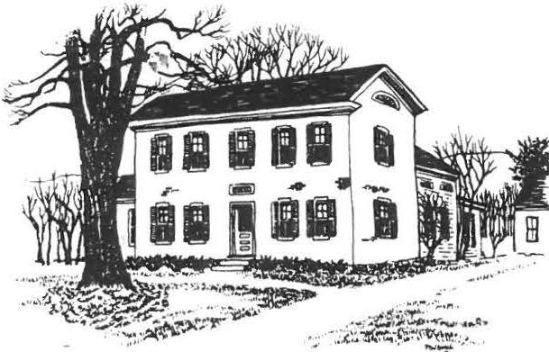
SHEFFIELD HISTORICAL SOCIETY
SHEFFIELD, MASSACHUSETTS
01257

VOLUME XVI, NO. 3

FALL AND EARLY WINTER ACTIVITIES

SEPTEMBER 8, 7:30, DEWEY IIALL
THE EXPERIENCE OF THE 250TH CELEBRATION OF TYRINGHAM WILL BE SHARED BY FOURTEEN OF OUR MEMBERS WHO PARTICIPATED IN THEIR RECENT PARADE . (DID YOU CATCH THE PICTURE OF ROGER DRURY IN HIS OUTFIT, WHICH ACCOMPANIED A FRONT PAGE ARTICLE IN THE SUNDAY SPRINGFIELD REPUBLICAN?) EIGHTY-SEVEN YEAR OLD ARNOLD HALE, WHO SERVED AS GRAND MARSHALL AND ALICE HALE, FORMER TOWN CLERK AND ACTIVE MEMBER OF THE
TYRINGHAM HISTORICAL SOCIETY WILL BE OUR SPECIAL GUESTS. THE HALES ARE A FOUNDING FAMILY OF TYRINGHAM. PICTURES OF THE PARADE AND A BRIEF HISTORY OF THE TOWN WILL BE PART OF THE PROGRAM.
OCTOBER 13, 7:30, DEWEY HALL
JUNE SPRIGG, AUTHOR AND CURATOR OF COLLECTIONS AT HANCOCK SHAKER VILLAGE WILL DISCUSS THE SHAKER COLLECTION AND SHOW SLIDES AS PART OF HER PRESENTATION.
OCTOBER 29, 12:00 AND 1 :30, AMERICAN LEGION
OUR ANNUAL TURKEY DINNER WILL BE HELD AT THE AMERICAN LEGION BUILDING ON ROUTE 7. SITTINGS WILL AGAIN BE AT NOON AND
1:30. THIS IS AN EXTREMELY POPULAR EVENT. BE READY TO BE CALLED ON TO HELP. MAKE YOUR RESERVATIONS BY CALLING 229- 2569. PROCEEDS FROM THIS EVENT FUND THE SOCIETY'S EDUCATIONAL ACTIVITIES FOR AREA YOUNG PEOPLE.
NOVEMBER 10, 7:30, DEWEY HALL
REGULAR MONTHLY MEETING. WHAT PROMISES TO BE AN UNUSUAL PRESENTATION IS STILL BEING PLANNED. WATCH FOR FURTHER DETAILS.
DECEMBER 8, 6:30, DEWEY HALL
OUR ANNUAL HOLIDAY AFFAIR WILL BE ORGANIZED BY VIRGINIA DRURY, WHO HAS AGREED TO REVIVE OUR HOLIDAY DI NER, SPECIAL MUSIC WILL BE PROVIDED. BRING YOUR OWN PLACE SETTING.

DECEMBER 10, 3:00 TO 6:00, O.R.H . ANNUAL HOLIDAY OPEN HOUSE.
JANUARY 12, 7:30, DEWEY HALL
MILTON BARNUM HAS ONCE AGAIN AGREED TO MC OUR POPULAR JANUARY REGULAR "SHOW AND TELL"--"WHAT'S IT" PROGRAM. START SEARCHING FOR A STUMPER.

COMMITTEE TO RECOMMEND BY-LAW REVISIONS

ROGER DRURY AND CATHERINE MILLER HAVE AGREED TO UNDERTAKE THE TASK OF COLLECTING AND WORKING WITH CHANGES IN THE SOCIETY BY-LAWS THAT ARE RECOMMENDED BY THE MEMBERSHIP. WHEN DID YOU LAST SEE THE BY-LAWS, AND WHAT'S IN THEM? WONDER NO LONGER. WE WANT EVERY MEMBER TO BE A PART OF THIS REVISION PROCESS, SO A COPY OF THE BY-LAWS IS INCLUDED FOR YOUR READING. AFTER CAREFU CONSIDERATION, MAKE YOUR IDEAS KNOWN TO THE COMMITTEE, OR TO A MEMBER OF THE EXECUTIVE COMMITTEE. ALL OF YOU SHOULD KNOW WHAT OUR BASIC GUIDELINES ARE AND BE A PART OF ANY CHANGES.

SHEFFIELD HISTORICAL SOCIETY
l . PU RPOSE. THE SHEFFIELD HISTORICAL SOCIETY, INC. IS A
NON-PROFIT ORGANIZATION, DESIGNED TO FOSTER INTEREST IN THE HISTORY OF THE TOWN OF SHEFFIELD, MASSACHUSETTS, ANO THE REGION OF WHICH IT IS A PART, AND IN RELATED EDUCATIONAL, CHARITABLE, AND ANTIQUARIAN PURPOSES APPROVED BY THE MEMBERS OR THEIR BOARD OF DIRECTORS.
- MEMBERSHIP IS OPEN TO ANY PERSON INTERESTED IN THE PURPOSES AND ACTIVITIES OF THE SOCIETY, UPON PAYMENT OF INDIVIDUAL OR JOINT DUES, THE AMOUNT OF WHICH WILL BE SET BY THE BOARD OF TRUSTEES (SEC. 4-E), A LIFE MEMBERSHIP DONATION, IN AN AMOUNT DETERMINED BY THE BOARD, WILL EXEMPT THE DONOR FROM PAYMENT OF ANNUAL DUES.

- MEETINGS OF THE SOCIETY WILL BE ON THE SECOND FRIDAY OF EACH MONTH, FROM SEPTEMBER THROUGH JUNE. ONLY MEMBERS IN GOOD STANDING WILL BE ELIGIBLE TO VOTE, ANO TWENTY-FIVE (25) SUCH MEMBERS WILL CONSTITUTE A QUORUM.
  - THE ANNUAL MEETING WILL BE THE JUNE MEETING. THE SOCIETY WILL RECEIVE ANNUAL REPORTS FROM OFFICERS AND COMMITTEES, ANO VOTE ON MATTERS OF GENERAL POLICY PREVIOUSLY PROPOSED BY THE BOARD OF TRUSTEES OR THE MEMBERSHIP. AFTER HEARING THE REPORT OF THE NOMINATING COMMITTEE (SEC. 7) AND ACCEPTING FURTHER NOMINATIONS FROM THE FLOOR, THE SOCIETY WILL ELECT OFFICERS, TO SERVE FOR THREE (3) YEARS, AS FOLLOWS: IN YEAR A, THE PRESIDENT AND TWO TRUSTEES; IN YEAR B, THE VICE-PRESIDENT, SECRETARY, AND ONE TRUSTEE; IN YEAR C, THE TREASURER AND TWO TRUSTEES. THE SOCIETY WILL ALSO ELECT OFFICERS TO FINISH OUT TERMS IN OFFICES VACATED DURING THE YEAR.

\
\ i. SPECIAL MEETINGS MAY BE CALLED BY THE BOARD OF TRUSTEES, EITHER AT THE PRESIDENT'S DIRECTION OR UPON PETITION TO THE BOARD BY TEN (10) MEMBERS, PROVIDED SEVEN (7) DAYS NOTICE IS GIVEN THE MEMBERS.

- ELECTED OFFICERS; THE PRESIDENT, VICE-PRESIDENT, SECRETARY, TREASURER, AND TRUSTEES SHALL BE ELECTED AS DESCRIBED IN
SECTION 3-A, AND MAY NOT SERVE TWO TERMS CONSECUTIVELY IN THE SAME OFFICE.
  - THE PRESIDENT SHALL PRESIDE AT ALL MEETINGS OF THE SOCIETY AND BOARD OF TRUSTEES; HAVE EXECUTIVE SUPERVISION OVER THE SOCIETY'S ACTIVITIES; APPOINT ANY COMMITTEE CHAIRMEN WHOSE APPOINTMENTS ARE NOT MADE UNDER THESE BY-LAWS, BY THE BOARD OF TRUSTEES; AND BE AN EX OFFICIO MEMBER OF ALL COMMITTEES.
8. THE VICE-PRESIDENT SHALL ASSUME THE DUTIES OF THE PRESIDENT IN THE EVENT OF THE LATTER'S ABSENCE, INCAPACITY, OR RESIGNATION; AND SHALL ACT AS CHAIRMAN OF ANY PROGRAM COMMITTEE AND APPOINT ITS MEMBERS.
- THE SECRETARY SHALL KEEP MINUTES OF MEETINGS OF THE SOCIETY AND THE BOARD OF TRUSTEES; MAINTAIN A CURRENT LIST OF MEMBERS; CONDUCT THE SOCIETY'S CORRESPONDENCE; AND
.PERFORM THE CORPORATE FUNCTION OF CLERK.
- THE TREASURER SHALL COLLECT ANNUAL DUES, DEPOSITING THESE AND ALL OTHER FUNDS DESIGNATED BY THE BOARD OF TRUSTEES AS OPERATING FUNDS, IN THE NAME OF THE SOCIETY, IN A
RELIABLE BANK; SEE THAT MEMBERS ARE NOTIFIED WHEN DUES ARE PAYABLE; PAY BILlS FOR CURRENT EXPENSES APPROVED BY THE PRESIDENT; AND PRESIDE AT MEETINGS OF THE FINANCE COMMITTEE.
- THE BOARD OF TRUSTEES SHALL CONSIST OF NINE (9) MEMBERS INCLUDING THE SOCIETY'S PRESIDENT, VICE-PRESIDENT, SECRETARY, ANO TREASURER. THE INVESTMENT MANAGER ANO CURATOR (SEC. 6-A AND 6-B) SHALL BE APPOINTED BY THE BOARD ANO SHALL MEET WITH IT WHEN REQUESTED, HAVING A VOICE BUT NO VOTE IN THE BOARD'S DECISIONS. THE BOARD SHALL MEET AT THE CALL OF THE PRESIDENT, AS OFTEN AS NEEDED TO CONDUCT ALL AFFAIRS OF THE SOCIETY WHICH DO NOT REQUIRE GENERAL MEMBERSHIP APPROVAL, OR WHICH CANNOT BE ACTED UPON AT A MEETING OF THE SOCIETY; FILL ANY VACANCIES IN OFFICE
UNTIL THE NE XT ANNUAL MEETING; APPOINT THE CHAIRMEN OF STANDING COMMITTEES, ANO HEAR AND ACT ON RECOMMENDATIONS OF THOSE COMMITTEES; ARRANGE FOR ANNUAL AUDITS OF THE SOCIETY'S BOOKS; AND SET A SCHEDULE OF MEMBERSHIP DUES ANO LIFE MEMBERSHIP. SPECIAL MEETINGS OF THE BOARD MAY BE CALLED AT THE REQUEST OF FOUR (4) TRUSTEES. A QUORUM SHALL BE FIVE (5) TRUSTEES.
- SUCCESSION TO THE PRESIDENCY. IN CASE OF THE CONTINUED ABSENCE OR INCAPACITY, OR THE RESIGNATION, OF BOTH THE PRESIDENT AND THE VICE-PRESIDENT, THE SECRETARY,. OR IN HIS ABSENCE, THE TREASURER, SHALL CALL A MEETING OF THE BOARD OF TRUSTEES TO ELECT AN ACTING PRESIDENT, TO SERVE UNTIL THE RETURN TO DUTY OF THE PRESIDENT OR VICE-PRESIDENT, OR UNTIL

THE NEXT ANNUAL MEETING. '' (
- APPOINTED OFFICERS. AN INVESTMENT MANAGER AND A CURATOR, WHO MAY NOT ALSO BE ELECTED OFFICERS, SHALL BE APPOINTED OR REAPPOINTED ANNUALLY BY THE BOARD OF TRUSTEES.
  - THE INVESTMENT MANAGER SHALL HAVE CARE OF THE SOCIETY'S

§A ifAb YN§§, iNVE§fiN§ T EM A§e§ §iN§ f§ §biei§§
APPROVED BY THE BOARD; MAINTAIN DETAILED ACCOUNTS OF PRINCIPAL AND INTEREST; AND RENDER A MONTHLY INCOME AND EXPENDITURE STATEMENT TO THE PRESIDENT AND AN ANNUAL REPORT TO THE SOCIETY. CHECKS IN THE AMOUNT OF $500 OR MORE, DRAWN ON ANY CAPITAL FUND ACCOUNT SHALL BE COUNTERSIGNED BY THE PRESIDENT OF VICE-PRESIDENT.
8. THE CURATOR SHALL HAVE CHARGE OF THE SAFEKEEPING, PRESERVATION, AND EXHIBIT OF ALL MOVABLE ANTIQUITIES OWNED BY, OR ON LOAN TO, THE SOCIETY; AND SHALL KEEP A RECORD OF ACQUISITIONS, OF OBJECTS LOANED TO OR BY THE SOCIETY, AND OF PROPERTY DONATED OR SOLD. THE CURATOR SHALL REPORT AT LEAST ANNUALLY TO THE MEMBERSHIP.
7. A NOMINATING COMMITTEE OF THREE SHALL BE APPOINTED BY THE PRESIDENT AT THE MAY MEETING, AND SHALL BE FURNISHED AT THAT TIME WITH A LIST OF OFFICES DUE TO BECOME VACANT IN JUNE ACCORDING TO THE ROTATION DESCRIBED IN SECTION 3-A (BEGINNING WITH"YEAR C" IN 1983), AND ANY OTHER OFFICES WHICH HAVE FALLEN VACANT DURING THE CURRENT YEAR. THE COMMITTEE SHALL
BRING A COMPLETE SLATE OF NOMINEES FOR THESE OFFICES TO THE ANNUAL MEETING IN JUNE.
- STANDING COMMITTEES.
  - FINANCE. THE TREASURER SHALL BE CHAIRMAN OF A FIVE-MEMBER FINANCE COMMITTEE, TO RECOMMEND FINANCIAL POLICY TO THE BOARD OF TRUSTEES. THE INVESTMENT MANAGER SHALL BE A MEMBER OF THIS COMMITTEE, AND THE REMAINING THREE MEMBERS
SHALL BE APPOINTED, ONE BY THE PRESIDENT AND TWO BY THE BOARD OF TRUSTEES.
  - A DAN RAYMOND HOUSE COMMITTEE OF SEVEN MEMBERS WILL ARRANGE FOR SPECIAL EXHIBITS AND FUNCTIONS AT
THE SOCIETY'S HEADQUARTERS; AND OVERSEE THE MAINTENANCE AND IMPROVEMENT OF THE GROUNDS, AND OF THE BUILDINGS EXCLUSIVE OF THEIR CONTENTS. THE COMMITTEE CHAIRMAN, APPOINTED OR REAPPOINTED ANNUALLY BY THE BOARD OF
TRUSTEES, WILL SELECT SIX ADDITIONAL MEMBERS, ONE OF WHOM SHALL BE THE CURATOR.
c. AN ACCESSIONS COMMITTEE OF FIVE MEMBERS SHALL ADMINISTER THE ACCESSIONS POLICY APPROVED BY THE SOCIETY. THE COMMITTEE SHALL INCLUDE THE CURATOR, THE PRESIDENT OF THE SOCIETY, THE CHAIRMAN OF THE DAN RAYMOND HOUSE COMMITTEE AND TWO MEMBERS AT LARGE
APPOINTED BY THE BOARD OF TRUSTEES AND SHALL ELECT ITS OWN CHAIRMAN.

'r
, l
9.' ROBERT'S RULES OF ORDER SHALL BE THE BASIS OF PROCEDURE AT ALL MEETINGS OF THE SOCIETY ANO ITS BOARD OF TRUSTEES.
- IF THE SOCIETY SHALL BE DISSOLVED BY ITS OWN ACTION OR ANY LEGAL PROCEDURE, ALL ASSETS THEN IN ITS POSSESSION, AFTER SATISFACTION OF ALL OBLIGATIONS, SHALL BE TRANSFERRED OR PAID OVER TO ONE OR MORE NON-PROFIT ORGANIZATIONS WHICH THEN APPEAR BEST ABLE TO CARRY FORWARD THE AIMS AND PROGRAMS OF THE SHEFFIELD HISTORICAL SOCIETY, AND WHICH QUALIFY UNDER SECTION 501(C)3 OF THE UNITED STATES INTERNAL REVENUE CODE OF 1954 AND AMENDMENTS THERETO. IF, AFTER REASONABLE DELIBERATION, THE SOCIETY IS UNABLE TO REACH MAJORITY AGREEMENT UPON SUCH BENEFICIARY OR BENEFICIARIES, THEN ALL SUCH ASSETS SHALL BE TRANSFERRED AND/OR PAID OVER TO THE
TOWN OF SHEFFIELD.
- AMENDMENTS TO THESE BY-LAWS WILL TAKE EFFECT IF APPROVED BY TWO THIRDS OF THOSE MEMBERS PRESENT AND VOTING AT A REGULAR MEETING OF THE SOCIETY. THE TEXT OF A PROPOSED AMENDMENT MUST BE MAILED TO ALL MEMBERS AT LEAST FOURTEEN (14) DAYS IN ADVANCE OF THE MEETING AT WHICH A VOTE THEREON WILL BE TAKEN.

OFFICERS AND COMMITTEE ASSIGNMENTS FOR 1989-90
PRESIDENT, JAMES MILLER VICE PRESIDENT, VACANT · SECRETARY, NANCY LECAKIS TREASURER, MORTON LEVIN
TRUSTEES, CHRISTOPHER COENEN, JOAN SAWYER, MARION WHITMAN, VIRGINIA DRURY, SANDIE Cuoco
FINANCE COMMITTEE, MORTON LEVIN (TREASURER) CHM., CARL SCHUMANN
(INVESTMENT MANAGER), ROGER DRURY, JOHN CARMICHAEL, NEAL HARDY
CURATOR, VIRGINIA MOSKOWITZ
DAN RAYMOND HOUSE, PENNY BROWNE, CHM. ACCESSIONS, CATHERINE MILLER, CHM. EDUCATION, MARION WHITMAN, CHM. REFRESHMENTS, MARION WILLCOX, CHM. PROGRAM, SALLEE HARDY, CHM.
TURKEY DINNER, MILTON BARNUM
LIAISON WITH BERKSHIRE SCHOOL, CHRISTOPHER COENEN NEWSLETTER, VACANT
BY-LAW REVISION, ROGER DRURY AND CATHERINE MILLER MEMBERSHIP, MARION WHITMAN
CHRISTMAS MEETING, VIRGINIA DRURY ANNUAL MEETING, DOROTHY MAROSY

THE VARIOUS CHAIRMEN WILL APPOINT MEMBERS OF JHEIR RESPECTIVE COMMITTEES. IF YOU ARE INTERESTED IN SERVING ON A SPEC IFIC COMMITTEE, CONTACT THE CHAIRMAN. THERE IS WORK FOR ALL PEOPLE, AT ALL LEVELS OF ACTIVITY.

1
ARZT AFGHAN ENHANCES EDUCATION FUND

AN AFGHAN, HAND MADE AND DONATED BY SOCIETY MEMBER GRACE ARZT, HAS NETTED $176.50 TO BE ADDED TO THE EDUCATION COMMITTEE FUND. CHANCES WERE SOLD AT THE SOCIETY'S ANTIQUES SHOW AND
o. .H.
gY IN THE EN H Y§E Ebg IN AU@U§i. o g w A E,
AND "THANK YOU" TO THE MEMBERS WHO GAVE THEIR TIME TOWARD THE SALE OF TICKETS.

VOLUNTEER(S) NEEDED
DURING THE NEXT FEW WEEKS, THE EXECUTIVE COMMITTEE WILL BE MAKING MAJOR DECISIONS FOR THE DIRECTION THE SOCIETY WILL TAKE NEXT YEAR. AMONG THOSE DECISIONS WILL BE "IF AND HOW" TO RUN THE ANTIQUES SHOW FOR 1990. A MAJOR PROBLEM WE FACE IS A FOOD CHAIRMAN FOR THE SHOW, A JOB SO ABLY HANDLED BY VIRGINIA DnURY THE PAST FIVE YEARS. SHE HAS RETIRED. ARE THERE ANY VOLUNTEERS OUT THERE?

ANNUAL DUES ARE DUE

PLEASE TAKE A MOMENT TO SEND IN YOUR DUES IF YOU HAVE NOT ALREADY DONE SO. MARION WHITMAN IS THE MEMBERSHIP CHAIRMAN. MAIL TO SHEFFIELD HISTORICAL SOCIETY, MARION HITMAN, Box 1733, SHEFFIELD, MA 01257
NAME

MAILING
ADDRESS

PHONE NUMBER

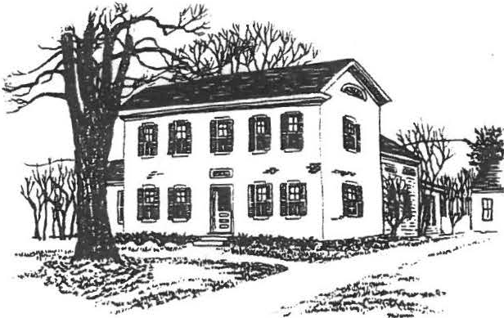
SHEFFIELD HISTORICAL SOCIETY
SHEFFIELD, MASSACHUSETTS
01257

FALL/WINTER ACTIVITIES
Vol. XVII, No. 2
September 1990

September 14, 7:30 p.m., Dewey Hall
Discovery Night with David LeBeau, professional antiques appraiser, owner of an antiques store in Sheffield, and assistant professor of fine arts at NYU. Bring in some­ thing you've always wondered about--a silver serving spoon, a porcelain vase, a photo of a piece of furniture, an old ring--for a free appraisal. You may discQver you have a treasure!
October 6 & 7, Dewey building, Main Street
Opening of the Family History Center. See page 3 for a description of this special program.
October 12, 7:30 p.m., Dewey Hall _
Boyd Hutchison, local cabinetmaker whose work has been featured at Hancock Shaker Village, will discuss Shaker Oval Boxes and demonstrate how they are made with examples of his own work.
October 28, 12 and 1:30 p.m., American Legion Hall
Annual Turkey Dinner. See the President's Column for details about this popular event.
November 9, 7:30 p.m., Dewey Hall
A special program by the Family History Committee.

December 14, 7:30 p.m., Dewey Hall Annual Holiday Party.
January 11, 7:30 p.m., Dewey Hall
Milton Barnum's annual What's It? program.

Other fall plans:
* * *

Plans are under way for a bus trip to historic houses in the Hudson Valley.
The Education Committee is arranging a cemetery walk for students in the regional school district. They are currently "digging up" a selection of interesting and unusual information about Sheffield's cemeteries. Anyone with suggestions is urged to call Martha Williamson at 229-8110.

-2-

THE PRESIDENT'S COLUMN
The latest figures on the Antiques Show, courtesy of treasurer Mort Levin, is a net profit of $8,045. We thank each and every one of you who worked so hard for the success of the show.
And while we're on the subject, I'd like to give special thanks to Catherine and James Miller, who have the operation at their fingertips--all the information about the dealers and the attendance. The third one in that trio is Chris Coenen. How fortunate we are to have Chris so calmly coordinating all the details between the Historical Society, the Sidelis, and Berkshire School. In addition, of course, the Society is very grateful to Berkshire School for the generous loan of their facilities.
The Open House on August 9-11 was not as successful as we would have liked, but it was certainly enjoyed by those who came by. Special thanks to Agnes Boardman, Lillian Preiss, Penny Browne, and Marion Barnum, who all worked so hard preparing the house and grounds.
How about Grace Arzt making that beautiful afghan by hand, with her own material, and then donating it to the Society! We received $75 in donations from it, and the lucky winner was Eleanor Ahlbaum of Buffalo, sister of our own Lucia Davidson.
Thank you very much, Grace!
Don't forget our Turkey Dinner on October 28. As you know, the proceeds go entirely toward scholarships. It will take many faithful members to bake 40 pies, roast and carve 13 turkeys, peel and cut 3 bushels each of squash and potatoes--after which we serve 160 people in 10 minutes! So when you are called, I hope you'll say , "Can't wait to help. What can I do?"
Thanks to a wonderful group,
Milton Barnum

* * * * *

Welcome to new members!
From Great Barrington: Jennifer Berryhill and Arnold & Jean Blackmur. Also Sheffield residents Donald & Amy Haworth, Bernhard & Shellie Schneider, and Mark & Claudia Ziobro.

Anyone else who's interested in joining the Historical Society is urged to send in the form at the end of this newsletter.

Missing: Our green 32-cup coffee maker and one insulated coffee pitcher. Any ideas?

-3-

OPENING OF THE FAMILY HISTORY CENTER

The formal opening of the Family History Center, in the 1816 Dewey building next door to the Dan Raymond House, will be marked by events and exhibits designed for all tastes and ages on Saturday, October 6, and Sunday afternoon, October 7. Circle these dates on your calendars and stay tuned for details.
The program will include: Dedication of the Center; a Historic House Walk led by Lillian Preiss; a special exhibit about the talented Smith Family of "Orchard Shade"; an opportunity to Stop Your Forebears From Fading by bringing in a valued family photograph or document for copying without charge; tips on How to Get Started on a Family Tree and fill in empty branches; a puzzle, Where in Ashley Falls Did William Jennys Spend the Night in 1795? and much more, including a sampling of reference materials that will be regularly available in the Center.
In addition, the Museums Committee will exhibit some items typical of those used or sold in the Hatter's Shop that occupied the building for 50 years.

This opening celebration has seemed to be a long time coming, but the committee has had its hands full of details to be considered and decisions to be made over the past 18 months. Not least of these concerns has been the renovation of the building-­ not as a restoration but as an adaptation to new uses.
The genesis of the Center came during a study of 10-year goals for the Society in 1988. To James Miller goes credit for setting that study in motion. Major credit also belongs to Lillian Preiss, town historian and unofficial family researcher for the Society, who knew the need and had long advocated an enlarged and organized family history effort; to genealogist Ursula Kilner, who dropped a hot spark into the tinder by suggesting use of the Dewey building for that purpose; to Virginia Moskowitz, Ruth Degenhardt, Guy McLain, and Helen McLallan, our guides through local history libraries in the region; to Penny Browne and Greg Farmer, consultants on the Hatter's Shop exhibit space; to John James, for architectural plans and advice; to Boyd Hutchison, designer/builder of the reading room table; and to many others.
The Committee members'have set policy, winnowed ideas and suggestions, and thereby earned credit for the overall results (still evolving) as well as blame for any blunders or oversights. The following have all shared enthusiastically in the work: Lillian Preiss, Bill Browne, Virginia Moskowitz, James Miller, Betty Chapin, Holly Coon, and Roger Drury. Chris Coenen, representing the SHS Executive Committee,- is our principal adviser on photo archives.

After the opening, we intend to have the Center open at least one evening and one afternoon each week, and at other times by request. Volunteers will be recruited to staff the Center for additional hours as demand requires.

-4-

A TREASURE OF TOWN HISTORY

The Society recently received from Alice Warren one of the early street lamps used in the town. This treasure from our past stood in front of "Orchard Shade" for many decades, surviving the assaults of weather and
the changes of fashion long after others of its type were replaced. It is un­ restored and in sotmd'"·con dition, except inside the conical shield which covers vents at the top, where fumes from the burning oil caused some severe rust.
Can one of our members tell us how those conical caps were attached over the vents? Better still, is there another unrestored old street lamp in existence which could serve as a guide for correct repair? Please call Roger Drury (229-2687) if you have information which might be of help .
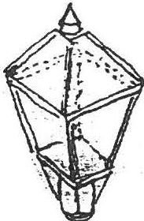

Have you looked at your SHS membership card lately? When did you last pay your annual dues?

To continue your membership for 1990-91, or to join for the first time, please fill out this coupon and send it with the proper amount to: •
Membership, Sheffield Historical Society
P.O. Box 1733, Sheffield, MA 01257

Name------ ----------
Address

Tel. Amount Renewal New member

I/we are especially interested in

I/we are willing to help out as volunteers for

Annual dues: Family $5, Individual $3

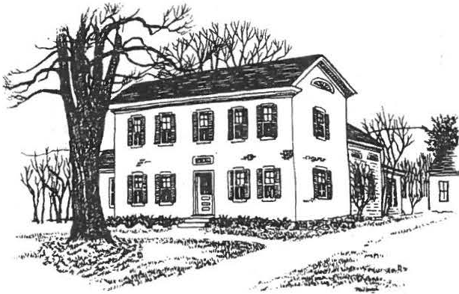
SHEFFIELD HISTORICAL SOCIETY
SHEFFIELD, MASSACHUSETTS
01257

WINTER ACTIVITIES
Vol. XVII, No. 4
November 1990

December 9, 3 to 6 p.m., Dan Raymond House Annual Holiday Open House -- see page 3.

December 14, 7:30 p.m., Dewey Hall Annual Holiday Party -- see below.

January 11, 7:30 p.m., Dewey Hall
"What's It" Night. Bring in historical artifacts you can't identify, to see if Milton Barnum and our other experts can. Or bring in something you can, but think they can't! Now's the time to find out about that odd bit of ironwork out in the barn, or that strange-looking old tool that's been rattling around in the kitchen. See how many of the other entries you can identify!
February 8, 7:30 p.m., Dewey Hall
A special program on notable Sheffield women, past and present. (If you have ideas/suggestions/inspirations on the subject, please call Sallee Hardy, program chairperson.)
March 8, 7:30 p.m., Dewey Hall
Grace Snyder, who with her husband operates Elliott & Grace Snyder Antiques in South Egremont, will present a program on textiles. She has a special interest in samplers, hooked rugs, needlepoint, and quilts.
ANNUAL HOLIDAY PARTY
Both tradition and novelty will make up the program of the December 14 meeting, starting at 7:30 p.m. in Dewey Memorial Hall.
A program of holiday music will be presented by the Friendly Chorus, directed by Betty Long and accompanied by Hilda Banks Shapiro. Both are well-known musicians in the Southern Berkshires.
A traditional component of the December meeting is Art Chase's not-to-be-missed rendition of "The Night Before Christmas." A semi-tradition (three years old) is a festive dessert buffet, for which Marion Whitman and Catherine Miller are in charge.
Come and enjoy!

2

THE PRESIDENT'S COLUMN

We are grateful to everyone who contributed in any way to our recent Turkey Dinner. Everyone worked together and had fun doing so. Mort tells us that we came close to $1,500--many thanks!

Don't forget our open house on Sunday, December 9 from 3 to
6 p.m., immediately before the town's tree-lighting ceremony. If you have never been to the Society's holiday open house, treat yourself and come by. The house committee does a great job: all the candles will be lit, the fireplaces glowing, the house fragrant with the gentle aromas of times gone by--and there are refreshments to top it off. Don't miss it!
Then on December 14 you can treat yourself again, to our annual holiday party. Marion Whitman and her committee have a great evening in store.
We'll be starting the New Year off with our regular show­ and-tell and "What's It" program. It's a fun evening, so look in your attic, cellar, barn, or top left drawer of the kitchen cupboard and see what you can come up with. Art Chase is getting rather proficient at this game, so let's see what we can bring in to stump him!

A Special Note: Too often we take for granted someone who has worked hard for a cause they believe in. I think that might be the case with Agnes Boardman. In her own quiet way she has always come through with tasks to aid the Society. Fifteen years ago she and the other volunteers scrubbed dishes to help us get an extra dime at the auctions. She has worked hard with the quilting group, takes care of calling people to bake pies, was secretary of the Society for several years--and has always done just about anything she thought would help. If you have not heard the tape Agnes made about her first teaching position--at the Brush Hill school--! urge you to ask her to play it for you. With Loring at her side at all times, giving her all the help he can,
they make a fine, loving couple. Thanks a lot, folks--we love you!

We wish each of you a happy holiday season, and a prosperous and healthy new year. Blessings to all--
Milton

WELCOME!
New Members:

Dr. and Mrs. Noel Cohen, and Gordon and Claire Height, from Sheffield. From Ashley Falls, Nancy and Bob Rathbun.
Ors. William and Eileen Evans, and Stanley and Diana Feld, from Lee.
And from Grosse Pointe Park, Michigan, Charles Ducharme, who writes that he is enjoying renewing his acquaintance with the Berkshires now that his son, Charlie, is a student at Berkshire School, his own alma mater.

3

WE MISS YOU, ED

Hardly a week goes by in Sheffield that someone doesn't ask, "Who was supposed to take care of that?" And the answer, "I don't know who was supposed to take care of that, but Ed Warren always did it."
It's high time to say how much we miss Ed Warren.
He was a charter member of the Historical Society and was active with the town Historical Commission, bringing his expertise as contractor, engineer, and carpenter to bear wherever it was needed.
He had enough faith in the fledgling Society to want to purchase the Dan Raymond House in hopes that the Society could eventually buy it. His labor and planning furthered the restoration.
He was the overseer of moving and restoring the Law Office, which his firm had donated to the Society. Many will remember Ed's clambering on the roof as the building settled on its new foundation. He worked on the carriage barn, the brick building, and the tool shed--busy shingling the roof as the first winter snowflakes fell.
And who can forget Ed's "dead men• and cables to straighten the Old Covered Bridge? His strategy didn't quite get the bend out, but it kept the bridge from sailing downstream like Noah's Ark.
Ed's contributions to Sheffield were too many to list here.
As superintendent of Center Cemetery he brought order out of chaos. An active member of the Friendly Union, Ed worked toward maintaining Dewey Hall and in preserving the goals of the society. He served the Grange, the Regional School Committee, and was a charter member of American Legion Post 340. And what a clock expert he was, as both collector and designer!
In his family and in his town, Ed was quick to see a need, generous with his skills and help, ready with a smile, quick of wit, and possessed of a great capacity for deep and abiding friendship.

OPEN HOUSE-•
--Art Chase

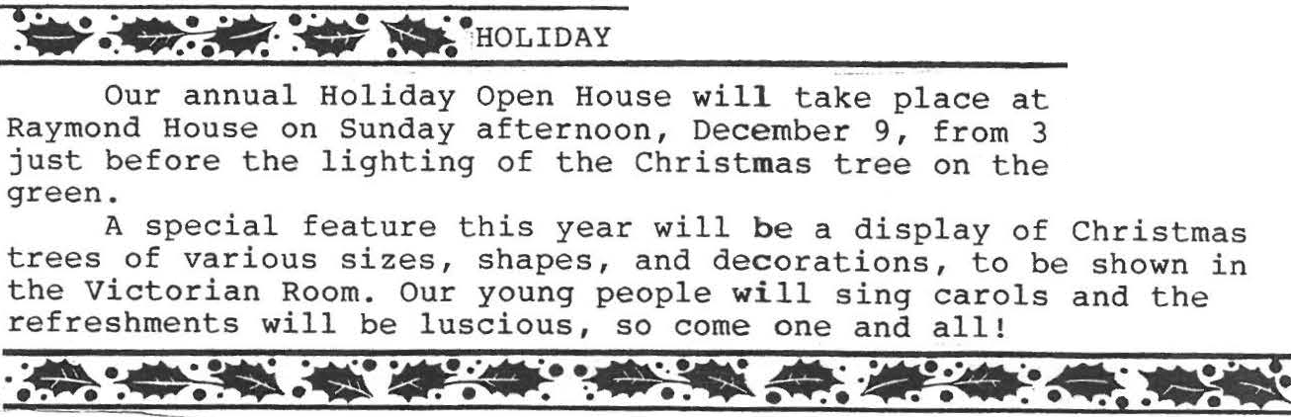
-AJiilll"• -.
the Dan to6p.m., village

Sorry you missed the .November program about two old Sheffield ' families, the Malnatis and the Bartholomews? Wish a friend could have been there? Come to the Family History Center, where we have a tape of the whole fascinating discussion.

4

UNK and Other Notes

(from the Family History Center)

Among your family photographs, are there a few you can't identify? Oh yes! The Family History Center can tell you who that stern old gentleman is, or who that lady is, leaning against the porch railing so fetchingly.
He is dear old UNK. She is UNK too, for sure!
Their pictures are in every family's archives. Their names were never penciled on the backs of the photos while anyone still knew them--so now you look at them in dismay and no one is left to tell you who they were. Are they kinfolk, or only friends of your great-grandparents, or who?
Too late. Their names are UNKnown.
Don't put it off! Some evening soon, get your family pictures together and write identifications on the backs of all the ones you know!

Open hours at the Family History Center have been re-set for the winter months: 1:30 to 4 p.m. ondays and Fridays--and other times by special arrangement.
The staff is presently engaged in sorting and cataloging a large collection of 18th- and 19th-century legal documents given to the Historical Society by Mr. Garrett H. Payne of Housatonic. The documents (some as early as 1740) include land deeds, indentures, court actions, etc., pertaining to several South Berkshire families from whom the donor traces descent.

ACQUISITIONS

The Sheffield Historical Society has received many acquisitions in the past few months:

A top hat and leather box, from Virginia Moskowitz.
Richard Combes's ink drawing of his mother, and a notebook of secret codes written by a child, both from David LeBeau.
A ledger book with many Sheffield names in it, from Helen McGoldrick. (Does anyone have her address? I need it.)
Two diaries that belonged to Lizzie Sage, dated 1879-1880 (more Sheffield names here), from Stanley Willcox.

The carriage barn's collection of old tools and other items is growing, too:
A broad ax and wood plane, from Lawrence Kervan.
A wooden bushel basket, old rake, corn knife, small ice tongs, 12-quart pail, and rug beater (remember the old beaters?)
--all from Marge Cahill.
Two saws and a horse blanket, from Mason Dutcher.

It's very gratifying to have these gifts, and we want to thank all of you.

--Marion M. Barnum, Curator

