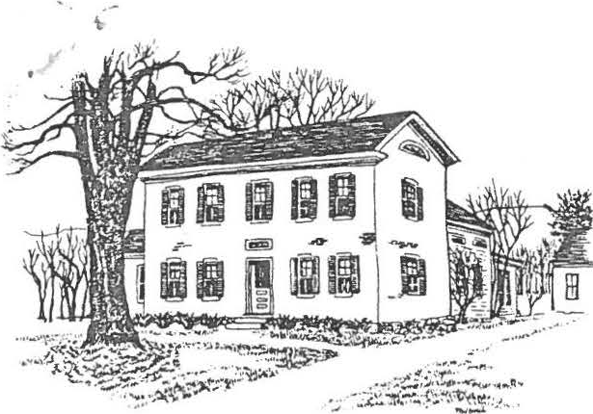
Dear Friends:

SHEFFIELD HISTORICAL SOCIETY
SHEFFIELD, MASSACHUSETTS
01257

Volume VIII, No. 3 Winter/Spring, 1981

This issue is between the usual dates for the newsletter, primarily be­ cause of the epistle that went out in the fall about the Society's program to renovate and furnish the Dan Raymond House. From that effort came many dona­ tions for which we are grateful. A chandelier for the keeping room and a pencil post bed in the northwest bedroom are among the new furnishings. Both bedrooms have newly plastered ceilings and paint, as does the upper hall.
Wooden storms for the entire house have been painted and installed and we are about to add insulation. We have, of course, very far to go and look forward to your continued support in the Dan Raymond House effort.
Meanwhile, the usual activities of the Society continue, and there are many dates which require your attention. Please note them at ttiis time by marking your calendar while the events are still fresh in your memory.
REGULAR MEETINGS (7:30, Dewey Hall unless otherwise no,ted)
January. Our January program tradition, Show and Tell, highlighted the first meeting of 1981. Milton Barnum returned to the spotlight as Master of Ceremonies for the event, delighting the audience with his knowledge of America past. Honors went to Carl Proper who was able to recognize the greatest number of myster.y items.
February 13. The Harpsichord: History, Construction, Styles, Sounds.
Cynthia Dixon of Sheffield, a member of the Society, will discuss this early instrument and its place in history. Early music, appro­
priate to America, will be presented in a brief concer.t Ms. Dixon,
whose husband Tom is Director of Development at the Berkshire School, has been a musician and teacher of harpsichord and piano for many years. She will bring her own instrument, a two manual Neupert, made in Germany fifteen years ago.
Refreshments: Milton Barnum, James Miller, Carl Proper
(The refreshments alone might make coming out to this meeting worthwhile.)
March 13: Antique Lighting Devices: Development of Fuels and Advances in Lighting. Martin Naumann, Professor of Environmental Science at Simon's Rock College, will discuss lighting in America from colonial times to the present, with particular emphasis on the changes in lamps and the influence of these changes on society. Long a collector of such early lighting devices, Dr. Naumann will illustrate his presenta­ tion with some of his collection.
Refreshments: Claire Barlow, Marion Barnum, Mandy Coenen

page 2
REGULAR MEETINGS -- (continued)
April 10. Porcelains and Their Restoration. James Sagris, one of fewer than a half dozen porcelain restorers in the country, will
discuss his craft. Mr. Sagris, recently commissioned by the govern­ ment of the United States to restore porcelains of the White House and the State Department, is known to many members of the Society.
Refreshments: Penny Browne, Eleanor Gaskill, Madge Valentine
May 8. Dolls: An Historical Perspective. Elizabeth G. Norwood of Worcester, Massachusetts, has a collection of about 400 dolls. Her interest in dolls stems from a small family collection which was presented to her daughter. Although in need of repair and clothes, th·e collection began to grow and to be shared with others in the
famil.y Mrs. Norwood, active for many years in various museums and
historical societies, is presently involved in the children's book department, 1821-1876, of the American Antiquarian Society, a nation­ al library of American history, located near Worcester.
Refreshments: Irene Armstrong,Virginia Siter, Frances Warren
June 12. Annual Meeting. Covered Dish/Pot Luck Supper. Penny Browne and her Connnittee. More information will follow, but you can expect a lot of the traditional excitement and culinary delight associated with this tradition.

DATES TO REMEMBER
May 30. 4th Annual Antiques Fair, 10 a.m. to 5 p.m.
July 12. Old Fashioned Picnic at Dan Raymond House, 4 p.m.
July 25. Annual Auction (To be held if there are enough quality items available)

DAN RAYMOND HOUSE COMMITTEE --
The Committee is planning a display of quilts during the month of April. All quilts in this group were completed by the quilting group which will also have a new pinwheel quilt on display with chances available.
The Committee is looking for collections of items that can be displayed in the Dan Raymond House. If you have something you wish to share, let the group know.

a

.,. - - ...

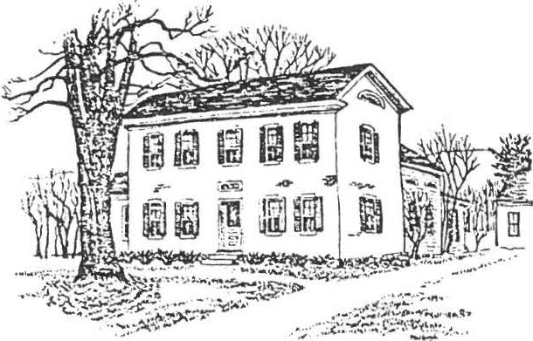

SHEFFIELD HISTORICAL SOCIETY
SHEFFIELD, MASSACHUSETTS
01257
Volume IX, No. 1 Summer, 1981-82

Dear Friends:
Summer for the Historical Society is usually a slow time but the amount of news to report and the level of activity merit a brief dispatch. A report on our regular meetings which begin on September 11, will be given in a later newsletter.
DATES OF IMPORTANCE
July 12 is the date of our annual summer picnic which this year will be a covered dish affair, previous announcements to the contrary not­ withstanding. So take note of that change and bring either a covered dish or a salad along with the usual place setting, chair, or blanket.
Beverage and dessert will be provided. Dan Raymond House lawn - 4:00 pm.
July 25. Tag Sale. Save your goodies to donate as this is in place of our annual auction. The site is Dewey Hall from 10:00 am to 3:00 pm. Bring donated items to De ey on Thursday, July 23 from 2:30 to 4:30 and 7:00 to 9:00 pm. This is one of our major fund raisers so mark your calendar now.
August 6, 7, and 8. Open House at the Dan Raymond House in conjunction with the annual antiques show which is put on by the Old Parish Church. While details are as yet incomplete, one of the historical displays will be a doll show.
A reminder that the Dan Raymond House is open each Friday afternoon from 2:00 to 4:00. Come on in and share some of our local history with your weekend guests and see with your own eyes the continuing progress in­ cluding the nine over six windows built by Ed Warren.
OF THINGS PAST --
The Society's annual Antiques Market, 1981, has come to a successful end. Chairman Carl Proper and his people report a tentative profit of $4,000 which will help in the Dan Raymond House restoration. Dealers numbered 137 and 940 paid their way in to enjoy the quality displays and beautiful weather. Carl deserves a special thank you from all of us for his con­ tinuing efforts on behalf of the Society. The tentative date for next year is May 29.
The June meeting was our annual meeting which brought us a new slate of officers for the coming year. Catherine Miller will continue with the second year of her two-year term as president, Milton Barnum and Lillian Preiss continue as trustees. New officers are as follows: Vice presi­ dent, Chris Coenen; Secretary, Agnes Boardman; Treasurer, Marion Barnum; and Trustee, Penny Browne.
At this writing, June 30, 1981, the old covered bridge was returned to its position spanning the HouLlatonicRiver, after extensive renovation by Milton Craton Associates. This Society and individual members played an important role in the success of this prbject.
a

ANNUAL MEETING -
Officers and Committees for 1981-82 -
President, Catherine B. Miller Vice-president, Christopher Coenen Secretary, Agnes Boardman Treasurer, Marion Barnum
Trustees -
Milton Barnum Penny Browne Lillian Preiss
.Curatorof Dan Raymond House - Lillian Preiss
Curator of Photography - Christopher Coenen
Dan Raymond House Committee - Marion Barnum
Irene Cranmer
Richard Combes, Consultant Ethel Mertching
Lillian Preiss Carl Proper Sally Proper
REPORT FROM THE EXECUTIVE COMMITTEE -
page 2

Dan Raymond House Grounds Committee - James Miller
Loring Boardman Arthur Chase Margaret Philbrick Caroline Treiber
Antiques Fair - Carl Proper Sally Proper
Newsletter - James Miller Grace Arzt
Treasurer, Development Fund - · Viola Bagnaschi
Turkey Dinner Committee Chairpersons - Milton Barnum
Penny Browne James Miller

Major emphasis has been directed toward the Dan Raymond Hous.eand its contents. Money was appropriated for the completion of the second bedroom in the apartment of the house with the work to be done by the tenant. A new heating system is to be installed this fall. Two furnaces will heat the apartment and the Society's headquarters separately. This big project is to be supervised by Milton Barnum and Carl Proper. The windows and trim are being painted Lynchburg Green and new windows installed. The bay window in the south parlor will be removed in Spring 1982 and the wall bricked in. Plans are in mo­ tion to begin the task of cataloging and filing several hundred glass plate negatives that Cris Coenen has put in order. The executive committee is looking for some individ­ uals with a willingness to assist.
OF THINGS PAST -
The Dan Raymond House Committee wishes to thank everyone for their cooperation during the wond€rful doll exhibit held August 6, 7, and 8. About 100 people stopped by to visit and admire the lovely dolls and also to observe the improvements that have taken place in the house since last summer. We had promises of some antique additions for the house as a result of the visits. The Quilters group has graciously consented to make the curtains for several of the rooms in the Dan Raymond House. This will be a fall project and will add greatly to the interior of the house.
A couple of local young ladies (ages 11 or 12) discovered the house for the first time and enjoyed it so much they went out and brought in some friends to see the lovely collections of dolls.
I am so pleased with the increased interest shown each year, that·it makes it so worth­ while being. open each Friday from 2 to 4 p.m. and also for special events. Please stop by and say hello.
----------Marion M. Barnum, Chairman
Under the energetic direction of Carl and Sally Proper the Society again enjoyed the rewards of a successful Antiques Fair during the Memorial Day weekend. The Propers

pres-e•n-ted the.
Society with a check for proceeds of $4,000 to be used on the Dan Ray

.. ' I
OF THINGS PAST (continued) -

page 3

Our Tag Sale, in· lieu of the annual auction, realized a net of $680. This money, too, is for the Dan Raymond House work. While the selling itself was fun, the ladies who worked so hard in preparation of the event certainly exceeded what the Society could reasonably expect from them.
The Quilting Group recently announced the winner of the most recent quilt made by the group. She was Miss Tamara Delmolino, daughter of Hr. and Mrs. Arthur Delmolino, Lime Kiln Road, Sheffield.
About 25 members and friends av iled themselves of the opportunity to attend the Annual Picnic. Ample food, good fun, - id a slide show on Sheffield prepared and narrated by Li lian Preiss made for a succe sful afternoo.n
REMINDER -
It's dues time again, still available at the popular prices of yesteryear. Single membership is $3.00 and family membership $5.00. If you are unable to attend a regular meeting, dues can be sent to Marion Barnum, Treasurer, Sheffield Historical Society, Sheffield, MA 01257.
The Sheffield Historical Commission will hold a dedication of the new Old Covered Bridge on Sunday, October 4 at 2:00. The public is invited to come early, enjoy a picnic and inspect the work of Milton S. Graton Associates. William Preston, vice­ chairman of the Commission, will be master of ceremonies. The Society as well as many of its individual members played a major role in this historic restoration.

Hear Ye! Hear Ye!
The big plump turkeys are on the loose. If you see anyone stalking the fields of harvest this fall, don't shoot. It'll be Penny, Jim, and Milt. They're headed for the game in preparation for our annual Turkey Dinner.
We hope the harvest will be in and the north fo.undations will be banked so that we can all take time out on October 25 to enjoy this fine dinner at the American Legion Home on Route 7. Dinners will be served this year at 12:00 p.m. and 1:30 p.m.
We have 13 turkeys being roasted, 40 pies being baked for this super af­ fair so don't eat for a week ahead of time. You'll make the cooks happy, and you will be able to get out those-clothes that you put away after
you went on that last diet.
Don't forget, October 25. Come and bring a friend.
---------- The Three Giblets
The 250th Anniversary of Sheffield Committee has held three Photo Discovery Days, during which Chris Coenen, our curator of photography, has copied old photographs of the town brought in by area residents. ·
The Committee is planning to publish a photographic record of Old Sheffield in 1983 to celebrate the 250th anniversary of the incorporation of the town. Anyone who has pictures he would like to share for this purpose may bri g them to any meeting of the historical society.
The Dan Raymond House Committee will again host a holiday open house in December. This is one of your best opportunities for a visit as the house will be decorated for the season.
Lillian Preiss is preparing a brochure on the Society and the Dan Raymond House for review by the Executive Committee and Trustees. The purpose is to answer questions about the Society and its programs for people who are interested in them.
The January Meeting will be the traditional Show and Tell,·sp keep your eyes ope for that "stumper".
a

SHEFFIELD HISTORICAL SOCIETY
SHEFFIELD, MASSACHUSETTS

01257
Volume IX, No. 3 Winter, 1982

Dear Members:

As the new year rolls around, we have the following programs and activities to announce as part of our continuing efforts to educat,e amuse and inform our member­ ship. Please mark your calendar for our regular meetings which are the second Friday of each month at Dewey Memorial Hall, 7:30 pm, unless otherwise noted. See you there!

January 8. This was our annual Shown' Tell and Whatsit. Forty items were brought in and a very large crowd showed up to try its luck at guessing ·the use of some unusual items. No one was able to guess Arthur Chase's "goose walker." See if you can find one to outdo that next year!
Excellent refreshments and table decorations were provided by Irene Armstrong, Alice Ann Chase and Carl and Sally Proper.

February 12. Twiggs Myers of BerkshireSchool will present a program on the Battlefields of the Civil War. Mr. Myers will show slides taken during his sabbati­ cal last spring, of the battlegrounds around Gettysburg, Pennsylvania. He will dis­ cuss the forts, generals and battles associated with Robert E. Lee and the Army of Virginia. ·
Valentine refreshments 9y Mssrs. William Browne, Michael Briggs, Christopher
Coenen and James Miller.
March 12. Police Chief James McGarry will talk about the history of the Sheffield police force as well as discuss home security.
Do not eat too much for dinner because a special treat is in store with the refreshments by Kenneth Allen, Edward Babb, Milton Barnum and Richard Combes.

April 4.The postal history cf Sheffield and Egremont will be the subject of a talk by Lee Drickamer and Leo L. Lincoln. Drickamer, a professor of biology at Williams College and Lincoln specialize in postal history.
Vi Howard, Margaret Philbrick and Rachel Willcox combine their talents for
the refreshments.

May 14. David Rutstein, Story of America Told in Song, an on America's history as seen through sheet music,movies, etc. ephemera collector and dealer with a shop in South Egremont.
audio-visual lecture Mr. Rutstein is an

Refrehsments compliments of gourmets Vera Conklin, Olive Trudy LeGeyt.
Gaylord and

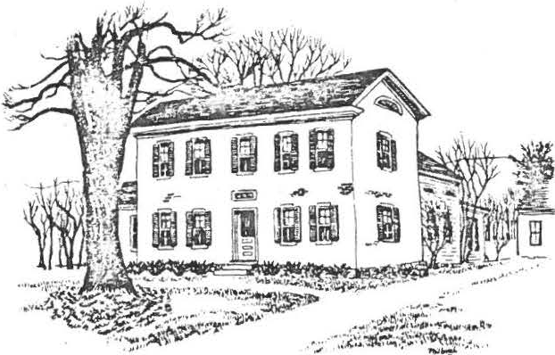
-
June 11. Annual Meeting. This will be a covered dish affair at 9;30pm.
Good old fashioned school days is the theme. The Society will provide dessert and beverage and as the time draws closer members will be contacted by telephone about what they should provide. Bring a place setting for yourself.

page 2
OF THINGS PAST

From the Turkey Quill: The Three Giblets report that at a roll call taken on October 26, eleven turkeys were reported missing. They were the reason for the success of the ar.nual Turkey Dinner. It was a fun affair and everyone had a good time meeting old acquaintances while enjoying a good dinner, We sincerely thank all the nice people who attended and we appreciate the turkey roasters, pie bakers and those who prepared vegetables, not to mention those who went the extra distance and worked on Sunday to put it all together, We realized a profit of
$907.76 to be used toward rennovation of the Dan Raymond House. We love you all! Many thanks. Penny, Jim and Milton
PS. At the dinner, someone took home a heavy duty alumin m cookie pan. We have in its place a regular weight aluminum cookie pan. Please look over your pans and see if you have one that doesn't belong to you. If so, kindly return it to Helen Rote or Milton Barnum. Thank you.

There are also two aluminum pie pans that are searching for an owner. Call Catherine Miller if these happen to be yours.

The annual Christmas Dinner was a sellout again this year with Virginia Drury and her committee serving a delicious roast beef dinner with all the trimmings for one hundred people. The theme, "A Child's Christmas" saw each table decorated
with old toys, candles and greens. On the stage wa an old fashioned Christmas tree trimmed with bright red bows and small wooden figures with child dolls arrang­
ed around a "mother" doll who was reading Christmas stories. As part of the program,
Arthur Chase recited Night Before Christmas and the whole group joined in singing Christmas carols with Madge Valentine on the piano. The committee in charge of this event should be complimented on a onderufl evening.

The Raymond House Committee would like to report a most successful Christmas Open House, The rooms were decorated in the Christmas spirit carrying out the theme of "A Child's Christmas". The weather was ideal and consequently
high attendance added greatly to the festivities. The quilting group met the dead­ line for finishing the draperies, and there were numerous compliments about the improvements to the house from the year before.
OF THINGS TO COME
In the weeks ahead, Milton Barnum has agreed to put on a display of old tools
ijt> -c the Dan Raymond House. Subsequent displays are in the formative stage, and we ask anyone with a special hand embroidered piece or other type of hand work to please contact Marion Barnum or Lillian Preiss.

On Sunday, February 14 the Society will host a breakfast cooked over the open fire at the Dan Raymond House. Reservations, which are required and very limited may be made by calling 229-2569 or 229-8388. Two settings, 9:00 and 11:00 am. Pleae bring your own table settings. $5.00 per person.

Carl Proper has announced that there are only four and one half months until our Outdoor Antiques Sale! Pray for good weather on that weekend as it promises to be the best sale ever.

m

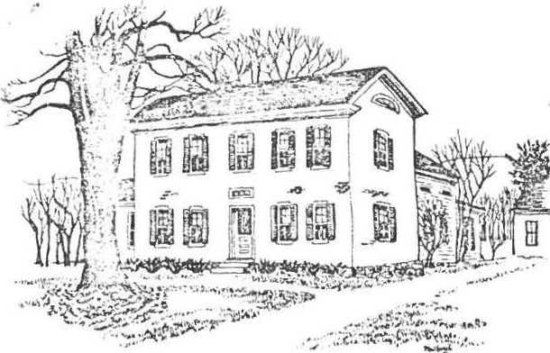
'( I

SHEFFIELD HISTORICAL SOCIETY
SHEFFIELD, MASSACHUSETTS
01257
Volume IX , No. 4 Spring, 1982

Dear Members:
The yearrolls right along and the May meeting is soon upon us. While the full schedule of events through June- w as available in the last Newsletter, here is a brief reminder of the events to come in the immediate future.

May 14.
David Rutstein, 11Story of America Told in Song," an
audio-visuallecture

on America's collector of
history as seen through sheet music, movies, etc. American ephemera.•••.
Mr. Rutstein is a

June 11. Annual Meeting. This will be a covered dish affair at 6:30 p.m. The meet­ ing and dinner will be a celebration of the tenth anniversary of the Society and there will be a special program to commemorate that event. The Society will provide dessert and beverage and members are currently being contactedabout what they should bring.
Bring a place setting for yourself. Reservations are necessary through Vera Conklin, Olive Gaylord or Trudy LeGeyt.
OF THINGS PAST -
On Sunday, February 14th, the Milton Barnums and Carl Propers entertainedtwenty­ five people at an Eighteenth Century style breakfastcooked in the fireplace at the Dan Raymond House.
Guests were served in two sessions with food prepared by Milton and Carl using griddles, pans and waffleirons from the 1700's -- it seemed to make the food more tasty. Jim Sagris made his modern kitchen available but it was used mostly for dish­ pan duty, the bulk of the food preparationtaking place in the Dan Raymond House fire­ place.
The first session was the most festive, as the early birds had the opportunity to sing "Happy Birthday" to Virginia Drury. The complete menu consisted of cider, scram­ bled eggs, bacon, pancakesand waffles with maple syrup, assorted homemade breads, cur­ ried fruit and tea or coffee.
The event netted the Dan Raymond House $105.05. The odd change was an Eighteenth Century tip by Bill Browne.
Maybe we can make this an annual event.
OF THINGS TO COME -
The biggest fund raiser of the year is just ahead! Be sure to set aside Saturday, May 29, for our annual Outdoor Antiques Fair. Volunteers are still needed to assist with this event. Call Carl Proper to sign up if you have not already been contacte.d
Milton Barnum has agreed to head once again the annual Tag Sale which this year will be Saturday, July 31. Set aside not only that day but any items you might have to con­ tribut.e
At the regular May meeting the membership will be polled to determine the level of interest in the July picnic which traditionally has been held on the grounds of the

....

OF THINGS TO COME (continued) -
page 2

Dan Raymond House. Participation the past few years has waned and the purpose of the question being raised at the May meeting is to determine the feasibility of continuing the July event either in its present or altered form. Plan to come to the May meeting with some fresh ideas. For example, the picnic could be held at a different location such as the covered bridge.
Christopher Coenen has had good fortune in his quest for old photographs of Sheffield but is still in need of pictures taken before 1900 or photos specifically related to events or groups in Sheffield after 1900. Prints of Sheffield or inter­ esting stories about the town or its residents are also welcome.
Material can be brought to the Dan Raymond House en Friday afternoons or to any of the Societ'ys meetings. It will be photographed and the original returned in perfect condition.
Time is running short. Let's give a helping hand to those working on the picture Anniversary Book of Sheffield's 250th.

FOR YOUR CONSIDERATION AND INFORMATION -
Those of you who attended the April meeting are aware that the subject of scholarships came up. The Charter of our Society calls for educational endeavors, and scholarships would be one way of partially fulfilling that responsibility.
Just what form the scholarship(s) would take is yet to be determined but will be the subject of preliminary s udy by a group appointed by the Executive Committee of the Society. Members Irene Cranmer, James Miller, Twiggs Myers, Lillian Preiss and Frances Warren will investigate ideas pursuant to this end and make a report and recommendation to the membership in the fall.
Possibilities in this area range from specific grants to individual students to funding educational trips for groups of students to Sturbridge Village, Deer­ field or the like.

Members have learned from attending the last few meetings that the Society is the beneficiary of a large segment of the estate of Sally Scanlon. Among items in the bequest are the Scanlon home and a major share of its contents, stocks and cash. The purpose of this gift is for the development Jf the Dan Raymond House.
The contents of the home will be first made available to the Dan Raymond House Committee and they will choose items suitable for a permanent place in our restoration project, with the balance of the contents disposed of for cash. After
careful consideration by the Executive Committee, it was decided to place the house on the market and it is believed that a suitable buyer has been found.
The final disposition and evaluation of the estate is still unsettle.d But
in the meantime, it is expected that the house will bring $96,000 and the balance of the estate $150,000 to $175,000.

a

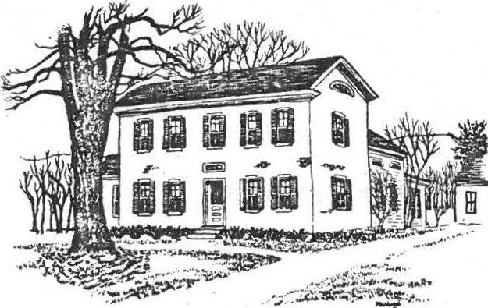
Dear Members:

SHEFFIELD HISTORICAL SOCIETY
SHEFFIELD, MASSACHUSETTS

01257
Volume X, No. 1
Fall, 1982

S.i..xteen people attended an oJt.ga.n.iza;U..onal. meeu.ng Tuuday even..<.ng a;t Vewe.y Hal.l ..ui She6n.leld and la.id the. 6ounda;U..on 6M. tite She66ie.ld H-i.hto!UC.ai. Soei.e;ty.
BeJrluh.vr.e CowueJL
Auguit 10, 1972

So much has happened in those ten years: programs, antiques fairs, auctions, tag sales, turkey dinners, fashion shows, quilters group, purchase and ongoing restoration of the DRH, and so many other projects which have brought pleasure and reward to the Society and the community it serves.

The purchase of the DRH property and the beginning of its restora­ tion and furnishing is perhaps the greatest achievement. Its very existence is a symbol of what the Society strives for•••preservation of our heritage for
the education of_ our youth, and service to the community. The continued
restoration and furnishing of the property is our show of faith in the coming generations and in our desire to make the area a better place to live.

As we begin our second decade there is much yet to be done. The spirit of cooperation and the commitment to ideas and proj cts that have charac­ terized the Society in the past are still the foundation upon which our future success will depend. This spirit and commitment have been the backbone of the Society and must continue to be so if we are to be the same viable organization Sheffield has known for these ten years. We now have the opportunity to hasten to our goals and to expand our commitment to the conmunity through the gener­ osity of Sally Scanlon.

But our enlarged resources alone will not enable us to realize the full potential of our purpose. It·will take the continued efforts of the member­ ship through new ideas, participation, fund raising and a continued spirit of cooperation to keep the candle aglow. I accepted your returning me to the presi­ dency of this organization last June on the condition that we would travel into the future with the same dispatch that permitted us to achieve the goals of our first decade. I accept that condition as a challenge and welcome the opportunity to work with all of you toward meeting it.

Catherine B. Miller

- 2 -

FALL PROGRAMS

All programs are scheduled for Dewey Hall, 7:30 p.m. unless otherwise specified.

September 10...Tony Malnati will speak on the history of Cooper Hill Farm. Refreshments•••Bessie Coons, Esther Kervan, D.S. Willcox, Marion Willcox.

October 8••••••Richard Babcock speaks on the Restoration of Old Barns. Refreshments•••William Browne, Penny
Browne, Carl Schumann, Alice Schumann, James R. ..iller
November 12••.•Program to be announced. Refreshments•••Irene Cranmer, Caroline Treiber, Ethel Mertching.
December 10•••.Christmas Dinner, 6:30 p.m. Reservations necessary.
There will be a small charge for this dinner.

January 14..•..The traditional ''Whatsit", so get your "Whatsit" wit whetted and start to select that item that will stump the experts.
OF THIMGS PAST

Annual Meeting, June 11. Our annual meeting this year was a covered dish supper which commemoratedthe tenth anniversary of the Society. Penny Browne· supplied appropriate and delightful decorations for the festive occasion which featured a program on Society activities narrated by Arthur Chase.

Officers for the coming year elected at the meeting were president, Catherine B. Miller; vice president, Chris Coenen; secretary, Agnes Boardman; treasurer, Marion Barnum; trustee, Lillian Preiss.

A motion from the floor proposed a professional survey of the DRll property as there seemed to be reason for concern over conflicting boundary claims by neighbors. The area has experiened more than one recent real estate transaction. As of this writing a survey has been completed by Robert Macy, RLS, and a copy of his work is on file at the DRH for those who may wish to review it. It has been registered with the Registry of Deeds in Great Barrington.

Executive Committee, June 24. At the first executive conmittee meeting subsequent to the annual meeting, the following appointments were made: Curator of the DRH, Lillian Preiss; Asst. Curator, Marlon Barnum; Chairman DRH Committee with responsi­ bilities for Friday afternoon open house, exhibits, Christmas open house, special functions, assistance in inventory of DRH, Penny Browne; Curator of Photography, Chris Coenen; Newsletter, James Miller and Grace Arzt; Newsreleases, Lillian
Preiss; Antiques Fair, Carl and Sally Proper; Turkey Dinner, Milton Barnum; Treasurer of Development Fund, Viola Bagnaschi; Historian, Dorothy Dinan; Christmas Dinner, Virginia Drury and crew; Scholarship Committee, James Miller (Chm.), Irene Cranmer,

- 3 -

C. Twiggs Myers, Lillian Preiss, Muriel Rokos, Frances Warren; By-Law Committee, Roger Drury (Chm.), Catherine B. Miller, Rachel Willcox, Harry Conklin; Membership, Irene Cranmer.

Annual Picnic. Our Annual Picnic was held July 25 at the restored upper bridge which project you will remember as the beneficiary of our first annual Turkey Dinner. It was a hot day but the inner sanctum of the ninety-one foot span was shaded and cool and held a banquet in home cooked delicacies includ-
ing genuine bean hole beans prepared by Milton Barnum. Each person brought his own lawn chair and they filled the length of the bridge, spreading out among the arrangements of field flowers, day lilies and common barn items that were
hung from the latticed walls of the bridge. An American flag.flewhigh over the two wagon wheels that flanked the entrance. A few brave souls jumped up and down on the resilient planking, some trod more cautiously, but all agreed the setting was unique, the food delicious and the company wonderfully compatible.
Tag Sale. We thank all who contributed articles for the sale, and all those faithful members who gave so much time working t. make the sale a success. We realized about $780 so· far, and have a tip on adding a little more to that amount. Such a profit makes wiping the brow a little bit easier, Again, many thanks.
The Committee
OF THINGS TO COME
Quilters. Now that summer is almost over, remember the squares to be finished so they will be ready for our October meeting on Wednesday the 13th.

October 24. Don't forget our annual Turkey Dinner. It's a beautiful time of the year to enjoy a turkey dinner, and then after getting helped back into your car, you can take a leisurely ride around our side roads to enjoy the foliage and again realize what a wise choice you made in settling here. (It's difficult to mention a Turkey Dinner without adding a little stuffing.) See you there!
The Giblets
The Docent Program. Are you interested in history? Do you enjoy meeting people? Are you flexible? Would you like to share what you have learned with others? If your answer is "Yes" to these questions, you have an opportunity to breathe life into the 18th century Dan Raymond House by volunteering to serve as a docent on an occasional Friday afternoon during the coming year.

Lillian Preiss, curator, Marion Barnum, assistant curator, and Penny Brown, chairman of the Dan Raymond House Committee, will conduct training sessions for anyone interested in serving in this capacity. The "coui;ses" will be held
on Fridays at 1 p.m. They are three-credit courses: One credit for satisfaction in serving the public; one credit for knowledge that you are helping your histori­ cal society to fulfill its purpose; one credit for enj,oyment gained from meeting people with similar interests.

- 4 -

If t ere is sufficient interest, we will try to arrange a trip to Old Sturbridge Village, Deerfield, or The Farmer's Museum in Cooperstown to see and hear experienced interpreters.
FOR YOUR CONSIDERATION ANV INFORMATION
DRH Restoration. Major restoration of the DRH is under way by the firm of Gilligan Brothers and also through the donated labor of Society members Carl Proper and Milton Barnum. The major portion of interior work should be com­ pleted in time for the Christmas Open House, followed by exterior work in the spring in time for the town's 250th Anniversary Celebration.

Gilligan Brothers has been engaged to strengthen the underpinnings of the original building, primarily the keeping room and the north and south parlors. The south parlor will undergo extensive additional renovation and alteration with a partition to be placed so that our present office will be separated from the south parlor and converted to a small bedroom or horning room with access from the keeping room. The tw parlors will then be dupli­ cates, as the Victorian bay window will be removed, bricked in and a window matching that in the north parlor installed. The painted floors will be reconditioned and the boards oiled. In addition to this restoration work, Gilligan's will modify and update the electrical and plumbing in the rear of the house in order that accommodation can be made for period furnishings and
the new Historical Society office. The entire building will be used for society storage, display and offices as the members voted at the June meeting to end .the rental arrangement on the rear apantment.

Carl and Milton are upgrading the heating system with the addition of two new boilers that have been purchased. They will be in place for the coming heating season. Thanks again to these two gentlemen who over the years have done so much for the Society.

From the DRH Committee. The membership of the Society is fortunate that through past efforts of enthusiastic members we have the DRH as our headquarters. We are also very fortunate to be the primary beneficiary of the Sally Scanlon estate which is to be used in various ways for the DRH project.

We are now in the midst of vital restorati.on Our traditional open house has been cancelled to accoDDOdate the construction. It is exciting to think we will soon be able to do aany of the things we have planned and want you to be a part of our future as we put together a docent program that you can read about in an accompanying article in this Newsletter. The DRH is facing a hopeful future. Please come and join us.

The fine arts appraisal of the·DRH contents has been completed by William Bradford who was kind enough to offer his professional services without a·fee. We now have the contents .insuredin keeping with the custom of histori-

..

.t

- 5 -

cal societies such as ours. Once again we owe a thank you to Bill. Partly as a result of his efforts the growing collection of the Society has been safeguarded against loss.

Membership. Annual dues are payable once again to Marion Barnum, Sheffield, MA 01257, or may be paid at one of the monthly meetings. As in the past they are three dollars ($ 3.00) single membership or five dollars ($5.00) for the family. Life memberships are fifty dollars ($50:00) PER PERSON. In addition, this fall, a cooperative membership is available with the Berkshire County
Historical Society for those who wish to join that Society as well. It will be available for an additional three dollars fifty cents ($3.50) per year which
if four dollars ($4.00) below the regular individual membership for that organi­ zation. Those who take part in the expanded membership will receive every bene­ fit of membership including free admission to Arrowhead, ten issues of the BCHS newsletter, the journal "Berkshire History", and admission to special programs at reduced rates.
mr

..

J. • : \,
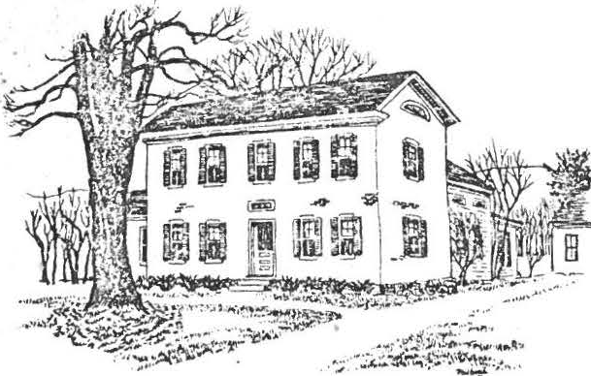
,

Dear Members:

SHEFFIELD HISTORICAL SOCIETY
SHEFFIELD, MASSACHUSETTS
01257

Volume X, No. 2 Winter, 1983.

.REGULAR MEETINGS, 7:30, Dewey Hall unless otherwise noted.

January 14. Annual What'sit and Show 'n' Tell with Milton Barnum as host. Some thirty-six items arrived on the scene for members
to examine and determine origin. The great turnout for this meeting included many new faces and attested to the increasing popularity of what has become a January staple for the Society. Another delight of the January meeting was the opportunity the Society had to honor Viola Bagnaschi who has served the past eight years as treasurer of the Development Fund. Her years of devoted service and attention to the many details necessary to such an important job have not gone unnoticed or unappreciated by us. She was awarded a certificate of appreciation by President Miller at the end of her term of office.
Thank you, Viola! ,.
February 11. Ernest "Bev" Bevilacqua of Wilton, CT, an industrial designer by trade, will present a program on spinning and weaving. There are 75 pieces of equipment associated with that craft and Mr. Bevilacqua who serves as a consultant to museums, historical
societies and private individuals will share particu1ars of the spin­ ning and weaving trade. Members are invited to bring items of their own for Mr. Bevilacqua to analyze.
March 11. James Parrish of the Berkshire County Regional Planning Co!TITlission will present a program entitled "Berkshire County Archeology and Public Planning". The slide program will survey American archeology and review the interface of local archeology and archeological site protection with public law. in Massachusetts.
April 8. We have planned a local specialist speaking on an interesting subject of local interest. Interested? Bring a friend.
May 13. Robert Kerker, Director of Executive Development of the New York State Division of the Budget and The Reverend Richard Thomas, a Methodist ministerwill share with the members a program on the Housatonic Line cf the New York-New Haven-Hartford Railroad. Slides and dialogue between these individuals will illustrate scenes from Danbury to Pittsfield.

June 10. Annual Meeting at Dewey Hall at 6:30 p.m. Supper with Society providing dessert and beverage. casserole or salad and your own place setting.
Covered Dish Bring a

; .
?•.

OF THINGS PAST

Christmas Activities, 1982
Since the DRH is in the midst of restoration it was not certain if we should (or could) hold our annual Christmas Open House. But the Committee decided it would not be right to skip this popular annual event, and so the demanding preparations began with a thorough cleaning required by 200 years of dust and debris raised by masons, electricians, and carpenters. Furniture was temporarily taken out of storage, new acquisitions pressed into temporary service, lots of evergree-nsplaced everywhere and the tree decorated with
old fashioned ornaments. Candles, of course, abounded and the traditional pineapple and apple centerpiece covered the trestle table along with goodies supplied by members. A crackling fire and hostess period costumes added to the holiday mood.
Pleasant comments were overheard about the 11feel11 of our keeping room.
Thanks to all who made our Christmas 1982 Open House a success.
Members and their guests al o enjoyed a repeat of our annual Christmas dinner, again under the management of the very capable Virginia Drury and committee. As usual, the event was a sellout with the ever popular roast beef menu serving as the main attraction. Guests, however, upon arrival expressed astonishment at the decorations put together by Penny Browne, who, along with Virginia, contributed to making this feast one of the great traditions of the Society for the year.
Following the dinner, the Society viewed the premier presentation of the plate designed by Margaret Phelbrick to commemorate the 250th anniversary of Sheffield. The plate, sponsored by the Society, is available in limited edition. Contact President Miller if you are interested in acquiring one.
Covered Bridge Restoration

The restoration project sponsored by the Sheffield Historical Commission
of the Upper Covered Bridge was the subject of an article in the December issue of "Americana" magazine. Society members active in 1979 will remember the turkey dinner we sponsored in order to assist the Commission in its restoration
efforts. The bridge is one of only two historic covered bridges along the entire length of the Housatonic River, and the Commission \•Jas fortunate to have Mi lton Graton who had restored over twenty covered bridges to supervise the work.
When Graton first inspected the bridge in April, 1979, it was bowed in the center and listed to one side. In the 19201 s new timbers had been incorrectly grafted to its trusses, un­ balancing the bridge. As a result, joints••• had come loose,
allowing water to seep in and rot the wood.•.. When Graton began work at Sheffield in January, 1980, western Massachusetts was locked in the grip of one of the severest winters in a decade.
On some days the temperature barely rose above zero, and the
cold incapacitated many of the hydraulic jacks, which were inserted beneath the bridge to relieve tension on the trusses. The cold was a boon in one respect, though: It froze the Housatonic to a depth of two and a half feet, giving Graton just the platform he
required for the cribwork... which would support the bridge as it was moved off the river for restoration.
Work on the bridge and abutments began in the spring and ran through October, when the bridge was rolled back across the Housatonic.

3.

OF THINGS PRESENT
ORH Restoration
The restoration work at the DRH is fully under way.
On the main floor the corner fireplaces that once heated the original eighteenth century farm house are being rebuil t in the north and south parlors. Research was done and the masonry and panel work will be appropriate to the period. Remnants of the original fireplaces were exposed during preparation work. When the walls were opened, Flemish bricks from the
initial construction were exposed. Hand made and hand fired, these bricks are a lovely example of colonial craftsmanship. Foot prints of a dog, a cat and a goat or lamb which lived in the eighteenth century were found
and will be part of a future exhibit. As the restoration program proceeds, small areas of eighteenth century construction wi ll be left exposed so people will be able to view the old methods.
Also on the main floor, the south parlor has been divided by a wall
built on the site of the original outside wall, with the small room partitioned off being accessible from the keeping oom. It will be a barning room.
Less noticeable to the visitor but no less impressive in its transformation is the DRH cellar. It sports the new heating system, seemingly miles of
new electrical wiring, new supports for the emerging treasures above, cleaned walls, and painted oil tanks. Perh ps we should have a meeting in the cellar.

Scholarship Fund Established
A scholarship fund has been established by the Society for the benefit of a range of students and activities.
Proceeds of the fund, which are to be raised by our group through the annual turkey dinner held in October, will finan ce.a local history field trip, provide an annual scholarship of $500 to a Mount Everett graduate and support other activities related to history as funds may be available.
An important feature of this effort is that it will help to perpetuate our annual October fund raising dinner which was first instituted to raise money for the restoration of the Upper Covered Bridge.
The scholarship, recommended by an ad hoc committee of the Society, will be administered by a permanent committee which, for the coming year, will consist of Muriel Rokos, Irene Cranmer and James Miller. This group will establish criteria for the implimentation of the program within guidlines established by the membership.

Development Fund Treasurer Appointed
William A. Browne, was appointed treasurer of the Development Fund following the resignation of Viola Bagnaschi•.
The appointment was made by a vote of the executive committee, effective December 1, 1982. Bill will be responsible for a range of functions connected with the investment of Society money. He will report to the executive committee and will work with it to see that the capital funds are properly managed to achieve long term growth.

J r

4.

Quilting Comm·ittee'sContinuing Efforts
.

The members of the Quilting.Committee are busy making draperies for the DRH. Their plan is to provide suitable period furnishings for all the windows.
The Committee was formed in 1974 and presently has thirteen members.
Since that time it has made thirteen quilts, and tied six for money making projects. Aprroximately $250.000 has been turned over to the Historical Society as a result of the group's efforts. Still another quilt is being made this winter to be raffled in the summe.r
A special surprise of 1983 will be an embroidery,drawn by Margaret Philbrick, of the Sheffield town seal that is being worked by the members. It, too, is to be art of the summer activies of the busy group.

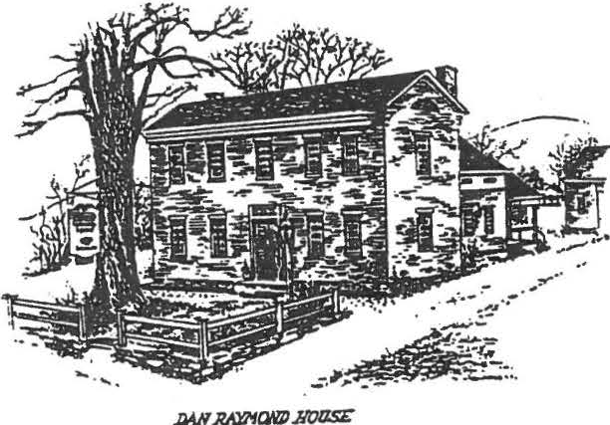
Sheffield Historical Society
Sheffield, MA 01257

VOLUME XX No. 2
November 1993

A MESSAGE FROM THE PRESIDENT WHAT'S GOING ON HERE?
The Historical Society has certainly started off the Fall season with a bang! The September and October meetings brought record-breaking numbers to Dewey Hall for two excellent programs - one on Native-American culture and music, the other on witch hunts. The Program Committee continues to bring us more fascinating subject matter this month, when Ed Kirby will discuss the geology of the
Upper Housatonic Valley. Come early so you can claim a good seat to view his slides. At the last meeting latecomers had to sit in the entryway!

We're all celebrating another successful turkey dinner. Once again, you have demonstrated that our Historical Society has enormous enthusiasm and energy. Catherine Miller did't have to seek out volunteers - they called her and offered to wait on tables, serve beverages, dole out pies, scrape plates, wash and dry dishes and silverware. The kitchen was full of eager squash and potato cookers/mashers, and beautifully baked
pies and roasted turkeys were delivered from home kitchens. Some members who had worked at previous turkey dinners were seen looking a bit wistful as they took a well-deserved rest and simply took a seat at a table! Does Milt Barnum have us brain-washed? Has he been sending out subliminal messages all year? Or is it just that this annual event really is a lot of fun?

Our thanks to all who participated - those who came and enjoyed the delicious food and those who helped to provide it. The Society is richer for it - both monetarily and in the pleasure of joining in a worthwhile communal effort.

Kathie Ness

ACCESSIONS REPORT:
The Society thanks Gery Torborg for his generous gift of three early school desks. They reside at present in "THE OLD SCHOOL ROOM" which is located in the brick building in back of the Dan Raymond House. We appreciate these additions to our furniture collection.

A FOND FAREWELL:

We wish Godspeed and Good Luck to long.:ti me member Margaret Philbrick Marganet will be greatly missed as she leaves Sheffield to her new home in the Eastern part of the state.

Among the many contributions to our Society, we remember these special gifts:
Her drawings for the quilt made by SHS Quilters Her design for the town seal done in crewel by the
SHS Quilters
Design work for early letterheads and notes
Donated framed silk screen of Sheffield Declaration resolution Demonstrated silk screen printing at Society meeting · Drew chapter-head illustrations for She field history
Made design for Covered Bridge plate
Donated books to Sally Scanlon library at DRH
We will miss you, Margaret! We hope you will visit us often.

FAMILY HISTORY CENTER:
Betty Chapin reports the Family History Center is preparing for the Spring 1994 exhibit SHEFFIELD MEN IN THE CIVIL WAR. his should be a fascinating subject.
The FHe would appreciate loans of any memorabilia you may have that would be appropriate for the display.
It has been a busy year with requests from California for the Westover family; Utah inquiries for the Noble and Saxon
families; North Carolina requests for the Huggins family; Florida for the Chapin family; Alaska for the Burrell and Noble family trees; Canada for the Dewey clan, etc., etc.
THANK YOU TO JOHN SISSON of Mill River for the gift of his inventory of the New Marlborough cemeteries. The FHC now has records of most of the South County cemeteries.

HEAR! HEAR!
The Sheffield Friendly Union and the Sheffield Historical Society jointly purchased a new lapel microphone. The unanimmous verdict is that it is a great improvement over the old hand-held one - both for the speaker, who can now move around easily, and for
the audience, who can now hear everything!

MARK YOUR CALENDAR:..•.......•.............•.•.••••.••
NOVEMBER 12th 7:30 PM
DENS AND QUARRIES OF THE BERKSHIRES
A program by Ed Kirby will talk about the historical significance of the iron ore industry, active and in­ active marble quarries and other geological points of interest in the area. Mr. Kirby is a geologist in the process of writing a book that will be a roadside guide for Northwest Connecticut and Southwest Massachusetts. Folowing his slide presentation and talk there will be a question and answer period.

DECEMBER 10th 6:30 PM

A FESTIVE HOLIDAY BUFFET will be
provided at our December meeting.

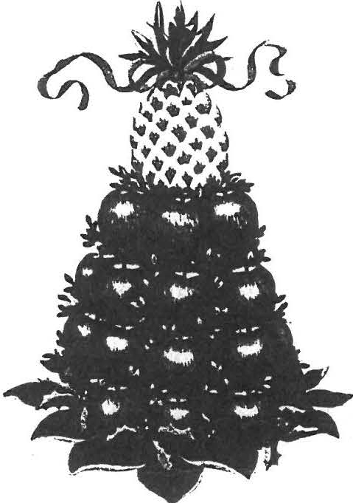
Program Chairman Virginia Drury and her committee wilt furnish all the food for this gala night.
Marjorie Crawford will provide holiday music and the Dan Raymond House Committee will present the "STORY OF THE DAN RAYMOND HOUSE".

Reservations should be made by Dec. 3rd to Grace Arzt (229-2110) or Virginia Drury (229-2687). Please bring your own table place setting. We all know the dishwashing facilities are limited at Dewey Hall.

************

Donations will be accepted to help defray expenses. No set amount or ticket charge this year.

·r
---.
.'.

JANUARY 14th 7:30 PM

The world reknowned program "WHAT'S IT?" will once again be presented. Scour your basements, barns, attics, your auction mistakes and bring them in for identification. A favorite night for many members••...don't miss this one.

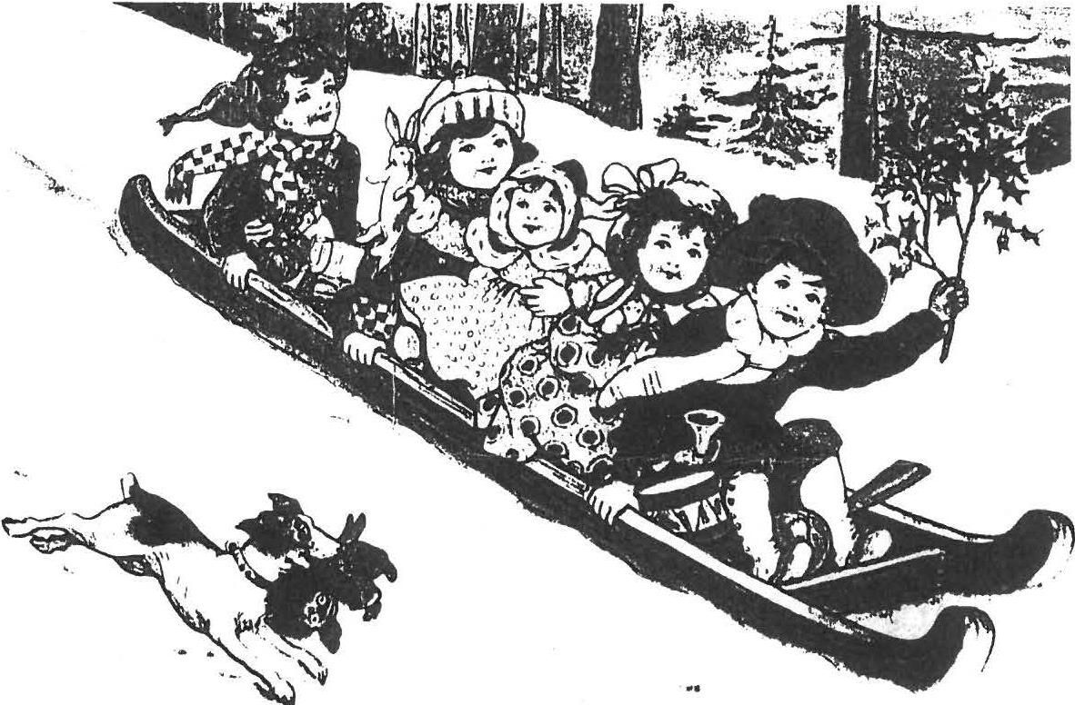

"A CHILD'S WORLD AT CHRISTMAS"

The Sheffield Historical Scoiety's HOLIDAY OPEN HOUSE will be held Sunday, December 5th from 3 to 6 PM at the Dan Raymond House.
The theme this year is "A CHILD'S WORLD AT CHRISTMAS".

As usual, the house will be decorated and candle-lit, the three fireplaces burning brightly and refreshments will be served in the keeping room.
Come and enjoy a warm, cozy interim with us. All are welcome and admission is free.
* HOLD THE PRESSE*S!
Milt has just announced
the net profit for the Turkey Dinner is $1501.00! He thanks all of you and We all say "THANKS, MILT!"

''U3 r-e v y pl s d t;t.• c rHtc-i:cJi;;:e t 1:• n'Cll.;,; , i oo r:,:;; your ci::,,.ew:ib:y f c,1
u. mtl:hbg B (:;J?.1: Lul grl!llt of $1,700 wdae·l' .- Cow. t t-J Gt·, t.a t' «. iJr ,fg,i:.', "
S..:· bllginsl /l.(Jr.J.1 18 1.ett:iar ft"Ulfl Wr,mt'd N,:;Colgr.: ., h ,-,•.mt:.Lve Ditr c:: t o;.• "f th
r .B!8 hu1t1,r;tts Bkent<. 1&:t C z s1 ® ., '"\:eit: _{1?f'e} l. fiitt::l".r1 MB.1,,.,i.t>ilun t-e,1
.:: it1!l$ r:.ccivina f-l'!!al Co.mdt>dan LJfip r c-vdl .
"foui:- pi.x .a l for th l'&Tk.e t' t. '3!tl1 Lmi! Of f-! .,s i'il .a we:11 -"-Cl) it-. i v.>.d .w.J
'IJ;/il <•-t, 'l ..-d pruJ< .:tp , N<,n lve of ,i::t> .-:.m.!.i;y u.it sr.t :ill tir,cl ec !te.Mt a7>.)Ut_ ( '1.,
31 sntsna l:.1. It slso ld eO'i'ltd .t:-<· J?.:e i? g1:-o!'d dc .; l tc.-rc,:i'.'d 1 ...r.i:til.m t luq:lit",, ", -.-.m t
e! Uf w yGU'l' ccaettmlt:-7."
'Ii.my itldi'iri.duah snd 0 131- Jt1l. u d nn ..i h.10 s r,>:irt h a:.-.:t1:?'ing tM.s muitr d ,
:.md titi!< ar" "'10i8t! g rs .: l!fu l to all vt,i, b .Y.pe;d, 11i1 h;;:_:.: g t the f' l'.<' ,i j -C'.'it 1.it1ci,e1· ·,;.;q
h f1.'?'$ l ; t hGilll11 ¥him tht.i lD\:11.'ie b g,.n> t h ,';J£>t:P. th..e m·ur t 1h·. le 1cruld ;, "' t d c:ti. >lt:7 adertaking<""'li'XCitii?g &:!d !-u::i M v-JSU .u. tuitl<a . ,!3teh fo "f.' ttt:t{v f
th !t m:id b rendy to off r wh t oe£3t:.n >-ots =am,

&! b11,au ti fa l ., h l us t ar y Satu:.dci!y .<.>1ttQ1>z10t.1n :r,t,idy itt h;zy. dgM: h:itdr, 'hi.9t o-cy bufft1 trt'W'tied ovsr t ett &lll1 p partly f'r stily plCJGed p.;.'i't l y cove:r.oo ,;n b btu h m-d brar.'blC? a to e:plcrei sc:ta cf Sh...iH..i1d ⁹9 littl,a0 'h\ o-, :,_ c.w tnd :t , U!.C J
21:H cm B.lt".?Atw tll guide. we 'ri ite-d the fvUcrm g e t:erleii _{i} <:atu.dee nl, Cbu t- h:l.H ,

ll d Meth">di!l•t
A: hley Falb 9 C ter, lluggi-u:11, Ch1r k .

Bi,ping t.c.-i i:iDd afJIU8 t r:. of Rthi!ir.:. Allr.mi 11 s:n.,.,.ycr ras id _{aic:'8} w. She-ff..ti!lc
(1167°1777) i) W•S 6i'.!ln:Jhed r.be t: ;,itcaa b t'ir,,tlmlB» i.tiR8t,l ·ai. gihle lGO!titl3
f-Dr oo tha!: Cllijlht r a -N "JOlliJ'fb All . •• Btlla acn .Jo::,q h dfod of i!Z'.ill x in
Sb ffiGld &i: the ase of el ev-m 9 but ao far hb buri.s1 pla;::<. l.l.i111 •bd ullee,uholst'!I .
MUto;m hs.si Gl'XPl'lll!S!la:d , ll lr. 5i10 r1e t.., 11! Motbca?' 8'M?b Gditfotl !f o '-...ir.;; l'G i=UJI'""
<t'Jt . Tha:e10 IBT4'i fourteem pubU,c -:.ee:teteri.i>;; ill. Sh.:. fisl::I mid ::t k1l t c:-..o ;,1-iNt-,, c,.,·;-:,,.

tel Mott h& d®'lted to tb r.oeiety !!ote tn'i t t t!ll in 1864 'hy i>t. Orv i l l H
'Oe--,- tc 4 lady he C..!clh 9 "My r h" e y S:trithon He, ¢1 l M th lec"t ,t'• lat'j' i1o j v,,;.
f.'P'!Dlng b.ar Wint.if' Tem pro .. i.yssditil very vd lo"
!'wry Dsny U3l8 m1 04rly H' s U.bb r, lt was an 1mu lly l;11rgt') , d
tuttu-med out nt t-Olffl !Mleting i!1 Sheff.ield !880. HOIWG \1.-:-te allt'fMd tiG tr. fM
tbef:lt-tstilM111 w , t bough the drill.!&-i': isxtew!IMI cnl7 hr et-r;-ee,.:10£:>.g a -eiwi..?<G
J!or rl•ebco l CDlll'l»itt . Whioo th Vll)lti,-ng _{l'} llcd that t,11in t , th e a:oof.:r-'!toI: o imc ;;.d
teh,it th,e: sl d, 1 ,an \ie'i'fi rti!dy to u-t r th-e l>...tli for the pu,:pcdG oi' vot tng. Th t.S.m.1
dibd down9 mad the inl vot6rl'I t.;ick 21eat-i cm th bmchet. to oot.:h the U1l??ee cmtli.'(! eYfflto I.eci by &ey 'Deny, the UGl!l<'!ln ent.eMti t ht, hlilU ' IL'tkOrted by lkp o , ':u .:rl ff J«>hn C, Sm.th O Altherul!h h r dgbt t:tJ Wl!Q ;,;,Q::J 4;.:1t1!1Sttgea Ci tl1..-i gn1.1!.ld t i:1.a'& Ji iP.d

uot -pd:
d a poll tax, Judgtii ln1d.ford all h.lR6l tlo"!o"1"7 to c t ts r b.:all c t follc,;-s,:-.3

I 'b? fil.:Jol! 81L?:.i Sligf:1 ¾n .i, Chr: J . s C. }.'!:,',':', ,o. .'.:'o G- :,:i:k. Gd.1.iiti.) ,-its.. \il U :.;; ;::1 ;:;,1
'
otnt.:tctJ ti,!:! El l 1b Qt b S g .. Nr:J, ::.rr u :,> ,:,: ·, ,, :>hs.- B, l-1. \'·.a .;},_,:r , ::...;:;; , Ji·• ,,:.;- .,"\ .- ,
.a:·. i - a . ,S!!r cll B, Bo d!tlz 1 , my;.3 D ;' a:1s J..1lso .,e f ii.0 $ t :.1 ri nr. t.o holo ;p':; ll_; :;,;_, .: :
i.<:. ,effi ld, tthrns bB t1:s11 eie u.1 l."..\ 1.375 ·;:I) r _1;1, !'icol -:..::.Gi'.::.:£c,

·tu e cmt r.ru.itb. g the r;p-,:.g,t " ·;; 1p, ; -r,.th t.11,;r: o !l 1:-.,<l'a)' , i'i"l:'1.-r.- S i."-uln i ,;.;,:--:.·tc _.
th t: H i o r-i;ir e to<l y \:o fiod "tJ?lalon,a t1ho 1j o y hii:; tcc.:'k ,.c r.::it :. :::-i. d _{i1h} .. r.
h c-k o8'il, l.t on t t''-lr '" e E.ni iii l.£ :::: :!'-3,;, F.-c.,:, 1?- t:hev. ,:v.-e.-1rc b c u t i f u i &..;:-.t .;.::-: ::,
b \iil t toeit' C'l\1 h ,$ J !Wt. G d 1:d.i;- m torn kt\..'(;, lli 1;,l,J i.:tir.,...i" Ot.n ;:'.l o t t! (;),:3,, u,:i '!
t_{b)}:JY t f.'lz t "Ctlc cf t c2, .::h:1ttl!.'il o f e i..:.t .-1 ;-' i:-c.,;..? l •i;).J:2 £J1::ji.'! d l(. lldi: fh.-:l i::i, (.i-' tW...,;.?h •
<11l y t3if;P his lll.:-.we c. i Gi t iD.1,3, " ris4 ,mt' i:-c ·i1::: m1· of t he i :, r, std, , i.zi th
;,.t,i.W i:icm. Gld th;;Jf d i cl nist .,7/H ; t:o b ci :'.i!lOcy M \J 'i3, h bt.:'l y ;-;-'! $..\::'£:>l'!(.'" :'fo , p\'.::?.i:od.t1 r.:,..
a:-e "t 11!-)t tG b l!"Xli" l 16:C-,t ' '

E:r it: Sl we aihould £El!! i.-n;;t 1.•,i r;ofog _{Ott} l..¥1 Stiuh : t- 1l d !''Lzi:':t !:ow.,
, p .,;,;•1,,,
;i: '"'

't:' Ung b ;-.ut i fu l th ii>gG₀ 57Jd the}' ei'e m e1l "t!l:, il& 21 W1lle:o-:t b.a!!l s i d 1!.t.­
!SS')?-.ti i;e tha elt\lUfaitely i:-'l'ilh ic. -:t€d .in i .qt, n ·t; p :! .i.r.t'Uf.lt tubl,.; "..If !.d11 h" h .:,:1-; "·.-<" - 6
rh,; iot-y forar affieo At thu Cbu':.uui:: HiH St-,. ai l'th<. .e th .. .;; -t l :; l ,·..., ,..;:.:· · -:;-;.:1,
th 1 r ie e fo $ 39. 500 Si g%2£l. .J th ,, o--Jl.<l h fo ur ·.:een doll..:,:es r.;-t) ·f,.! 'fk 11,; i:a i-:-.r· c:,'-'
:ralf:t ..1rca {ift:y c.rot.:, ra.d b , puti:hse d :.at ehe l1:.11.m t:."7 :t'(':\:t L1rrbc1: Ccc:e;.;,...:.-:;·.
Th.a pillow 1'£: U :m th<! S:;.'\t:hod;.-nl .-,un t pa t 1l: r ll by b 1 'i;f·.Ju.: ;J;: (,. f'\'l\!ld
'io for tha &ocieey. A .; ,or'k qu'.i.1 1: R..,iAt:: by t :i a i t:t :-fi h ead oy U:A>£ l i t Ci .!!t
i :l'l v:lw _{llO,,.,} M. the 4.½1 -'Y P;;,i'ia P<il!i·c Dl f it; (:;\,. '.r-l '! 'i.: t s n ;; i.:1 $.i 00 ., O.s:.w1.u t ot' i·::!ll; ,,
.;:tA quilt: t.Hl wk ·pl.ai: ;;;t the tSnn; u. 1 ...dog alo Ju.ti iih

At t ! ifl \'.'.:'".,1)'3lt &: wl'l h..!.v Hl \l"1i d.,up :ib ar !l 9 a v eey rt ibu 6 i: n 'I.I.Olh ? i -:Jt
:!ftA"..t!JBt ef Mt y tu., 'f".:;:rr:'"• ol d . S!n c¾ (' ,·u r fi:«:a1 yratn:- n m e fr _{.uq..,} 1 to H,11 .H.
d l.l # for 197t:-" ·75 l.11 &ec:n 'be ou.;, tf yr.iu -wi • t.o jo i u by uljyourri;rzy ,; d y'l.'.,'.;i r
eih2e to tho tr re'I:', Mn.£.Wi:i1t r E-c.trlbure » A-sli l ffif Fa ll s• 'K!llis.:i.=hust';tt.i; U.l.2 .

N - - - - - - - - ·- - - - -- - -
.-. ---w- -,

J \:::.i Me.·•d,"°'-r (1, .11.u r 18 ys:x .c: !';1 :;1-.::)
tncli v.ul l Adul\; lil.enbe;r
J:.i l'l e-: t.p Soat i.ling 2mb r6 flusfa sc Fim s
Life Mzi:d>e c ( Gl'iPt f a.;nnu l du£n}
B E"f to"t"s (<i::C!l!i!Pt f annual d.-.: i:;)
$ ,.5.')
3 . 0-0
'5 .00
10.00
- 5, 00

s .oo
100 . 00

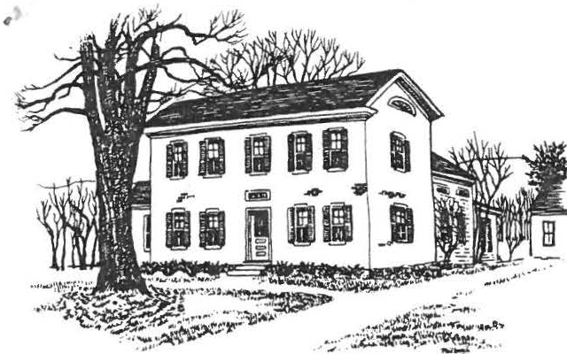
\,

SHEFFIELD HISTORICAL SOCIETY
S HEFFIELD, MASSACHUSETTS

01257

Vol. 13, No. 1
Fall 1985

MESSAGE FROM THE PRESIDENT

Again a new season is upon us and many Society events are visible on the horizon. I'd like to take a moment to reflect on some landmarks of the recent summer and some future ideas that are being discussed.
Our Antiques Show was one of the most beautiful gatherings of its kind that anyone had seen in a long time. We need to streamline parts of our operation to reap more financial rewards, but we learned a great deal and everyone who participated is to be commended. -- The Picnic and Open House were both well attended. -- Buyers abounded at the sunnner Tag Sale held at the Legion grounds. The Tag Sale is a chance for the Society to repay its debt to all those workers who toil for free as volunteers during the year.
Work is proceeding smoothly on the addition to the Carriage House. On completion of the storage shed, we will be able to use the barn as a show­ place and gifts of old or unique tools can be gladly accepted.
Also up for consideration is the fate of the old High School building.
We welcome your input on possible purchase of the building, followed by the major undertaking of moving it to our lot and starting renovation of the interior.
As you can see, your Society is always on the move. We appreciate your participation and sincerely hope you can be a part of the events of the coming year.
Chris Coenen

APPLE PIES IN THE BANK?

Now is the prime time to make apple pies, which can be frozen (they freeze wonderfully) and stowed away until the Antiques Show next sunnner. June will retllrn before you know it and the food department of the Show can sell as many apple pies as members can make and have freezer space to keep!

I

-2-

CHARTING THE COURSE

The Executive Committee has engaged Greg Farmer, president of New England Historical Services Inc., to prepare a thorough narrative history of the Dan Raymond House, based on research in property deeds; probates; church, census, and assessment records; and other sources. From this narrative account of the place of the house and its occupants in town and Berkshire history, Mr. Farmer will suggest a detailed furnishing plan and interpre­ tive approach which accords with the life of the house. Further, his study will include a proposed schedule for implementing the furnishing plan, and will identify items in our present collection which could add strength to it. He will also recommend sources of additional furnishings, and tech­ niques for procurement of what is most appropriate.
In the end, his work should guide us in developing not a mere museum of period antiques, but a collection which explains and illustrates the life of eighteenth and nineteenth century Sheffield in a coherent fashion.
The Board is enthusiastic about Mr. Farmer's approach and confident of his qualifications for the research and for the policy advice which he will base upon it. He has had many years' experience in the use of his­ torical resources and in the development of program plans for museums and historical societies such as ours.

TURKEY-TALK
(about our October 27 dinner to benefit the SHS Education Fund)

"When you wish upon a star, makes no difference where you are." Well, that's O.K. for a tune, but you ought to make better plans for October 27. That is, if you want one of· our huge turkey wish­ bones from one of the several turkeys we are preparing for you.
Come and join the gang. Beat your drumsticks at your friends' doors and tell them about the turkey, stuffing, gravy, mashed pota­
toes, squash, cabbage salad, cranberry sauce, rolls, coffee, tea, or milk, and home-made pie. All for $6 (adults), $3 (children under 13) and toddlers under 5, free.
Don't be a turkey and stay away because you have no one to come with.
Come anyway! I'm sure you'll have a good meal, gain a couple of new friends, and leave full and happy to boot!
01' Tom Gobbler

! SHADOW QUILT?

The Quilting Group will meet the month. We have thoughts one has a better suggestion. raised $317 and was won by a
on October 9 -- the second Wednesday of of starting a "shadow quilt," unless some­ The crazy quilt exhibited in the summer lady from Great Barrington.

-3-

DAN RAYMOND HOUSE NOTES

We recently added two fine items to our collection of accessories: a brass bed-warmer with eagle design on the cover, and an 18th century pewter charger. The bed-warmer stands by the fireplace in the South Parlor, while the charger has joined the display of pewter plates on the Keeping Room mantel.
The signatures of many welcome visitors from near and far swelled
the Guest Book during the sunnner. Twenty-five were added on September 18, when the Progress Club of Delmar, New York, toured Sheffield.
We look forward to the fall activities, with changing exhibits and the craft classes (see below) which begin soon. Come and visit, and learn!
P.B.

ATTENTION -- CRAFTERS! Fall classes will be held in the brick building at the rear of the Dan Raymond House, according to the schedule below. How­ ever, it must be noted that if we do not have the minimum number of sign­ ups required for a class, at least a week before it is due to start, the class will be cancelled.
Please call Muriel Rokos (528-4767) if you are interested in one of the classes, or if there is a craft not listed which you would like to see offered.
Basketry: Tuesday, October 8 (Hip Basket), 9:30 a.m. - 2:30 p.m.
Fee, $20, including all materials. Minimum class, 8 people.
Thursday, October 17 (Muffin Basket), 7 - 10 p.m.
Fee, $13, including all materials. Minimum class, 8 people.

Quilting: Thursday, October 24 (six Thursdays, of which Oct. 24 is the first), 9:30 - 11:30 a.m.
Fee, $14, with participants supplying their own fabric.s Minimum class, 8 people.
Punched Tin: Wednesday, October 16, 7 - 9:30 p.m.
--Fee, $13, including all materials. Minimum class, 6 people.

Pierced Tuesday, November 5, and Tuesday, November 12, 10 a.m. - 1 p.m. Lamp Shades: Fee, $28, including both classes and all materials.
Minimum class, 6 people.

Spice! Herbal Wreath:
Wednesday, November 13, 7 - 10 p.m.
Fee, $11, including all materials to make a 6-inch ring Fee, $16, including all materials to make an 8-inch ring Minimum class, 8 people.

Check your calendar and call Muriel today to sign up!

\

-4-

MOTH AND RUST
Museums like our Dan Raymond House must be vigilant to protect articles made of paper, cloth, wood, etc. from the subtle attack of such enemies as mildew, moths, and dry-rot. Unless seen and halted, deterioration can con­ tinue until the damage is beyond repair. This year we have budgeted a sum specifically for "conservation," to help preserve a few items of high
value to us.
Conservation of such treasures is a science which often carries a jolting price tag. We cannot, therefore, go at it wholesale but must choose the items owned by the SHS which have greatest significance to Sheffield and to our collection goals. The Society urges members and friends who are fortunate enough to possess important Sheffield memorabilia -- particular­ ly of paper or cloth fabrics -- to consider offering them as gifts to the SHS so that they may get the expert attention they may require to remain in good condition for the delight and instruction of later generations.

CALENDAR (through February)
Timothy Beard's amusing and very informative talk on how to dig for family roots, at our September meeting, will be followed by a varied schedule of programs through fall, winter, and spring. Except for the Christmas Par­ ty, all meetings listed here start at 7:30 p.m.
October 11 -- Muriel Walker, speaking about Oriental Rugs.
(Refreshment:s Marion and Dirk Willcox, Ruth Dutcher)
November 8 -- Carole Owens, speaking on "Berkshire Cottages''. (Refreshments: Irene Cranmer, Frances Warren, Ethel Mertching, Penny Browne)
December 13 -- Covered Dish Christmas Supper at 6:30, and short enter­ tainment. Please bring a place setting. ( Committee: Dorothy Marosy, Virginia Drury, Sandra and Bill Preston, Fran and Prescott Coan)
To add to the festivities, all who attend are requested to bring a hand-made ornament to adorn the tree. Your contribution may be as simple as a bow, as natural as a milkweed pod, or as artful as a min­
iature paintin.g The ornament may be left on the tree to be used in
subsequent years, or removed at the end of the meeting and taken home. Thank you for your joyous participation!
January 10 -- Milton Barnum's famous Show & Tell and "What's It?" program. (Refreshmen:tsEd Babb, Charles Joch, Agnes Boardman, Sally Proper)
February 14 -- "Matters of the Heart," with Bill Preston as M.C. (Refreshments: Lillian Preiss, Marion Barnum, Muriel Rokos)
The Valentine overtones of the February topic are intentionally vague. The program committee expects members to be stimulated to bring to the meeting all kinds of artifacts relating more or less to the HEART -- its shape, emotional significances, history, or what-have-you. If this description is either too vague or not
vague enough; call Bill or Sandra Preston ( 229-2077) in the evening, and they will be glad to elaborate, obfuscate, becloud, or illu­
minat.e Good luck!

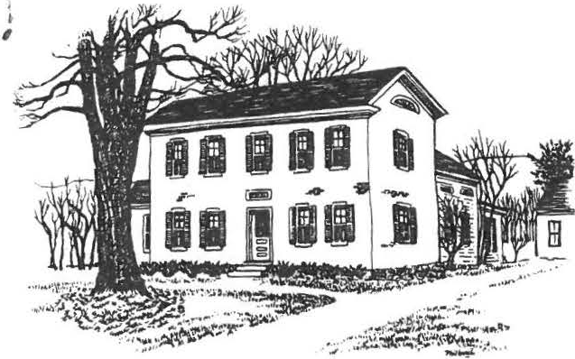
i

SHEFFIELD HISTORICAL SOCIETY
SHEFFIELD, MASSACHUSETTS

01257

Vol. XI, No. 3
April 1984

NEWSLErl'ER

April 4
April 13
April 24

May 11
May 15
May 26

June 8
June 23
June 29

CALENDAR
Historical books, DRH, 2 p.m.
Regular meeting. James Shanahan, speaker Quilting classes begin
Regular meeting. Michael Black, speaker Deerfield trip
Outdoor antiques market, 10-5
Annual meeting and elections, 6:30 p.m. Second annual Covered Bridge Ramble
Tag sale, 10-4

-!HI- PROPOSED BYLAW CHANGE ii-if

The Board of Trustees has proposed a bylaw change as follows:
8 c. An ACCESSION>COMMITTEE of five members shall administer the Accessions Policy approved by the Society. The committee shall include the Curator, the President of the Society, the Chairman of the Dan Raymond House Committee and two members at large appointed by the Board of Trustees and shall elect its own chairman.
The effect of this bylaw change will be to enlarge the committee from three to five members, to allow the Board of Trustees to appoint both members at large and to permit the committee to select its own chairman.
According to our bylaws, an amendment to the bylaws may be made if approved by two-thirds of those members present and voting at a regular meeting of the society. This change will be voted upon at the April 13 meeting.

- 2 -

HISTORIC DEERFIELD
A visit to Historic Deerfield has been p4Ilned for Tuesday, May 15.
Deerfield was the last outpost on New England's frontier when it was settled in 1669, and its historical traditions have been carefully preserved.
L,v sf :

A minimum of thirty people are needed to engage a bus for the trip• .,/8'/?·JI This includes the bus and admission fees. If you wish to have lunch at the charming Deerfield Inn, you may do so; otherwise, you may bring a brown bag.
We plan to stop at the Whale Inn in Goshen for dinner on the way home.
The proposed schedule:

8 a.m.

10 a.m.
10-12
12-1:15

1:30 p.m.
2:30 p.m.
4:30 p.m.
Leave from American Legion grounds Arrive in Deerfield
Introduction to Historic Deerfield Tour of Hall Tavern
Lunch
Tour Sheldon-Hawks House Tour Ashley House
Leave Deerfield
Stop for dinner in Goshen

HALL TAVERN (c1760) Built in Charlemont when it was still a French and Indian War outpost, this hostelry long served travellers going West. Be­ yond the gift shop and information center is a seven-room museum with outstanding New England country furniture, pewter, horn, treen, textiles, miniature furniture and a stencilled ballroom.
SHELDON-HAWKS HOUSE (1743) Home of the Sheldon family for two centuries, the large size and fine panelling of this timber frame house attest to the wealth of early Deerfield farmers. Here visitors can see cooking and sewing equipment, fine English ceramics, and the Potter collection of furniture from Boston and the Connecticut Valley and hear about Hon. George Sheldon, Deerfield's colorful Town historian.
ASHLEY HOUSE (c1730) The home of Deerfield's Tory minister during the Amer­ ican Revolution, this house was later moved from its foundations and used as a tobacco barn for 75 years. Painstakingly restored to its original site and appearance, it shows the splendor of the minister's lifestyle in early New England.
Please let Catherine Miller know if you plan to take advantage of this opportunity for a great trip, which should be both entertaining and educa­ tional. Call her at home (229-8668) or at the office (229-8064).

TAG SALE

The change in format for our 1984 tag sale was described in the last newsletter, so this is just a reminder. If you would like to have a table on July 28 from 10 to 4, Chris Coenen will
be happy to reserve a space for you in front of the American Legion Hall. This is an opportunity to sell your white elephants without the bother of advertising. Bring your own table and chair. The charge is only $10.

- 3 -

OUTDOOR ANTIQ,UES MARlCEn'

Of course you don't need a reminder about our seventh annual antiques market. Or do you? This is our big source of revenue for accessions, and we must make it a BIG one.
Chairman Carl Proper has already delegated some responsibilities, but more help is needed. This is a mammoth job, and it talces a lot of people to make it run smoothly. If you have not already offered
(or been commandeered) to help, please let Carl or Catherine know of your willingness.
It's also important to spread the word and invite your friends to attend. REMEMBER.: SATURDAY, MAY 26, 10 to 5.

HISTORICAL BOOKS

The first "historical reading circle" got off to an auspicious start with the realization that the book selected for the inauguration of this project was excellent preparation for David McAlleste1rs pro­ gram on March 9th. Prospering by Elizabeth Speare deals largely with the Sheffield and Stockbridge Indians of the Mahican tribe.
Those attending the reading group were enthusiastic enough to schedule a second session. Art Chase has agreed to review The Duke of Stockbridge by Edward Bellamy on Wednesday, April 4, at 2 p:iii:° atthe Dan Raymond House. Come and join us for a lively discussion of a book about Shays' Rebellion. This is timely because plans are already under way for a bicentennial reenactment of the last battle of Shays' Rebel­ lion, which took place in Sheffield on February 27, 1787.

SPRING CRAFTS PROGRAM
Workshops in various crafts will be scheduled this spring if there is sufficient interest. For any of the following classes, call Muriel Rokos a 528-4767 if you are interested.
Q,UILTING. The tried and true quilting classes, taught by Betty Gagne, will begin on April 24 and continue for six weeks. Individual instruc­ tion in beginner, intermediate and advanced categories will be avail­ able from 9:30 to 11:30. Maximum: ten people.
BASKEl'RY. Carol Hart of Falls Village offers an all-day workshop in basket-making. A fee of $35, including materials, will be charged. The session, probably in June, will run from 9:30 to 3. Participants should bring a lunch and will be able to go home with a completed bas­ ket. Minimum: five people.
RUG HOOKING. Seven two-hour lessons in punch-hooking, called Oriental rug-making, will be offered for a minimum of four or five people. The fee is S47 per person, with participants supplying their own materials.
HERB WREATHS. This workshop will be scheduled in the fall, and more information will be available later on.

- 4 -

SHEFFIELD SCHOOLS A CENTURY AGO
To'Wil records, April 4, 1870. Voted that the to'Wil eatablish a High School to be kept alternately five months at Ashley Falls and five months at some place near the center in rooms to be obtained and rented by the School Committee.
Berkshire Courier, September 20, 1871. The new high school house at Shef­ field is finally completed and ready to be occupied. It has the capacity of seating 80 pupils, and the people in the center of the to'Wil hope by furnishing quarters, to keep the high school with them the year round, instead of having it dodge off to Ashley Falls for a term or two every year as formerly.
School Report, 1871-72. HIGR SCHOOL. Scholars have been admitted by com­ petitive examination•••The standard of scholarship required for admission has been such as could be reached by any intelligent child in the dis­ trict schools.
Berkshire Courier, September 9, 1874. The village district school is unusu­ ally large this term. Miss Ida Roraback has about fifty scholars, so that some of them are obliged to sit three in a seat, an arrangement far more likely to promote sociability and good times than mental improvement.
Berkshire Courier, October 14, 1874. The new school building in Ashley Falls was completed a few days ago. It stands upon the old site, for­ merly occupied by the schoolhouse which was so unceremoniously and swiftly hurled to destruction in the hurricane last spring.
School report, 1876-77. One of the difficulties is the want of a full supply of uniform school books. Some parents are too poor to buy them, and at the same time dislike to receive them as alms from the town. The commit­ tee recommends that the town own all school books.
Berkshire Cow,ier, March 31, 1880. The high school closed last Thursday with a public examination. The classes in Roman History, Caesar, Arith­ metic and University Algebra are entitled to especial praise.
Connecticut Western, August 25, 1886. Walter S. Candee, Zacheus H. Candee and Alice Wickwire passed the examination last week for admission to enter the High school next term.

@ IN LlGHTER VEIN 0

The eighth grade history teacher asked her class: "What charac­ ter in history do you most admire?"
While most of the members of the class were busy searching their brains, one brilliant boy in the back row raised his hand and answered: "My history teacher!"

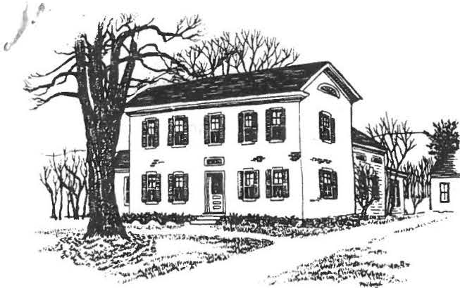
SHEFFIELD HISTORICAL SOCIETY
SHEFFIELD, MASSACHUSETTS
01257

NEWSLE'.l'TER

Vol. XI, No. 4
July 1984

"THE OLD ORDER CHANGE11H, YIELDING PLACE TO NEW" Tennyson

For the third time in the history of our society, the presidential order has yielded to the new. We are very grateful to Catherine Miller, who guided the organization through a very active and productive four years, and we salute our new president, Chris Coenen.
To·completethe roster for 1984-85, the other officers are: Virginia Drury, vice president; Agnes Boardman, secretary; Roger Drury, treasurer; Milton Barnum, Penny Browne, Catherine Miller, Alfred Richardson and Muriel Rokos, trustees.
Appointments are as follows: Curator - Lillian Preiss
Assistant Curator - Marion Barnum
Curator of Photography - Christopher Coenen
Dan R^{i}l'/y^{r} mond House Committee - Penny Browne, chairman
Marion .Barnum Milton Barnum 'William Browne Catherine Miller Lillian Preiss Muriel Rokos

Finance Committee - Roger Drury, chairman
Grace Arzt Alfred Richardson Carl Schumann
Accessions Committee - Penny Browne
Christopher Coenen Lillian Preiss Carl Proper Muriel Rokos
Education Committee - Irene Cranmer
James Miller Muriel Rokos
Antiques Market Manager - Carl Proper Program Committee - Virginia Drury, chairman
Eleanor Blake Christopher Coenen Lillian Preiss Sandra Preston
Refreshment Chairman - Marion Barnum

"SUMER IS ICUMEN IN"

A Report from the President
I (

2.
.

Anonymous, ca. 1250

Summer is in full swing! Mandy and I have been very busy moving, building and travelling b t expect to find time to join in the Society picnic and tag sale. I appreciate the support everyone has given me as new president of the Sheffield Historical Society. It will be hard to follow in Catherine Miller's footsteps. Her dynamic, hard-working leadership will be sorely missed. She guided the Society through a period of transition, and it will be my job to further the goals of the
Society. The demands of boarding school life will make it difficult for me to be as conspicuous as I would like, but I'm sure all of the commit­ tees are in capable hands. Virginia Drury has formed a fine program committee, and they are already hard at work on next year's meetings.
Now that the Dan Raymond House is well on its way, we should focus our attention on other projects. The barn needs work, and we have to decide what its final function will be. Any suggestions for its use are welcome. Another exciting possibility is the old High School building. It is presently owned by the town and sits next to our property. The Society should think seriously about the possibility of obtaining the building and consider what its ult.imateuse would be. We certainly need space to store and display some of our fine artifacts which are not nec­ essarily appropriate for the Dan Raymond House. If we decide to buy and use the old High School, it would require extensive repairs and renova­ tions. Certainly, we are no strangers to renovation projects, and this would be an exciting new dimension to our grounds. A small museum would be a welcome addition to our educational programs.
I see the years ahead as ones of growth and maturity for the Society. We should strive to increase our membership, particularly younger members, and further the educational ideals of our charter.
I hope everyone is enjoying their summer, and I'll see you all at the picnic on July 22.
Chris Coenen

"EVERYONE LIVES 13Y SELLING S0Mm'HING"

Stevenson

Antiques market chairman Carl Proper reports that, although attendance and sales were both down from last year, he expects that the net profit from this year's antiques market will come to about
$3,500.
Antique dealers and show managers report that this decline seems to be a general rule this year.· The 1984 gate counted 990 paid ad­ missions, whereas there were over 1,200 last year. Dealers, both on the field and pickers, numbered 127. Perhaps we should think about a better way of spreading the word next year.

) ,

"HAND IN HAND \o/ITH LOVE IN SUMMER'S WONDERLAND"

Noyes

Several S.H.S. activities a.re planned for "summer's wonderland."
SUMMER HOURS AT THE DAN RAYMOND HOUSE. Du.ring July and August the Dan Raymond House will be open on Friday and Saturday afternoons from 1:30 to 4. Anyone who is willing to help out on Saturdays will be most wel­ come. Just let Penny Browne, Marion Barnum or Lillian Preiss know.
The July exhibit will be a display of antique lighting devices, and in August we will show old-time laundry equipment.
PICNIC. JULY 22. Starting at 4 p.m. there will be a covered dish picnic on the Dan Raymond House lawn. The society will provide beverages and desserts. Members should bring a place setting, chair, mosquito repel­ lant if desired - and friends! A feature this year will be horseshoes and croquet. It sounds like fine fun and fellowship.
TAG SALE. JULY 28. This type of tag sale is an innovation for us. The society is providing table space at the American Legion Hall for those who wish to sell their own items. Those who desire to participate may still rent space for 110 a table. If you have not already signed up, please call Chris Coe.nen at 229-3323. The sa.le will be held rain or shine, and the society will sell light refreshments. Participants are expected to bring their own tables and to take back any unsold items (if any) at the end of the day. Hours are 10 to 4.
OPEN HOUSE1 AUGUST 9. 10. 11. The Dan Raymond House, outbuildings and law office will be open during the three days of the Sheffield Antiques Show. There will be special exhibits and demonstrations, including two live sheep on the back lawn. This will be a good time for visitors and
prospective members to get an overview of what the society is all about. Again, we could use some help in staffing the house and grounds for these three days.

"AND GLADLY WOLDE HE LERNE, AND GLADLY TECHE."

Chaucer

Quilting lessons will again be offered this fall if there is suf­ ficient interest. Betty Gagne has a.greed to teach another six-week session, and it has been suggested that an evening schedule might be more convenient for some people. Tentatively, the classes are planned for Wednesday evenings from 7 to 9 starting the third week in September.
There also seems to be some interest in rug braiding classse. If you are interested in either of these programs, please call Muriel Rokos at 528-4767. If you can't reach her during the day when she is working outside, try evenings!

•

"I \I/ILL POINT YE OUT THE RIGHT PATH OF A VIRTUOUS AND NOBLE EDUCATION"
Milton

You may remember that a scholarship fund has been established by the society to finance the local history field trip, to provide an annual scholarship of $500 to a Mount Everett graduate and to support other activities of a historical nature. Proceeds.from the annual.
turkey dinner are used for this fund.
rA

Gregory Carpenter, the 1983 recipient, is studying political science at Northeastern University and is doing well there, according to Bob Krol, guidance director at Mount Everett. This year the scho­ larship went to Sheri Burkholder, who plans to attend Dartmouth to major in public administration.
The scholarship is awarded at graduation hut;not paid to the col­ lege until the beginning of the student's second year, thus providing assurance that the money is assisting a perseveri student.
N.B. The turkey dinner this year will be held on October 28. Please mark your calendar now.

"WHAT NEWS ON THE RIALTO?"

Shakespeare

Getting the News in 1775 (from the Berkshire Courier, Nov. 9, 1905)
"For the Purpose of getting speedy and certain Inteligence from the Army at Boston, We the Subscribers hereby promise and agree to Ride from this Town to Tyringham or Sheffield by Turns so as to bring Inteli­ gence from Thence each Day (the Sabbath excepted) and to Report the same at the House of Mr. Josiah Smith - And in Case no regular method is come into for bringing the News to said Tyringham we promise to bear our pro­
portionable part of the Erpense in procuring Inteligence from Springfield twice in each Week - Witness our hands this third Day of May 1775.n
Following the agreement on the document is a list of days with the name beside each of some citizen who was to be the rider for that day. Jacob VanDeusen, who agreed to be the first man to ride to Tyringham or Sheffield, was to go for it on Monday, May 8th, and Mark Hopkins was to follow on Wednesday, the 10th day of May, the service from then on alter­
nating except as to the Sabbath, which compelled a no-news interval of
two days in each week. ·!

To submit items for the 1984 newsletters, call Lillian Preiss, current editor. In 1985 Roger Drury will take over the- tq.rship.

:;

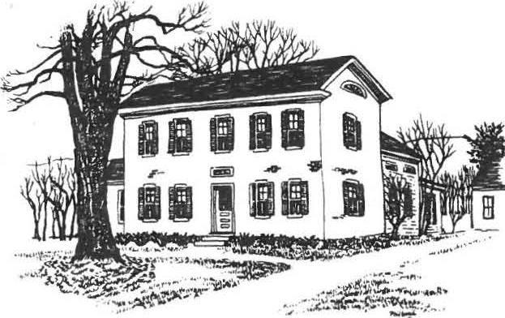
/

SHEFFIELD HISTORICAL SOCIETY
SHEFFIELD, MASSACHUSETTS

01257

Vol. 12, No. 2
January 1985

TEST YOUR ANTIQUITY QUOTIENT - January 11

This mid-winter newsletter brings you, first of all, a reminder that the Society's January meeting is not to be missed. It features the annual "What's It?" program, when we try to identify all manner of odd antique artifacts, from household, shop, farmyard, and attic. Those with the highest AQ may aspire to rank alongside such long-time wizards as Loring Boardman or Arthur Chase. Bring your favorite What's It and see if you can stump the experts. The meeting opens in Dewey Hall at 7:30, Friday, January 11.

A MESSAGE FROM THE SOCIETY'S PRESIDENT

Welcome to 19851 Your Historical Society is looking forward to an exciting new year with a number of projects getting off the ground. The great success of the Turkey Dinner enables us to sponsor more school outings such as the Fifth Grade trip to the American Indian Institute in Washington, Conn., which we helped finance last fall.
Our biggest fund-raiser, of course, is the Antiques Show. This year we will be making some major changes. The Show will be in­ doors at the Berkshire School hockey arena, on June 28, 29, and 30. With that change of date and location, and the help of show mana­ ger Jacqueline Sideli, we hope to attract a large number of high­ quality antique dealers and to put on an affair that we will be proud to call our own.
The Sheffield Historical Society will still be in charge of all
the food and refreshment.s This includes the Preview Benefit on
Friday night -- a gala party which is sure to attract a large fol­ lowing. We are excited about the new format of the show and hope all our members will lend a hand to make it the success it de­ serves to be.
The Accessions Connnittee is hard at work searching for those items still needed to furnish the Dan Raymond House. We have asked the noted antique authority Robert Herron to assist us in this

-2-

task. He will make suggestions and help verify the appropriateness and authenticity of any piece that goes into the House.
I'd like to take this opportunity to thank all those who have helped me in my first year as President. There are capable people running the various committees, and this has made my job much eas­ ier. Always remember that you, the members of the Sheffield His­ torical Society, are the Society. The Dan Raymond House and other projects simply reflect our commitment to the Town and its history. Keep up the good work!
Chris Coenen

DAN RAYMOND HOUSE NOTES

(The focus of SHS life and activity is the Dan Raymond House, our headquarters on Main Street, open every Friday afternoon from 1:30 to 4, as well as for the kind of special programs described below.)

Holiday Open House: The excitement of transforming the House was con­ tagious, as members helped decorate the mantels with fruit and greens, light fires in the three fireplaces, set candles at every window, and serve mulled cider and Christmas goodies in the Keeping Room. If you weren't able to stop in for the warmth and welcome within, you surely felt the glow from the windows as you passed by, going from one seas­
onal function to another on that beautiful December afternoo.n The
House is at its best when full of interested members and townspeople, as it was that day.

Workshop:s We had a steady schedule of craft classes during the fall: an
herb wreath workshop in November which attracted its full quota of en­ thusiasts, a series of quilting classes, and two basketry workshops.
Basketry seems to be addictive, especially as taught by Rita LePrevost whose.two all-day workshops were immensely popular -- so much so that a new basket-making class is being planned for later in January. For information about date, time, and fee, call Muriel Rokos (528-4767).
Another quilting series, taught by Betty Gagne, is tentatively planned
for the spring, most likely on Tuesday evening.s Spread the word about these always-popular classes!

Accessions: A generous $500 gift from the Quilting Group has been used to purchase three early pewter plates, now proudly displayedon the man­ tel in the Keeping Room. The Group, which has been a benefactor of our Society from the outset, has recently provided two thermos coffee serv­ ers for use at SHS functions.

FOUR MEMORABLE EVENTS OF 1984

(It behooves an historical society to record its own doings before time covers them up. Hence, we are putting a brief spotlight on four noteworthy events of the past year.)

MARCHING THROUGHDALTON. Seventeen SHS members went by bus to Dalton on

,
>
-3-

June 23 to take part in that town's 200th Anniversary parade. The Shef­ field Historical Commission funded our bus, but the SHS provided the impetus and the bodies! Our presence, serving as a friendly gesture be­ tween old Berkshire towns and particularly as a thank-you for Dalton's participation in our 250th Anniversary parade in 1983, was warmly ap­ preciated by Dalton people. They applauded our period costumes and chuck­ led at the jogging shoes visible beneath one ankle-length skirt. Many
in oor contingent had lived through more than a third of the 200 years being celebrated -- but we were all glad to have gone!

SAUNTERING THROUGH STURBRIDGE. An even hotter and more humid day (Sep­ tember 25) saw twenty-five members taking a deep swim in history at Stur­ bridge Village. It was an all-day excursion, leaving the Legion Hall at
8 a.m. and returning after dinner at Valle's in West Springfield at 8:45
p.m. We had seven hours at Sturbridge, time to take the exhibits at a leisurely pace, to have picnic lunch in the pine grove, to observe the ticking of ancient clocks, the bundling of straw brooms, the come-and-go of the water-powered sawmill, and much more, and at last to sink grate­ fully into our seats in the cool bus as we drove back into the Twentieth Century. These all-day excursions are as much fun for the fellowship with other SHS members as for the places seen. Where shall we go next?
TURKEY DINNER NO "TURKEY." No indeed! Some 322 ravenous diners declared the turkey dinner on October 28 a sensational success, a tribute to the organizing and the plain old-fashioned hard work of chairman Milton Barnum and twenty-seven helpers -- including a student-teacher-parent delegation from the Mt. Everett 8th Grade. The proceeds of $1126 exceeded all re­ cent years. As President Chris Coenen's message notes, this gives us in­ creasing flexibility for encouraging historical outreach by students -­ the purpose of our Education Fund and of the annual turkey dinner which supports it.

CHRISTMAS MIRACLE REPEATED. The annual Christmas dinner brought a full house to Dewey Hall on December 14. It would be easy to sell tickets be­ yond the limit of 100 persons, but the tiny kitchen would explode at the very thought. The committee repeated the annual miracle, serving a ten­ dollar dinner for three dollars, while making ends meet! The evening ended with lovely carol singing by Linda and Chris Best (and finally by the whole group) accompanied by Mary Anne Carter.

FIFTH GRADE HISTORICAL FIELD TRIP

The entire Fifth Grade from Mt. Everett, seventy-five strong, accompanied by four chaperons, three teachers, and an aide, were bused to Washington, Connecticut, on December 5, to visit the American Indian Archaeological Institute -- a trip made possible in part by a contribution from the Soc­ iety's Education Fund.
The class was guided through a mock-up of an archaeological dig and a re­ constructed Indian village and garden, learning about the types of dwel­ lings used by Indians of this region over a period of 5000 years, and the

-4-

techniques of excavation.
In the lecture hall, an American Indian, Mr. David Richmond (of the Snipe clan, Mohawk tribe, and Iroquois nation) described the customs, tradi­ tions, and skills of his people and showed a film of life on a reservation. Traditional Indian life style and culture, he said, are enjoying a renais­ sance today. After lunch on the bus, there was time to view more exhibits and to buy Christmas presents in the gift shop.
Mr. Leo Alvares, who organized the trip, feels it was "a first class success for the students and staff. Thoughtful students may well spend some y ars sorting out why what they heard from an authentic American Indian contrJ­ dicted 95% of that which they heard from their teacher and read in their texts. Geronimo!"

COMING PROGRAMS

February 8 -- Dallas Cline, speaking on dulcimers. Refresh­ ments by Sally and Carl Proper, Catherine and James Miller, Mandy and Chris Coenen.

March 8

April 12

May 10
Susan Edwards, Director of the Berkshire County Historical Society. Refreshments by Marien and Milton Barnum, and??? (volunteers needed).
The Shakers. Refreshments by Rachel Willcox, Louise Stevens, Muriel Rokos.
Mrs. John Batty, speaking about the Normal Rock­ well Museum. Refreshments by Vera Conklin, Olive Gaylord, Gertrude LeGeyt.

WANTED: A GOOD HOME FOR THESE WOODEN WAIFS

Fifteen or twenty old wooden-seated folding chairs -- the kind that used to cling together in sets of five or so and make a real bedlam when the seats were flipped -- are being disposed of by the SHS free of charge, to the first comers. They have been cut apart, will stand alone, and can be had -- one, or a few, or all -- for nothing. Call Milton Barnum (229-
25 69).

Don't let those dates be stolen by any competing activity! Circle them now on your calendar and plan to respond with a hearty "OF COURSE!" when you are asked to give a few hours of your time, helping to make the "new" SHS Antique Show a resounding success!

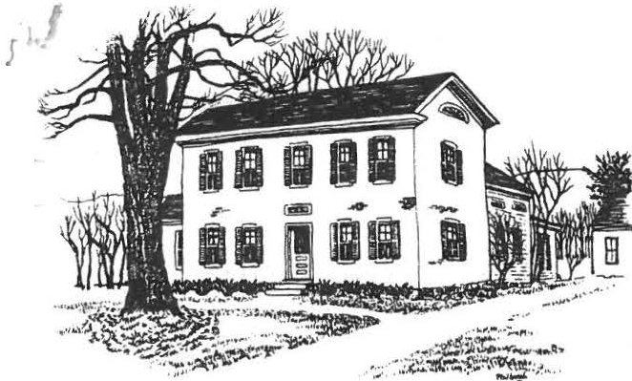SHEFFIELD HISTORICAL SOCIETY
C
SH EFFIELD, MASSACHUSETTS
01257

DAN P.AYMOND HOCIS£

Vol 12, No. 3
April 1985

HATS OFF TO BILL SILK
If there's a book of gold somewhere in which a recording angel writes the names of benefactors of the Sheffield Historical Society, the name of Bill Silk must be on page one.
Bill has been a quiet, solid supporter of the SHS ever since its founding -- selling Lillian Preiss's "Sheffield: Frontier Town", Chris Coenen's pictorial history, jubilee T-shirt-sand buttons, and turning over every cent of the proceeds to the Society. Where else would you find such continuous, friendly
C promotion of our work?

DAN RAYMOND HOUSE NOTES
Colonial Meal -- On Wednesday, March 27, twelve Eighth Graders and three teachers from Mt. Everett Regional School were served a Colonial meat cooked over the open fire in the Keeping Room. Choice of the twelve students was based on essays they submitted on colonial living.
As part of the visit the students examined a display of "what's its" which was set up in the Keeping Room, and tried to guess what the uten­ sils had been used for. They also went up to the south chamber, Clow -­ a children's room, observed everything in the room, and then came down and tried to recall all they had seen.
This annual visit of the young people to the Dan Raymond House is a re­ warding experience for the DRH committee. The students are eagerly
·,·cur i ous ; what ' s . more- , t he y ' r e a ll y e n joy · the · mea l and tell ue sol

Boxes - Old & New -- An interesting collection of containers made of tin, wood,ceram.ics, and leather, lent to us by members of the Society, is on exhibit during April. Our thanks to the lenders, Catherine and
Jim Miller, Rachel Willcox, Margaret Philbrick, Ruth Leffingwell, and Penny Browne.

Grounds Work -- No matter how hard it tries, winter is losing the battle to spring. The bulbs are up and soon we will start our annual clean-up -­ raking, weeding, and looking things over to see what has survived and
C

' I...
f

-2- )
to consider what we might want to plant this year.
If any one in the Society would like to wield a shovel. a rake, pruning shears. etc., or would just like to give a little time to weeding, we certainly can use the help. The brunt of these activities falls on the shoulders of only a very few members. So-o-o, those of you who have strong backs or green thumbs and can spare an hour now and then -- let us know!
Penny Browne

SPRING WORKSHOPS AT THE D.R.H.

Muriel Rokos, chairman of the workshop program, will gladly sign you up or give you further information about three workshops being held at the Dan Raymond House in April and May. Call her at 528-4767.
Punched Tin Workshop: an introductory class running from 10 to 2 0 1 clock, Wednesday. April 24. Enrollment fee, $13. All equip­ ment and materials will be provided. Participants bring their own lunch and can expect to complete two small projects to take home. George Bayley is the instructor.
)

Quilting Class:

Basketry Workshop:
on six consecutive Tuesdays, from 9:30 to 11:30, starting April 23. Betty Gagne is the instructor of this popular class. costing $14 for the six sessions.

Wednesday. May 1. from 10 to 2:30, at a cost of $13. including materials. Participants will make a Shaker­ type egg basket under the guidance of Rita LePrevost. Bring your own lunch.

"!!!! BEST CARRIAGE BARN IN TOWN," says DAN
Are you able to do the chores yet or are you still laid low by that flu that hit the area? If you haven't taken your turn doing chores and haven't been to the barn yet, you're in for a big surprise.
Remember Dobbin's stall, how it slanted down to the farther corner and you feared he might step through? Well, now it's as sound as a dollar. New joists have been put in, and a new floor too. The barn floor has been shored up and is safe enough for a barn dance. Now, when you back the surre.y in, you know it will stay put. New aills are under the east wall, and the corner posts were repaired as well.
The old dormer on the east roof has been removed and a loft door has been cut in on the south gable end. When the hay is mowed away this summer there will be a few less bumped heads to moan about.
)
The window sills and some clapboards were replaced. New purlin beams were put under the center rafters of both the east and west roof. The east roof was stripped and a new roof put on. as well as a new roof on the south side

/'
)
I

-3-
( of the brick building.
If you stroll by and see someone sitting there in the open door, just grin­ ning, you'll know why. So stop in and sit a spell. I think right now we have the best carriage barn in town. We even have a 3-holer to boot, but as far as carriages go, I have to admit, for distance, that Henry Massini's Sheffield Tours is the best way to get there.
Say, by the way, how about a cupola on that ridge? Give it some thought and let our fearless leader Chris know. So long until chore time,

Dan

SMITHSONIAN DEACCESSIONS COME TO D.R.H.

An important addition to the children's room on the second floor of the Dan Raymond House will be arriving shortly, according to a letter just received from the chairman of the Arlington Historical Commission.
A collection of cast iron toys deaccessioned by the Smithsonian Insti­ tution was made available to the Arlington camnission for local distribu­ tion. Institutions interested in receiving a part of the collection were invited to send a letter telling how they would use the toys and what fa­ cilities they have for storage or exhibitio.n
( In answer to our letter describing the Dan Raymond House visitation schedule and the Society's educational program, the Arlington commission
chairman wrote to inform us that we have been selected to receive a por­ tion of the collection, between five and ten toys going to each of the qualified applicants.
The toys should be in place in the children's room by the time the Eighth Graders visit the House for their local history field trip.
Lillian Preiss, Curator

ACCESSIONS NOTES

A handsome brass candle-snuffer with tray, bought during the winter with money from the Kurt Preiss Memorial Fund, has been added to the furnishings of the south parlor. Nothing could be more important to- the order of a well-run seventeenth cen­ tury household that this amall clever tool for making candles burn efficiently. (Do all our members know the difference be­ tween a snuffer and an extinguisher?)
Meanwhile, the purchase of three major items of furniture for the D.R.H. was approved by the Finance and Executive Camnittees. The three pieces, which were recommended by our consultant Robert Herron and will be sought during the coming months, are a chest, a reeded post field bed, and a slant-top desk. Funds for these purchases will come from the Accessions Budget (proceeds of the annual Antiques Shows) and a withdrawal, if necessary, from the Society's invested funds.
(

J
I

-4- J
-D-A-TES -O-N -T-HE -S-.-H.S.-CA-LENDAR
May 10 May meeting of the Society. Mrs. John Batty will talk about the Normal Rockwell Museum. Refreshments provided by Vera Conklin, Olive Gaylord, and Gertrude LeGeyt. Time 7:30 p.m.

June 8 Bean Hole Bake, master-minded by Milton Barnum. Keep your ears alert for further details of this unusual Saturday fund-raise.r

June 14 Annuel meeting dinner of the S.H.S.

June 22 The Covered Bridge Ramble, a runner's delight and an opportunity for onlooker-types to help at the starting gate and finish line. Mandy Morgan heads up the organization of this annual event.

June 28
June 29
June 30

July 27
THE SHEFFIELD HISTORICAL SOCIETY ANTIQUES SHOW, our big money­
raiser for purchase of accessions for the Dan Raymond House. Three committees are already in gear: a Preview Party committee headed by President Chris Coenen (planning the Friday evening "do"); a Food C011111ittee, of Milton and Marion Barnum, Sandra and Bill Preston, Catherine and Jim Miller, Eleanor Blake, Penny Browne, and Virginia Drury, chairman (planning food service for Saturday and Sunday); and a Manpower Committee, with Roger Drury
)
as chairman (lining up help to man the gate, control parking, etc.) There will be a slot for every willing member to fill (and free admission for workers).

Tag Sale. A re-run of last summer's immensely successful affair on the Legion grounds. You pay for exhibit space, then set up your own display of wares and take home all your proceeds.

_)

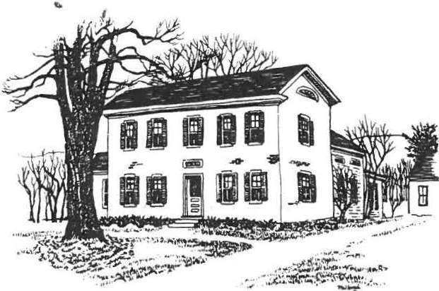
}

SHEFFIELD HISTORICAL SOCIETY
SHEFFIELD, MASSACHUSETTS
01257

Vol. 12, No. 4
July 1985

COME TO THE PICNIC AUGUST 4 COME TO THE PICNIC AUGUST 4 COME TO THE PICNIC

THE BIG SHOW

Thanks to the high-spirited help of some fifty-five members and friends of the Society, our late June Antiques Show was able to make the most of every other favorable circumstance.

Chief of these was the generosity of Berkshire School, which gave us the use of its vast indoor hockey rink t'o house not only the Show (which could never have been risked under the open sky) but also the cafe run by the Society for visitors and dealers.

The cooperation of John and Jacqueline Sideli, managers of the Show, was first class. Their planning and design as well as the quality and variety
of displays and the friendliness of the dealers set a high standar.d Pre­
dictably, we got a sampler of the unpredictable Berkshire weather -- heavy rain on Friday evening for the Preview Party, cold drizzle on Saturday, and gorgeous sunshine on Sunday. We learned that Saturday's damp and chill
were exactly right for an indoor show ( though not for the ladies of the Quilting Group who were selling chances on their quilt right by the drafty entrance!).

The final tally of proceeds must await a few delayed bills but it should be in the neighborhood of $4000 -- very good for the first year of this new type of show and a credit to the hard work and high morale of those
55 certified saints! Not so easy to calculate is the enormous pleasure
we all had working together.

FEATHER-IN-THE-SHS-CAP DEPARTMENT The September 1985 issue of Lady's Circle Pattchwork Quilts magazine features three pages of pictures of Dan Raymond House interiors, displaying quilts owned by the Society.

\

-2-

LAURELS AND CHALLENGES

Our coU ecti·iG>ns have had the benefit of three surveys during the past year, each from a different perspective.

The Williamstown Regional Art Conservation Laboratory conducted a site survey, focusing on works of art, manuscripts, and printed
material.s Noting that the Society "appears to be well-organized,
with future goals well-planned," the Associate Conservator of Paint- ings at the laboratory recommended conservation of certain paint­ ings and documents at a cost of several thousand dollars.

The Federation of Historical Services of Troy submitted a survey report referring to our "fine museum" and adding, "The Society's volunteers should be proud of the museum they have created. The work and dedication of the members are evident." The consultant recommended establishing more specific policies in some areas and the use of more acid-free materials for protection of vulnerable objects.

The most recent survey, made by a consultant funded by the Massa­ chusetts Council on the Arts and Humanities, was offered to us at no cost by the Federation of Historical Services. The consultant observed that "the Society has served the community well by preserv­ ing, restoring, and furnishing the Dan Raymond House."• He suggest­ ed a multiple-period interpretation of the house, furnishing dif-
- " ferent rooms in different periods from 1780 to the 1920's. His re­ commendations will be considered carefully before we make any changes in direction. The report praised, for its "seriousness of purpose
and interest in education, the committee which has managed the house
so superbly (the level of housekeeping and collections care is really quite above comparable institution.s")

We are certainly grateful for the practical help we have received from these consultants. According to them, we have made a good be­ ginning. We must not rest on our laurels but continue to improve.
Lillian Preiss, Curator

DAN RAYMOND HOUSE NOTES

Summer Picnic -- Come rain or shine, come all ye members and friends of the Society to the S.H.S. Potluck Picnic on Sunday afternoon, August 41 The picnic will be on the Dan Raymond House lawn, starting at 5 o'clock. Bring with you a lawn chair AND a covered dish or salad or whatever of your choice. Beverages will be provided by the committee.

August Open House -- Three days of special exhibits and demonstrations will be featured during the annual Open House, from 11 a.m. to 4 p.m., August 8, 9, and 10. Punch will be served between land 3 each day. On exhibit

I

-3-

will be a fine collection of Nineteenth and Twentieth Century glass (as well as some earlier pieces), and a variety of Indian arrowheads and other artifacts found in this area. There will also be demonstrations of tin-piercing, candle-making, quilting, and basketry.

Such an Open House takes extra help to staff the buildings and grounds for the three days. Please call Penny Browne (229-8598) to volunteer your services •

Eighth Grade Visit -- Looking back to June 7, the House Committee is stil1 tingling from the visit of eighty 8th Graders from Mt. Everett Regional School who came to the Dan Raymond House as part of the annual 8th Grade Local History Field Trip. Having studied Colonial Life in school this year, the young people brought some prepared questions, but there were also many questions off the cuff which we answered to the best of our ability.as we guided the students through the house. One is often surprised at the in­ quiries they come up with and much is learned on both sides. It is a pleas­ ure to work with the children as our educational program is such a vital part of what the Historical Society has to offer.
Penny Browne

SCHOLARSHIP WINNERS

Congratulations to Jennifer Kinsley of South Egremont, this year's winner of the S.H.S. $500 scholarship. Jennifer is heading for Mary Washington College in Virginia, where she plans to major in pre-law. -- Sheri Burk­ holder, the 1984 winner, starts her second year at Dartmouth in the fall.

Every member can be a promoter of the Turkey Dinner which finances these scholarship awards as well as the 8th Grade Local History Field Trip. The dinner will be on Sunday, October 27 -- a date to mark on your calendar today!

DUES DUE
The S.H.S. year began·with the Annual Meeting in June, so it is now time for a tidal wave of 1985-86 dues to roll in on the Treasurer from those whom he didn't catch that evening! Please fill in the form below, to up­ date our mailing list, and send it with your check payable to the Society to Sheffield Historical Society, P.O. Box 1733, Sheffield, MA 01257. The dues, which have been kept low so that all may join, are $3 for a single membership, or $5 for a family.
Name(s) Mailing Address
-------------- Telephone

-4-

RAMBLE RE-RUN

The fine sunny morning of Saturday, June 22, saw seventy-eight en­ trants take off in the third annual S.H.S.-sponsore"dCovered Bridge Ramble." The 4\ mile road race crosses the Housatonic twice over Sheffield's two covered bridges (one is the granddaddy of all surviving covered bridges in Massachusetts and the other
is one of the youngest). Road conditions were good this year and new records were set: Pam Roberts for women, 29:05, and Ed Lahr for men, 23:46. Organizer Mandy Morgan suggests that if we could find sponsore to underwrite the cost of T-shirts and trophies the
Ramble would be a money.-raiserfor the Societ.y This year, ex­ penses equalled proceeds.

MASTHEAD AND YARDARM

The Society's elected officers for the current year (with the last year of their 3-year terms indicated) are: President, Christopher Coenen '87;
Vice-President, Mason Dutcher '88; Secretary, Agnes Boardman '86; Treasurer, Roger Drury '86; Directors, Milton Barnum '86, Muriel Rokos '86, Penny Browne '87, Catherine Miller '87, and Edward Warren '88.

Appointments for 1985-86 are: Curator, Lillian Preiss; Assistant Curator, Marion Barnum; Investment Manager, William Browne; Dan Raymond House Com­ mittee Chairman, Penny Browne; Accessions Committee, Sandra Preston and Carl Proper ( plus the ·President,Curator, and D.R. House Chairman); Finance Committee, Grace Arzt, Carl Schumann, and Catherine Miller (plus the Presi­ dent, Treasurer, and Investment Manager); Education/Scholarship Commi tee,. James Miller, Martha Williamson, and Marion Whitman; Refreshments Chairman, Virginia Drury; Turkey Dinner Chairman, Milton Barnum (with Catherine Mil­ ler in charge of "creature comforts"); Christmas Dinner organizers, Vir­ ginia Drury and Dorothy Marosy.

flELP WANTED: As Vice-President, Mason Dutcher has charge of planning programs for our regular meetings through the year. He is now recruiting a committee and will greatly appreciate calls from any members who can either suggest lively program topics or would like to join the planning committee. His tele­ phone is 229-8576.

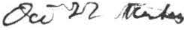
, I S HE : F I ELD HI S 'f OHI C1\ L SOCIC:'l'Y EXECU'I'IVE C:Oi'.Jl'/JI'r'r i:;
July 22,1985

Ap p oi n t me n t s : Curator J f asst. Curator k. 6
Dan Raymond House Comm.(?) I}-, fl
Accessions Committee ( 5) a/ ·• .,. .J,.,

Finance Committee (5)

--- ,·z^{C};..^{J},⁽.;,

I c.,._;,.J.a..,.

Ed u ca t i on/ S c h ol ar s h i p Committee (J)/1.:t[..,
-.
1
v..Jt....-, p

Invest·me n t Manager • wJ
A ."°'
OJ

Refreshments Cha ir ma n V• 9.-r--- j

An t i q u e s Show Program Committee 7
Ed i to r of Newsletter KJ>
Turkey Dinner 1-\ . vJ-\
Chr i s tma s Di n n er V .,p. · 7114 - "Jt{

2Review of Antiques Show
J) Non-profit mailing status r:d,4 .

4) Use of Carriage House , ,
5 emeeting times for Ex e c . Co mm. - -'( >-, )
6) Other

MAI i. i NG OPTIONS FOR ANTIQUES FAIR BROCHURE
l. Non Profit Status Third Class Rate
.06 per piece; minimum of 200 pieces required per mailing apply for non profit status(so done)
if accepted, pay $50.00 permit fee(one time charge) also must pay each year a $50.00 fee
sort by zip code
delivery in local area within 3-4 days and 8-10 out of area non deliverables not forwarded, but thrown away
- Third Class Status
.12 per piece with 200 piece minimum sort by zip code
non delt erab les not forwarded , but thrown away
- Regular First Class Status
.22 per piece with no minimum
sort by zip code not required, but would expedite delivery

COSTS:

.22 | X | 2000 | = $440
.06 | x | 2000 | + $50 permit+ $50 annual | fee= | $220
.12 | X | 2000 | :$240

CBM
5/85

SHEFFIELD HISTORICAL SOCIETY MEMBERSHIP LIST 1984-85
( I me.an • not yet enrolled for '84-'85)
Dec. 1, 1984

#Andress, M/M Thomae (Karen)
42 Bellmore Dr., Pitt1field 01201
1-442-2227

Browner, MM Murray A. (Florence) Box 222, South Egremont 01258
Campbell, Mr. Dwight P. 528-3319

528-3266

Andrew,, Mrs. Regina
Main St., Sheffield 012S7 229-8394
Armstrong, Mrs. Irene H.
Berkshire Sch. Rd., Sheffield 01257 229-8864
Arzt, Mrs. Grace
Egremont Plain Rd., North Egremont 01252
Chase, M/M Arthur C. (Alice Ann) 229-8350
Berkshire School Rd., Sheffield 01257
Clark, Mrs. Stanley (Winnie) 229-8985
Maple Ave., Sheffield 01257

P.O. Box 484, Sheffield 01257
Babb, Mr. Edward
229-211(:foan, M/M Prescott (Fran) 229-8561
RD l, Box 48, Sheffield 01257

Ashley Falla, 01222 229-7957
Bagnaschi, .M'{MRJohn (Viola)
Box 87, Sheffield 01257 229-7766

Baker, Mrs. Elsie L.
Park Lane, Sheffield 01257

' Barlow, Mrs. Claire
Coenen, M/M Christopher (Mandy) 229-3323
Berk1hire School, Sheffield 01257

Colline, Mr,. Carol 229-7782.' 950 Park Ave., NYC 10028
Combee, M/M Abbott C. 1-442-1216
15 Barker Rd., Pittsfield 01201

Squire Lane, Sheffield 01257
229-8824 #Combes, Richard S. 229-7978
S. Main St., Sheffield 01257

Barnum, M/M Milton W. (Marion)
Cook Rd., Sheffield 01257 229-2569
Benjou, Mr. Paul ,

Conklin, Mr. Harry E.
Box 473, Sheffield 01257
528-1542

Cooper Hill Rd., Ashley Falla 01222

Bennett M/M C.W.
Conklin, M/M William J. (Vera) 229-2653
Ashley Falls, 01222

  - Box 96, A1hley Falla 01222 229-2579
Blake, Mr1. Eleanor
RFD 1, Box 114, Sheffield 01257
229-8607
Boardman, M/M E. Loring (Agnes) RFD 1, Box 53, Sheffield 01257
229-7750
Boardman, Mr. E. Shears
    - fS­
Be• US, Nekumia, A::: 5 3 3
f.o,?Jcrf,- 75- .J:.. ,1-
Bradford, M/M William (Lois)
Route 7A, Sheffield 01257 229-8007
Cook, Mr1. Sarah (and Rebecca & Lindsay) Box 545, Sheffield 01257 229-8538 (c/o Hill, 259 E . 78th St., NYC 10021)

Coone, Mrs. Be1sie M. 229-8843 Route 7A, Sheffield 01257

Cranmer, Mrs. Irene 229-2819 Main St., Sheffield 01257
Cruikshank, Mrs. Audrey 229-2190
RD 1, Box 89, Sheffield 01257
#Cull, Mr1. Marjorie
71 Alice Ave., Walpole, MA 02081

#Brazie, Mrs. Theresa L. Miller Ave., Sheffield 01257
Daly, Mies Elizabeth Maple Ave, Sheffield
229-7735
01257

Browne, M/M William (Penny) Bow Wow Road, Sheffield 01257
Davidson, Mrs. Graham (Lucia)
P.O. Box 763, Sheffield 01257 229-8598

 |  | -2-
Davia, M/M George | 229-2022 | Gay.lord, M/M Everett P. (Olive) | 229-7784
P.O. Box 113, Sheffield | 01257 | Ashley Falla 01222

#Delaolino, M/M John (Caniela) Main St., Sheffield 01257 229-2740
Dinan, Mrs. Dorothy F. 229-2140

Main St., Sheffield 01257
Gibbs, Mra. Kathryn 229-2580

Berk. Sch. Rd., Sheffield 01257
Gorman, Mra. Kathleen L. 229-2890 RD 1, Box 57, Sheffield 01257

Dixon, M/M Thanu

Berkshire School,
229-2340
(Cynthia) Sheffield 01257
Granger, K/M Gordon R. (Betty)
P.O. Box 508, S. Egremont 01258
#Groaa, Charles J, 229-3438
528-9115

Downie, M/M John R. (Auor y)

RD 1, Box 268, Ashley Fallo (;;,.':::, 229-2564
Drury, M/M Roger w. (Virginia)
Berkshire School, Sheffield 01257
Holmes, Mr•. Eletha
c/o Christine Welch, Ashley Falla

01222

RD 1, Box 206C, Sheffield 01257
I
229-2687
Howard, M/M Paul (Vi) Box 323, South Egremont
528-1417
01258

Dutcher, M/M Mason (Ruth) 229-8576 79 Hewins St., Sheffield 01257
Edmonston, M/M Lee (Molly)
808 Five Point• Rd., Virginia Beach VA 23454 1-804-481-6804

Ellis, Mrs. Ruth Gordon 229-7947 Ashley Falla 01222
Hurlburt, Mias Helen H. 1-203-522-9636 319 Fairfield Ave., Hartford, CT 06144
Hurlburt, Mrs. R. Walter (Alice) 229-7922 Ashley Falla 01222

Joch, Mr. Charles Sr. 229-8928 407 Hewins St., Ashley Palla 01222
Johnson, M/M Herbert (Elva) 528-4392

Elabach, Dr. and Mrs. Peter (Patricia) RD 2, West Stockbridge 01266
Salisbury Rd., Sheffield 01257

(440 E.·.23d St., NYC 10010) 229-7758 Jones·, Mrs. Daniel (Margaret)
P,O. Box 253, Sheffield 01257
229-8976

Ford, M/M Dwight (Margaret) 229-2575 RD l, Bcm 124, Sheffield 01257
French, Mr. Willard C. 229-7719 Plymouth Lane, Sheffield 01257
Forman, Mr•.Robert S. 229-3449 Cooper Hill Rd., Ashley Falla 01222
Kelly, M/M Kingsley (Sally) 229-2565 RD 2, Box 194, Great Barrington 01230
Kellam, M/M Bayard (Suzanne) 229-8570
Berkshire School, Sheffield 01257
Kervan, M/M Lawrence (Esther) 229-6655 RD 2 Box 198A, Great Barrington 01230

French, M/M Carlton (Edith) Sheffield, 01257
229-2133 #Kinne, Peter 229-8834
Berkshire School, Sheffield 01257

Gagne., M/M Thomas (Betty) 229-2317 Kotur, Mra. Robert (Sheila) RD 2, Box 198D, Great Barrington 01230 229 E. 79th St., NYC 10021
229-2570

Garrahan, Mias Marion E. 229-8426
P.O. Box 96, Sheffield 01257

#Gaskill, Rev. & rs. John (Eleanor)
Bow Wow Rd., Sheffield 01257

229-8978
Kramer, M/M Charles (Kimba Wood) 229-3414
P.O. Box 547, Sheffield 01257
Lane, Mrs. Frances 229- 2890

RD 1, Box 57, Sheffield 01257

-3-

La1ky, Dr. Judith and Dr. Richard O'Connor, Ms. Elizabeth
P.O. Box 725, Sheffield 01257 528-9084 163 Ea1t 81st St., NYC 10028
(257 Central Park West, NYC 10024)

Law, M/M James (Flo) 229-2505

P.O. Box 626, Sheffield 01257
#Leafgre n, M/M Martin (Olga) 229-8403
Park L_a e , Sheffield 01257

Ledlie, M/M Robert (Ruth) 229-2092 461 N. Village Ave., Rockville Ctr. NY
11570
O'Connor, Mrs. F. Barnard 876 Park Ave., NYC 10021

Oleen, M/M Holger 229-8181 Barnum St., Sheffield 01257
#Parrish, M/M James (Susan)

780 Holmes Road, Pittsfield 01201
Philbrick, Mrs. Margaret 229-8726 Sheffield Plain, Sheffield 01257

Leffingwell, M/M Lewis C. (Ruth) ts

RD 1, Box 3, Sheffield 01257 229-666 reiss, Mrs. Lillian 229-8726
Sheffield Plain, Sheffield 01257

LeGeyt, Mrs. Gertrude 229-8608 Tobey Hill Farm, Sheffield 01257
LePrevost, Rita K. 1-243-0679

Preston, M/M William (Sandra) 229-2077 County Road, Sheffield 01257

P.O. Box 100, Lee 01238
Macchi, M/M John 229-2502
Ashley Falls 01222
#Malnati, M/M Gilbert F. (Michelle) Box 62, Ashley Falls 01222 229-3351

Marosy, Do othy A. 229-2769 Box 608, Sheffield 01257
Proper, M/M Carl L. (Sally) 229-8388 Sheffield 01257
Richardson, M/M Alfred (Dick & Doris)
Main St., Sheffield 01257 229-6698

Roberts, Mrs. Barbara

Sheffield 01257

Rokos, Mrs. John (Muriel) Box 422, South Egremont 01258

Martin, Mrs. Winifred
S. Main St., Sheffield

McNerney, Beverly M.
229-8452
01257 Rote, M/M Lewis (Helen) Box 273, Sheffield 01257
229-2087

470 Holt Ave., Winter Park, FL 32789
#Mead, Mrs. Marion 229-2.569 c/o Barnum, Sheffield 01257

Mertching, Mrs. R.A. (Ethel) 229-8427 RD 1, ,ox 190, Sheffield 01257
Scherer, M/M Albert G. (Clara) 229-2024 Kellogg Rd, Sheffield 01257
(1192 Park Ave, NYC 10028)
Schneider, Dr. and Mrs. L. Ronald 229-6681 'Box 644, Sheffield 01257
Schofield, Mrs. Gladys 528-0387

Miller, M/M James (Catherine)

P.O. Box 7, Sheffield 012 7
Miller, Mrs. Edith 229-8987 Sheffield 01257
 |  | Silver, Mrs. Leah W. | 229-2136
Mott, M/M Howard S. | 229-2019 | S. in St., Sheffield | 01257
Main St., Sheffield | 01257

Z29-8668 P.O. Box 65, South Egremont 01258

Schumann, M/M Charles W. Jr. (Alice) 229-8149 RR 2, Box 198A, Great Barrington 01230

Myers, Mr. C. Twiggs 229-2811 Berkshire Schoo.lRd., Sheffield 01257

Skelton, Mrs. Louise 229-8300 Foley Road, Sheffield 01257

-4-
#Squire, M/M Frederick (Patricia) Sheffield 01257

West, M/M Ronald F. (Elsie) 229-2572 Silver St., Sheffield 01257

Stalker, M/M Herbert C.
P.O. Box 449, Canaan, CT

Stevena, Kra. Loui1e W.
(Barbara) _Jwhitman, Marion E. (Mrs. Frederick 06018 229-66jBox 608, Sheffield 01257 229-2769
229-7937 Willcox, M/M Durward s. (Marion)
T.)

Box 513, Sheffield 01257
#Straleau, Mrs. Helen B. 229-7948
Main St., Sheffield 01257
#Timm, M/M Ronald (Judith) 229-8131
Main St., Sheffield 01257
#Tobi••• Judge & Mrs. Meyer !( Adelaide) Howfar, Sheffield 01257 229-8435
#Tompkins, J. Richard 229-2548
P.O. Box 333, Aahley Fal • 01222
Traub, M/M Peter (Doria) 229-8551 Silver St., Sheffield 01257
Ashley Falla 01222 229-2196

IWillcox, M/M Oliver C. 528-3378 RFD 3, Great Barrington 01230

Willcox, Mrs. Rachel 528-3598 Box 1, South Egremont 01258

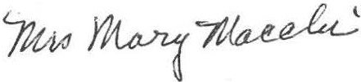

Treiber, Mrs. Caroline Silver St., Sheffield
229-8941
01257

Ullrich, M/M George (Sabina) 229-8910 RD 1, Box 80, Sheffield 01257

Valentine, M/M George F. 229-8719 BowWow Road, Sheffield 01257
ilVanderWerf, M/M Lester S. (Betty)
Park Lane, Sheffield 01257 229-3362
Velmans, M/M Loet (Edith) 229-2709
BowWow Road, Sheffield 01257

Victor, Mr. Donald 528-3742
P.O. Box 248, Great Barrington 01230

Walbridge, Mrs. Rodney 0.
Main St., Sheffield 01257
Warner, Mias Jane

(Marie)
229-7978

64 Northfield St., Greenwich, CT 06830
#Warren, Mrs. J . Wesley (Al:..: <-= ..::... s...t.3 Map'le Ave., Sheffield, 01257
Warren, M/M Edwarl.l { 'fr .!!!'!.•-...,.1 :!29-7730 Sheffield 01257

Welch, Mrs. George Sr. (Christine) Ashley Falls 01222 229-8521

