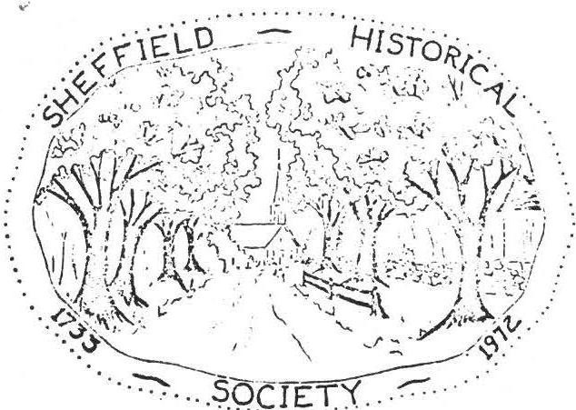
SHEFFIELD HISTORICAL SOCIETY
SHEFFIELD. MASSACHUSETTS
01257

NEWSLEI'TER

Vol. IV, No. 2 December 1976

CHRIS'E-1. S HF.STIJ:rG

The December meeting of the Sheffield Historical Society will begin with a "covered dish supper" at 6:30 on December 10 at Dewey Memorial Hall.
Important req_uest: please bring your O\m place setting-a dinner plate, a cup and saucer, and knife, fork and spoon.

We are very grateful to Helen Woodbeck and her able committee: Mrs. Loring Boardman, N.rs. Edwin LeGeyt, Hrs. Willia...'11. Conklin, and Mrs. Dorothy Dinan, for planning this festive occasion.
Mrs. Wilfred Millet is in charge of the entertainment, which
will follow a short business meeting.

SHEFFIELD: F:tONTIER TO\-Jl'T

With Christmas coming on, we have been pleased with the interest of Sheffield residents, both present and past, in havign Lillian's history mailed out of town. The mail order business is being handled by Art Chase with padded envelopes and postage included in the 75¢
shipping charge. /
Mr. and Mrs. Silk have given most generous assistance in selling
everal hundred autographed copies at the Sheffield PharIT'.acy without a:ny commission beyond the thanks of the Sheffield Bicentennial Com­ mittee. They will stock books through the season--a great Christmas idea for the person "who has everything."

GUILTIWG CO·:'.HI TT

The lucky winner of the diamond-shaped quilt last complete.dby the quilting com.r:u.ttee was A. Lockwood of Wethersfield, Connecticut. Con­ gratulations to the winner!

- 2 -

BRIGGS GRAVESTONSS
On page 86 of Sheffield: Frontier To m is the statement:

"The Briggs quarry was most active following the Civil War, when John R. Briggs received a contract for 100,000 stones for veterans' graves at $2.65
a stone."

Last month one of these marble stones, discarded because of a chipped edge, was set up at the corner of the foundation on which the Briggs mill once stood. To anyone sighting it from Berkshire School Road: No, it's not a new b,µ-y-patch.

SOUTH BERKSHIRE TOUR

During October we were honored by inclusion in the South Berk­ shire tour of the Berkshire Historical Society. Two bus loads of archivists were met by Lillian Preiss at their lunch stop at The Shed Restaurant. She pointed out some of the highlights of early Sheffield history and later escorted the tour to the Old Covered Bridge, the Dan Raymond House, the Parker Hall law office, and the Old Parish Church.
At the town hall Selectman Dwight Ford and Margaret Ford, in their prize-wnining bicentennial costumes, welcomed the visitors to the display of Sheffield's most cherished document, the Sheffield Declaration of 1773.

GOALS COMMITTEE

On November 17th Carl Proper, chairman of the Goals Committee of the Sheffield Historical Society, hosted a meeting of members to dis­ cuss the acquisition and use of the Dan Raymond House.
Emphasis was placed on:

- the priorities in repair and renovation required after the house is ta. en over, /
- the need for a detailed statement of the projected uses of the house after acquisition.

NOVEMBER MEEI'ING

La.st month Jesse O'Hara shared with us some of the fun as well as the hard work involved in researching one's family tree. Jesse is well qualified for such an assignment for he is a member of numerous genea­ logical organizations. He is currently working on research for America."'ls of Royal Descent.
The cheapest way to have your family tree traced is to run for public office.
Charleroi, Pa., Free Press

. . . . . . . . . . .

- I "
_..·,;-1\ :i j:i
.
_ -_ _ ,. Hi sro·n· -.

,. ._-i,
f :;,, ,{ /4'l / ,'.
:r_,._·,• ..".½!\: ,,;-1_ { C·. "' 'T/C' ··

,-_:"Jj?··:<, , _{:7-}
- ;;•i_•,(1-
.:-.?; 1. ,: i-·
.
- -- '.' ·\I -1<_-.
· ':) Y'. ,ii".•. • 0L ;)">• , '-_' ;,,;_, , - ·"'- · ·
. I ' . , . J t i_,.,j . . ' ·. V • \

\i I.• I -;· - ...'h.-c:-- ..._.,, . .:l-.f"r·,,\
: -
. .
_\i'',"f\'.! . .

SHEFFIELD Hl TORICAL SOCIETY

:\ ' ( ' 1M•1•-:,..:, .;;_- ••! ••- .-• J !
., . •
  - :
SHEFFIELD. MASSACHUSETTS

- t"
:J{ '' I.
/ , · \_ : f 1·1 ' '1

'•
\ \ f ; 1. / ."

••. 1,•'
- )' .
\.i I• , J

1 1.s',, · <; '! 4-,
. l ""'"·'=
\ t f I
,-! ;
>;-)'.•' • .' )c
i:-·- , ·_ <-,, v \ . -_
t
----
01257

  - -. tI
-:• j.- ' -· / . .- <, ---- "=, A..i:;_"Jl / '¢?/ _:

-. ,,. • I • \ ,_I'::_. _/ : --
• • • • . . - •· • • ·'

?-:EWSLETTER

Vol. IV, No. 3 March 1977

APRIL MEETING

The She field Historical Society and the Friendly Union
will join forces in presentin the Storrowton Village Dancers at Dewey Hall on Friday, April 1 at 8 P.H. The Historical Society will hold its business meeting at 7:30 prior to the entertainment.

Admission is free to members of' both organizations and
$1 'for non-members.

The Storrowton group, consisting of' a caller and twenty dancers in costume, will demonstrate a variety of period sets that should recall festive evenings at the Ashley House and in the several inn-ballrooms of' colonial Sheffield.

UNA..'¾TI!OUS VOT E FOR DAN RAYNOl-.'D HOUSE

At the Narch meeting the Sheffield Historical Society reached a signal milestone when President -!!il ton Barnum called f'or a vote on the acquisition of' the Dan Raymond House. The 1arge Society attendance approved the purchase of' the house unanimously (or as Theodore Sedgwick wrote at the end of the Sheffield Declaration, Nemine Contradicente.

Near April 1 the Society will col!lp le te the purchase for
$29,500 from r-ril ton Ba rn um and Edward Warren who bought the house in September 197J and generously held it until the Society could raise enough money f'or its purchase. The members may well be prot:.d of' this acquisition which gives an educational center for Shef'field and a home for the Society.

BOUNTI FUL BHE JC...'G'AST

On Saturday, Earch 25, another group was initiated in the delectable rites of' :fireplace cookin g by Carl and Sci.lly Pro p e r . These memorable events bring joy to the guests and cor:1:fort to the Development Fund.

I
A:fter the vote· on the purchase of' the Dan Raymond House Milt Barnum .and Vera Conklin presided over an illuminating and at tirnes hilarious collection of 11s1;,ow-and-tell" i tems.

Among the relics that did not defy identification were Roffer Drury's rer.1:.1r k able wri tin g -and-sh a vin e- desk of a sea-.fn rin g ancestor, 'Marie Walbridge's O?ium pi pe·,(drugs were a problem
way back when) Richard Combes' 18th century tea set of remark­ able origin, and Lillian Preiss' collection of bells :for every animal but the cat. Featured were camel, water bu:f:f'alo, and elephant bells. Reverend Herbert Robinson demonstrated a mechanical check-writer to protect good and bad checks :from being altered. Loring Boardman's 11\'shatzi t" was designed to defeat any energy crisis. (Mr. Schlesinger take notice.}

Vera Conklin's ove·n produced delectable prizes fpr the experts (and not-so-experts) in identification.

PLEDGES DUE

Members and friends who made pledges to the Development Fund f'or purchase o:f the Dan Raymond House have scored a remarkable record in keeping up their payments. As this news letter went to press only three pledges totaling $290 can be said to be due or past due.

A total o:f $9,285 was pledged during the campaign. Of this &mount $'.),100 by :four members is due the day the Historical Society formally takes title to the property. Two more pledg-es totaling S600 are still outstanding because they were ruade
late in 1976 and are not due w1til 1977 or 1978.
It is hoped overdue pledges will. soon be paid, as the funds are needed now :for the work o:f restoration.

Meanwhile new [)ledges by members and :friends to begin the
first stages o:f re3toration would be welcomed.
SPRING FASHION SHmv
On Tuesday, April 26th at 8:00 ?.N. the She:f:field Historical Societ!•:· '
in co-operation with J:.nc-land Brothers in Pittsfi€ld is sponsoring a Sori1c. Fashion Show in the large cafeteria at Mt. Everett Regional School. Twelve tables will be decorated representing each month of the year. Door pri:,,es includinrr the center piece· :from each table will be given away.
Tickets at $2,00 each will be available at the April 1st meetin6 and
as it is important that a minicmm of 200 be sold, the cooperation of' all our members is needed.
Twelve i;,odels ar e' needed, willin to invest one trip to Pitts1'i e ld f o r
a :fi tting---:for the :;>leasure of bein g a u:odel the ni h t of the fashion sh ow.
Every Society mer..b c r is r e s poHsible :for r.iakin ,; a "fancy dess0 r t" :':'-:­ the refreshment table. Contact }lrs. Wi.llia til Elliot at 229-2126 to tell her what you will brine,
Any one willing to work the night of the f'azhion show as ushers or ticket takers, or .J'wd.·tJ.1. any questions---contact Robert Krol at 229-9755.

.,,.. ;
)

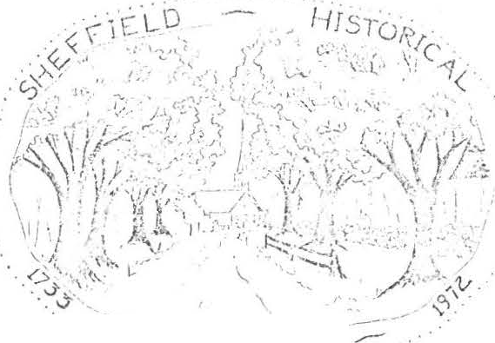S H E F ·r.:. rE L D H IS T O R I C A L SOClC-.:'TY

- - - _.. SQ( i Ct -:<'.
S H E F F IE L !J . M A S S A C H U S E T T S
01257

Vol. nr, No. 4

NEviSJ.E.PTER

SOCIEr TAKES !r£.LE !Q. HOUSE

July 1977

After an enere;etic, three-a.nd-a,-half y ea:r: fund-raising program, the Sheffield Historical Society has taken title to ·the pre-Revolutionary War Dan Raymond House. Work bees have been held to clean up the grounds, anci. a committee is en{,-aged in establishing priorities for necessai-y work to be
done on the house Hself. One room has been set aside to hold acquisitions of the society until a permanent dispaly can be arra.1¥.; d.
Carl Proper reported at the June meeting that he has researched the ownership of the house as far back as 1793, when Dan Raymond sold it to Ezra Fellows.
DEDICATION QE. 1fil OFFICE

A gala eveniug has been scheduJ.ed for Fridayf August 5, when our restored law office will be dedicated. A sign designating the bu.Uding as the office of Parker L. Hall, attorney a-t law, will be inwl;alled, with President MJ.lton Barnum cutting the ribbon.
The dedication ceremony will start at 6 p.m., followed by a community potluck supper. Nancy Boardrww. has graciously consented to serve as chairman of the supper. Unless ahe calls to ask you for something specific, please bring a cold dish for the buffet table. Each person should also bring his own place setting and a folding chair. Iced tea will be furnished. We are hoping to have some informal musical entertainme11t,. Come and bring a friend.
During the afternoon on August 5 from two to five, there will be a display of local history projects made by eighth grade students at Mount Everett Re­ gional School under the direction of Paul Menin and Bill Gillooly. Please en­ courage non-membe s as well as members to see this interesting- group of models, old pictures, family trees, and dioramas. The exhibit will be set up in the Dan Raymond House.
The Bicentennial quilt made by members of the society will also be exhibited there during the afternoon, and chances will be sold by members of the quilting committee. The group is already at work on a second quilt, which will remain the property of the society and will be on permanent display in the Raymond House. Also available at that time will be the tape of an interview with Fred "Doc" Shook. The tape was made at a meeting of the society on May 13.,

, ..

FOURTH ANNUAL AUCTION

Antiques and mi.scellaneous items will be offered !or sale at the society's fourth annual auction to be held Saturday, July 30, at the Sheffield American Legion Hall starting at 10 a.m. Proceeds will be used to start restoration and repair work on the Dan Raymond House. Bill Bra.d.f'ord will conduct the auction.
Assistance is needed to help move auction articles to the hall, to help price items !or the tag sale, and to work during the auction and tag- sale.
If you can spa.re some time before July 30 or on that day, please contact Milton Ba.mum or Loring Ba.mum. Refreshments will be sold by the American Legion Auxiliu,..
THE "BOW-WOW DISTRICT"

We !ear we ma.y have cast an evil impression on the readers of the Courier in writing about "Bow-wow" district, sometime ago, as we do not wish them to infer that we are suoh a noisy neighborhood. That name was given several years a.go, because a number of families kept dogs, which kept up such a continual barking that it was called "Bow-wow," but the name is beco obsolete, as the section is seldom called by that name now.
L.H.
(from The Berkshire Courier of April 5, 1871)

MEMBERSHIP

Dues for 1977-78 are now due. Some memberships were paid at the annual meeting in June, but 1! you would like to join by mail you ma.y send your check to the treasurer now.
Please remit to: Mrs. Marion Ba.rmtm, Sheffield, Mass. 01257
Name
Address-------------

Zip _

Please check:
Cl Junior Member ( under 18 years of age)
C7 Individual Adult Member
a Joint Membership (husband and wi!e)
D Susta.in1¥ Member
.a Business Firm

er Life Member ( exempt i"rom annual dues)
C7 Benefactors ( exempt from annual dues)
$ .50

3.00
5.00
10.00
25.00
- P,.00
1oti.oo

Additional contribution (ta:i: deductible

Amount enclosed...,$

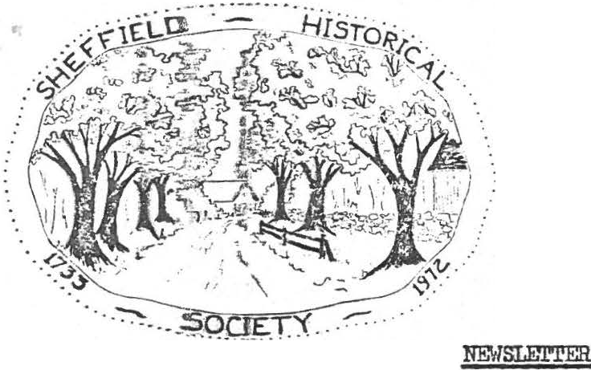
SHEFFIELD HISTORICAL SOCIETY
SHEFFIELD. MASSACHUSETTS 01257

Vol. V., No. 1 November 1977
DECEMBER MEm'ING

A mut}lt'.L,re program will. be presented at our Christmas meeting on Decembmr 9 a.t Dewey Memorial Hall. All we will say is: "Don't miss the surpdsre! fl
V&gima. Drury has graciously consented to serve as chairman of the covered .dim supper, which will start at 6:30 p.m. Her committee requests that eax:ch me bring a complete place setting except for a dessert dish.
Unless «>therwise solicited, each person whose last name begins with the letters .A-Ji are also asked to bring a "meat type" casserole large enough to serve eight. Suggestions: baked beans, macaroni and cheese, meat loaf, scallopred ddcken, fish casserole, etc. Those whose names begin with N-Z should lbri.»g a vegetable dish to serve eight. Suggestions: tossed salad, string lbean casserole, gelatine salad, creamed onions, etc. Please also brilg w.ervisg utensils.
Thie ccmnittee will supply tea, coffee, milk, pies, androlls. Those
few vho .are lllla.ble to bring prepared dishes are invited to make a contri­
bution ftowmd the buying of the beverages, the butter, the cream, the dec­ oratroms, am so forth. Ha.ny thanks f:rom Marion l3arnum, Virginia Drury, Ca.'rlio:a:. Mott_ Muriel Rokos, and Helen Rote•

.Qr!!IIOUSE

Bneakfa.st at the home of Carl and Sally Proper, dinner with Milton and Marl.on JBa.rman. and now dessert vith Lewis and Ruth Leffingwell - all for the benei'i i;: of ihe Sheffield Historical Society! The breakfasts and dinners
have al:-:reao, taken place, and ·those fortunate nough to have been able to partake of ihe sumptuous repasts have said a hearty thank-you to their hosts. At 'botlx boas there wasa convivial gathering in a setting reminiscent of days 1a.-.ng Bll),lle. It wa.s great f'U?l and delicious food for a worthy cause.
Ou. Slmi!a.y afternoon, December 11, Ruth and Lewis Leffingwell will open theJr 1"'q.61 !.ouse, also for the benefit of the society. Guests will enjoy coffee and iressert and have an opportunity to visit a charming old house -
all r just $1.50. Theopen house will run from 2 to 6 p.m. Don't miss
this one!

, - 2 -

DAN RAYMOND HOUSE NEWS
Our current exhibit at headquarters is a collection of tinware belonging to Richard Combes. This display will continue through April, when another exhibit will be shown.
A lady from Spencertown, N.Y., visited the house recently to see our slide/ tape show. She is preparing one for her town.
. The D.R.H. Committee is planning a "bring-a-teacup-or-teaspoon" party for in an effort to build a collection of cups for the society's use. There
will be a special exhibition of dolls and doll furniture at that time.
Don't forget our annual auction on July 28. If you have anything to donate, let Milton Barnum know.

RECENT DONATIONS

The following articles have recently been donated to the society: a letter opener which belonged to President Willia.m McKinley from Barbara Hurlburt Brooks; a painting of Sage's Ravine and a watercolor sketch of Mount Everett Regional School by Walter Cole from Willard French; an advertising souvenir of Cassidy Brothers store from Josephine Hamilton; four place settings of ironstone from Carl Proper; and two lovely cups and saucers from Marion Barnum.
SHEFFIELD'S OLD COVERED BRIDGE
Although not a historical society project, strictly speaking, there is no group in town which should be more interested in the preservation of one of Shef­ field's most cherished landmarks than our society. We cherish it not only for
- its aesthetic and historical significance but because it stands as a testimonial to the skill and ingenuity of our forefathers.
The Connecticut River Valley Covered Bridge Society has donated $500 to the Sheffield Historical Commission toward the preservation of this historic struc­ ture, and the National Society for the Preservation of Covered Bridges has donated another $500. These funds will be used to match a grant from the Massachusetts Historical Commission, if our application is approved. The selectmen have agreed to insert an article in the town meeting warrant asking for an appropriation of
$5,000 toward the restoration of the bridge. A concerned citizen has promised to underwrite the cost of hiring Milton Graton, the foremost covered bridge builder in the country, to come to Sheffield as a consulta t.
A broad base of support for the project will help immeasurably in our quest for funding. Anyone who would like to contribute toward saving a valuable Shef­ field antique, probably the olnest covered bridge in Massachusetts, may send a check to the Sheffield Historical Commission for the "Save the Bridge Fund,"
% Lillian E. Preiss, chairman of the s.H.C., Sheffield 01257. Charles Kuralt has
noted that America has lost half her covered bridges in the past twenty years by flood or by neglect. The Connecticut River Valley Covered Bridge Society has adopted
as its motto, "Remove not the ancient landmark which thy fathers have set." (Prov. 22:28)
MEMORIAL FUND
Over $400 has been donated to a fund established in memory of Kurt Preiss, who passed on February 4. He was a willing worker in many of the society's projects, and he would be pleased to know that its goals are being furthered in such a way.
Lillian wishes to express her heartfelt gratitude to those who contributed so generously to this fund.

.. . .. .. . .....

SHEFFIELD HISTORICAL SOCIETY
SHEFFIELD, MASSACHUSETTS
01257

NEWSLErTER

Vol. V, No. 2 April 1978

SHEFFIELD HISTORICAL SOCIETY CALENDAR - .12I§.

April 14
April 17
April 25
May 12
May 27, 28

June 9
July 29

Sept. 8
Regul meeting - ! Place!!l
Price Chopper fund Day

:i'ashion Show Regular meeting Flea Market AnnUct.l meeting Auction
First meeting of 1978-79

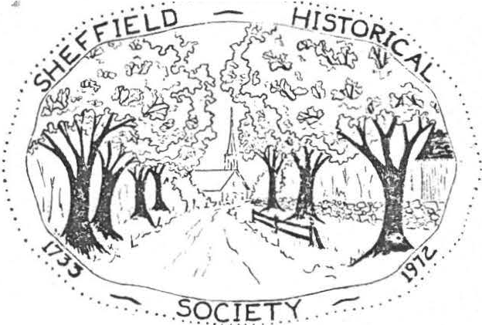
! PLACE Jl!

"It's been done in other places in the country and after all we've got this beautiful heritage, why don't we make the most of it?" Does this sound as though it might have been spoken in Sheffield? It's the way Paul Steinhardt, narrator to a film produced last year by the National Trust for Historic Preservation, sums up what preservation is all about.
The film,!, Place .!!2, , features 25 historic preservation efforts in 14 states. New Hampshire filnsker John Karol spent two years travelign around the country talking with preservationists about their projects.
The premiere of the film was held last April at the Faneuil Hall Market­ place in Boston.
We are very fortunate to be able to see this film, courtesy of Holger Oleen, at our next meeting. Come and bring your friends - April 14 - Dewey Memorial Hall - 7:30 p.m.
PRICE CHOPPER !!!!ill, M!

April 17 has been designated as s.H.s. Fund Day at the Price Chopper Supermarket in Great Barrington. Five percent of all money spent at the supermarket that day by p rsons presenting a s.H.s. Fund Day card wnl be returned to our society. Cards will be available at our next meeting or from :Mi lton Ba.mum or Lillian Preiss now. Plan to stock: up your pantry on April 17th!

..

z,.

- 2 -
FASHION ..§.fillli. - APRIL £2

Again, through the courtesy of England Brothers and Bob Krol, we will sponsor a spring fashion show. It will be held at Mount Everett Regional School on April 25 starting at 7:30 p.m.
The theme for decorating the tables this year is "Holidays." There are a few tables and holidays still awaiting the imagination of some willing hands and minds. If you have not yet signed up to decorate a table, see Bob Krol to choose a holiday and ask Marion Barnum for a $10 check to cover ex­ penses.
Marion Elliott is chairman of the refreshment table. If you will make a dessert for the table, please call her at 229-2126 and let her know what you will bring. Tickets ($2.50) will be available at our meeting April 14. It's not too early to start telling your friends about this festive occasion. It was great fun last year. Let's see if we can top it this year.

Do you have May 27 and 28 ma.riced in red on your calendar? Those are the dates for our "first annual" flea market to be held on the Massini and Wilhelm properties on Route ?A. Carl Proper, general chairman, has been working for months with Henry Coger, manager, to make thi·san event worthy of perpetuating. It could be a major·fund-raiserif we all work together to make it a huge success. More details at our April 14 meeting.

1QQ CABIN QUILT

The S.H.s. quilting committee has completed another beautiful quilt. Currently being raffled are tickets for a log cabin quilt in bright, har­ monizing colors. Tickets may be obtained at $1 each from Vera Conklin or Marion Barnum and will be available April 14 and April 2,5.

PROGRESS .Q!! RAYMOND HOUSE

If you are in the vicinity of the Dan Raymond House while the workmen are there, stop in to see what is being done. In accordance with a vote taken at the March meeting, we have secured a $10,000 mortgage for ten years.
This will enable us to prepare an apartment so that there will be someone living on the premises. The roof has been raised toward the west and shingled, the interior walls are up and the sheetrock on. Plumbing and electrical work is under way, so before long it will be ready for occupancy.

M! STATE HISTORICAL LEAGUE
At our March meeting we voted to apply for membership in the Bay State Historical League. The quarterly meetings of the League feature interestgin and knowledgable speakers, and the bulletins contain information applicable to all historical societies. '.Phe next meeting of the League will be held in Worcester on April 15. For more information see Lillian Preiss.

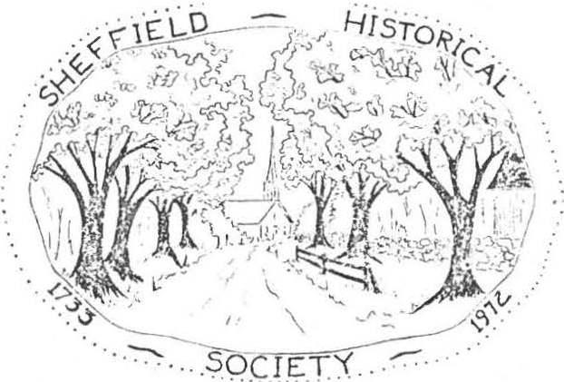
•• . ............

SHEFFIELD HISTORICAL SOCIETY
SHEFFIEL D, MASSACHUSETTS
01257

NEWSLEI"l'ER
XXJOOCOJ!XX
LKXXX.XXX.XX '
. Vol. V, No._2) July 1978

OPEN HOUSE AND PICNIC

All members, friends, and other interestedmembers of the community are invited to attend an Open House and picnic at the Dan Raymond House on August
4. Nancy Boardman has again consented to serve as chairman for the picnic·, which will begin at 6:30. She requeststhat everyone, except those called
for socrething specific,bring a covered dish for the buffet table, his own place setting, and a folding chair.
There will be three showings of an audio-visual history of Sheffield - at 2, 4, and 7:30. The slide show will be presentedin the large meeting
room of the Dan Raymond House. Bill Gilligan has offered the society a carousel projector on more or less permanent loan. Mr. and Mrs. Charles Schumann have given a cassette recorder-player. We a.re grateful to these generous peopl.e
Other recent acquisitions are the followig:n an 1801 map of Massachusetts
donated by Howard Crockett, two silver spoons decorated with Sheffield scenes donated by R. w. Smith of Lee, books and a. sand shaker inscribed "S. R. Kellogg"
given by Willard French, an inkwell with sand shaker from Lillian Preiss, book and pictures from Rachel Willcox, book from }1arion Barnum, album of Sheffield pictures from the Ballston Spa Public Library, a silver spoon made by a Shef­ field silversmith from Ruth Gordon Ellis, and an 1817 indenture paper witnessed by James Bradford from Irene Armstrong.
These artifacts, as well as other.s previously acquired, will be on view during the open house in the Dan Raymond House and the Par er L. Hall law office. Members who have other pertinent material they would be willing to show may con­ tact any member of the open house committee: Arthur C se, Lillian Preiss, Marion Barnum, Irene Crd.l11Jler, or Muriel Rokos.
There will be a mystery table holding pictures and objects for visitors to identify. The person who succeeds in identifying the greatest number cor­ rectly will win a prize of a can of Sheffield maple syrup donated by Arthur Chase. Duplicate prizes will be awarded in case of tied entries.
A check representing the proceeds from the antiques flea market held on May 27 and 28 will be presented to President Milton Barnum by Carl Proper, chairman of the flea market.
The second Sheffield historical quilt and the log cabin quilt ma.de by the society's quilting committee will be on display, and raffle tickest will be sold.
The house and law office will be open on August 4 from 2 to 6:30 and from 7:30 to 8:30. Hostsand hostessesare needed for both locatoins to serve for two-hour shifts. Anyone who is willing to act in this capacity should let a member of the committee know the time he can be there.

- 2 -

PAUL IVORY TO SPEAK

Paul Ivory, administrator of Chesterwood, will presenta program for the Friendly Union and the historical society on November 17 at Dewey Memorial Hall. The historical society's business meeting will be held on its regular meeting date, November 10, but all are encouraged to attend this informative program on Chesterwood.

NEW LOGO??? I

It has been suggested that a new logo more suggestive of the society's present concerns would be desirable. Our current logo served its purpose as the organization was coming into being, but now that we have acquired a head­ quarters house and are developing a program for its use, perhaps a more per­ tinent symbol is in order. Members of the society are asked to think about this suggestion and offer opinions. No change will be made without membership approval.

July 29

August 4
September 8
October 13
November 10
November 17
CALENDAR

Auction and tag sale Open house and picnic First meeting of 1978-79 Regular meeting
Regular meeting
Combined meeting with Friendly Union - Paul Ivory AUCTION

Our fifth annual auction and tag sale will be held on July 29 at 10 a.m. at the American Legion grounds. Articles for the auction are urgently needed. If you have somethingto donate and wish to have it picked up, you may call Milton Barnum at 229-2569 or Loring Boardman at 229-7750.

WEDDING ANNOUNCEMENT
From the Berkshire Courier of' 1842:

At Sheffield on Thursday evening by Rev. Mr. Erad.ford - Jeremiah Shears Esq. to Mrs. Florilla Lamb
"What if the Shears are old and rusty What if the Lamb is young and frisky A faint heart ne'er a victory won, Persevere - the Shearing is done!"

MEMBERSHIP COUPON

Dues for 1978- 79 are now due. Some memberships were paid at the annua.l meeting in June, but if you would like to join by mail you may send your check to the treasurer now. Please remit to: Mrs. Milton Barnum, Sheffield, MA 01257 Individual member, $3; Joint membership, $5; Sustainingr $10; Life members, $50.
-------------

Name
Amount enclosed
Address

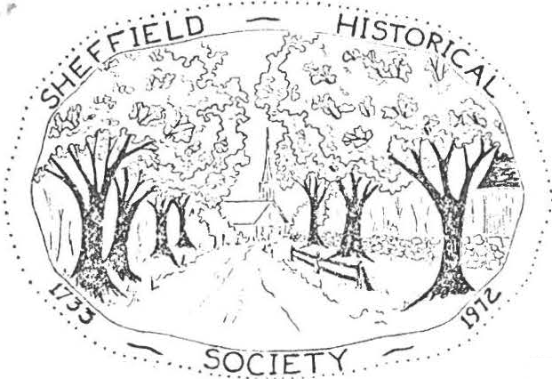
r

SHEFFIELD HISTORICAL SOCIETY
SHEFFIELD. MASSACHUSETTS
01257

NEWSLErTER

Vol. VI, No. 1 November 1978
CHRISTMAS MEETING
The menu for our December meeting includes an appetizerof Christmas gaiety, an entree of reverence in keeping with the season, and a dessert of Christmas music. Traditionally, this meeting has included a holiday dinner and entertainment rather than a serious discussion.
Virginia Drury, our ingenious chairman for the dinner, has enlisted a superb committee to help with a great idea: each table will have its own roast turkey together with the familiar accompaniments. Various society members have been asked to help with the cooking, for which everything will be furnished by the committee. The charge for the dinner will be a modest
$2!
Virginia has asked that each person bring his own place setting: din­ ner plate, dessert plate, cup and saucer, and silverware. Napkins will be furnished. Remember - December 8, 6:30, Dewey Memorial Hall.
CHRISTMAS OPEN HOUSE
Do you remember our gala open house in December 1973, before we had ac­ quired the Dan Raymond House? If you do remember, you'll surely want to come this year, and if you don't remember, you'll most certainly want to come this year.
The Dan Raymond House, decorated for Christmas, will be open for the whole community from 4 to 7 p.m. on Sunday, December17. Simple refreshments will be served. All membersare encouraged to invite their friends. We are hoping to make this a community-wide tradition.

REGULAR HOURS AT-T-HE-DAN RAYMOND HOUSE

Anauspicious beginning for opening our headquarters to the public on Fri­ day afternoons from 2 to 4 has been reportedby the Dan Raymond House committee. On the first day, October 27, we had visitorssteadilyfrom 2 to 4; on the third day the hours lengthened to 4:45. It has been most gratifying.
Alice Hurlburt of the Berkshire Courier, Dick Delmasto of the Berkshire Eagle, and Bernard Drew of the River Valley Chronicle have taken pictures of the quilt and will have a story for their respective papers.
The committee, consistignof Marion Barnum, Alice Ann Chase, Ethel Mert­ ching, Lillian Preiss, Carl Proper, and Muriel Rokos, is formulating goals for the house, drafting an accessions policy, opening during regular hours, planning exhibits, planning educational programs, maintaining a sales table, showing our historical slide/tpae program on request, selling raffle tickets, and opening the law office for visitors.

- 2 -

' Carl and Irene Cranmer will be host and hostess there on the day after Thanksgiving, and Lillian Preiss will show the slide-tape history at 2:30 p.m.
CURRENT EVENTS

Items for our 6th annual auction and tag sale are already coming in, Pres­ ident Barnum has reported. Keep your eyes peeled for articles which you can add to this July 28th event.
Our society contributed toward the cost of the public address system at Dewey Memorial Hall so that all may hear what is being said. Each paying one third of the cost.were the S.H.s., the Freindly Union, and the Council on Aging.
There's always work to be done at the Dan Raymond House, as any homeowner knows. On one day recently a group of members - Milton Barnum, Lewis Leffing­ well, Carl Proper, and Ed Warren - put a new roof on one side of the pottery shop behind the house. On Veterans Day a clean-up crew raked leaves, cut brush, and spruced up the grounds. Workign outside on a beautiful November day were Loring Boardman, Arthur Chase, Lewis Leffingwell, Kurt Preiss, and Charles Schumanr..
PRICE CHOPPER-FU-ND-DAY
December11 has been designated S,H.S, Fund Day at Price Chopper in Great Barrington. We tried to get a date before Thanksgiving, but the chQice dates had all been spoken for. Next year we'll have to start earlier.
Fund Day cards will be available at the Dan Raymond House and also at our December 8 meeting. Remember: five percent of all funds spent at Price Chopper on December 11 will be returned to the society, but you must present a pink card at the time of purchase in order to have the amount credited to the society.

MEMBERSHIP
Every once in awhile we hear rumors that some people think of the histor­ ical society as a closed corporation. Nothing could be further from the truth! Let's all work to dispel that bit of fiction. Although we have an appointed membership committee - Agnes Boardman and Nancy Boardman - each member of the society should consider himself a part of the membership committee. Spread the word wherever you have an opportunity. We heartily welcome participation of all kinds - membership, attending meetings, and visitign the house. Agnes and Nancy will have more on this subject anon.
-DO -Y-OU -S-A-VE -T-OP -V-A-LUE-ST-AM-PS-?

The Dan Raymond House has need of many items that could be obtained at the TV stamp redemption store; for example, lamps, tables, coffee pot, clock, house­
keeping accessories, etc. If you save TV stamps but don't have time to paste them in the books, you're welcome to donate loose stamps to the house committee. If you wish to donate completed books, the committee will thank you doubly!
LEl'TERS -T-O-THE EDITOR
Do you have a helpful idea to share with other members? Here's a vehicle
for communicating with like-minded people. Short letters of consrtuctive com­ mentor suggestion regarding the society or the newsletter will be published in future issues. Please send to Arthur Chase or Lillian Preiss, editors. Address simply: Sheffield, MA 01257.

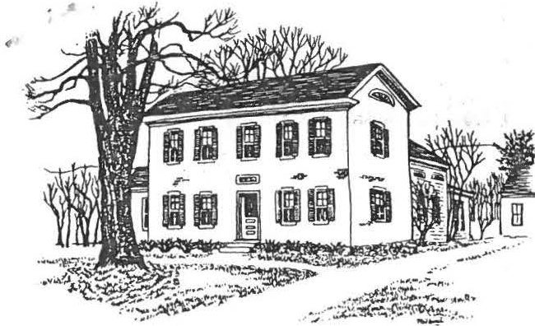

DAJ( RHMOND H>US1:

SHEFFIELD HISTORICAL SOCIETY
SHEFFIELD, MASSACHUSETTS
01257

Volume VII, No. 1 Fall, 1979

Welcome back to all members from summer vacations and related activi­ ties. The executive committee is looking forward to a productive year and· has been busy on plans for the fall, so get out your calendar to mark down a few events.

REGULAR MEETING DATES (7:30, Dewey Memorial Hall)

September 14. Gerard Chapman, noted Berkshire County historian
_ will speak on the Erie Canal.

October 12. Martha Greene will present a program on the Mahican Indians on the Housatonic. Bring arrow heads or other Indian items for dating.

November 9. " 'Know all men by these presence.' Searching the old records," a program by Paul Greene and Harry Conklin explaining the operation of the Registry of Deeds. Find out how to learn the history ?f your house.

December 14. Our traditional Christmas dinner, again headed by Virginia Drury. She will be contacting some of you for assistance as the holiday season approaches. Bring your own place setting. ;

The program for winter and spring has many openings so make your interests known. If you know of somebody who could offer a good program, or if you would like to present a program of your own contact Catherine Miller, 229-8668.

OTHER DATES OF IMPORTANCE

October 6, 7, and 8. Covered Bridge Days. The Sheffield Histor­ ical Commission has put together an ambitious fund raising week­ end to help save our local landmark. The event will be centered at Westenhook Gallery and feature crafts, art work, silent auction and refreshments. On Sunday, October 7, a radio telethon sponsor­ ed by Kiwanis, Rotary, Lions Club and station WSBS will be held.
Call in your pledges. Help support this local cause with your contributions of food, labor and patronage. The Commission is now _ halfw;1y in its local drive for $25,000. Have you contri­ buted yet?

. ,

OTHER DATES OF IMPORTANCE -- (continued)

page 2

December. Dan Raymond Christmas openhouse. Date to be announced.

The Executive Committee announces the following Committees for 1979-80.

DAN RAYMOND HOUSE COMMITTEE: Lillian Preiss, Chairman; Marian Barnum, Ethel Mertching, Muriel -Rokos, Alice Ann Chase, Carl Proper.

CURATOR: Lilliam Preiss

CURATOR OF PHOTOGRAPHY: Chris Coenen

ANTIQUES SALE: Carl Proper PROGRAM: Catherine Miller REFRESHMENTS: Rachael Willcox NEWSLETTER: James Miller
REMINDER -- It's time for annual membership dues. Rates are $3.00 single membership, $5.00 for family membership. Or, if you prefer, life membership is availab e for $50.00 per individual. If you have not done so, pay Marian Barnum at a regular meeting or mail payment to her.

This is a good time to get after that friend who has been talking of joi ing. We have good programs, good causes and lots of fun.

OF THINGS PAST -- Our annual antiques auction and tag sale netted
$2,400.00, good new.s for our ongoing program with the Dan Raymond House.
Many people worked hard to bring this continued success. By Christmas we hope to have the keepingroom taped and painted, and the windows and door trim completed for the open house. '

The Doll Show last June was a huge success with about seventy-five people attending. Exhibitors included Louise Stevens, Maria Barnum, Ruth Leffingwell and Carl Cranmer. Plans are for another show next year. New dolls are being sought so talk to your friends and search the attic and closets,

a

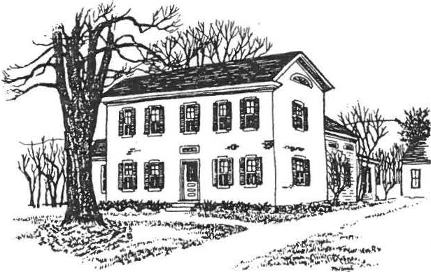
SHEFFIELD HISTORICAL SOCIETY
SHEFFIELD, MASSACHUSETTS

01257
Volume VII, No. 2 Winter, 1979-80

Merry Christmas and Happy New Year to our members and friends, both old and new. We do have some of both to report on, people whose contri­ butions in time, money, talents, or donations have made this year very successful and cause us to look eagerly ahead to the coming year. But more of that later in the Newsletter.
REGULAR MEETING DATES (7:30, Dewey Memorial Hall unless otherwise
noted.)
December 14. Our Traditional Christmas Dinner, 6:30 p.m. Note the special time. Tickets must be purchased in advance,
$2.50, from Ethel Mertching, 229-8427 or Mount Everett Lumber, 229-8777. There is a limit of 90 tickets. According to Virginia Drury, chairperson, the dinner will be a duplicate of last year featuring stuffed turkey, squash and creamed onions, rolls, cranberry sauce, and coffee/tea with pumpkin or apple pie for dessert.
Bring your own place setting of dinner plate, dessert
plate, cup and saucer, and flatware.
The evening will feature traditional holiday readings by Timothy Chung and Scott Kalicki of Great Barrington plus Christmas caroling to the music of our own Madge Valentine.

January 11. Dig in to your old trunks and closets. Milton's favorite program - Show & Tell.
Refreshments: Alice Ann Chase, Sally Proper, Margaret Philbrick.
February 8. The Society's curator of photography and faculty member at Berkshire School, Chris Coenen, will give a brief, illustrated history of photography.
Refreshments: Charlotte Oleen, Margaret Jones
March 14. Doreen Young, faculty member at Simon's Rock Early College, Board of Directors of Arrowhead, will draw from her vast knowledge and experience in things historical to bring us the evening's program.
Refreshments: Lillian Preiss, Marion Barnum, Marie Walbridge, Richard Combes.

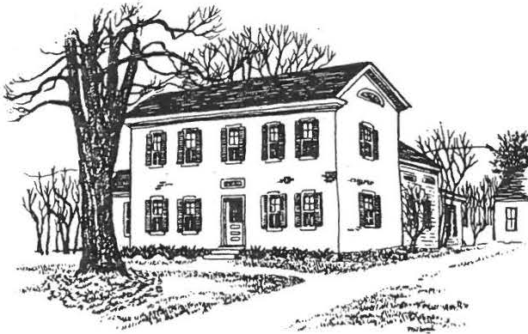
SHEFFIELD HISTORICAL SOCIETY
SHEFFIELD, MASSACHUSETTS

01257
Volume VII, No. 2 Winter, 1979-80

Merry Christmas and Happy New Year to our members and friends, both old and new. We do have some of both to report on, people whose contri­ butions in time, money, talents, or donations have made this year very successful and cause us to look eagerly ahead to the coming year. But more of that later in the Newsletter.
REGULAR MEETING DATES (7:30, Dewey Memorial Hall unless otherwise
noted.)
December 14. Our Traditional Christmas Dinner, 6:30 p.m. Note the special time. Tickets must be purchased in advance,
$2.50, from Ethel Mertching, 229-8427 or Mount Everett Lumber, 229-8777. There is a limit of 90 tickets. According to Virginia Drury, chairperson, the dinner will be a duplicate
of last year featuring stuffed turkey, squash and creamed onions, rolls, cranberry sauce, and coffee/tea with pumpkin or apple pie for dessert.
Bring your own place setting of dinner plate, dessert plate, cup and saucer, and flatware.
The evening will feature traditional holiday readings by Timothy Chung and Scott Kalicki of Great Barrington plus Christmas caroling to the music of our own Madge Valentine.
January 11. Dig in to your old trunks and closets. Milton's favorite program - Show & Tell.
Refreshments: Alice Ann Chase, Sally Proper, Margaret Philbrick.

February 8. The Society's curator of photography and faculty member at Berkshire School, Chris Coenen, will give a brief, illustrated history of photography.
Refreshments: Charlotte Oleen, Margaret Jones
March 14. Doreen Young, faculty member at Simon's Rock Early College, Board of Directors of Arrowhead, will draw from her vast knowledge and experience in things historical to bring us the evening's program.
Refreshments: Lillian Preiss, Marion Barnum, Marie Walbridge, Richard Combes.

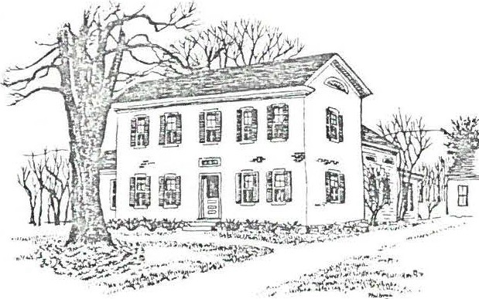
DA /'I RAYMOND HOUSE
SHEFFIELD HISTORICAL SOCIETY
SHEFFIELD, MASSACHUSETTS
01257

Volume VII, No. 3 Spring, 1980

Spring is here. Just last week we saw our first flock of robins and if that doesn't bring to mind milder weather and a new round of Society summer activities nothing does.

It has been an eventful fall and winter for the Society and the town of Sheffield, the most noteworthy event for the community being the success­ ful completion of the fund raising for the old covered bridge. Our society made a sizeable contribution to the drive. More of that later in the News­ lett r.

REGULAR MEETINGS AND SPECIAL EVENTS. All meetings at Dewey Memorial Hall, 7:30, unless otherwise noted. Mark your calendar.

April 11. Lee Wool, Mill River, will provide a program on hats, a subject appropriate to the spring season. More importantly, it will be informative and amusing.
Refreshments: Frances Warren, Irene Armstrong.

May 9. Anthony King, executive director of the Berkshire County Historical Society will show a short film entitled "Berkshire Legacy". It deals with the lives of five Berkshire County resi­ dents whose impact on history has been felt-l-law thorne, Melville, Wharton, French, Rockwel.l
Refreshments: Olive Gaylord, Vera Conklin, Trudy LeGeyt

May.31. Outdoor Antiques Show. Be sure to save this date as much help will be needed. Carl Proper is again in charge.

June 13. Our Annual Dinner Meeting under the capable direction of Mrs. Helen Rote. Dewey Memorial Hall, 6:30. Note the time change.

July 13. Box lunch social. Here, men, is a chance to meet that special girl. Each lady will bring a fancy box lunch to be auc­ tioned off to the highest bidder--that's where the men come in because they get to share it with the one who prepared it. But that's not all. We hope to have a blacksmithing demonstration too. A fund and fun raiser for the Society at the Dan Raymond House, beginning 1:00 p.m. Wear historical costumes.

page 2

REGULAR MEETINGS AND SPECIAL EVENTS -- (continued)

July 26. Annual Historical Society Auction and Tag sale. We desperately need items for this important and traditional fund raising event so don't throw out that Queen Anne table, donate it to the auction. The success of this event hinges on your donations and any contributions will be gratefully appreciated.

September 12. First meeting of the fall. No program yet. What do your suggest?

OF THINGS PAST --

Only eight months into the effort, the old covered bridge fund reached its goal. At the regular February meeting, President Milton Barnum announced the termination of the drive to attain
$25,000 to qualify for a matching grant to restore Massachusetts' oldest covered bridge on Covered Bridge Lane, Sheffield. Lillian Preiss, Chairman of the Historical CoDWlission, began the drive that saw donations come in from across the country.
Stabilization work to protect the structure from winter and spring weather began last November when local volunteers, guided by the restoration project's chief engineer, Milton Graton, in­ stalled five cables to straighten and anchor the bridge. The remaing work will soon be underway. Our fall Newsletter will have details.

DAN RAYMOND HOUSE NEWS

Art Chase has a display in our headquarters on the history of maple sugaring. Art is a well known member of the society who operates a sugar bush in town. The house and his display of artifacts are open to the public each Friday afternoon from 2:00 to 4:00. Drop in and bring a friend.

Richard Combes was kind enough to donate a collection of Antiques magazines to the society and they are housed there also. They are available to the public if anyone has a need to use them.

NEW MEMBERS

Mr. and Mrs. Mr. and Mrs.
Albert Scherer Robert Ledlie

Mr. and Mrs. Gordon Granger Mr. and Mrs. Arnold Brewer Mr. and Mrs. Gilbert Malnati Miss Helen Hurlburt
Mr. and Mrs. Howard Mott

a

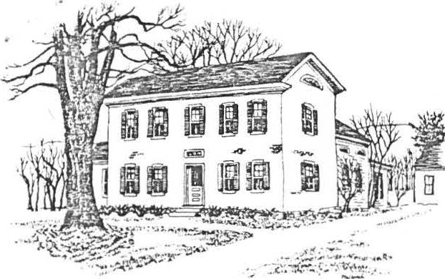
Dear Member:

SHEFFIELD HISTORICAL SOCIETY
SHEFFIELD, MASSACHUSETTS

01257
Volume VIII, No. 1 Fall, 1980

We are anticipating an unusually productive year and hope to have the active support of all members, whether it be in the form of a time commitment, ideas or contributionsof material, or financial support. The program committee has put toge ther the following fall schedule for your enjoyment and edification and we hope to see you there. Please mark your calenda.r
REGULAR MEETING DATES (7:30, Dewey Memorial Hall)
September 12. Chris Coenen will show slides depicting some of the ac­ tivities of the past year in the Society, such as the Antiques Fair, Auction, Box Lunch Social, and an added attraction -- Covered Bridge Days.
Refreshments: Ethel Mertching, Irene Cranmer, Alice Schumann, Caroline Treiber
October 10. Edward Winslow will give a program on the history of paper and paper making, including modern techniques and uses of paper. Mr.
Winslow is a teacher of physics at Berkshire School and has exhibited water color paintings locally, many done on paper he made himself.
Refreshments: Rachael Willcox, Alice Hurlbur,t Marian Willcox, Bessie Coons

November 14. Paul Shafiroff will speak on The Art of CoZZectin.g
Why

people collect and Refreshments:
some of the "hows" of antiques collecting.
Agnes Boardman, Marian Garrahan, Carmella Delmolino, Cathernie Miller

December 12. Annual Christmas Dinner and Program. Virginia Drury has again agreed to head up the committee. She will be calling on some of you for assistance as the season approaches. Bring your own place set­ ting. This event will begin at 6:30.
The program schedule for winter and spring still has some openings, so if you have suggestions to make or if you have a special interest, make them known to Chris Coenen, program chairman.
A MESSAGE FROM PAST PRESIDENT M. BARNUM
Dear Friends:
As your immediate past President, I would Zike to take this opportunity to thank you aZZ for the fine support you gave the Society and me dur­ ing the past four years. We have come a Zong way with our house, and in addition to the constructi,onhave received many items for it. But more importan,t we are being noticedin the town, county, and state. We have had friends from other Societies teZZ us how amazed they are that our Society, in such a smaZZ town, can do so much.

A MESSAGE FROM PAST PRESIDENT M. BARNUM -- (continued)
page 2

Friend,s it is because of people like you who care and are interested
in preserving what we can of history that makes it all possible. For instance, one day in the early part of June, Lillian Preiss escorted seventy-two students through our grounds and building, and explained life in the early days. When you see school children that interested in what we are doing then our perspiration turns to tears of joy.
Again, thank you for the privilege of serving you these past four years. I hope we can all support Catherine in her efforts with the same energy that you supported me.
Milton
THE ANNUAL MEETING
The following officers were elected at the annual meeting in June.
PRESIDENT: Catherine Miller
VICE PRESIDENT: Christopher Coenen SECRETARY: Agnes Boardman TREASURER: Marion Barnum
TRUSTEES: Arthur Chase (continuing)
Lillian Preiss (continuing) Milton Barnum
Committees: (first listed chairman)
DAN RAYMOND HOUSE: Marion Barnum, Alice Ann Chase, Ethel Mertching, Muriel Rokos, Lillian Preiss
DAN RAYMOND HOUSE GROUNDS: James Miller, Loring Boardman,
Caroline Treiber, Arthur Chase, Margaret Philbrick
DAN RAYMOND HOUSE FURNISHINGS: Carl Proper, Milton Barnum,
Richard Combes, Ruth Gordon Ellis, Lillian Preiss CURATOR OF PHOTOGRAPHY: Christopher Coenen
NEWSLETTER: James Miller, Grace Arzt PUBLIC RELATIONS: Lillian Preiss ANTIQUES FAIR: Carl Proper, Sally Proper AUCTION: Milton Barnum
TREASURER OF DEVELOPMENT FUND: Viola Bagnaschi
A report from Dan Raymond House committees will be given at the September meeting and will subsequently be reported on in a newsletter.
REMINDER -- It's time for dues again, still available at the popular prices of yesteryear. Single membership is $3.00 and family membership $5.00. If you are unable to attend a regular meeting, dues can be sent to Marion Barnum, Sheffield, MA 01257. Why not encourage a friend to join. We have many good causes to promote and the refresheemnts themselves are worth the membershi.p
OF THINGSPAST -- In May we again had a most successful Antiques Show under the chairmanship of Carl Proper. It netted the Society $4 ,000. This was followed in July with the annual auction which yielded $2,400. The bulk of this money is to be used toward an ambitious program for rebuilding and furnishing the Dan Raymond House property.

page 3
OF THI::GS Pc\ST -- (continue,l)
Society members enjoyed a box lunch social on the grounds of the Dan Raymond House on Sunda·, July 13. A part of the day's activities included a black­ smithing demor 3tration and a slide presentation on the history of Sheffield.
Dur -n - July ar ex'., i bit of cov2red bridge artifacts and souvenirs was on dis­
play ac the Dan Raymond House, followed by a doll show in August.
Lillian E. Preiss, past president of the Society, was elected a director of the Bay State Historical League this su mmer.
Although not a function of the Society, The Sheffield Historical Commission, you will be happy to learn, was chosen by the Massachusetts Historical Com­ mission for an award for its efforts in preserving the old covered bridge.
The local Commission raised $25,000 this past year toward the restoration which was matched by the state Commission.

* * * * * * * * * * * * * * * * * * * * *
* *
* *
- NECROLOGY *
* *
- Carl. C. Cranmer *
- Rel.en L. Washburn *
*
*
* *
* *
* * * * * * * * * * * * * * * * * * * * *

a

