SHEFFIELD HIS T O R I C A L SOCIETY
SHEFFIELD. MASSACHUSETTS
01257

NEWSLEI'TER
Vol. I, No. 5 July 1974
PRESIDENT I S AfTI-llJAL REPORT
This has been an eventful and excitign year. Our celebration of the "Sheffield Declaration" last summer has had far-reachingrepercus­ sions:
Several people from other towns have joined the society as a resultof attending the three-day even.t
Fred Bellinger of Stamford, producer of a Bicentennial film, came to Sheffield to photograph the Declaration and was given a transcribed copy of the text. In his letter of appreciation for the help received, he wrote: "In preparing our Bicentennial motion picture we occasionally 'discover• fascinating things as we go along. The Sheffield Declaration is perhaps the most fascinating item we have come upon as yet."
Art Chas'es well-researched, wwelll-written, and well-acted play, "All This Freedom Talk," has come to the attention of William Miles, executive director of the Berkshire County Bicentennial Committee, who is very interested in the prospect of producing it for a wider audience.
The parade, the piano concert by Arthur Greene, the historical exhibits, and the crafts demonstrations gave a great deal of pleas­ ure to thousands of people.
During the past year, Muriel Rokos, program chairman, organized a series of diverse programs- interestin,g informative, and entertainnig. Speakers includedEllen Kenney Glennon of the Hitchcock Chair Compan;y Harold Travis and Roy Dickson of the Weston Historical Society, who were largely responsible for the restorationof the Isaac Fiske law office; Polly Pierce, who spoke on the Sedgwick family; Wes Warren giving us a history of the postal service in general and Sheffield postoffices in par­ ticular; and Miss Elizabeth Ryder and Nrs. Marian Finke, who spoke on little-known aspects of well-kno'\,,Jl gems and precious metals.

Other programs attracting ent usiastic audiences were the Christmas party a the Little House; the historical "show and tell," which may well becomean annual event; and the dramatic "This Is Your Life" program, in which Milton Barnum, the protagonist, demonstrated his mettle by recover­ ing rapidly from the surprise and responding to the plaudits with a well­ turned quip. Vera Con. lin and her refreshment committee rovided a pleas­ ant finale for each program.

- 2 -

Donations to the society this past year included a munificent gift of about eighty old books fo-:: the law office, given by Nrs. Randolph Brown of Minneapolis; a letter opener belonging to President NcY.inley, who used it while he was in be White House, and two books on early blue laws, Nrs. Barbara :arookis of Hartford; a beaded cape, beaded bag, and an 1860 -61 School Committee Report, Hartin Leaf­ green; old pictures, Jane Warner, Alice Warren, Helen Straleau, and Mrs, Charles Cuccio; copies of the Pine Knoll Register, Wes Warren, Jay Clarke, and Holger Oleen; an 1864 letter from Orville Dewey to Lucy Smith, Howard Mott; old history books and gazetteers, Lillian Preiss; and other memorabilia given by friends cf Sheffield. '

A committee consisting of Mari.onBarnum, Agnes Boardman, Winnie Clark, Vera Conklin, Irene Cra er, Betty Dina:1, Dorothy Dinan, Alice Warren, Frances Warre,n Phyllis Whalen, and Rachel Willcox made a beautiful patchwork quilt for a ;:-affle, which was won by Charles Kaspar of Great :Barrin gton. The winning ticket for the miniature piecrust table made by Russell Willcox belonged to Milton Barnum. A quilted pillow made by- RachelWillcox went to E. Man...lrus of Enfield, Heartfelt appreciation is due to all of those who created the works of art and to those who contributed by buying tickets.

1974 got off to a fine start with a decision by the Internal Revenue Ser­ vice to grant tax-exemptstatus to the society. This decision not only allows prospective donors to deduct their contributions from their federal income tax returns but paved the way for applying for an American Revolution Bicentnenial Commission grant.
A progressive step, which was extremely gratifying to those who worked on the grant applicati,onwas the announcement on April 18 that the society had re­ ceived a grant of S2,700 for the restoration of the Parker L. Hall law offic,e On June 20 the Board of Appeals granted a variance for moving the law office to a location near the historic buildings in the center of town. Ed Warren is in charge of restoration, and if you would like to volunteer labor, 1.aterials, or moral suppor,t please let him know. The first step is to take do.m the chimney, brick by brick. Work of this kind can be done by amateurs; other tasks must be left to professinoals. Let's make this a labor of love, a project that we can enjo.yworkingon and take pride in when it is complete.

Simultaneously, our drive for funds for the acquisition of the Will and Clara Little House is getting under way. A descripitve brochure, prepared by Carl Cranmer, has been sent to all members. We are very grateful to Paul Green,e who 1:1a.de the drawing of the property for the brochure. Under the chairmanship of
Carl Cranmer and Winnie Clark, a committee is planning a covered dish supper on. the lawn of the Little House, July 14 at 5 p.m. This event, reminisce:it of the
days when community picnics were more common, is a "must;" come and bring your friends.
AUCTION, AUGUST 3
Our a ction on Saturday, August 3, pro□ises to be a good one. Henry HoffQZn will be the auctioneer, and Narion Barnum has been collecting articles for the sale for month"s. It would be a great help if everyone would search his home and yard for white elephants to contribute. It would also help greatly if yo would spread the word of the auction. Come yourself and encourage others to attend. Last year's auctio was pleasurable and profitabl;e with a la.rg r attendance this year, it will be more pleasurable and more profitable.

SHBPPIELD HISTORICAL SOCIE'l'Y
NEWSLETlER
Vol. I1 No. 3 March 1974
HISTORICAL SllJW AND TELL
Did you lmowthat there is a letter from Abraham Lincoln in a Sheffield home?
A collecti011 of steel traps? A monk's bell? Some unusual quilts? A dinasaur toe? Alaakan artifacts? An Amat Phillips portrait? Unusual china? Minutes of the
- fir s t Congreaa'l

All theae and many more 1 we hope 1 will be on display at the next meeting of the S._B. S. Friday evening, March 8, at 7:30 at Dewey Memorial Ball. Muriel Rokos, program chairman• will be glad to hear from you with regard to what you would like
to show and tell about. Call her at 229•7772 and let her know what family treasures you vill show. If you want to just see andhear, rather than show and t el1 1 come anyway. We need you too I

APRIL MEB"l'ING
flle April meeting would normally fall onGood Friday this year. In order to avoid conflict with Good Friday observances, ve voted laat IIIOD.th to hold our April meeting on the third Priday1 which will be April 19th. At that time Wea Warr will mlighten ua about the postal hletory of the area, and there will be eoma early envelopes and letters ondisplay
SHIPFIILD CEMETBRIES
The Stephen Greene PreH of Brattleboro ia planning a guide book to Bew England cemeteries. 'l'he compiler is collecting suggestiona ae to the cemeteries of particular intereat--graves of famous peopl e ₁ unusual epitaphs, or remarkable examples of atone cutting or 1110Dumenta. We have already sublllitted one suggestion to Mr. Kull, the com­ piler, andhehas replied that ha liked it very much and will be happy to include it.
The ap{taph suggested to Mr. ltull is that on the tombstone of Simon Willard, who was killed by a lightning bold:

Stop here. ye gay
& ponder 'llhay ye doeth Blue lightning flew and aviftly seiz'd my breath A more tremendous
flub will fill theskies
When I and all that sleep in death shall rise.

If you 'know of ot her ■ wrorthy of inclusion in this guide, please let us know. Ve are planning a tour of Sheffield cemeteries some fine day this spring. More on that later. ·

BETSY ROSS FLAG

As the national Bicentennial approaches, interest in the Pirst Stars and Stripes I popularly called the Betsy Ross flag. ta kindling. Hilton Bamum has
ordered a supply of these flags to be sold for the benefit of the historical society. The flags are 3 ¹ x 5 ¹ and will sell for $10 each. Kil ton is taking orders now.

'l'ha Betsy Ross flag adopted by the Congress on June 14, 1777, .ba a a circle of thirteen stars on a blue field. Legend has it that the symbolism of this flag was described by George Washington as follows: "We take the stars from heaven, the red from our mother country, aeparating it by white stripes, thus showing that we have separated from her, and the white stripes shall go down to posterity representing liberty."
BOBEKr WELCH PURI>

The fund started last SUIIIIDer in memory of Robert Welch has now reached the impressive sum of $92.71. Donations to this fmtd have been kept separate in hopes of using it for something which will be a memorial forever to Mr. Welch, perhaps a nice old piece of fumiture for the restored law office, or a set of books, or some other article on which an engraved plaque could be placed. 'l'he Board of Trustees ia very grateful to all those who made contributions in Mr. Welch's memory.
LAW OPPICB BBS'l'OBATION
. .
'l'he application- for a grant from t he - Maas ac h us et t a Bicentmmial Commission for the restoration of the law office baa finally been completed and submitted to the MBC in Boston. Chris B.eavey, aide to Senator Alan Sialtsky, has coaneaded the com­ mittee for the thorough documentation accompanying the application. Fifteen letters from individuals and organizations pledging money. materials, labor, equipment, and moral support were attached to the application. along with newspaper clipping■ and a copy of the Weston Historical Society Bu letin, which showed a picture of our dilapi­ dated structure juxtaposed with pictures of beautifully restored law of fi c e ■, such
as that of Isaac Fiske 1n Weston. We are most appreciative of the apleadicl COIIIIIIUll{ty
support for thia project.
CARAAR - PALLS VILLAGE MEETING
'l'he Canaan - Palla Villqa Historical Society has 1nvf.ted all members of the· Sheffield Historical Society to a meeting on April 3 at the Bousatonic Valley Region­
al High School. Bri_an Dow, publi_c information supervisor for the Bicent ial for
the s ate of Connecticut, will speak on Bicentenulaf planning and projects. It should be an interesting and worthwhile meeting. All are warmly :Invited to attend. The meeting will start at 7:45 p.m.

SHEFFIELD HIS T O R I C A L SOCIETY
SHEFFIELD. MASSACHUSETTS
01257

NEWSLEI'TER
Vol. I, No. 5 July 1974
PRESIDENT I S AfTI-llJAL REPORT
This has been an eventful and excitign year. Our celebration of the "Sheffield Declaration" last summer has had far-reachingrepercus­ sions:
Several people from other towns have joined the society as a resultof attending the three-day even.t
Fred Bellinger of Stamford, producer of a Bicentennial film, came to Sheffield to photograph the Declaration and was given a transcribed copy of the text. In his letterof appreciation for the help received, he wrote: "In preparing our Bicentennial motion picture we occasionally 'discover• fascinating things as we go along. The Sheffield Declaration is perhaps the most fascinating item we have come upon as yet."
Art Chas'es well-researchedw,ell-written, and well-acted play, "All This Freedom Talk," has come to the attention of William Miles, executive director of the Berkshire County Bicentnenial Committee, who is very interested in the prospect of producing it for a wider audience.
The parade, the piano concert by Arthur Greene, the historical exhibits, and the crafts demonstrations gave a great deal of pleas­ ure to thousands of people.
During the past year, Muriel Rokos, program chairman, organized a series of diverse programs- interestin,g informative, and entertainnig. Speakers includedEllen Kenney Glennon of the Hitchcock Chair Compan;y Harold Travis and Roy Dickson of the Weston Historical Society, who were largely responsible for the restorationof the Isaac Fiske law office; Polly Pierce, who spoke on the Sedgwick family; Wes Warren giving us a history of the postal service in general and Sheffield postoffices in par­ ticular; and Miss Elizabeth Ryder and Nrs. Marian Finke, who spoke on little-known aspects of well-kno'\,,Jl gems and precious metals.

Other programs attracting ent usiastic audiences were the Christmas party a the Little House; the historical "show and tell," which may well becomean annual event; and the dramatic "This Is Your Life" program, in which Milton Barnum, the protagonist, demonstrated his mettle by recover­ ing rapidly from the surprise and responding to the plaudits with a well­ turned quip. Vera Con. lin and her refreshment committee rovided a pleas­ ant finale for each program.

- 2 -

Donations to the society this past year included a munificent gift of about eighty old books fo-:: the law office, given by Nrs. Randolph Brown of Minneapolis; a letter opener belonging to President NcY.inley, who used it while he was in be White House, and two books on early blue laws, Nrs. Barbara :arookis of Hartford; a beaded cape, beaded bag, and an 1860 -61 School Committee Report, Hartin Leaf­ green; old pictures, Jane Warner, Alice Warren, Helen Straleau, and Mrs, Charles Cuccio; copies of the Pine Knoll Register, Wes Warren, Jay Clarke, and Holger Oleen; an 1864 letter from Orville Dewey to Lucy Smith, Howard Mott; old history books and gazetteers, Lillian Preiss; and other memorabilia given by friends cf Sheffield. '

A committee consisting of Mari.onBarnum, Agnes Boardman, Winnie Clark, Vera Conklin, Irene Cra er, Betty Dina:1, Dorothy Dinan, Alice Warren, Frances Warre,n Phyllis Whalen, and Rachel Willcox made a beautiful patchwork quilt for a ;:-affle, which was won by Charles Kaspar of Great :Barrin gton. The winning ticket for the miniature piecrust table made by Russell Willcox belonged to Milton Barnum. A quilted pillow made by- RachelWillcox went to E. Man...lrus of Enfield, Heartfelt appreciation is due to all of those who created the works of art and to those who contributed by buying tickets.

1974 got off to a fine start with a decision by the Internal Revenue Ser­ vice to grant tax-exemptstatus to the society. This decision not only allows prospective donors to deduct their contributions from their federal income tax returns but paved the way for applying for an American Revolution Bicentnenial Commission grant.
A progressive step, which was extremely gratifying to those who worked on the grant applicati,onwas the announcement on April 18 that the society had re­ ceived a grant of S2,700 for the restoration of the Parker L. Hall law offic,e On June 20 the Board of Appeals granted a variance for moving the law office to a location near the historic buildings in the center of town. Ed Warren is in charge of restoration, and if you would like to volunteer labor, 1.aterials, or moral suppor,t please let him know. The first step is to take do.m the chimney, brick by brick. Work of this kind can be done by amateurs; other tasks must be left to professinoals. Let's make this a labor of love, a project that we can enjo.yworkingon and take pride in when it is complete.

Simultaneously, our drive for funds for the acquisition of the Will and Clara Little House is getting under way. A descripitve brochure, prepared by Carl Cranmer, has been sent to all members. We are very grateful to Paul Green,e who 1:1a.de the drawing of the property for the brochure. Under the chairmanship of
Carl Cranmer and Winnie Clark, a committee is planning a covered dish supper on. the lawn of the Little House, July 14 at 5 p.m. This event, reminisce:it of the
days when community picnics were more common, is a "must;" come and bring your friends.
AUCTION, AUGUST 3
Our a ction on Saturday, August 3, pro□ises to be a good one. Henry HoffQZn will be the auctioneer, and Narion Barnum has been collecting articles for the sale for month"s. It would be a great help if everyone would search his home and yard for white elephants to contribute. It would also help greatly if yo would spread the word of the auction. Come yourself and encourage others to attend. Last year's auctio was pleasurable and profitabl;e with a la.rg r attendance this year, it will be more pleasurable and more profitable.

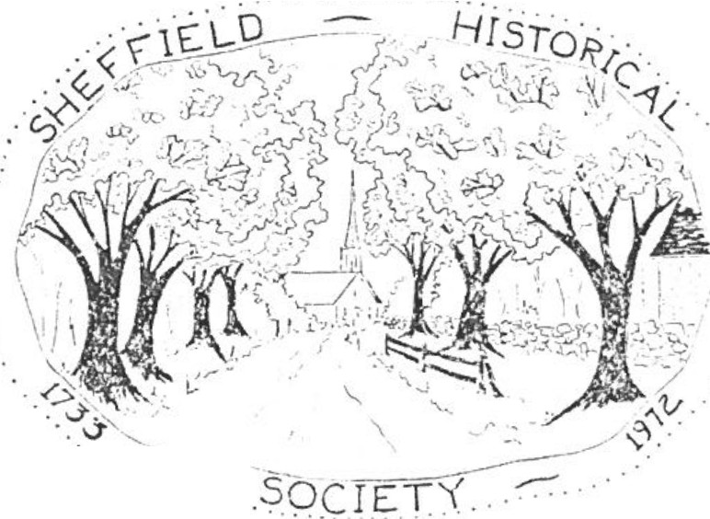SHEFFIELD HISTORICAL SOCIETY
. . .---.
SHEFFIE L D . MASSACHUSETTS 01257

Vol. II, No. 1. September 1974

DEMONSTRATIO N OF OLD-T FRA11ING

Al Petersen and Ed Warren will demonstrate old-time framing at the first society meeting of the 197 4 - 75 season September 1 3 at 7:30 in Dewey Memorial Hall. This is an antique method which has proved its effectiveness and should be most interesting to observe.
This will be a novelty in our programming and should"relieve the
dullness of history"! In her March 2, 1894 report as clerk of the Shef­
field Friendly Union, Julia Atkins Miller wrote: "I am aware that there is a feeling that some of our lectures are too profound for general accep­ tance. The lecture committee take great pains to have a variety of topics so as to suit all classes, and they have ample room in the programme for entertainments to relieve the dullness of history."

MOVING THE LAW OFFICE

Early on the morning of August 7 the Parker Hall law office, having been securely boxed in and hoisted onto a trailer truck the day before, started its journey down Route 7 to the Little House grounds. There it was guided by Ed Warren onto a new stone foundation.
Slides of the moving process will be shown at the September 13 meet­ ing. Volunteers are needed for non-professional work in connection with the restoration. We hope you will express your willingness to help.

BUS TRIP TO SEE RESTORED "LAW OFFICE

If enough people are interested, we could sponsor a trip to either Old Sturbridge Village or the Farmer I s Museum in Coopersto,m, N.Y. Both villages include a beautifully restored nineteenth century law office among other appealing exhibits and demonstrations.
At our next meeting we will have more information on costs and possible dates. If you cannot attend the meeting but are interested in going on the trip, please let Lillian Preiss know at 229-8726.

BUHPER STICKERS

Bumper stickers bearing the legend "Bicentennial Begins Here" have been receivedfrom the Massachusetts Bicentennial Commission. Those now on hand will be available at our next meeting, and more can be ordered if wanted.

NSNBERSHIP FOR 19 74 -1 97 5

This copy of the ne·.rnletter goes to all past and resent members. FutUI'e issues will be se:it only to cl.ll'rent members since this is one of the benefits of raembership. If there is any doubt about whether you nave paid your dues for '74-'75, please call Alice Hurlburt.

The noard of Trustees is seeking a volunteer to assume the responsibilyit of editing the newsletter. If you are interestde, please let us know.

rhe society's fiscal year runs from June 1 to May 31 . Dues for the curre:1t year may be sent to: Nrs, R . Walter Hurlburt, Ashley Falls, Mass. 01 222. The foll01-ring coupon is for your convenience in remitting dues.
Name

Aci.o.ress

CJ Junior Member (under 18)
Cl Individual Adult Member
§
Joint Nembership Sustainign Members
g
G Business Firms
Life Members ( exemptfrom annual dues)
Benefactors (exempt from annual dues)
S •50 3.00
5.00
10.00
25.00
50.00
100 ,00

RECENT ACCESSIONS

Several fascinating articleshave been donated recently by Lilias Warner. A ong them is a scrapbook from which the above quotation fro Mrs. Miller's report was taken. Also included were a steel engraving
of Edward Everett, a copy of the New-England Galaxy of July 4, 1828 , and a copy of the Ulster ColL ty Gazette of January 4, 1800 .
Four scrapbooks containing some local material were donated by ::rs. Nary Hulett, now of Kent, Connecticut. Ruth Chapin has given a copy of the February 3, 1766 Connecticut Courant, which includes interesting com­ ment on the reactio of the people to the Stamp Act, as well as the re­ port of a lecture or. "full-bottom'd wigs."
As our collection of artifacts grows, it becomes increasingly apparent that we need storage and display space. More people should have access to this rich storehouse of information.

DEVELO NT FUNTI
An energetic, enthusiastic, active committee under the chairmanship of Carl Cranmer and ":/innie Clark has succeeded in raising a total of
$13,563 in cash and :;,ledges toward the purchase of the Little House. This figure includes the proceeds of several projects representing the efforts of any people. Our August 3 auction, sparked by Marion Barnum, cleared a little over $1 ,300, including the sale of hot dogs and soda by Millie Smith and her young helpers. The patchwork quilt was won by Andy Wein­
berger of Brooklyn, who bought his raffle ticket at the auction. S0J1e very gener_ous checksand pledges have added to the present healthy total. Our heartfelt thaP- s go to all who have contribute.d
Vtrs. Harry Warre!l has made and donated a beautiful braided rug to be
raffled off or used in any way we choose to benefit the societ.y Ideas
are welcome on whether we should have another raffle or whether we should try to find other ways to earn mo!'ley on such articles.

BUSING IN SHEFFIELD IN 1903
Late in 1903 the Sheffield school committee decided to reopen the schoolhouse on the ?lain, which had been closed for nearly a year. The plan was to bus the colored children from the New Guinea district to the Plain school, where they were to be taught by Niss Cora Fowler, a young colored woman who had graduated from Sheffield High School at the head
of a class of ten. nese children were not '€mjoying proper school oppor­ tunities," according to Supt. Collins, because of irregularity of attend­ ance due to the condition of their clothes, lack of transportation, a_ d indifference on the part of some parents.
When the school opened., no children appeared on the first day and only three on the second d.ay. Shortly thereafter the school committee received a letter f:com a :aoston lawyer stating that he had been retained by interestedparties to file a complaint against them, alleging unjust discrimination against the Negro children in trying to insist on their attendi g a separate sctool devoted to members of their race and taught by a colored woman.
And you thought that 'Jusing problems were confined to the prese:1t day?

MEMBERSHIP

Dues for 1975-76 are now due. Some memberships were paid at the annual meeting in June, but if you would like to join by mail you may send your che to the treasurer now.
Please remit to: Mrs. R. Walter Hurlburt, Ashley Falls, Mass. 0J222
Name

Address-------------------

Junior Member ( under 18 years of age) Individual Adult Member
Joint Membership (husband and wife) Sustaining Members
Business Firms
Life Members (exempt from annual dues) Benefactors (exempt from annual dues)
$ .50
3.00
5.00
10.00
25.00
50.00
100.00

Amount enclosed _

SHEFFIELD HISTORICAL SOCIETY
SHEFFIELD. MASSACHUSETTS
01257

Newsletter
Vol. II• No. 2 November 1974

Societ y To Present Exhibit
It was voted at the September meeting to present an exhibit frora the Smithsonian Institu ion Traveling Exhibition Service. The exhibit entitled "ria uscript s of the American Revolution", consists of JO documents and letters selected by the Manuscript Society to provide a panorama of this important era in our country's history. It begins with the Stamp Act of
1765 and ends with the election of George Washington as president. It ls highlighted by silk-screened-on-parchment copies of letters by Washington. Nathaniel Greene, Samuel Adams. John Hancock,
Benedict Arnold and others. The society will try to reserve the exhibit for the period of June 21- July 20 for a rental fee of $100.00.

Developme nt Fund
Pled es for the develop ent fund thus far total the amount of $14.228.71. The amount in the bank is $4.529.48. A good portion of the money pledzed has been donated by non­ members of the society. Let's all strive to raise the per­
centage of me bers donating much higher than the present 42%,·
The amount of the donation makes no difference.
Mrs. Lewis Leffingwell raffled off a lovely handmade tablecloth, realizing for her efforts the sum of- 134,50, This sum she asked to have donated to the development fund. The winning ticket for the tablecloth was held by Betty Barnum from Newington, Conn.
November Meetin
Our November meeting will be held November 8 at 7:30 at Dewey Memorial Hall. We are pleased to have as our 6 uest that evening [·1rs. Mars;aret Philbrick, owner of Westenhook Gallery in Sheffield. She will give a demonstration of silk
screen painting and will tell some of the history of stenci llin,g

.;:'

Mrs. Philbrick has several gallery aff iliations among them being the Ainst<1orth Gallery in Boston and the Westwood Galler1 in her home of Westwood , Nass.
She has work in many museums and private collecti◊ns, to mention just a few the Library of Cor1;3ress in Washingtbn , D. C., the Virginia Museum of Fine Arts and the Brooklyn I·m­ seum in New York City.

Mrs. Philbriclc has won innumerable awards and special honors, a recent one being the John Taylor Ar s Prize, Na­ tional acad emy, N.Y. in 1972.
This will be a very interesting program. We hope to see you all there.
Some Facts About Shefrield Can you place the following?
"The principal strea'lls that empt,y into the Housatonic
in Sheffield are the Running Brook , which drains the north­ eastern part of the town and has its mouth a short distance below Sheffield village; Williams Creek, which coraes from the northwesern part; and Bishop Creek, through which are
discharged the waters of the southwestern part. These streams unite in the village of Sheffield and empty into the riv r through a co:in o n t runk."

Education in Sheffield

Considerable attention was given by early inhabitants to education. In 1750 a gra mmar school was co menced and continued for a number of years. In 1827 there were thir­ teen school districts, instructing 769 children, the sum annually appropriated and raised by taxation was $750.00 and in 1837 the sum was raised by taxation and ,;-1 , 275 in addition by private subscription . At this time there were two academies or private schools to which 300.00 tuition
was paid. In 1839 a private school was started by a r1ir . Stone
from Litchfield, Conn. and was incorporated as the Sheffield Academy, with a capital of il0,000.00 on March 12, 1840.
The coporators were Ed:<1ard F. Ensi gn , Moses Forbes, and Jo­ seph Willcox. A building was erected in the center of the square on the plain, the school was later given up.
For 18 rears after this schnol closed there was no high school taught in Sheffield. In 1870 by a vote of the town, a high school was established with Niss Ann Fitch (.later to become Mrs. Dresser) as principal.

The first term of this school was kept at Ashley Falls but it was then removed to Sheffield , where it was continued for many years. The school cU.d -0 1 : and was well sustained. By a hequest of Geor e B. Cobk, in 1873 the town received a fund , the income of which was applied to the support of this school.

This was takerr- from History of Berkshire County Mass ­ chusetts, Volume L publtshed in 1835 by Press of J. Henry Probst New York, N. Y.

I would welco e anyone's sug estic s about the Newsletter . If you have something of interest t at you would like to share please let me know. I would be interested in any corn. ents you mi ht have about possible additions to the Newsletter. You may call me at 229-266? or drop me a
note Mrs. Eda;ar Board..'llan County Rei. Sh effield, Mass.

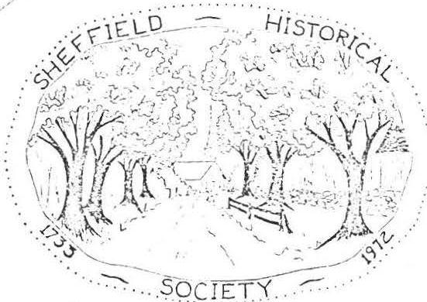
SHEFFIELD HISTORICAL SOCIETY
SHEFFIELD. MASSACHUSETTS
01257

Newsletter

Vol. II, No. 3 January 1975
January Meet iITT?;
Our January meetin g will be held on January 10 , this Friday, at 7:30 at Dewey l·iemorial Hall. .i'he pro g ra m is entitled "Reminis­ cing". Mrs. Gladvs Rora.back a nd Mr. Oliver Willcox will share with us their own remembrances of people, places, and thin s in Sheffield. This will "be a n opportunity to learn some historical
facts never written down plus some amusing anecdotes from the past. Let's begin this new year with a lar e attendance at this meet ing.
Colonel Ashley House

We've learned from Mr. and Mrs. Robert Carpenter of the Ashley House that an application was made this pas t summer to have the Colonel Ashley House declared a National Historic Land­
mark. l'he application was filed with the !-iassa.chusetts "'istor ical Comnission. The Department of the Interior next receives the application a!'ld from there it goes to the National Parks Service. They look at the house and determine if it qualifies as a histori­ cal landmark. After it is ap proved, there rill be a dedication, awar ding of a certificate and a bronze plaque designating the house as a National Historic Landmark.
Notes Frcm Previous Meet in s
The November meeting with Mrs. Margaret Ph ilbrick as guest was an especially interesting one. She told of the history of stencilling and pointed out one particularly interesting point of history.
Jarred Johnson, a 19th century farmer and cabinet- a er, who lived on Brush Hill in Sheffield produced many Hitchcock type stencils before his death in 1873, According to the author of Early Al:!er ican Stencils , Janet Wari r. , his oris-ina l stencil bears as close a relationship as those on Hitchcock chairs as any that have been found. It is not k nown, howe ver , what ccn­ nection, if any, Mr. Johnson may have had w ith La mbert Hitchcock founder of the Hitchcock Chair Factory.

Our Christmas reeetinT as estive and gave everyone the Chrtst as s pirit , e were enc0 r:ained by the Cobbletones, a local har½ersh'.)p ?r up. fheir ·.- -=---sio,s of carols and some of thei r c n favorite songs was eartwarrning, The cendlel i h t and table ecnrattons a•1ed up o : : 1c RY ea ty nd he goodies hrou ht by all were the perfec i al touch to R festive eetin .

Ji d You Kno•,:':
.Jam iar v 3 0 "'::h l J J - ' . '!lone·i ·•:.'.?.s raised. to huild the fi r s t
e tin house, )5 x 5 e e , whi was erected a hout three quarters 0 f a mile nrt o t e ;r sent church an1 was occupied until 1760. It was eviientlv n2 er0 cted until the following vear , 17) 5, as the ollo i v es passe1 ay 22nd , 1735 , in
re ard o its lnca 10 anrl r a t s \ tr1i cate:
"VotP.'1 to Set tre, ee inll; no· .: 3 e 0n a Certa in t\ole of Land Easterly of hr. '. illia111 Go,..,A:- hes Dwelli:1g House ·,1htc h i..s In the Street or Hi av.
" Voted to allo en v Gall: s 0f Rhu b towards or or the Raising- of the :.eeti P.: house er for the to'.ms us e.
"Voted to allo;1 :hree :Ca rr els of Good Beare towards or for 0r for the Raisin 0f the meeting house.
"Vote1 to allow twen y pounds of Sugar to o with the Rhumb and Obadiah Noble and Ensi2 n shley were made choice to Dool out Drlnks to stranzers or t ns people and also to receive the ney likewise 3nsi n Ashley to serve as pinman.
"Voted to al1 0 ;•1 no Drink to t:':e Lah orers after they are Dis­ mist from la our et .

1'ak en fromRistorv of Berkshire County Massachusetts, Volume I published tn 19 5 hv Press f J , Henry Probst , N. Y. N.Y.

BENEFIT AUCTION

MarionBarnum has served most capably for two years as auction chairman and. has asked us to find another chairman for this year's benefit sale. Please let Lillian Preiss or any other officer know if you are willing to serve in this capacit.y You may call on the entire membersihp for your committee!

SHEFFIELD HISTORICAL SOCIETY
SH EFFIE LD. MASSACHUSETTS
01257

NEWSLEI1TER
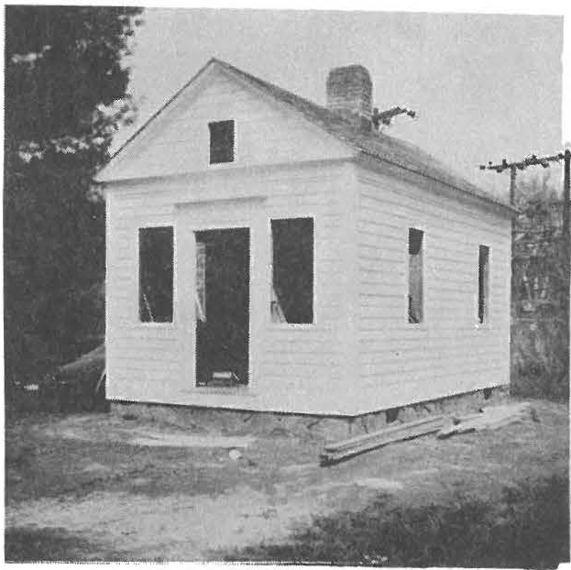
Vol. II, No. 5 June 1975
Parker L. Hall Law Office - May·1975

ANNUAL MEEI'ING
The third annual meeting of the Sheffield Historical Society will be held on June 13 at Old Parish Church beginning with a covered dish supper at 6:30. Each family is asked to bring a casserole or salad. The commit­ tee will take care of dessert and place settings. Laura Percy is in charge of the supper arrangements.
Followign the supper there will be a short business meeting, includign election of officers for 1975-76. The program will be a "show and tell" similar to the popular March 1974 rogram. If you have an antique or other personal·treasure that you would like to show at the meeting and tell the group about, please let Muriel Rokos or Lillian Preiss lmow so that we can plan the necessary space•.
PRESIDENT'S ANNUAL REPORT
Approaching the Bicentennial year 1976, we rejoice in the fact that Sheffield has a thriving young historical society with 140 members. The organization is embarked upon a number of significantprojects, each incor­ porating one of the Bicentennial themes: Heritage '76, Festival U.S.A., Horizons '76.

- 2 -

Activities of the 1974-75 year got off to a scorching start, when we held a potluck picnic supper on a blistering July day on the back lawn of the Dan Raymond-Will Littl House. It was a delightful spot for a picnic, and members and friends had an opportunity to look over the property that the society is hoping to acquire.
The next event at that location was the moving, on August 7, of the Parker L. Hall law office from Sheffield Plain to its restoration site. A supporting cage was built around the structure, and a giant crane then picked it up in a cable sling and swung it aboard a Berkshire Engineering Company trailer truck. It moved quickly down Route 7 and was placed on the new foundation prepared by Warren and Macchi. The cement cellar has proved to be perfectly dry and will provide valuable storage space. Much of the exterior work has been completed. If you haven't seen it lately,
take a look; it's impressive.
Through the generosity of many peopl,e more than $17,000 in cash and pledges has been raised toward the purchase of the Dan Raymond House. A very successful auction in August encouraged us to schedule another one for August 2 of this year. Please let Milton Barnum or Arthur Chase know what you have to donate for this importantevent. It is one of our major fund­
raising project.s Our industrious needlewomen have produced some beautiful
works of art for the benefit of the development fund: an embroidered table­ cloth by Ruth Leffingwell, a quilted pillow by Rachel Willcox, and a patch­ work quilt by the indefatigable quilting committee.
Programs this past year have proved that history is far from dull. A demonstration of the old-time method of framing by Al Petersen and Ed Warren was elucidated by a display of antique woodworking tools. :Margaret Phil­ brick demonstrated the silk-screeningprocess and reviewed the historyof stencilling as an art form, with particular emphasis on Jarred Johnson, a Brush Hill farmer and cabinetmaker who produced many Hitchc·oc-ktype stencils. Other programs of local interest were given by Gelston Hardy, who spoke on the Ashley family monument;Oliver Eldridge, whosetopic was Chauncey Jerome, a Canaan cloclanaker; and Oliver Willcox and Gladys Rorabac,k who contributed historical anecdotes and reminiscences. Louise Stevens broughta fascinating collection of dolls to illustrate her talk, and Bernard Frye brought samples
of student work to add interest to films he showe.d Pure entertainment was
afforded by the Cobbletone,s who sang at our candlelight Christmas party.
We are delighted to have additional opportunity for cooperating with
other community organization.s The Campfire Girls will serve at the opening
of our collecto'rsexhibit Augugt 3. Members of the Sheffield Garden Club will be hostesses at the Col. Ashley House at the conclusion of the histor­i cal tour of the town on August 16. Your president has addressed the Mothers' Club and the Sheffield Friendly Union and has been invited to speak at the Jliemorial Day exercises at Sheffield Center Schoo,l where the fourth graders have planted a □ountain ash as a "second liberty tree."
A stimulating series of lectures will be offered this fall for enjoyment, edification,and profit. Sponsored by the develo ment fund committee, the lectures will be presented by Blaine A. Cota, Jr., BFA and MFA, Yale Unive­r sity, an accomplished artist, craftsna,n social histoiran, and lecturer. You will hear nore of this later, but s-oread the word and save the dates of Sep­ tember 19 and 26 and October) and 10.
Ha ny, man / thanks to all 1:1h o have helped to make this a great year!
Lilliari T . ?rciss, i->resident

L

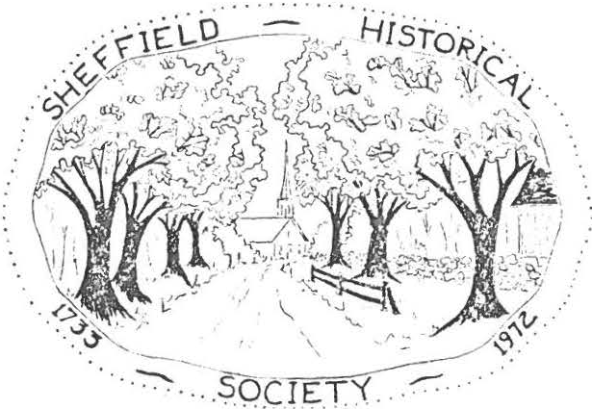
SHEFFIELD HISTORICAL SOCIETY
SHEFFIEL D. MASSACHUSETTS
01257

NEWSLE1.1TER

Vol. III, No. 1 September 1975

LEOI'URE SERIES
A major fund-raising project for the acquisition of the Dan Raymond­ Will Little House will offer entertainment, edification, rnd excellence when a lecture series by Blaine Cota of Litchfield begins on September 19 in the parish hall of Our Lady of the Valley Church.
Mr. Cota is president of Heritance House, Inc., a private non-profit educational historical studies project, director of the Deacon Peter Buell Dwelling House Restoration, a member of the four-man active restora­ tion committee for the Tapping Reeve Law School, and a lecturer on 17th and 18th century New England social history. His lecture series will in­ clude:
- September 19 - The Deacon Peter Buell House Restoration. A discussion about the authentic restoration of the 1728 dwelling house of Deacon Peter Buell in Litchfield, in terms of documented social aspects of the family unit spanning 50 years from 1734 to 1784. Profusely illustrated.
- September 26 - Colonial Gardens. A program in color on gardens of col­ onial America, their adaptation from European and English origins, their development through the 18th century and illustratiosn of regional d.iffer­ ences with specific emphasis on a ten-year restoratino of a New Engla.d garden.
- October 3 - Lighting the Wilderness. A comprehensive view of the de­ velopment of early lighting devices and their proper usage in New England during the period before whale oil lamps. Slides and artifacts.
- October 10 - The Bake Oven and Down-Hearth Cookery. A discussionof colonial foods, methods of cookery, specific usage of down-hearth equip­ ment and firing the brick oven, as well as cookery books of the period and their peculiar function in the home.
The development committee hopes that all S.H.s. members will buy a series ticket and encourage friends and acquaintances to attend any or all of the talks. Prices are: series of four lectures, $12.00; single lecture,
$3.50; student ticket, $2.00;student seriesticket, $7.00. At the con­ clusion of each lecture there will be a question and answer period. Re­ freshir..ents will be served.

L

I - 2 -

The regular open meeting of the society will be omitted in October because of Mr. Cota's program. All members are urged to attend the lec­ ture on our regular meeting night. Admission for all will be by ticket only.

SEP'l'EMBER MEEl'ING
Mr. Edward J. Fales, Jr., of Falls Village will be the speake= at th opening meeting of the 1975-76 season. The meeting will be held September 12 at Dewey Memorial Hall starting at 7:30 p.m.
Mr. Fales, past president of the Falls Village-Canaan HistoricalSoci­ ety, is a graduate of the College of William and Mary. Describing himself as a "history-journalist," Mr. Fales has been an editor, a writer, and the publisher, with his wife, of a paper called "The Country Letter." Four years ago he wrote the story of the "Iron Country," the northeastern corner of Connecticut, an intriguing subject for a future program.
On the 12th Mr. Fales will describe the trip of the Baroness von Rie­ desel, who, with her childrP.n, accompanied her husband during the campaign down from Canada, his capture at Saratoga, and his years as a prisoner of the American forces. On their way to Cambridge the entourage passed through Great Barrington and the following year went by way of Norfolk and Canaan to the prison camp in Virginia. Mr. Fales will use the remarkable diary kept by the Baroness to depict the New England people and towns of that era as she and her a.ides saw them. Her experiences, Mr. Fales reports, were "vivid, dangerous, troublesome-and sometimes very amusing."
SUMMER A<n'IVITIES
It has been a busy summer for the historical society and the Bicenten­ nial committee. Because so many people did so much to help, a list of "credits" would read like the telephone directory. The exquisite and esthe­ tio accomplishments of the quilters and pillow makers was matched by the Herculean labors of the auction committee led by Milton Barnum and Arthur Chase. Bill Bradford donated his services as auctioneer and put on a non­ stop performance in near-100-degree weather.
People who attended the collectors exhibit are still talking about the hospitality of host Richard Combes. John Campbell was most cooperative about opening and closing the library for the exhibit. Dwight Ford and John Bag­ naschi made wishing-wells for contributions to the development fund. Together they brought in $90. Margaret Philbrick donated to the society one of her
new serigraphs, "The Sheffield Declaration,"which had its first showing at the collectors exhibit. Henry Massini donated his bus and his time for the historical tour on August 16. Narrators were Art Chase, Dwight Ford, and Lillian Preiss. Our heartfelt thanks to those named and to the many unnamed who participated in this historic pre-Bicentennial summer.

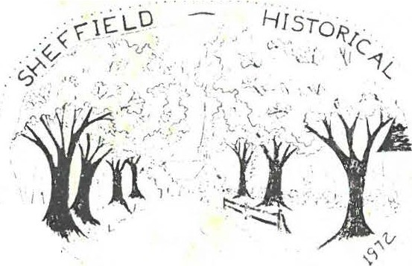SHEFFIELD HISTORICAL SOCIETY
. \"
>
- .;
SH E""FIEL D. MASSACHUSETTS
01257
.

. . ::·-:---·-
... SO_ C JET Y. _.

NEW >LETTER

Vol. IV, No. 1 3eptember1976
Lillian Preiss wilJ. be the speake1'a.t the openine meetine; of the 1976-
1977 season to be held September 10 ,2 t D 0.3wf!y Memorial Hall startign at 7:30
  - Her talk, entitled HistoricPreservation in Germany. will be illus­ trated with slides taken on her recent travels in 3ast and West Germany. Nuremberg, Munich, Rothenburg, Heidelberg, Frankfurt, and. Tri er are among the cities visite.d
We are fortunate in arranging !;his talk so soon after the ?reis'ss return.
SHEFFIELD: FRmrrIER !QillI
After a number of agonizing delays, l celsior Printing Company assures us of delivery of Lillian's history th.is week. It is a handsom,e hard-bound
book with town seal, end papers, inset map, chapter headings drawn by Margaret Philbrick,and dust cover- - a worthy monument to Lillian's selfless devotion to this demanding project.
An autograph party will be held Sunday, September19, from 3 to 5 p. m. at the Westenhook Gallery, at which Lillian will be available to autograph the title pages, Margaret Philbrick, the drawings, and Art Chase, the poem "And Always New Frontiers,"which serves as an end piece of the history.
The price of Sheffield: Frontier !.mfil is $7.50.
SUN,Ml"!'R ACTIVITIES
An officer of the Berkshrie County Histoircal Society recentlyexpressed amazement at the range of summer activities in Sheffield and the number of members involve.d
The Bicentennial Ball, under the chairmanship of Marion Barnum, with assistance from Milt, Dwight Ford, Hargery Kirchner, and Millie Smith, brought out a distinguished collection of costumes that reappeared a week later in the
j ury box for Mumbet's case in the Sheffield play, fil FreedomTalk. Both
eventscelebrated the Sheffield vote for independecne of June 1 8 , 1776.
The first Arts, Crafts, and quiltsFestival, engineered by Bob Krol, brought together over fifty craftsmen and a magnificent collection of quilts. Bob had yeoman assistance from Millie Smith, Jean Curtiss, Pamela Krol, Iona Brigham, Viola Bagnaschi, Carl Cranmer, Shears Boardman, and a lot of other.s

- 2 -

The quilters were well ro:;-ir cs nted by the work of ,\cncs :lo:i.rdma,n linni Clark, Trudy LeGey,t Vera. Conklir.., Ir ene Cranmer, 1'1a.rion Barnu,m Ra.chel·,.'ill­ cox, Virginia Siter, Dorothy and Rctty Dinan, ffar.ia.n ',/illcox, Louise -;tevenn, Phyllin \l·hal en, and Alica ch-.imann.
In addition during the summ8r the Bicenten".'lial ',u.i.lt had assist2.nc,:, from Harsra.ret l1hilbric,t :-:stherKervan, Alice·.f:::i.rre:n, Frances \i;:i.rr cn, ·T'.velyn'.•ii ll­
cox, Minnie Markham, Mrn. Paul Batacchi,i'r-'i s . Jost, and Betty L Gcyt.
Featured in the Great Barrington p ra<le were the Budweiser Clyde d;:i.les and the Sheffield HistoricalSociety float, powered by }'rancis Nourse,Sr. and transported b y thP. American Legion wa0"'0r.. T c float depicted a Quiltine;
Bee that ncluded Ae,'11e , ':linnie Trud!, Vera., and VirGi?ia.,. and the Signi.n8" of the Sheffield Declaration ( 1773J by Mi lt , Lorine, Charlie Viall, and. Ar t - - ( those same costumes!)
Bright weather brought a fine crowd to the societyauction to hear Auction­ eer Bill Bradford knock down the impresive collection of antiques and atti ues handed him by Chairman Milt Barnum, Lewis 1effing,e!ll, Shears Boardman, Loring Boardman, and Durward v/illcox, while Millie Smith provi<led refreshments, Marion Barnum recorded, Muriel Rokos, .1iinnie Clark and Carl and Irene Cranmer assisted,
Aeries Boardman, Ruth Leffingwell and DorothyDinanran a tag sale, and Arthur
an d. Alice Ann Chase sold books.
The proceeds from summer activities carried the Development Fund past the
$30,000 mark and strengthened our hope of taking possession of the Da.n Raymond House in 1976.

OFFICERS

With the end of Lillian Preiss's term as President and Muriel Rokos's as Program Chairman, we have some feelings of apprehension. The new officers have great need for sugeestions and assistance from everyone. The officers and chair­ persons for 1976-77 are:
Preside:1t, Milton Barnum Vice Presid.ent, Arthur Chase Treasurer, Marion Barnum Secretary, Agnes Boardman
Proe;rarn Co:nmittee, Vera Conklin, Wesley Warren, Arthur Chase Publicity, Lillian Preiss
Refreshments, Helen Woodbeck Newsletter, Arthur Chase, Lillian Preiss Curators, Muriel Rokos, Alice Ann Chase Membership, Alice Hurlburt
Goals, Carl Proper
INCIDENTAL INFORMATION
The Berkshire County Historical Society has scheduled a South County bus trip from Pittsfield, October 6th, which will include a lunch stop at The Shed and visits under the guidance of Lillian Preiss to the Old Covered Bridge, the Law Office, Town Hall, Dan Raymond House and Old Parish Church.

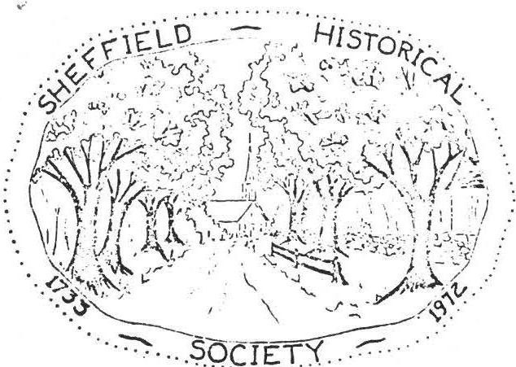
SHEFFIELD HISTORICAL SOCIETY
SHEFFIELD. MASSACHUSETTS
01257

NEWSLEI'TER

Vol. IV, No. 2 December 1976

CHRIS'E-1. S HF.STIJ:rG

The December meeting of the Sheffield Historical Society will begin with a "covered dish supper" at 6:30 on December 10 at Dewey Memorial Hall.
Important req_uest: please bring your O\m place setting-a dinner plate, a cup and saucer, and knife, fork and spoon.

We are very grateful to Helen Woodbeck and her able committee: Mrs. Loring Boardman, N.rs. Edwin LeGeyt, Hrs. Willia...'11. Conklin, and Mrs. Dorothy Dinan, for planning this festive occasion.
Mrs. Wilfred Millet is in charge of the entertainment, which
will follow a short business meeting.

SHEFFIELD: F:tONTIER TO\-Jl'T

With Christmas coming on, we have been pleased with the interest of Sheffield residents, both present and past, in havign Lillian's history mailed out of town. The mail order business is being handled by Art Chase with padded envelopes and postage included in the 75¢
shipping charge. /
Mr. and Mrs. Silk have given most generous assistance in selling
everal hundred autographed copies at the Sheffield PharIT'.acy without a:ny commission beyond the thanks of the Sheffield Bicentennial Com­ mittee. They will stock books through the season--a great Christmas idea for the person "who has everything."

GUILTIWG CO·:'.HI TT

The lucky winner of the diamond-shaped quilt last complete.dby the quilting com.r:u.ttee was A. Lockwood of Wethersfield, Connecticut. Con­ gratulations to the winner!

- 2 -

BRIGGS GRAVESTONSS
On page 86 of Sheffield: Frontier To m is the statement:

"The Briggs quarry was most active following the Civil War, when John R. Briggs received a contract for 100,000 stones for veterans' graves at $2.65
a stone."

Last month one of these marble stones, discarded because of a chipped edge, was set up at the corner of the foundation on which the Briggs mill once stood. To anyone sighting it from Berkshire School Road: No, it's not a new b,µ-y-patch.

SOUTH BERKSHIRE TOUR
During October we were honored by inclusion in the South Berk­ shire tour of the Berkshire Historical Society. Two bus loads of archivists were met by Lillian Preiss at their lunch stop at The Shed Restaurant. She pointed out some of the highlights of early Sheffield history and later escorted the tour to the Old Covered Bridge, the Dan Raymond House, the Parker Hall law office, and the Old Parish Church.
At the town hall Selectman Dwight Ford and Margaret Ford, in their prize-wnining bicentennial costumes, welcomed the visitors to the display of Sheffield's most cherished document, the Sheffield Declaration of 1773.

GOALS COMMITTEE

On November 17th Carl Proper, chairman of the Goals Committee of the Sheffield Historical Society, hosted a meeting of members to dis­ cuss the acquisition and use of the Dan Raymond House.
Emphasis was placed on:

    - the priorities in repair and renovation required after the house is ta. en over, /
    - the need for a detailed statement of the projected uses of the house after acquisition.

NOVEMBER MEEI'ING

La.st month Jesse O'Hara shared with us some of the fun as well as the hard work involved in researching one's family tree. Jesse is well qualified for such an assignment for he is a member of numerous genea­ logical organizations. He is currently working on research for America."'ls of Royal Descent.
The cheapest way to have your family tree traced is to run for public office.
Charleroi, Pa., Free Press

. . . . . . . . . . .

  - I "
_..·,;-1\ :i j:i
.
_ -_ _ ,. Hi sro·n· -.

,. ._-i,
f :;,, ,{ /4'l / ,'.
:r_,._·,• ..".½!\: ,,;-1_ { C·. "' 'T/C' ··

,-_:"Jj?··:<, , _{:7-}
- ;;•i_•,(1-
.:-.?; 1. ,: i-·
.
- -- '.' ·\I -1<_-.
· ':) Y'. ,ii".•. • 0L ;)">• , '-_' ;,,;_, , - ·"'- · ·
. I ' . , . J t i_,.,j . . ' ·. V • \

\i I.• I -;· - ...'h.-c:-- ..._.,, . .:l-.f"r·,,\
: -
. .
_\i'',"f\'.! . .
SHEFFIELD Hl TORICAL SOCIETY

:\ ' ( ' 1M•1•-:,..:, .;;_- ••! ••- .-• J !
., . •
    - :
SHEFFIELD. MASSACHUSETTS

- t"
:J{ '' I.
/ , · \_ : f 1·1 ' '1

'•
\ \ f ; 1. / ."

••. 1,•'
- )' .
\.i I• , J

1 1.s',, · <; '! 4-,
. l ""'"·'=
\ t f I
,-! ;
>;-)'.•' • .' )c
i:-·- , ·_ <-,, v \ . -_
t
----
01257

  - -. tI
-:• j.- ' -· / . .- <, ---- "=, A..i:;_"Jl / '¢?/ _:

-. ,,. • I • \ ,_I'::_. _/ : --
• • • • . . - •· • • ·'

?-:EWSLETTER

Vol. IV, No. 3 March 1977

APRIL MEETING

The She field Historical Society and the Friendly Union
will join forces in presentin the Storrowton Village Dancers at Dewey Hall on Friday, April 1 at 8 P.H. The Historical Society will hold its business meeting at 7:30 prior to the entertainment.

Admission is free to members of' both organizations and
$1 'for non-members.

The Storrowton group, consisting of' a caller and twenty dancers in costume, will demonstrate a variety of period sets that should recall festive evenings at the Ashley House and in the several inn-ballrooms of' colonial Sheffield.

UNA..'¾TI!OUS VOT E FOR DAN RAYNOl-.'D HOUSE

At the Narch meeting the Sheffield Historical Society reached a signal milestone when President -!!il ton Barnum called f'or a vote on the acquisition of' the Dan Raymond House. The 1arge Society attendance approved the purchase of' the house unanimously (or as Theodore Sedgwick wrote at the end of the Sheffield Declaration, Nemine Contradicente.

Near April 1 the Society will col!lp le te the purchase for
$29,500 from r-ril ton Ba rn um and Edward Warren who bought the house in September 197J and generously held it until the Society could raise enough money f'or its purchase. The members may well be prot:.d of' this acquisition which gives an educational center for Shef'field and a home for the Society.

BOUNTI FUL BHE JC...'G'AST

On Saturday, Earch 25, another group was initiated in the delectable rites of' :fireplace cookin g by Carl and Sci.lly Pro p e r . These memorable events bring joy to the guests and cor:1:fort to the Development Fund.

I
After the vote· on the purchase of' the Dan Raymond House Milt Barnum. and Vera Conklin presided over an illuminatine· and at times hilarious collection of usl.ow-and-tell" items.
I
Among the relics that did not defy identification were
Rog-er Drury's rer.1:.irb:able wri ting-und-shavine-desk of a sea-faring ancestor, Harie Walbridge's O?ium pipe·,(drugs were a problem
way back when) Richard Combes' 18th century tea set of remark­ able origin, and Lillian Preiss' collection of bells for every animal but the cat. Featured were camel, water bu:f:falo, and elephant bells. Reverend Herbert Robinson demonstrated a mechanical check-writer to protect good and b.ad c.hecks from being altered. Loring Boardman' s ",,:hatzit" was designed to defeat any energy crisis. (Mr. Schlesinger take notice.}
Vera Conklin's ovenproduced delectable prizes f'�r the experts (and not-so-experts) in identification.

PLEDGES DUE

Members and friends who made pledges to the Development Fund for purchase of the Dan Raymond House have scored a remarkable record in keeping up their payments. As this news letter went to press only three pledges totaling $290 can be said to be due or past due.
A total of $9,285 was pledged during the campaign. Of'
this ruuount $:}, 100 by :four members is due the day the His tori cal Society formally takes title to the property. Two more pledg-es totaling �600 are still outstanding because they were ruade
late in 1976 and are not due until. 1.977 or 1978 •.
It is hoped overdue pledges will. soon be paid, as the fnnds are needed now for the work of restoration.
Meanwhile new pledges by members and :friends to begin the
first stages of re3toration would be welcorued.
SPRIN G FASHION SHOW
On Tuesday, April 26th at 8:00 .?.M. the Shef'f'ield Historical Societ!1:·
in co-operation with t'n�land Brothers in Pitts:fi€ld is sponsoring a Sorii.c Fashion Show in the large cafeteria at Mt. Everett Regional School. Twelve tables will be decorated representing each month of the year. Door pri'.l',es includinrr the center piece· :from each table will be given away.
Tickets at $2.00 each will be available at the April 1st meeting and
as it is important that a miniC1um of' 200 be sold, the cooperation of all our members is needed.
Twelve modelsearC" needed, willing to invest one trip to Pittsfield for
a f'i tting---for th :;>leasure of being a rr.odel the nieht of the fashion sho\,'.
Every Society mer.ibcr is respo1tsible for r.iaking a "fancy <less0rt" :':--: the re:freshment table. Contact }lrs. Wi.lliaril Elliot at 229-2126 to tell her what you will bring.
Any one willing to work the night of the fa$hion show as ushers or ticket takers, or M�i:t.1.1. any ques tions---con tact Robert Krol at 229-79 55.

.,,.. I
J

. ··--···• ...s··-ocjct>'- .
SHEFF-"[El_fJ HISTORICAi.. SOClC-:TY
SHEFFIEL!J. MASSACHUSETTS
01257

Vol. IV, No. 4
NEWSLEI'TER

SOCIEr� TAKES mt,E 1Q. HOUSE

July 1977

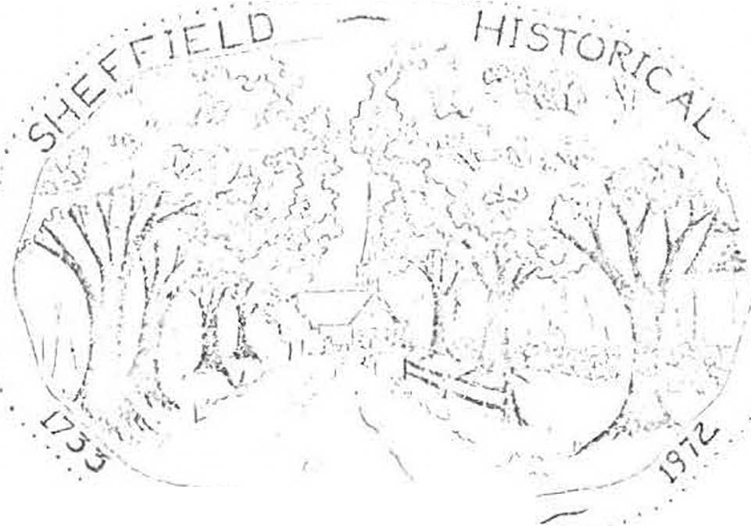After an ene:r.eetic, three-a.nd-a-half yeaAi: fund-raising program, the Sheffield Historical Society has taken title to ·the pre-Revolutionary War Da.n Raymond House. Work bees have bee11 held to clean up the g·rounds, ano. a committee is en{,saged in establishing priorities for necesaaxy work to be
done on the house Hself. One room has been set aoide to hold acquisitions of the society until a permanent display can be arra.nf;�d.
Carl Proper reported at the June meeting that he has researched the ownership of the house as fa.r back: as when Dan Raymond sold it to Ezra Fellows.
1793,
DEDICATION .QE. � OFFICE
5,
A gala eveniug has been scheduled for Friday, 11.ugust when our restored law office will be dedicated. A sign designating the bu.Uding as the office of Parker L. Hall, attorney a-t law, will be installed, with President MJ.lton Barnum cutting the ribbon.
The dedication ceremony will start at 6 p.m., followed by a community potluck supper. Nancy Board.man has graciously consented to serve as chairman of the supper. Unless she calls to ask you for something specific, please bring a cold dish for the buffet table. Each person should also bring his own place setting and a folding chair. Iced tea will be furnished. We a.re hopi.ng to have some informal musical entertainme11t ,. Come and bring a friend.
During the afternoon on August 5 from two to five, there will be a display of local history projects made by eighth g:r..-2.de students at :Mount Everett Re­ gional School under the direction of Paul Menin and Bill Gillooly. Please en­ courage non-membe:r-s as well as members to see this interesting- group of models old pictures, family trees, and dioramas. The exhibit will be set up in the Dan Raymond House.
,
The Bicentennial quilt made by members of the society will also be exhibited there during the afternoon, and chances will be sold by members of the quilting committee. The group is already at work on a second quilt, vhich will remain
the property of the society and will be on permanent display in the Raymond House. Also available at that time will be the tape of an interview with Fred nnoc" Shook. The tape was made at a meeting of the society on May 13 .,

, ..

FOURTH ANNUAL AUCTION
Antiques and mi.scellaneous items will be offered !or sale at the society's fourth annual auction to be held Saturday, July 30, at the Sheffield American Legion Hall starting at 10 a.m. Proceeds will be used to start restoration and repair work on the Dan Raymond House. Bill Bra.d.f'ord will conduct the auction.
Assistance is needed to help move auction articles to the hall, to help price items !or the tag sale, and to work during the auction and tag- sale.
If you can spa.re some time before July 30 or on that day, please contact Milton Ba.mum or Loring Ba.mum. Refreshments will be sold by the American Legion Auxiliu,..
THE "BOW-WOW DISTRICT"
We !ear we ma.y have cast an evil impression on the readers of the Courier in writing about "Bow-wow" district, sometime ago, as we do not wish them to infer that we are suoh a noisy neighborhood. That name was given several years a.go, because a number of families kept dogs, which kept up such a continual barking that it was called "Bow-wow," but the name is beco obsolete, as the section is seldom called by that name now.

L.H.
(from The Berkshire Courier of April 5, 1871)

MEMBERSHIP

Dues for 1977-78 are now due. Some memberships were paid at the annual meeting in June, but 1! you would like to join by mail you ma.y send your check to the treasurer now.
Please remit to: Mrs. Marion Ba.rmtm, Sheffield, Mass. 01257
Name
Address-------------
Zip _

Please check:
Cl Junior Member ( under 18 years of age)
C7 Individual Adult Member
a Joint Membership (husband and wi!e)
D Susta.in1¥ Member
.a Business Firm
er Life Member ( exempt i"rom annual dues)
C7 Benefactors ( exempt from annual dues)
$ .50
3.00
5.00
10.00
25.00
- P,.00

1oti.oo

Additional contribution (ta:i: deductible

Amount enclosed...,$

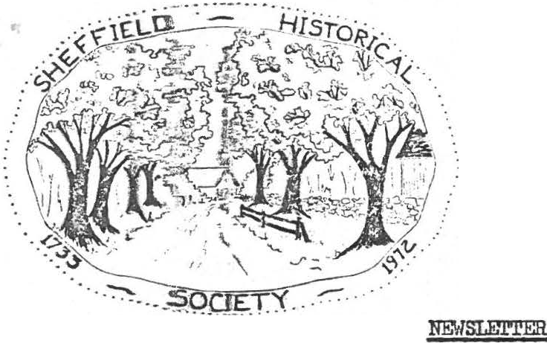
SHEFFIELD HISTORICAL SOCIETY
SHEFFIELD. MASSACHUSETTS 01257

Vol. V., No. 1 November 1977
DECEMBER MEm'ING

A mut}lt'.L,re program will. be presented at our Christmas meeting on Decembmr 9 a.t Dewey Memorial Hall. All we will say is: "Don't miss the surpdsre! fl
V&gima. Drury has graciously consented to serve as chairman of the covered .dim supper, which will start at 6:30 p.m. Her committee requests that eax:ch me bring a complete place setting except for a dessert dish.
Unless «>therwise solicited, each person whose last name begins with the letters .A-Ji are also asked to bring a "meat type" casserole large enough to serve eight. Suggestions: baked beans, macaroni and cheese, meat loaf, scallopred ddcken, fish casserole, etc. Those whose names begin with N-Z should lbri.»g a vegetable dish to serve eight. Suggestions: tossed salad, string lbean casserole, gelatine salad, creamed onions, etc. Please also brilg w.ervisg utensils.
Thie ccmnittee will supply tea, coffee, milk, pies, androlls. Those
few vho .are lllla.ble to bring prepared dishes are invited to make a contri­
bution ftowmd the buying of the beverages, the butter, the cream, the dec­ oratroms, am so forth. Ha.ny thanks f:rom Marion l3arnum, Virginia Drury, Ca.'rlio:a:. Mott_ Muriel Rokos, and Helen Rote•

.Qr!!IIOUSE

Bneakfa.st at the home of Carl and Sally Proper, dinner with Milton and Marl.on JBa.rman. and now dessert vith Lewis and Ruth Leffingwell - all for the benei'i i;: of ihe Sheffield Historical Society! The breakfasts and dinners
have al:-:reao, taken place, and ·those fortunate nough to have been able to partake of ihe sumptuous repasts have said a hearty thank-you to their hosts. At 'botlx boas there wasa convivial gathering in a setting reminiscent of days 1a.-.ng Bll),lle. It wa.s great f'U?l and delicious food for a worthy cause.
Ou. Slmi!a.y afternoon, December 11, Ruth and Lewis Leffingwell will open theJr 1"'q.61 !.ouse, also for the benefit of the society. Guests will enjoy coffee and iressert and have an opportunity to visit a charming old house -
all r just $1.50. Theopen house will run from 2 to 6 p.m. Don't miss
this one!

, - 2 -
DAN RAYMOND HOUSE NEWS
Our current exhibit at headquarters is a collection of tinware belonging to Richard Combes. This display will continue through April, when another exhibit will be shown.
A lady from Spencertown, N.Y., visited the house recently to see our slide/ tape show. She is preparing one for her town.
. The D.R.H. Committee is planning a "bring-a-teacup-or-teaspoon" party for in an effort to build a collection of cups for the society's use. There
will be a special exhibition of dolls and doll furniture at that time.
Don't forget our annual auction on July 28. If you have anything to donate, let Milton Barnum know.

RECENT DONATIONS
The following articles have recently been donated to the society: a letter opener which belonged to President Willia.m McKinley from Barbara Hurlburt Brooks; a painting of Sage's Ravine and a watercolor sketch of Mount Everett Regional School by Walter Cole from Willard French; an advertising souvenir of Cassidy Brothers store from Josephine Hamilton; four place settings of ironstone from Carl Proper; and two lovely cups and saucers from Marion Barnum.
SHEFFIELD'S OLD COVERED BRIDGE
Although not a historical society project, strictly speaking, there is no group in town which should be more interested in the preservation of one of Shef­ field's most cherished landmarks than our society. We cherish it not only for
- its aesthetic and historical significance but because it stands as a testimonial to the skill and ingenuity of our forefathers.
The Connecticut River Valley Covered Bridge Society has donated $500 to the Sheffield Historical Commission toward the preservation of this historic struc­ ture, and the National Society for the Preservation of Covered Bridges has donated another $500. These funds will be used to match a grant from the Massachusetts Historical Commission, if our application is approved. The selectmen have agreed to insert an article in the town meeting warrant asking for an appropriation of
$5,000 toward the restoration of the bridge. A concerned citizen has promised to underwrite the cost of hiring Milton Graton, the foremost covered bridge builder in the country, to come to Sheffield as a consulta t.
A broad base of support for the project will help immeasurably in our quest for funding. Anyone who would like to contribute toward saving a valuable Shef­ field antique, probably the olnest covered bridge in Massachusetts, may send a check to the Sheffield Historical Commission for the "Save the Bridge Fund,"
% Lillian E. Preiss, chairman of the s.H.C., Sheffield 01257. Charles Kuralt has
noted that America has lost half her covered bridges in the past twenty years by flood or by neglect. The Connecticut River Valley Covered Bridge Society has adopted
as its motto, "Remove not the ancient landmark which thy fathers have set." (Prov. 22:28)
MEMORIAL FUND
Over $400 has been donated to a fund established in memory of Kurt Preiss, who passed on February 4. He was a willing worker in many of the society's projects, and he would be pleased to know that its goals are being furthered in such a way.
Lillian wishes to express her heartfelt gratitude to those who contributed so generously to this fund.

.. . .. .. . .....

SHEFFIELD HISTORICAL SOCIETY
SHEFFIELD, MASSACHUSETTS
01257

NEWSLErTER

Vol. V, No. 2 April 1978
SHEFFIELD HISTORICAL SOCIETY CALENDAR - .12I§.

April 14
April 17
April 25
May 12
May 27, 28
June 9
July 29
Sept. 8
Regul meeting - ! Place!!l
Price Chopper fund Day
:i'ashion Show Regular meeting Flea Market AnnUct.l meeting Auction
First meeting of 1978-79

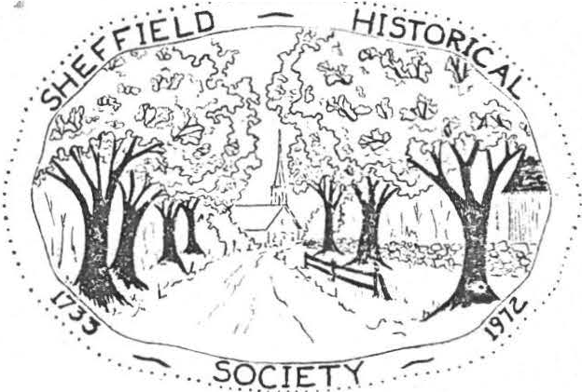
! PLACE Jl!
"It's been done in other places in the country and after all we've got this beautiful heritage, why don't we make the most of it?" Does this sound as though it might have been spoken in Sheffield? It's the way Paul Steinhardt, narrator to a film produced last year by the National Trust for Historic Preservation, sums up what preservation is all about.
The film,!, Place .!!2, , features 25 historic preservation efforts in 14 states. New Hampshire filnsker John Karol spent two years travelign around the country talking with preservationists about their projects.
The premiere of the film was held last April at the Faneuil Hall Market­ place in Boston.
We are very fortunate to be able to see this film, courtesy of Holger Oleen, at our next meeting. Come and bring your friends - April 14 - Dewey Memorial Hall - 7:30 p.m.
PRICE CHOPPER !!!!ill, M!
April 17 has been designated as s.H.s. Fund Day at the Price Chopper Supermarket in Great Barrington. Five percent of all money spent at the supermarket that day by p rsons presenting a s.H.s. Fund Day card wnl be returned to our society. Cards will be available at our next meeting or from :Mi lton Ba.mum or Lillian Preiss now. Plan to stock: up your pantry on April 17th!

.. - 2 -

z,.
FASHION .fil!Q:!!. - APRIL gj_

Again, through the courtesy of England Brothers and Bob Krol, we will sponsor a spring fashion show. It will be held at Mount Everett Regional School on April 25 starting at 7:30 p.m.
The theme for decorating the tables thi_s year is "Holidays." There are a few tables and holidays still awaiting the imagination of some willing hands and minds. If you have not yet signed up to decorate a table, see Bob Krol to choose a holiday and ask Marion Barnum for a $10 check to cover ex­ penses.
Marion Elliott is chairman of the refreshment table. If you will make a dessert for the table, please call her at 229-2126 and let her know what you will bring. Tickets ($2.50) will be available at our meeting April 14. It's not too early to start telling your friends about this festive occasion. It was great fun last year. Let's see if we can top it this year.

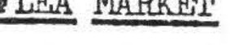
Do you have l'Iay 27 and 28 marked in red on your calendar? Those are the dates for our "first annual" flea market to be held on the Massini and Wilhelm properties on Route 7'A. Carl Proper, general chairman, has been working for months with Henry Coger, manager, to make this· an event worthy
of perpetuating. It could be a major·fund-raiserif we all work together to make it a huge success. More details at our April 14 meeting.

1QQ CABIN QUILT
The S.H.s. quilting committee has completed another beautiful quilt. Currently being raffled a.re tickets for a log cabin quilt in bright, har­ monizing colors. Tickets may be obtained at $1 each from Vera Conklin or Marion Barnum and will be available April 14 and April 25.,
PROGRESS ill! _M! RAYMOND HOUSE
If you are in the vicinity of the Dan Raymond House while the workmen are there, stop in to see what is being done. In accordance with a vote taken at the March meeting, we have secured a $10,000 mortgage for ten years.
This will enable us to prepare an apartment so that there will be someone living on the premises. The roof has been raised toward the west and shingled, the interior walls are up and the sheetrock on. Plumbing and electrical work is under way, so before long it will be ready for occupancy.

M!. STATE HISTORICAL LEAGUE
At our March meeting we voted to apply for membership in the Bay State Historical League. The quarterly meetings of the League feature interesting and knowledgable speakers, and the bulletins contain information applicable to all historical societies. 'l'he next meeting of the League will be held in Worcester on April 15. For more information see Lillian Preiss.

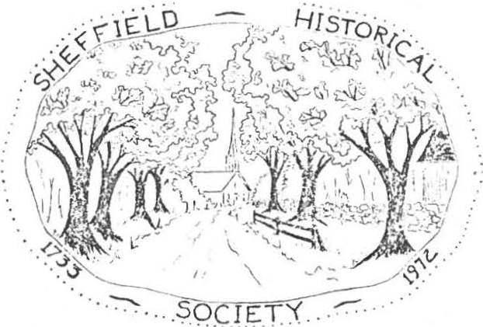
•• . ............

SHEFFIELD HISTORICAL SOCIETY
SHEFFIEL D, MASSACHUSETTS
01257

NEWSLEI"l'ER
XXJOOCOJ!XX
LKXXX.XXX.XX '
. Vol. V, No._2) July 1978
OPEN HOUSE AND PICNIC

All members, friends, and other interestedmembers of the community are invited to attend an Open House and picnic at the Dan Raymond House on August
4. Nancy Boardman has again consented to serve as chairman for the picnic·, which will begin at 6:30. She requeststhat everyone, except those called
for socrething specific,bring a covered dish for the buffet table, his own place setting, and a folding chair.
There will be three showings of an audio-visual history of Sheffield - at 2, 4, and 7:30. The slide show will be presentedin the large meeting
room of the Dan Raymond House. Bill Gilligan has offered the society a carousel projector on more or less permanent loan. Mr. and Mrs. Charles Schumann have given a cassette recorder-player. We a.re grateful to these generous peopl.e
Other recent acquisitions are the followig:n an 1801 map of Massachusetts
donated by Howard Crockett, two silver spoons decorated with Sheffield scenes donated by R. w. Smith of Lee, books and a. sand shaker inscribed "S. R. Kellogg"
given by Willard French, an inkwell with sand shaker from Lillian Preiss, book and pictures from Rachel Willcox, book from }1arion Barnum, album of Sheffield pictures from the Ballston Spa Public Library, a silver spoon made by a Shef­ field silversmith from Ruth Gordon Ellis, and an 1817 indenture paper witnessed by James Bradford from Irene Armstrong.
These artifacts, as well as other.s previously acquired, will be on view during the open house in the Dan Raymond House and the Par er L. Hall law office. Members who have other pertinent material they would be willing to show may con­ tact any member of the open house committee: Arthur C se, Lillian Preiss, Marion Barnum, Irene Crd.l11Jler, or Muriel Rokos.
There will be a mystery table holding pictures and objects for visitors to identify. The person who succeeds in identifying the greatest number cor­ rectly will win a prize of a can of Sheffield maple syrup donated by Arthur Chase. Duplicate prizes will be awarded in case of tied entries.
A check representing the proceeds from the antiques flea market held on May 27 and 28 will be presented to President Milton Barnum by Carl Proper, chairman of the flea market.
The second Sheffield historical quilt and the log cabin quilt ma.de by the society's quilting committee will be on display, and raffle tickest will be sold.
The house and law office will be open on August 4 from 2 to 6:30 and from 7:30 to 8:30. Hostsand hostessesare needed for both locatoins to serve for two-hour shifts. Anyone who is willing to act in this capacity should let a member of the committee know the time he can be there.

- 2 -

PAUL IVORY TO SPEAK

Paul Ivory, administrator of Chesterwood, will presenta program for the Friendly Union and the historical society on November 17 at Dewey Memorial Hall. The historical society's business meeting will be held on its regular meeting date, November 10, but all are encouraged to attend this informative program on Chesterwood.

NEW LOGO??? I

It has been suggested that a new logo more suggestive of the society's present concerns would be desirable. Our current logo served its purpose as the organization was coming into being, but now that we have acquired a head­ quarters house and are developing a program for its use, perhaps a more per­ tinent symbol is in order. Members of the society are asked to think about this suggestion and offer opinions. No change will be made without membership approval.

July 29
August 4
September 8
October 13
November 10
November 17
CALENDAR

Auction and tag sale Open house and picnic First meeting of 1978-79 Regular meeting
Regular meeting
Combined meeting with Friendly Union - Paul Ivory AUCTION

Our fifth annual auction and tag sale will be held on July 29 at 10 a.m. at the American Legion grounds. Articles for the auction are urgently needed. If you have somethingto donate and wish to have it picked up, you may call Milton Barnum at 229-2569 or Loring Boardman at 229-7750.

WEDDING ANNOUNCEMENT
From the Berkshire Courier of' 1842:
At Sheffield on Thursday evening by Rev. Mr. Erad.ford - Jeremiah Shears Esq. to Mrs. Florilla Lamb
"What if the Shears are old and rusty What if the Lamb is young and frisky A faint heart ne'er a victory won, Persevere - the Shearing is done!"

MEMBERSHIP COUPON

Dues for 1978- 79 are now due. Some memberships were paid at the annua.l meeting in June, but if you would like to join by mail you may send your check to the treasurer now. Please remit to: Mrs. Milton Barnum, Sheffield, MA 01257 Individual member, $3; Joint membership, $5; Sustainingr $10; Life members, $50.
-------------

Name
Amount enclosed
Address

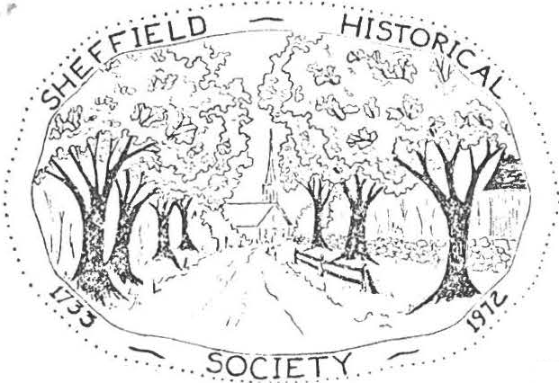
r

SHEFFIELD HISTORICAL SOCIETY
SHEFFIELD. MASSACHUSETTS
01257

NEWSLErTER

Vol. VI, No. 1 November 1978
CHRISTMAS MEETING
The menu for our December meeting includes an appetizerof Christmas gaiety, an entree of reverence in keeping with the season, and a dessert of Christmas music. Traditionally, this meeting has included a holiday dinner and entertainment rather than a serious discussion.
Virginia Drury, our ingenious chairman for the dinner, has enlisted a superb committee to help with a great idea: each table will have its own roast turkey together with the familiar accompaniments. Various society members have been asked to help with the cooking, for which everything will be furnished by the committee. The charge for the dinner will be a modest
$2!
Virginia has asked that each person bring his own place setting: din­ ner plate, dessert plate, cup and saucer, and silverware. Napkins will be furnished. Remember - December 8, 6:30, Dewey Memorial Hall.
CHRISTMAS OPEN HOUSE
Do you remember our gala open house in December 1973, before we had ac­ quired the Dan Raymond House? If you do remember, you'll surely want to come this year, and if you don't remember, you'll most certainly want to come this year.
The Dan Raymond House, decorated for Christmas, will be open for the whole community from 4 to 7 p.m. on Sunday, December17. Simple refreshments will be served. All membersare encouraged to invite their friends. We are hoping to make this a community-wide tradition.

REGULAR HOURS AT-T-HE-DAN RAYMOND HOUSE
Anauspicious beginning for opening our headquarters to the public on Fri­ day afternoons from 2 to 4 has been reportedby the Dan Raymond House committee. On the first day, October 27, we had visitorssteadilyfrom 2 to 4; on the third day the hours lengthened to 4:45. It has been most gratifying.
Alice Hurlburt of the Berkshire Courier, Dick Delmasto of the Berkshire Eagle, and Bernard Drew of the River Valley Chronicle have taken pictures of the quilt and will have a story for their respective papers.
The committee, consistignof Marion Barnum, Alice Ann Chase, Ethel Mert­ ching, Lillian Preiss, Carl Proper, and Muriel Rokos, is formulating goals for the house, drafting an accessions policy, opening during regular hours, planning exhibits, planning educational programs, maintaining a sales table, showing our historical slide/tpae program on request, selling raffle tickets, and opening the law office for visitors.

- 2 -
' Carl and Irene Cranmer will be host and hostess there on the day after Thanksgiving, and Lillian Preiss will show the slide-tape history at 2:30 p.m.
CURRENT EVENTS
Items for our 6th annual auction and tag sale are already coming in, Pres­ ident Barnum has reported. Keep your eyes peeled for articles which you can add to this July 28th event.
Our society contributed toward the cost of the public address system at Dewey Memorial Hall so that all may hear what is being said. Each paying one third of the cost.were the S.H.s., the Freindly Union, and the Council on Aging.
There's always work to be done at the Dan Raymond House, as any homeowner knows. On one day recently a group of members - Milton Barnum, Lewis Leffing­ well, Carl Proper, and Ed Warren - put a new roof on one side of the pottery shop behind the house. On Veterans Day a clean-up crew raked leaves, cut brush, and spruced up the grounds. Workign outside on a beautiful November day were Loring Boardman, Arthur Chase, Lewis Leffingwell, Kurt Preiss, and Charles Schumanr..
PRICE CHOPPER-FU-ND-DAY
December11 has been designated S,H.S, Fund Day at Price Chopper in Great Barrington. We tried to get a date before Thanksgiving, but the chQice dates had all been spoken for. Next year we'll have to start earlier.
Fund Day cards will be available at the Dan Raymond House and also at our December 8 meeting. Remember: five percent of all funds spent at Price Chopper on December 11 will be returned to the society, but you must present a pink card at the time of purchase in order to have the amount credited to the society.

MEMBERSHIP
Every once in awhile we hear rumors that some people think of the histor­ ical society as a closed corporation. Nothing could be further from the truth! Let's all work to dispel that bit of fiction. Although we have an appointed membership committee - Agnes Boardman and Nancy Boardman - each member of the society should consider himself a part of the membership committee. Spread the word wherever you have an opportunity. We heartily welcome participation of all kinds - membership, attending meetings, and visitign the house. Agnes and Nancy will have more on this subject anon.
-DO -Y-OU -S-A-VE -T-OP -V-A-LUE-ST-AM-PS-?
The Dan Raymond House has need of many items that could be obtained at the TV stamp redemption store; for example, lamps, tables, coffee pot, clock, house­
keeping accessories, etc. If you save TV stamps but don't have time to paste them in the books, you're welcome to donate loose stamps to the house committee. If you wish to donate completed books, the committee will thank you doubly!
LEl'TERS -T-O-THE EDITOR
Do you have a helpful idea to share with other members? Here's a vehicle
for communicating with like-minded people. Short letters of consrtuctive com­ mentor suggestion regarding the society or the newsletter will be published in future issues. Please send to Arthur Chase or Lillian Preiss, editors. Address simply: Sheffield, MA 01257.

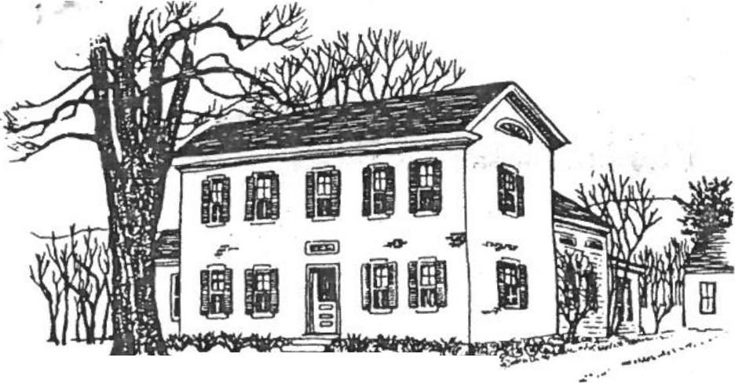•
_ _ ,., 7 \- '. ·• ·-- ?-;::.;;...
, : ;:;;-··· •

. ,,,"(.; ...,,.. .. ·· ·,·• , :,,: •· - - f :.i, ..-... •••
SHEFFIELD HISTORICAL- SOCIETY
SHEFFIELD, MASSACHUSETTS
01257

·•' "' S. · .."1-.:-..:,.... ·· ;",.,t.,",,.....- · J •..·... \>. '!(_,:-:c,/.lic".. ,w J>!:l:,. •

Volume VII, No. 1

DAN R,O'MOND HOUSC
Fall, 1979

Welcome back to all members from summer vacations and related activi­ ties. The executive committee is looking forward to a productive year and· has been busy on plans for the fall, so get out your calendar to mark down a few events.

REGULAR MEETING DATES (7:30, Dewey Memorial Hall)

September 14. Gerard Chapman, noted Berkshire County historian
. will speak on the Erie Canal.

October 12. Martha Greene will present a program on the Mahican Indians on the Housatonic. Bring arrow heads or other Indian items for dating.

November 9. " 'Know all men by these presence.' Searching the old records," a program by Paul Greene and Harry Conklin explaining the operation of the Registry of Deeds. Find out how to learn the history of your house.

December 14. Our traditional Christmas dinner, again headed by Virginia Drury. She will be contacting some of you for assistance as the holiday season approaches. Bring your own place setting. ;

The program for winter and spring has many openings so make your interests known. If you know of somebody who could offer a good program, or if you would like to present a program of your own contact Catherine Miller, 229-8668.

OTHER DATES OF IMPORTANCE

October 6, 7, and 8. Covered Bridge Days. The Sheffield Histor­ ical Commission has put together an ambitious fund raising week­ end to help save our local landmark. The event will be centered at Westenhook Gallery and feature crafts, art work, silent auction and refreshments. On Sunday, October 7, a radio telethon sponsor­ ed by Kiwanis, Rotary, Lions Club and station WSBS will be held.
Call in your pledges. Help support this local cause with your contributions of food, labor and patronage. The Commission is now. halfway in its local drive for $25,000. Have you contri­ buted yet?

page 2

OTHER DATES OF IMPORTANCE -- (continued)

December. Dan Raymond Christmas openhouse. Date to be announced.

The Executive Committee announces the following Committees for 1979-80.

DAN RAYMOND HOUSE COMMITTEE: Lillian Preiss, Chairman; Marian Barnum, Ethel Mertching, Muriel -Rokos, Alice Ann Chase, Carl Proper.

CURATOR: Lilliam Preiss

CURATOR OF PHOTOGRAPHY: Chris Coenen

ANTIQUES SALE: Carl Proper PROGRAM: Catherine Miller REFRESHMENTS: Rachael Willcox NEWSLETTER: James Miller
REMINDER -- It's time for annual membership dues. Rates are $3.00 single membership, $5.00 for family membership. Or, if you prefer, life membership is availab e for $50.00 per individual. If you have not done so, pay Marian Barnum at a regular meeting or mail payment to her.

This is a good time to get after that friend who has been talking of joi ing. We have good programs, good causes and lots of fun.

OF THINGS PAST -- Our annual antiques auction and tag sale netted
$2,400.00, good new.s for our ongoing program with the Dan Raymond House.
Many people worked hard to bring this continued success. By Christmas
we hope to have the keepingroom taped and painted, and the windows and door trim completed for the op.en house. '
The Doll Show last June was a huge success with about seventy-five people attending. Exhibitors included Louise Stevens, Maria Barnum, Ruth Leffingwell and Carl Cranmer. Plans are for another show next year. New dolls are being sought so talk to your friends and searc the attic and closets,

a

